

BA Leadership and Management
Module Assignment Submission

Student Name: | Holly Gauci
Student Number: | 1910922
Module No: | BMSK6001
Module Title: | Emergent Leadership Skills for the Workplace

Statement of Confirmation of Authenticity
By the act of making this submission, the student declares that this is the work of the student named above. The work has not, in whole or in part, been knowingly presented elsewhere for assessment, or where assessment has been built on a previous assessment, this has been identified. Where materials have been used from other sources it has been properly acknowledged. If this statement is untrue, the student acknowledges that an assessment offence has been committed.
Attention is drawn to the plagiarism and unfair practice policies of UWTSD.

Table of Contents
1. Introduction 3
1.1 The difference between leadership and management 3
1.2 What is leadership? 4
2. Critically assess a recognised leadership model or theory in relation to its ability to impact on individual’s workplace performance 5
2.1 A brief history of leadership 5
2.2 Situational leadership 6
3. Evaluate own ability to use a range of leadership styles, in different situations and with different types of people, to fulfil the leadership role 7
3.1 The role of the leader 8
3.2 Self-assessment of leadership skills 9
4. Asses your own ability to set direction, motivate, delegate and empower others to bring about a workplace change 11
4.1 Setting direction and motivating others 11
5. Conclusion 12
References 13
Appendix A 15
Appendix B 15

- Introduction

The author of this report is a student at the University of Wales Trinity St David, they are studying a BA in Leadership and Management Skills for the Workplace. The purpose of this study is to investigate the differences between leadership and management and discover new ways in which they can manage and lead their staff and enhance their career. The student currently owns a salon and manages a team of six self-employed staff, this business model comes with its own set of complex problems, however, knowing how to lead such a team is inevitably beneficial to the workplace and its success. To do this the student will look at their ability to fulfil a leadership role, identifying their leadership styles, to assess strategies, in which they can effectively lead their team. This strategy aims to improve leadership and generate change within the workplace, which will result in improved workplace performance. In part one of this report, the student looks at the differences between leadership and management. Part two looks at the different leadership models and theories that contribute to workplace change. Part three looks at the student’s ability to use different leadership styles in different situations. Part four looks at the student’s ability to motivate, delegate and empower others in the quest for workplace change.

  - The difference between leadership and management

When analysing findings of typically cited differences between leadership and management, Ladkin (2019, p.28) identifies that management is about planning whereas leadership is about a vision, and where management monitors, controls and co-ordinates, leadership influences, inspires and guides. Furthermore, Management is seen to be rational and recognises the importance of expertise, whereas leadership is seen to be emotional and depends on trust. Zaleznik (1992/2004) agrees that managers and leaders have different qualities, stating that whilst managers need rapid solutions to problems and seek order and control, leaders prefer a lack of structure and can tolerate chaos, which in contrast to managers keeps solutions guarded in order to evaluate situations in depth. “Leaders are an emblem of social structuring and serve symbolic and emotional purposes that management does not” (Ladkin, 2019, p.32).
Management, according to Kotter (1990, pp.4-5), entails planning, organising, and controlling, whereas leadership entails defining direction, aligning, and inspiring people. He claims that this is too much for one individual to handle, and that separate responsibilities are required for organisations to thrive. Witzel (2013) highlights some negative aspects in which differentiating leadership and management has caused, citing that there is a case for discussing leadership and management as two distinct concepts, questioning whether that should imply that managers and leaders are two distinct categories of people? Witzel concludes that ‘Management and leadership are different things, but managers and leaders should be one and the same person’. Tyler (2007, p.276) backs this argument, stating that as a leader, the capacity to articulate a vision, influence others, and gain their trust, will be critical to attaining your personal and organisational goals as a manager.
Mitzberg (2009, p.8) also recognises that ‘is has become fashionable to distinguish leaders from managers’, but questions whether we should try to separate managers from leaders in practice, further adding that management with a lack of leadership would be ‘dispiriting’, and that leadership without management would be ‘disengaging’.
Zaleznik (1992/2004) questions whether leadership and management are characterised by the type of person rather than the role and that the persons position may be influenced by past experiences. The student can Identify with this by recognising that in their twenties they had a goal of reaching management and their idea of this was to have a powerful, well-paid position that enabled them to sit back and make decisions for other people. This perception of management no longer seems wholly admirable to the student, and through their life experiences and academic learning, leadership seems a more attractive position. Leadership prompts feelings of empowerment and transformation, not only for the student but what they can influence in others and the workplace. However, in the student’s current position, they understand the importance that both roles bring to their workplace and agrees with Witzel (2013) and Tyler (2007) that the skills from both leadership and management can assist their career, especially in a small business such as the one they currently own, where hierarchal roles are not currently part of the business model.
The students understanding of leadership is that it is about leading by example and encouraging people to do things, whereas management is more about telling people what to do or managing people into positions to get jobs done. Theoretically speaking, managers can show leadership skills, but someone in a leadership position may not be in a management position. However, this belief is formulated on the idea of a hierarchal business model and draws on the ideas that whilst management can still inspire with leadership, leaders may be constrained in performing management duties. However, the student questions this idea, surely this doesn’t mean that leaders have no opportunity or ability to manage? Leaders can develop their skills by managing projects within their leadership role, to eventually take on a management role?

  - What is leadership?

You should never confuse leadership with management. Management is about setting out a series of goals and managing people to deliver them, very important, but that’s not leadership. Leadership is about vision, and sometimes its only a vision you can see, and your art as a leader, is to persuade people to believe in your vision and help you deliver it.
(Brady, 2022)

UWTSD (n.d) looks at leadership from two perspectives, assigned leadership is based on the position of an individual, such as their job role, and whilst these roles expect leadership, it is emergent leadership which sets the ‘leadership roles’ apart from the leading individuals. Furthermore, emergent leadership reflects the involvement of the leader with their followers over time, looking at communication and inclusivity. Lee and Farh (2019) agree that whilst leadership is formal and assigned in hierarchically structured teams, it is informal and fluid in other teams, where it can "emerge" from team members as needed to achieve tasks.
Treadway et al. (2014) consider leadership as a political process in which leaders and followers participate in social influence behaviour to establish shared meaning, drive change, and increase effectiveness, which is different from most approaches to leadership. To some extent Carroll et al. (2019, p 3) supports the aforementioned definition, whilst questioning whether leadership is better understood as a process that involves people, thus inherently social, and prone to change throughout time, depending on where and why it occurs. Some academics consider leadership to be a trait or a behaviour, while others look at it from an information or relational standpoint (Northhouse, 2010, p.1). So whilst many agree that you shouldn’t confuse the definition of leadership and management, you could argue that both roles can be intertwined, depending on different situations and factors.

- Critically assess a recognised leadership model or theory in relation to its ability to impact on individual’s workplace performance

Leadership is a multi-faceted arena, we can identify different types of leaders, and we can investigate different leadership theories to assist leaders in achieving desirable outcomes. This section investigates individuals as a leader and their access to different models or theories which could have an impact on their workplace. The student shows particular attention to Hershey and Blanchard’s situational leadership model, as a widely researched model that seems to assist leadership in ever-changing micro and macro environments.

  - A brief history of leadership

The last one hundred and fifty years has seen leadership theories develop from trait theory to behavioural and style-based theory, followed context specific and contingency approaches, followed by charismatic leadership and more recently transformational and ethical leadership (Cullen, 2019, p.72). Cullen argues that whilst some believe these theories and approaches replace its predecessor with its new knowledge, it is more apparent that former theories remain in the subject’s domain for re-generation using creative approaches to make them more suitable to different audiences. Despite this, the student believes that the more recent theories are inevitably going to reflect modern demographics. Although the time passed between trait theory and transformational theory is only one hundred years, transformational theory emerged in the seventies, after the human rights movement. The student would argue that this is a pivotal point for leadership theories and marks the pressing need for change and ethical focus, and it is at this time that thought provoking leaders and leaders for change like Martin Luther King emerged. In addition to this belief, it is also worth considering that the research and findings before the human rights movement would have been particularly gender and race biased. However, situational leadership is interesting because directs specific action towards certain scenarios, which supports Carroll et al. (2019, pp.1-3) views that leadership approaches need to change through time and depend on ever-changing situations.
  - Situational leadership

Three fundamental components make up Hersey and Blanchard's situational leadership model, the degree to which a leader demonstrates task-oriented behaviour through the direction and guidance they give followers, the degree to which the leader demonstrates relationship-oriented behaviour, and the degree to which organisational members demonstrate willingness to perform a specific task, activity, or objective (Cullen, 2019, p.77)

Table 1. The Situational Leadership Model, Hersey and Blanchard

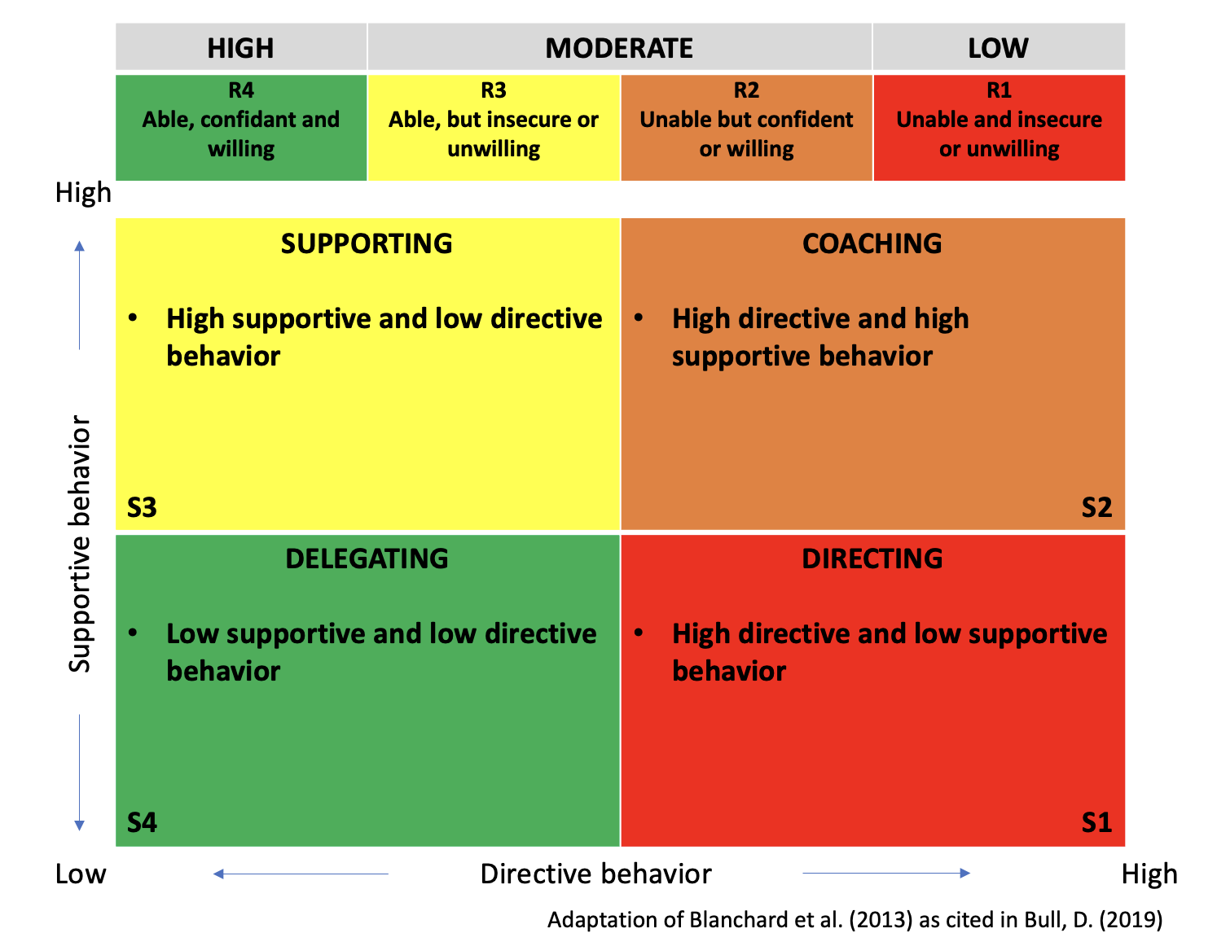

Cullen (2019, p.78) continues to explain that in order to suggest a leadership style that is suitable for the circumstance the leader finds themselves in, task (S1-S4) and relationship behaviours (R1-R4) must be examined simultaneously. The model recommends that:
- The leader adopts a delegating style and hands over responsibility for making and implementing choices to followers if the circumstance involves minimal degrees of work and connection.
- The leader should exchange ideas and promote conversations among followers, which will lead to definite conclusions, where relationships are strong, but the situation is low on the task aspect.
- The leader's approach should consist of selling, where they explain and clarify decisions, if the scenario is high on both the situation and the work.
- If the situation is high on task, but low on relationship, the leader’s approach should consist of telling, where specific instructions are given to followers and their performance is closely supervised (Cullen, 2019).

The situational leadership model exudes simplicity in theory, however, the student questions whether certain leading individuals can recall information to apply to different situations, whether that be by drawing on other leadership theories to apply to the situation or by recognising their follower’s attitudes and behaviours. Whilst recalling information regarding other theories may come with study and practice, recognising follower’s attitudes and behaviours can come down to their own emotional intelligence. Goleman (1996) states that studies show, companies that invest in emotional intelligence, gain four times return on investment. If this is so, the emotional intelligence applied to situational leadership is having a direct affect on workplace performance and outcomes. West et al. (2015, p.23) suggest that there is clear evidence linking leadership to staff engagement, well-being, turnover and absenteeism which is also linked to financial performance and overall quality of care in which West et al attributes to the healthcare setting.
Focusing on a workplace setting, leader behaviour theories typically contended that effective leadership required attention to both organising activities and cultivating positive connections (Wilson, 2019, p.11). Furthermore, Wilson discussed the idea that this approach was too simplistic and rigid which produced situational theories that suggested a variety of leadership styles are needed in order to respond to a range of situational conditions.

- Evaluate own ability to use a range of leadership styles, in different situations and with different types of people, to fulfil the leadership role

Leadership as an act, and the people described as leaders, are located in time and space – in other words, leading means different things at different moments and places. Times and places are always variable, changing and important – textbooks that claim to present you with eternal, unchanging truths about leadership are therefore not helpful. The world is so varied, different moments in time are so distinctive, organizations are so diverse, people are so unpredictable, that theories can only ever be convincing insofar as they are meaningful to people in places at specific times.
(Carroll et al., 2019, p.1)

  - The role of the leader

Leadership organisation Franklin Covey agrees with Carroll et al., (2019) that the demands and requirements of leadership change every day, stating that what may work one day may not work the next (Franklin Covey, n.d). To continue achieving results and lead a team well, Franklin Covey produced a short course on the four essential roles of leadership (Table. 2.), which as a summary covers inspiring trust, creating vision, executing strategy and coaching potential, and has the flexibility to change when problems or failures manifest.

Table. 2. Coveys four essential roles of leadership.

INSPIRE TRUST  - Demonstrate the four cores of credibility to inspire trust.  - Integrity; congruence, humility & courage.  - Intent; care about your people and values, seek mutual benefit, and act in the best interests of all involved.  - Capabilities; inspire confidence through your attitude, knowledge, skills and talents.  - Results; through past performance and producing new results followers will be able to anticipate future performance. | CREATE VISION  - Inspire team vision by creating a vision statement, producing a strategic narrative.  -Mission  -Vision  -Strategy  Start with your own creative ideas to set a starting point, then engage with your team to influence creativity and involvement.
EXECUTE STRATEGY  - Leaders must be able to execute their strategy after inspiring creation. They can do this with their followers and through them. The student can do this by aligning the six rights of alignment by asking  - Do we have the right people?  - Do we have the right structure?  - Do we have the right rewards?  - Do we have the right resources?  - Are the right decisions being made?  - Are the right processes in place to support strategy?  and the four disciplines of execution:  - Focus on the important stuff that needs to be done.  - Act on the leading measures with the highest leverage.  - Keep a scoreboard, motivating and engaging teams whilst keeping track of the results.  - Create accountability by engaging in weekly processes that highlight success, looks at failures and corrects trajectory where needed, creating a performance management system. | COACH POTENTIAL  - Leaders can coach their followers to achieve their potential, this can be done with a coaching framework focusing on four steps:  - Clarify  - Learn  - Explore  - Commit  Leaders can develop others potential and improve performance by providing feedback and coaching. Franklin Covey identify three key coaching requires key coaching skills:  - Listening  - Questioning  - Acknowledging  Adapted from Franklin Covey (n.d.)

Dogru (2019) considers that traditional management approaches are less effective in the modern workplace, as transport, communication, technology and employee needs change. To seek understanding before attempting to be understood is the first guideline of communication, leaders must understand the value of their staff (Surji, 2015). The student notices the recent change to the cost of living and the emphasis covid-19 put on working from home has impacted employees and their ideals. On discussion with the team, the student found that staff were concerned about the increased costs associated to working and that they had reassessed their future goals during the 2020 Covid-19 pandemic lockdowns. The lockdowns showed the staff that they valued their free time and family life more than ever, and the staggered reintroduction to work presented flexible working patterns, this inevitably gave staff a desirable working pattern whilst recognising their targets were still being met. As a result, the student decided to close their salon an extra day per week but open longer for the remaining days, this meant that it cost less for employees to travel to work each day and gave them a little more time at home. The staff are still hitting targets and have the option to do overtime if they choose to, giving staff a choice on how to manage their time.

3.2 Self-assessment of leadership skills

The student assessed their leadership skills using a core leadership skills self-assessment (Appendix A) this represented the student’s level of administrative, interpersonal and conceptual skills. The student scored very high in conceptual skills, followed by high levels of interpersonal skills and administrative skills. These findings indicate that the student’s overall capability of leadership is high. Looking into these core leadership skills (Figure 1.1) the student can identify that they should have strong problem-solving skills, be capable of strategic planning and be able to create visions. Whilst they agree that they possess these skills, they also recognise that they can’t bring these skills to their current workplace for reasons that needs further exploration, that this is because of a poor company culture and lack of communication. SAGE (n.d, p.132) explains that conceptual skills are about working with concepts and ideas and that leaders should be able to communicate those ideas to shape an organisation through goals, missions and problem solving. This definition enabled the student to identify that whilst doing a business plan for their business, they managed to embody these conceptual skills, creating a solid plan in which their funding stakeholders commented it was one of the best salon business plans they had seen. Less than six months into the business the student started to feel some conflicting ideas regarding their business ideas, where the student wanted to set specific roles and responsibilities the business partner didn’t. This could be where the student’s interpersonal skills could be associated with being slightly lower than conceptual skills, on the understanding that they didn’t know how to deal with the conflict at the time. On reflection the student also understands that scoring high in conceptual skills can also be associated to their belief that they are an ‘ideas person’, they enjoy setting up businesses, creating vision and implementing plans to get the business started, however, has always lost interest when the, now recognised, administrative and interpersonal skills are called upon. This does not mean that the student should continue to believe that is their only option, quite clearly, they have the skill strength to draw upon the other core leadership skills but knowing how to apply them at the right times with the right people is another matter.

Figure 1.1. Core leadership skills

Interpersonal
Administrative
Being Socially Perceptive
Showing Technical Competence

Showing Emotional Intelligence
Core Leadership
Skills

Managing Resources

Managing Interpersonal Conflict

Managing People

Creating Visions

Strategic Planning

Problem Solving

Conceptual

Adapted from SAGE (n.d)

SAGE(n.d, p.124) explains how administrative skills, although mundane, are integral part of the leadership role. The student identifies that within their workplace, they have neglected administration, although they would usually enjoy administration work when focussing on independent projects or jobs. This could indicate that the workload is too much for the individual, but it could also indicate their loss of passion for the role due to underlying issues. The student further identifies that they would like to ‘sit back’ when it comes to administration, recommendations can be made and delegation would be recommended which draws on the importance of situational leadership in the interests of the business. Indirectly taking back control of administration by delegation, the efforts could provide data to key aspects of business performance and aid arguments for implementing change within the workplace.
With the core leadership skills assessed, the student did a leadership style questionnaire (Appendix B) scoring highest as a democratic leader, very low as an authoritarian leader and low as a laissez-faire leader. The student recognises that a democratic leader reflects the leadership style displayed by David Marquet, a United States Navy captain. Marquet’s (2013) story is inspiring and reflects what the student believes leadership is and as a leadership style they wish to develop further.
Marquet (2013) was posted to a new team to launch a submarine with 6months to learn about the vessel and its team. Knowing that it took one year to learn about his previous post, Marquet took on a leadership approach to better suit his current position, empowering the team and creating synergy. His democratic leadership style meant that he made the final decisions although he included the team in the decision-making process.

4. Asses your own ability to set direction, motivate, delegate and empower others to bring about a workplace change

A theoretical framework is provided by Maslow's hierarchy of needs. It asserts that in order to set the stage for greater motivation and empowerment, all employees must first have their basic needs met. Maslow suggests that people can’t advance through the hierarchy until lower needs are satisfied, and once these needs are met, motivation becomes more complex when considering different people and their needs. Therefore, the student believes that leaders must be sensitive to these unique preferences if they are to be successful in inspiring workers to feel empowered and to be effective in their work. To build a motivated and empowered team, it can be crucial to take the time to understand each employee's requirements. This is something the student knows that they are capable of but being able to execute a plan to deliver is a separate issue. This draws on the issues related to recalling information and relying on emotional intelligence to deliver plans.

4.1 Setting direction and motivating others

The student recognises they fall short on setting direction withing their workplace, this is blamed on being ‘too busy’ and that staff already work to a satisfactory standard. However, the student also recognises that a satisfactory standard is not what they want for their business. Setting direction requires leadership, and for the student, this means taking a satisfactory situation and applying the correct methods to implement workplace change. Setting direction can be as simple as arranging weekly/monthly goal setting meetings with staff to ensure everyone is on the same page, rather than waiting for a crisis-point to establish new plans. Furthermore, the student’s democratic leadership style can be utilised to motivate staff to work independently, whilst involving them in any decisions. In section 3.2 the student identified ways in which they can delegate to staff to alleviate strains on their position whilst propelling the business forward. To empower staff, students must communicate effectively which is a weakness of the student and within the culture of the business. Yet, this can be changed if the student draws on their leadership skills.

5. Conclusion

The student has identified some interesting connections between situational leadership and their ability to lead. Whilst in theory, the application of leadership to any given situation seems achievable, the student has their own skills, workplace culture and willingness to initiate workplace change to contend with. The student is encouraged to research emergent leadership further, as per the definition, it is clear that the student’s leadership needs to emerge. Whist they know they have the skills of a competent leader; in their current workplace they have a moderate relationship with tasks (Situational leadership quadrant R3) but believes that to motivate and empower others they should be in the R4 quadrant themselves. There is still work to be done, and the student can draw on their past leadership experiences to bring workplace change to their current workplace culture.

References

Brady, K. [@Steven]. (2022, April 17). Leadership vs management. #stevenbartlett #womenceo #womenempowerment #femaleceo #karrenbrady #bossbabe [Video]. TikTok. https://www.tiktok.com/@steven/video/7087391313674439941?is_copy_url=1&is_from_webapp=v1

Bull, D. (2019). The relationship between hospital employee overall readiness and turnover intentions. Journal of business, technology & leadership. https://www.researchgate.net/publication/337313302_The_Relationship_between_Hospital_Employee_Overall_Readiness_and_Turnover_Intentions

Carroll, B., Ford, J., & Taylor, S. (2019). Leadership: Contemporary critical perspectives. (2nd ed.) Sage.

Cullen, J, G. (2019). Leading through contingencies. In Carroll. B., Ford, J., & Taylor, S. (Eds.), Leadership: Contemporary critical perspectives. (2nd ed., pp. 68-92). SAGE.

Dogru, C. (2019). Handbook of research on contemporary approaches in management and organizational strategy. IGI Global.

Franklin Covey. (n.d). The 4 essential roles of leadership. https://www.franklincovey.com/solutions/4essentialroles/

Goleman, D. (1996). Emotional intelligence: Why it can matter more than IQ. Bloomsbury Publishing.

Kotter, J. P. (1990) A force for change: How leadership differs from management. The Free Press.

Ladkin, D. (2019). Leadership, management and headship: Power, emotion and authority in organizations. In Carrol. B., Ford, J., & Taylor, S. (Eds.), Leadership: Contemporary critical perspectives. (2nd ed., pp. 28-48). SAGE.

Lee, S. M., & Farh, C. I. C. (2019). Dynamic Leadership Emergence: Differential Impact of Members’ and Peers’ Contributions in the Idea Generation and Idea Enactment Phases of Innovation Project Teams. Journal of Applied Psychology, 104(3), 411–432. https://doi.org/10.1037/apl0000384

Marquet, D. (2013, October 15). Inno-versity presents: greatness by David Marquet. [Video]. YouTube. https://www.youtube.com/watch?v=psAXMqxwol8

Mintzberg, (2009). Managing. (1st ed.). Berrett-Koehler Publishers

Northouse, P, G. (2010). Leadership: Theory and practice. (5th ed.). SAGE.

SAGE (n.d) Chapter 6: Developing leadership skills. SAGE. https://www.sagepub.com/sites/default/files/upm-binaries/59372_Chapter_6.pdf

Surij, K. (2015). Understanding leadership and factors that influence leaders effectiveness. European journal of business and management, 7(33), 154-167. http://dx.doi.org/10.7176/EJBM/7-33-2015-03

Tyler, S (2007) The manager’s good study guide. (3rd ed.) The Open University. https://ebooks.arabou.edu.kw/ebooks/LMS_eBooks/OU_Courses%27eBooks/B628/B628%20PDF/B121_Managers-Good-study-guide.pdf

West, M., Armit,K., Loewenthal, L., Eckert, R., West, T., & Lee, A. (2015). Leadership and leadership development in healthcare: The evidence base. London, Faculty of medical leadership and management.
https://www.kingsfund.org.uk/sites/default/files/field/field_publication_file/leadership-leadership-development-health-care-feb-2015.pdf

Treadway, D. C., Bentley, J. R., Williams, L, R., & Wallace, A. (2014). The Skill to Lead: The Role of Political Skill in Leadership Dynamics. In The Oxford Handbook of Leadership and Organizations. Oxford University Press. https://doi.org/10.1093/oxfordhb/9780199755615.013.025

Wilson, S. (2019). Prologue: An unconventional history of leadership studies. In Carroll, B., Ford, J., & Taylor, S. (Eds.), Leadership: Contemporary critical perspectives. (2nd ed., p. 11). SAGE.

Witzel, M. (2013) Leaders and managers should be one and the same. https://www.ft.com/content/0f0eeee0-9891-11e2-867f-00144feabdc0

Zaleznik, A. (2004). Managers and leaders: Are they different? Harvard business review, 82(1), 74-81. (Original work published 1992).

UWTSD (n.d). BMSK6001 Emergent leadership skills for the workplace: Evening session 2 [PowerPoint slides]. UWTSD. Microsoft Teams.

Appendix A

Core Leadership Skills Questionnaire 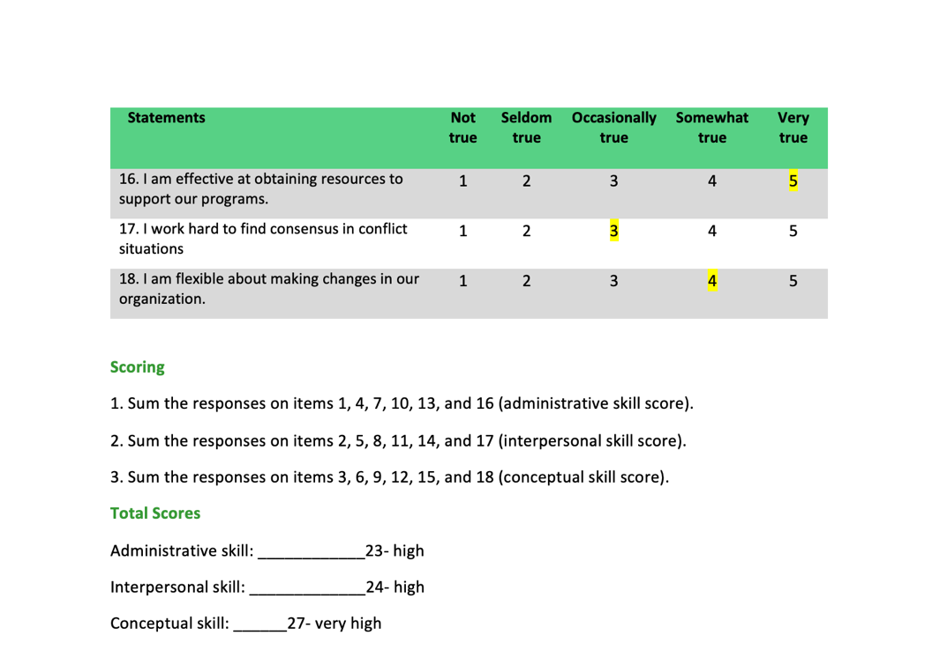

Appendix B

Leadership Style Questionnaire


