

Module Name: Employability and Career Development
Module Code: LCLM4005
Assignment Title: Reflective Report
Student Name: Anita Rai
Student ID: 2511027
Lecture Name: Sujeewa Herath

Table of Contents
Introduction 3
Task 1. Compare two Job adverts and identify Key Skills 4
1.1 Identify Common Skills and Knowledge Areas 4
1.2 Choose one shared skill and explain why that skill is important 4
Task 2: Self-assessment and Evidence of readiness 5
2.1 Self-Assessment SWOT Analysis 5
2.6 Evidence of Readiness 6
Task 3: Set Employment Goals and develop a personal development plan 9
3.1 Short-term Employment Goals: 10
3.3 Personal Development Plan 10
Conclusion 12
Reference List 12

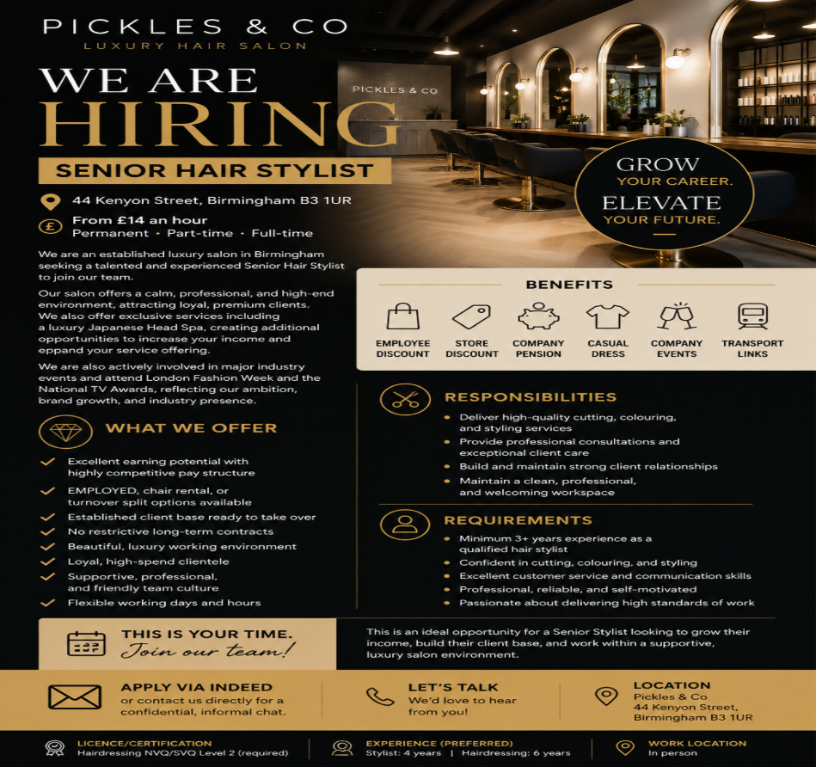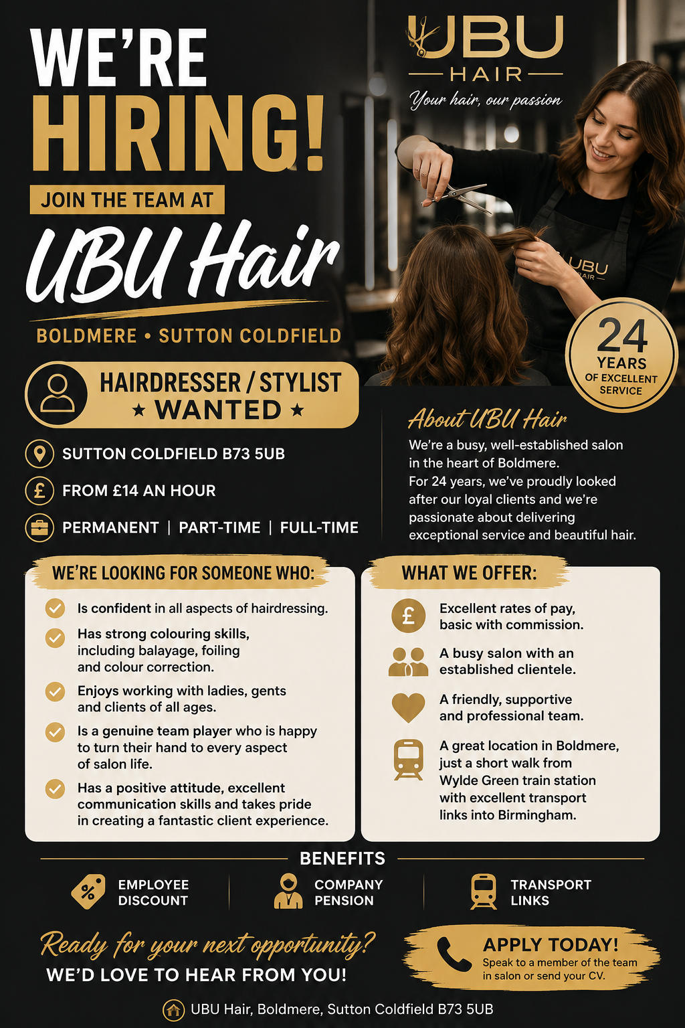

Introduction
This assignment explores my career development and employability as a professional hair stylist. It begins by comparing two job advertisements to identify the key skills, qualifications, and experience employers are looking for. I then complete a self-assessment to evaluate my own strengths and areas for improvement, supported by evidence of my readiness for employment. Based on this assessment, I set both short-term and long-term employment goals and develop a personal development plan to improve my skills and achieve my career aspirations. This assignment demonstrates my commitment to continuous learning, professional growth, and preparing for a successful career in the hair and beauty industry.

Task 1. Compare two Job adverts and identify Key Skills

Key Skills/Knowledge | UBU Hair | Pickles & Co
Qualified Hair Stylist | ✔ | ✔
Hairdressing experience | 6 years preferred | 3–6 years preferred
NVQ/SVQ Level 2 Hairdressing | Not specified | Required
Hair colouring techniques | Balayage, foiling, colour correction | Professional colouring skills
Excellent customer service | ✔ | ✔
Communication skills | ✔ | ✔
Teamwork | ✔ | ✔
Build client relationships | ✔ | ✔
Professional appearance and workspace | ✔ | ✔
Flexible working | Part-time/Full-time | Flexible hours and working options

1.1 Identify Common Skills and Knowledge Areas
Both job adverts show that employers want a hair stylist with experience and the right hairdressing qualification. They are looking for someone who has good customer service and communication skills and can make clients feel welcome. Both employers also want a stylist who can work well in a team, has a positive attitude, and is confident in hair colouring and styling. It is also important to keep the salon clean, tidy, and professional. These skills help provide a good experience for customers and make the salon successful. In today’s highly competitive business landscape, outstanding customer service has become a key factor that sets successful organisations apart. This narrative review explores how active listening functions as a core communication skill in creating high-quality customer service interactions (Tarannum, Akter and Sarwar, 2025).

1.2 Choose one shared skill and explain why that skill is important
One of the most important skills required in both job adverts is excellent customer service. In my future role as a hair stylist, I will use strong customer service skills to welcome clients warmly, understand their needs, provide professional advice, and deliver high-quality hair services. Good customer service helps clients feel valued and satisfied, encouraging them to return and recommend the salon to others. According to Harris (2002), customer service is essential for building customer satisfaction and loyalty. It also helps build trust, improve the salon's reputation, and increase customer loyalty, which contributes to business success.

Task 2: Self-assessment and Evidence of readiness
2.1 Self-Assessment SWOT Analysis
A self-assessment SWOT analysis helps identify my Strengths, Weaknesses, Opportunities, and Threats. It allows me to evaluate my current skills, experience, and areas for improvement so that I can plan my future career development. By understanding these factors, I can set realistic goals, improve my employability, and prepare for a successful career in the hair and beauty industry. According to Fullmer (2009), a SWOT analysis is a useful tool for identifying strengths, weaknesses, opportunities, and threats in order to support personal and professional development planning. Advanced techniques—including quantified scoring, integration of the TOWS matrix, and iterative refinement—are explored to increase both the analytical depth and the practical effectiveness of SWOT analysis (Karadzhov, 2025).
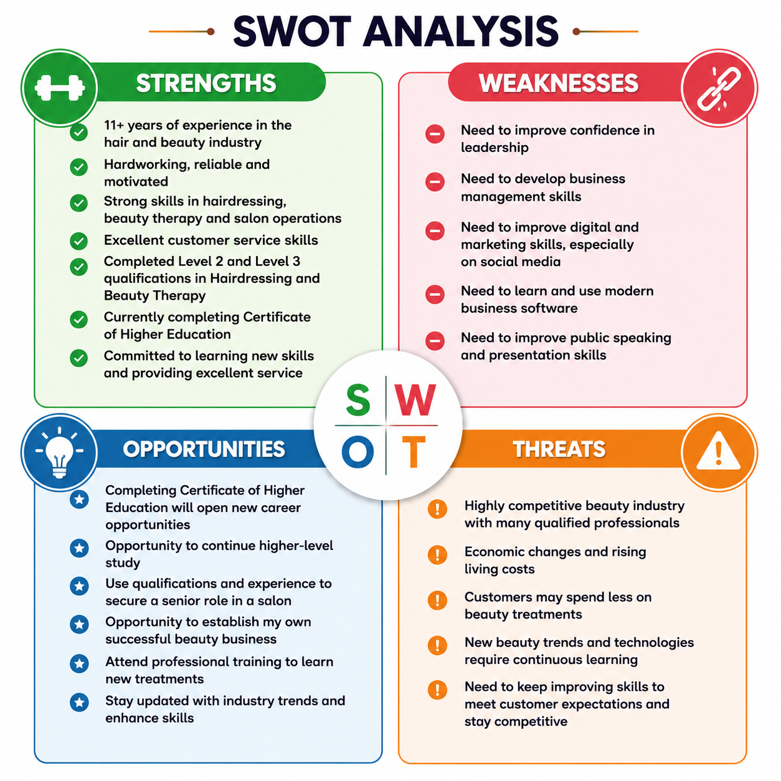

2.6 Evidence of Readiness
I have developed the knowledge, skills, and experience needed for employment and future career progression. During my Certificate of Higher Education, I completed modules including Academic Skills (40%), Digital Skills (64%), Effective Teamworking and Communication (50%), and Problem Solving and Decision Making (57%). These modules have improved my research, digital, communication, teamwork, and problem-solving skills. Combined with my 11 years of experience in the hair and beauty industry and my professional qualifications, I feel prepared to progress in my career and achieve my goal of building my own beauty business.
In addition, my career motivation test showed that financial reward is my strongest motivator, with a score of 80%. This means I am motivated to work hard to achieve a good income and financial stability while providing excellent customer service. Earning a competitive salary encourages me to improve my skills, deliver high-quality hair and beauty treatments, and ensure every client has a positive experience. It also motivates me to continue learning, build strong relationships with customers, and work towards my long-term goal of running a successful hair and beauty business.

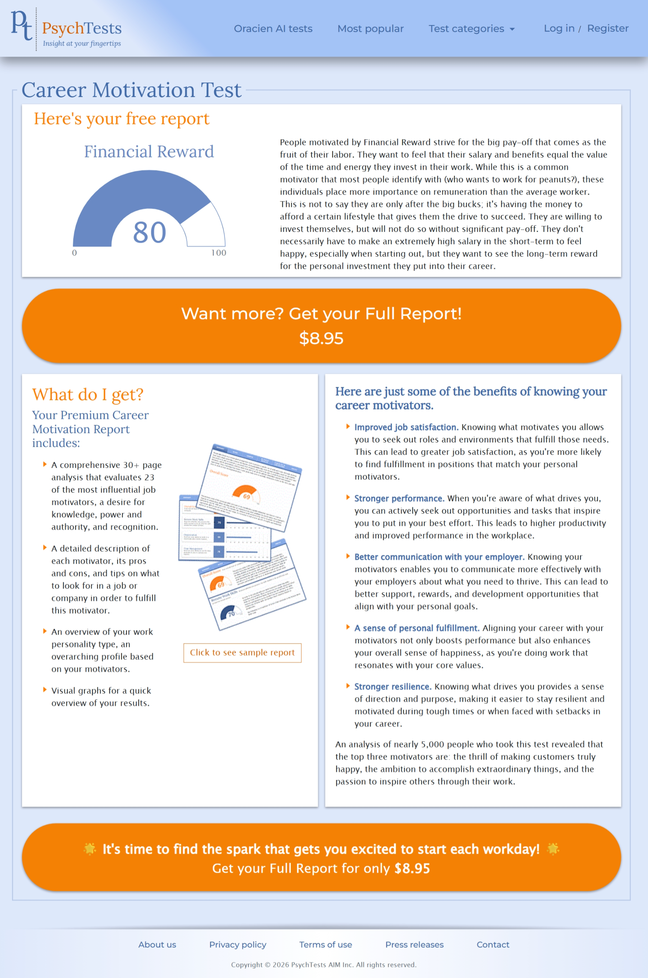
Personality Test: My personality test showed that I have a high level of emotional insight, with a score of 90%. This means I am able to understand my own feelings and recognise the emotions of others. This skill helps me communicate effectively, build positive relationships with clients and colleagues, and provide better customer service. Emotional insight is important in the hair and beauty industry because it allows me to understand clients’ needs and create a comfortable and supportive experience.

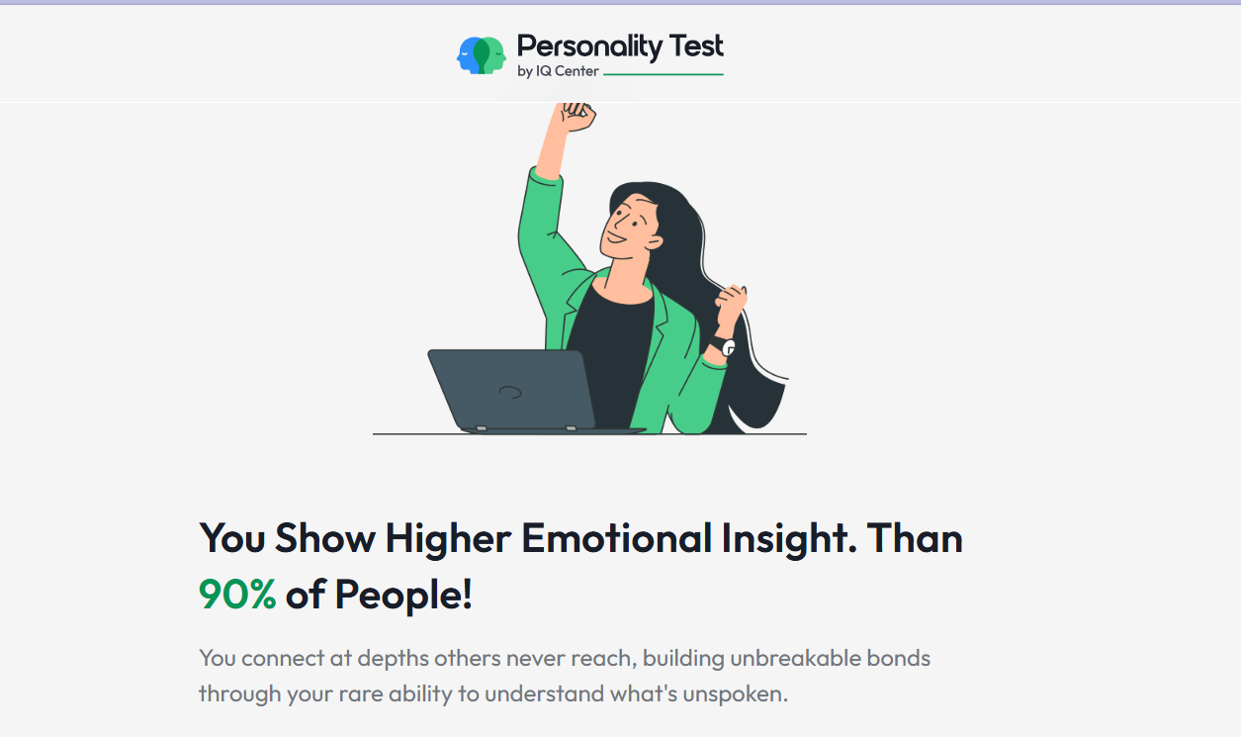

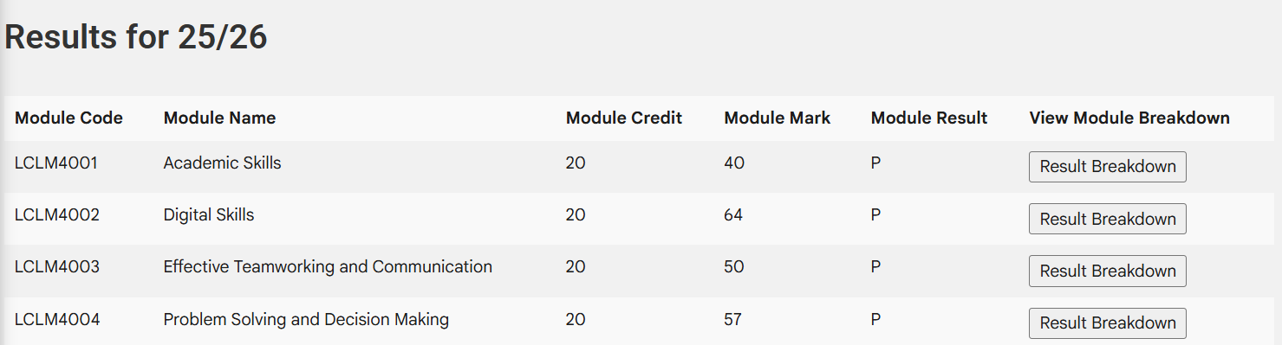

Task 3: Set Employment Goals and develop a personal development plan

I have developed the knowledge, skills, and experience needed to be ready for employment and future career progression. I am currently in the final stages of completing my Certificate of Higher Education, which has strengthened my understanding of communication, teamwork, problem-solving, leadership, and business management. According to Lamb, Maire and Doecke (2017), key skills for the 21st century, such as communication, collaboration, critical thinking and problem-solving, are essential for success in education and the workplace. Through my coursework and assignments, I have improved my research, academic writing, presentation, and critical thinking skills. I
In addition to my academic achievements, I have over 11 years of experience in the hair and beauty industry. I have worked as a Hair Stylist and Beauty Therapist, providing professional hairdressing, beauty treatments, and excellent customer service. My apprenticeship at Sandwell College allowed me to gain valuable practical experience in a busy salon environment while developing my technical skills and professionalism.
I have also completed Level 2 and Level 3 qualifications in Hairdressing and Beauty Therapy, along with additional certifications in Acrylic Nail Extensions and Ear Piercing. These qualifications demonstrate my commitment to continuous professional development and lifelong learning. Feedback from tutors, trainers, and clients has recognised my reliability, strong work ethic, friendly attitude, and ability to build positive relationships with customers and colleagues. These experiences have increased my confidence and prepared me to work effectively in a professional environment, while also supporting my long-term goal of progressing into leadership and eventually building my own beauty business.
Based on my SWOT analysis, I have identified areas for further development, including improving my leadership, business management, digital marketing, and communication skills. According to Coman and Ronen (2009), a focused SWOT analysis helps individuals identify their most important strengths and weaknesses, enabling them to make informed decisions and develop effective improvement plans. Setting clear employment goals will help me continue my personal and professional growth and achieve my long-term career aspirations.

3.1 Short-term Employment Goals:
My short-term goal is to secure a position as a qualified Hair Stylist and Beauty Therapist in a professional salon environment where I can continue developing my technical skills, gain more UK industry experience, and improve my confidence. I also aim to strengthen my knowledge of salon management, customer relationship management, and digital marketing skills. These goals are important because they will help me build professional confidence, expand my experience, and prepare me for future career opportunities.
3.2 Long-term Employment Goals:
My long-term goal is to progress into a leadership or management role within the beauty industry and eventually establish my own successful hair and beauty business. I want to use my practical experience, higher education knowledge, and entrepreneurial skills to create a professional salon that provides high-quality services and excellent customer experiences. These goals align with my career aspirations because I am passionate about the beauty industry and want to combine my creativity, skills, and business knowledge to achieve long-term success and independence.

3.3 Personal Development Plan
Based on my SWOT analysis, I have identified areas for improvement, including leadership skills, business management knowledge, digital marketing skills, and confidence in communication and presentations. According to Mittendorff, Jochems, Meijers and Den Brok (2008), personal development plans and portfolios can support career guidance by helping individuals reflect on their skills, progress, and future goals. Therefore, creating a personal development plan will help me monitor my progress, develop my abilities, and work towards achieving my career aspirations in the hair and beauty industry. The following personal development plan outlines the actions I will take to improve these areas and support my career progression.

Area to Improve | Action | Timeline | Resources | How I Will Measure Progress
Leadership Skills | Learn from experienced managers and take part in team activities. | 6 months | Manager, tutor, online courses | I feel more confident leading tasks and receive positive feedback.
Communication Skills | Practise speaking with clients and give presentations during my studies. | 3–6 months | Tutors, classmates, work experience | I can communicate more confidently with clients and colleagues.
Digital Marketing | Learn how to use social media to promote beauty services. | 6 months | YouTube, online courses, social media | I can create and post professional business content online.
Business Knowledge | Continue learning about business management and salon operations. | 12 months | Certificate of Higher Education course, business books | I have a better understanding of running a business
Professional Skills | Attend beauty and hair training courses to learn new techniques. | Ongoing | Training courses and workshops | I gain new certificates and improve my practical skills.

Conclusion: This assignment has helped me reflect on my career skills, experience, and future goals as a professional hair stylist. By comparing job adverts, completing a self-assessment, and creating a personal development plan, I have identified my strengths and areas for improvement. My experience, qualifications, communication skills, and commitment to customer service provide a strong foundation for my career development. By continuing to improve my leadership, digital marketing, and business skills, I will be better prepared to achieve my long-term goal of becoming a successful hair and beauty business owner.

Reference List
Coman, A. and Ronen, B. (2009) ‘Focused SWOT: Diagnosing critical strengths and weaknesses’, International Journal of Production Research, 47(20), pp. 5677–5689.
Fullmer, P. (2009) ‘The assessment of a tutoring program to meet CAS standards using a SWOT analysis and action plan’, Journal of College Reading and Learning, 40(1), pp. 51–76.
Harris, E.K. (2002) Customer Service: A Practical Approach. 3rd edn. Upper Saddle River, NJ: Prentice Hall.
Lamb, S., Maire, Q. and Doecke, E. (2017) Key skills for the 21st century: An evidence-based review. Sydney: NSW Department of Education.
Mittendorff, K., Jochems, W., Meijers, F. and Den Brok, P. (2008) ‘Differences and similarities in the use of the portfolio and personal development plan for career guidance in various vocational schools in The Netherlands’, Journal of Vocational Education and Training, 60(1), pp. 75–91.
Tarannum, T., Akter, S. and Sarwar, A.S.M., 2025. The Art of Listening: Communication Techniques for Exceptional Customer Service. Pacific Journal of Business Innovation and Strategy, 2(3), pp.31-37.
Karadzhov, V., 2025. How to create the best SWOT analysis. International Journal of Research and Review, 12(1), pp.66-75.

