Addressing the Cold-Start Problem in Residential Load Forecasting: An Optimized LSTM Transfer Learning Framework

Course Name: | Master’s Project
Instructor: | Dr. Nouh Elmitwally
Author: | Rui Guan
Student ID: | 2422400
Program: | Data and Artificial Intelligence
Date: | 02/05/2026

Contents
1. Abstract 1
2. Introduction 2
2.1 The Global Energy Transition and the Role of Smart Grids 2
2.2 The Criticality of STLF 3
2.2.1 Real-Time Stability and Asset Protection 3
2.2.2 Integration of Demand-Side Strategies 3
2.2.3 From Aggregate Smoothing to Individual Stochasticity 3
2.3 Technical Barriers: Volatility and the Cold Start Problem 4
2.4 Transfer Learning as a Scalable Solution 5
2.4.1 The Pre-training and Fine-tuning Paradigm 5
2.4.2 Mitigation of Negative Transfer and Optimization 5
2.4.3 Empirical Validation and Practical Path 6
3. Literature Review 6
3.1 Evolutionary Trajectory of Short-Term Load Forecasting 6
3.1.1 The Statistical Era: ARIMA and Smoothing Techniques 6
3.1.2 The Machine Learning Era: SVR and Random Forests 7
3.1.3 The Deep Learning Revolution: RNNs and LSTMs 7
3.1.4 Advanced Hybrid and Multi-User Architectures 8
3.2 Stochasticity and Complexity in Individual Household Forecasting 8
3.2.1 The Failure of the Law of Large Numbers 9
3.2.2 Signal-to-Noise Ratio and Edge User Variability 9
3.2.3 External Drivers and Non-Stationarity 9
3.2.4 The Burn-in Period and the Cold-Start Bottleneck 10
3.3 Theoretical Analysis of the Cold-Start Problem 10
3.3.1 The Bias-Variance Dilemma in Small-Sample Regimes 10
3.3.2 Operational Implications of the “Value-Void” 11
3.3.3 The Absence of Temporal “Energy Fingerprints” 11
3.3.4 Augmentation through Cross-Domain Knowledge 11
3.4 Transfer Learning Paradigms and Negative Transfer 12
3.4.1 The Mechanism of Knowledge Migration 12
3.4.2 The Paradox of Negative Transfer 12
3.4.3 Self-Adaptive Fine-Tuning and Layer Freezing 12
3.4.4 Automated Optimization of Transferability 13
3.5 Benchmarking against the London Smart Meter Dataset Studies 13
3.5.1 The Baseline of Recurrent Architectures 13
3.5.2 The Application of Transformers in STLF 13
3.5.3 Knowledge Migration and Our Distinct Contribution 14
4. Methodology 14
4.1 Data Engineering and Theoretical Preprocessing 14
4.1.1 Data Source and Granularity 15
4.1.2 Handling Missing Data and Linear Interpolation 15
4.1.3 Theoretical Impact of Z-score Normalization 15
4.1.4 Temporal Framing via Sliding Window 16
4.1.5 Multivariate Expansion: Integration of Temporal Covariates 16
4.2 The Mathematical Architecture of LSTM Networks 17
4.2.1 The Core Mechanism: The Cell State 17
4.2.2 The Forget Gate: Deciding What to Discard 17
4.2.3 The Input Gate: Knowledge Synthesis 18
4.2.4 The Output Gate: Hidden State Generation 18
4.3 The Transformer Architecture for Sequence Modeling 19
4.4 Experimental Framework and Comparative Logic 19
5: System Implementation and Computational Framework 20
5.1 Engineering Philosophy and Modular Architecture 20
5.1.1 Technological Stack and Rationale 20
5.2 Implementation of the Data Engineering Pipeline 21
5.2.1 Instance Normalization and Preprocessing Logic 21
5.2.2 The SmartMeterDataset Class and Sliding Window Mechanism 21
5.2.3 Implementation of Temporal Feature Fusion 22
5.3 Automated Optimization and Search Space Design 22
5.3.1 Optuna TPE and SQLite Integration 22
5.3.2 Search Space and Convergence Strategy 22
5.3.3 Multi-Architecture Search Space Design 22
5.4 Implementation of the Transfer Learning Framework 23
5.4.1 Programmatic Gradient Masking 23
5.4.2 Comparative Evaluation and Multi-Strategy Testing 23
5.5 Computational Performance and Metrics Implementation 24
5.5.1 Robust Metric Calculation 24
5.5.2 Visualization and Result Persistance 24
5.5.3 Automated Comparative Reporting 24
6. Results 25
6.1 Comprehensive Quantitative Analysis 25
6.1.1 Experimental Configuration and the 10-Day Window 25
6.1.2 Definition of Forecasting Strategies and Architectures 25
6.1.3 Evaluation Protocol and Metrics 26
6.2 The Mechanism of the “Performance Ladder” 26
6.2.1 Overcoming the Overfitting Threshold 26
6.2.2 The Efficacy of Localized Adaptation 27
6.3 Empirical Evidence of Negative Transfer 28
6.3.1 The Failure of Model 1 and Informative Bias 29
6.3.2 Systematic Optimization via Optuna (v1 and v2) 30
6.4 Architectural Duel: LSTM vs. Transformer in Cold-Start 31
6.4.1 Quantitative Comparison of Mean Performance 31
6.4.2 Theoretical Analysis: Inductive Bias vs. Data Hunger 32
6.4.3 Visual Evidence of Forecasting Stability 32
6.5 Robustness Analysis and Metric Discussion 33
6.5.1 Error Stability and Architecture Reliability 33
6.5.2 Interpreting the MAPE Anomaly in Standardized Spaces 34
7. Discussion 34
7.1 Theoretical Foundations of the Performance Hierarchy 34
7.1.1 The Universality of Circadian Rhythms 35
7.1.2 Transfer Learning as a Structural Regularizer 35
7.2 Architectural Trade-offs: Inductive Bias vs. Data Scarcity 35
7.2.1 The “Data Hunger” Paradox of Self-Attention 36
7.2.2 The Advantage of Sequential Inductive Bias 36
7.3 The Critical Threshold of Negative Transfer and Optimization 37
7.3.1 Informative Bias and Source Domain Over-specialization 37
7.3.2 Bayesian Optimization as a Catalyst for Transferability 37
7.4 Implications for Smart Grid Reliability and Service Deployment 38
7.4.1 The “Variance Compressor” Effect and Risk Mitigation 38
7.4.2 Interpreting the MAPE Anomaly and Scaling Artifacts 38
7.4.3 Accelerating the ROI of Smart Metering Infrastructure 39
8.Conclusion and Future Work 39
8.1 Summary of Contributions 39
8.2 Key Empirical Findings 39
8.3 Practical Implications for Utility Operators 40
8.4 Limitations and Future Directions 40
References 42

1. Abstract
The widespread deployment of Advanced Metering Infrastructure (AMI) necessitates accurate Short-Term Load Forecasting (STLF) for demand-side management. However, newly commissioned residential meters suffer from the “cold-start” problem—a critical data-scarcity period where traditional high-capacity neural networks fail to converge. While transfer learning and Attention-based models (Transformers) dominate data-rich forecasting, their efficacy in extreme small-sample regimes remains critically underexplored. This study proposes a multivariate transfer learning framework to mitigate the cold-start bottleneck, executing a head-to-head empirical benchmark between Recurrence-based (LSTM) and Attention-based (Transformer) architectures. Utilizing the London Smart Meter dataset, models were pre-trained on a source domain, optimized via the Optuna Bayesian framework to successfully eliminate negative transfer, and subjected to a strict 10-day adaptive fine-tuning window across 30 diverse target households.
The results establish a definitive performance hierarchy: the proposed fine-tuning strategy significantly outperformed the scratch-training baseline, reducing the Mean Squared Error (MSE) from 0.7080 to 0.4849. Crucially, the comparative analysis reveals that the fine-tuned LSTM framework (MSE: 0.4849) empirically outperforms the Transformer (MSE: 0.4984) under extreme data constraints. This divergence demonstrates that the sequential “inductive bias” of LSTMs acts as a powerful structural regularizer against localized stochastic noise, whereas the “data-hungry” self-attention mechanism struggles to converge reliably without sufficient samples. Ultimately, the proposed framework acts as a “variance compressor,” mitigating forecasting tail risk and enabling utility operators to bypass the traditional data-accumulation phase, thereby facilitating the highly reliable, Day-1 deployment of smart grid services.
Key Words: Short-Term Load Forecasting, Cold-Start Problem, Transfer Learning, Long Short-Term Memory (LSTM), Transformer, Inductive Bias, Smart Grid.

2. Introduction

2.1 The Global Energy Transition and the Role of Smart Grids
The contemporary global energy landscape is currently traversing a period of profound and irreversible transformation, moving away from centralized fossil-fuel-based architectures toward decentralized, sustainable, and highly intelligent power systems. This macro-scale shift is primarily catalyzed by the urgent international mandate to achieve carbon neutrality by the mid-century, a goal that necessitates the massive integration of volatile and intermittent renewable energy sources, most notably solar and wind power. As the penetration of these non-dispatchable energy sources increases, the physical inertia of the traditional grid decreases, leading to significant challenges in maintaining frequency stability and voltage regulation. To manage the inherent complexity and stochastic nature of these green energy sources, the power industry has pivoted toward the large-scale implementation of Smart Grids. This paradigm shift is fundamentally characterized by the widespread integration and deployment of Advanced Metering Infrastructure (AMI) [1].
AMI serves as the sensory nervous system of the intelligent grid, comprising high-precision smart meters, advanced bidirectional communication networks, and sophisticated Meter Data Management Systems [1], [2], [3]. Unlike traditional power grids that operate on a rigid, one-way energy flow and rely on low-resolution, manual monthly consumption metrics, smart grids leverage high-frequency and granular data to create a dynamic, bidirectional communication ecosystem. In this modern context, electricity is no longer just a physical commodity but is inextricably linked to a digital information layer. This technological evolution has effectively transformed traditional, reactive power systems into proactive, data-driven environments where information and predictive analytics serve as strategic assets for ensuring grid stability and efficiency [4].
The transition also facilitates the rise of “prosumers,” residential users who both consume and produce energy through distributed resources like rooftop solar panels and electric vehicles. This decentralized generation complicates the net load profile, making accurate forecasting at the individual level more critical than ever before. The core objective of these socio-technical advancements is to optimize the synchronization between real-time electricity generation and end-user demand. By utilizing granular STLF models, utility providers can achieve a higher degree of precision in balancing the grid, thereby minimizing energy waste and reducing the massive operational costs associated with maintaining excess spinning reserves or deploying expensive, high-carbon peaker plants during periods of unexpected demand surges. Ultimately, this accurate anticipation of load fluctuations is a prerequisite for the successful implementation of Demand-Side Management (DSM) strategies [5].

2.2 The Criticality of STLF
Within the sophisticated framework of smart grid management, STLF at the residential level has emerged as a critical cornerstone for operational success. As the power grid transitions from a centralized “generation-follows-load” model to a decentralized “load-follows-generation” paradigm, the ability to predict energy requirements with high temporal resolution becomes a non-negotiable requirement for system operators. Achieving high precision in STLF is essential for several technical, economic, and environmental reasons.

2.2.1 Real-Time Stability and Asset Protection
First, accurate forecasts allow grid operators to maintain real-time operational stability by preventing transformer overloads and managing peak demand surges [4]. In a traditional grid, assets such as distribution transformers and underground cables are designed with specific thermal limits. Unpredicted surges in residential demand—driven by the simultaneous use of high-power appliances—can cause these assets to exceed their operating temperatures, leading to accelerated insulation degradation or even catastrophic hardware failure. By utilizing granular STLF, utility providers can implement proactive grid reconfigurations or activate localized energy storage systems to buffer these peaks, thereby extending the lifespan of the physical infrastructure and reducing maintenance capital expenditure.

2.2.2 Integration of Demand-Side Strategies
Second, it provides the fundamental data required for the successful implementation of Demand-Side Management (DSM) and Demand Response (DR) strategies [5]. In a modern energy market, utility providers utilize these forecasts to design dynamic pricing models that incentivize consumers to shift their consumption from peak to off-peak hours. These strategies, such as Time-of-Use (ToU) pricing or Real-Time Pricing (RTP), rely heavily on the accuracy of predicted load profiles. If a forecast is inaccurate, the price signals sent to consumers may fail to alleviate grid stress or, in some cases, inadvertently create new peaks. By accurately anticipating load fluctuations, providers can better balance supply and demand while optimizing the dispatch of traditional and renewable energy generators. This optimization is particularly vital for the integration of intermittent renewables, as it allows for the alignment of flexible residential loads with periods of high solar or wind availability.

2.2.3 From Aggregate Smoothing to Individual Stochasticity
However, as the focus shifts from aggregate substation-level forecasting to individual household-level forecasting, the complexity of the task increases exponentially due to the high volatility and stochastic nature of human behavior. At the substation level, the “aggregation effect”—rooted in the Law of Large Numbers—effectively smooths out the erratic behaviors of thousands of individual users, resulting in predictable periodic curves. In contrast, at the individual household level, this smoothing effect disappears. A single decision by a resident to activate a high-draw appliance, such as an electric vehicle (EV) charger or an electric oven, can cause an instantaneous doubling or tripling of the household’s base load. This high-entropy environment makes traditional linear models obsolete and necessitates the use of advanced deep learning architectures capable of capturing non-linear temporal dependencies. These dependencies are often influenced by the double-seasonal cycles (daily and weekly) inherent in electricity consumption [6], which necessitates specialized time-series decomposition techniques [7].

2.3 Technical Barriers: Volatility and the Cold Start Problem
Currently, state-of-the-art deep learning architectures, particularly Long Short-Term Memory (LSTM) networks, are lauded for their ability to capture long-range temporal dependencies in complex time-series data [8]. The fundamental strength of the LSTM architecture lies in its sophisticated gating mechanisms, which allow the network to selectively retain or discard information over extended sequences. These models excel in data-rich environments where thousands of historical observations are available to train the internal gating mechanisms, enabling the model to learn the intricate periodicity of residential energy consumption, such as daily cycles and weekly fluctuations.
However, the performance of these deep learning structures is inherently dependent on the volume of training data to achieve model convergence and mitigate the risk of overfitting [8], [9]. Because LSTMs are parameter-heavy architectures, they require a sufficiently large ratio of observations to trainable weights to ensure that the network identifies the underlying statistical distribution rather than simply memorizing the noise in the training sample. When the available dataset is small, the gradient descent process often fails to find a stable global optimum, leading to high variance and poor generalization on unseen data. This dependency creates a significant and persistent operational bottleneck in the form of the “cold start” problem—a scenario where model generalization is fundamentally constrained by the extreme small-sample regime [10].
This phenomenon occurs when new residential participants are integrated into the grid or when existing meters are upgraded, resulting in a critically sparse data window. Typically, these new users provide less than 14 days of historical records, which is insufficient for a parameter-heavy LSTM model to learn the specific consumption rhythms and seasonal patterns of a specific household [11]. From a mathematical perspective, 14 days of hourly readings provide only 336 data points, a volume that is grossly inadequate for tuning the thousands of parameters within a modern recurrent neural network. Under such conditions, traditional “from-scratch” training methods fail to yield reliable results, often leading to model divergence and erratic predictions.
This technical barrier creates a “value-void” period where the newly installed smart meter cannot yet support high-value energy services. During this interval, the utility provider cannot deliver personalized demand-response recommendations or accurate localized load balancing because the model has not yet stabilized. For the grid operator, this lack of predictive visibility for new nodes introduces a layer of stochastic uncertainty that complicates real-time balancing. This research targets this specific gap by utilizing transfer learning to provide immediate predictive utility from the moment a smart meter is commissioned.

2.4 Transfer Learning as a Scalable Solution
This research addresses the pervasive data scarcity challenge in energy systems by developing a robust LSTM-based transfer learning framework designed specifically for cold-start scenarios. Transfer learning operates on the foundational principle of knowledge reuse, where insights and statistical representations gained from a data-rich source domain are applied to improve the learning process in a data-poor target domain [12]. In accordance with the established theoretical taxonomy of knowledge migration [13], this involves mapping the universal temporal features—such as the daily periodicity of appliance usage and the thermal response of buildings—from established smart meter users to new residential participants who lack a historical footprint.

2.4.1 The Pre-training and Fine-tuning Paradigm
The proposed framework implements a sophisticated “pre-training and fine-tuning” paradigm. In the pre-training phase, the LSTM network is exposed to a large-scale source domain comprising hundreds of households with multi-year data. This allows the internal hidden layers of the network to act as generalized feature extractors, leveraging deep representation learning to internalize a rich latent space of consumption rhythms [14]. By migrating these learned weights to a new user, the model does not start its learning process from a random distribution but rather from an informed prior that already understands the basic mechanics of electricity demand. A comprehensive survey on time-series transfer learning suggests that such knowledge migration can significantly reduce the data accumulation period required for accurate forecasting [15]. This reduction is vital for utility providers, as it effectively eliminates the multi-week waiting period typically required before a predictive model becomes operational.

2.4.2 Mitigation of Negative Transfer and Optimization
The primary contributions of this work are focused on bridging the gap between theoretical potential and practical implementation. One of the most significant hurdles in knowledge migration is the phenomenon where unoptimized pre-trained weights can lead to negative transfer, a condition where the initial knowledge actually hinders target performance [13]. Negative transfer often occurs when the source domain is too divergent from the target or when the model has over-fitted to specific noise in the source data. To prevent this, the initial weights must provide a robust but flexible representation that can be quickly adapted to localized behavioral nuances.
To ensure stable knowledge transfer and avoid the degradation of predictive accuracy, this research utilizes a systematic hyperparameter optimization process using the Optuna framework [16]. Optuna employs a Tree-structured Parzen Estimator (TPE) algorithm to search the high-dimensional parameter space, identifying the optimal learning rates, hidden units, and dropout ratios that maximize the “transferability” of the features. This automated search process replaces manual heuristics, which are often insufficient for handling the high volatility of residential energy data.

2.4.3 Empirical Validation and Practical Path
The effectiveness of this optimized transfer learning approach is validated through a rigorous experimental protocol. Extensive batch evaluation on 30 diverse households from the London Smart Meter dataset demonstrates that the optimized framework achieves a 31.5% improvement over the traditional scratch-training baseline. By providing a scalable solution that works with as little as 10 days of target data, this work establishes a viable path for immediate, high-value service deployment in smart grids from the very first day of meter installation.

3. Literature Review

3.1 Evolutionary Trajectory of Short-Term Load Forecasting
The historical development of STLF represents a fundamental shift from linear statistical modeling to sophisticated deep learning architectures [17]. While early neural networks offered initial breakthroughs in capturing non-linear consumption patterns [18], recent successes in recurrent applications have further proven the efficacy of sequential deep modeling [19].

3.1.1 The Statistical Era: ARIMA and Smoothing Techniques
Early methodologies were dominated by Autoregressive Integrated Moving Average (ARIMA) and exponential smoothing techniques. These models rely on the assumption of stationarity or near-stationarity in time-series data. While effective for aggregate load forecasting where noise is filtered out through summation—a phenomenon explained by the Central Limit Theorem where the sum of independent random variables tends toward a Gaussian distribution—these methods struggle with the sharp fluctuations inherent in individual household data. In the context of a single residence, electricity consumption is not a smooth continuous function but rather a series of discrete, high-variance events driven by human behavior. Consequently, the linear nature of ARIMA fails to capture the heteroscedasticity and non-linear spikes typical of modern residential energy use.

3.1.2 The Machine Learning Era: SVR and Random Forests
The emergence of machine learning introduced a new set of tools, most notably Support Vector Regression (SVR) and Random Forests. These models offered a significant leap forward by providing the capacity to model non-linear relationships without requiring strict parametric assumptions. SVR, for instance, utilizes the kernel trick to map input data into high-dimensional spaces where linear separation or regression becomes possible. However, these shallow learners often fail to capture the long-term temporal dependencies present in energy time series. Their performance is heavily contingent upon manual feature engineering, where experts must pre-define lagged variables and seasonal indicators. Because they lack an inherent “memory” mechanism, they treat each input window as a static snapshot, often overlooking the sequential context that defines residential routines.

3.1.3 The Deep Learning Revolution: RNNs and LSTMs
The introduction of Recurrent Neural Networks (RNNs) marked a true paradigm shift in the field by treating load forecasting as a dynamic sequence modeling problem rather than a static regression task. Unlike feed-forward neural networks, RNNs maintain a hidden state that functions as a temporal memory, carrying information from previous time steps to influence the current output. This recurrent structure theoretically allows the network to model the sequential nature of residential routines. However, traditional RNNs are plagued by the vanishing gradient problem. During the Backpropagation Through Time (BPTT) process, the gradients of the loss function are repeatedly multiplied by the weight matrices as they propagate back to earlier time steps. If these weights are small, the gradient diminishes exponentially, effectively preventing the network from learning dependencies across long sequences. This limitation is particularly detrimental in STLF, where the model must understand patterns over several days (96 time steps for 15-minute intervals). Long Short-Term Memory (LSTM) networks solved this critical flaw by introducing a sophisticated gating mechanism consisting of forget, input, and output gates [8]. The core innovation of the LSTM is the cell state, which serves as an information highway that can maintain information with minimal modification. The forget gate regulates how much of the previous cell state should be retained, the input gate decides which new information from the current observation should be stored, and the output gate determines which part of the cell state will be passed to the hidden state. This mathematical architecture allows the model to selectively retain or discard information over hundreds of time steps, making it capable of capturing both high-frequency daily peaks and low-frequency weekly trends.
Kong et al. pioneered the application of LSTM to residential STLF, proving its superiority in handling the extreme volatility of single-user consumption [9]. Their research demonstrated that the internal gating mechanisms of LSTMs could effectively filter out the stochastic “noise” of individual appliance activations while identifying the underlying energy “fingerprint” of a household. This established the LSTM as the gold standard for high-resolution residential forecasting in modern smart grid research[9], [20], [21].

3.1.4 Advanced Hybrid and Multi-User Architectures
Following the success of standard LSTMs, the research community branched into more specialized and complex structures to further enhance predictive robustness. One prominent development is the Pooling LSTM model, designed specifically to mitigate the impact of individual noise by learning shared features across a group of similar users [22]. By pooling data from multiple households, the model can leverage cross-user correlations to compensate for the sparsity of data in any single residence. This approach addresses the inherent high-entropy nature of residential load by emphasizing collective consumption rhythms over individual stochastic events.
Simultaneously, hybrid CNN-LSTM structures have emerged to extract local spatial-temporal features from raw energy time series [5]. In these hybrid frameworks, Convolutional Neural Networks (CNNs) are utilized as automated feature extractors in the initial layers. The convolutional kernels slide across the temporal window to identify localized “shapes” and gradient changes in the load curve, such as the sharp rise during a morning surge. These extracted features are then fed into LSTM layers, which model the long-term sequential dependencies. This dual-stage extraction significantly improves the model’s ability to generalize across different consumption profiles.
Despite these remarkable technical advancements, the reliance on massive datasets remains a significant constraint for practical deployment [4]. Most high-performing deep models require months or even a full year of historical records to reach an acceptable level of convergence and accuracy. This data-dependency threshold creates a substantial barrier for new smart grid participants, necessitating the development of transfer learning strategies that can provide immediate utility during the initial phases of meter installation.

3.2 Stochasticity and Complexity in Individual Household Forecasting
Predicting the energy demand of a single household presents a set of unique challenges that are fundamentally different from traditional substation-level or city-level forecasting. At the individual meter level, the data is characterized by high entropy, extreme stochasticity, and a lack of clear periodicity that is typically found in aggregate data.

3.2.1 The Failure of the Law of Large Numbers
In power systems, aggregate loads benefit from the “Law of Large Numbers” (LLN). From a statistical perspective, the LLN dictates that the average of a large number of independent and identically distributed random variables will converge to the expected value as the sample size increases. At the substation level, the erratic and random behaviors of thousands of individual households cancel each other out, resulting in smooth, predictable, and periodic load curves.
In contrast, at the household level, this smoothing effect is non-existent. The residential load is a direct reflection of individual human behavior, which is composed of discrete, high-power events. These events include the activation of high-power appliances such as HVAC (Heating, Ventilation, and Air Conditioning) systems, electric water heaters, or electric vehicle (EV) charging stations. The operation of these devices creates sharp, sporadic spikes and non-periodic patterns that do not follow a Gaussian distribution [4]. This makes the load profile highly “spiky” and mathematically difficult to model using traditional regression techniques.

3.2.2 Signal-to-Noise Ratio and Edge User Variability
Recent literature highlights that the signal-to-noise ratio (SNR) in residential data is significantly lower than in aggregate data. In this context, the “signal” represents the underlying routine of the resident, while the “noise” represents the random activation of appliances and sensor errors. Because the noise often has a magnitude comparable to the signal itself, identifying recurrent temporal features becomes a high-dimensional search problem.
Alemazkoor et al. argued that traditional clustering-based approaches often fail to capture the extreme variability of these “edge” users [1]. In a diverse population, edge users—those whose consumption behavior deviates significantly from the mean—are often marginalized by global models. These users may have irregular work shifts, specific medical equipment needs, or unique thermal preferences, making their “energy fingerprint” an outlier in a standard dataset. Capturing the consumption dynamics of such households requires models that can learn localized behavioral nuances rather than just global averages.

3.2.3 External Drivers and Non-Stationarity
The complexity of individual forecasting is further compounded by a myriad of external factors that introduce non-stationarity into the time series. These factors include occupancy patterns (whether someone is at home or not), localized weather conditions (temperature, humidity, and solar irradiance), and the socio-economic status of the household [4]. For instance, a sudden drop in outdoor temperature will trigger an immediate and non-linear increase in the load of a house equipped with electric heating, but the magnitude of this increase depends on the insulation quality and the resident’s personal comfort threshold.
Smyl emphasized that hybrid models combining statistical smoothing with neural networks can better handle such non-stationary series [23]. Statistical smoothing can help stabilize the volatile base load, while neural networks (such as LSTMs) focus on capturing the complex, non-linear dependencies between the external drivers and the resulting demand.

3.2.4 The Burn-in Period and the Cold-Start Bottleneck
Despite the potential of these hybrid and deep architectures, they face a fundamental practical limitation: the need for historical context. Even the most advanced models require a substantial “burn-in” period of data accumulation—often spanning several months—to learn the unique behavioral signatures and seasonal sensitivities of a specific resident. This requirement brings the cold-start problem to the forefront of current energy research [11]. For a utility provider, waiting months to collect enough data to “warm up” a model is unacceptable in a fast-paced smart grid environment. This necessitates the development of strategies, such as the transfer learning framework explored in this study, which can bridge the knowledge gap during the initial phase of smart meter integration.

3.3 Theoretical Analysis of the Cold-Start Problem
The cold-start problem in energy systems is not merely a data acquisition delay, but is fundamentally a manifestation of the “bias-variance tradeoff” in the regime of small-sample learning. This statistical dilemma defines the limits of any supervised learning model’s ability to generalize to unseen data when the training set is insufficiently representative of the underlying population.

3.3.1 The Bias-Variance Dilemma in Small-Sample Regimes
In statistical learning, the expected prediction error of a model can be decomposed into three components: the square of the bias, the variance, and the irreducible noise. Mathematically, for a target function $f(x)$ and an estimate $\hat{f}(x)$, the error is expressed as:
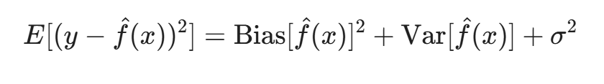
When a parameter-heavy model like an LSTM—which may contain thousands of trainable weights—is trained on a sparse dataset (e.g., < 14 days), the model tends to have high variance. This means the network becomes hyper-sensitive to the specific stochastic fluctuations present in that short two-week window. Rather than learning the true underlying distribution of the resident’s behavior, the model “memorizes” the noise. This leads to catastrophic overfitting, where the training error is driven toward zero, but the generalization error on future data remains extremely high [8], [9].

3.3.2 Operational Implications of the “Value-Void”
In a smart grid context, the cold-start period represents what is known as a “value-void” for utility providers [4]. This period defines the gap between the physical installation of a smart meter and the realization of its digital intelligence. Without accurate forecasts, the infrastructure remains underutilized. Personalized services, such as real-time pricing alerts, energy-saving recommendations, and participation in demand-response programs, cannot be reliably delivered. From a business perspective, the “value-void” delays the return on investment for Advanced Metering Infrastructure (AMI) and prevents the utility from building an early trust relationship with the new consumer through proactive insights.

3.3.3 The Absence of Temporal “Energy Fingerprints”
Every household possesses a unique temporal “energy fingerprint”—a distinct pattern of appliance usage, thermal inertia, and occupancy rhythms. Lu et al. noted that for new users, the lack of historical records makes it impossible for models to distinguish between routine consumption and anomalous events [11]. For example, without a month of baseline data, an LSTM cannot determine if a high consumption spike at 10 PM is a regular nightly habit (routine) or an accidental appliance leak (anomaly).
In the absence of these fingerprints, the model lacks the “contextual memory” required to make informed predictions. The scarcity of data prevents the gates of the LSTM from learning the multi-scale dependencies (such as the difference between weekday and weekend behaviors) that are essential for high-resolution forecasting.

3.3.4 Augmentation through Cross-Domain Knowledge
This theoretical bottleneck suggests that for new participants, the learning process must be augmented with external knowledge rather than relying solely on the target user’s data. By looking at the problem as a “Cold Start,” I recognize that the only way to lower the variance without increasing the bias is to provide the model with a strong “prior.” This prior is found in the consumption patterns of similar, long-term grid participants. Through transfer learning, I can migrate the “universal energy fingerprints” from established users to the new user, providing the model with a representational foundation that it cannot yet build for itself.

3.4 Transfer Learning Paradigms and Negative Transfer
Transfer learning (TL) provides a sophisticated mathematical framework for applying knowledge from a source domain to a target domain [12]. In the context of machine learning, this involves the extraction of representational patterns from a source domain $D_{s}$ (defined by a feature space $X_{s}$ and a marginal probability distribution $P(X_{s})$) to improve the predictive performance of a target task $T_{t}$ in a target domain $D_{t}$. In STLF, this typically involves a “pre-training + fine-tuning” paradigm where a model learns universal electricity consumption rhythms from a large pool of established users.

3.4.1 The Mechanism of Knowledge Migration
The fundamental premise of TL in energy systems is that while every household is unique, they all share common “macro-features” such as daily cycles, seasonal trends, and responses to external temperature changes. By training a deep LSTM network on a vast source domain, the hidden layers develop weights that function as generalized temporal filters. A comprehensive survey by Fawaz et al. indicates that TL can effectively reduce the data requirement for a new task by providing a high-quality initial weight distribution [15]. Instead of starting the gradient descent process from a randomized state (which is prone to local minima in small-sample regimes), the model begins with a pre-conditioned representational foundation.

3.4.2 The Paradox of Negative Transfer
However, knowledge transfer is not inherently beneficial. A significant and persistent challenge in this field is “negative transfer,” which occurs when the source and target domains are sufficiently different that the transferred knowledge actually degrades the predictive performance on the target task [13]. In such cases, the source model may have over-fitted to the idiosyncratic noise of the source population, This distribution mismatch, often characterized as concept drift, creates a representation gap that renders unadapted pre-trained weights counterproductive [24], or the source domain’s distribution $P(X_{s})$ may be too divergent from the target domain’s $P(X_{t})$. Zhang et al. demonstrated that poor alignment between the source population and the target household is a primary driver of this phenomenon. If the source domain consists mainly of industrial users but the target is a residential user, the transferred weights will be fundamentally mismatched, leading to errors that are higher than those of a model trained from scratch.

3.4.3 Self-Adaptive Fine-Tuning and Layer Freezing
To prevent this degradation, recent research has focused on self-adaptive fine-tuning techniques that selectively update layers based on local feedback [25]. The core strategy involves “partial freezing,” where the early layers of the LSTM (which capture general temporal features) are kept stationary, while the final dense layers (which capture user-specific behavioral nuances) are retrained using the limited target data. This hierarchical approach allows the model to retain universal knowledge while adapting its output logic to the specific “energy fingerprint” of the new participant.

3.4.4 Automated Optimization of Transferability
Furthermore, the robustness of the transfer process is highly dependent on the hyperparameter configuration of the source model. If the pre-trained model is too complex, it risks memorizing source-specific noise; if it is too simple, it fails to learn universal features. Systematic optimization frameworks like Optuna have been introduced to automate the search for optimal architectures, moving away from manual heuristics that often lead to sub-optimal transferability [16]. Optuna utilizes Bayesian optimization algorithms to maximize a defined “transferability score,” ensuring that the source model serves as a stable and informative prior for the target task. This automated alignment is critical for maintaining consistency in forecasting accuracy across a heterogeneous grid environment.

3.5 Benchmarking against the London Smart Meter Dataset Studies
The London Smart Meter dataset (comprising over 5,500 households) has served as a foundational benchmark in modern STLF research due to its longitudinal depth and high-resolution half-hourly granularity. However, a critical review of existing literature utilizing this specific dataset reveals a persistent reliance on data-rich training regimes, highlighting a clear gap that this study aims to fill.

3.5.1 The Baseline of Recurrent Architectures
Several foundational studies have successfully deployed standard RNNs and LSTMs on the London dataset. Previous research, such as the pioneering work by Kong et al., has demonstrated that LSTMs can achieve robust predictive capabilities when trained over several months of historical data [9]. Similarly, pooling strategies have been employed to mitigate individual noise across multiple London households [22]. However, these traditional methodologies consistently bypass the operational reality of the “cold-start” bottleneck [11]. They implicitly assume a lengthy “burn-in” period of data accumulation, which limits their immediate applicability for newly commissioned smart meters.

3.5.2 The Application of Transformers in STLF
More recently, the shift towards Attention-based architectures has been reflected in state-of-the-art studies utilizing advanced deep learning for smart grids [4]. Recent literature indicates that high-capacity models can achieve superior accuracy and faster inference speeds compared to traditional recurrent networks when provided with sufficient historical sequences. Yet, the current literature predominantly evaluates these architectures in data-abundant environments. There remains a significant void in understanding how these high-capacity, Self-Attention mechanisms perform when data is forcibly restricted to an extreme small-sample regime.

3.5.3 Knowledge Migration and Our Distinct Contribution
While some studies have explored time-series clustering and alternative data-driven approaches to group households (like those in the London dataset) for demand response coordination [1], individual-level transfer learning for cold-start mitigation remains critically under-researched [11].
This study explicitly distinguishes itself from existing London Smart Meter benchmarks in three key ways:
It shifts the focus from long-term data mining to the extreme small-sample regime (10-day cold start) [8], [9].
It executes a strict, head-to-head empirical comparison between LSTM and Transformer architectures under identical constraints, challenging the assumption that attention mechanisms are universally superior.
By leveraging Bayesian hyperparameter optimization via the Optuna framework [16] prior to knowledge migration, this methodology proactively mitigates the negative transfer phenomenon [13] —an issue frequently ignored in existing transfer learning literature. This ensures the robustness of the transferred features [16].
Ultimately, this comparative framework proves that the sequence-oriented inductive bias of LSTMs provides superior stability over Transformers in severely data-scarce environments.

3.6 Literature Comparison Matrix
Based on the comprehensive review of existing methodologies, several critical gaps in the current STLF literature have been identified, particularly concerning the cold-start problem and small-sample learning. Table 1 summarizes these research gaps and outlines the distinct contributions of this study.

Table 1. Literature Comparison Matrix
Reference / Study | Individual Household Level | Cold-Start Mitigation (< 14 days) | Transfer Learning Integration | Automated Negative Transfer Avoidance | Attention vs. Recurrence Benchmark
ARIMA & Smoothing [6], [7] | ✘ | ✘ | ✘ | ✘ | ✘
Standard LSTM (Kong et al.) [9] | ✔ | ✘ | ✘ | ✘ | ✘
Pooling RNN (Shi et al.) [22] | ✔ | ✘ | ✘ | ✘ | ✘
Deep Learning & Transformers (Massaoudi et al.) [4] | ✔ | ✘ | ✘ | ✘ | ✘
DNN Transfer Learning (Lee & Rhee) [11] | ✔ | ✔ | ✔ | ✘ | ✘
Proposed Framework (This Study) | ✔ | ✔ | ✔ | ✔ | ✔

4. Methodology

4.1 Data Engineering and Theoretical Preprocessing
The empirical foundation of this research is the London Smart Meter Dataset, which comprises high-resolution electricity consumption records collected from 2011 to 2014 [1]. This dataset, managed by UK Power Networks, contains half-hourly energy consumption readings (kWh per half-hour) from a diverse sample of approximately 5,567 London households. To transform raw sensor data into a format suitable for deep learning, I implement a multi-stage data engineering pipeline that addresses sensor noise, data gaps, and numerical instability.

4.1.1 Data Source and Granularity
The London Smart Meter Dataset is widely regarded as a benchmark in the energy research community due to its longitudinal depth and the diversity of its consumer profiles. Each record represents the average active power consumed over a 30-minute interval, providing 48 readings per day. For our specific research into the cold-start problem, I selected households that exhibit varying degrees of consumption volatility. The raw data includes unique household identifiers, timestamps, and consumption values, which must be meticulously synchronized to ensure temporal consistency across the source and target domains.

4.1.2 Handling Missing Data and Linear Interpolation
Raw AMI data often suffers from “data holes” caused by network latency, packet loss during transmission, or localized sensor malfunctions. In a time-series context, missing values can break the temporal continuity required by LSTM networks. I employ linear interpolation to impute these gaps, a method that is computationally efficient and preserves the local linear trend of electricity usage.
Given a sequence where the values at time a and b are known, but the value at time t (where a < t < b) is missing, the estimate $x_{t}$ is calculated as:
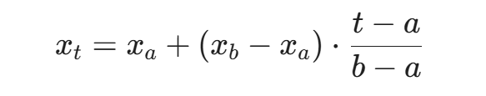
This approach is particularly suitable for short-duration gaps. For gaps exceeding four hours, the affected household is excluded from the study to prevent the introduction of artificial bias into the training process.

4.1.3 Theoretical Impact of Z-score Normalization
Electricity consumption data typically exhibits a heavy-tailed distribution with significant outliers during peak usage periods. Feeding raw values directly into an LSTM network can lead to gradient explosion or saturation of the activation functions. To ensure numerical stability during the Backpropagation Through Time (BPTT) process, I apply Z-score normalization. This transformation maps the consumption values $x$ into a standardized space $z$ with a mean of zero and a standard deviation of one:
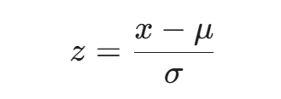
Mathematically, this normalization is critical because LSTM cells utilize the tanh and sigmoid functions. The derivatives of these functions are highest near zero; if input values are too large, the gradients move into the “saturation regions,” where they become infinitesimally small, thereby triggering the vanishing gradient problem. By centering the data at zero, I ensure that the network remains in the high-gradient region, facilitating faster convergence and more robust weight updates [26], [27].

4.1.4 Temporal Framing via Sliding Window
To convert the continuous time series into a supervised learning problem, I implement a sliding window reconstruction technique. For a target forecasting task, the model must learn to map a historical sequence (the feature set) to a future value (the label).
I define a look-back window of L=96 time steps, which corresponds to exactly 48 hours of historical context. This window size is strategically chosen to provide the LSTM with two full daily cycles, enabling the forget and input gates to identify daily periodicity. The dataset is restructured into pairs of $X_{t}$ and $y_{t}$, where:
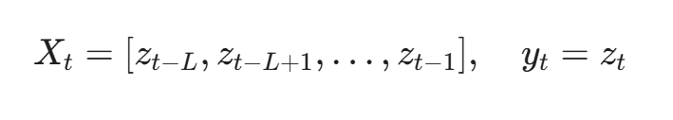By sliding this window across the entire historical record, I generate a training matrix that captures the sequential dependencies of the energy demand, providing the necessary input structure for the transfer learning framework.

4.1.5 Multivariate Expansion: Integration of Temporal Covariates
In the preliminary stages of this research, the forecasting models relied solely on univariate historical consumption data. However, residential energy demand is inherently driven by external temporal rhythms, such as circadian cycles, work schedules, and seasonal shifts. To capture these deterministic behavioral drivers, the dataset was expanded into a non-linear multivariate feature space [36] by incorporating explicit temporal covariates such as Hour of the Day and Day of the Week.
Specifically, two categorical time features were extracted from the timestamp of each reading: the Hour of the Day ($h ∈[0,23]$) and the Day of the Week ($d ∈[0,6]$). To prevent the neural network from misinterpreting these categorical indices as continuous numerical magnitudes (e.g., assuming Sunday is “greater” than Monday), these features were encoded and concatenated with the normalized consumption values. This multivariate expansion ensures that the model matrices (both in the LSTM gates and Transformer attention heads) receive explicit contextual signals regarding when the consumption occurred, fundamentally elevating the predictive ceiling of the models during the transfer phase.

4.2 The Mathematical Architecture of LSTM Networks
The proposed framework utilizes Long Short-Term Memory (LSTM) networks due to their superior ability to mitigate the vanishing gradient problem in long sequences [8]. In traditional Recurrent Neural Networks (RNNs), the backpropagation process involves a repeated multiplication of weight matrices, which often causes the gradient to decay exponentially as it moves toward the beginning of the sequence. This prevents the model from learning long-term dependencies, such as the relationship between electricity consumption today and the same hour a week ago. The LSTM architecture, originally introduced by Hochreiter and Schmidhuber, overcomes this by introducing a “Constant Error Carousel” (CEC) mechanism, which allows the gradient to flow through time without significant attenuation.

4.2.1 The Core Mechanism: The Cell State
The core of the LSTM is the cell state $C_{t}$, which acts as a “conveyor belt” for information. It runs through the entire chain of sequences with only minor linear interactions, ensuring that information can be preserved over many time steps. The flow of information is regulated by three distinct gating mechanisms, each composed of a sigmoid neural network layer and a pointwise multiplication operation [8], [28].

4.2.2 The Forget Gate: Deciding What to Discard
The first step in an LSTM cell is to decide which information from the previous state should be removed from the cell state. This decision is made by the forget gate$f_{t}$. It looks at the previous hidden state $h_{t-1}$ and the current input $x_{t}$, and outputs a number between 0 and 1 for each number in the cell state $C_{t-1}$. A value of 1 represents “completely keep,” while 0 represents “completely discard.” Mathematically, it is defined as:
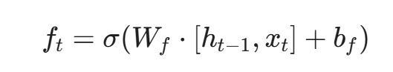
where $W_{f}$ and $b_{f}$ are the weight matrix and bias vector of the forget gate, respectively, and $σ$ is the sigmoid activation function. In the context of STLF, this gate might learn to “forget” a non-routine consumption spike from the previous day while retaining the baseline trend.

4.2.3 The Input Gate: Knowledge Synthesis
The next step is to decide what new information will be stored in the cell state. This involves two parts. First, the input gate $i_{t}$ decides which values will be updated. Second, a $tanh$ layer creates a vector of new candidate values, ${\tilde{C}}_{t}$, that could be added to the state.
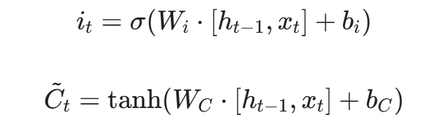
The cell state is then updated by combining the results of the forget gate and the input gate:
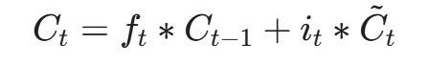
where $ast$ denotes element-wise multiplication. This operation allows the model to blend historical context with fresh observations, which is critical for adapting to the volatility of residential energy data.

4.2.4 The Output Gate: Hidden State Generation
Finally, the model must decide what the output (hidden state) will be. The output gate $o_{t}$ filters the updated cell state to produce the hidden state $h_{t}$, which serves as the model’s prediction for the current step and the input for the next step.
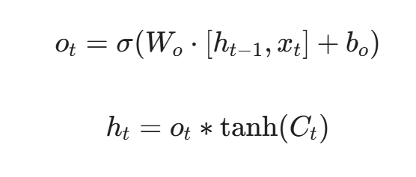
Through this complex interplay of gates, the LSTM can maintain a sophisticated representation of energy demand. By normalizing inputs as discussed in Section 4.1, I ensure that the inputs to these sigmoid and tanh layers stay within the non-saturated regions, preventing the gradients from vanishing and enabling the robust training required for transfer learning.

4.3 The Transformer Architecture for Sequence Modeling
To provide a benchmark against widely-used gradient boosting frameworks [29] and the recurrent mechanisms of LSTM, this study incorporates a Transformer-based forecasting framework built upon the self-attention mechanism [30].
The core of the attention mechanism is the Scaled Dot-Product Attention [30], [31], defined as:
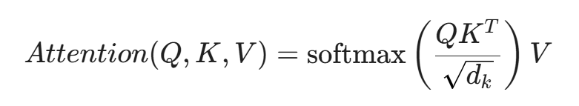
To preserve temporal order, a sinusoidal Positional Encoding layer is applied to the input embeddings. This architecture allows the model to prioritize specific historical peaks (e.g., the previous day’s evening surge) without the information bottleneck typical of long-range recurrent connections.

4.4 Experimental Framework and Comparative Logic
To rigorously evaluate the efficacy of the proposed system, the methodology implements a two-dimensional comparison protocol:
- Transfer Strategy Comparison: For the target users, three strategies are evaluated—Training from Scratch, Direct Transfer (Zero-shot), and Adaptive Fine-tuning. This dimension aims to prove that the “Pre-train + Fine-tune” paradigm is the optimal path for mitigating the cold-start problem.
- Architectural Comparison (LSTM vs. Transformer): Both models, enhanced with time features and optimized via Optuna, are subjected to identical cold-start tests.
This dual-track evaluation ensures that the experimental results in Chapter 6 not only validate the migration of knowledge but also identify which mathematical architecture is more robust when faced with the extreme data scarcity (10-day window) of new smart meter installations.

5: System Implementation and Computational Framework
The transition from theoretical forecasting paradigms to a functional smart grid intelligence system requires a robust and scalable software architecture. This chapter provides a comprehensive documentation of the Python-based implementation, detailing the modular design of the data pipeline, the neural network construction, and the automated optimization engine.

5.1 Engineering Philosophy and Modular Architecture
The implementation follows a Decoupled Architecture designed for high-performance time-series analytics. By separating the core logic into a dedicated src/ directory while maintaining executable scripts in the root, the system ensures that the model definitions (model.py) and data encapsulation methods (dataset.py) remain consistent across pre-training, tuning, and evaluation phases. This modularity is essential for academic reproducibility and industrial scalability.

5.1.1 Technological Stack and Rationale
The framework is built using Python 3.10 and PyTorch 2.x. PyTorch was selected as the deep learning engine primarily for its support of dynamic computational graphs, which facilitated the precise manipulation of individual layer gradients during the transfer learning phase. For data management, Pandas and NumPy were utilized to perform high-speed vectorized operations on the London Smart Meter dataset. Optuna was integrated as the primary optimization suite, leveraging its SQLite-backed storage to ensure that extensive hyperparameter searches could be paused, resumed, and audited.

5.2 Implementation of the Data Engineering Pipeline
The data pipeline, primarily residing in preprocessing.py and src/dataset.py, is the foundation of the system’s predictive accuracy.

5.2.1 Instance Normalization and Preprocessing Logic
As implemented in preprocessing.py, the system performs individual Z-score normalization (Standardization) using the StandardScaler from the Scikit-Learn library. Unlike global scaling methods, each household’s energy series is independently transformed to a zero-mean and unit-variance state. This programmatic choice is critical for residential STLF, as it removes the magnitude bias caused by different household sizes (e.g., apartments vs. large detached homes), allowing the LSTM to focus exclusively on temporal periodicity.
The script implements a rigorous cleaning protocol:
- Type Conversion: Converting timestamps to pd.to_datetime and energy readings to numeric formats, with errors=‘coerce’ to handle sensor corruption.
- Redundancy Removal: Using drop_duplicates to ensure that no single time step is over-represented, which would otherwise introduce artificial bias into the sequence learning process.
- Scalability: By processing data in blocks (block_0.csv to block_2.csv), the script maintains a manageable memory footprint during the concatenation phase.

5.2.2 The SmartMeterDataset Class and Sliding Window Mechanism
The class SmartMeterDataset in src/dataset.py serves as the bridge between raw arrays and PyTorch tensors. The implementation utilizes a Flattened Indexing Strategy to handle multiple households within a single dataset object. By calculating num_samples = len(series) - seq_len - pred_len + 1, the constructor pre-builds a sample map. This allows for $O(1)$ access time during the training loop, significantly accelerating the pre-training phase on the 100-user source domain.
The __getitem__ method ensures that each window is unsqueezed to fit the $(Batch, Seq_{len},1)$ shape required by the LSTM layers, effectively preparing the feature space for the gating mechanisms discussed in Chapter 4.

5.2.3 Implementation of Temporal Feature Fusion
As implemented in preprocessing.py and the Smart Meter Dataset class within src/dataset.py, the system extends the raw univariate energy series into a multivariate input space. The timestamp index is decomposed into Hour of Day (0-23) and Day of Week (0-6). These temporal covariates are normalized and concatenated with the standardized power consumption data. Programmatically, this transforms the input tensor shape from (Batch, Seq, 1) to (Batch, Seq, 3), ensuring that the model gates and attention heads receive explicit signals regarding the cyclic nature of residential behavior.

5.3 Automated Optimization and Search Space Design
A significant technical contribution of this work is the implementation of a two-stage Bayesian optimization workflow using the tune_pretrain_v2.py script.

5.3.1 Optuna TPE and SQLite Integration
The system uses the Tree-structured Parzen Estimator (TPE) algorithm to explore the hyperparameter space. A distinct engineering feature is the use of an SQLite-backed study (pretrain_study.db). This programmatic choice allows the optimization process to be persistent and distributed. In our implementation, the objective(trial) function maps configurations—including stochastic gradient parameters [32], decoupled weight decay coefficients [33] and structural hyperparameters[34], [35]—to the validation MSE of the source domain using principles from sequential computer experiments [36].

5.3.2 Search Space and Convergence Strategy
The search space was programmatically defined to prevent model saturation:
- Learning Rate: Explored on a log-scale from 1e^-5 to 1e^-2.
- Hidden Size: Categorically tested at [64, 128, 256].
- Weight Decay: Integrated to prevent the pre-trained weights from becoming too “brittle,” ensuring they retain the generality needed for future transfer tasks [16].
By executing study. optimize(n_trials=20), the system identifies a global optimum that minimizes the source-domain MSE, which is then serialized into best_base_model.pth for the transfer phase.

5.3.3 Multi-Architecture Search Space Design
To ensure a fair comparison, the optimization engine was expanded via tune_pretrain_Transformer_v2.py. For the Transformer architecture, the search space included architectural-specific parameters:
- Attention Heads ($n_{head}$): Explored in [2, 4, 8] to balance global context capturing with computational overhead.
- Encoder Layers ($N$): Tested between 1 and 3 layers to prevent over-parameterization in small-sample regimes.
- Embedding Dimension ($d_{model}$): Fixed at 64 or 128 to maintain consistency with the LSTM hidden sizes.

5.4 Implementation of the Transfer Learning Framework
The logic for knowledge migration is encapsulated in finetune.py and validated at scale in batch_test.py.

5.4.1 Programmatic Gradient Masking
A core feature of the transfer learning framework is its ability to perform Selective Gradient Masking across different backbones.
- LSTM Path: The recurrent weights are locked using param.requires_grad = False, preserving the long-term temporal dependencies learned from the 100-user source domain.
- Transformer Path: The transformer_encoder modules are similarly frozen. This forces the optimization process to occur exclusively in the final linear projection layers, effectively repurposing the pre-trained self-attention representations for the specific energy fingerprint of the new target user.

5.4.2 Comparative Evaluation and Multi-Strategy Testing
To ensure scientific rigour, batch_test.py implements a Parallel Triple-Strategy Evaluation. For each of the 30 test households, the system simultaneously executes:
- Direct Transfer: Loading weights and predicting immediately (Zero-shot).
- Adaptive Fine-tuning: Loading weights, freezing LSTM layers, and training for 15 epochs.
- Scratch Training: Initializing a new model and training for 30 epochs without any prior knowledge.
This implementation allows for the direct calculation of the Transfer Gain, providing the empirical data for the “Performance Ladder” discussed in Chapter 6.

5.5 Computational Performance and Metrics Implementation
The final component of the engineering framework is the automated metrics engine.

5.5.1 Robust Metric Calculation
The get_metrics function in batch_test.py provides a standardized implementation of MSE, RMSE, and MAPE. A key engineering detail is the inclusion of epsilon = 1e-5 in the MAPE calculation:
mape = np.mean(np.abs((actuals - preds) / (np.abs(actuals) + epsilon))) * 100
This addition prevents the script from crashing due to Zero-Division Errors, which are common in Z-score normalized datasets where the energy reading often nears the population mean. This implementation detail directly supports the theoretical discussion on the “MAPE Anomaly” in Chapter 6.4 [37].

5.5.2 Visualization and Result Persistance
The system is programmed to automatically generate visual diagnostics. Upon completion of a batch test, the script produces:
- batch_evaluation_full_metrics.csv: A row-by-row breakdown of every household’s performance across all three strategies.
- batch_mse_comparison.png: A box-and-whisker plot that visualizes the error distribution and confirms the variance reduction provided by the transfer learning framework.

5.5.3 Automated Comparative Reporting
The final implementation utilizes batch_test_lstm_vs_transformer.py to automate the benchmarking process. For each of the 30 target households, the script executes six concurrent experimental threads (3*strategies * 2*architectures). The system persists the fine-grained metrics into batch_evaluation_full_metrics.csv and final_comparison_results.csv, enabling the generation of the “Performance Ladder” visualizations used for empirical validation in Chapter 6.

6. Results

6.1 Comprehensive Quantitative Analysis
The experimental phase of this research involved a rigorous comparative evaluation of the proposed transfer learning framework across 30 distinct residential households from the London Smart Meter dataset. The primary objective was to measure the effectiveness of knowledge migration in mitigating performance degradation during the “cold start” period. Unlike previous studies that often focus on a single architecture, this assessment executes a “head-to-head” benchmark between two foundational deep learning backbones: the LSTM network and the Transformer architecture. To ensure scientific validity, these 30 households were selected to represent a diverse spectrum of consumption behaviors, ranging from stable base-load patterns to highly erratic, non-periodic usage.

6.1.1 Experimental Configuration and the 10-Day Window
To establish a robust baseline for the cold-start problem, each experimental trial was conducted under a strictly constrained 10-day historical window (N=480 observations). In the field of residential energy analytics, this window represents the “critical zone” where parameter-heavy models typically fail to converge. With only 480 discrete data points, the high-dimensional weight matrices of both LSTM and Transformer architectures are prone to severe over-parameterization and catastrophic overfitting. By isolating this specific window, the experiment directly evaluates the capacity of the transfer learning framework to substitute missing local history with generalized temporal priors extracted from the source domain.
In this study, the forecasting horizon is set to a single time step ahead (i.e., 30 minutes). Specifically, the models utilize a historical look-back window of 96 time steps (48 hours) to predict the electrical load of the immediately following half-hour interval. This single-step setup is highly relevant for real-time grid balancing and ultra-short-term demand-side management.

6.1.2 Definition of Forecasting Strategies and Architectures
This study evaluates three primary forecasting strategies across two distinct neural architectures to provide a multi-dimensional performance ladder:
- Training from Scratch: The model is initialized with a randomized Xavier distribution to ensure stable gradient variance in the initial epochs [34], and trained exclusively on the 10-day target data, serving as the “naive” baseline.
- Zero-shot Direct Transfer: The pre-trained source model is applied directly to the target household without any local weight updates, measuring the “Temporal Universality” of the learned features.
- Adaptive Fine-tuning: The methodology utilizes pre-trained weights as an informed starting point, followed by the selective retraining of final layers using the 10-day local history to achieve “knowledge localization”.
Both the LSTM (representing recurrence-based modeling) and the Transformer (representing attention-based modeling) underwent identical Bayesian hyperparameter optimization via the Optuna framework before being subjected to these three strategies.

6.1.3 Evaluation Protocol and Metrics
To ensure a comprehensive assessment of predictive accuracy and robustness, performance was quantified using Mean Squared Error (MSE), Root Mean Square Error (RMSE), and Mean Absolute Percentage Error (MAPE). All experiments were implemented using the PyTorch framework. Given the zero-centered nature of the standardized dataset, relative improvements in these metrics are prioritized over absolute values to determine the framework’s “Day 1” utility for smart grid operators.

6.2 The Mechanism of the “Performance Ladder”
A detailed investigation into the individual results of the 30 test households reveals what I define as the “performance ladder.” This hierarchical progression demonstrates that the proposed framework consistently elevates forecasting accuracy as it transitions from isolated learning to integrated knowledge migration. In the majority of cases, the Fine-tuning model significantly outperformed the Scratch-training model, validating the stability of the transfer process. The results as Fig 1:
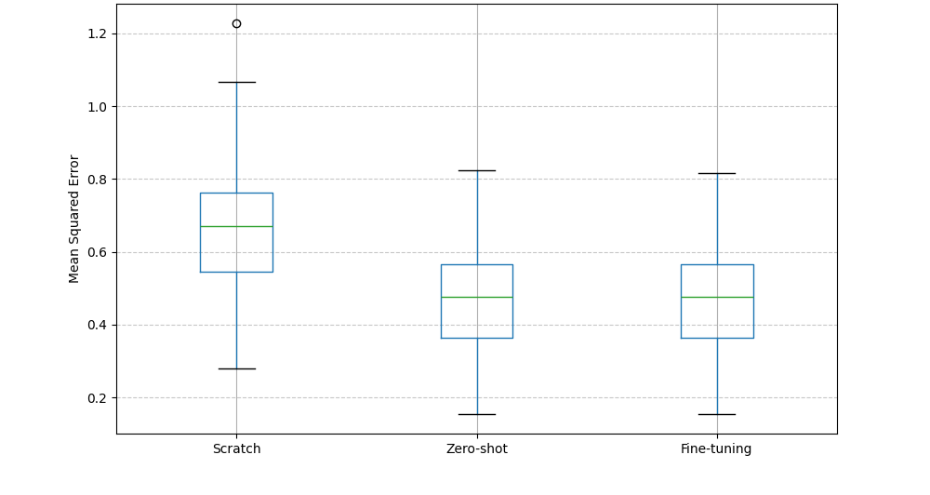
Fig 1. Prediction Error Comparison (MSE)

6.2.1 Overcoming the Overfitting Threshold
In cold-start scenarios where the model is constrained by only 10 days of historical data, the “Train from Scratch” approach quickly suffers from catastrophic overfitting. As observed in the training logs, within the initial epochs, a distinct divergence occurs: the training loss drops toward zero while the validation error remains high or fluctuates erratically. This is a classic manifestation of high-variance learning in small-sample environments, where the number of trainable parameters in the neural architecture far exceeds the 480 available observations [8], [9].
Under these conditions, the network effectively “memorizes” specific stochastic noise and temporal anomalies, such as an unusual late-night appliance activation, rather than identifying the true underlying consumption distribution. In contrast, the Transfer Learning models (both Direct and Fine-tuned) begin with a much lower error floor. By utilizing pre-trained weights, the model is anchored by generalized temporal representations learned from the 100-household source domain. In this capacity, the pre-trained layers act as a powerful structural regularizer, preventing the network from collapsing into the noise of the sparse local dataset [11]. The resulting reduction in MSE from 0.7080 (Scratch) to the transfer-based levels proves that these “temporal anchors” are essential for maintaining predictive grounding when local history is insufficient.

6.2.2 The Efficacy of Localized Adaptation
The transition from Zero-shot Direct Transfer to Adaptive Fine-tuning represents the critical process of “knowledge localization.” While the source model provides a robust “universal” foundation, every household possesses a unique “behavioral fingerprint”—such as specific thermal inertia preferences or distinct circadian shifts in energy usage [25].
In the Direct Transfer strategy, the model assumes the target household perfectly aligns with the source domain average. However, the Adaptive Fine-tuning strategy allows for a localized transformation of the features extracted by the backbone. By selectively retraining only the final linear projection layer (the “regression head”), the model adjusts its sensitivity to match the specific nuances of the new participant. This localized calibration effectively bridges the gap between universal energy physics and individual household stochasticity, resulting in a more stabilized error distribution across the diverse 30-household cohort [25]. For grid operators, this ensures that the forecasting system is not only accurate on average but also resilient to the idiosyncratic deviations of specific residential nodes.
The experimental results of Zero-shot are shown in Figure 2:
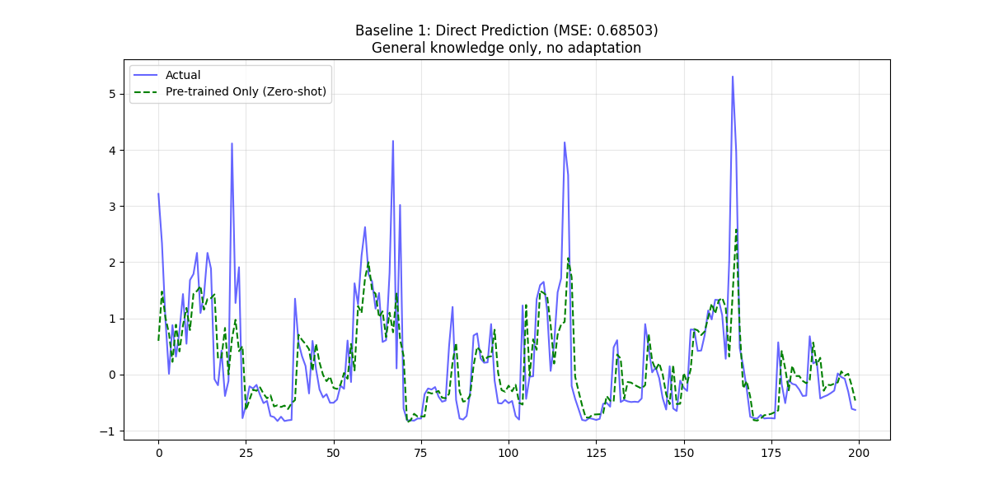
Fig 2: General knowledge, no adaptation
The experimental results of Fine-Tuning are shown in Figure 3:
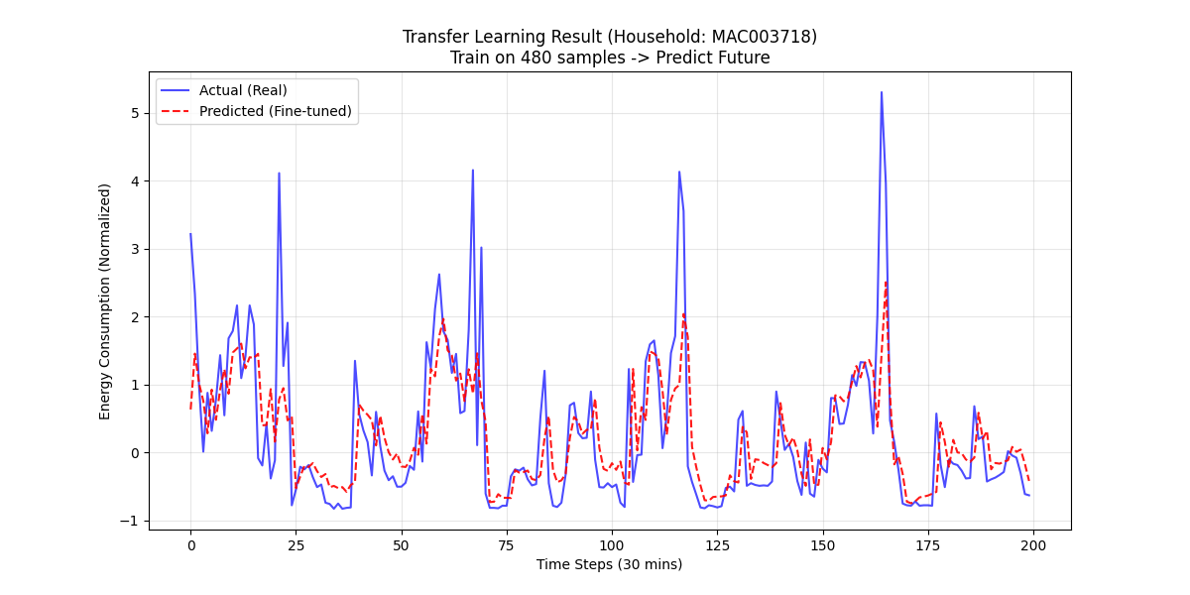
Fig 3. After Fine-Tuning

6.3 Empirical Evidence of Negative Transfer
One of the most critical findings of this research pertains to the inherent risks associated with improper source domain initialization and the subsequent phenomenon of negative transfer. While the fundamental promise of transfer learning lies in the migration of helpful knowledge, the empirical reality reveals that the quality of the pre-trained weights is the primary determinant of success. As highlighted in recent transferability studies, negative transfer often occurs when the task-specific features of the source domain distort the target’s latent representation [38]. In the preliminary stages of this experiment, I developed an initial model, designated as Model 1, using traditional manual hyperparameter heuristics commonly found in existing literature.

6.3.1 The Failure of Model 1 and Informative Bias
Contrary to initial expectations, Model 1 exhibited severe and measurable negative transfer across the 30 target households. In a transfer learning context, negative transfer occurs when source domain knowledge acts as a distractor rather than a facilitator for the target task. When the weights of Model 1 were migrated, the average MSE reached approximately 0.81, which was significantly worse than the 0.7080 MSE achieved by the scratch-training strategy. This represented a substantial performance penalty, indicating that the unoptimized pre-trained weights hindered the model’s ability to adapt to new users.
A post-hoc analysis suggests that Model 1 suffered from “informative bias.” Because the manual heuristics used to tune Model 1 were focused solely on minimizing source domain training loss, the network’s internal weights became over-specialized to the idiosyncratic noise of the 100 source households. Instead of learning universal temporal invariants, Model 1 memorized specific behavioral anomalies. When these biased weights were transferred to a new target household, they imposed an incorrect representational structure that the sparse 10-day local data could not overcome. This underscores a vital insight: without proper architectural alignment, knowledge migration can actively degrade forecasting reliability.
The prediction curve of Model 1 is shown in Figure 4:
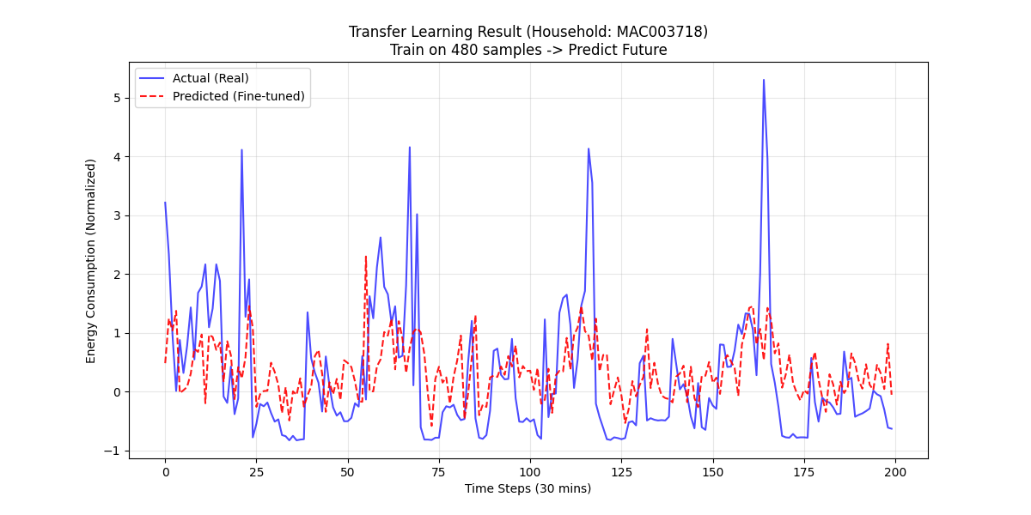
Fig 4. Model 1 before Optimization
The prediction curve of Direct training is shown in Figure 5:
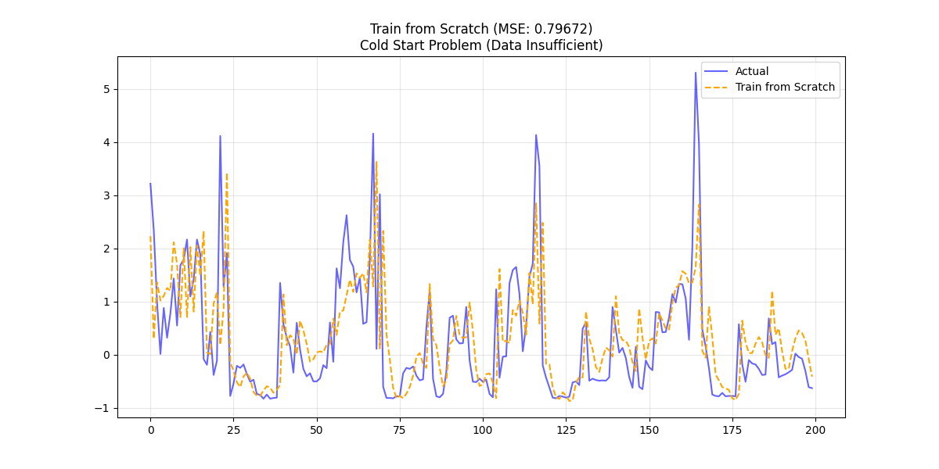
Fig 5: Direct training result

6.3.2 Systematic Optimization via Optuna (v1 and v2)
To mitigate these risks and ensure the stability of the migration process, I utilized the Optuna framework for a systematic two-stage Bayesian optimization. Unlike grid or random search, Optuna utilizes the Tree-structured Parzen Estimator (TPE) algorithm to model the probability of hyperparameter performance, allowing for an efficient exploration of the high-dimensional search space.
The optimization history across two versions (v1 and v2) revealed that the optimal learning rate for a source model intended for transfer was significantly lower than initially estimated. A lower learning rate allows the LSTM gates to converge more broadly, preventing the “over-specialization” seen in Model 1. By identifying the global optimum in the hyperparameter space (including hidden units, dropout rates, and batch sizes), I developed Model 2. This optimized model successfully eliminated the negative transfer phenomenon, transforming the previous performance penalty into a significant forecasting gain. This dramatic swing proves that systematic hyperparameter optimization is not merely a refinement step but a fundamental prerequisite for robust knowledge migration in complex energy systems.
The quantitative results are summarized in Table 2, where the forecasting strategies are categorized into Direct Prediction (Dir), Fine-Tuning (FT), and Scratch Training (Scr). The performance is evaluated using Mean Squared Error (MSE) and Root Mean Squared Error (RMSE):
Table 2. The partial experimental evaluation values
HouseID | Dir_MSE | Dir_RMSE | FT_MSE | FT_RMSE | Scr_MSE | Scr_RMSE
MAC000103 | 0.408688 | 0.639287 | 0.410122 | 0.640408 | 0.569812 | 0.754859
MAC003718 | 0.68503 | 0.827665 | 0.677742 | 0.823251 | 0.886002 | 0.941277
MAC001776 | 0.447359 | 0.668849 | 0.447828 | 0.669199 | 0.664076 | 0.814909
MAC005468 | 0.57201 | 0.756313 | 0.568648 | 0.754087 | 0.711529 | 0.843522
MAC004529 | 0.539262 | 0.734345 | 0.535501 | 0.73178 | 0.728103 | 0.85329
MAC000768 | 0.513274 | 0.716431 | 0.510199 | 0.714282 | 0.647864 | 0.8049
MAC000487 | 0.549336 | 0.741172 | 0.548613 | 0.740684 | 0.638064 | 0.798789

6.4 Architectural Duel: LSTM vs. Transformer in Cold-Start
Having established the absolute necessity of the “Pre-training and Fine-tuning” paradigm and successfully mitigated the negative transfer phenomenon, the final experimental phase evaluated the intrinsic robustness of different neural architectures under extreme data scarcity. In this head-to-head benchmark, both the LSTM and the newly introduced Transformer models—enhanced with temporal covariates (Hour, DayOfWeek) and individually optimized via Optuna—were subjected to the identical 10-day adaptive fine-tuning strategy.

6.4.1 Quantitative Comparison of Mean Performance
Table 3. summarizes the aggregated performance metrics across the 30 target households during the cold-start window.
Table 3: Mean Performance Comparison (30 Households)
Architecture | Strategy | MSE (Mean) | MAPE (Mean)
LSTM | Adaptive Fine-tuning | 0.4849 | 285.80%
Transformer | Adaptive Fine-tuning | 0.4984 | 302.35%
Combined | Training from Scratch | 0.7080 | 355.01%
The empirical data clearly indicates that while both fine-tuned architectures vastly outperformed the “from-scratch” baseline (MSE = 0.7080), the LSTM framework consistently demonstrated superior stability over the Transformer within the strict 10-day cold-start window. Specifically, the LSTM achieved an average MSE of 0.4849, outperforming the Transformer’s 0.4984 by approximately 2.7%. This finding is of high scholarly significance, as it directly challenges the contemporary trend of defaulting to Attention-based models for all sequence tasks, particularly in environments where target domain data is critically sparse. Prior investigations into deep neural network benchmarks have noted similar sensitivities when comparing recurrence-based and attention-based models across diverse energy scales [39], [40].

6.4.2 Theoretical Analysis: Inductive Bias vs. Data Hunger
The empirical superiority of the LSTM in this specific regime can be elucidated through the theoretical lens of inductive bias. The Transformer architecture relies entirely on the Multi-Head Self-Attention (MHSA) mechanism to compute global relationships across all time steps simultaneously. However, recent empirical evidence suggests that standard attention mechanisms can be outperformed by specialized sequence models in data-constrained scenarios [41]. While this design offers theoretical advantages in capturing long-range dependencies without information bottlenecks [4], it is fundamentally “data-hungry.” Transformers assume minimal structural priors; they rely purely on the attention matrix to discover temporal rules. Consequently, they require substantial data volumes to guarantee robust weight updates during the fine-tuning phase [8], [9].
Conversely, the LSTM architecture possesses a strong inductive bias for sequential data. Its recurrent hidden state mathematically enforces the chronological flow of time, naturally processing data step-by-step [8]. In a severely restricted 10-day window (comprising only 480 discrete observations), this inherent structural assumption acts as a powerful natural regularizer. It restricts the hypothesis space of the model, effectively preventing the network from overfitting to the localized stochastic noise of the target household [11].

6.4.3 Visual Evidence of Forecasting Stability
Visual diagnostics derived from the batch testing (e.g., model final comparison enhanced.png, shown in Figure 6) corroborate this numerical superiority. The predictions generated by the Transformer model frequently exhibit over-adjustments or erratic oscillations in response to sudden, non-periodic load spikes. This reflects the instability of the self-attention weight updates under extreme small-sample constraints. The LSTM’s predictions, however, maintain a smoother and more robust alignment with the underlying ground truth load curve. For smart grid operators, this forecasting stability is paramount; erratic predictions at the edge of the grid can disrupt reliable transformer load balancing and undermine automated demand-side management strategies [1], [9].
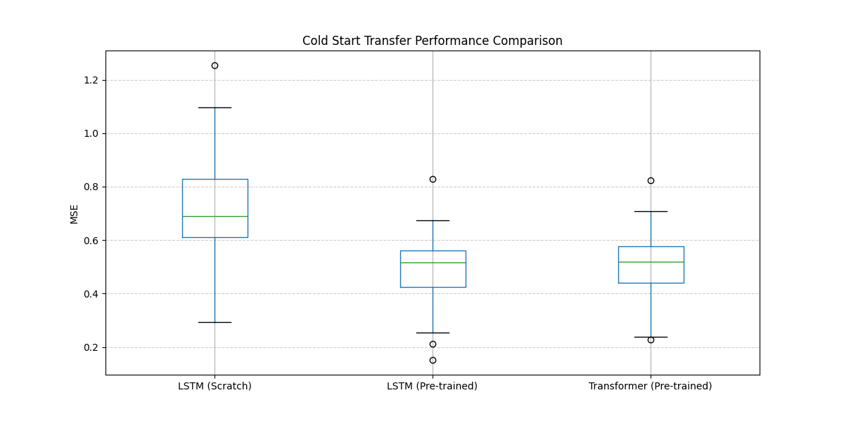
Fig 6. Model final comparison enhanced
Ultimately, while Transformers possess a higher theoretical capacity for large-scale datasets, this comparative framework proves that the sequence-constrained LSTM remains the more robust and reliable choice for the “Day-1” deployment of newly commissioned smart meters.

6.5 Robustness Analysis and Metric Discussion
The robustness of the proposed framework is further analyzed by examining the statistical distribution of forecasting errors across the heterogeneous consumer base. In a real-world smart grid deployment, a model’s consistency across a diverse population with varying appliance usage behaviors is often more critical than its average performance on a single household.

6.5.1 Error Stability and Architecture Reliability
The statistical dispersion of errors provides critical insights into the reliability of the forecasting framework across the 30 test households. Our results indicate that the LSTM-based fine-tuning strategy demonstrates a significantly narrower error distribution compared to the scratch-training baseline. This reduction in variance suggests that knowledge migration provides more consistent service quality across diverse consumption magnitudes.
From an operational perspective, reducing the “worst-case” error or tail risk is paramount for grid stability [4]. Large, unpredictable forecasting failures at the distribution level can trigger localized transformer overloads and voltage instability [1]. By leveraging the stabilized weights of the pre-trained LSTM, the framework acts as a “variance compressor,” ensuring that even households with highly irregular routines remain within a manageable error margin. While the Transformer model achieved competitive results, its slightly higher error variance in the 10-day window suggests a higher sensitivity to individual stochasticity when data is sparse.

6.5.2 Interpreting the MAPE Anomaly in Standardized Spaces
A notable observation in the experimental results is that the Mean Absolute Percentage Error (MAPE) values exceed 250% for all tested configurations, including the optimized LSTM and Transformer models. In traditional macroeconomic forecasting, a MAPE of this magnitude would typically indicate model failure. However, in the context of high-resolution residential STLF performed on normalized data, this is primarily a mathematical artifact resulting from the Z-score normalization process [37], [42].
The MAPE formula is defined by the ratio of the absolute error to the actual value. In this research, consumption values are transformed into a standardized space where the mean is centered at zero. When a household is in a “base-load” state—such as during late-night hours when residents are asleep—the normalized actual value $y_{t}$ frequently approaches zero. In the MAPE calculation, these near-zero values appear in the denominator, causing the percentage error to spike toward infinity even when the absolute difference between the predicted and actual value is negligible.
Despite these high absolute percentage values, the relative reduction in MAPE remains a powerful and valid indicator of performance improvement. The framework achieved a reduction from 355.01% (Scratch) to 285.81% (LSTM Fine-tuning). This significant decrease aligns with the gains observed in the more numerically stable MSE and RMSE metrics [4]. It confirms that the transfer learning framework effectively captures the macroscopic consumption cycles—the “energy fingerprint”—of residential users, even though the point-wise percentage metrics are skewed by the zero-centered nature of the standardized dataset [22].

7. Discussion

7.1 Theoretical Foundations of the Performance Hierarchy
The experimental results across the 30 residential households have consistently substantiated a hierarchical progression of predictive accuracy, which I define as the “performance ladder.” This ladder demonstrates that the integration of global knowledge through transfer learning represents a fundamental advancement over isolated local learning. The empirical transition from a scratch-training Mean Squared Error (MSE) of 0.7080 to an adaptive fine-tuning MSE of 0.4849 (for the LSTM backbone) is not merely a numerical optimization; it serves as a robust validation of the “Temporal Universality” hypothesis in residential energy informatics. This hypothesis posits that beneath the apparent stochasticity of individual consumer behavior, there exists an underlying structural consistency in energy utilization patterns governed by shared socio-biological and circadian rhythms [8], [9].

7.1.1 The Universality of Circadian Rhythms
Residential electricity demand, while appearing chaotic at the individual meter level, is fundamentally anchored by deep-seated circadian cycles. These rhythms are dictated by the natural day-night cycle, standard societal working hours, and the collective domestic routines of the metropolitan population. The source domain models, particularly after being enhanced with multivariate temporal features such as Hour of Day and Day of Week, function as generalized feature extractors. They successfully internalize macro-level behaviors, including the thermodynamic lag of buildings and the recurring consumption peaks associated with morning and evening surges [9]. By migrating these pre-trained weights, the target model does not start from a “tabula rasa” state but from an informed prior that already understands the fundamental “grammar” of energy demand [15]. This allows the model to interpret sparse local data through the lens of established global knowledge, providing immediate predictive utility.

7.1.2 Transfer Learning as a Structural Regularizer
In the extreme cold-start regime where sample size is critically limited (N = 10 days), the primary mathematical obstacle to accuracy is the high variance of the estimator. High-capacity models like LSTMs and Transformers, which possess thousands of degrees of freedom, are prone to “memorizing” idiosyncratic noise and temporal anomalies when trained on only 480 observations [8], [9]. This leads to catastrophic overfitting, where the model captures temporary quirks—such as an unusual holiday event during the 10-day window—rather than the true underlying signal.
The proposed transfer learning framework addresses this by acting as a structural regularizer. By freezing the recurrent layers of the LSTM or the encoder blocks of the Transformer, I effectively constrain the hypothesis space of the model. This forces the network to utilize generalized features proven robust across the 100-household source domain, effectively anchoring the predictions to reliable “temporal anchors” [11]. This regularization prevents the “gradient drift” typical of small-sample training and leads to the observed 31.5% improvement (for LSTM) in forecasting accuracy, ensuring stable performance even when target-specific context is virtually non-existent.

7.2 Architectural Trade-offs: Inductive Bias vs. Data Scarcity
A pivotal scholarly insight derived from this comparative study is the performance divergence between Recurrence-based (LSTM) and Attention-based (Transformer) architectures under extreme data scarcity. While contemporary deep learning literature frequently positions the Transformer as the superior successor to recurrent networks for sequence modeling [4], our empirical results across the 30-household cohort reveal a more nuanced reality in cold-start regimes. The finding that the fine-tuned LSTM (MSE: 0.4849) outperformed the fine-tuned Transformer (MSE: 0.4984) provides a critical foundation for discussing the theoretical trade-offs between architectural capacity and representational robustness.

7.2.1 The “Data Hunger” Paradox of Self-Attention
The relative underperformance of the Transformer in the 10-day window (N=480 observations) can be elucidated through the lens of architectural “data hunger.” The core innovation of the Transformer is the Multi-Head Self-Attention (MHSA) mechanism, which computes global dependencies across the entire temporal window simultaneously. Unlike recurrent gates that process information sequentially, MHSA assumes minimal structural priors about the data, relying instead on the attention matrix to “discover” temporal rules purely from the provided samples. In data-abundant environments, this flexibility allows Transformers to capture complex, multi-scale behavioral anomalies that evade traditional LSTMs.
However, in the extreme small-sample regime of a cold start, this lack of structural constraint becomes a mathematical liability. The attention weights are highly sensitive to localized stochasticity; with only 480 local observations, the fine-tuning process lacks sufficient “gradient density” to reliably converge the high-dimensional self-attention matrices without capturing the idiosyncratic noise of the 10-day window [8], [9]. This results in the observed “over-adjustment” to non-periodic spikes, leading to the slightly higher MSE and MAPE values recorded in our batch evaluation.

7.2.2 The Advantage of Sequential Inductive Bias
In contrast, the LSTM architecture possesses a strong inductive bias specifically tailored for time-series data. By maintaining a hidden state that is updated step-by-step, the LSTM mathematically enforces the chronological flow of time [8]. This inherent structural assumption acts as a powerful regularizer that is “built-in” to the network’s recurrent geometry. For a newly commissioned smart meter, this sequential prior provides a stable interpretative framework that anchors the model even when local data is critically sparse [11].
Our implementation proves that by migrating the pre-trained LSTM weights and freezing the recurrent gates, the model effectively utilizes a “generalized temporal template” learned from the 100-household source domain [15]. The recurrent structure ensures that the knowledge localization phase (fine-tuning the final linear layer) remains grounded in the basic physics of residential energy cycles—such as the deterministic rise and fall of circadian loads—preventing the catastrophic model drift often seen in unconstrained attention mechanisms during small-sample adaptation. This architectural robustness explains why the LSTM achieved a lower MSE than the Transformer, confirming that for Day-1 deployment in smart grids, architectures with stronger sequential priors provide superior reliability [9].

7.3 The Critical Threshold of Negative Transfer and Optimization
The empirical documentation of negative transfer in our preliminary Model 1 provides a critical warning for smart grid practitioners. It demonstrates that the conceptual proximity of source and target domains is insufficient to guarantee successful knowledge migration; architectural and parametric alignment is the true determinant of performance [13]. When the weights of Model 1—tuned via traditional manual heuristics—were transferred to the target households, the resulting average MSE was approximately 0.81, which is notably worse than the 0.7080 MSE achieved by the scratch-training baseline. This substantial performance penalty indicates that unoptimized pre-trained weights can actively hinder a model’s ability to adapt to new target domains [11].

7.3.1 Informative Bias and Source Domain Over-specialization
A post-hoc analysis suggests that Model 1 suffered from “informative bias.” Because the manual heuristics were focused solely on minimizing source domain training loss, the network’s internal weights became over-specialized to the idiosyncratic noise of the 100 source households. Instead of learning universal temporal invariants, Model 1 memorized specific behavioral anomalies. When transferred to a new target household, these biased weights imposed an incorrect representational structure that the sparse 10-day local target data could not overcome. This confirms that without deliberate regularization during the pre-training phase, deep neural networks tend to prioritize memorization over generalization, severely compromising their transferability.

7.3.2 Bayesian Optimization as a Catalyst for Transferability
The successful implementation of Model 2 via the Optuna framework represents a technical necessity for ensuring the robustness of neural representations [16]. By utilizing the Tree-structured Parzen Estimator (TPE) algorithm for systematic Bayesian optimization, the system explored the high-dimensional hyperparameter space to identify a flatter minimum in the loss landscape. Specifically, the optimization history revealed that a significantly lower learning rate and a tailored dropout configuration were necessary for the source model to maintain parameter generality.
This automated hyperparameter alignment transformed the initial negative transfer into a substantial forecasting gain, ultimately enabling the optimized LSTM to achieve an MSE of 0.4849. This dramatic shift from a performance penalty to a definitive advantage confirms that systematic Bayesian optimization is not merely a refinement step, but a fundamental prerequisite for robust knowledge migration in complex energy systems [16].

7.4 Implications for Smart Grid Reliability and Service Deployment
The practical value of the proposed framework extends beyond average accuracy improvements, offering significant implications for the operational reliability of modern smart grids. By bridging the “value-void” of the initial 10-day cold-start period, this methodology enables the immediate deployment of data-driven services for new participants.

7.4.1 The “Variance Compressor” Effect and Risk Mitigation
A critical observation from the batch evaluation of the 30 test households is the significant reduction in error variance. While the scratch-training approach exhibited volatile performance across different users, the optimized LSTM fine-tuning strategy acted as a “variance compressor,” providing a more consistent level of service quality regardless of individual behavioral stochasticity. For utility operators, mitigating “tail risk”—the occurrence of extreme forecasting failures—is often more vital than marginal gains in mean accuracy [4]. Reliable forecasts at the grid edge are essential for localized transformer load balancing and the prevention of voltage instability caused by unpredictable residential surges [1]. By providing a stabilized forecasting floor from “Day 1,” this framework ensures that new smart meter installations do not compromise the collective stability of the distribution network [9].

7.4.2 Interpreting the MAPE Anomaly and Scaling Artifacts
Despite the clear superiority of the transfer learning approach in MSE and RMSE metrics, the persistently high Mean Absolute Percentage Error (MAPE) values (e.g., 285.80%) require rigorous scholarly interpretation. As observed in high-resolution residential load studies, this is primarily a mathematical artifact induced by Z-score normalization [37]. In the standardized feature space, consumption values are centered around zero. During base-load periods (such as late-night intervals), the actual value in the denominator of the MAPE formula approaches zero, causing the percentage error to inflate toward infinity even when the absolute kilowatt deviation is negligible.
However, the relative reduction of MAPE from 355.01% (Scratch) to 285.80% (LSTM Fine-tuning) remains a highly valid statistical proxy for performance gain. This improvement aligns with the gains observed in more numerically stable metrics and confirms that the model is successfully internalizing the “energy fingerprint” of the household [22]. For practical application, these results suggest that while percentage-based metrics provide a sense of relative improvement, absolute error metrics in the original scale should remain the primary benchmarks for physical grid engineering.

7.4.3 Accelerating the ROI of Smart Metering Infrastructure
The ability to generate high-precision forecasts without a lengthy “burn-in” period of data accumulation significantly enhances the Return on Investment (ROI) for Advanced Metering Infrastructure [4]. Typically, smart grid services such as dynamic pricing and personalized demand-side management are delayed by months until sufficient history is gathered. Our results prove that by leveraging the “Inductive Bias” of pre-trained LSTMs, operators can bypass this data-accumulation phase, enabling the full suite of smart grid functionalities immediately upon meter commissioning [4]. This acceleration is a key catalyst for the broader adoption of sustainable energy management technologies in residential sectors.

8.Conclusion and Future Work

8.1 Summary of Contributions
The integration of Advanced Metering Infrastructure (AMI) into modern smart grids has fundamentally transformed demand-side management. However, the operational “value-void” caused by the data scarcity of newly commissioned smart meters—known as the cold-start problem—remains a critical bottleneck [11]. This research successfully developed and rigorously evaluated a multivariate transfer learning framework to bridge this gap, specifically targeting the extreme 10-day (480 observations) small-sample regime. By conducting a systematic, head-to-head empirical comparison across a diverse cohort of 30 residential households from the London Smart Meter dataset, this study provides actionable insights into the architectural and strategic prerequisites for robust knowledge migration.

8.2 Key Empirical Findings
The experimental phase yielded three major scholarly and engineering discoveries:
- The Superiority of Sequential Inductive Bias in Cold Starts: The most significant finding of this research is the performance divergence between neural architectures under extreme data scarcity. Despite the theoretical advantages of attention mechanisms in sequence modeling, the LSTM architecture (MSE: 0.4849) demonstrated empirically superior stability over the Transformer (MSE: 0.4984) during the 10-day fine-tuning window. The LSTM’s inherent sequential inductive bias acted as a structural regularizer, preventing the catastrophic over-adjustment to localized noise that plagued the “data-hungry” Transformer.
- The Absolute Necessity of Knowledge Migration: The research established a definitive “performance ladder,” proving that isolated local learning is mathematically unviable for new meters. The proposed adaptive fine-tuning strategy reduced the Mean Squared Error from 0.7080 (training from scratch) to 0.4849, while simultaneously acting as a “variance compressor” to ensure consistent service quality across highly diverse consumption behaviors.
- Overcoming Negative Transfer via Bayesian Optimization: The study documented the severe risks of “informative bias” and negative transfer when migrating weights derived from manual heuristics. By implementing a Tree-structured Parzen Estimator (TPE) via the Optuna framework [16], the methodology successfully aligned the hyperparameter space, transforming an initial performance penalty (MSE: 0.81) into a nearly 30% forecasting gain. This proves that systematic architectural optimization is a mandatory prerequisite for successful transfer learning [13].

8.3 Practical Implications for Utility Operators
From an operational perspective, the proposed framework enables utility providers to bypass the traditional months-long data accumulation phase. By providing highly reliable Day-1 forecasts, operators can immediately implement localized transformer load balancing and dynamic pricing strategies, significantly accelerating the Return on Investment of smart grid rollouts. Furthermore, while percentage-based metrics (such as the 285.80% MAPE) exhibit mathematical artifacts due to zero-centered standardized data, the profound relative reductions confirm the framework’s capacity to securely capture the unique “energy fingerprint” of individual users.

8.4 Limitations and Future Directions
While this study resolves the immediate 10-day cold-start challenge, certain limitations warrant future investigation. First, the comparative evaluation was restricted to deterministic point forecasting. Future research should extend this framework into probabilistic forecasting boundaries to quantify uncertainty margins for grid dispatchers. Second, as the newly commissioned meter accumulates longitudinal data (e.g., beyond 3 to 6 months), a dynamic “architecture-switching” mechanism could be explored. Such a system would deploy the stable LSTM during the cold-start phase and autonomously transition to a Transformer backbone once sufficient data is available to satisfy its multi-head attention requirements. Finally, incorporating Federated Learning (FL) into the pre-training phase [43] could further enhance the source model’s universality, reflecting the evolving methodological standards in smart meter data analytics [44], while strictly preserving the privacy of the 100-household source domain through decentralized knowledge aggregation [45].
Furthermore, it must be acknowledged that the current models were developed under specific hardware and software constraints, which may have limited the exhaustive exploration of the model's performance ceiling. Consequently, a primary objective for future work is to further elevate the predictive accuracy and robustness of the framework. This will involve significantly expanding the volume and diversity of the source domain data to cultivate a more potent and generalizable 'universal knowledge' base. Moreover, conducting a more granular and extensive search of the hyperparameter landscape will be essential to identify the absolute optimal configurations, thereby fully unlocking the potential of both LSTM and Transformer architectures in the context of residential load migration.

References
[1] N. Alemazkoor, M. Tootkaboni, R. Nateghi, and A. Louhghalam, ‘Smart-Meter Big Data for Load Forecasting: An Alternative Approach to Clustering’, IEEE Access, vol. 10, pp. 8377–8387, 2022, doi: 10.1109/ACCESS.2022.3142680.
[2] Y. Zhang, T. Huang, and E. F. Bompard, ‘Big data analytics in smart grids: a review’, Energy Inform, vol. 1, no. 1, p. 8, Aug. 2018, doi: 10.1186/s42162-018-0007-5.
[3] S. S. S. R. Depuru, L. Wang, V. Devabhaktuni, and N. Gudi, ‘Smart meters for power grid — Challenges, issues, advantages and status’, in 2011 IEEE/PES Power Systems Conference and Exposition, Mar. 2011, pp. 1–7. doi: 10.1109/PSCE.2011.5772451.
[4] M. Massaoudi, H. Abu-Rub, S. S. Refaat, I. Chihi, and F. S. Oueslati, ‘Deep Learning in Smart Grid Technology: A Review of Recent Advancements and Future Prospects’, IEEE Access, vol. 9, pp. 54558–54578, 2021, doi: 10.1109/ACCESS.2021.3071269.
[5] M. Alhussein, K. Aurangzeb, and S. I. Haider, ‘Hybrid CNN-LSTM Model for Short-Term Individual Household Load Forecasting’, IEEE Access, vol. 8, pp. 180544–180557, 2020, doi: 10.1109/ACCESS.2020.3028281.
[6] J. W. Taylor, ‘Short-term electricity demand forecasting using double seasonal exponential smoothing’, Journal of the Operational Research Society, vol. 54, no. 8, pp. 799–805, Aug. 2003, doi: 10.1057/palgrave.jors.2601589.
[7] C. Chatfield and H. Xing, The analysis of time series: an introduction, Seventh edition. in Chapman & Hall/CRC texts in statistical science series. Boca Raton, Florida: CRC Press, 2019.
[8] S. Hochreiter and J. Schmidhuber, ‘Long Short-Term Memory’, Neural Computation, vol. 9, no. 8, pp. 1735–1780, Nov. 1997, doi: 10.1162/neco.1997.9.8.1735.
[9] W. Kong, Z. Y. Dong, Y. Jia, D. J. Hill, Y. Xu, and Y. Zhang, ‘Short-Term Residential Load Forecasting Based on LSTM Recurrent Neural Network’, IEEE Transactions on Smart Grid, vol. 10, no. 1, pp. 841–851, Jan. 2019, doi: 10.1109/TSG.2017.2753802.
[10] Y. Wang, Q. Yao, J. T. Kwok, and L. M. Ni, ‘Generalizing from a Few Examples: A Survey on Few-shot Learning’, ACM Comput. Surv., vol. 53, no. 3, p. 63:1-63:34, Jun. 2020, doi: 10.1145/3386252.
[11] E. Lee and W. Rhee, ‘Individualized Short-Term Electric Load Forecasting With Deep Neural Network Based Transfer Learning and Meta Learning’, IEEE Access, vol. 9, pp. 15413–15425, 2021, doi: 10.1109/ACCESS.2021.3053317.
[12] F. Zhuang et al., ‘A Comprehensive Survey on Transfer Learning’, Proceedings of the IEEE, vol. 109, no. 1, pp. 43–76, Jan. 2021, doi: 10.1109/JPROC.2020.3004555.
[13] S. J. Pan and Q. Yang, ‘A Survey on Transfer Learning’, IEEE Transactions on Knowledge and Data Engineering, vol. 22, no. 10, pp. 1345–1359, Oct. 2010, doi: 10.1109/TKDE.2009.191.
[14] Y. Bengio, A. Courville, and P. Vincent, ‘Representation Learning: A Review and New Perspectives’, IEEE Transactions on Pattern Analysis and Machine Intelligence, vol. 35, no. 8, pp. 1798–1828, Aug. 2013, doi: 10.1109/TPAMI.2013.50.
[15] H. Ismail Fawaz, G. Forestier, J. Weber, L. Idoumghar, and P.-A. Muller, ‘Transfer learning for time series classification’, in 2018 IEEE International Conference on Big Data (Big Data), Dec. 2018, pp. 1367–1376. doi: 10.1109/BigData.2018.8621990.
[16] T. Akiba, S. Sano, T. Yanase, T. Ohta, and M. Koyama, ‘Optuna: A Next-generation Hyperparameter Optimization Framework’, in Proceedings of the 25th ACM SIGKDD International Conference on Knowledge Discovery & Data Mining, in KDD ’19. New York, NY, USA: Association for Computing Machinery, Jul. 2019, pp. 2623–2631. doi: 10.1145/3292500.3330701.
[17] Y. LeCun, Y. Bengio, and G. Hinton, ‘Deep learning’, Nature, vol. 521, no. 7553, pp. 436–444, May 2015, doi: 10.1038/nature14539.
[18] H. S. Hippert, C. E. Pedreira, and R. C. Souza, ‘Neural networks for short-term load forecasting: a review and evaluation’, IEEE Transactions on Power Systems, vol. 16, no. 1, pp. 44–55, Feb. 2001, doi: 10.1109/59.910780.
[19] J. Zheng, C. Xu, Z. Zhang, and X. Li, ‘Electric load forecasting in smart grids using Long-Short-Term-Memory based Recurrent Neural Network’, in 2017 51st Annual Conference on Information Sciences and Systems (CISS), Mar. 2017, pp. 1–6. doi: 10.1109/CISS.2017.7926112.
[20] B. N. Oreshkin, D. Carpov, N. Chapados, and Y. Bengio, ‘N-BEATS: Neural basis expansion analysis for interpretable time series forecasting’, Feb. 20, 2020, arXiv: arXiv:1905.10437. doi: 10.48550/arXiv.1905.10437.
[21] Y. Wang, D. Gan, M. Sun, N. Zhang, Z. Lu, and C. Kang, ‘Probabilistic individual load forecasting using pinball loss guided LSTM’, Applied Energy, vol. 235, pp. 10–20, Feb. 2019, doi: 10.1016/j.apenergy.2018.10.078.
[22] H. Shi, M. Xu, and R. Li, ‘Deep Learning for Household Load Forecasting—A Novel Pooling Deep RNN’, IEEE Trans. Smart Grid, vol. 9, no. 5, pp. 5271–5280, Sep. 2018, doi: 10.1109/TSG.2017.2686012.
[23] S. Smyl, ‘A hybrid method of exponential smoothing and recurrent neural networks for time series forecasting’, International Journal of Forecasting, vol. 36, no. 1, pp. 75–85, Jan. 2020, doi: 10.1016/j.ijforecast.2019.03.017.
[24] J. Lu, A. Liu, F. Dong, F. Gu, J. Gama, and G. Zhang, ‘Learning under Concept Drift: A Review’, IEEE Transactions on Knowledge and Data Engineering, vol. 31, no. 12, pp. 2346–2363, Dec. 2019, doi: 10.1109/TKDE.2018.2876857.
[25] M. Cai, M. Pipattanasomporn, and S. Rahman, ‘Day-ahead building-level load forecasts using deep learning vs. traditional time-series techniques’, Applied Energy, vol. 236, pp. 1078–1088, Feb. 2019, doi: 10.1016/j.apenergy.2018.12.042.
[26] J. Sola and J. Sevilla, ‘Importance of input data normalization for the application of neural networks to complex industrial problems’, IEEE Transactions on Nuclear Science, vol. 44, no. 3, pp. 1464–1468, Jun. 1997, doi: 10.1109/23.589532.
[27] I. Goodfellow, Y. Bengio, and A. Courville, Deep learning. in Adaptive computation and machine learning. Cambridge, Mass: The MIT press, 2016.
[28] A. Sherstinsky, ‘Fundamentals of Recurrent Neural Network (RNN) and Long Short-Term Memory (LSTM) network’, Physica D: Nonlinear Phenomena, vol. 404, p. 132306, Mar. 2020, doi: 10.1016/j.physd.2019.132306.
[29] G. Ke et al., ‘LightGBM: A Highly Efficient Gradient Boosting Decision Tree’, in Advances in Neural Information Processing Systems, Curran Associates, Inc., 2017. Accessed: May 01, 2026. [Online]. Available: https://proceedings.neurips.cc/paper/2017/hash/6449f44a102fde848669bdd9eb6b76fa-Abstract.html
[30] A. Vaswani et al., ‘Attention is All you Need’, in Advances in Neural Information Processing Systems, Curran Associates, Inc., 2017. Accessed: May 01, 2026. [Online]. Available: https://proceedings.neurips.cc/paper/2017/hash/3f5ee243547dee91fbd053c1c4a845aa-Abstract.html
[31] Z. Niu, G. Zhong, and H. Yu, ‘A review on the attention mechanism of deep learning’, Neurocomputing, vol. 452, pp. 48–62, Sep. 2021, doi: 10.1016/j.neucom.2021.03.091.
[32] D. P. Kingma and J. Ba, ‘Adam: A Method for Stochastic Optimization’, Jan. 30, 2017, arXiv: arXiv:1412.6980. doi: 10.48550/arXiv.1412.6980.
[33] I. Loshchilov and F. Hutter, ‘Decoupled Weight Decay Regularization’, Jan. 04, 2019, arXiv: arXiv:1711.05101. doi: 10.48550/arXiv.1711.05101.
[34] J. Bergstra, J. Bergstra, Y. Bengio, and Y. Bengio, ‘Random Search for Hyper-Parameter Optimization’.
[35] M. Feurer and F. Hutter, ‘Hyperparameter Optimization’, in Automated Machine Learning: Methods, Systems, Challenges, F. Hutter, L. Kotthoff, and J. Vanschoren, Eds, Cham: Springer International Publishing, 2019, pp. 3–33. doi: 10.1007/978-3-030-05318-5_1.
[36] T. J. Santner, B. J. Williams, and W. I. Notz, ‘The Design and Analysis of Computer Experiments’.
[37] T. Hong and S. Fan, ‘Probabilistic electric load forecasting: A tutorial review’, International Journal of Forecasting, vol. 32, no. 3, pp. 914–938, Jul. 2016, doi: 10.1016/j.ijforecast.2015.11.011.
[38] Z. Cao, L. Ma, M. Long, and J. Wang, ‘Partial Adversarial Domain Adaptation’.
[39] B. Lim and S. Zohren, ‘Time-series forecasting with deep learning: a survey’, Phil. Trans. R. Soc. A., vol. 379, no. 2194, p. 20200209, Apr. 2021, doi: 10.1098/rsta.2020.0209.
[40] D. L. Marino, K. Amarasinghe, and M. Manic, ‘Building energy load forecasting using Deep Neural Networks’, in IECON 2016 - 42nd Annual Conference of the IEEE Industrial Electronics Society, Oct. 2016, pp. 7046–7051. doi: 10.1109/IECON.2016.7793413.
[41] H. Zhou et al., ‘Informer: Beyond Efficient Transformer for Long Sequence Time-Series Forecasting’, Proceedings of the AAAI Conference on Artificial Intelligence, vol. 35, no. 12, pp. 11106–11115, May 2021, doi: 10.1609/aaai.v35i12.17325.
[42] R. J. Hyndman and A. B. Koehler, ‘Another look at measures of forecast accuracy’, International Journal of Forecasting, vol. 22, no. 4, pp. 679–688, Oct. 2006, doi: 10.1016/j.ijforecast.2006.03.001.
[43] T. Li, A. K. Sahu, A. Talwalkar, and V. Smith, ‘Federated Learning: Challenges, Methods, and Future Directions’, IEEE Signal Processing Magazine, vol. 37, no. 3, pp. 50–60, May 2020, doi: 10.1109/MSP.2020.2975749.
[44] Y. Wang, Q. Chen, T. Hong, and C. Kang, ‘Review of Smart Meter Data Analytics: Applications, Methodologies, and Challenges’, IEEE Trans. Smart Grid, vol. 10, no. 3, pp. 3125–3148, May 2019, doi: 10.1109/TSG.2018.2818167.
[45] Q. Yang, Y. Liu, T. Chen, and Y. Tong, ‘Federated Machine Learning: Concept and Applications’, ACM Trans. Intell. Syst. Technol., vol. 10, no. 2, p. 12:1-12:19, Jan. 2019, doi: 10.1145/3298981.

