Python basics

Print function

print()

Automatically has a line break

You can stop the linebreak

print("Hello",end='')

print("Hello", end='')
print("How are you")

Multiple:
print("I like tea", "and my favourite is Yorkshire")

with Separator
print('A', 'B', 'C', sep='-')

Using Comments

Use #

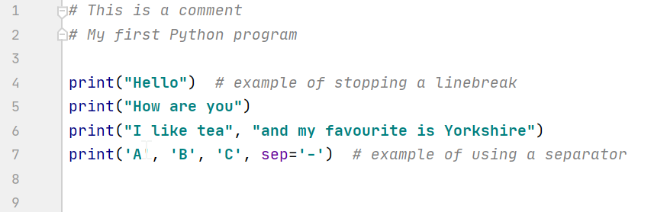

"""This
is a
multi-line
comment"""

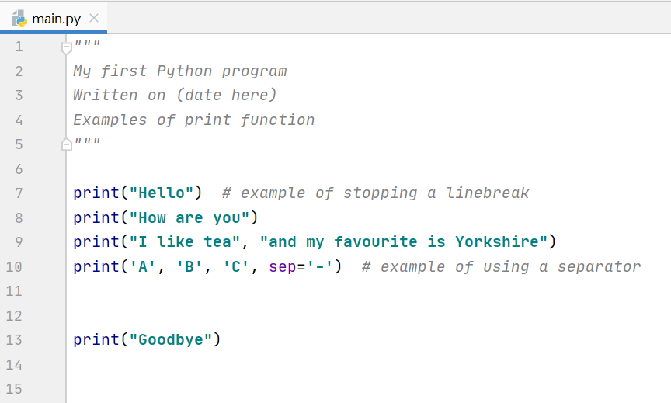

Variables
What are variables about?
Blah

Types of variables – int, float, string

No declaring variables in Python

Some languages insist on us declaring the type upfront, so it can allocate memory for it. Python does not have a command for declaring a value, the type will be inferred.

For example:

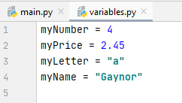
If there are letters in the contents, put " " or ' ' around the contents.
Types will be inferred.

We can print variables on the screen using the print() function

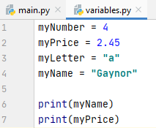

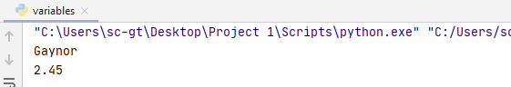

To find out the type that has been inferred by Python, we can print it out.

print(type(myNumber))
print(type(myName))

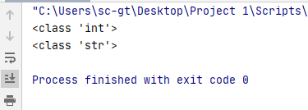

However, you can also specify the type, rather than rely on Python inferring (sometimes Python might get it wrong) This is known as casting.

Casting
For example, I might intend myNumber to be of float type. So I can specify the type:

myNumber=float(4)

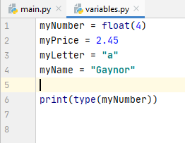
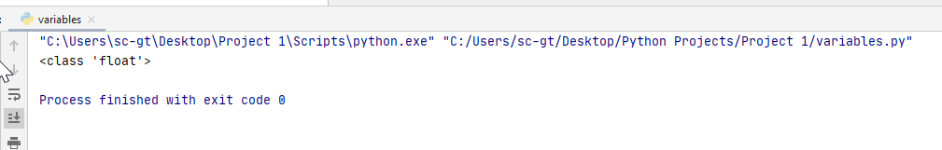

I can only do this within reason. For example, I can't make myName = "Gaynor" into an int type!

Also, if I specify myPrice above into as an int type :

myPrice=int(2.45)

Python will truncate the value – so only the whole number 2 is left. This may be what I want, but not necessarily!

Python is more forgiving than other languages about mixing types, if I add an int and a float for example, it will change the type to a float

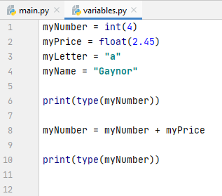

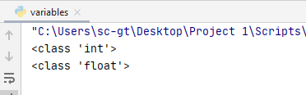
type has changed to float

Choosing a suitable variable name

• A variable name must start with a letter or the underscore _ character

(eg myName)

• A variable name cannot start with a number

(so myNumber1 is OK, but not 1myNumber)

• A variable name can only contain alpha-numeric characters and underscore (A-Z, a-z, 0-9, and _ )
we cannot use special characters such as ?!-$%^

• Variable names are case-sensitive

(ie myname, myName and MYNAME are not the same)

Self-describing variable names
I would add to the above rules that a variable name should be self-describing:

For example, carPrice=2300 make it quite easy to understand what the purpose of the variable is, a=2300 does not. This is especially important when you haven't worked on a program for a while – it may be difficult to recall what a refers to.

Camel Casing
You have seen above that I have chosen variable names such as myName, myNumber, carPrice

You may have wondered why they have a random capital letter in the middle of them. This is known as camel casing, which is a programming convention.

Camel casing is not a rule - but many programmers, not just in Python, but in many other languages, use camel casing to make their variables easier to read.

For example, myname is quite short and not too bad to read, but myName makes it clear where the words are without resorting to using underscore (although my_name or my_Name is also OK!)

When variable names become longer, camel casing can help with readability:

myfirstname -> myFirstName
mymiddlename -> myMiddleName
mysurname -> mySurname

There are no hard and fast rules here. If you don't like camel casing, you don't have to use it, but bear in mind that other programmers who may maintain your program in the future may prefer it!

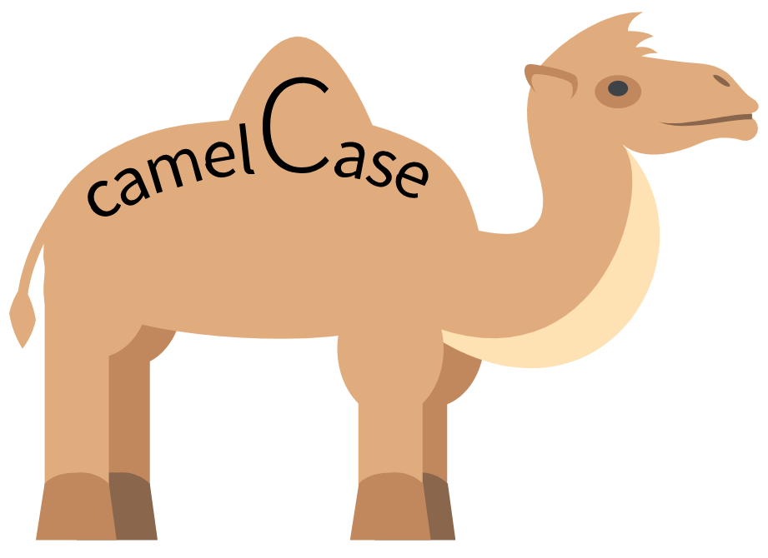

By Emoji One, myself - File:Emojione 1F42B.svg, CC BY-SA 4.0, https://commons.wikimedia.org/w/index.php?curid=81071410

