

Programme: Master of Business Administration
Module: Marketing Management
Module code: LCMB7024
Title: Marketing Portfolio
Word count: 2526
Lecturer : Dian Mayasari
Student Name:Samit Chanda
Student ID: 2504511
Submission Date- 19th November 2025

Table of Contents
Introduction ......................................................................................... 3
Element 1: STDP Analysis ................................................................... 3-6
Element 2: Critical Analysis of the Marketing Mix (7Ps) ..................... 6-10
Element 3: Marketing Pitch Poster Explanation ................................ 10-11
Element 4: Reflection ......................................................................... 11-12
Conclusion…………………………………………………………………..12
References .......................................................................................... 12-14

Introduction
This marketing team suggests a marketing idea to innovate a new smart water-purification bottle, EcoSip+, that can expand wellness and sustainability offered by Brita. Based on the framework of the 7Ps marketing mix and the STDP, the portfolio will form a brand plan and analyze it and consider the procedure as a whole. Brita is an internationally recognised water filtration giant that is experiencing an increase in consumer desire to purchase smart, health-oriented, environmentally-conscious solutions, compelling the company to be innovative enough to develop a system that is not as standard. EcoSip+ is the transition that Brita has made in terms of smart sustainability, integrating digital and physical health. The report consists of STDP analysis, marketing mix evaluation, a promotion poster reasoning and a reflection on learning part.

Element 1: STDP Analysis
1.1 Segmentation Strategy
The EcoSip+ by Brita will take a multi dimensional approach to segmentation that is dependent on the demographic, psychographic, behavioural and geographic factors, to identify the market segment that is wellness oriented and environmentally conscious.
EcoSip+ is a drink aimed at working professionals and health enthusiasts who are 20-45 years old. This segment is known to have urban consumers who prefer to embrace technology-based wellness and have the ability to spend a moderately premium price ranging between PS39.99 (Statista, 2025).
EcoSip+ targets a psychographically diverse target audience, namely a perfectionist wellness-seeking market that is attentive to its health and encouraging clean living and sustainability (Kotler et al., 2023). These consumers are not just purchasing a bottle but they are investing in an upgrade of their lifestyle which will include the purification, monitoring of hydration and the enhancement of minerals.
Brita divides its consumers in terms of loyalty and innovation adoption, behaviourally. The company targets first-mover people, individuals who are enthusiastic about smart health devices, such as a fitness watch and digital health-trackers (Mintel, 2024). They are also wellness-oriented and willing to make long-term investments in health, which perfectly corresponds with the concept proposed by EcoSip+.
The first product will be geographically focused, meaning that most of the urban UK markets, specifically London, Manchester, and Birmingham, will be targeted, as these areas have the highest level of gym culture and sustainability consciousness (ONS, 2024). The domestic success would be followed by expansion into the urban centres in the EU and Asia.
In brief, the segmentation of EcoSip+ will focus on the consumers who view hydration as a wellness activity and place Brita on the position of fulfilling both modern health and environmental demands.

1.2 Targeting Strategy
Brita also uses differentiated targeting approach with EcoSip+, when quality of the product is required to be smart, health-oriented, and environmentally friendly to target the young professionals and fitness-oriented consumers. This strategy acknowledges that the market of traditional bottled water is saturated, yet the market of the so-called smart hydration is comparatively unexploited (Euromonitor, 2024).
The primary target includes:
- Urban elites between age 25-40 and medium to high income.
- Wearable health technologies that are used by gym-goers, cyclists, and runners.
- Existing customers are environmentally conscious, and they buy single-use plastics instead of reusable ones.
This group follows the trend of a wellness economy, worth an estimated 1.5 trillion world-over (McKinsey, 2024). EcoSip+ addresses their lifestyle and provides a purified and mineral-enriched and trackable hydration solution, which improves their convenience and self-happiness.
Combining a hydration-tracking application and a mineral booster, Brita intends to fill the hybrid between the health technology and sustainable lifestyle niche. This two-pronged attractiveness provides Brita with an excellent competitive edge over such brands as HydrateSpark and LARQ that focus on either technology or purification, but not both.
1.3 Differentiation Strategy
EcoSip+ is distinguished by the original technological, sustainable and health advantages. The conventional Brita filters aim at purification only but EcoSip+ comes with smart purification, addition of minerals, and tracking hydration a three-dimensional bonus.
Its differentiated selling propositions (USPs) are:
- Smart bottle design based on plastic waste reduction.
- The Smart TDS sensor is able to measure the purity and read the values digitally.
- Mineral enricher to add calcium and magnesium to the food and to make it taste good and healthy.
- Filter subscriptions that guarantee the convenience and constant interaction.
This type of multidimensional differentiation is compatible with the focus strategy of Porter, which puts more emphasis on value creation rather than cost rivalry (Porter, 1985). The EcoSip+ does not merely filter water, but also turns the hydration experience into a quantifiable wellness habit one can have- a bridge between hydration, sustainability and digital health.
1.4 Positioning Strategy
EcoSip+ is being placed as a high-quality, but affordable, wellness innovation with a logo of Sip Smarter. Live Better." Its positioning against its competitors such as LARQ and HydrateSpark is indicated in the perceptual map below:
Brand | Innovation | Price | Sustainability
LARQ | High | High | Medium
HydrateSpark | Medium | High | Low
Brita EcoSip+ | High | Medium | High

The EcoSip+ is a unique brand of sustainable smart hydration brand that blends both sustainability and quantifiable wellness benefits. The digital display, the access to applications and the ability to add minerals all to the brand contribute to the brand image of Brita as a smart hydration innovator.
With the help of the brand trust it already has, Brita can easily market EcoSip+ as the next step in its history of water purification (Kotler and Keller, 2022). The new position takes advantage of the history of the brand and targets modern consumers who are driven by technology.

Element 2: The Critical Analysis of the Marketing Mix (7Ps).
Product
The EcoSip+ is a smart water bottle that is made of bio-based materials and is capable of purifying and remineralising as well as monitoring hydration levels through a smart mobile application. The bottle entails combining the long-standing experience of Brita in the field of filtration and the latest digital technologies with replaceable filters that are eco-friendly, a digital glow sensor that lets a person know their hydration progress, and an instant Total Dissolved Solids (TDS) purity meter that would keep the user constantly informed about the water quality.
EcoSip+ takes the existing Brita value creation of filtered, clean water and moves it to the wellness-technology segment repackaging the concept of hydration as an experience and personalised health-focused activity. It encourages convenience, proactive health care, and user interaction by providing app-based hydration data, hydration reminders, and filters replacement alerts (Hoyer et al., 2020).
The design is eco-friendly, its shell is made of bio-based material which substitutes more than 1,000 single-use plastic bottles, which is consistent with the emerging global trend towards eco-friendly innovation and sustainable living (NielsenIQ, 2024). Brita Better Planet programme is supported by the use of recycling material and limited packaging.
Nonetheless, business success would be determined by a consistent technological performance of the product. The connectivity of the apps, battery, and sensorities must be of standard in a device that is being sold on the basis of technological accuracy. Any failure will jeopardize user confidence. It will thus require Brita to do constant product testing and frequent updates on the firmware to achieve long term reliability and retention of customers.
On balance, EcoSip+ is a new strategic innovation change in Brita, which combines hydration, health, and sustainability into a single wellness-oriented product.

Price
EcoSip+ will sell at PS39.99, which will put it at the mid-premium segment- affordable but aspirational. The price is a reflection of the technological value added yet it is in line with the reputation of Brita to offer quality and cheap prices. PS7.99 per month subscriptions on filters and mineral cartridges are a source of recurrent revenue and a stronger brand loyalty in the long-term.
This value-based and subscription-based pricing paradigm is a compromise between the perceived and profitability (Jobber and Ellis-Chadwick, 2023). The subscription will streamline the process of reordering and establish the product in the digital environment of Brita, encouraging the process of habitual engagement by notifying users and providing unique insights into wellness.
Even though recurring costs might be viewed as an obstacle by some consumers, the advantages, which are real-time hydration, water-purity, and sustainability, support the value of the product. Brita can also promote affordability perception by providing package deals, referral discounts, and student wellness packages as a way of promoting it in health-conscious societies.
With this type of pricing dynamics, Brita can stay competitive in this rapidly expanding smart-hydration market, which helps with the customer loyalty and lifetime customer value.

Place
EcoSip+ will be distributed with the usage of omnichannel approach which will be an integration of direct-to-consumer (D2C) sales and selective retail partnerships. The major platforms to be used in sales are the official Brita online store, Amazon, and cooperation with gyms and wellness centers. Co-operations with credible retailers like Boots and John Lewis will strengthen the position of Brita as a high-end but health-conscious brand.
This approach makes it very accessible and enables Brita to have control over the customer experience. It needs a robust digital presence, especially since the UK e-commerce market penetration is expected to go past 87 percent by 2025 (Statista, 2025). Bringing the product to fitness centres will position it in front of the wellness-based, tech-savvy target market.
This hybrid strategy increases convenience, credibility and experiential connection by ensuring maximum touchpoints online and offline.

Promotion
EcoSip+ does not utilize conventional advertising but instead, relies on an interactive and community-based approach to promotion. The flagship campaign, the Purity Challenge suggests users to test and post the local water-purity rates online, sparking the discussion on the topic of hydration and sustainability (Keller, 2023).
The brand will partner with fitness influencers, nutritionists and eco-lifestyle activists in order to create authenticity and trust. Short-form content, testimonials, and user stories will be posted on digital channels Instagram, Tik Tok, and YouTube. SEO-optimised blogs and hydration insights in the form of apps will reinstate Brita as the leader in wellness-tech.
The message of the promotion is inspirational and evidence-based, and it is targeted to the emotion (well-being, motivation) and the logic (science, purity). Experiential marketing will be offline, including hydration pop-ups in gyms and universities, where they will be given the opportunity to test the product.
Such tactics cause emotional appeals, raise awareness, and lead to lifestyle long-term association.

People
Brita engages in EcoSip+ with expertise and trust that are facilitated by the human-resource strategy. A wellness-based customer-service teams, nutritionists, and fitness influencers add to an environment of brand, focus on wellness. After-sale services, such as in-app feature support, installation support, and custom hydration recommendations, enhance the overall user experience, which is an essential element of consumer satisfaction with technology-enhanced products (Homburg et al., 2020).
Internal sustainability participation also supports brand authenticity, when workers are engaged in environmental activities, the general credibility and cultural unity is enhanced. Therefore, the people dimension is operational and strategic in the process of creating the EcoSip+ brand experience.
Process
EcoSip+ service process is focused on efficiency, automation, and sustainability. The app can perform automatic filter-subscriptions renewals, gadget connection, and hydration tracking and therefore simplifies and standardizes daily habits.
Brita will implement filter-recycling plans where customers can post through postal or drop-offs in the store. It is the circular-economy strategy which mitigates the environmental impact and strengthens sustainability promises (UNEP, 2024).
Through incorporation of sustainability in the working processes, Brita will improve brand credibility and attractiveness among the environmentally conscious consumers.

Physical Evidence
Physical evidence is the center of the message of product quality and technological innovation communication. The performance is physically illustrated through the visible bottle, green light hydration ring and digital purity sensor. Green typography, recyclable packaging and Brita logo assist in building brand identity and environmental alignment.
The retail displays will include TDS demo kits that include interactive displays and customers will get to see the process of purification. QR codes that direct to the instructions on the setting up of the app are advanced and easy to use.
EcoSip+ is not only a practical product, but it is the embodiment of the healthy, mindful, and sustainable lifestyle due to all these touchpoints.

Element 3: Pitch Strategy Marketing.
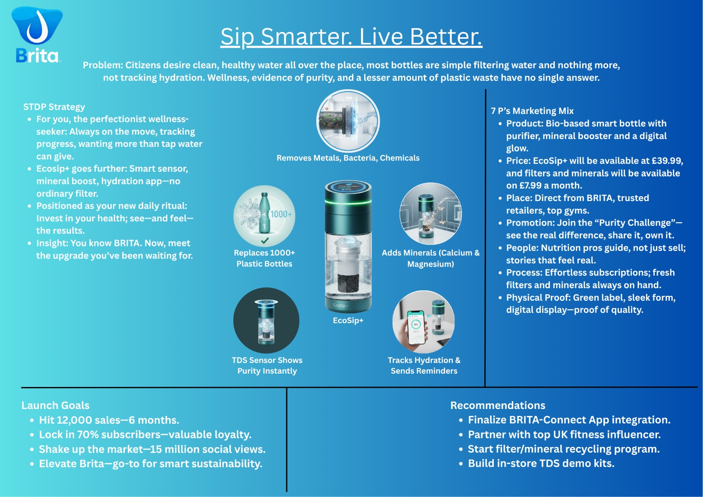
The EcoSip+ advertising poster delivers the assurance of the product- Sip Smarter. Live Better.- by being health conscious, technological and green. It identifies the problem, the dumb filter bottles, and offers the solution the purifier, which removes the metals, keeps the minerals and monitors the hydration. The STDP segment, which is perfectionism and wellness orientation is designed to make the EcoSip+ a quality improvement of the existing traditional Brita bottles. The 7Ps mix is helpful, as it will offer product differentiation, definite pricing, and strong online communication. The measurable goals are: 12,000 sales within six months and 70 percent retention rate of the subscribers through recommendation that encompasses: integration of apps and using influencers. The blue gradient that is aesthetically pure, trusting, and technologically groundbreaking is compatible with the Brita brand identity. Generally, there is a coherent, persuasive message in the poster, and it includes both appeals to practice and emotion.

Element 4 : Reflection
The creation of the EcoSip+ brand strategy gave some essential understanding of how sustainability, technology, and wellness can be incorporated into one marketing strategy. It involved analytical and imaginative thinking as well so that segmentation, targeting and positioning would take into consideration the contemporary consumer demands, in particular, the increased integration between environmental conscious behaviour and technology-based health practices.
The application of the STDP framework helped me deepen knowledge regarding the role of segmentation in strategic focus and meaningful differentiation. Similarly, the use of the 7ps marketing mix revealed the need to ensure consistency in the product, price, place and promotion mix to strengthen the Brita brand of being sustainable and innovative. Every aspect had to make a value addition to the brand.
Coming up with the pitch poster helped me improve my skills in moving the theoretical information into the skills of good visual communication, demonstrating how strategic thoughts can be easily put across in a way that is convincing and persuasive using images and short messages. The pitching also gave me a boost in confidence to give clear arguments that are audience-focused and balances between data and emotional appeal.
To enhance this in the future, primary consumer insights would be collected, and the competitor analysis would be done more thoroughly to prove assumptions and positioning would be refined. Also, digital performance analytics to be implemented after launch would help in continuous optimisation.
On the whole, the given project helped me to enhance my expertise in strategic planning, brand differentiation, and creative communication--the core competencies in my upcoming career in the sphere of marketing and innovation.
Conclusion
EcoSip+ marketing portfolio shows how Brita can effectively transform itself out of the traditional water-filtration to the emerging smart-wellness market. Using the STDP framework and the 7Ps marketing mix, the strategy makes EcoSip+ an innovative, sustainable and health-promoting hydration solution to the contemporary eco-conscious customers. The combination of purification, remineralisation and digital monitoring makes the product distinctive and in line with Brita tradition of trust and sustainability. Coherent communication, consumer insight, and strategic creativity are also emphasized in the poster pitch and reflection. On balance, EcoSip+ is a prospective business that can enable Brita to respond to the new wellness and sustainability requirements.

References
Black, C. and Smith, J. (2024) Smart sustainability and consumer innovation. Journal of Marketing Futures, 12(3), pp. 215–231.
Euromonitor (2024) Global wellness and hydration trends report 2024. Available at: https://www.euromonitor.com [Accessed 10 November 2025].
Homburg, C., Kuester, S. and Krohmer, H. (2020) Marketing management: A contemporary perspective. 4th ed. London: McGraw-Hill.
Hoyer, W.D., MacInnis, D.J. and Pieters, R. (2020) Consumer Behavior. 8th ed. Boston: Cengage Learning.
Jobber, D. and Ellis-Chadwick, F. (2023) Principles and practice of marketing. 10th ed. London: McGraw-Hill Education.
Keller, K.L. (2023) Strategic brand management. 6th ed. Harlow: Pearson Education.
Kotler, P. and Keller, K.L. (2022) Marketing management. 16th ed. Harlow: Pearson Education.
Kotler, P., Kartajaya, H. and Setiawan, I. (2023) Marketing 5.0: Technology for humanity. New Jersey: Wiley.
McKinsey & Company (2024) The global wellness economy 2024. Available at: https://www.mckinsey.com [Accessed 10 November 2025].
Mintel (2024) UK health and fitness technology market overview. Available at: https://www.mintel.com [Accessed 10 November 2025].
NielsenIQ (2024) Green consumer behaviour report 2024. Available at: https://nielseniq.com/global [Accessed 10 November 2025].
ONS (2024) Urban living and sustainability: UK consumer trends. London: Office for National Statistics.
Porter, M.E. (1985) Competitive Advantage: Creating and Sustaining Superior Performance. New York: Free Press.
Statista (2025) Smart bottle market size and UK consumer trends 2025. Available at: https://www.statista.com [Accessed 10 November 2025].
UNEP (2024) Circular economy and sustainable product design. Available at: https://www.unep.org [Accessed 10 November 2025].
Homburg, C., Jozić, D. and Kuehnl, C. (2020) ‘Customer experience management: Toward implementing an evolving marketing concept’, Journal of the Academy of Marketing Science, 48(3), pp. 255–273.
Hoyer, W.D., Kroschke, M., Schmitt, B., Kraume, K. and Shankar, V. (2020) ‘Transforming the customer experience through new technologies’, Journal of Interactive Marketing, 51, pp. 57–71.
Jobber, D. and Ellis-Chadwick, F. (2023) Principles and Practice of Marketing. 10th edn. London: McGraw-Hill Education.
Keller, K.L. (2023) Strategic Brand Management: Building, Measuring, and Managing Brand Equity. 6th edn. Harlow: Pearson.
NielsenIQ (2024) Global Sustainable Consumer Report 2024. Available at: https://nielseniq.com [Accessed 10 November 2025].
Statista (2025) E-commerce penetration in the United Kingdom 2025. Available at: https://www.statista.com [Accessed 10 November 2025].
UNEP (2024) Circular Economy and Sustainable Consumption Report. United Nations Environment Programme. Available at: https://www.unep.org [Accessed 10 November 2025].

