Alternative Propulsion Systems
Kinetic Energy Recovery
ACHA5010
Mark Sandford
Mikel Olaberria
2416696

Contents Page:

Page 1: Title page
Page 2: Contents page
Page 3: Introduction
Page 4: Task 1,2 & 3
Page 5: Tractive Graphs & Task 4
Page 6: Task 4
Page 7: Task 5
Page 8: Task 6
Page 9: Task 6 & kinetic graph
Page 10: Task 8
Page 11: Conclusion
Page 12: References

Introduction

Kinetic Energy Recovery System is a device used to recover the energy that would have been wasted by traditional friction braking and using it to improve the efficiency of the engine by reducing the vehicles fuel consumption. KER system is new technology which is only found in modern and specialised vehicles. The role of the assignment is to research the KER system and calculate the effects it would have if it were installed in a vehicle of our choosing. Furthermore, we are tasked in choosing the specific type of KER system which will work best for our chosen vehicle. This will include research such as size, weight and energy capacity.

I have chosen the Ford GT because it is a high-performance racing vehicle without a KER system. By choosing this car, it allows me to see the advantages it could bring to the car by enhancing its performance and how to improve its efficiency. In addition to this, modern day motorsport is continuously trying to improve the vehicles efficiency and carbon footprint, so the KER system is a good upgrade which this vehicle can receive.

- Research and identify the required dynamic characteristics of the vehicle, including: Test Mass (which is not kerb mass or GVW)

Ford GT 2017
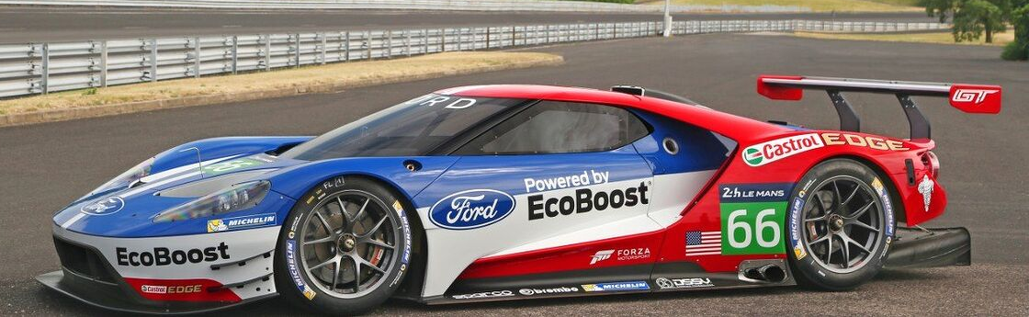

Test mass: 1,385 kg
Frontal area: 1.779 m^2
Coefficient of Aerodynamic drag: 0.388
Rolling resistance coefficient: 0.025 (Mustang6g.com (2017)
(Ford (2017a)

- Select the appropriate Worldwide harmonised Light vehicle Test Procedure (WLTP) for your selected vehicle.

Power to mass ratio: power (W)/mass(Kg)

Power: 647 hp = (647 x 745.7) = 482Kw
Mass: 1,385 Kg

Power to mass ratio= 482Kw/1385Kg= 0.348 Kw/Kg 348W/Kg

Top speed= 347 Km/h 216 mph (Ford (2017b)

Appropriate WLTP= 348 w/kg CLASS 3

The Ford GT fits into class 3 of the WLTP requirements as it fits the power to mass ratio of over 34 W/Kg..

WLTP of ford GT 2017: 315 g/km (Engine in Detail (no date)

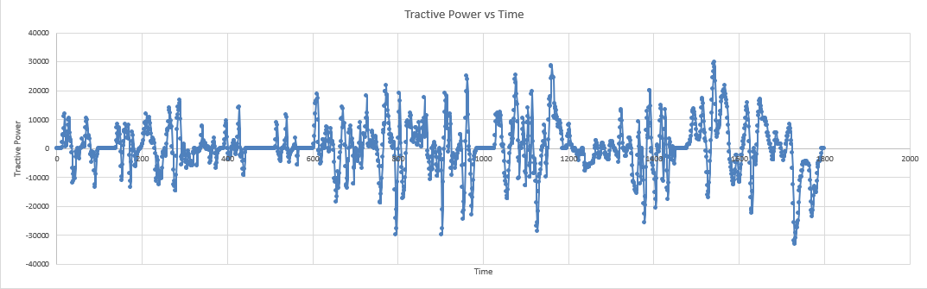
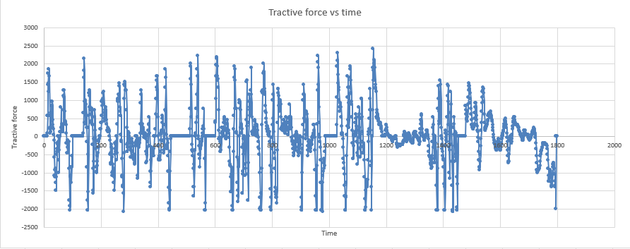

- Produce a spreadsheet to:

Plot the cumulative tractive energy required at the wheel over the WLTP cycle.

Plot the cumulative braking energy required at the wheel over the WLTP cycle.

- Identify the moments of largest ‘possible’ KERS power input and energy storage requirements. (Assume that the energy for each recovery period is used before the next recovery period). These values should be used to help you to define your system requirements.

Largest possible power: 33,064 W

To find the losses incurred during the cycle, we must subtract the total for cumulative braking from the total for cumulative Tractive. Total amount of losses during the cycle= 352300.8256 (Watts)

- Identify the moments of largest ‘possible’ KERS power input and energy storage requirements. These values should be used to help you to define your system requirements.

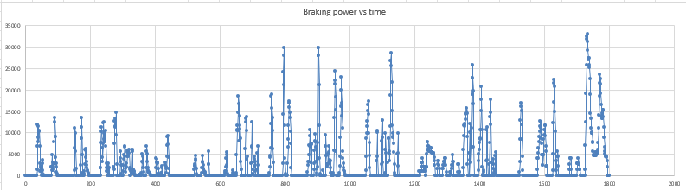

The largest possible power input is 33,064 (Watts). This is without accounting for the loss in power due to the efficiency of the KER system and how much of that energy it can recover. These requirements can be met as flywheel used in other motorsport vehicles such as F1 have flywheels capable of 60KW (Racecar Engineering (no date) of power per lap. Although these flywheels are manufactured for high performance vehicles and are not commonly found, this data shows that it is possible to make and implement into my chosen vehicle.

- Specify a suitable KER system, size the components and find values of their efficiencies.

Electronic KERS (Batalha project (2009): Electronic KER systems work by getting the braking rotational force using an electric motor and storing it in a battery. The electric motor is connected to the vehicle’s crankshaft, so when the vehicle requires that electric power, it goes from the battery back to the electric motor helping to power the vehicle.

To store the energy from the electronic KER system, large lithium batteries are required. These batteries require ample space and add weight to the vehicle affect performance. The weight of the battery varies depending on the application but can be around 35kg. In addition to this, lithium batteries will get hot after constant use and therefor require introduction of new cooling systems such as air ducts to keep it cool.

Energy efficiency (MDPI (no date): approximately 60.1%

Electro-mechanical KERS (Batalha project (2009): Electro-mechanical KER systems work by spinning a flywheel to store the energy kinetically. This means that there is no need for large batteries in vehicle saving space and weight. The flywheel spins in a vacuum to reduce loss of energy in heat and aerodynamics making sure that as much of the energy collected from braking. The flywheel is connected to an MGU (motor generator unit) which converts the braking torque into an electrical charge so as the flywheel spins, it can induce a current creating electricity which will be used to power the vehicle.

Using a flywheel to store energy is more efficient than batteries as it weights much less than the batteries at around 25kg while also taking up less space. This means that it can be put into more applications as it will affect it less.

Energy efficiency (Kinetic energy recovery system (no date): approximately as high as 90%

Mechanical KERS (Batalha project (2009): mechanical KER systems also use a flywheel, but instead of using an MGU like the electro-mechanical method, it uses a transmission to transfer the energy. Unlike electronic or electro-mechanical, this method does not require the energy to be transformed from one type to another making it much more efficient. This is due to the fact that when energy is converted into other forms, there will be loss of energy.

Energy efficiency (Kinetic energy recovery system (no date): approximately 90%-95%

For my chosen vehicle, a suitable KER system is the electro-mechanical system. I have chosen this method of KER system as it doesn’t require my vehicle to carry a large battery. Furthermore, by not having batteries, the vehicle will save weight and space as the flywheel weights around 5Kg while the batteries weight around 30kg. This weight reduction can have a large difference in performance. This is especially important for a motorsport vehicle such as the Ford GT as in motorsport, any weight reduction can be the difference between winning or losing. Instead, a flywheel will be used to house the energy in kinetic energy form. The flywheel requires less storage space in the vehicle which will affect its performance less. In addition to this, the electro-mechanical KER system can have an efficiency of up to 90% making it more efficient than an electronic KER system. This will help the vehicle get the most performance possible out of the system and allow the driver to deliver the power to the car on demand.

The cost for a KER system is unknown, for a motorsport application such as my chosen car, as the KER system would be designed specifically for the vehicle. However, the closest system will be the F1 KER system costing $96,000. This will differ as the specification will be different, however expected cost for a motorsport KER system will be high.

The highest value for braking power calculated for my chosen vehicle is at 33,064 (Watts). This happens towards the end of the WLTP cycle at 1734 seconds. However, all this power will not be used as the electro-mechanical KER system has an efficiency of up to 90%. This means that for a braking power the system will be able to gather up to 33,064 x 0.9= 29,757.6 (Watts)

- Plot the Kinetic Energy Recovered that is returned to the wheel road contact.
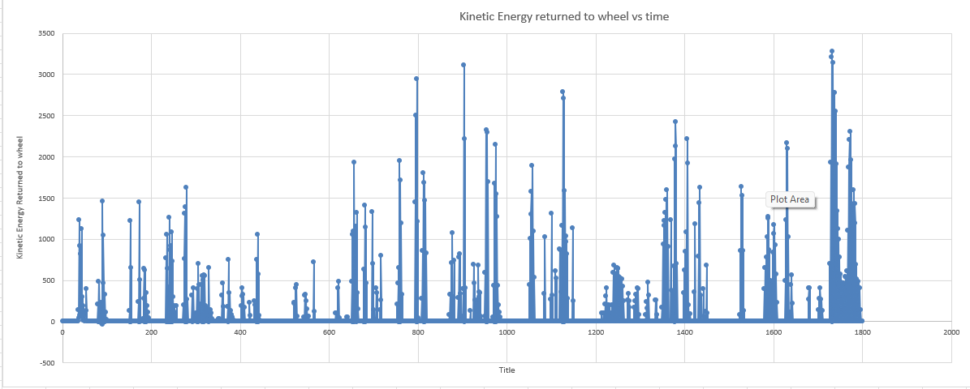
This graphs show energy peaks during the braking and drops when the vehicle is accelerating.

- Explain how the system operates, assumptions made and variations that the driver may feel, when compared to the conventional ICE and friction brake vehicle.

KER system: (Kinetic energy recovery system (no date)

In a conventional vehicle, the braking system provides high amounts force to the wheel, causing it to reduce its kinetic energy and turning it into heat energy. This heat energy is wasted as the vehicle has no use for it. The KER system works by storing part of the kinetic energy during breaking that would have been wasted, to use later during acceleration. This helps the vehicle become more efficient as it reduces fuel consumption while also reducing the work the engine must do. The KER system is only put to work when the vehicle is braking, meaning it is more useful for vehicles which will be used in urban areas. This is because more braking and stopping is done in urban areas compared to motorways making the KER system more effective. The amount of energy the system can capture depends on the capacity of the battery. Once the capacity has been reached, traditional friction brakes are required so that the batteries aren’t overloaded.

When driving a vehicle with KERs, the driver will feel a power boost when accelerating. This differs to a normal ICE as now a battery is also providing power to the vehicle. The new source of power will allow the engine to work less when needing to accelerate, which will with the fuel consumption. This will also reduce emissions, which is important for the future as many urban areas have emission zones, fining vehicles whose emissions exceed a limit.

For this assignment we assumed that the rolling resistance coefficient and aerodynamic coefficient are constant. In real life applications these values may vary but for the purpose of the assignment and calculations, they are kept as constants.

Conclusion:

For this assignment we researched data on a chosen vehicle to calculate the potential advantage, a Kinetic Energy Recovery system will bring to the vehicle. By calculating values such as, total tractive force, tractive power and cumulative tractive and braking energy, it allows for the potential of the KER system to be evaluated. With this data, we can see the power that the vehicle is wasting while braking instead of using it to its advantage. For my KER system I chose the electro-mechanical system as it had a high efficiency while maintaining a low weight which is fundamental for my chosen vehicle.

References:

Batalha project (2009) Vehicle Suspension Project. Clemson University. Available at: https://cecas.clemson.edu/cvel/auto/AuE835_Projects_2009/batalha_project.html

Engine in Detail (no date) Ford GT 2017 – Specs, Review & Tests. Available at: https://www.engineindetail.com/pa/ford-gt-2017

Ford (2017a) 2017 Ford GT Technical Specifications (EU). Available at: https://media.ford.com/content/dam/fordmedia/Europe/en/2017/05/gt_technical_specs_EU.PDF

Ford (2017b) 2017 GT Technical Specifications. Ford Racing. Available at: https://www.fordracing.com/content/dam/fordracing/enthusiasts/Media%20Room/2017/01/2017_GT_Tech_Specs.pdf

Kinetic energy recovery system (no date) Kinetic energy recovery system – Overview. ScienceDirect Topics. Available at:
https://www.sciencedirect.com/topics/engineering/kinetic-energy-recovery-system

Mustang6g.com (2017) 2017 GT350R vBox Results. Available at:
https://www.mustang6g.com/forums/threads/2017-gt350r-vbox-results.81318/

Racecar Engineering (no date) Flywheel Hybrid Systems (KERS). Available at:
https://www.racecar-engineering.com/articles/f1/flywheel-hybrid-systems-kers/

MDPI (no date) A Priority System for KER. Available at:
https://www.mdpi.com/2624-8921/5/2/22

