

Module name: Change-makers: Building your Personal Brand for Sustainable Employment
Module code: BMHP5015
Student name: Jamila Zakari
Student ID: 2322381
Lecturer’s name: Caroline Salami

Introduction
This assignment reflects on my learning and development throughout four units of the module: Unit 1 Brand You, Unit 2 It is a Small World, Unit 3 Opportunity Knocks, and Unit 4 The Pursuit of Happiness. The assignment explores how each unit developed my understanding of personal branding, global connections, professional opportunities, and wellbeing. I will critically reflect on how the knowledge and skills gained from these units have influenced my personal and professional development and how I can apply them to my future career in health and social care. Reflection allows individuals to examine their experiences, identify learning, and use this understanding to improve future practice (Gibbs, 1988).
Reflecting on these three key concepts from Unit 1: personal branding, emotional intelligence, and networking. It then considers how Unit 2 increased my awareness of globalisation and its impact on health and social care. Unit 3 focuses on recognising and creating opportunities for career development, while Unit 4 explores happiness, wellbeing, and personal fulfilment. Throughout the reflection, I connect my learning to relevant academic literature and consider how the module has contributed to my confidence, employability, communication, and future professional development.

Task 1 – Reflection on Unit 1: Brand You
Unit 1, Brand You, helped me understand that personal branding involves more than creating a good first impression. It involves communicating my values, strengths, skills, experiences, and professional identity to others. Before completing this unit, I viewed personal branding as something associated with businesses and social media. However, the lectures changed my perspective by showing me that I also have a personal brand that influences how others perceive me in academic, professional, and social environments.
One important concept I learned was self-awareness. Understanding my strengths and weaknesses has helped me recognise the areas I need to improve as I develop my career in health and social care. For example, I identified communication, empathy, and active listening as strengths, while confidence in high-pressure situations is still an area for development. Goleman (1998) argues that self-awareness forms an important part of emotional intelligence because it enables individuals to understand their emotions, strengths, limitations, and behaviours. This encouraged me to become more honest about my development needs rather than avoiding areas where I lack confidence.
The second concept was emotional intelligence. I learned that professional success depends not only on technical knowledge but also on how effectively I understand and manage my emotions and respond to other people. Goleman (1998) highlights the importance of emotional intelligence in developing effective relationships and workplace performance. This is particularly relevant to health and social care because professionals work with individuals who may experience distress, vulnerability, or difficult circumstances. Developing emotional intelligence will therefore help me communicate with service users and colleagues more effectively.
The third concept was networking and personal visibility. I learned that building professional relationships can create opportunities for learning, collaboration, mentoring, and employment. Networking is particularly important in modern careers because professional development increasingly depends on relationships and the ability to communicate one’s skills and interests (Capela, 2021). I now understand that I should actively develop professional relationships rather than waiting for opportunities to appear.
Unit 1 changed how I view myself as a developing professional. I now recognise that my personal brand should reflect authenticity, professionalism, empathy, and my commitment to health and social care. I will continue developing my communication and confidence so that my personal brand reflects the professional I want to become.

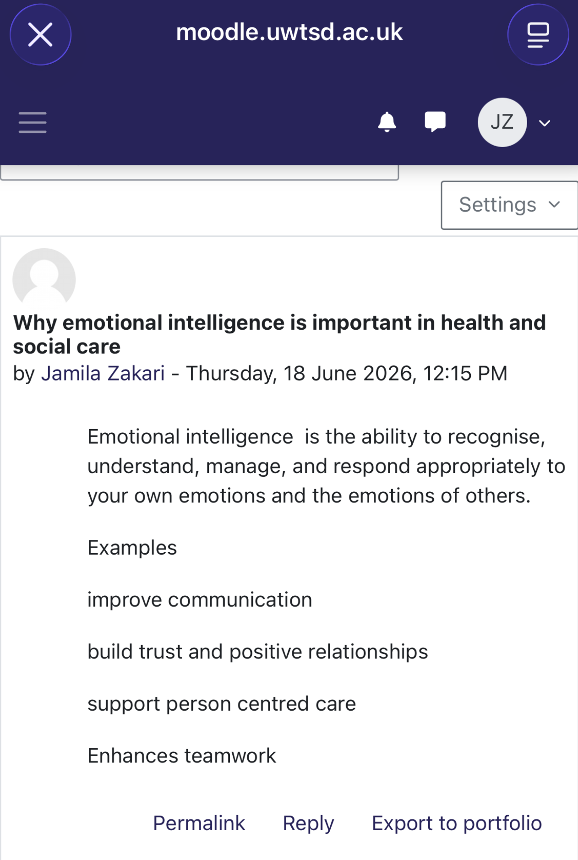
Screenshot one- Reflects on understanding and managing my emotions and responding to other people.

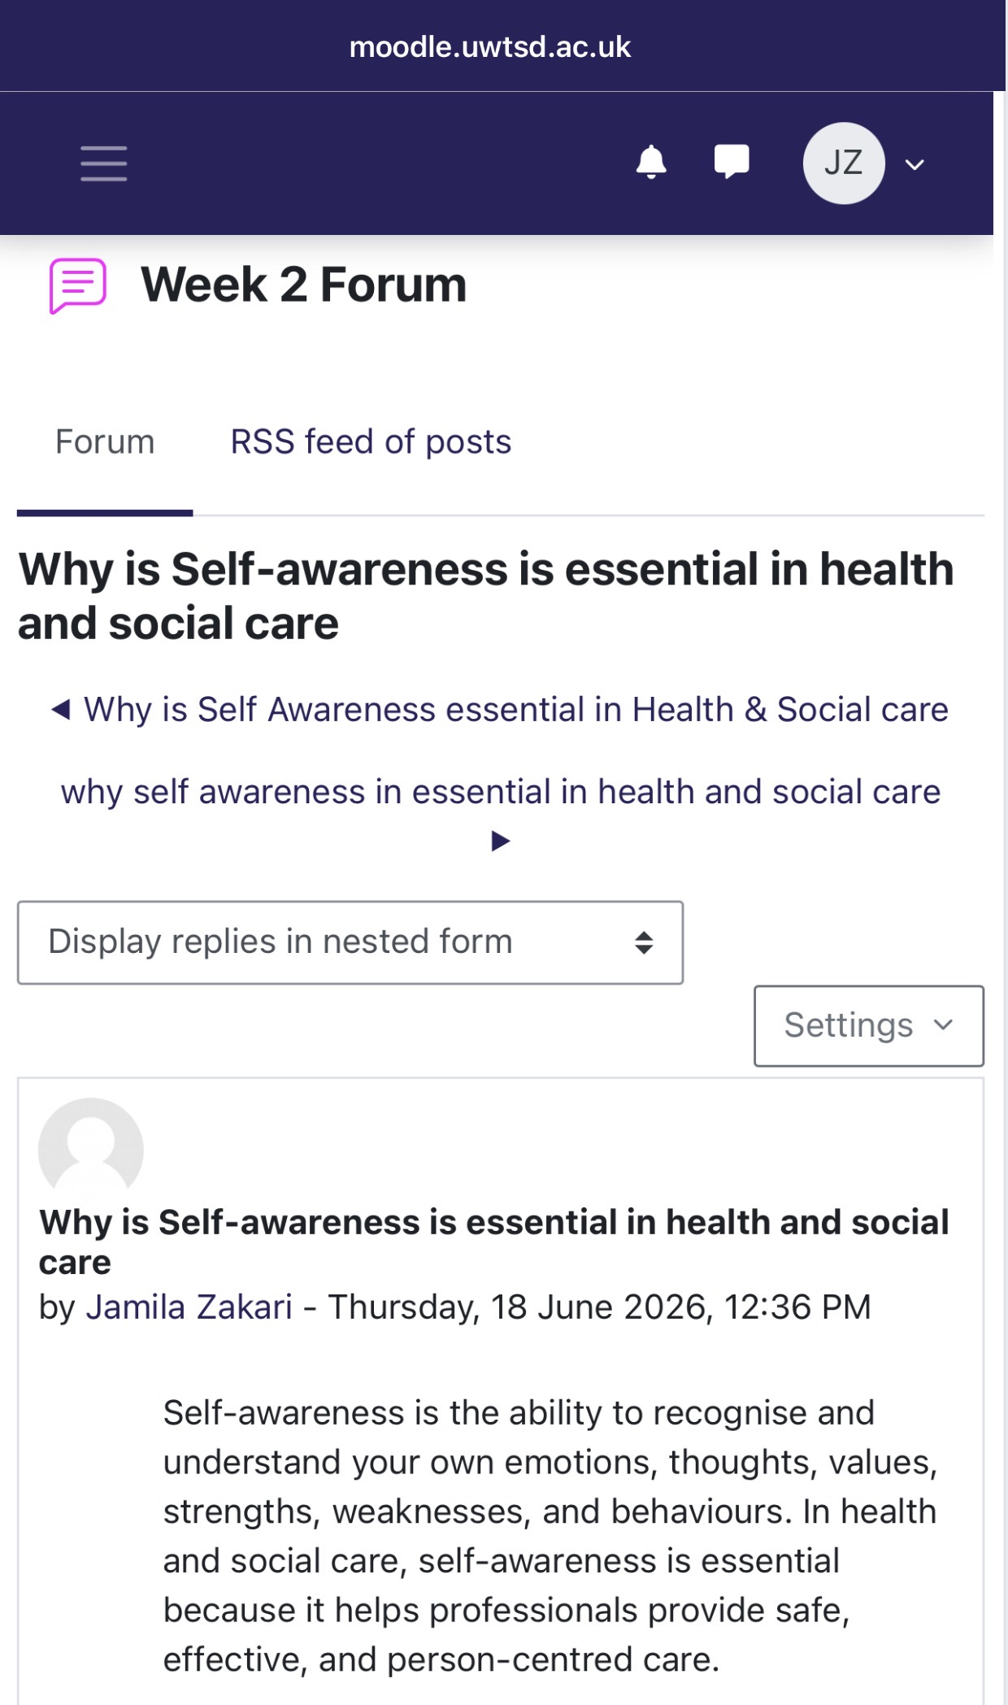
Screenshot two - Reflecting on this unit, I now recognise that I can create opportunities by being proactive.

Task 2 – Reflection on Unit 2: It’s a Small World
Unit 2, It’s a Small World, developed my understanding of how interconnected the world has become and how global changes can influence health and social care. The unit explored themes such as globalisation, cultural diversity, international connections, and the movement of people, knowledge, and resources across countries. These topics encouraged me to consider health and social care from a wider perspective rather than focusing only on my local community.
One of the main lessons I gained was the importance of cultural awareness. Health and social care professionals work with people from diverse cultural, social, and religious backgrounds. I learned that effective care requires professionals to recognise individual differences and avoid making assumptions about people’s beliefs or needs. The NHS (2023) emphasises the importance of providing inclusive services that respond to the needs of diverse populations. This helped me understand that cultural competence is essential for delivering respectful and person-centred care.
The unit also increased my awareness of global health inequalities. Health outcomes differ significantly between populations because of factors such as socioeconomic conditions, access to healthcare, education, and the wider determinants of health. The World Health Organisation (WHO, 2023) explains that social and economic conditions have a significant influence on people’s health and wellbeing. This made me reflect on how factors outside an individual’s control can affect their ability to access healthcare and achieve positive health outcomes.
Another key area was globalisation and the health and social care workforce. The movement of healthcare professionals between countries shows how interconnected health systems have become. This made me recognise the importance of working effectively with colleagues from different backgrounds and respecting diverse perspectives. It I will also remain open to learning from people whose experiences and backgrounds differ from my own.
Unit 2 broadened my understanding of health and social care. I learned that effective practice requires a global outlook, cultural awareness, and an understanding of health inequalities. In my future career, I will use this knowledge to provide respectful, inclusive, and person-centred care. I will also remain open to learning from people whose experiences and backgrounds differ from my own.

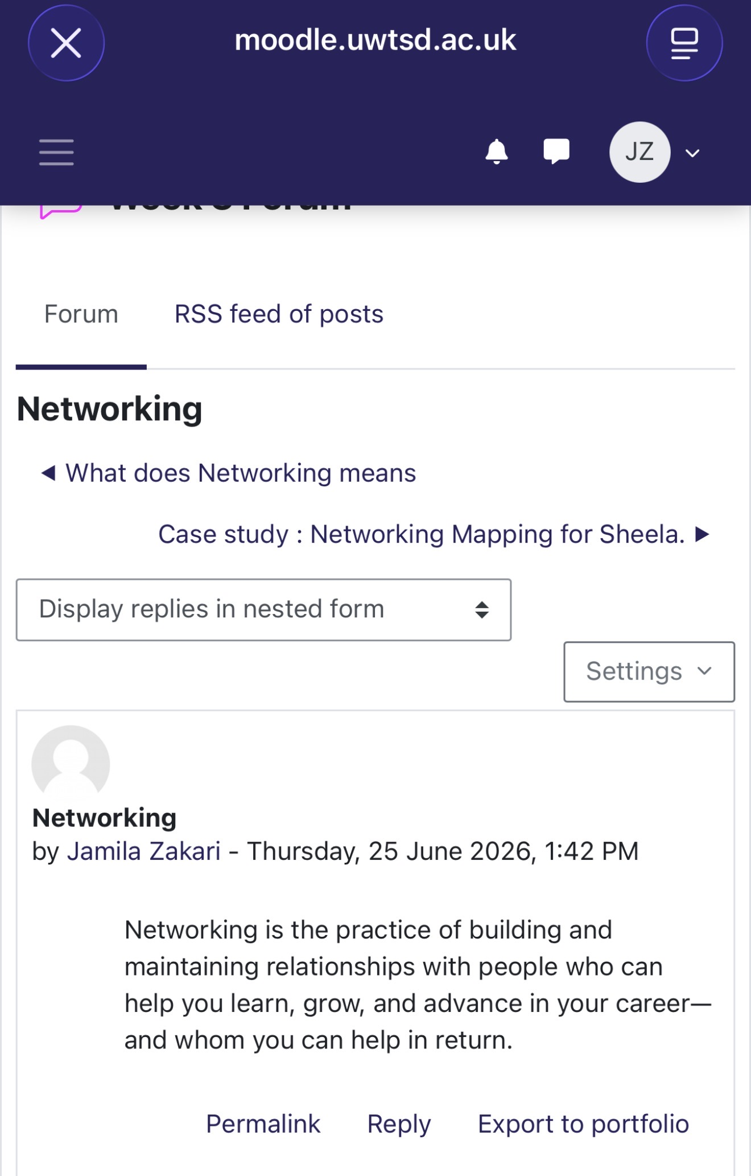
Screenshot one- Reflection: I will remain open to learning from people whose experiences and backgrounds differ from my own.

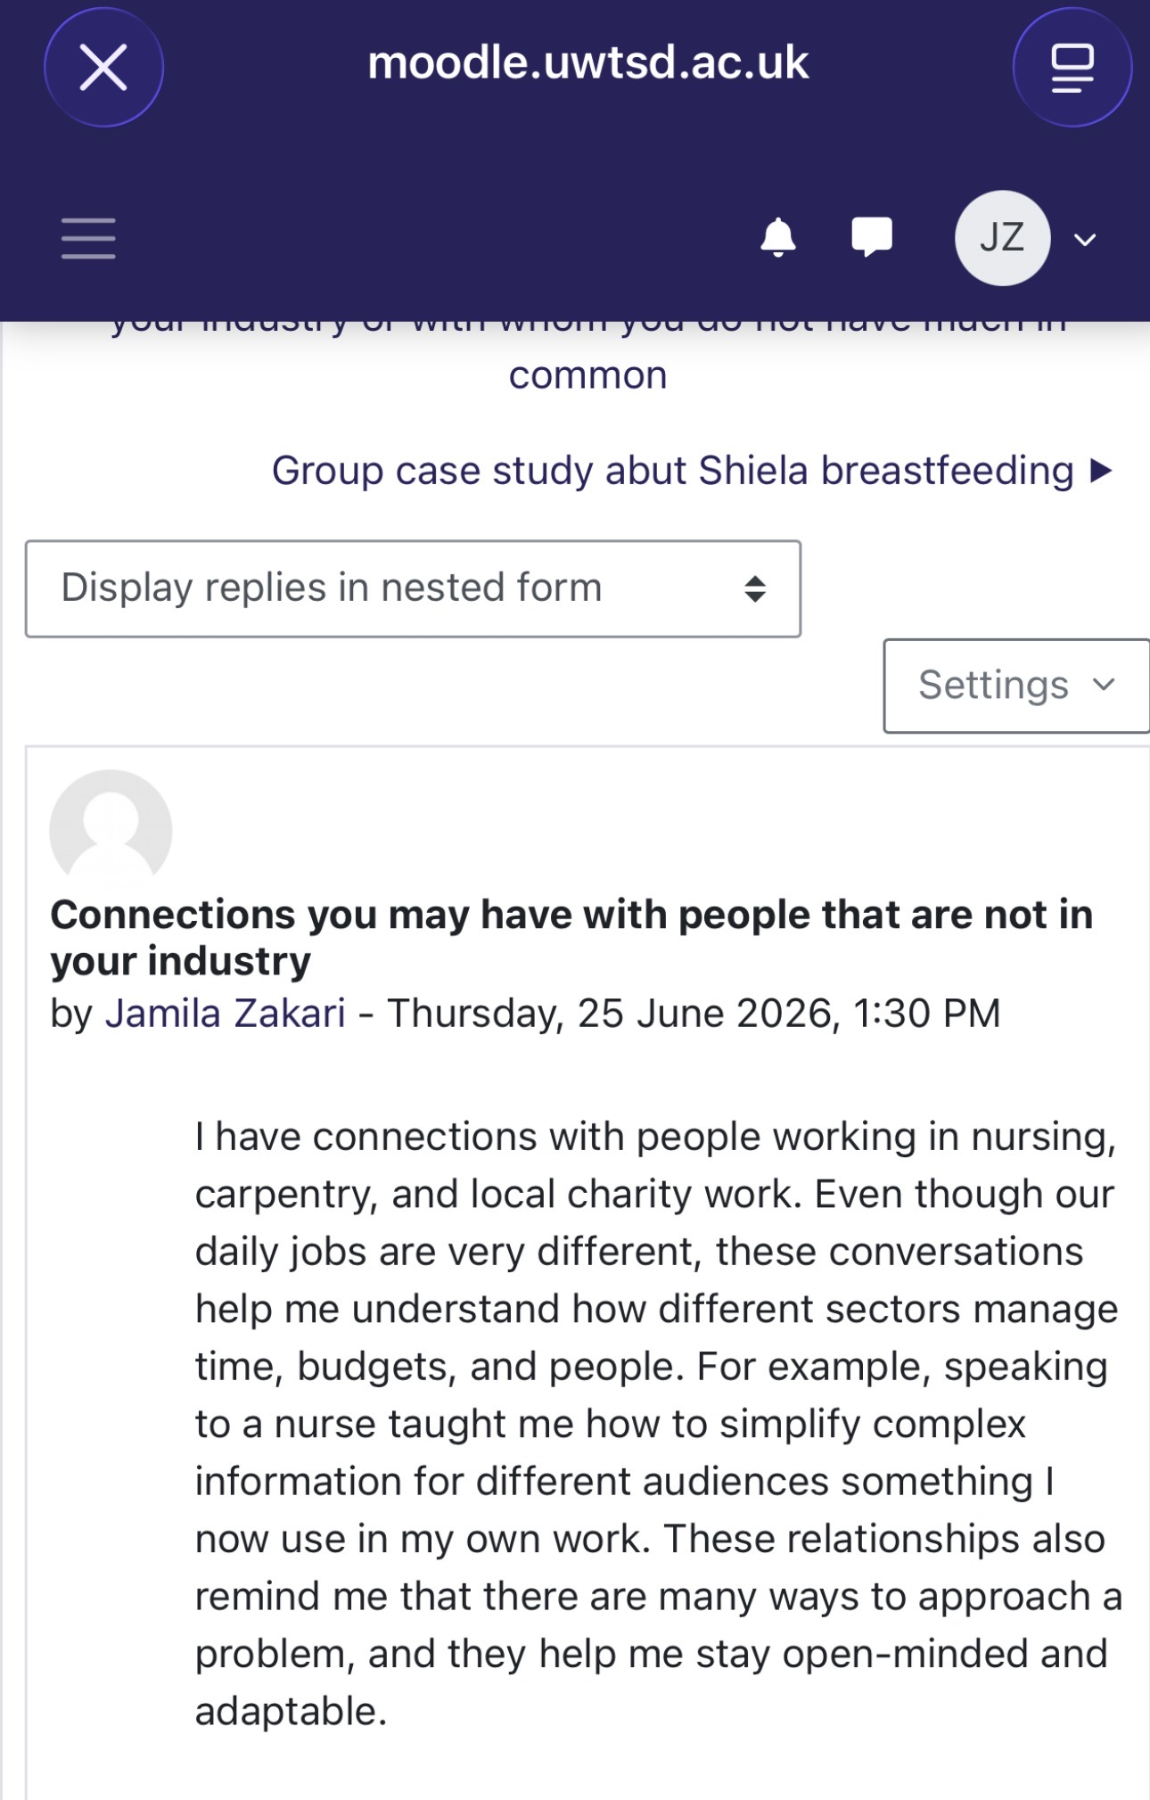
Screenshot two- Reflection: The movement of healthcare professionals between countries shows how interconnected health systems have become.

Task 3 – Reflection on Unit 3: Opportunity Knocks
Unit 3, Opportunity Knocks, helped me understand that career opportunities do not always happen automatically. I need to recognise opportunities, prepare for them, and take positive action. The unit explored topics related to employability, career development, networking, personal development, and identifying opportunities. These topics encouraged me to take greater responsibility for my future career in health and social care.
One key area I learned was the importance of employability skills. Employers look beyond academic qualifications and value communication, teamwork, problem-solving, adaptability, and professionalism. The World Economic Forum (2023) finds skills such as analytical thinking, resilience, flexibility, and lifelong learning as increasingly important in the changing world of work. This encouraged me to reflect on the skills I already possess and those I need to strengthen.
The unit also helped me understand the importance of networking in career development. I learned that networking could help me build relationships with professionals, discover opportunities, gain advice, and increase my awareness of different career pathways. Capela (2021) highlights the importance of developing professional relationships and personal visibility when building a career. I therefore recognise that I should actively take part in professional activities, engage with others, and seek opportunities to learn from experienced professionals.
Another important lesson was the value of continuous professional development (CPD). Health and social care is constantly changing, so professionals must continue developing their knowledge and skills. The Health and Care Professions Council (HCPC, 2023) emphasises the importance of keeping and developing professional knowledge and skills. This has encouraged me to view learning as an ongoing process rather than something that ends when I complete my degree.
Reflecting on this unit, I now recognise that I can create opportunities by being proactive. For example, I can improve my confidence through presentations, develop my communication skills, attend relevant training, seek work experience, and build professional networks. These actions will help me become more prepared for future employment and professional responsibilities.
Unit 3 encouraged me to take greater ownership of my career development. I now understand that opportunity requires preparation, confidence, and action. I will therefore continue to develop my skills and actively seek opportunities that support my long-term professional goals.
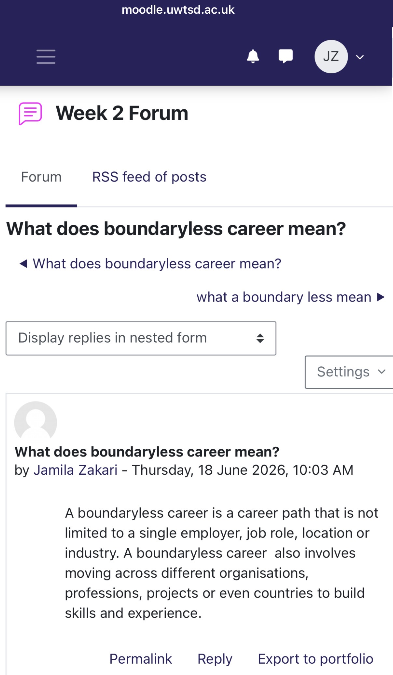

Screenshot one - Reflecting on this unit, I now recognise that I can create opportunities by being proactive.

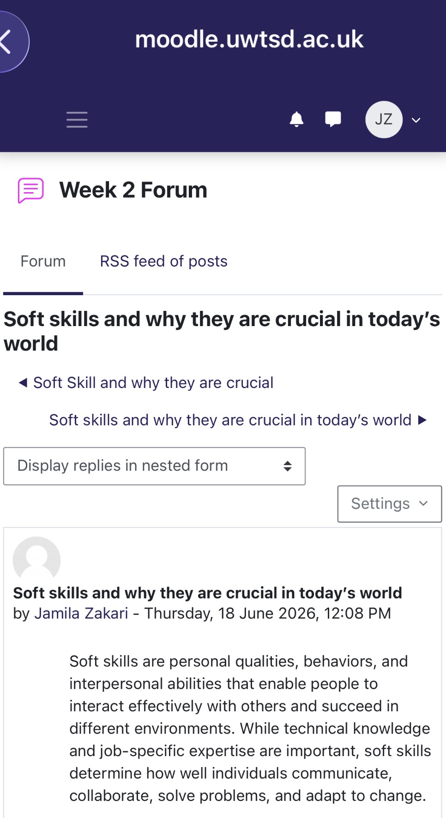
Screenshot two- Reflection: I will continue to develop my skills and actively seek opportunities that support my long-term professional goals.

Task 4 – Reflection on Unit 4: The Pursuit of Happiness
Unit 4, The Pursuit of Happiness, encouraged me to reflect on the relationship between happiness, wellbeing, personal values, and professional success. Before studying this unit, I often associated success with achieving career and academic goals. However, the unit helped me recognise that long-term success also requires keeping personal wellbeing and developing a healthy balance between professional responsibilities and personal life.
One important lesson was the importance of wellbeing and resilience. Working in health and social care can be emotionally and physically demanding. Professionals may experience stress, pressure, and challenging situations. The NHS (2023) highlights the importance of supporting staff wellbeing because staff health and wellbeing can influence both individual performance and the quality of care provided. This made me realise that I need to develop healthy strategies for managing stress and keeping my wellbeing throughout my career.
The unit also encouraged me to reflect on purpose and personal values. I learned that happiness is not simply about experiencing positive emotions but can also involve having meaning, purpose, and a sense of achievement. Seligman (2011) argues that wellbeing includes several elements, including positive emotions, engagement, relationships, meaning, and accomplishment. This perspective helped me understand that my future career should align with my personal values and desire to make a positive difference to people’s lives.
I also recognised the importance of work-life balance. As I progress in my career, I will need to manage professional responsibilities while protecting time for myself and my personal relationships. Keeping balance can support resilience and reduce the risk of burnout. This reflection has encouraged me to view self-care as a professional responsibility rather than something I should only consider when I feel overwhelmed.
Unit 4 helped me understand that personal and professional development are connected. Developing my career is important, but I also need to protect my wellbeing, keep meaningful relationships, and remain connected to my values. The unit encouraged me to think about the type of professional and person I want to become.

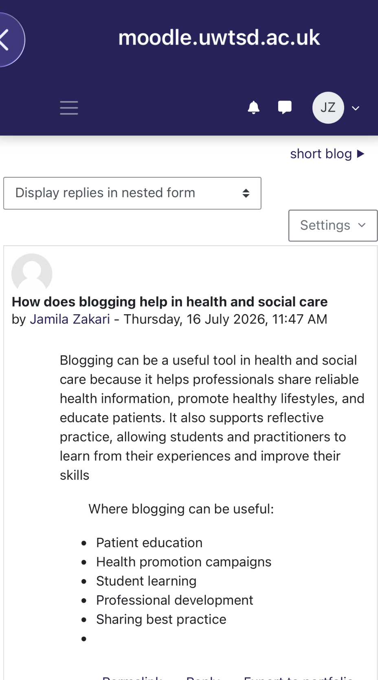

Screenshot one – Reflecting on promoting a healthy lifestyle
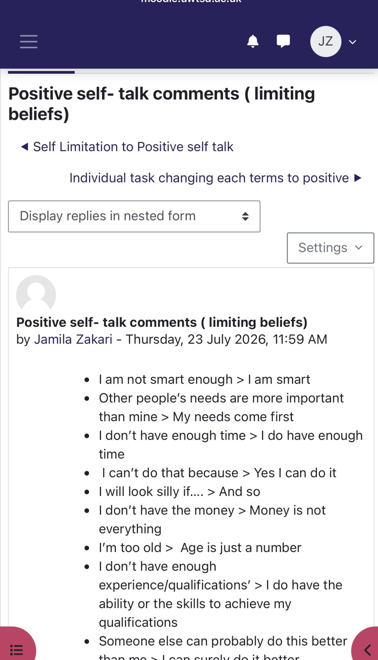

Screenshot two-Reflection: I also recognised the importance of work-life balance

Conclusion
In conclusion, completing this module has strengthened my understanding of the importance of personal and professional development within health and social care. Unit 1, Brand You, enabled me to explore self-awareness, emotional intelligence, personal branding, and networking. It helped me recognise my existing strengths while finding areas that require further improvement. Unit 2, It’s a Small World, increased my awareness of globalisation, cultural diversity, and health inequalities, highlighting the need to provide inclusive, respectful, and person-centred care. Unit 3, Opportunity Knocks, encouraged me to take greater ownership of my career development by improving my employability skills, developing professional networks, and recognising opportunities for lifelong learning. Finally, Unit 4, The Pursuit of Happiness, encouraged me to reflect on the importance of wellbeing, resilience, personal values, and achieving a healthy balance between work and personal life. This module has helped me become more reflective, confident, and prepared for my future career. I have learned that becoming a successful health and social care professional involves more than gaining academic qualifications. It also requires compelling communication skills, emotional intelligence, resilience, adaptability, and a willingness to continue learning. The knowledge and skills developed throughout the module will help me build effective professional relationships, manage future challenges, and contribute positively to the people I support. I will use this learning to develop into a compassionate, confident, reflective, and professional practitioner who can make a meaningful contribution to health and social care.

Reference
Capela, A. (2021) Building your brand for sustainable employment. (Module learning materials)
Gibbs, G. (1988) Learning by Doing: A Guide to Teaching and Learning Methods. Oxford: Oxford Polytechnic.
Goleman, D. (1998) Working with Emotional Intelligence. London: Bloomsbury.
Health and Care Professions Council (HCPC) (2023) Continuing professional development (CPD). Available through the HCPC website.
NHS (2023) Equality, diversity and inclusion. Available through the NHS website.
Seligman, M.E.P. (2011) Flourish: A New Understanding of Happiness and Well-being – and How to Achieve Them. London: Nicholas Brealey Publishing.
World Economic Forum (2023) The Future of Jobs Report 2023. Geneva: World Economic Forum.
World Health Organisation (WHO) (2023) Social determinants of health. Geneva: World Health Organisation.

