Module Code: BMIH4005
Module Title: Marketing Essentials
Student Name:Ionela Lacramioara Balta
Student ID:2208099
Lecture’s Name:Luciana Suardi
Table of Contents
Introduction 3
Situation analysis 3
Company 3
Customers 4
Competitors 4
Collaborators 5
Climate 5
Objectives 6
Strategy 6
Tactics 7
Action 8
Control 9
Conclusion 9
Reference List 10
Appendix 12
Identified opportunities in the market 12
Identified customer segments 13
Marketing plan 14
Implementation of the marketing plan 15

Introduction
In recent times the UK economy has gone through several disruptive factors such as the pandemic, Brexit, international political conflicts, the energy crisis, and more. These factors have a massive impact on the hospitality industry of the country. This marketing report has demonstrated a detailed marketing plan to leverage the disruption to improve profitability and revenue generation abilities for Premier Inn. It has further user SWOT, PESTLE, perceptual positioning map, 5C’s model and 4P marketing mix to develop a detailed marketing plan.

Situation analysis

Company
Strengths  - Largest hospitality brand in the UK  - Annual revenue of 307.4 million GBP in 2022 | Weaknesses  - Dealing with market disruptions due to the pandemic, Brexit, and demographic evolution  - Managing higher satisfaction levels within allotted budget
Opportunities  - Revenue per hotel room is estimated to reach 105% of pre-pandemic levels in 2023 | Threats  - Increased competition in limited service segment
Table 1: SWOT Analysis
(Source: Created by the learner)
Premier Inn is the largest British limited service hotel chain in the UK; the organisation is owned by Whitbread Plc which has several other hospitality organisations under them. The primary strengths of the organisation include its strong market position in the growing hospitality industry in the UK. Furthermore, the organisation has also rebounded from the pandemic losses and generated 307.4 million GBP annual revenue in 2022 (Premier Inn, 2023). However, Premier Inn has been facing certain challenges in adapting to the disruptions in the market caused by the pandemic, Brexit, and the changes in the demographic. However, as market estimation has stated, the UK hotel segment in the hospitality industry is going to increase by 105% pre-pandemic levels, which will help Premier Inn to deal with the disruptions (PricewaterhouseCoopers, 2022). Finally, increased competition and consumer retention are some of the most important threats in this industry.

Customers
A limited-service hotel mainly focuses on a few selected amenities and services; typically, a limited-service hotel excludes a full-service restaurant (Belarmino et al., 2022). This is one of the most effective methods of keeping prices low for consumers. Therefore, Premier Inn mainly targets families and business travellers looking for budget accommodation; within this segment, the organisation’s primary target is business travellers (Premier Inn, 2023). Using its detailed and comprehensive marketing strategy it has positioned itself as a limited-service hotel offering comfort and quality services.

Competitors
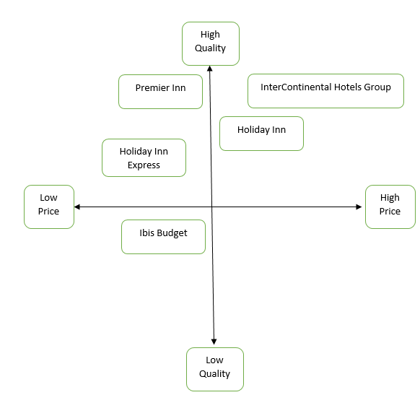
Figure 1: Perceptual Positioning Map
(Source: Created by the learner)
The perceptual positioning map helps in understanding and demonstrating an organisation’s position in the relevant market, and in context with its key competitors. As can be seen here the key competitors of Premier Inn are Holiday Inn Express which is also a limited-service budget hotel chain operating in the same industry, as well as Ibis Budget. In terms of luxury and high-price hospitality organisations Holiday Inn and InterContinental Hotel Groups are its primary competitors.

Collaborators
Premier Inn has developed several successful strategic partnerships within the tourism and hospitality industry; one of the most significant partnerships is with travel management companies and hotel booking agents. This type of business-to-business relationship helps the organisation to expand its target consumer groups, generate more revenue streams, and so on. ATPI is one of its most prominent business relationships; it is a travel management organisation specialising in the mining industry in the UK (ATPI, 2023). Premier Inn does not incorporate the franchise business model within its organisational framework, the properties of Premier Inn are owned by this brand, that further owned by Whitbread Plc.

Climate
Factors | Analysis
Political | Brexit and the recent Russia-Ukraine conflict have the highest impact on the UK’s political scene. Owing to Brexit several national and international policies have changed; for example, there are several more restrictions on the ability to work in the UK for non-EU nationals (Alberg and Granada, 2022). The international created a massive energy crisis, thereby increasing the energy costs for Premier Inn.
Economic | As of October 2022 the inflation rate in the UK is 10.5%; due to the continually increasing inflation rate, the organisation has also been forced to increase its prices. In 2023 Premier Inn is expecting a 60 million GBP increase in its costs (Sweney, 2022).
Social | The UK demographic is changing significantly with the ageing population; hence, customer trends have also evolved. Staycation is a significant trend in the hospitality industry, whereas business travel has decreased which is one of the primary revenue streams for Premier Inn (Khan et al., 2021).
Technological | The UK is witnessing several significant technological innovations; brands like Premier Inn can leverage the same to increase their competitive edge in the market. The organisation is known for its successful implementation of various technologies, such as touchless payments, instant booking through mobile applications, and more (Premier Inn, 2023).
Legal | The immigration policy changes have further contributed to the labour shortage. Therefore, especially the hospitality industry is witnessing a significant staff shortage, and Premier Inn is also facing challenges in recruiting talented employees.
Environmental | Premier Inn has a comprehensive environmental policy which adheres to necessary national policies regarding environmental sustainability, energy conservation, and more (Premier Inn, 2023).
Table 2: PESTEL Analysis
(Source: Created by the learner)

Objectives
Premier Inn has developed a specific business objective which will help it to retain its market position. The objective is to expand penetration in the UK and developing markets through acquisition and mergers in the next 2 years.

Strategy
In marketing value proposition refers to the complete value and economic benefits an organisation provides or promises to provide to its current and prospective consumers (Bowie et al., 2017). ‘Rest Easy’ is the organisational motto for Premier Inn, the goal is to simplify the process of booking, checking in, and enjoying the services and benefits effectively; using various technologies and digital methods it has made the process from booking to bed seamless for the consumers.
Providing payment plan options is one of the strategic innovations implemented by the organisation; flex, semi-flex, advance, standard, and non-flex are the types of payment plans offered to consumers (Premier Inn, 2023). The key flexibility here is the option to pay at arrival, cancel any time, and amend the bookings as well; for business travellers, these flexible payment options can be quite helpful as their plans may change even at the last moment. In the case of families looking for affordable accommodation, based on the rates offered they can adopt a specific payment plan, which also suits their schedule. The organisation already has an elaborate traditional marketing and promotional strategy in place with new television commercials, celebrity guests, and more. However, to further communicate the benefits of the business strategies, it can also leverage social media marketing, digital marketing, and video advertisements (Jobber and Ellis-Chadwick, 2019).

Tactics
Product - In a hospitality industry such as Premier Inn, there are two different types of offerings, both products and services (George, 2021). The hotel room itself and the available amenities can be considered products, and cleanliness, customer services, seamless booking, housekeeping and so on can be considered services. Segmentation is the key product strategy adopted by Premier Inn, it allows the brand to cater to different groups of consumers with the same products and services (Kotler et al., 2020). Through its varying payment plan, the organisation is able to target and cater to different consumer groups based on their income and spending abilities.
Price - Being a limited-service hotel, the organisation has adopted value-based pricing that lets the audience or the consumers pay the price they believe is right for the value being offered. It helps in creating a substantial amount of market share and develops consumer rapport (Smith and Zook, 2020).
Place - Being the largest limited-service hotel chain in the UK, there are over 800 hotels in the UK. The organisation specifically targets major city centres, and places closer to tourist attractions; the goal is to attract either tourists visiting these places or business travellers who are travelling to major business destinations (Premier Inn, 2023). Being located near the transport hubs also help the target consumers locate and reach its hotels near airports, bus stations, and so on.
Promotion - The primary promotional strategy includes using celebrities and television personalities to narrate the video advertisements to establish relatability and connection with the audience (Premier Inn, 2023). In addition to this, the organisation also needs to adopt comprehensive digital marketing strategies, establish a social media presence, and develop a community surrounding the brand.

Action
Actions | Week 1 | Week 2 | Week 3 | Week 4 | Week 5 | Week 6 | Week 7
Market research and data collection
Identifying new consumer groups
Developing communication strategy
Implementing new communication strategy
Gathering feedback and result
Table 3: Gantt Chart
(Source: Created by the learner)
The changes in the demographic and the disruptions in the hospitality industry is presenting Premier Inn with newer opportunities to target and cater to different consumer groups. Hence, the organisation needs to conduct thorough market research based on which new segments can be identified. After identifying the specific platforms to effectively communicate with them need to be identified; based on this plan the above Gantt chart has been developed.

Control
Digital and social media marketing provide access to a wide range of metrics to measure the success of the implemented strategies. Hence, to increase market share the organisation needs to improve brand awareness, conversions, as well as a social media presence. Alongside the financial reports of the organisation which show the expected increase in revenue and profitability, the number of social media followers, and website traffic can also measure the success of the communication plan (Chaffey and Ellis-Chadwick, 2019).

Conclusion
In conclusion it can be said that Premier Inn has successfully dealt with the challenges of intense disruptions caused by the pandemic, Brexit, political and economic instability, and technological advancements. The detailed and comprehensive marketing strategies of the organisation have helped in mitigating the challenges of a disruptive and unstable economy.
- Identifying the relevant social media platforms to communicate with its target consumers is necessary for a successful social media strategy.
- Using digital technologies such as chatbots, and AI for social listening and understanding evolving customer needs.

Reference List
Agrawal, S., De Smet, A., Lacroix, S. and Reich, A., 2020. To emerge stronger from the COVID-19 crisis, companies should start reskilling their workforces now. McKinsey Insights (Issue May).
Åhlberg, M. and Granada, L., 2022. The making of irregular migration: post-brexit immigration policy and risk of labour exploitation. Journal of Poverty and Social Justice, 30(2), pp.120-140.
ATPI. 2023. Business, Marine, Energy & Sports Travel Management | ATPI | ATPI. [online] Available at: https://www.atpi.com/ [Accessed 11 Feb. 2023].
Bankofengland.co.uk. 2022. Inflation and the 2% target. [online] Available at: https://www.bankofengland.co.uk/monetary-policy/inflation [Accessed 11 Feb. 2023].
Belarmino, A., Koh, Y. and Shin, H.H., 2022. Blurred lines: comparing room rates, star-ratings, and user-generated contents for full-service and select-service hotels. Service Business, 16(3), pp.721-742.
Bowie, D., Buttle, F.. Brookes, M., and Mariussen, A., 2017. Hospitality Marketing. 3rd ed, Routledge, London
Chaffey, D. and Ellis-Chadwick, F., 2019. Digital marketing. 7 thed, Pearsons, London.
George, R., 2021. Marketing tourism and hospitality: concepts and cases. Springer Nature.
Ghauri, P. N., 2014. International Marketing, 4 th Ed, McGraw Hill, London
Jobber, D. and Ellis-Chadwick, F., 2019. EBOOK: Principles and Practice of Marketing, 9e. McGraw Hill.
Khan, A., Bibi, S., Lyu, J., Latif, A. and Lorenzo, A., 2021. COVID-19 and sectoral employment trends: Assessing resilience in the US leisure and hospitality industry. Current Issues in Tourism, 24(7), pp.952-969.
Kotler, P. and Kartajaya, H. 2017. Marketing 4.0 Moving from Traditional to Digital. Wiley. New York.
Kotler, P., Armstrong, G., Harris, L.C. and He, H., 2020. Principles of marketing-Eight European edition. Harlow: Pearson Education Limited.
Premier Inn, 2023. About us. [online] Available at: https://www.premierinn.com/gb/en/why.html [Accessed 11 Feb. 2023].
Premier Inn, 2023. Book a hotel. [online] Available at: https://www.premierinn.com/gb/en/book-a-hotel.html?INTCMP=topNav [Accessed 11 Feb. 2023].
Premier Inn, 2023. Our rates. [online] Available at: https://www.premierinn.com/gb/en/why/rates.html [Accessed 11 Feb. 2023].
PricewaterhouseCoopers 2022. Hotels Forecast 2022 - 2023: Recovery stalls after strong rebound - PwC UK. [online] PwC. Available at: https://www.pwc.co.uk/industries/hospitality-leisure/insights/uk-hotels-forecast.html [Accessed 11 Feb. 2023].
Smith, PR. and Zook, ZE., 2020. Marketing Communications. 7th ed, Kogan Page, London
Sweney, M. 2022. Whitbread warns of £60m increase in costs due to inflation. [online] the Guardian. Available at: https://www.theguardian.com/business/2022/oct/25/whitbread-costs-increase-inflation [Accessed 11 Feb. 2023].

Appendix

Identified opportunities in the market
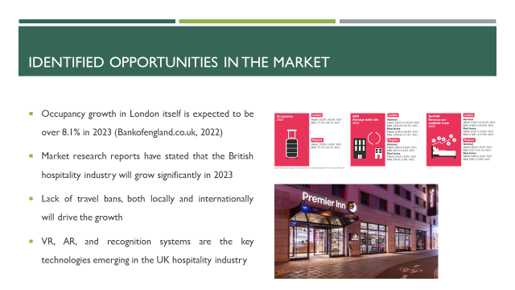
According to market research reports occupancy growth in London itself is expected to be over 8.1% in 2023 (Bankofengland.co.uk, 2022). Various market research reports have stated that the British hospitality industry will grow significantly in 2023 owing to the lack of travel bans, both locally and internationally. Furthermore, virtual and augmented reality is one of the emerging technologies used the most in the hospitality industry, as it allows consumers to have a better understanding of the rooms while booking. A recognition system comprising both fingerprint and face recognition allows for fast and seamless check-in and check-out, as well as touchless payments.

Identified customer segments
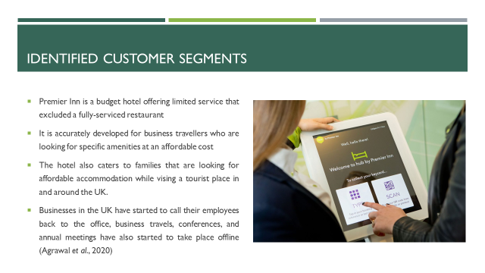
Premier Inn is a budget hotel offering limited service that excluded a fully-serviced restaurant; hence, it is accurately developed for business travellers who are looking for specific amenities rather than luxury. It also caters to families that are looking for affordable accommodation while vising a tourist place in and around the UK. As businesses have started to call their employees back to the office, business travels, conferences, and annual meetings have also started to take place offline (Agrawal et al., 2020). The brand needs to start catering to these segments however, as their needs have changed, the communication approach also needs to improve.

Marketing plan
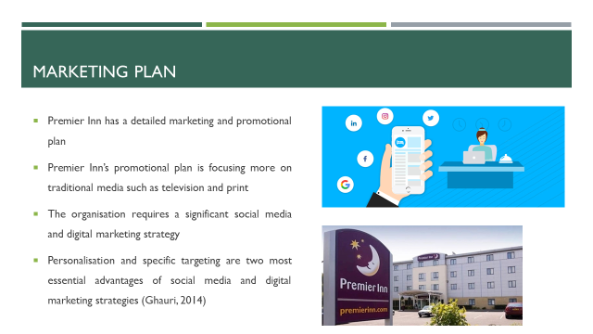
The organisation has a detailed marketing and promotional plan; however, currently, it is focusing more on traditional media such as television and print. The organisation requires a significant social media and digital marketing strategy. It will help in targeting a wider range of audiences and make the strategies more relevant by targeting and personalising the message for each consumer (Ghauri, 2014). AI and IoT currently exist in every piece of digital technology which continue to make the business process faster. Premier Inn needs to implement the same within its website to attract new consumers.

Implementation of the marketing plan
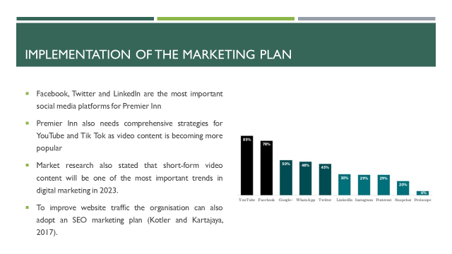
Facebook, Twitter and LinkedIn are some of the most frequented social media platforms by the target consumer groups of Premier Inn. Alongside these platforms, Premier Inn also needs comprehensive strategies for YouTube and TikTok as video content is becoming more popular. The market research also stated that short-form video content will be one of the most important trends in digital marketing in 2023. Furthermore, to improve website traffic the organisation can also adopt an SEO marketing plan, which drives traffic from various sources, using different tools (Kotler and Kartajaya, 2017).

According to market research reports occupancy growth in London itself is expected to be over 8.1% in 2023 (Bankofengland.co.uk, 2022). Various market research reports have stated that the British hospitality industry will grow significantly in 2023 owing to the lack of travel bans, both locally and internationally. Furthermore, virtual and augmented reality is one of the emerging technologies used the most in the hospitality industry, as it allows consumers to have a better understanding of the rooms while booking. A recognition system comprising both fingerprint and face recognition allows for fast and seamless check-in and check-out, as well as touchless payments.

Premier Inn is a budget hotel offering limited service that excluded a fully-serviced restaurant; hence, it is accurately developed for business travellers who are looking for specific amenities rather than luxury. It also caters to families that are looking for affordable accommodation while vising a tourist place in and around the UK. As businesses have started to call their employees back to the office, business travels, conferences, and annual meetings have also started to take place offline (Agrawal et al., 2020). The brand needs to start catering to these segments however, as their needs have changed, the communication approach also needs to improve.

Slide 5

The organisation has a detailed marketing and promotional plan; however, currently, it is focusing more on traditional media such as television and print. The organisation requires a significant social media and digital marketing strategy. It will help in targeting a wider range of audiences and make the strategies more relevant by targeting and personalising the message for each consumer (Ghauri, 2014). AI and IoT are currently existing in every piece of digital technology which continue to make the business process faster. Premier Inn needs to implement the same within its website to attract new consumers.

Facebook, Twitter and LinkedIn are some of the most frequented social media platforms by the target consumer groups of Premier Inn. Alongside these platforms, Premier Inn also needs comprehensive strategies for YouTube and Tik Tok as video content is becoming more popular. The market research also stated that short-form video content will be one of the most important trends in digital marketing in 2023. Furthermore, to improve website traffic the organisation can also adopt an SEO marketing plan, which drives traffic from various sources, using different tools (Kotler and Kartajaya, 2017).

