Introducing the modern workplace

Assignment 1
Organizational structure and Culture

Student name: Rosca Ana Diana
Student ID: 2020311
Date: 06.09.2021

Table of Contents
Introduction 3
Organizational structure and organizational performance-Literature review 4
Tesco Profile 4
Tesco business model mission, vision and values 5
Tesco organizational structure.……………………………………………………………………………………………………………….6
Tesco organizational culture…………………………………………………………………………………………………………………...8
Tesco’s role of leadership staff motivation and performance management … .10
Tesco -Factors that influence individual behavior at work…………………………………………………………………….11
Application of different motivation theories within the workforce………………………………………………………..11
Conclusion………………………………………………………………………………………………………………………………………….…14
References …………………………………………………………………………………………………………………………………………...15

Introduction

The scope of this report is to address how the organizational structure and the company’s culture influence the organizational performances at TESCO. Also, based on behavioral approach this report will show how different factors can influence individual behavior at workplace.
Throughout this report we will first analyze the relationship between structure, culture people and organizational performance. Secondly, we will attempt to identify the essential nature of managerial work and explain the variables that determine TESCO effective management and leadership. Last, this report is set to show an understanding of what are the factors affect differences in individual behavior and evaluate that behavioral approach to management.
This report will show that undoubtedly, the organizational structure influences the culture of the organization. The structure of TESCO portrays the prescribed relationships between tasks, between departments and the workflow. Their structure also defines how activities like task allocation or supervision are focused on achieving the company’s goals and trough it’s perspective it is how individuals see their company and its environment.

Organizational structure and organizational performances-Literature review

Over the last decades organizations have changed their views over the way they should be structured and managed. Chandler’s theory of organizational structure was concerned with the universal principles of organizational design. The contingency theories from the 1970s claimed that there is not just a single approach that is heathier, and that organizational design should be adapted to the contextual necessities (Chandler, A.D;, 1962)
Organizational theorists defend the idea of an organic flow, which calls for a necessary shift in organizational structure from hierarchies to networks (Kenis, et al., 2009). The traditional organizational structures don’t offer on the request for quickness and elasticity when dealing with contexts that are quickly changing. The organization structures capable of promoting innovation are those which stimulate learning, knowledge-sharing, problem-solving groups and job rotation (Aleksić & Jelavic, 2017)
The organizational structure of a company is highly important because some of its elements are highly important when it comes to the company’s productivity and work relations between colleagues. There are studies that shows us that the organizational design of a company has an effect over its innovation factor and attributes like flexibility and freedom or opportunity for collaboration promote creativity (Kenis, et al., 2009). Opposed to that factors, firmness or higher degrees of correction tend to negatively affect the process of innovation and inventiveness.

For innovation to occur, leaders should create conditions for their employees in order to improve individual performance. The employee’s attention should be directed towards the creation of new products, processes and services crucial to the firm’s survival (Lambert, 2016)

Tesco Profile
Tesco is a retail company founded in 1919 headquartered in Walwyn Garden City, Hertfordshire, the UK. They are engaged in the business of Retailing and associated activities and Retail banking and insurance services. (Reuters, 2021)
The major reason for their success is the fact that Tesco’s corporate strategy focuses on delivering quality products at cheap prices and they believe in contributing to the social wellbeing of their customers (TESCO, 2016). Tesco has now over 3000 stores in UK only, raging from Extra-large Hypermarkets to small Tesco Express stores. If their business started in 1919 with selling groceries from a stall, they have now diversified and their products range from grocery to general merchandise to banking services, insurance services as well as electronic or telephone equipment. They employ more than 367,300 people across the world, and they have over 7000 stores worldwide (Global Data, 2021).
The group sales of TESCO PLC have reached £5.65 bn in 2020 with an operating profit of £2.959m. The retail cash flow has been reported around 132% with a value of 2.063m. (Tesco, 2021)
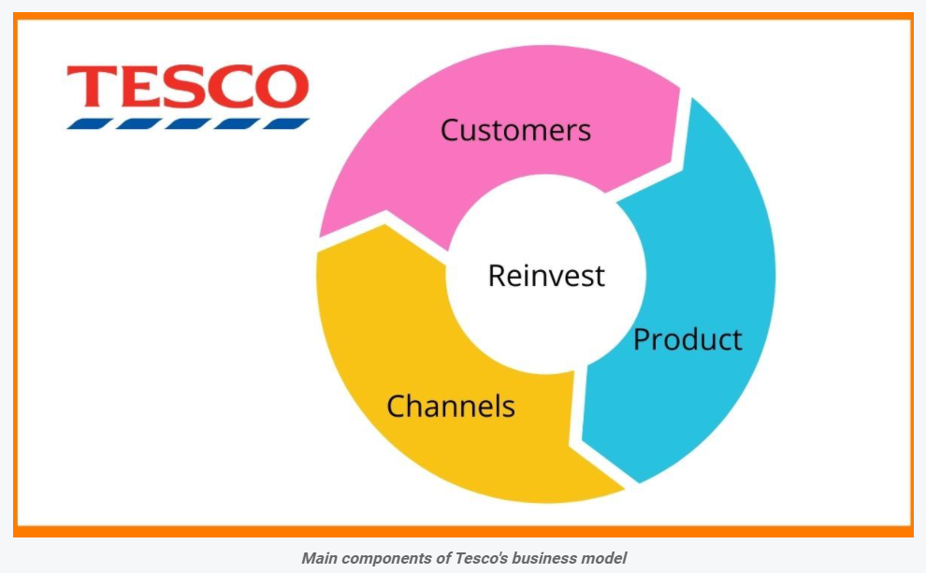

Tesco business model -mission vision and values
Tesco describes their business model as straightforward and it focuses on four core activities: customers, products, channels and reinvestments. Their aim is to gain insight into what their customers want and to better understand their needs. Only understanding their customers’ needs will they be able to sell and distribute the company products. (Tesco, 2021)
Tesco’s motto is “Serving shoppers a little better every day” and their mission is simple, to be the leader for their customers by making their life easier and improving their quality of life. They put this into practice by following these values:
There is no one that tries harder than them for customers- to understand their needs so that they can be first to achieve them and to act in a responsible manner for their communities.
Treat people how they want to be treated- they value solidarity, they value trust and respect and also sharing the knowledge and experience.
Every little step makes a great difference.

Tesco Organizational structure

Tesco has a hierarchical structure. It is a functional structure that has its focus on the different departments of the business. They adopted this structure because they are a large organization with multiple layers within. As its can be observed in the figure below, The Tesco Corporate Governance structure, the organizational structure of the company is complied of 5 comities: Audit, Corporate Responsibility, Nominations, Remuneration and Disclosure and they all report to the Tesco PLC Board.
The scope of the board is to obtain long term success for the business as well as long term returns for the shareholders. They have to keep high standards of corporate governance and to ensure that their decision-making process is transparent.

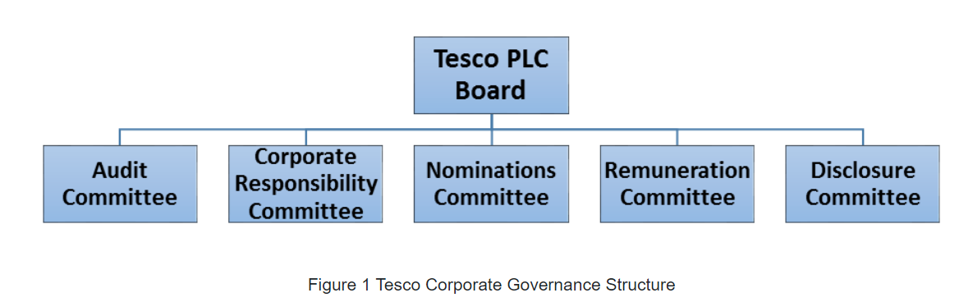

Because it must function at a very high level, Tesco requires a strong support management. As most of the international multicompanies, Tesco follows a management system that ensures that the company functions in a smooth and efficient mode from base to top level. (Hierarchy Structure , 2021). Although somehow traditional, this structure allows them to better define the roles for everyone ensuring the fact that there is no confusion created
Tesco employees over 3607,000 of people across the world and it would be impossible for one person to keep an eye on all of them which is the reason for which they use the hierarchical structure. In this way they lead different countries, different stores and different people.
Considering the large size of the business, even in store level we can observe the same hierarchical structure with different levels of management as we can observe in the figure below.

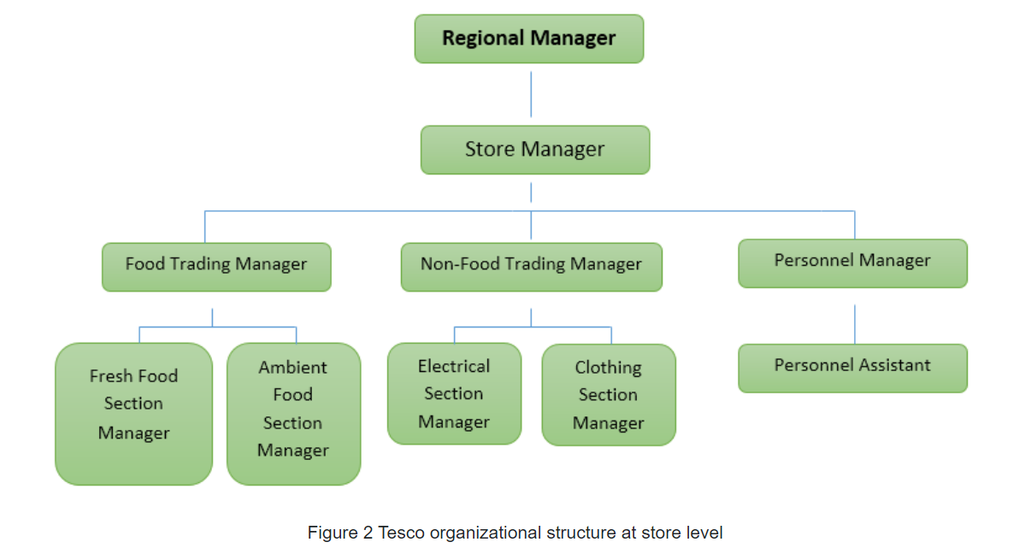
It is though, very important to mention the fact that this structure is one that can differ, and it is not a rigid one for all Tesco stores. Some stores operate in a slightly different structure and this depends on, multiple factors such as store location, store size or other specific factors. This happens so that there won’t be any problems with coordination or so that miscommunication or gaps between top and bottom people is cut.
Tesco organizational culture
“Organization behavior is concerned with the study of the behavior of people within an organizational setting. It involves the understanding, prediction, and control of human behavior” (Mullins, 2010)
As reviewed by Mullins in 2010 there are four types of organizational cultures.
Power Culture – the power is concentrated at a high level and it’s controlled like a net.
Role Culture – it has a well-defined design, and It is more based on the power of the person who delegates
Task Culture – the power is controlled by a small team that has their own area of proficiency
Person Culture – it is generally formed when and individual considers himself superior to the organization and it can operate well in some professional partnerships.

Tesco PLC is a company that flourishes on a tall organization structure. All the employees are supervised closely, and the control is quite tight. There is a manager for each small number of employees and as it can be seen in the figure below its extended structure, management structure and responsibilities of each manager are clear and defined. The benefit of this type of organization is that success can be clearly observed and the stepladder for promotion or rewards is clear.

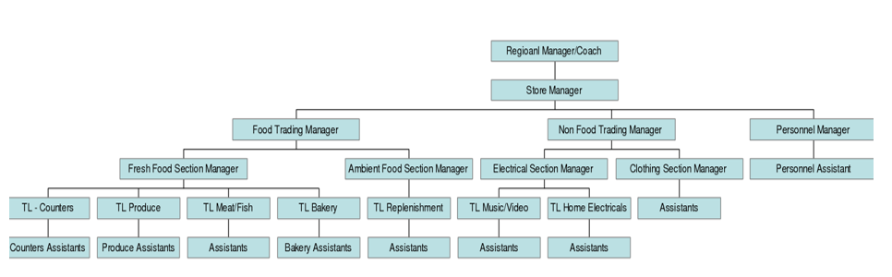

Tesco has adopted the task culture because of its business. The company is slow in adapting a change. Tesco are employee centric and encourage a culture where employees can contribute with their thoughts, they can participate rather than being passive. Additionally, their focus is on high customer satisfaction and providing the best quality services. But even so, because of their type of business the emphasis is not that high on creativity and innovation. Their customers tend to expect uniform practices so that a more even service level is ensured. Taking this into consideration Tesco’s employees are not provided with a great level of independence. Tesco has adopted the Task culture due to its nature which leads to a low level of motivation
They employ a democratic style of management and consider the following processes to be critical when it comes to performance management:
Clear recognition for those individuals that perform at a high level
A system of performance that does consider the individual strengths
An assessment process that is to be transparent and clearly presented across all workforces
Performance goals that can be achieved are that are in alignment with the company’s strategic goals
Recognition not only for the results that people bring in but also for the values and behaviors that build those results
They have a steering wheel with balance scorecard that consists of five perspectives which are followed by two goals (Marr, 2018):
Responsibility and Honesty
Save time and Money

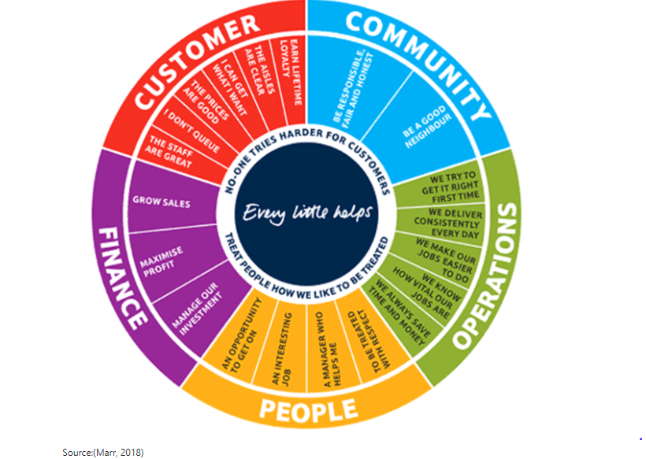

Tesco’s role of leadership in staff motivation and performance enhancement

We can define leadership as the ability to influence or motivate a group of individuals so that we can achieve the set goal for the growth and development of the organization Invalid source specified... Being a retail business, they need to be able to grasp changes in a resourceful manner and adapt to the market tendencies in a flexible manner.
The style of leadership that is more suitable to Tesco is the situational leadership. They can not give their employees more independence as they are constricted in certain aspects and cannot completely lead them in a transformational style. The situational leadership consist of 4 factors such as selling, telling, delegating and participating. It is mainly used for collaborative working among the employees of the company Invalid source specified..

Tesco- Factors that influence individual behavior at work
Tesco PLC believes “Everyone welcome” and believes that if a person is passionate, determined, ambitious, dedicated, enthusiastic and devoted than they can work with Tesco PLC. They are certain that any individual with those characteristics can work with them after they graduate and follow their training and development program.
On as different note, the employees tend to be a bit more introverted because of the company’s task culture. The perception is that employees feel obliged to their tasks. Their approach follows the theory X of McGregor that states that the average person is lazy and has an inherent dislike of work
The lack of support given by Tesco to their employees has made them stressed and less motivated at work. Stress is mainly caused when a wrong person is recruited to a wrong job. It has been a challenge as these employees are supervised very closely and are not given any room to take decision on their behalf. The organizations culture is the main factor that influences the stress among the individual.

Application of different motivation theories within the workplace
According to Maslow’s Hierarchy of needs that can be observed in the image bellow, the human needs are arranged on level of importance. In his opinion people have needs that will increase based on what they have already obtained. The highest level on his hierarchy is Self-actualization and it comes when the lower-level needs are no longer motivating. (Corporate Finance Institute, 2020)
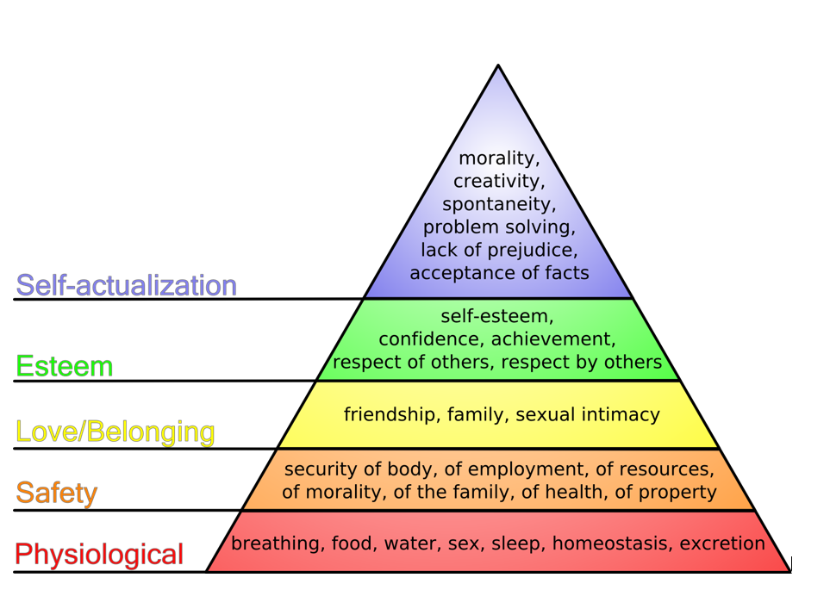
Another theory is Hertzberg’s two factor theory that proposes two factors: Hygiene factor and Motivation factor. His aim was that the lack of interpersonal relations, the company policy or the working conditions can create job dissatisfaction. The motivation factor makes up a range leading from no-satisfaction to satisfaction trough different factors like achievement, accomplishment and job inspiring. (Expert Program management , 2018)
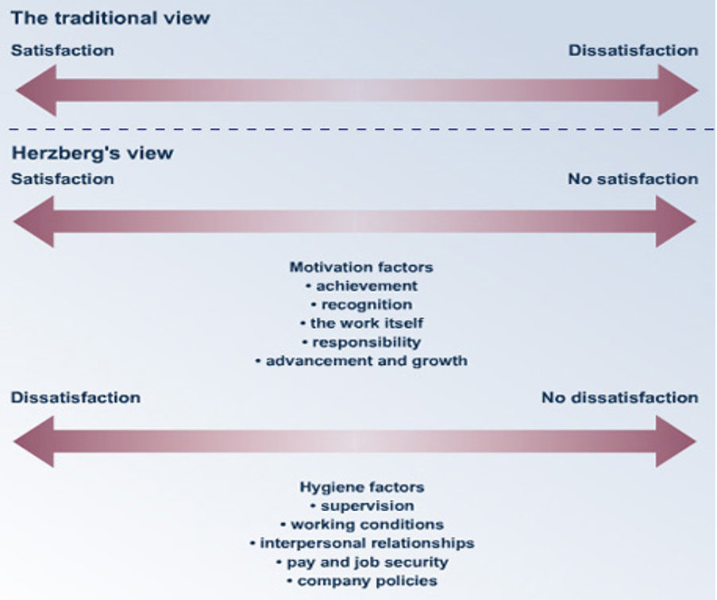
McGregor Theory X and Y are built on motivation in human behavior and is based on two extreme possible behaviors. Theory X organization the workers are lazy, unmotivated and will avoid work at all possible ways. Theory Y organization the workers are self-motivated and thrive on responsibility. The Management style is more participative, and they involve employee in decision-making. (Lumen, 2021)
All these theories help us understand better the importance of knowing the motivation behind a employee’s behavior and can be a real help in human Resources departments so that they are able to recruit people according to the job’s role. Among the factors of motivation, we can enumerate:
- Rewards and incentives
- Recognition
- Training and development

Conclusion

Every organization has its unique culture and employee behavior. Through this paper we’ve shown that leadership when it comes to Tesco is an essential element that helps formulate the growth of the company.
Taking all these theories into account we can say the conditions met at work are responsible for the motivation of the work-staff and their performance is exposed to their motivational level.
Thus, organizations and managers must adapt new ways and vary their behavior accordingly as per the situations and the different needs and the motivations of the employees.

The discussed motivational theories suggest the need of basic factors that need to be presented in order achieve a better satisfaction for the employees. Factors like salary, recognition, rewards or training and development are some of the most significant factors that can influence the individual behavior at the workplace.

References
Aleksić, A. & Jelavic, S., 2017. Testing for strategy-structure fit and its importance for performance. Management: Journal of Contemporary Management Issues, 22(1), pp. 80-103.
Chandler, A.D;, 1962. Strategy and Structure: Chapters in the History of the American Industrial Enterprise. Cambridge: MIT Press.
Corporate Finance Institute, 2020. CFI. [Online]
Available at: https://corporatefinanceinstitute.com/resources/knowledge/other/maslows-hierarchy-of-needs/
[Accessed 01 September 2021].
Expert Program management , 2018. Expert Program Management. [Online]
Available at: https://expertprogrammanagement.com/2018/04/herzbergs-two-factor-theory/
[Accessed 01 September 2021].
Global Data, 2021. Global Data. [Online]
Available at: https://www.globaldata.com/company-profile/tesco-plc/
[Accessed 27 August 2021].
Hierarchy Structure , 2021. Hierarchy structure. [Online]
Available at: https://www.hierarchystructure.com/tesco-management-hierarchy/
[Accessed 26 August 2021 2021].
Kenis, P., Janowicz-Panjaitan, M. & Cambre, B., 2009. Temporary Organizations: Prevalence, Logix and Effectiveness. Cheltenham ed. Gloucestershire,UK: Edward Elgar.
Lambert, J., 2016. Cultural diversity as a mechanism for innovation: workplace diversity and the absorbtive capacity framework. Journal of Organizational Culture, Communications and Conflict, 20(1), pp. 2-6.
Lumen, 2021. Lumen Introduction to business. [Online]
Available at: https://courses.lumenlearning.com/wmintrobusiness/chapter/reading-douglas-mcgregors-theory-x-and-theory-y-2/
[Accessed 01 September 2020].
Marr, B., 2018. Tesco: Evolving The Strategic Performance Framework. [Online]
Available at: https://bernardmarr.com/default.asp?contentID=112
[Accessed 18 August 2021].
Mullins, L., 2010. Management and Organizational behaviour. Management and Organizational behaviour, Issue 9, pp. 2-44.
Reuters, 2021. Reuters. [Online]
Available at: https://www.reuters.com/companies/TSCO.L
[Accessed 28 August 2021].
TESCO, 2016. Corporate Responsability update. [Online]
Available at: https://www.tescoplc.com/media/391787/corporate-responsibility-update_nov-2016-final.pdf
[Accessed 26 August 2021].
Tesco, 2021. Tesco Anual Report 2021. [Online]
Available at: https://www.tescoplc.com/
[Accessed 27 August 2021].

