

Assignment Title: A Project portfolio.

Student Name : Ibrahim Mahamad
Student number : 2337318
Module code: LCLM5003
Module Leaders: Rexon Nting

Part A- Project proposal poster

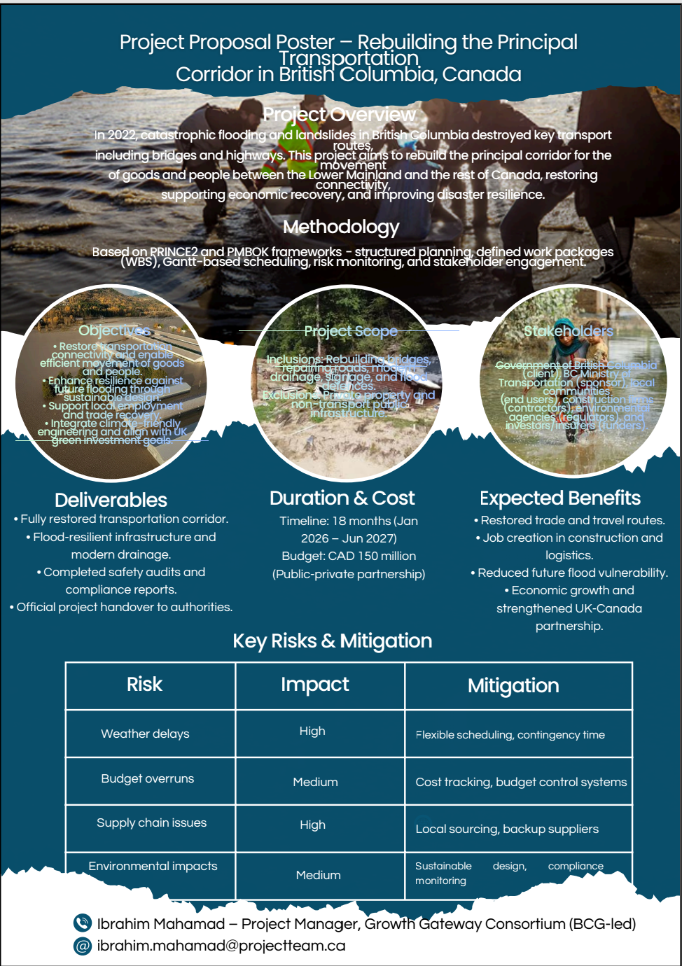
PART B – REFLECTION FROM FEEDBACK RECEIVED FROM TUTOR.

The feedback received from both the tutor and peers on the project proposal poster provided valuable insights that contributed to improving the quality and depth of the final project management plan. Overall, the feedback confirmed that the selected project topic, which focuses on rebuilding the principal transportation corridor in British Columbia after the 2022 flooding, was relevant, realistic and well aligned with the assessment brief. The tutor indicated that the project demonstrated strong potential in addressing a real-world infrastructure challenge while applying professional project management principles.
A major strength identified in the feedback was the clarity of the project’s purpose. The poster successfully communicated the importance of restoring connectivity between the Lower Mainland and the rest of Canada. The inclusion of a defined budget and project timeline was also praised, as it demonstrated an understanding of large-scale infrastructure planning. The visual layout of the poster was considered informative, with clearly identified objectives, risks and expected benefits.
Another positive aspect highlighted was the risk section. The tutor noted that the identification of risks such as weather disruption, supply chain challenges and environmental impact reflected awareness of industry realities. Peers also commented that the proposed mitigation strategies were logical and reasonably practical. Furthermore, referencing recognised frameworks such as PRINCE2 and PMBOK increased the credibility of the work and showed an understanding of professional project governance.
However, the feedback also highlighted several areas for improvement. One of the main recommendations was to expand the Work Breakdown Structure (WBS). Although the poster presented the stages of the project, it lacked sufficient operational detail. In response, the final project management plan has introduced a more comprehensive breakdown of tasks and work packages.
Another area of development was stakeholder involvement. It was noted that while key stakeholders were identified, the poster did not sufficiently explain their roles or influence. The final plan therefore includes a detailed stakeholder section outlining engagement strategies, governance roles, and communication plans.
Feedback also revealed that practical application of PRINCE2 and PMBOK could be improved. The tutor suggested demonstrating not only knowledge of the frameworks but also how they are applied in real project execution. This led to the integration of structured governance processes, change control systems and risk registers in the final plan.
In summary, the feedback provided constructive direction and significantly strengthened the final submission. The improvements made ensure a more professional, structured and academically sound project management plan that demonstrates both theoretical knowledge and practical application.

Part C: Project Management Plan

1. Introduction

In 2022, the Canadian province of British Columbia experienced catastrophic flooding caused by an extreme atmospheric river event. This disaster triggered landslides, bridge collapses, and large-scale road washouts across several regions. One of the most critical impacts was the failure of the principal transportation corridor connecting the Lower Mainland with the rest of Canada. This corridor plays a vital role in the movement of goods, passenger travel, and access to emergency services. When the route became unusable, national supply chains were disrupted, businesses experienced operational delays, and communities faced limited access to essential resources such as fuel, food, and healthcare services (Government of British Columbia, 2022).
Transportation infrastructure is fundamental to economic and social stability. Efficient transport systems enable trade, employment mobility, and public service delivery. When these systems are damaged, the impact extends beyond physical infrastructure loss to include economic decline and reduced social wellbeing (OECD, 2021). The events in British Columbia highlighted the increasing vulnerability of infrastructure to climate change and the urgent need for resilience-focused reconstruction.
This Project Management Plan (PMP) presents a structured approach for rebuilding the principal corridor for the transportation of goods and people in British Columbia. The project aims not only to restore connectivity but also to incorporate improvements that reduce vulnerability to future flooding. This includes enhanced drainage systems, strengthened structural design, and improved environmental protection measures.
The project adopts a professional management approach based on the PRINCE2 framework and the Project Management Body of Knowledge (PMBOK). PRINCE2 provides a governance structure with defined roles and stage controls, while PMBOK offers practical tools for managing schedule, cost, quality, risk, and stakeholder engagement (PMI, 2021; Turner, 2019). The project is funded through a public–private partnership with an approved budget of CAD 150 million and a proposed duration of 18 months from January 2026 to June 2027. This plan provides stakeholders with clear guidance on project objectives, responsibilities, and delivery strategy

2. Project Description

The project focuses on the reconstruction and enhancement of the principal transportation corridor that connects the Lower Mainland of British Columbia with the rest of Canada. This corridor is a critical route for the movement of freight, passenger traffic and emergency services, supporting industrial operations, agriculture, and national distribution networks. During the 2022 flooding event, significant sections of the route were damaged or destroyed due to landslides, erosion and overloaded drainage systems, resulting in severe disruption to transport operations and economic activity (Government of British Columbia, 2022).
The project will involve the demolition of unsafe structures and the rehabilitation of highway pavements, bridge foundations and drainage networks. New construction works will include slope stabilisation, erosion protection, and upgrades to water management systems to reduce the risk of future flood-related failures. Bridge elevations will be improved where feasible, and road surfaces will be rebuilt using durable materials to withstand extreme weather conditions.
In addition to physical infrastructure restoration, the project incorporates modern engineering solutions aimed at improving long-term performance and resilience. This includes the use of flood-resistant materials, reinforced concrete technology, and advanced drainage designs that increase water-flow capacity. Digital monitoring systems will also be incorporated to support asset management and early detection of structural stress.
Delivery of the project will take place through a public–private partnership arrangement, ensuring shared responsibility, financial accountability, and professional governance. The project is scheduled for completion within eighteen months, with performance measured through safety compliance, operational readiness, and stakeholder satisfaction.

3. Scope

Defining the project scope is essential to ensure that objectives are clearly understood and that delivery remains controlled in terms of time, cost, and quality. The scope of this project is limited to the reconstruction and improvement of infrastructure directly associated with the principal transportation corridor between the Lower Mainland and the rest of Canada. Clear scope boundaries reduce the risk of project overruns and provide a framework for effective performance management (Kerzner, 2021).
The in-scope activities include the full reconstruction of damaged bridges and highway surfaces, upgrading drainage and water-management systems, implementing soil stabilisation measures, and completing all required safety inspections and commissioning procedures. Environmental restoration activities, including landscaping, erosion control and habitat protection, are also included. Temporary traffic management, including diversions and safety signage, forms part of the project scope to ensure public safety during construction.
The out-of-scope activities consist of residential rebuilding, compensation administration, long-term infrastructure maintenance, and economic recovery programmes. These responsibilities remain with appropriate government departments or insurance agencies.
Scope verification is achieved through staged approvals under the PRINCE2 framework. At the end of each phase, deliverables are reviewed against agreed requirements before progression is approved. Any change in scope must be submitted through a formal change control process. Impact assessments are conducted to evaluate changes in cost, schedule and risk before authorisation by the Project Board.
By maintaining disciplined scope management, the project ensures that resources are directed efficiently toward achieving core objectives and that the corridor is restored within the approved budget and timeframe.

4. Work Breakdown Structure

The Work Breakdown Structure (WBS) provides a structured framework for organising and managing the project’s activities by breaking them down into smaller, manageable components. It allows the project team to identify deliverables clearly, assign responsibility, estimate costs and time accurately, and monitor progress effectively. The WBS serves as the foundation for planning, scheduling, risk management and resource allocation (PMI, 2021).
For this project, the WBS is divided into six main phases, each containing several work packages.

Phase 1: Initiation and Planning
This phase includes site inspections, damage assessments, environmental analysis, feasibility reviews, and the development of the project execution plan. Stakeholder engagement and approval of the business case are also completed at this stage.

Phase 2: Design and Engineering
This stage focuses on producing detailed technical designs, hydraulic modelling, structural calculations and regulatory approvals. Risk registers and quality standards are finalised to guide construction activities.

Phase 3: Procurement and Mobilisation
This phase includes tendering procedures, evaluation of bids, contract awards, procurement of materials and mobilisation of contractors and equipment.

Phase 4: Construction and Rehabilitation
Major works are completed including demolition of damaged structures, bridge reconstruction, resurfacing of highways, installation of drainage systems and slope stabilisation.

Phase 5: Testing and Commissioning
Structural integrity testing, safety inspections, environmental compliance checks and operational readiness assessments are undertaken.

Phase 6: Project Closure
Documentation, performance review and formal handover to authorities conclude the project.
This structured approach ensures accountability, efficiency, and timely delivery.

5. Quad Chart

A quad chart is a visual management tool that summarises key elements of a project using four main dimensions: cost, schedule, performance and risk. It provides a concise overview of project health and supports informed decision-making by senior management and stakeholders. For this project, the quad chart is used to communicate strategic priorities and performance expectations during each review meeting.

Cost:
The total project budget is CAD 150 million, allocated across design, construction, environmental mitigation, and contingency funding. Financial performance will be controlled through regular cost monitoring and variance analysis. Earned Value Management (EVM) is applied to measure actual progress against planned expenditure, allowing early identification of cost overruns and corrective action (PMI, 2021).

Schedule:
The project is planned over an 18-month period with key milestones including design completion, contract award, construction commencement and final handover. The critical path focuses on bridge reconstruction and drainage system installation. Regular progress reviews ensure that delays are detected early and schedule adjustments are implemented efficiently.

Performance:
Performance objectives include restoring full corridor usability, improving safety standards and increasing flood resistance. Quality indicators include compliance with engineering regulations, completion of safety audits and satisfaction among users. Performance is validated during testing and commissioning phases.

Risk:
Environmental conditions, supply chain disruptions and resource constraints represent key risks. A risk register ensures mitigation strategies are recorded and reviewed.
The quad chart provides quick insight and supports proactive management.

6. Gantt Chart
The Gantt chart is used to illustrate the project timeline, sequence of activities and duration of each phase. It enables visual tracking of progress and identifies dependencies between tasks. The chart below represents the planned schedule for rebuilding the principal transportation corridor over an 18-month period.

Figure 1: Project Gantt Chart – Transportation Corridor Reconstruction
Project Phase | M1 | M2 | M3 | M4 | M5 | M6 | M7 | M8 | M9 | M10 | M11 | M12 | M13 | M14 | M15 | M16 | M17 | M18
Planning & Feasibility | █ | █ | █
Design & Engineering |  | █ | █ | █ | █
Procurement & Contracts |  |  |  | █ | █
Construction Phase |  |  |  |  |  | █ | █ | █ | █ | █ | █ | █ | █ | █
Testing & Commissioning |  |  |  |  |  |  |  |  |  |  |  |  |  |  | █ | █ | █
Final Handover & Closure |  |  |  |  |  |  |  |  |  |  |  |  |  |  |  |  |  | █

The Gantt chart presents the project timeline across eighteen months and illustrates the logical flow of activities from initiation to closure. Planning and feasibility are scheduled for the first three months to allow sufficient time for damage assessments, environmental review and stakeholder engagement. Detailed design follows closely alongside planning to minimise delays and allow early procurement.
Procurement occurs in months four and five, enabling materials, workforce and equipment to be ready for construction. The construction phase begins in month six and continues until month fourteen. This phase is the most resource intensive and includes bridge reconstruction, highway resurfacing and drainage installation.
Testing and commissioning take place between months fifteen and seventeen. These activities ensure structural integrity, safety compliance and environmental acceptance before opening the corridor for use. The final month is dedicated to formal project closure, training and documentation handover.
The critical path of the project runs through design approval and bridge reconstruction tasks. Delays within these tasks will directly affect project completion, therefore close schedule monitoring is essential.

7. Stakeholders’ Involvement

Stakeholder involvement is a critical component of this project because the reconstruction of the principal transportation corridor affects a wide range of groups with differing interests and levels of influence. Effective stakeholder management ensures transparency, reduces conflict and supports successful project delivery (PMI, 2021).
The primary stakeholders include provincial government departments responsible for transportation, infrastructure authorities, and the private-sector contractors involved in design and construction. These stakeholders hold direct responsibility for decision-making, funding approval and operational delivery. Engineering consultants and environmental regulators also play key roles in ensuring technical compliance and environmental protection throughout the project lifecycle.
The secondary stakeholders include logistics companies, public transport operators, local businesses and residents living near the construction zone. These groups are indirectly affected by the project through potential delays, noise, and temporary access restrictions. Their involvement is essential to maintain community support and minimise disruption.
Under the PRINCE2 framework, governance responsibilities are structured through the Project Board, consisting of an Executive representing business interests, a Senior User representing corridor users, and a Senior Supplier representing delivery organisations (APM, 2020). This structure ensures balanced decision-making and accountability.
Communication strategies include regular progress reports, public consultations, community briefings and digital information platforms. Feedback mechanisms such as complaint-management systems allow stakeholders to raise concerns that can be addressed promptly.
By engaging stakeholders proactively and transparently, the project increases trust and cooperation, contributing to successful completion and long-term infrastructure sustainability.

8. Allocation of Resources

Effective allocation of resources is essential to ensure that the project is delivered within the approved budget, schedule and quality standards. This project requires careful management of financial, human, physical and information resources to support efficient operations and reduce waste.
Financial resources are controlled using a detailed cost management plan. The approved project budget of CAD 150 million is distributed across design activities, construction works, environmental mitigation, risk contingency and project management costs. Regular financial reviews are conducted to track expenditure against budget forecasts. Earned Value Management techniques are applied to monitor cost variance and predict project performance (PMI, 2021).
Human resources include civil engineers, project managers, site supervisors, quality inspectors, environmental specialists and health and safety officers. Roles and responsibilities are formally assigned through a responsibility matrix to ensure accountability. Training is provided where necessary to promote safe working practices and compliance with professional standards.
Physical resources include construction machinery, tools, materials and monitoring technology. Equipment scheduling is implemented to prevent clashes and reduce idle time. Materials such as concrete, steel and aggregates are sourced through multiple suppliers to reduce reliance on a single supply chain and minimise delays.
Information resources consist of project management systems, scheduling software and document control platforms. These tools support accurate reporting, version control and stakeholder communication.
Through structured planning and continuous monitoring, resource utilisation is optimised, supporting efficient delivery and financial sustainability.

9. Risk Analysis

Risk management is essential for infrastructure projects due to the complexity, scale and uncertainty associated with construction activities. This project adopts a structured risk management process aligned with the PMBOK framework and ISO 31000 standards, involving risk identification, assessment, mitigation and continuous monitoring (PMI, 2021; ISO, 2019).
The most significant risk is the potential recurrence of extreme weather events during construction. British Columbia is increasingly vulnerable to heavy rainfall and landslides due to climate change. This risk could cause delays and structural damage. Mitigation measures include the integration of enhanced drainage systems, weather-resilient construction methods and contingency buffers within the project schedule.
Cost escalation represents another critical risk. Inflation in construction materials and labour shortages may increase expenses. To manage this risk, fixed-price contracts, regular financial reviews and contingency reserves are implemented.
Supply chain disruption also poses a risk to timely delivery. Delays in sourcing construction materials can disrupt scheduling. Multiple suppliers and early procurement reduce dependency on single sources.
Environmental non-compliance is a regulatory risk. Failure to meet environmental standards may result in legal penalties and project suspension. Regular environmental audits and regulatory engagement help prevent violations.
Health and safety risks exist due to heavy machinery and hazardous terrain. All contractors must comply with safety regulations and attend induction training.

Risk | Likelihood | Impact | Mitigation Strategy
Flooding | High | High | Drainage design
Cost inflation | Medium | High | Budget controls
Material delay | Medium | Medium | Supplier diversity

Risk reviews are conducted monthly to ensure proactive responses.

10. Conclusion
The rebuilding of the principal transportation corridor in British Columbia represents a critical investment in economic recovery, public safety, and long-term infrastructure resilience. The flooding disaster of 2022 exposed vulnerabilities within the transportation network and demonstrated the severe consequences of infrastructure failure on supply chains, emergency services and regional connectivity. Restoring this corridor is therefore essential not only to reinstate normal transport operations but also to strengthen preparation for future climate-related events.
This Project Management Plan has presented a structured approach to delivering the project through clearly defined scope, phased implementation and professional governance arrangements. The Work Breakdown Structure and Gantt Chart provide clarity regarding how tasks are organised and scheduled, ensuring that the project remains achievable within the 18-month timeline. The allocation of resources reflects a balanced and efficient strategy that maximises value while controlling costs through effective monitoring and accountability systems.
The integration of PRINCE2 and PMBOK offers a robust governance framework that supports both strategic oversight and operational control. PRINCE2 ensures accountability through formal roles, stage boundaries and approval procedures, while PMBOK contributes practical tools for managing schedule, budget, quality and risk. Together, these approaches enable effective decision-making and continuous performance monitoring throughout the project lifecycle.
Stakeholder engagement and risk management have been positioned as central elements of the project strategy. Transparent communication and structured consultation help maintain trust and reduce resistance during construction, while proactive risk management reduces the likelihood of cost overruns, delays and safety incidents.
Overall, the successful delivery of this project will restore national transportation capacity, improve resilience to future flooding and support sustainable economic development in British Columbia. The project represents a forward-looking investment that delivers both immediate recovery and long-term national benefit.

11. References.
APM (2020) Directing change: A guide to governance of project management. High Wycombe: Association for Project Management.
British Columbia Ministry of Transportation and Infrastructure (2022) Flood recovery and transportation reconstruction report. Victoria: Government of British Columbia.
HM Government (2021) National infrastructure strategy. London: HM Treasury.
International Organization for Standardization (ISO) (2019) ISO 31000: Risk management – Guidelines. Geneva: ISO.
Kerzner, H. (2021) Project management: A systems approach to planning, scheduling, and controlling. 13th edn. Hoboken: Wiley.
KPMG (2020) Public–private partnerships in infrastructure projects. London: KPMG International.
Muller, R. and Lecoeuvre, L. (2014) ‘Operationalizing governance categories of projects’, International Journal of Project Management, 32(8), pp. 1346–1357.
OECD (2021) Adapting transport to climate change and extreme weather: Implications for infrastructure owners and network managers. Paris: OECD Publishing.
PMI (2021) A guide to the project management body of knowledge (PMBOK Guide). 7th edn. Newtown Square, PA: Project Management Institute.
RICS (2020) Guidance note: Infrastructure delivery. London: Royal Institution of Chartered Surveyors.
Turner, J.R. (2019) The handbook of project-based management. 4th edn. London: McGraw-Hill Education.
UN Office for Disaster Risk Reduction (UNDRR) (2022) Global assessment report on disaster risk reduction. Geneva: United Nations.
World Bank (2021) Climate-resilient infrastructure: A framework for adaptation. Washington, DC: World Bank.
Zou, P.X.W., Zhang, G. and Wang, J. (2006) ‘Identifying key risks in construction projects’, Journal of Construction Engineering and Management, 132(6), pp. 601–610.
Flyvbjerg, B. (2017) ‘Survival of the un-fittest: why the worst infrastructure gets built’, Oxford Review of Economic Policy, 32(1), pp. 62–78.

