University of Wales Trinity Saint David
Wales Institute of Science and Art


Kinetic Energy Recovery

Alternative Propulsion System ACHA5010

Ben Ellis-Jones
2204298
Date
Contents
1 Introduction 1
1.1 Dynamic characterises of the vehicle (table) 1
1.2 Select the appropriate Worldwide harmonised Light Vehicle Test Procedure 1
1.3 Spreadsheet 1
1.4 Identify the moment of largest possible KERS power input and the energy storage requirements 1
1.5 Specify a suitable KER system 2
1.6 Plot Kinetic Energy Recovered that is returned to the wheel road contact 2
1.7 Explain how the system operates 2
2 Task 2 3
3 Task 3 4
4 References 5

Introduction

KERS stands for Kinetic Energy Recovery system. The goal of a KER system is to turn the kinetic energy in your vehicle from breaking to useful energy instead of just heat. This energy can be used to power electronics with the car or even help the vehicle to accelerate. This is a verry useful feature of car from an environmental point of view because energy from breaking that would typically get dissipated through heat can now be stored and used to accelerate the car. This means that less fuel will have to be burnt to achieve the same outcome.
The car I have chosen is the 2014 Toyota Yaris. Specifically, the 5 door 1L petrol manual. I chose this car because it is the vehicle that I learnt how to drive in.

Dynamic characterises of the vehicle (table)

Test Mass | 1615 Kg
Frontal Area | 2.15 m^2
Width | 1695 mm
Hight | 1510 mm
Coefficient of Aerodynamic Drag | 0.31
Coefficient for rolling resistance | 0.015
Power | 68 bhp / 50.7 KW
Torque | 95Nm / 70 ft-lb
CO₂ Emissions | 99 g/km
Euro Emissions Standard | 6

(Anon., n.d.)

Select the appropriate Worldwide harmonised Light Vehicle Test Procedure

The car has a power to weight ratio of 31.39 W/kg. Because this value falls between 22 and 34, the car is in class 2.

Spreadsheet
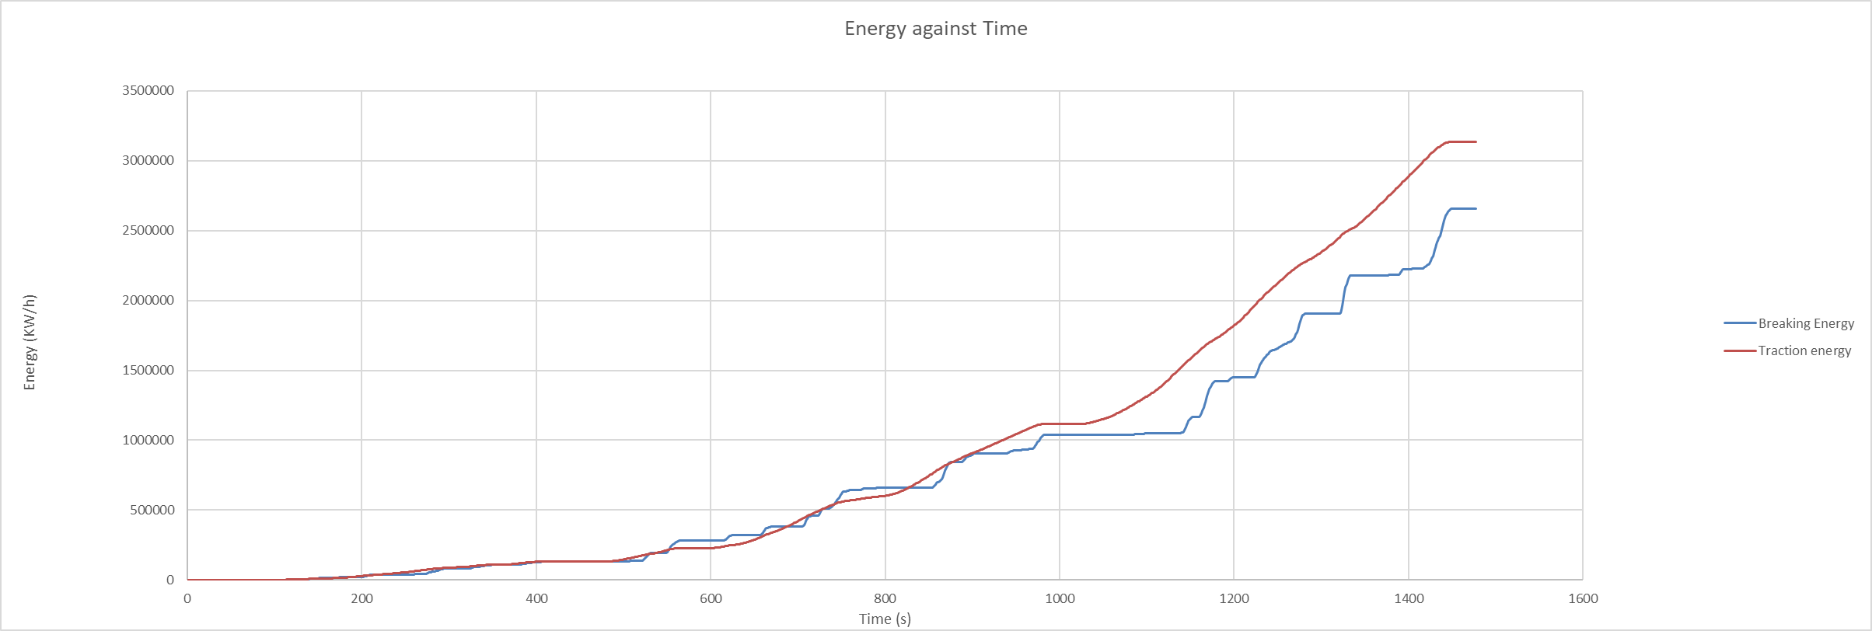
Figure 1- Traction and Breaking energy against Time

Identify the moment of largest possible KERS power input and the energy storage requirements

The moment of largest possible KERs power is at 1334 seconds into the cycle where the required breaking energy was 28 Watts

Specify a suitable KER system
Size the components
There are many different types of Kinetic Energy Recovery systems including Electrical, Hydraulic and Mechanical. They all convert kinetic energy into another form of energy that is stored for later use.
The mechanical designs store the energy as potential energy. The most common example of this is the flywheel design but does include systems that use springs as a potential energy store, as the car slows, the energy is transferred to a flywheel which will spin allowing the car to store kinetic energy ready for when the energy is needed. The flywheel design is mechanically simple compared to other designs this means that it is easy to fix if there is an issue and there is no need for a specialist to do the job how either they are limited and can only store a relatively small amount of energy and can be expensive to manufacture due to the high stress materials needed in its construction. This lends the flywheel design to smaller hatch backs and city cars as it cannot handle high amounts of energy.
The electrical storage design uses batteries and in some cases capacitors to store the energy. This design allows for high energy storage. Batteries have a long life span especially when compared to mechanical systems such as the flywheel design. This design can be heavy and expensive when compared to other systems. This design can have a slower charge and discharge rate than the mechanical systems.
The Hydraulic design stores the energy in a mixture of kinetic and heat in pressurised liquids. It is a verry efficient system but it is a complex and heavy design. Hydraulic issues are expensive and difficult to diagnose. This design is rarely seen.
(K.R. Pullen, 2014)
The KER system for the Toyota Yaris should be inexpensive, reliable and effective. I would select a regenerative breaking system. If I was Toyota I would use the system that they have already developed for their Toyota Prius. By reusing this system they will save time and money because they will not have to buy or design a new system. This system has been in use for many years and has become a low maintenance and efficient option. For a vehicle like the Toyota Yaris that will encounter a lot of stop start computing, this system is perfect it will increase the range of the car, lower its emissions and can increase the life span of break pads .
Regenerative breaking systems change the characteristics of a car. When driving it feels like the engine breaking is enhanced. this feels weird at first but is easy to get used to.

Plot Kinetic Energy Recovered that is returned to the wheel road contact

Explain how the system operates

The system works using a motor that also functions as a generator. When the car is slowing, it acts as a generator converting kinetic energy into electrical energy that is stored in the battery. The system is designed to run automatically and seamlessly. When the driver begins to pull away from a stopped position, the systems motor/generator acts as a motor to assist the ICE in accelerating the vehicle.
Find values for their efficiency assumptions made and variations that the driver may feel when compared to the conventional ICE and friction break vehichle

References
(Format to Harvard style as per handbook)
No table of figures entries found.

