

NETWORK OPERATING SYSTEMS AND SECURITY

Tutor: Terry Walcott
Student: Silvia Diana Iagar
ID: 1805743

Table of Contents

- Introduction 3
- Information security, related policies and defences procedures 4
2.1 Information Security Triad 4
2.1.1 Confidentiality 4
2.1.2 Integrity 5
2.1.3 Availability 5
2.1.4 Additional enabling requirements 5
2.2 Defence mechanism 5
2.2.1 DiD Depth Defence 6
2.1.2 Defence strategies 6
- Hacking issues and solutions 4
3.1 MitM attack 8
3.2 Cracking password 9
3.3 Access via an Internet Wi-Fi facility offered for roving staff working at home....9
- Auditing and Checking 11
4.1 Networking audit and monitoring 11
4.2 Penetration Testing 11
- Conclusion 13
- References 14

- Introduction

Information is an essential asset of an individual or an organisation, and thus needs to be properly covered. The protection of information defends data from a wide spectrum of attacks.
The introduction of an appropriate collection of laws, praxis, processes, operational frameworks and programme functions ensures information security. These components must be incorporated as long as they meet the relevant safety goals.
The goal of this study was to investigate some specific principles, practises and management of the recently observed low-level hacking incident Information Security Republic of Snowdenia County Council. Many of the private records have recently been released in the public domain by the Snowdenia County Council in an insider attack. Jones-Smith Truman Consultants (JSTC) have been commissioned by the Republic of Snowdenia County Council to provide recommendations on data safety.
In this study will be presented the basic criteria for maintaining the confidentiality, honesty and availability of information to the Council; denouncing the previous issue of hacking; and presenting some specifics of an audit or testing strategy to ensure proper compliance with data protection legislation.

- Information security, related policies and defence procedures

  - Information Security Triad
Information security is illustrated as the ability of the information processing system to ensure in a certain period of time the possibility of executing the requirements established according to the magnitude of the probability of events, manifested in:
- exodus of information;
- modification or loss of data, which has a certain value for the holder.
The causes of these events can be the impact of human stochastic actions or the impact of premeditated human actions in the form of unsanctioned access to the system.
Security in the information system is defined as ensuring and preserving as follows:
- confidentiality
- integrity
- availability

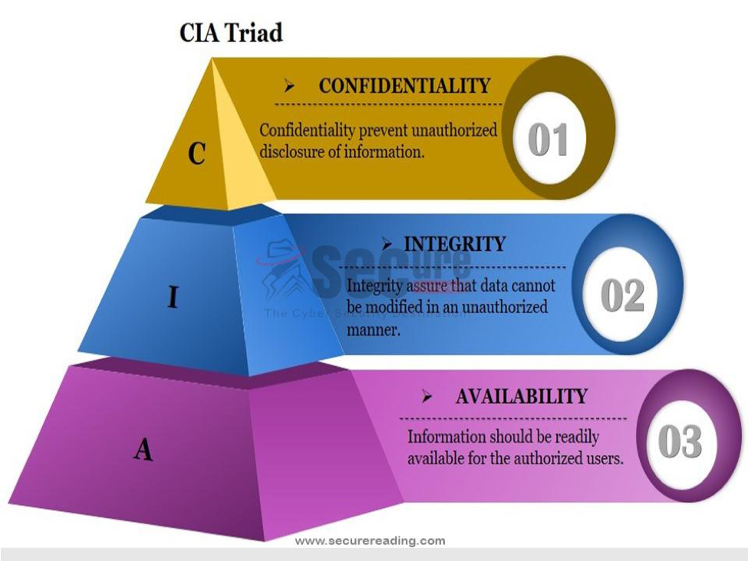
Fig.1 The Triad

    - Confidentiality
Privacy, often referred to as confidentiality, is meant to prohibit unauthorised access to non-individual information. The primary goal of information protection is confidentiality. You need to decide what information is to be covered and who does or should not have access to the information in order to ensure confidentiality. This means that security mechanisms exist for information stored on computers and transmitted from computers to the network. Within the Internet, protection in the context of protection control mechanisms takes on new dimensions.

2.1.2 Integrity
Integrity, also referred to as accuracy, aims to ensure that information stored on a device cannot be changed or updated only by authorised persons. In modifying the data, the modification and degradation of the data is intentionally intended. However, it is not only because of malicious behaviour, but even because of a hardware, a software error, a human error or a security system mistakes that data can be changed or even lost. In this scenario, a recovery and recovery plan (existence of a backup) is required.

2.1.3 Availability
The aim of the availability is to allow access for approved persons to data stored on computers. Only data intended for use should be open to users. Two types of users with specific access privileges can be distinguished here: device administrators and general users, excluding operating systems that equip desktop computers. Any commonly used user can change the computer's security settings by cancelling them.
It is clear that confidentiality is the basic requirement of their data protection framework based on the collection of specifications and the activities of the Snowdenia County Council.

2.1.4 Additional enabling requirements
In any company it is critical that its own safety criteria are defined. Throughout this end, three main sources have to be utilised:
- risk assessment. The risks to infrastructure have been identified, the vulnerability and probability of their occurrence have been evaluated and the possible impacts have also been estimated;
- current laws which an entity must comply with;
- safety analysis.
A company should define its own safety standards in order to determine the risks. In general, this phase includes the four key stages of identification of protected resources, danger / threat identifying unique to each resource, danger hierarchy, controls to remove / decrease risk.

  - Defence mechanisms
The financial element is an important aspect of the development of security mechanisms. A control function should not surpass the safe value of the asset. Upon identifying the safety policy objectives, the next step will include the selection of security services – the various security-enhancing functions.
The different methods (Security Mechanisms) may be used by each Service to execute the so-called functions on security management. Security management consists of monitoring and transmission of information to all networks, using security resources and protocols and reporting security incidents to network managers.
The next step is to create the model for safety. There are multiple layers reflecting the safety level around the topic to be covered in the security model of an information system. Each level isolates the subject and makes it harder than the one to reach it was intended.

2.2.1 DiD Depth Defence
Depth defence (DiD) is a cybersecurity strategy that sets out a variety of advocacy strategies for the defence of sensitive information and data. If one method is unsuccessful, other steps up to thwart an attack. This multi-layered approach with intentional redundancies improves the protection of the entire network and deals with several different attack vectors.

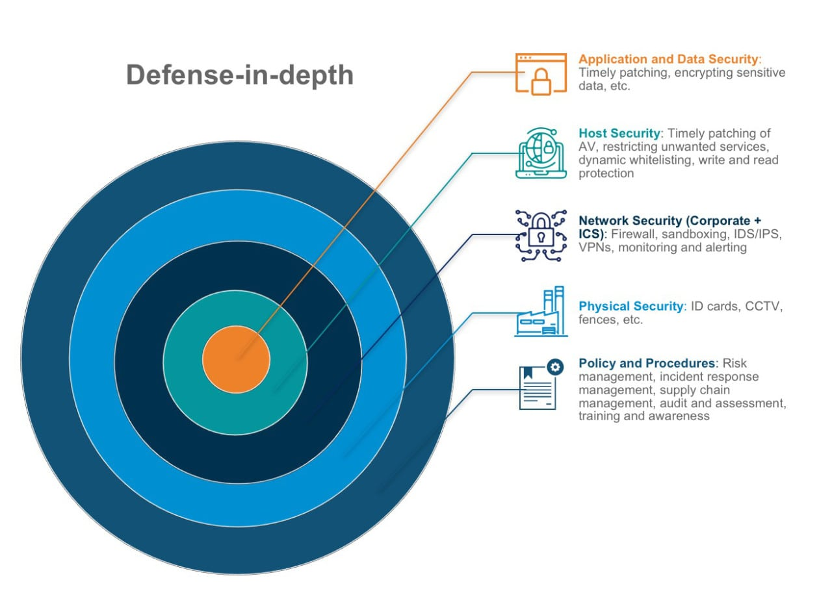

Fig.2 Defense-in-Depth

2.2.2 Defence Strategies

Security vendors are actively developing new security technologies for network and device defence with an ever-growing array of security threats to address. These are some of the most important elements of protection found in the Depth Defence Strategy:
- Network Security Controls – the primary protection when protecting a network. Based on a set of safety principles, firewalls prohibit admission to and from unauthorised networks and grant or halt traffic. Intrusion defence systems also work together with firewalls to detect and respond promptly to possible security threats.
- Antivirus Software - is important to protect toward malware and viruses. Divers versions are therefore also highly dependent on the identification of their signatures. Even though these solutions provide good malware security, smart cybercriminals can take advantage of signature-based products.
- Data Integrity Analysis - is a picture of a file showing how much a recorded list of viruses and other malicious code may be used by its use and source. Incoming files can be labelled suspicious if fully machine defined.
- File and network behaviours - provide perspective frequently during an ongoing or occurred infringement. The firewall or intrusion security resolutions fail if analysis of conduct is allowed.
It is the firewall, as described earlier, that provides your first line of defence for a deep defence strategy of your organisation. Therefore, the option of a solution with a variety of features designed to defend against a continuously changing risk environment and the changes in the needs of modern business today makes sense.

- Hacking issues and solutions

Unlike the problem of approved individuals' access, it is very difficult to develop and maintain information systems to avoid access by unauthorised persons. The key effects of unauthorised access are network and its computers being compromised with malware and attacks, such as stopping services. Malware is a common term used for programmes that penetrate a system, or harm it. This means not only numerous Trojan viruses but also spyware, loggers and dealers for botnets.
There are few things to remember from the low-level, three-pronged hacking incident in the Republic of Snowdenia County Council.
- Man-in-the-Middle (MitM) attack
- Cracking password
- Access via an Internet Wi-Fi facility offered for roving staff working at home.
The successful three-way attack demonstrates that the individual, technology and organisational requirements have been met inadequately. This has caused a loss of privacy. Moreover, adequate defence techniques for fighting this insider attack were not available.

  - MitM attack
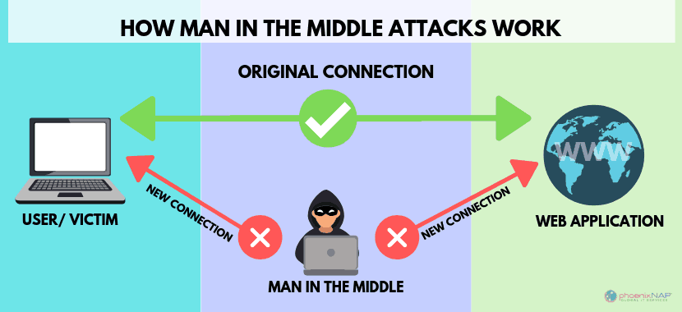
Fig.3 MitM Attack
MitM allow assailants to interrupt or modify communications in secret. It is hard to detect MitM attacks, but they can be avoided. The attack happens when an intruder intercepts communication between two parties to secretly eavesdrop or modify traffic between them.
Attacks by MitM consist of either observing or manipulating the traffic between links of two parties. This can be achieved by interfering with legitimate networks or by building the attacker's fake networks. Compromised traffic would then be removed from encryption to steal, alter or re-route traffic to the attacker's target.
To stop attacks, workers should not use public Wi-Fi and Wi-Fi services in public areas where possible, considering that spoofing is much simpler than cellular telephone connexions and warning them that domains or links may not be valid from browsers should be found. To ensure secure connexions, using VPNs.

3.2 Cracking passwords
Cracking passwords is the act of seeking to enter restricted systems using passwords or encryption mechanisms. Unauthorized entry to restricted systems is likely.
Cracking the password uses a range of methods to accomplish its objectives. Cracking involves adding saved passwords to word lists or using algorithms to create similar passwords. The detection of intruder password cracking is usually difficult due to simple password stealing.

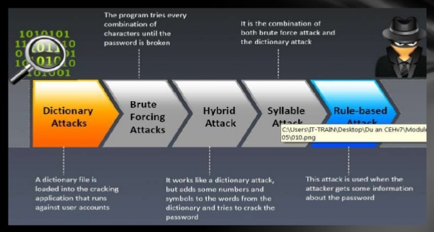
Fig.4 Password Cracking Techniques
In order to prevent an attack, you can use a 2-factor authentication system to add an additional security layer, for example a password combination of biometric data. More sophisticated authentication protocols could be used in addition to that. A stricter lockout could also be used, for example, after 3 lazy password attempts lockout

  - Access via an Internet Wi-Fi facility offered for roving staff working at home
Many of the most successful attacks in the wireless networks are opportunistic. Wi-Fi hackers search for easy to attack wireless networks. The assaults can be particularly lucrative. Allow entry to a company network, ransomware can be introduced and the credit and debit card numbers of dozens or hundreds of thousands of customers taken if malware can be introduced on POS networks.

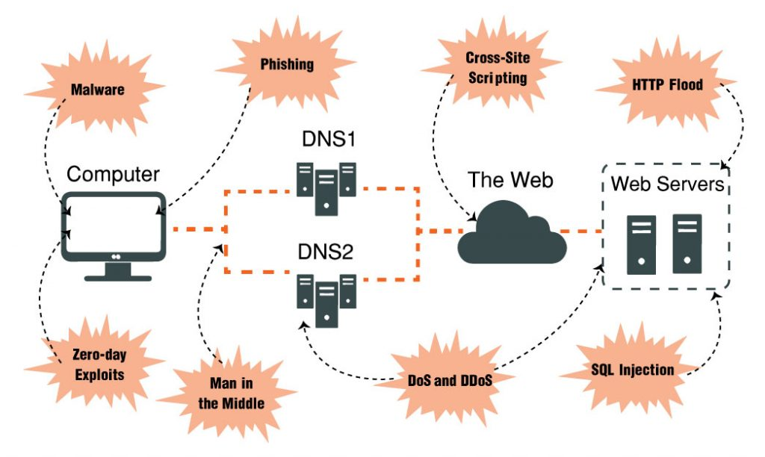

Fig.5 Wireless Network Attacks

The Council's Wi-Fi facilities allow modification of the router by enforcing security actions such as isolation of guest networks, Wi-Fi encryption, firmware upgrade, Wi-Fi access limitations, internet protection and web philtre use.
Furthermore, the County Council of the Republic of Snowdenia’s work from home could be changed to function better.

- Auditing and Checking

Organizations must provide a way of evaluating the degree of trust to which their security features and infrastructure in the information system mediate and implement their security policy in the information system. This is generally referred to as policy. Assurance can be tested using various methodologies and approaches, examples of such a method include checking and auditing penetrations.

  - Network Audit and Monitoring
Network auditing involves collaborative activities for assessing, monitoring and gathering data on a network for safety assessment in accordance with the network / company requirements.
Implementation of network audit and control procedures assists in ensuring that information networks are properly secured using security controls. Daily audits can be performed within an entity by a private company, or by third party auditors. Third-party auditors are typically accredited by different bodies / associations such as the Accredited Information Security Auditors Internal auditors can assist in evaluating the compliance of an entity with standards and due care practise. I may also suggest strengthened monitoring and protections.
Monitoring is about an active process of identifying and reporting security events that could be harmful to a network and its component. Sometimes monitoring could be a real-time process. Penetration testing, intrusion detection mechanisms and the processing of violations support a successful monitoring process

  - Penetration Testing
Penetration Testing is a method used by a company or another organisation to carry out security tests on a network system.
Penetration testing assists in finding flaws in a network. It indicates that there is a distinct distinction between running a penetration test and a risk evaluation.
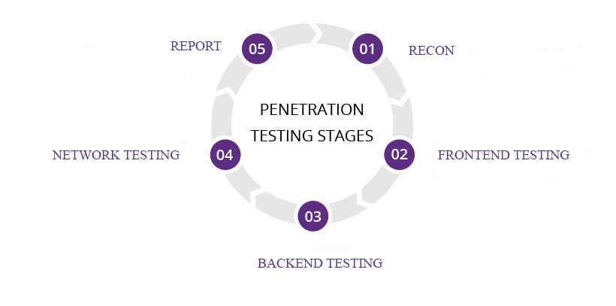
Fig.6 Penetration Testing Stages
It is a process simulation used by a hacker to target a business network, attached computer, network app, or website. The simulation's aim is to identify security issues before hackers can find them and do an exploit.
There are several kinds of penetration tests, including internal, external, zero, partial, zero, closure, and open box. Such various sections cover different kinds of scenarios. For instance, an internal penetration test could have helped to assess the vulnerabilities and impacts of a hacker operating within a network perimeter, in the case of the hacking incidence of the Republic of Snowdenia Council.

- Conclusion

Information security is a vast area requiring very good knowledge and relentless efforts to ensure a proper level of computer system security. It is worth noting that, as a general approach, needs analyze and implement protection measures proportionately with the importance of the resources to be secured to determine the safety risks to which businesses and individuals are exposed. In reality, protection means managing risks.
Information security is obviously very essential for the proper working of the County Council of the Republic of Snowdenia. The information and network security system have different requirements, including confidentiality, availability and integrity. The most critical aspect of the information management framework in the Council is undoubtedly confidentiality.
The Council should implement pen testing to check the network and get a better understanding of the vulnerabilities and the protocols which have been already established, should increase quality of information security, security framework analysis and enhancement also improvement of processes for risks and reactions will be advisable.
Also, the Council should start awareness and regulation of cybercrime for employees, train workers regularly to address the types of threats.

- References

- Perez, A., 2014. Network Security. London: Iste.
- POOLE, O., 2017. NETWORK SECURITY. [Place of publication not identified]: ROUTLEDGE.
- McClure, S., Scambray, J. and Kurtz, G., 2012. Hacking Exposed. Emeryville, Calif.: McGraw-Hill/Osborne.
- Ibm.com. 2020. Network Security And Protection. [online] Available at: <https://www.ibm.com/security/network-security> [Accessed 02 May 2020].
- Microsoft Security. 2020. Network Security - Microsoft Security. [online] Available at: <https://www.microsoft.com/security/blog/network-security/> [Accessed 11 May 2020].
- Lopez, J., 2012. Critical Infrastructure Protection. Berlin, Heidelberg: Springer Berlin Heidelberg.
- Engebretson, P., 2013. The Basics Of Hacking And Penetration Testing. Waltham, MA: Syngress.
- Cannings, R., Dwivedi, H. and Lackey, Z., 2008. Hacking Exposed Web 2.0. New York: McGraw-Hill.

