

LEVEL 7 ASSESSMENT SPECIFICATION

Student name: | Rucha Vaghela | Student ID number: | 2437863
Programme: | MSc Public Health and Social Care in Practice
Module: | Population Health and Digital Health Promotion
Module code: | LCHS7009
Lecturer: | Dr Besty Jose
Assignment Title: | Component 1  2 Blogs

Table of Contents
Blog 1: Evaluating Video-Observed Therapy in NHS Tuberculosis Management 3
References 7
Blog 2: Assessing HyperAI Coach in Hypertension Management 8
References 12

Blog 1: Evaluating Video-Observed Therapy in NHS Tuberculosis Management
Addressing the Public Health Problem
Tuberculosis (TB) is a significant health issue in the UK, particularly to individuals who are left behind, such as migrants, the indigent homeless, and individuals with drug issues. The number of TB cases in the year 2024 has risen 13% in England, that is, 4,850-5,480 (GOV.UK, 2025). The illness requires a period of six months of medication. Several individuals fail the course, allowing the disease to propagate and creating drug-resistant TB that is more difficult and costly to treat. By making people complete treatment, this is part of the NHS plan for TB.
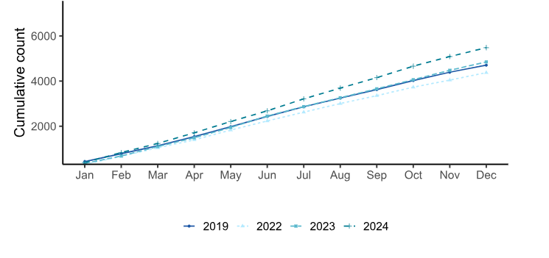
Figure 1: Increase in TB notifications over the years.
(Source: GOV.UK, 2025)
Use of Digital Technology in Health Promotion
Video-Observed Therapy (VOT) allows TB patients to record or live stream taking of medicine using a secure NHS app to ensure medication is taken and provide assistance instantly. In comparison with Directly Observed Therapy (DOT),which requires making daily visits to the clinic, VOT is more flexible, preserves privacy, and is more convenient (Ravenscroft et al., 2020). It thus enhances treatment compliance and reduces obstacles to treatment completion.
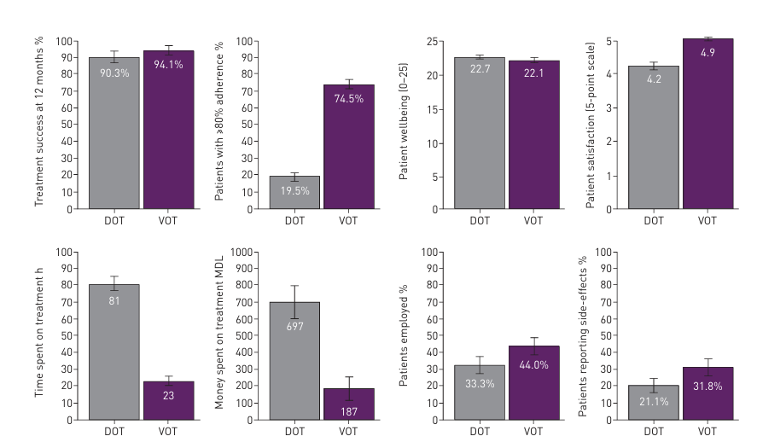
Figure 2: Comparing Outcomes of Treatment: DOT vs. VOT for TB Management
(Source: Ravenscroft et al., 2020)
Evidence of Effectiveness
As part of its efforts to overcome the problem of special assistance, in 2021 the NHS experimented with VOT and DOT together in 16.1% of TB cases. Approximately 58.7% of the entire TB patients received one of them as supervised treatments (GOV.UK, 2024). The national data indicate that VOT aids individuals to complete treatment and particularly high-risk individuals. It has been demonstrated that the viewing of videos will keep patients on schedule and reduce the funds the health system spends.
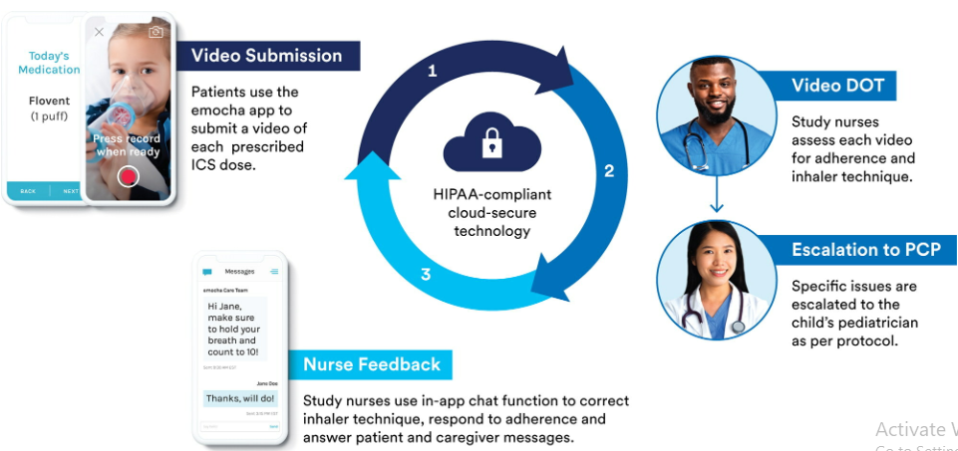
Figure 3: An Intervention Schematic for Enhancing TB Management with VOT
(Source: McIntire et al. 2022)
Critical Discussion: Impact
Advantage
VOT has simplified treatment and saved more time saving clinic visits, and provided more power to patients in terms of their care (Ravenscroft et al., 2020). It also enhances adherence towards monitoring so that it can allow the healthcare providers to track the progress of the patient more effectively and also intervene whenever it is necessary.
Disadvantage
However, some individuals are not able to utilise the technology due to a lack of a phone, sufficient data, and internet connectivity. Furthermore, among those who still use technology, a very insignificant portion of them utilise it for health care purposes (ONS, 2025). Concerns about the security of personal data also arise, and the reason is that individuals have reduced face-to-face interactions with health workers.
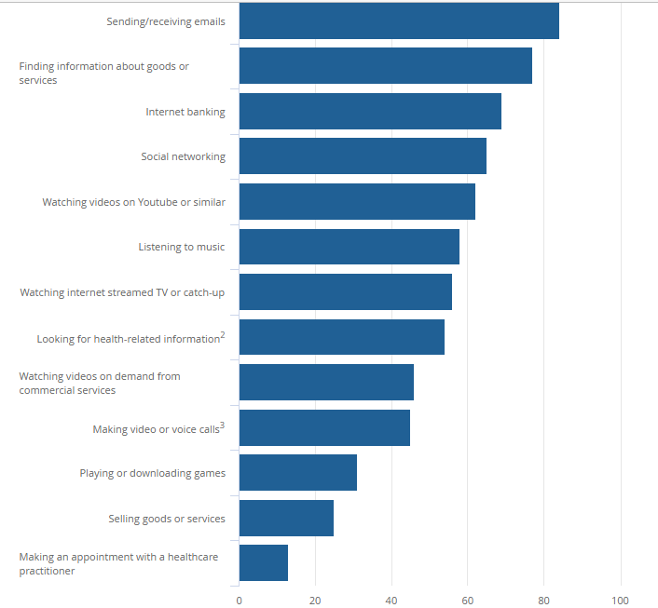
Figure 4: Use of technology by the adults of the UK
(Source: ONS, 2025)
Addressing the Shortfall
The ways the NHS can address these issues include borrowing phones, issuing data packs, and educating the population to adopt digital tools. VOT with a dose of face-to-face assistance of the neediest patients can be better (McIntire et al., 2022). It will lead to a fair, private, and effective treatment.

References
GOV.UK (2024). Tuberculosis treatment and outcomes, England, 2023. [online] Available at: https://www.gov.uk/government/publications/tuberculosis-in-england-2024-report/tuberculosis-treatment-and-outcomes-england-2023 [Accessed 27 Oct. 2025].
GOV.UK (2025). National quarterly report of tuberculosis in England: quarter 4, 2024, provisional data. [online] Available at: https://www.gov.uk/government/statistics/tuberculosis-in-england-national-quarterly-reports/national-quarterly-report-of-tuberculosis-in-england-quarter-4-2024-provisional-data [Accessed 27 Oct. 2025].
McIntire, K., Weis, B., Litwin Ye, L. and Krugman, S.D., 2022. Feasibility of video observed therapy to support controller inhaler use among children in West Baltimore. Journal of Asthma, 59(10), pp.1961-1972.https://www.tandfonline.com/doi/pdf/10.1080/02770903.2021.1984525
ONS (2025). Exploring the UK’s Digital Divide. [online] Available at: https://www.ons.gov.uk/peoplepopulationandcommunity/householdcharacteristics/homeinternetandsocialmediausage/articles/exploringtheuksdigitaldivide/2019-03-04 [Accessed 27 Oct. 2025].
Ravenscroft, L., Kettle, S., Persian, R., Ruda, S., Severin, L., Doltu, S., Schenck, B. and Loewenstein, G., 2020. Video-observed therapy and medication adherence for tuberculosis patients: randomised controlled trial in Moldova. European Respiratory Journal, 56(2). https://publications.ersnet.org/content/erj/56/2/2000493.abstract

Blog 2:Assessing HyperAI Coach in Hypertension Management
Hypertension: A Growing Public Health Concern
Hypertension is one of the significant public health problems. For example, approximately 30% of adults in the UK have this (NHS Digital, 2023). Moreover, many of them are unaware of its presence or lack adequate medication. It may cause kidney failure, stroke and heart disease. It becomes expensive to the NHS when not controlled, and individuals tend to feel okay, which explains the reason why its early discovery and permanent change of habits is very important.
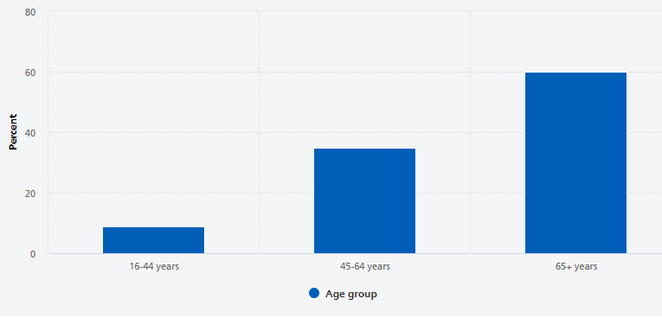
Figure 1: Hypertension’s prevalence by age
(Source: NHS Digital, 2023)
The Technology: HyperAI Coach
The app,which is called HyperAI Coach, could be used either on a phone or a computer (Gujar, 2024). It collaborates with domestic blood pressure devices. It will integratethe Blood Pressure(BP) scores into the application and display the patterns, and also alert whether oneis at a high or a low score. It can provide easy tips regarding salt, physical activity, and weight and invitesone to take medicine. It will also allow one to forward one’s information to the physicians and provide individualised motivation utilising UK health regulations.
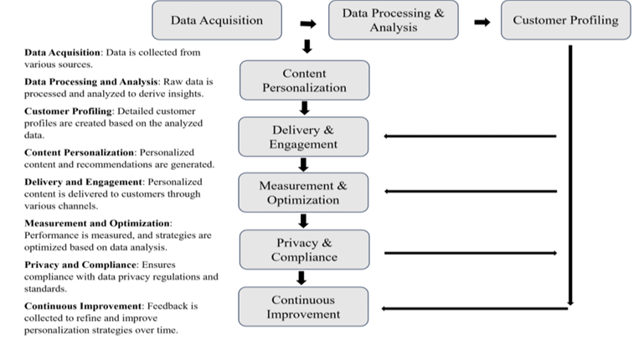
Figure 2: Personalisation Framework for Hyper AI
(Source: Gujar, 2024)
Use in Health Promotion
The application will assist individuals in monitoringtheir BP and educate them on the manner in which to manage it. It will also convert the complex numbers into easy charts and offer brief lessons in habits on a behavioural science basis. It further aids the doctors in identifying high-risk patients. The HyperAI and related digital health tools are predicted to increase in the market by approximately 15.5% CAGR per year (Sawal, 2025). That indicates that there are increasing users of remote health systems and AI wellness applications. These devices can be used to locate hypertensive patients and enhance long-term management.

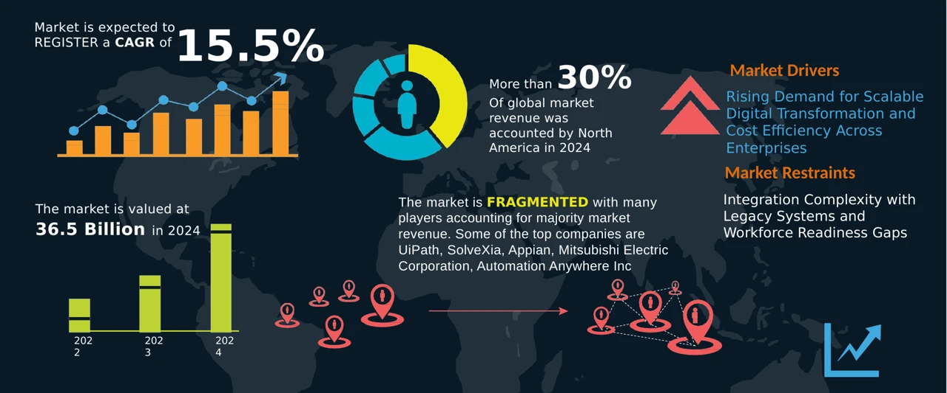
Figure 3: Predicted market growth of HyperAI
(Source: Sawal, 2025)
Critical Appraisal
Advantage
The application may involve a large number of individuals and allow them to remain engaged, identify issues at the earliest stage, and reduce the amount of work that physicians perform (De Silva et al. 2025).
Disadvantage
However, there are issues: it might be overlooked by older or less technology-aware individuals; the devices will not necessarily read properly; users might be intimidated by excessive notifications; and certain concerns about data security can be expressed (Gujar, 2024).
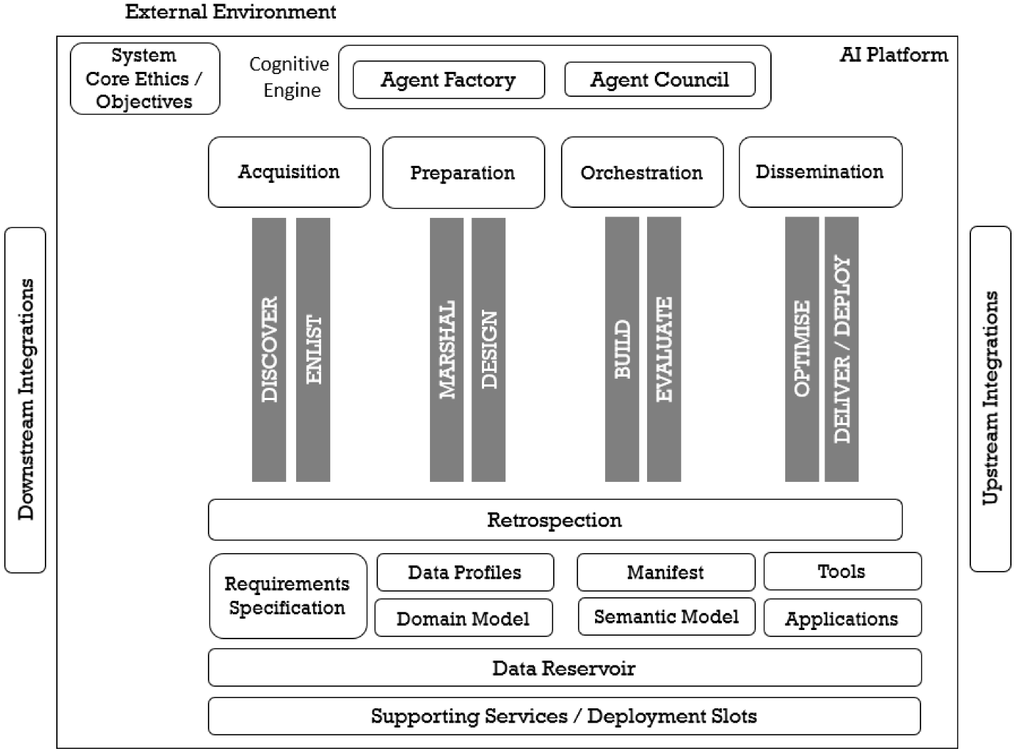
Figure 4: HyperAI Ecosystem for a scalable technology solution
(Source: De Silva et al. 2025)
Addressing Shortfalls
The fixes to these problems include the provision of simple-to-use devices and presentation of simple and multi-language screens. This would be the imaging of the information by doctors and the enhancement of cybersecurity (Sahoo, 2025). It will also ensure that the service is available to everybody via the local programmes and national support.

References
De Silva, D., Mills, N., Moraliyage, H., Rathnayaka, P., Wishart, S. and Jennings, A., 2025. Responsible artificial intelligence hyper-automation with generative AI agents for sustainable cities of the future. Smart Cities, 8(1), p.34.https://www.mdpi.com/2624-6511/8/1/34
Gujar, V., 2024. AI Camera: Unique Technique to Hyper AI Personalization for Malls. International Journal of Science and Research (IJSR), 13(4).https://www.researchgate.net/profile/Vivek-Gujar/publication/379757135_AI_Camera_Unique_Technique_to_Hyper_AI_Personalization_for_Malls_IndoAI_Case_Study/links/6618b5cef7d3fc28744321e4/AI-Camera-Unique-Technique-to-Hyper-AI-Personalization-for-Malls-IndoAI-Case-Study.pdf
NHS Digital (2023). Adults’ health: Hypertension. [online] Available at: https://digital.nhs.uk/data-and-information/publications/statistical/health-survey-for-england/2021-part-2/adult-health-hypertension [Accessed 27 Oct. 2025].
Sahoo, D., 2025. Chapter-6 The Rise of Intelligent Hyper-Automation: Reinventing Business with Artificial Intelligence (AI) & Machine Learning (ML). AND PRACTICE OF, p.129.https://www.andhraloyolacollege.ac.in/mba_books/Principles,%20Fundamentals%20AND%20PRACTICE%20OF%20MANAGEMENT.pdf#page=134
Sawal, J. (2025). Hyperautomation Market Size USD 22.84 Bn by 2027 | CAGR of 18.2%". [online] www.emergenresearch.com. Available at: https://www.emergenresearch.com/industry-report/hyperautomation-market [Accessed 27 Oct. 2025].

