December 2020

Oana Maria Shega 1921778
Lecturer: DR. Olusoyi Ashaye
University of Wales Trinity St. David
Digital Skills and Research Methods
BMSW4003_LON

Abstract
The aim of the research is to investigate into the benefits and usefulness of VLE Moodle as an online learning and teaching platform offered by the UK universities. Both primary and secondary investigation have been carried out, and quantitative data analysis have been conducted to accomplish the research objectives. The findings suggest that VLE Moodle is a user friendly, responsive, secured and well-built platform that improves engagement and productivity of the learning process, and thus, offers a great learning experience to the students. However, the platform can be well-organised and easily accessible to the students. If the platform is further improved, it can deliver greater engagement rate.

Table of Contents
Abstract 1
1.0 Introduction 3
2.0 Background 3
3.0 Aims and objectives 5
4.0 Research methodology 5
5.0 Results of primary data investigation 6
6.0 Discussions 13
7.0 Conclusion 15
References 16
Appendix 17
Questionnaire: 17

1.0 Introduction
The following research report presents discussions on the impact of Virtual Learning Environment- Moodle as a tool for enhancing the student’s learning journey and experience as a whole. The University of Wales Trinity Saint David London Campus provides its students with the access to the VLE Moodle to make their learning journey more dynamic, digitally empowered and productive. The use of Moodle in students’ learning journey has long been acclaimed by both teaching professionals and students (Barker and Gossman, 2017). However, this research report will have a look at the actual impact of this digital platform using both primary and secondary data findings to make a more conclusive and objective view on this issue.

2.0 Background
VLE Moodle is an example of how digital technology is revolutionizing the education sector in the UK. The benefits of this platform has been documented in many studies in the recent years. The platform continues to innovate learning experiences for the students in the UK.
Jenny Barker and Peter Gossman’s (2017) article titled “The Learning Impact of a Virtual Learning Environment: Students’ views” revealed some useful and insightful findings on the impact of VLE on students. The article includes findings of the survey conducted on 250 second year students. The aim of the study was to investigate if the use of VLE Moodle had positive impact on the learning experience of the students; if the VLE use had encouraged independent learning; and if the VLE Use had contributed to students’ motivation in learning activities. The findings of the survey revealed that the use of VLE-Moodle did relate to the significant improvement of learning experience and students’ motivation. The findings had also indicated positive impact on the teachers’ motivation in teaching and their involvement with the students in the learning and teaching journey (Gitlin, 2019). The study concluded that the teaching professions recommend the use of VLE as the necessary means for improving the learning experience. However, while this is a good thing, it should also be noted that the dependency on this can often discourage students from attending the classes and lecture seminars (Dragan Cvetkovic, 2019).
According to Carmein (2018), one of the ways in which VLE Moodle enhances the learning experience is by allowing real time collaboration, which otherwise, would not have been possible. The study also suggests that one of the achievements of this platform has been its ability to satisfy the needs of learners with different learning styles. The failure to address the needs of the different styles of learners could have been a major setback to the educational system, which has been solved by VLE. To understand why, one should look at the benefits of this platform. There are students with different learning styles and preferences (Smale and Fowlie, 2015). Class room activities or usual lecture sessions would not have helped everyone the same way because not everyone learns the same way.
Another study by Carnegie et al. (2019) revealed the sustainability aspect of learning by using VLE. The study finding suggests that the use of VLE has made significant achievements in terms of the sustainability practices in the educational sector. The platform minimizes the need for resources that leaves high carbon footprint, and its design helps students to achieve energy efficiency in learning as well (Carnegie et al., 2019). Therefore, in terms of sustainability, the platform has made great impact to the learning experience in a positive way.
The study conducted by Kalayci (2015) reveals the platform’s contribution to the students’ behaviours and attitudes towards collaboration. The findings suggest that the platform has improved the collaboration between the teachers and students in a significant way. However, the study also shows that the platform has affected the real time collaboration between students in a negative way. Because of this platform, some students prefer to go through their learning activities by themselves rather than collaborating with other students, unless they are attending to any group projects. The study recommends that the platform should have features that will allow real time virtual collaboration between students. The platform could include games or stimulation that the students need to attend to on different stages of their learning journey. This is one way to improve the platform for the students (Barker and Gossman, 2017). Without such platform, it wouldn’t be possible for them to keep track of all the materials from different weeks and use them in a responsive way when working on summative tasks.
In overall, the findings of the secondary data investigation suggest that the platform adds significant value to the learning experience in general. The development of this platform has highly improved the learning and teaching experience in the universities. More so, the platform is continuously getting improved to incorporate new features and new conveniences. There is no doubt that VLE Moodle is the perfect example of how digital technologies are enhancing the education system in the UK.

3.0 Aims and objectives
The research aims to present objective findings on the impact of Virtual Learning Environment- Moodle as a tool for enhancing the student’s learning journey in the UK universities.
The following objectives will be addressed in this study;
1. To explore the benefits of VLE Moodle in the teaching and learning process.
2. To investigate into the benefits of VLE Moodle as a communication and information exchange platform for students.
3. To explore the technical aspects of this digital learning platform in the perspective of the students.
4. To present the data findings in a comprehensive way.

4.0 Research methodology
The research aims to present objective findings on the impact of Virtual Learning Environment- Moodle as a tool for enhancing the student’s learning journey. Thus, the study is based on positive research philosophy.
The research data have been collected from both primary and secondary data sources. Primary sources include a sample group of students of the University of Wales Trinity Saint David. The sample population has been selected using convenience sampling method, which involves selecting the sample group of respondents based on the convenience in terms of accessibility. Since these are the time of pandemic, therefore, the convenience sampling method makes the most sense (Carnegie et al., 2019). For the primary data collection, the students have been surveyed using a structured questionnaire, distributed to them online by sharing the Google forms link. The sample size for the questionnaire survey is 100.
The secondary data for this research have been collected from the university sources, recent peer review journal articles and already published survey findings by renowned research groups. To gather valid and reliable secondary data, I have only selected sources that are on the relevant topic, and have been published within the last three years.
The collected primary data have been analysed statistically, and thus, the findings of frequency analysis have been presented in this report. The collected secondary data, on the other hand, have been analyzed to find common themes and patterns on this topic.
In compliance with the data regulations, the names of the respondents have been excluded from this report, and the researcher avoided collecting any other personal information from them.

5.0 Results of primary data investigation
An almost balanced number of students from different levels of their education had participated in the survey, which adds to the presentability of the survey findings.
1. VLE-Moodle makes the access to learning resources easier.
Strongly Agree | 48%
Agree | 49%
Neutral | 0
Disagree | 1%
Strongly disagree | 2%

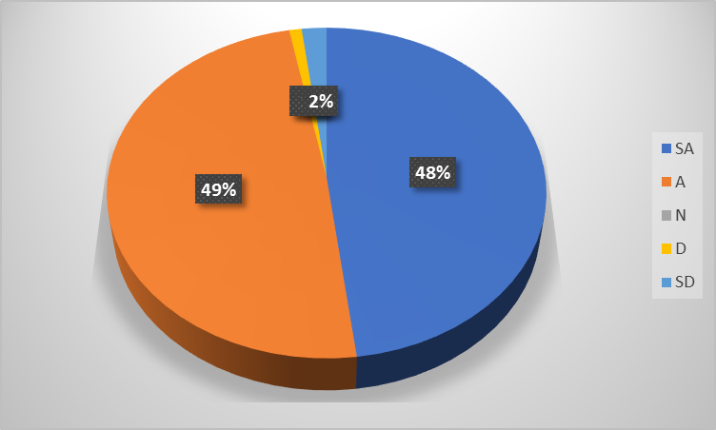
Figure: Responses gathered on VLE-Moodle making the access to learning resources easier
2. VLE-Moodle makes learning more responsive.
Strongly Agree | 52%
Agree | 45%
Neutral | 0
Disagree | 1%
Strongly disagree | 2%

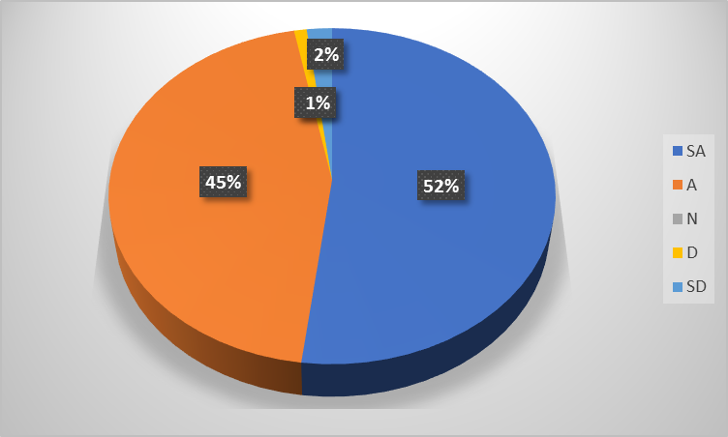
Figure: Findings on the VLE-Moodle making learning more responsive
3. VLE-Moodle makes learning more engaging.
Strongly Agree | 55%
Agree | 42%
Neutral | 0
Disagree | 1%
Strongly disagree | 2%

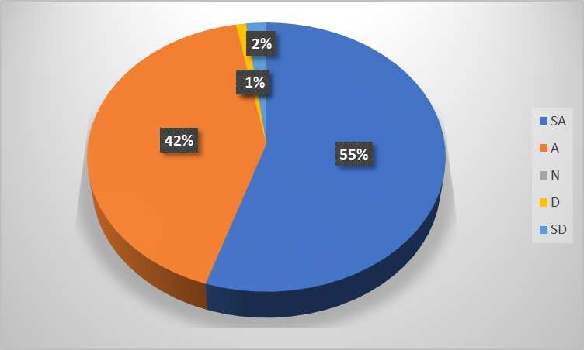
Figure: Findings on VLE-Moodle making learning more engaging
4. VLE-Moodle helps with the communication with the academic officials and teaching professionals whenever needed.
Strongly Agree | 57%
Agree | 39%
Neutral | 0
Disagree | 2%
Strongly disagree | 2%

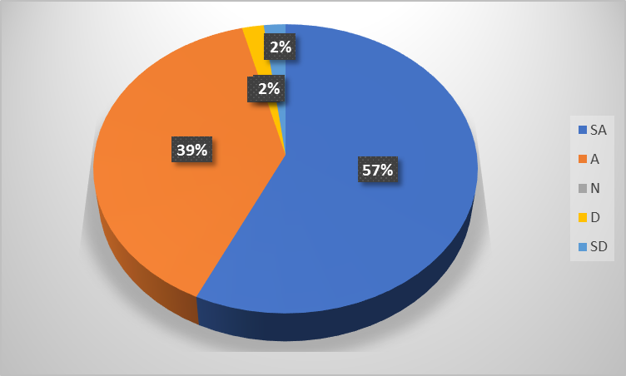
Figure: Findings on VLE-Moodle improving the communication
5. VLE-Moodle saves time and makes learning more productive.
Strongly Agree | 61%
Agree | 38%
Neutral | 1%
Disagree | 0%
Strongly disagree | 0%

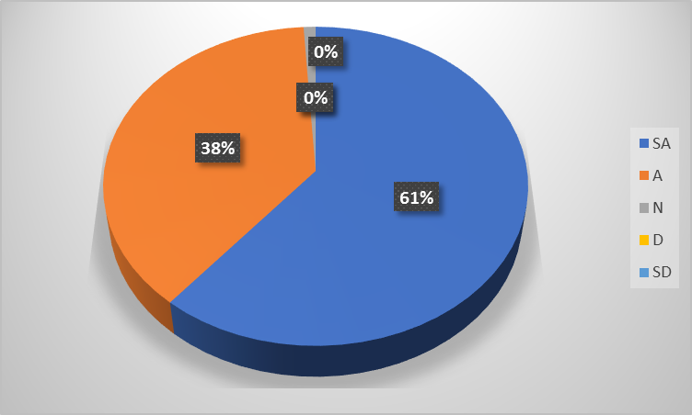
Figure: Findings on VLE-Moodle saving time and making learning more productive
6. VLE-Moodle makes the submission of tasks safer and more secured.
Strongly Agree | 48%
Agree | 49%
Neutral | 1%
Disagree | 2%
Strongly disagree | 0%

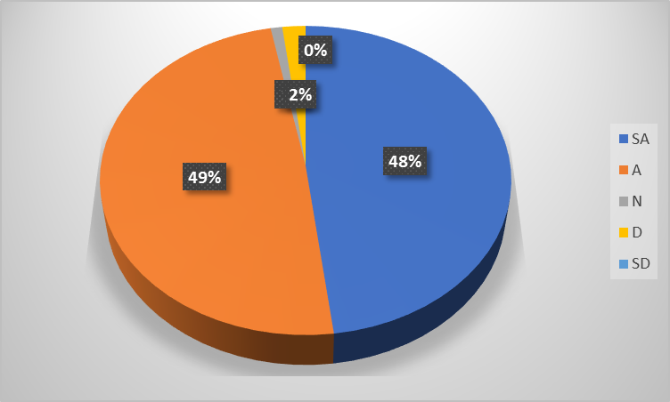
Figure: Findings on VLE-Moodle making the submission of tasks safer and more secured
7. VLE-Moodle has a user-friendly interface.
Strongly Agree | 18%
Agree | 39%
Neutral | 9%
Disagree | 32%
Strongly disagree | 2%

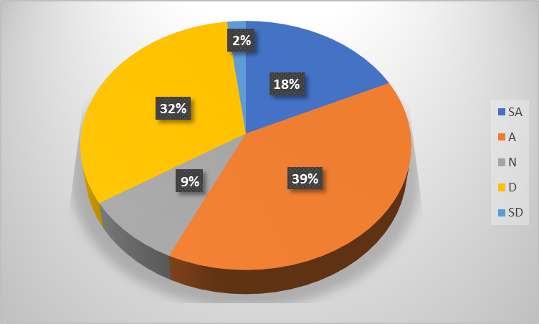
Figure: Findings on VLE-Moodle having a user-friendly interface
8. VLE-Moodle helps contribute to academic discussions.
Strongly Agree | 38%
Agree | 49%
Neutral | 9%
Disagree | 3%
Strongly disagree | 1%

Figure: Findings on VLE-Moodle helping contribute to academic discussions

6.0 Discussions
The students were first asked about whether VLE Moodle has improved the access to learning resources or not. As the data above shows, most of the students stated that the platform is very accessible. Only about 2% of the students stated that the platform should do more to improve its accessibility features. However, it is obvious that this digital platform does make learning resources more accessible to students.
The students were asked whether or not VLE Moodle makes learning more responsive. More than 97% of the students agreed or strongly agreed that the platform is in fact responsive in terms of learning activities. Which means the students can take help from any materials from any learning week when working on a particular topic (Gitlin, 2019).
The reason why this question has been asked is that engagement and responsiveness are not both the same. Engagement means whether the students are made more engaged to the learning activities with the use of VLE Moodle platform. When asked about this, 97% of the students agreed that the platform does make learning experience more engaging. For example, they can learn from the available learning resources any time they want to, without facing any barriers. They also stated how the platform makes it more engaging to learn by promoting self-managed learning activities (Keppell, Souter, Riddle and Tynan, 2014).
The students often need to communicate with the staffs or teaching professionals but the distance or the circumstances could not have allowed them to communicate with them on time, if not the platform was there. Moodle allows the students to communicate with their teachers and university staffs when they need to, and thus, solve the problems they are facing (Keppell, Souter, Riddle and Tynan, 2014). This is definitely one of the most significant benefits of the platform to the learning experience of the students.
Productivity is related to the outcomes of learning. Almost all the students agreed that the platform improves the productivity of learning. Moodle includes resources and materials of different types that the students of different learning preferences and needs will find useful. This is how the learning is made more productive by VLE Moodle (Skoyles, Bullock and Neville, 2019). Moreover, the platform allows the students to explore materials outside the class lectures or core texts, which also improves learning experience by making the information collection process more efficiency and productive.
One of the problems that students would have faced without a platform like Moodle is the submission of tasks or papers (Smale and Fowlie, 2015). Through Moodle, they can easily submit the tasks without having to worry about their files being accessed by third parties. Moreover, they can use this platform for Turnitin submission. Thus, the students can use this platform to exchange the files in a safer and secured manner.
When asked about the user-friendliness of the interface, the responses were quite diverse. Many students stated that the interface is quite user-friendly, whereas many other stated that the interface is not user-friendly. This shows that the interface is not perceived the same way by everyone. There are definitely ways to improve the interface more to improve the learning experience of the students. Often times, the lack of user-friendly interface can discourage the students from navigating the links to collect the materials and resources, which can affect their learning outcomes (Keppell, Souter, Riddle and Tynan, 2014). Therefore, focus should be made on this area.
One of the principles of modern educational sector is that the learning and teaching experience should be interactive. VLE Moodle has been designed in a way that students can also participate in different academic discussions and contribute to the various planning and undertakings. This may not be directly linked to the learning experience, but this does contribute to the students’ experience (Ismail, 2019).

7.0 Conclusion
The use of digital platforms such as VLE Moodle has been a great advancement in the educational system. It has made learning experience more motivating, engaging, value adding, sustainable and interactive for both students and the teachers in their teaching practices. The VLE definitely needs to go through some improvements as well. The platform should be made more user friendly and resourceful for the students of different learning styles and preferences.

References
Barker, J. and Gossman, P., 2017. The Learning Impact of a Virtual Learning Environment: Students’ views. Teacher Education Network Journal, 5(2).
Carnegie, S., Done, J., McMillan, K., McMillan, K. and Trought, F., 2019 Developing Your Skills.
Dragan Cvetkovic, 2019 Virtual Learning.
Gitlin, M., 2019 Virtual Learning.
Ismail, S., 2019. Using a Virtual Learning Environment for Problem Based Learning (P.B.L). SSRN Electronic Journal,.
KALAYCI, S., 2015. Students’ Attitudes Towards Collaborative Tools In A Virtual Learning Environment. EDUCATIONAL PROCESS: INTERNATIONAL JOURNAL, 4(1-2), pp.71-86.
Keppell, M., Souter, K., Riddle, M. and Tynan, B., 2014. Physical And Virtual Learning Spaces In Higher Education. Hershey: IGI Global.
Sadeghzadeh, S., 2019. Energy-Efficient Algorithm for Mixed-Criticality Systems in E-Learning Environment. Interdisciplinary Journal of Virtual Learning in Medical Sciences, 10(2).
Shandilay, D., 2018. Virtual Learning Environment Scenario in Higher Education (Web-based Learning). International Journal Of Management And Economics Invention, 04(05).
Skoyles, A., Bullock, N. and Neville, K., 2019. Developing Employability Skills Workshops for Students’ Higher Education Achievement Reports. New Review of Academic Librarianship, 25(2-4), pp.190-217.
Smale, B. and Fowlie, J., 2015. How To Succeed At University. Los Angeles: SAGE.

Appendix

Questionnaire:
The impact of Virtual Learning Environment (VLE) on
Student Learning Experience
This questionnaire is intended only for academic purpose and all the given details will be treated with confidentiality.
Section A: general information
(optional)
Name and surname:
Age:
Gender:
University name
University year:
Section B: Questionnaire
Please answer the following questions appropriately to your experience, where (5) is strongly agree and (1) is strongly disagree.

Questions | Strongly agree (5) | Agree (4) | Neutral  (3) | Disagree  (2) | Strongly disagree (1)
1. VLE-Moodle makes the access to learning resources easier. | 5 | 4 | 3 | 2 | 1
2. VLE-Moodle makes learning more responsive. | 5 | 4 | 3 | 2 | 1
3. VLE-Moodle makes learning more engaging. | 5 | 4 | 3 | 2 | 1
4. VLE-Moodle helps with the communication with the academic officials and teaching professionals whenever needed. | 5 | 4 | 3 | 2 | 1
5. VLE-Moodle saves time and makes learning more productive. | 5 | 4 | 3 | 2 | 1
6. VLE-Moodle makes the submission of tasks safer and more secured. | 5 | 4 | 3 | 2 | 1
7. VLE-Moodle has a user-friendly interface. | 5 | 4 | 3 | 2 | 1
8. VLE-Moodle helps contribute to academic discussions. | 5 | 4 | 3 | 2 | 1

