Student name: Clare Ghigo 2115757
Date: 9th January 2023
Module BMPF7008: Work-based learning project.

Contents:
- Project proposal form
- Project report:
- Introduction
- Literature review
- Methodology
- Findings
- Discussion
- Conclusion

Project Proposal
Researching the acoustical impact that Cervical/ Lumbar imbalance leaves on singers suffering with Lordosis/Kyphosis

1.The Context
In recent years several studies have emerged addressing the importance of holistic practices such as musculoskeletal therapy, Pilates, Yoga and Alexander Technique for singers and their effect on voice production (Cuddy & Gaskell, 2020; Green, 1998; Schneider et al., 1997). This ongoing research is showing the usefulness of manual therapy such as stretching and corrective movement for pain management in singers (Cardoso et al., 2017; da Cunha Pereira et al., 2018; Rubin et al., 2007). The general statistics, dealing with patients suffering with both spinal issues and voice loss, show the need for further investigation on the subject (Carneiro& Teles, 2012; Franco et al., 2014; Karulkar et al., 2021). Currently, singers suffering from slight postural imbalances such as Cervical Kyphosis and Lumbar Lordosis do not find specific localised treatments aimed at patients having spinal issues. These imbalances, which do not allow the singer to achieve optimal posture, create havoc on sound production due to cervical restrictions (Sabatucci et al., 2015). Although postural awareness has been addressed in research, remedial rehabilitation has so far been non-specific (Cardoso et al., 2019). The aim of this research is to observe the behavioural impact of spinal issues such as Cervical Kyphosis and Lumbar Lordosis and how these might influence the singer’s acoustics.

2.The Justification
Current studies that, focus on the importance of posture in singers, seem to provide indicators but do not suggest any rehabilitative exercises that can be introduced to singing (Lloyd et al., 2017; Rubin et al., 2004).
Having worked in the industry for over eight years, I have observed several singers suffering from such conditions at the cost of not finding sufficient remedy that can help them directly with their singing performance.
Therefore, I am undertaking this research to understand how simple stretches may be able to free up spinal tensions created by cervical/ lumbar imbalances and monitor any acoustic changes via computerised readers such as Voce Vista
3. The Intended Impact
Making singers aware of postural alignment is key when dealing with foundational issues. By designing simple stretches (Spence, 2008) Postural Restoration Institute (Hruska.,2020) yoga poses (Lloyd et al., 2017) and simple stretches, I aim to monitor the participants’ acoustical voice and projection patterns. A broader observation and awareness of these two conditions can benefit by providing structured guidelines, which can aid to release discomfort in performers suffering from these specific conditions (Carman, 2004; Chopp-Hurley et al., 2018; Lloyd et al., 2017).

4.The Outlined Intent.
- Five participants will be chosen via snowball sampling method. (Allibang, 2020).
- A blog post will be created and posted on social media channels.
- A questionnaire will be given to the participants chosen by a cross sectional study and on basis such as issues with the: spine, voice ranges, sex, breath issues and other conditions that apply to this study.
- Methods will be designed for both virtual and in-person students.
- A variety of photographs and measurements will be requested from the participants, such as the length of the spine, hip to shoulder, ear to jaw on both sides. Side jaw/ TMJ (temporomandibular joint) issues will be observed.
- Each session will be approximately 30 minutes weekly for five weeks.
- Voice efficiency such as duration of power will be monitored via PRAAT.

5. Ethics
- The research will be conducted with the participants’ written consent.
- Sound evaluation will be used solely for the research’s purposes and strict confidentiality will be adhered to.
- The methods designed and used will be non- invasive and tailored for each participant to maintain moral values and dignity (Alibang,2016).
- It will be ensured that the results will be unbiased for transparent outcomes.
- Results will be communicated with the participants and the participant’s details will remain anonymous to comply with the confidentiality clause. Being an insider researcher might create conflict due to familiarity and due to the sensitivity of the subject (Saidin, 2017: Costley. Elliott, & Gibbs, 2010).
- However, being an insider researcher, I need to make sure to evaluate of all possible outcomes than the results that I envisage upon the project.

6.Personal Learning Outcomes
• To be able to design simple stretches that can be incorporated with singing exercises.
• Deepen my knowledge on the importance of postural alignment and its effect on sound production.
• Better understanding of available therapeutic methods and practices.
• Further my knowledge on the function of the cervical spine and if it might impact the singer’s acoustics. I aim to create simple stretches that can also help other teachers, when faced with any of these issues in their students.

Project Report
Project Title: Researching the use of simple stretching exercises and observing their acoustical impact that Cervical/ Lumbar imbalance leaves on singers suffering with Lordosis/Kyphosis.

Introduction
Researching the possible impact that spinal misalignments might leave on singing which is reflected the singing’s acoustics has been an interest of mine, for a long time. This is because I have suffered from cervical Lordosis and rib misalignment which created difficulty in voice production. I started researching the importance of alignment maintenance and rehabilitation exercise to sing pain free.
The project will examine a group of five professional singers from a cross-sectional study of backgrounds and to:
- assess their posture,
- analyse their voice’s acoustical frequency using PRAAT (phonetic analysing software)
- introduce weekly rehabilitative exercises that they can add to their singing practice
and,
- monitor any changes.

It is required to observe if:
- there were acoustical changes,
- the was singer able to replicate the exercises without assistance,
- these rehabilitative exercises can improve and become more integrated with the daily singing practice routine.
The learning outcomes of the project include:
- Understanding the dynamic patterns of the participants’ alignment and address if/any common misalignment factors.
- Creating different postural and alignment exercises that can be done without any assistance, and which target a variety of spinal issues.
- Observing the outcome that the rehabilitative exercises might have on the voice.

Literature review
Postural-related pain in singers
Muscular and postural-related pain in musicians caused by the nature and intensity of the job is a well-documented factor (Davies, 2020). Musicians tend to suffer from musculoskeletal pain due to muscle endurance when playing an instrument and/ or singing which puts pressure on postural alignment (Cardoso et al., 2017). Although the general conception of pain free playing correlates with an optimal posture gained with a good technique, this is not always the case.
Even though musicians have postural awareness that enables them to perform, the body requires a certain strength and stamina to maintain structure and keeping a constant optimal posture. But according to Davies (2020) and Phelan (2021) maintaining such conditions is somewhat impossible. As Friendlander (2018.p.52) proposes: ‘Alignment is inherently dynamic and therefore cannot be defined as an ideal posture (…).’
The literature that targets the importance of alignment for singers is truly vast and studies shown observing a myriad of changes in postural composition and how it affects the voice. Such studies include seated versus standing, and the assessment of head flections in opera singers (Asher, 2009; Knight & Austin, 2020, Bruno et al., 2009; Johnson & Skinner, 2009b; Longo et al., 2019; Rubin et al., 2004a; Sabatucci et al., 2015; Sundberg et al., 1991) . As a result, the literature show that in their work, singers use similar muskoloskeletal biomechanics to athletes, such that the singer relies on the body’s postural efficiency to function and any slight muscular tension or compensation creates an imbalance in the system (Friendlander, 2018).
One of the most common spinal disabilities diagnosed in a wide range of societies worldwide, deals with chronic lumbar (low back) pain (Karimi et al., 2021). Postural imbalances such as Kyphosis and Lordosis contribute to neck and shoulder stiffness, and back pain. These are among the most common conditions from which musicians suffer (Scotto di Carlo, 1998).
Lumbar Lordosis refers to the curvature of the lower part of the spine such that it arches the back, thus restricting the diaphragm. This, hence, negatively affects the breathing processes since the diaphragm is the major respiratory muscle (Malde, Allen, & Zeller, 2020).
On the other hand, Kyphosis refers to a sunken chest resulting in upper back curves, thus inhibiting the chest muscles function optimally (Calais-Germain, 2016). Both conditions result in spinal curvatures that compromise the body in order to function (Sparrey et al., 2014). Therefore, compromised postures such as Kyphosis and Lordosis impact the efficiency of the vocal technique and create unnecessary challenges on the voice production (Scotto Di Carlo, 1998).
Remedies for singers
Recent research findings regarding therapeutic methods such as physiotherapy, yoga, Pilates, and Alexander Technique have shown a positive impact in alleviating the strenuous muscular effect that a compromised posture creates (Bruno et al., 2009; Cardoso et al., 2017; Carman, 2004; Green, 1998; Lloyd et al., 2017; Mezzedimi et al., 2019b). The scope of these therapies lies in restoring bodily functions. A study dealing with the use of physiotherapy in singers suffering with Kyphosis and Lordosis showed that the alignment is not necessarily linked to their level of skill but mainly related to the repetitive (adaptive) use of the maladaptive position. Therefore, the spinal imbalances can also be a contributing factor impacting one’s lifestyle (Martins et al., 2014; Schneider et al., 1997). The common localised therapies applied to patients with Lordosis and/or Kyphosis were physiotherapy and manipulative techniques which prove to be beneficial in restoring alignment (Cuddy & Gaskell, 2020; Green, 1998).
Furthermore, singers that practised holistic-based activities such as Alexander Technique, yoga, and Pilates improved their postural awareness and adopted a better one (Asher, 2009).
Spinal assessment.
Being aware of the spinal issues that singers with Kyphosis and Lordosis suffer from, the scope of the study was to investigate existing singing posture related to static stretches and compare them to postural maintaining exercises derived from Pilates, Yoga, Alexander Technique, Longitudinal Osteo-Articular Decoaptation (ELDOA), and Postural Restoration Institute (PRI).
A common factor that emerged in examined disciplines is the practice of an initial assessment. According to the literature, the postural/ rehabilitative examination in singing is measured by observing the standing posture (Friendlander, 2018). The pedagogical literature addresses the postural imbalances such as Kyphosis and Lordosis but overlooks these issues’ assessment from an active (varying) posture (Daniels & Rosenberg, 2021).
In Pilates, Alexander Technique, Yoga, ELDOA, and PRI the posture assessed statically and dynamic. One common example of a risk-free spinal examination is called gait assessment. This type of assessment deals with the patient’s walking pattern and is widely used by PRI, Chiropractors, Physiotherapists and General Practitioners (Manickam & Gardiner, 2021; Rahmatalla et al., 2005; Sweeting & Mock, 2007). Gait assessment is effective because it addresses two components; firstly, the movement of the foot on the floor from heel strike to toe off (also known as ‘stance phase’) and secondly ensuring the forward movement from toe off to next heel strike (also known as ‘swing phase’) (Manickam & Gardiner, 2021).
People suffering from Lordosis and/ or Kyphosis would usually show a constricting movement in the swinging phase (Hruska, 2020). The swinging phase is what enables the person to shift weight from one leg to the other and breathe efficiently (Cantrell, 2011; Schneider et al., 1997; Sweeting & Mock, 2007). Examining swinging motion in singers gives the practitioner insight into positioning of the singer’s diaphragm and therefore, due to its rigid nature static postural assessment might not be an efficient enough tool for a teacher. However, one must keep in mind that even gait assessment does not provide direct conclusions and can result in negatively affecting one area whilst compensating another (Sweeting & Mock, 2007). Therefore, being a certified Yoga Teacher and gaining Postural Restoration Institute accreditation, I included this practice as a pre- examining phase which gave me a clear indication of any spinal imbalances, postural traits and muscular weaknesses which might impact the voice.
Apart from the walking pattern exercise, static exercises were also included, so that the available rehabilitative practices could be explored further. Static stretches which are simple localised stretches have proven to help singers by providing a range of motion and flexibility of the muscles (Schneider et al., 1997). Pilates, Yoga and ELDOA practices focus on the elongation of the vertebrae and on the creation of vertebral room so that the joints can function more freely (Shafaq Shahid, 2021). Apart from aiding in the release of tension, static exercises increase bodily awareness, so that singers can have a more conscious posture to ensure optimal alignment.
A pre-Pilates technique that helps a patient recognises their starting position is known as imprinting (Asher, 2009; Green, 1998; Mezzedimi et al., 2019b; van der Linden et al., 2011). Similar to the principles in PRI, Pilates aims to observe bodily patterns to strengthen weak core muscles (Cuddy & Gaskell, 2020; Green, 1998).
A comparable exercise to imprinting which is practised in Pilates, Alexander Technique and in Postural Restoration Institute, is called the stance. The stance is a static exercise that allows the body to distribute the weight accordingly (Thompson, Thompson, & Lewis, 2018) . In Pilates, the notion of stance is known as neutral position, whilst in PRI the stance is used to read the patient’s alignment and its variation so that the patient finds more connection to the floor (Eliks et al., 2019; Mezzedimi et al., 2019a). Due to its neutral state, there are no evidence showing that the stace pattern could be limiting or induce any risk. Even more so, in Alexander Technqiue, the stance is used to map the body’s pattern of weight distribution. Therefore, this posture (as shown in Figure1) was used as a rehabilitative exercise because of its neutral and efficient state.
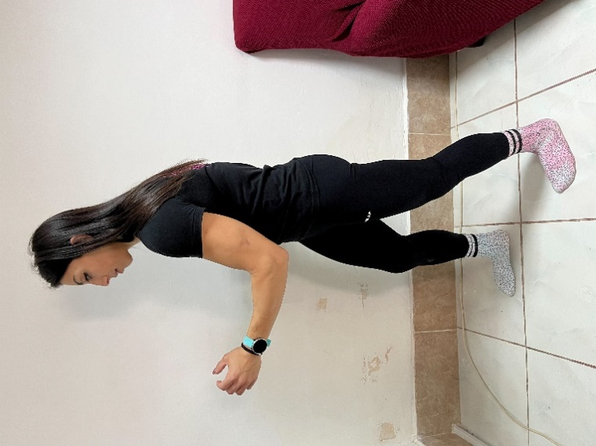
Figure 1: Stance exercise (Ghigo, 2023).

Moreover, this posture can be practised without the aid of a trainer and is a comfortable enough posture to sing in. The static stretches suggested by Daniels and Rosenberg (2021) are more complicated to be used whilst singing and were mainly targeting a particular muscular tension.
Rehabilitative Exercises
Another vital exercise that addresses tension is monitoring stability. It is important for a singer to be able to maintain a dynamic still posture to be able to deliver long phrases efficiently (Friendlander, 2018,; Thompson, Thompson, & Lewis, 2018). The pedagogical nature of the singing skill suggests that the singer’s ability is monitored through the efficiency of breath management and the strength of the acoustical core of the sound (Salomoni et al., 2016).
The ability to stabilise an optimal posture can also be monitored by addressing the complex position of the pelvis (Savage et al., 2021). This is because the interconnectivity of the breathing system needs to be monitored from the base of the spine up to the larynx. (Hruska,2021).
A risk-free exercise that addresses muscular weakness and tension is a leg balance. Figure 2 shows the balancing on one leg with a rounded spine. In Postural Restoration Institute, this exercise reveals the patient’s favoured side (right or left), spinal traits and the pelvis position. Similarly, Alexander Technique, yoga and Pilates all emphasise the importance of balance exercises which enhance muscular and postural stability and core (pelvis) strength (Cuddy & Gaskell, 2020; Green, 1998; Klein et al., 2014).
Figure 2: One leg balance movement (Ghigo, 2023).
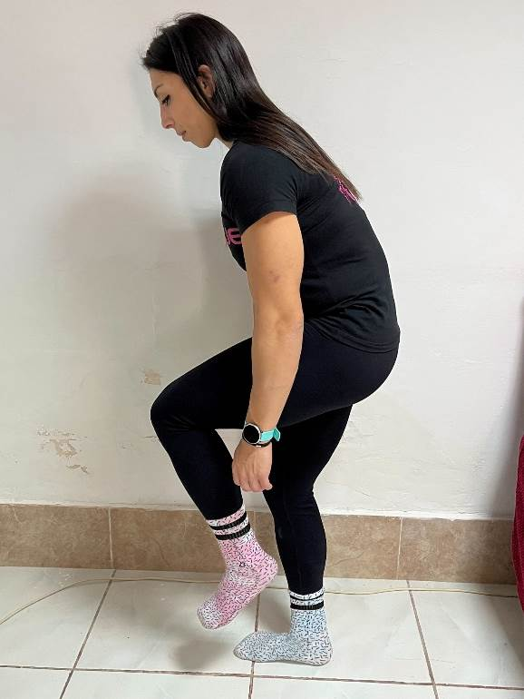

In PRI the balance exercise shows (Hruska, 2018):
- The hip joint’s neutral position
- The position of the cranium
- The position of the diaphragm, ribs, and sternum (thus addressing spinal rotation)
- The ability of the body to remain neutral (centred).
Similarly, body mapping literature, shows that the body has six core points of balance which are listed hereunder (Malde, Allen, & Zeller, 2020; Friendlander, 2018; Daniels and Rosenberg, 2021): -
- Head/ neck balance AO joint
- Arm and shoulder region
- The thorax and lumbar spine relationship
- The hip joint and its relationship with the spine
- The knees
- the arch of the foot and the ankle.
Whilst there are slight differences in these literatures, the main balance component remains the same. The stability exercise is a non-invasive way of understanding the patient’s spine and pelvis connection (Friendlander, 2018). Patients suffering from severe lumbar Lordosis are for the most part, unable to balance on one leg because the common pelvis position is tipped forward thus disabling the glute muscles to efficiently balance the pelvis (Hruska 2017).
According to Postural Restoration Institute, the pelvis tipping forward position is referred to as PEC (Posterior Exterior Chain), which indicates the forward placement of the pelvis (Hruska, 2017). In this position, the pelvis constricts the movement of the torso, which results in rib flaring. This is a condition emerging out of core weakness and instability, person is supported only by the heels, ending up prone to inkling backwards (Savage et al., 2021). To combat the issue, widely used counter pose is the functional squat (Figure3), or the squat with a rounded back. This puts the pelvis in a position which enables air efficiency and could in turn, help a singer with a compromised spine to manage their breathing and respiratory processes more efficiently (Hruska, 2017).
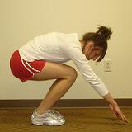
Figure 3: Functional squat, with a round back and neutral neck (Hruska, 2008).

In my experience, most pedagogues are not capable of helping students with such spinal issues. This is mainly due to the complexity of the anatomy and the physical limitation that some practices have gathered (Chopp-Hurley et al., 2018; Cuddy & Gaskell, 2020; Hunt, 2010). Although pedagogues overlook the connection between weak pelvic stability and vocal production, the uncorrected misalignment might in time, induce vocal dystonia due to the diaphragm’s instability leading to the inability to use the manage the breath efficiently (Cloward, 1988; di Carlo, 1998b). Even more so, the inability of balancing on one leg also reveals the possible misaligned positioning of the diaphragm and Hruska (2017) states that:
‘Posture is the reflection of patterned airflow’.
Airflow is a reflection of the “position” of many systems that are regulated, determined and created through limited functional patterns. These patterns reflect our ability and inability to breathe, rotate and rest symmetrically.
Therefore, in PRI the diagnosis for Kyphosis/ Lordosis is determined by the inability to breathe efficiently due to displacement of the diaphragm and the inability to have optimal ZOA (zone of Apposition). Kyphosis and Lordosis are spinal curvatures which deal predominantly with the placement of the diaphragm, torso / spine, and pelvis (Malde, Allen, & Zeller, 2020).
An exercise which helps balance the zone of apposition is the stance/reach posture. Both Alexander Technique and PRI acknowledge the use of arms to enable an easier flowing breath. The singing technique is based on the ability to efficiently manage breath (Friendlander, 2018). Therefore, any exercise that adds more spatial awareness around the shoulder girdle which enables a better rib expansion aids any singer in releasing tension and manage the voice better.
Most patients dealing with spinal issues may have misaligned torso and shoulders (Hruska, 2017). PRI, Pilates, and Alexander Technique include the shoulder girdle placement as part of the examination and rehabilitation process (Malde, Allen, & Zeller, 2020, Friendlander, 2018). The position and weight of the hand might influence the behaviour of the spine. Therefore, an exercise that helps maintaining an easier breath flow, is shoulder mobility and arm reaching exercises. These are simple arm reach movements, which are executed without shoulder or ribs movement. Figure 4 shows the inward rotation of the shoulder blades as the patient tries to reach up while Figure 5 shows a wall assisted, one arm reach.
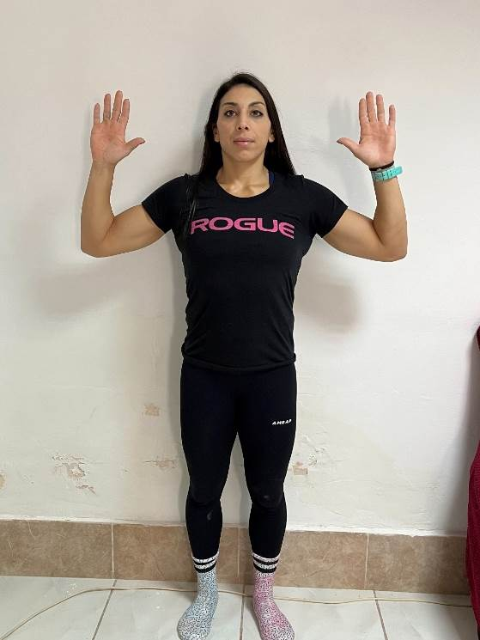
Figure 4: Inward rotation of the shoulder blades (Ghigo, 2023).

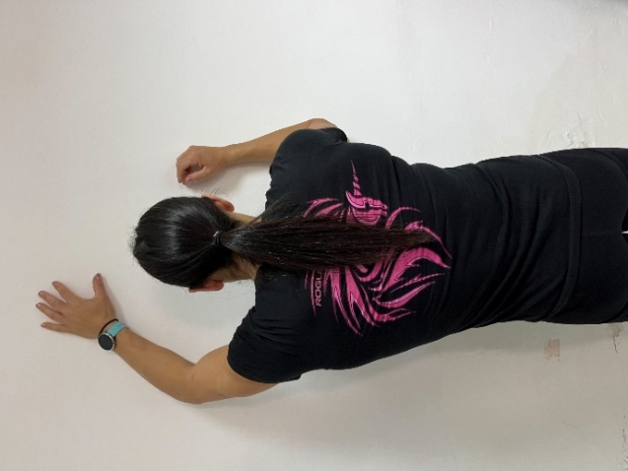
Figure 5: wall assisted, one arm reach (Ghigo, 2023).

These exercises create awareness in the shoulder girdle area.
The shoulders of patients suffering from kyphosis are positioned in a rounded forward manner, thus inhibiting the ribs from expanding efficiently (Friedlander 2020). Phelan (2021) and the Alexander Technique state that the traditional ‘singing posture’ might inhibit the natural shoulder/ spine position. They suggest that singers with shoulder issues should align the shoulder girdle to the torso without lifting their chest in an extended position. Moreover, PRI (2017) and Friedlander (2020) state that the shoulder is part of the (brachial chain) that is connected to our breathing. Pedagogues might be interested to include simple shoulder mobility tests and exercises to help singers with spinal issues (Malde, Allen, & Zeller, 2020). Risk-free exercises such as the arm reach and the wall assisted arm glide are vital exercises for singers because they create awareness in the shoulder and ribs’ area.
Methodology
Ethics
The researched subject of Kyphosis and Lordosis is a medical concern and therefore the practitioner requires to have medical background or a medical point of reference (Williamson & Johanson, 2018).
I have practised yoga for several years and gained 200-hour yoga teacher training. Having suffered with spinal issues, I have taken interest in rehabilitation methods. I attained accreditation from Postural Restoration Institute courses, the primary courses: Pelvis Restoration and Postural Restoration, secondary and tertiary courses: Cervical Restoration and Voice Box Restoration. Besides these qualifications, a physiotherapist monitored and confirmed my exercises thus, ensuring that the chosen exercises were simple, risk-free and would help singers suffering from Kyphosis/Lordosis.
Another important ethical consideration is the transparency of the researched matter and making sure the participants know what the research consists of. This also coincides with the safeguarding of personal and private information. The participants, who voluntarily participated in this research, were not asked to disclose any private information, such as pictures or medical data. Short voice clips of the sessions were required which were collected in a password-secured file. Ultimately, it is vital for any researcher to treat participants with dignity and respect, avoid any bias or judgement to attain the best possible results from the research process (Costley, Elliot, & Gibbs, 2010).
Mixed methods study
The kind of research approach taken was a mixed method study where both qualitative and quantitative results were collected and analysed. The aims of this mixed methods work-based project are:
- to examine the behaviour of the spine with associated spinal and postural issues in professional singers,
- introduce simple rehabilitative exercises that can be done whilst singing and
- observe any possible changes in the acoustical patterns.
Choosing the most ethical method to gather data is always subjective because appropriate methods are dependent on the researched matter (Berg, 2004).
The aim of the Qualitative research method is to explore and gather in-depth information about the nature of a subject on which little research is currently available (Morgan & Hoffman, 2021). An example of such research is this project, where data is collected by means of interviews whereby the participants can share their abilities and experiences during the assigned exercises. On the other hand, quantitative methods analyse data from a logical and objective stance using statistical analysis. This targets the second part of the research study where data is collected through a preliminary questionnaire allowing the researcher to gather the number of participants with spinal issues from the results (Allibang, 2006).
Being an insider researcher and by using mixed methods, I aimed to achieve more possibilities in which I could assess my research and results through triangulation of data where data was collected by means of document analysis, structured interviews and spectrogram evaluation as mentioned above. (Morgan & Hoffman, 2021). When using any sampling method, it is important to note that it is impossible to sample all eligible participants and therefore, the chosen results cannot be conclusive on a universal level (Kaplan, 2004). There are two main types of sampling methods, which are probability and non-probability (Allibang, 2006; Berg, 2001). The researched topic, which is only relatable to a specific niche of classical singers, and it falls under the non-probability sampling method.
I targeted participants via snowball sampling method. This was done by posting on social media sites and asking for participation of singers who have been suffering from spinal issues. Social media has been a great tool to reach a variety of singers across the globe, and from different backgrounds and stages in their careers. Another plus was that the research was conducted virtually and therefore allowed the cross section of singers to participate, which would else have been a limitation of the study if conducted in person.
Preliminary Questionnaire
A variety of participants around the world, having different backgrounds were interested in taking part. A preliminary questionnaire was given to them to collect statistical data such as:
- age,
- sexual orientation,
- years in performance,
- general postural concerns.
The preliminary questionnaire revealed that the ages of the participants ranged from 25 to 50 years and have all been working for over five years. All participants underwent professional classical singing training and are still active performers. The questionnaire consisted of eleven, questions (refer to Appendix 1). It was made sure that the questions were concise and, straight to the point to avoid overwhelming the participants (Bell, 2005). The questionnaire also revealed the participants’ approach to their Lordosis/Kyphosis related issues and the therapies they underwent. Only 20% of the participants mentioned that they have the occasional back pain, whilst 80% mentioned that the pain is chronic. From the total of five participants, 70% of them reported that the spinal pain affected their use of voice, and the rest of the 30% stated that the voice was mainly affected when they suffered fatigue or stress. All participants claimed to have shoulder and neck tension, and all are having frequent chiropractic treatment, physiotherapy, and Alexander Technique sessions. Regarding these issues all participants sought help from a medical professional, and they all mentioned that the pain still persevered.
An advantage of conducting the preliminary questionnaire is that it created a concise overview of the main spinal issues that these participants suffered from, and the statistics were gathered anonymously (Bell, 2005). From the results, is clear that all participants are aware of their pain and their spinal limitations and although they are undergoing therapeutic remedies, they feel that more could be addressed regarding the pain/ singing connection. The preliminary questionnaire was not used to gather any statistical data but to provide a good overview on how I can manage the sessions.
PRATT findings
A quantitative method in which the researcher can gather information without any direct say in the matter is the descriptive design (Allibang, 2006). Therefore, apart from the preliminary questionnaire, a descriptive way which was used to gather data is through the phonetic analysing programme PRAAT. The sound clips consisted of a phrase from an aria that the participants were currently singing or studying, and the data was collected and the spectrographic wave of each sound clip from each participant was analysed (Morgan & Hoffman, 2021; TSURUTA, 2009).
Spectrogram wave can be classified as quantitative data, hence being both a descriptive design and a sampling method (Gorris et al., 2020). The recorded information gathered from the spectrogram was a good indication of the change in airflow. A disadvantage presented by this type of sampling is that the PRAAT programme is complicated and time consuming but successfully managed to gather the information needed within the proposed time frame. An insider researcher is generally committed because of the familiarity of the organisation and therefore, generally benefits from it himself (Saidin, 2017; Costley, Elliot& Gibbs, 2010).
From the PRAAT samples, the results showed that with the use of the exercises, each participant could manage the breath better. The spectrogram showed a more consistent breath flow in 70% of the participants. All participants showed a more consistent vocal emission and less inconsistent vocal line. Being an insider researcher, I could identify the vocal issues from the spectrogram and following the data gathered from the structured interviews, I could gather data in how the spinal inhibitions were showing up in the spectrogram. For example, if the singer was finding it harder to sustain a particular phrase, I knew that it was either technically challenging or that the breath was compromised due to a spinal limitation. The exercises placed ease on spinal limitation and therefore I was able to see improvements in a more detailed manner.
Whilst gathering both the spectrographic samples and the structured interviews, it was necessary to avoid bias and to come to any immediate conclusions (Williamson & Johanson, 2018).

The PRAAT Results
The objective of this study was to observe any vocal frequency changes during the exercises.
Wave stability
Figures 6-10 show that the wave tends to be more stable and coherent. Participant 1 (figure 6), who has a chronic scoliosis condition, could produce a longer sound (wave) whilst doing the exercise. Figure 6 shows a change in the length of the wave. Participant 2 felt more sustained, and the wave in figure 7 shows a change in the stability of the sound. Participant 3 felt a new resonating space opening and figure 8 shows a change in the resonance of the wave. The wave in figure 8 shows the freedom of the sound executed, and a longer phrase. The wave of Participant 4 in figure 9, shows a slight wave improvement and a homogeneous vibration, whilst that of participant 5 (figure 10) shows that the sound is more grounded and resonant.

Breath management and the ZOA
The waves also show that the exercise chosen establishes the ZOA and therefore the breath was more accessible and managed better. From figure 6, which shows the wave of participant 1, who suffers from severe scoliosis, immediate improvement and an execution of a wider wave was observed thus suggesting a better ZOA and a less compromised body. The wave of participant 2 (Figure 7) whose tendency was to use too much air at once, showed a change in the control of air flow and air pressure. The wave of participant 3, (Figure 8) whose ZOA was not compromised, shows that by focusing on a more efficient posture, a more coherent air pressure can be achieved thus suggesting a vocal improvement and a more homogeneous sound. The wave of participant 4 (Figure 9) seems to even out thus suggesting a better vibrato and vocal projection. The wave of participant 5 (Figure 10) shows a growth in the volume thus suggesting a better projection. A sustained projected voice is also an indication of achieving a better ZOA.
Participant 1. Figure 6
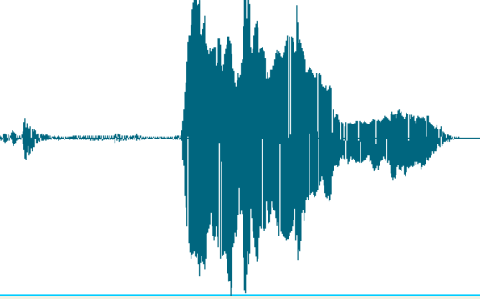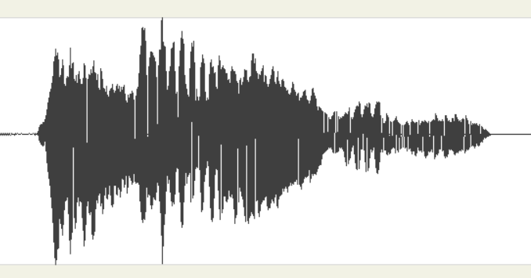

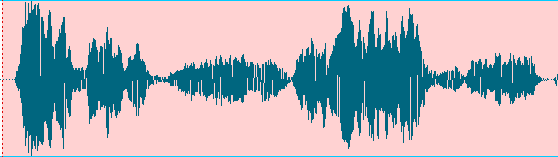
Participant 2. Figure 7
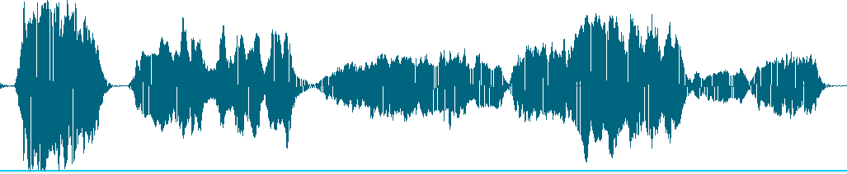

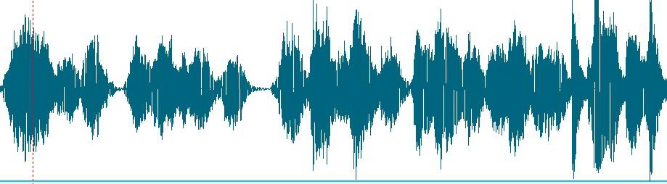
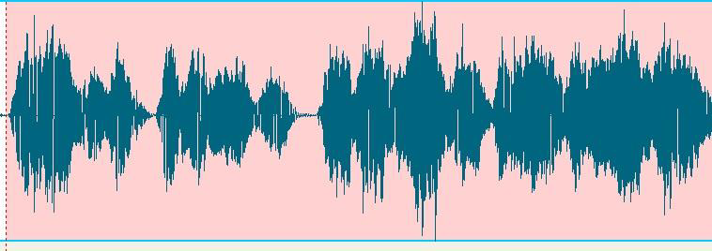
Participant 3. Figure 8

Participant 4 Figure 9.
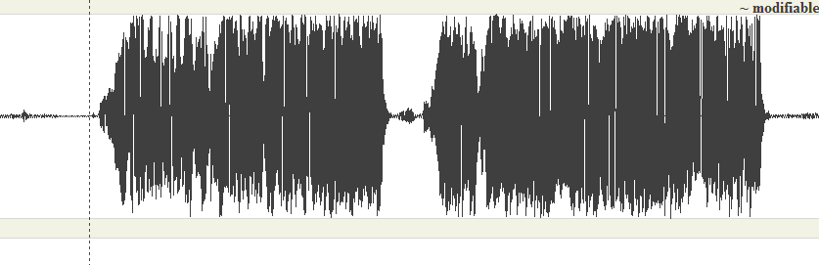
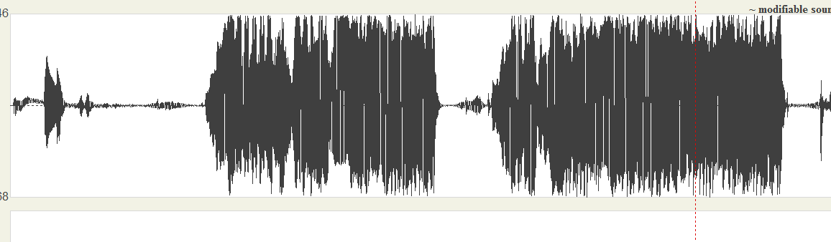

Participant 5 Figure 10.
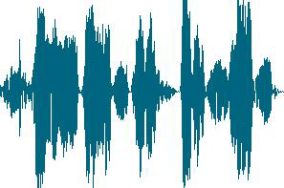
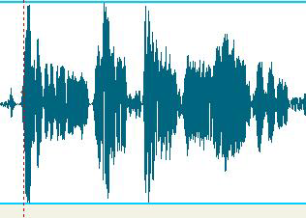

Structured Interviews
A qualitative way in which the findings were recorded was with the use of structured interviews (Allibang, 2006). There are three types of interviews, the structured, the semi- structured and the unstructured. The difference between the structured and the semi structured interviewing process is mainly the way the process is conducted (Williamson & Johanson, 2018). All participants had spinal issues and in this research study the interviews were structured because the same questions were given to all participants. Due to the nature of this research, the structured interview method was chosen so that a specific spinal issue could be addressed.
In each session the participants were asked:
- If they had any / new concerns regarding the exercises.
- If they were able to practise the exercises on their own.
- If they had any difficulty in practising them.
- What they were experiencing vocally.
All sessions were held virtually and on a one-to-one basis. This enabled flexibility in the availability and allowed privacy for each participant. It was made sure that the medical conditions of every participant and the variety of spinal disorders which resulted to be from mild (muscular tension) to quite severe (chronic scoliosis) were aware of.

Concerns regarding the exercises:
Due to the nature of the exercises, none of the participants had any medical concerns in executing them. Some of the participants asked for simpler execution, or for a variation of an exercises which focuses on a specific issue, for example TMJ pain or an exercise which helps with a protruding neck. However, by the end of the sessions they all achieved a sense of their postural traits and became more aware of body alignment. All participants felt an immediate and temporary sense of ease during the exercises. This enabled to include such exercises in their practice and monitor the results themselves. One difficulty that arose was that due to the virtual nature of the research. All participants were curious if the sessions would be more beneficial in person. However, due to the cross section and their international locations, this would not have been possible.
Doing the exercises.
Following the gait assessment, every participant was asked to balance on each leg and report any observations. The participants found that they preferred to balance on a preferred leg. A total of 80% preferred the left whilst the other 20% preferred the right. Similarly, when executing the stance exercise, 80% preferred the left in front whilst 20% preferred the right. It was worth noticing that the 20% that were preferring the right, mentioned ongoing chronic spinal conditions. One participant has been suffering with thoracic scoliosis for over twenty years and another participant mentioned a hernia on the left lumbar side of the spine. These observations surely add complications to the pelvis position but were only drawn as information and not as concluding results as more tests would be required to investigate further.
The structured interviews gave me an insight on how the participants felt during the exercises and their preferred exercises. All participants reported that by doing the exercises they were now more aware of their alignment and more in control of their movement. All participants disliked singing whilst balancing on one leg which is a clear indication that this exercise could be more advanced than the other exercises and therefore could be introduced at a later stage. However, all participants enjoyed singing in the squat position and felt more grounding in their singing. The pelvis rebalancing exercises were amongst the preferred exercises, because all participants felt a direct corelation to their singing. Furthermore, the pelvis rebalancing exercises re-established the ZOA which could be another indicator for its positive result.
In physiotherapy and rehabilitative biomechanics, the nature of the position of the pelvis is understood by observing the distribution of the weight in the legs (Adams, 2004; Almeida et al., 2013; Cazden, 2019). Therefore, when the participants were asked to report the distributional patterns of their feet, 80% of the participants mentioned that they put most of their weight on the heel, which usually contributes to the Lordosis whilst the other 20% who put the weight on the toes tend to have a more kyphotic spinal nature.
When changes in grounding levels were introduced, all participants felt more grounding and breath connection, and one participant also mentioned that:
‘I wish I always feel this ease when singing’.
Although the research involves a small number of participants, this confirmed that these participants were benefiting from the exercises.
Since the exercises are simple enough to execute without assistance, the participants were asking for more exercises. Since all of them had mentioned tightness in the shoulder and neck regions, shoulder mobility exercises were introduced to examine the shoulder movement and its independency from the torso. The creation of more dysphonic symptoms results due to the diaphragm being positioned on the right-hand side of the torso and the possibility of the shoulder collapsing into the laryngeal area (Hruska 2020). To prevent such symptoms, reaching exercises were introduced.
All participants found the hand reach movements beneficial. One participant who suffers from severe Lordosis and has some difficulty in pronouncing the vowel ‘i’, found that the hand reach exercise created more laryngeal space. Another participant reported that she could feel more spinal and abdominal freedom and could execute a longer phrase.
The participants’ view regarding the exercises.
All participants stated that the exercises were simple enough, to do. The participants that made use of the exercises frequently to practise their singing, felt that they could see immediate improvement. One participant who asked to have one of the sessions before a competition round, felt that she won the competition with the help of the awareness the exercises gave her. She stated that:
‘The exercises gave me an insight on how to be more grounded in singing’.
Another participant stated that the exercises created a more flexible but stable alignment that compliments the singing mechanism. The participant stated that:
‘I wish this is taught in conservatoires, so that more singers can find accessible ease’.
The exercises gave the five participants new perception on aligned singing and a more substantiated sense of singing. Moreover, another participant stated that the exercises gave her a newfound vocal space that creates a more resonant and stable sound.
The participants’ positive comments brought insight on the possibility of a change in the results obtained should there have been more time available to conduct the research study. It is impossible to gather concrete changes and conclusions from five week-long research. However, the outcome and feedback towards the practice has brought a positive light to these exercises. It is intended that these are developed further so that teachers can integrate these exercises within their practice.
Voice observations
The structured interview process also included observations that the participant’s teachers or coaches made.
- A participant who suffers from the chronic scoliosis commented that a coach noticed a significant improvement over the five-week period and that her voice never sounded so even and free.
- A second participant got a positive review in an article stating his voice has now more depth and colour.
- Another participant mentioned that her teacher stopped focusing on her alignment and that she was told that her vibrato is more even and resonant.
- The fourth participant mentioned that her teacher noticed a more homogenous sound in her singing
- The fifth participant mentioned that his teacher noticed better pronunciation.
Other remarks and comments
The structured interviews were key to gain feedback regarding the whole process. All participants noticed an improvement in their singing, and they all felt that five sessions were too few. They were all willing to continue to have more sessions to monitor their process. One negative remark from the participants was the inability to replicate the same vocal freedom that was achieved with the help of the exercises, in their normal singing practice. This is mainly because the body needs more time to adapt to new positions (Folland & Williams, 2007). The participants noted that they could practice for a longer period without having their spine related pain induce any fatigue. On the other hand, a positive remark was that these exercises inspired to look for further therapeutic remedies to aid their spinal conditions.

Discussion
This work-based research provided the opportunity to gain insight on how students can benefit from simple exercises that are designed to be incorporated with their singing practice. It made me aware of the current issues that classical singers, who have spinal issues, face and what treatment is accessible to them. All participants are observed by holistic practitioners and physiotherapists independently of their singing lessons, and yet all of them reported great benefit from the basic exercises they were introduced to. The gait exercise made the practice less invasive and lessened the responsibility of storing personal information. The participants were constantly asked for their feedback to ensure they are adequately involved, while also strengthening the validity of the research.
It is interesting how two sceptical students changed their idea to a positive one when they started to feel more bodily engaged and more efficient in singing. It became apparent that even though the exercises were simple and almost the same ones applied to all participants, the exercises had to be constantly modified to ensure that each participant was being fully benefitted from them.
All participants felt immediate improvement and the PRATT spectrogram shows the changes in breath management and tone intensity. A drawback that the computerised programme presented is its complexity. Time was required to be more knowledgeable about reading spectrograms and frequencies, which presented to be time consuming and quite complicated. Moreover, having multiple recordings weekly for all participants became a bigger task than anticipated. Even more so, the recordings were done via personal recorders and not with professional equipment, therefore this created possible technical limitations and approximate results.
Another drawback is that the research was conducted for a short period of time (5 weeks) in which it is too short for the muscles to adapt to a new posture. Therefore, a longer research period could be more conclusive. Moreover, the research consisted of only five participants and although they were from different countries and in different career stages, the research would eventually require a bigger participation to ensure validity of the results.
One advantage was that all students felt more aware of their alignment, and they were more conscious of the fact that help is available to aid with their vocal/ spinal frustrations. All the participants felt a better sense of vocal freedom and they all mentioned that five sessions were not enough for their issues but gave them an insight on possible rehabilitative practices. They all agreed that they are interested in furthering their sessions and they would be interested to have longer in person sessions.
This research made me aware of the vulnerability of working performers due to the difficulty of the job and the need for anatomy rehabilitating vocal pedagogues. The vast literature provided a thorough understanding that most of the findings revolve around rehabilitative exercises or rehabilitative treatment that are independent of the singing or else cannot be incorporated with the singing practice due to the equipment involved.
Most of the literature that dealt with rehabilitation of the singing discussed stretches, done independently of the singing. During the interviews with some singing teachers, the frustrations they came across when trying to help students with spinal issues became apparent due to their lack of knowledge on the subject.
One research finding was the need for stretches and simple poses for singers that can be done to enhance their ability to maintain the phrase which will help them build vocal stamina. It seems that performers who suffer with Lordosis/ Kyphosis cannot deal with spinal rehabilitation whilst singing efficiently. This is an assumption concluded from the participants’ responses and not concrete evidence. However, all the participants were eagerly practising into their poses which gave them immediate ease. The advantage of using a mixed methods was the observation of the process using a variety of data collection tools and although the processes were lengthy and time consuming, it created a more rounded overview.

Conclusion
The main aim was to design simple exercises that can be practised and incorporated into the singing, and which are simple without causing a health detriment, so that teachers can use them in their teaching sessions. The work-based research provided a clear perception for the urgent need of risk-free simple exercises that can help singers achieve a better sense of ease during singing. All participants made use of similar variations of the exercises however, the exercises are still being developed and a further investigation is needed to create a more concrete practice for a wider range of spinal issues.

  - Bibliography
- Allibang, S. D. (2016). Reasearch methods: Simple Shortand straightforward Way of Learning Methods of Research.
- Berg. (2001). Qualitative research for social sciences. Massachusets: A Pearson Education Company.
- Calais-Germain, B. F. (2016). Anatomy of Voice: How to Enhance and Project Your Best Voice. Toronto: Healing Arts Press.
- Carman, J. E. (2012). Yoga for SIngers, A developmental tool for technique and performance. New York: Oxford University Press.
- Costley, C., Elliott, G. C., & Gibbs, P. (2010). Doing Work Based Research.Approaches to Enquiry for Insider-Researchers. California: Sage.
- Dayme, M. B. (2010). Dynamics of the Singing Voice. Vienna: Springer -Verlang.
- Denscombe, M. (2014). THe good research guide. For small scale social research projects. Berkshire: Open University Press.
- F.Staes. Lieve., J. A. (2011). Physical Therapy as a Means to Optimize Posture and Voice Parameters in Student Classical Singers: A Case Repor. Journal of Voice, 91-101.
- Hruska, R. (2008). www.posturalrestoration.com/the-science/what-is-posture. Retrieved from https://www.posturalrestoration.com: https://www.posturalrestoration.com/the-science/what-is-posture
- Kaplan, D. (2004). The Sage Handbook of the Quantitative Methodology for Social Sciences. California: Sage Publication. .
- Lutz, F. (1986). ‘Ethnography: The holistic approach to understandingschooling’, Chapter 3.1 in M. Hammersley Controversies in Classroom reseacrh. Milton Keynes: Open University Press.
- McKinney, J. (1982). Diagnosis and Correction of Vocal Faults. Baptist Sunday School Board.
- Miller, R. (2004). Solutions for Singers: Tools for Performers and Teachers . Oxford: Oxford University Press.
- Morgan, D. (2014). Integrating Qualitative and Quantitative Methods: A Pragmatic Approach. California: Sage.
- Piekartz, H. J. (2007). Craniofacial Pain: Neuromusculoskeletal Assessment, Treatment and Management. Elsevier Limited.
- Rubin, H. a., & Rubin, G. (1995). Qualitative Interviewing: The Art of Hearing Data.Thousand °. California: Sage.
- Saidin, K. (2017). INSIDER RESEARCHERS: CHALLENGES & OPPORTUNITIES. International Seminar on Generating Knowledge Through Research, U. Malaysia: University of Malaysia.
- Stirling, U. o. (2019). Univeristy of Stirling. Understanding Ethics. Retrieved from University of Stirling: https://www.stir.ac.uk/research/research-ethics-and-integrity/understanding-ethics/
- -blog/v-team-vocal-care/posture-body-stopping-reaching-vocal-potential/
- Williamson, K., & Johanson, G. (2018). Research Methods, Information, Systems and Contexts (2nd ed.). Killingdon, United Kingdom: Elsevier.

--------------------------------------------------------------------------------------------------------------------------

References
- Adams, M. A. (2004). Biomechanics of back pain. In Acupuncture in Medicine (Vol. 22, Issue 4). https://doi.org/10.1136/aim.22.4.178
- Almeida, F., Pinho, J. C., Coimbra, D., Pais Clemente, M., & Santos, N. (2013). Biomechanics of the temporomandibular joint in singers. Revista Portuguesa de Estomatologia, Medicina Dentaria e Cirurgia Maxilofacial, 54(3). https://doi.org/10.1016/j.rpemd.2013.02.004
- Asher, V. K. (2009). The Olympic singer: Integrating Pilates training into the voice studio. In ProQuest Dissertations and Theses.
- Bruno, E., de Padova, A., Napolitano, B., Marroni, P., Batelli, R., Ottaviani, F., & Alessandrini, M. (2009). Voice Disorders and Posturography: Variables to Define the Success of Rehabilitative Treatment. Journal of Voice, 23(1). https://doi.org/10.1016/j.jvoice.2007.06.002
- Cantrell, M. (2011). A PRI analytical Overview of Functinoal Thoracic Positioning and Thoracic-Scapular Stability. Postural Restoration Institute.
- Cardoso, R., Lumini-Oliveira, J., & Meneses, R. F. (2019). Associations between Posture, Voice, and Dysphonia: A Systematic Review. In Journal of Voice (Vol. 33, Issue 1, pp. 124.e1-124.e12). Mosby Inc. https://doi.org/10.1016/j.jvoice.2017.08.030
- Cardoso, R., Meneses, R. F., & Lumini-Oliveira, J. (2017). The effectiveness of physiotherapy and complementary therapies on voice disorders: A systematic review of randomized controlled trials. In Frontiers in Medicine (Vol. 4, Issue APR). https://doi.org/10.3389/fmed.2017.00045
- Cardoso, R., Meneses, R. F., Lumini-Oliveira, J., & Pestana, P. (2021). Myofascial Release Effects in Teachers’ Posture, Muscle Tension and Voice Quality: A Randomized Controlled Trial. Journal of Voice. https://doi.org/10.1016/j.jvoice.2021.03.029
- Carman, J. (2004). Yoga and Singing: Natural Partners. Journal of Singing, 60(5).
- Carneiro, P. R., & Teles, L. C. da S. (2012). Influência de alterações posturais, acompanhadas por fotogrametria computadorizada, na produção da voz. Fisioterapia Em Movimento, 25(1). https://doi.org/10.1590/s0103-51502012000100002
- Cazden, J. (2019). Complete Vocal Fitness: A Singer’s Guide to Physical Training, Anatomy, and Biomechanics. Voice and Speech Review, 13(3). https://doi.org/10.1080/23268263.2019.1588505
- Chopp-Hurley, J. N., Prophet, C., Thistle, B., Pollice, J., & Maly, M. R. (2018). Scapular muscle activity during static yoga postures. Journal of Orthopaedic and Sports Physical Therapy, 48(6). https://doi.org/10.2519/jospt.2018.7311
- Cloward, R. B. (1988). Diaphragm paralysis from cervical disc lesions. British Journal of Neurosurgery, 2(3). https://doi.org/10.3109/02688698809001012
- Cuddy, P., & Gaskell, L. (2020). “How do Pilates Trained Physiotherapists utilize and value Pilates Exercise for MSK conditions? A Qualitative Study.” Musculoskeletal Care, 18(3). https://doi.org/10.1002/msc.1463
- da Cunha Pereira, G., de Oliveira Lemos, I., Dalbosco Gadenz, C., & Cassol, M. (2018). Effects of Voice Therapy on Muscle Tension Dysphonia: A Systematic Literature Review. In Journal of Voice (Vol. 32, Issue 5). https://doi.org/10.1016/j.jvoice.2017.06.015
- Davies, J. (2020). Alexander Technique classes improve pain and performance factors in tertiary music students. Journal of Bodywork and Movement Therapies, 24(1). https://doi.org/10.1016/j.jbmt.2019.04.006
- di Carlo, N. S. (1998a). Cervical spine abnormalities in professional singers. Folia Phoniatrica et Logopaedica, 50(4).
- di Carlo, N. S. (1998b). Cervical spine abnormalities in professional singers. Folia Phoniatrica et Logopaedica, 50(4).
- Eliks, M., Zgorzalewicz-Stachowiak, M., & Zeńczak-Praga, K. (2019). Application of Pilates-based exercises in the treatment of chronic non-specific low back pain: State of the art. In Postgraduate Medical Journal (Vol. 95, Issue 1119). https://doi.org/10.1136/postgradmedj-2018-135920
- Folland, J. P., & Williams, A. G. (2007). The Adaptations to Strength Training. Sports Medicine, 37(2). https://doi.org/10.2165/00007256-200737020-00004
- Franco, D., Martins, F., Andrea, M., Fragoso, I., Carrão, L., & Teles, J. (2014). Is the sagittal postural alignment different in normal and dysphonic adult speakers? Journal of Voice, 28(4). https://doi.org/10.1016/j.jvoice.2014.01.002
- Gorris, C., Ricci Maccarini, A., Vanoni, F., Poggioli, M., Vaschetto, R., Garzaro, M., & Aluffi Valletti, P. (2020). Acoustic Analysis of Normal Voice Patterns in Italian Adults by Using Praat. Journal of Voice, 34(6). https://doi.org/10.1016/j.jvoice.2019.04.016
- Green, W. (1998). The Mind Body Workout with Pilates and Alexander Technique. Physiotherapy, 84(10). https://doi.org/10.1016/s0031-9406(05)65881-6
- Hunt, J. (2010). Yoga for Singers. The International Journal of the Arts in Society: Annual Review, 5(1). https://doi.org/10.18848/1833-1866/cgp/v05i01/35807
- Karimi, N., Fathizadeh, M., Nourbakhsh, M. R., & Biglarian, A. (2021). Efficacy of Pelvic Repositioning Exercises on Pain, Hip and Shoulder Range of Motion and Disability of the Patients with Chronic Nonspecific Low Back Pain: A Single Blinded Randomized Controlled Trial. Journal of Rehabilitation Sciences and Research, 8(3). https://doi.org/10.30476/JRSR.2021.90914.1159
- Karulkar, R. R., Ravi, R., & Gunjawate, D. R. (2021). Voice-related complaints and vocal and nonvocal habits of Hindustani classical singers: a questionnaire-based study. Logopedics Phoniatrics Vocology. https://doi.org/10.1080/14015439.2020.1788158
- Klein, S. D., Bayard, C., & Wolf, U. (2014). The Alexander Technique and musicians: a systematic review of controlled trials. In BMC complementary and alternative medicine (Vol. 14). https://doi.org/10.1186/1472-6882-14-414
- Lloyd, A., Hoffman-Ruddy, B., Silverman, E., & Jeffrey, L. L. (2017). Vocal Yoga: Applying Yoga Principles in Voice Therapy. Journal of Singing.
- Manickam, A., & Gardiner, M. D. (2021). Gait assessment in general practice. Australian Journal of General Practice, 50(11). https://doi.org/10.31128/AJGP-12-20-5777
- Martins, D. L. L., Lima, L. F. S. C., Sales, V. S. de F., Demeda, V. F., Silva, A. L. O. da, de Oliveira, Â. R. S., de Oliveira, F. M., & Lima, S. B. F. (2014). The Mouth Breathing
- Syndrome: prevalence, causes, consequences, and treatments. A Literature Review. JOURNAL OF SURGICAL AND CLINICAL RESEARCH, 5(1). https://doi.org/10.20398/jscr.v5i1.5560
- Mezzedimi, C., Spinosi, M. C., Patalano, M., Ferretti, F., & Iezzi, L. (2019a). Voice and Pilates: The influence of Pilates on the singing voice. Revista de Logopedia, Foniatria y Audiologia, 39(3). https://doi.org/10.1016/j.rlfa.2019.03.004
- Mezzedimi, C., Spinosi, M. C., Patalano, M., Ferretti, F., & Iezzi, L. (2019b). Voice and Pilates: The influence of Pilates on the singing voice [Voz y pilates: la influencia de pilates en la voz del canto]. Revista de Logopedia, Foniatria y Audiologia, 39(3).
- Morgan, D. L., & Hoffman, K. (2021). Searching for qualitatively driven mixed methods research: a citation analysis. Quality and Quantity, 55(2). https://doi.org/10.1007/s11135-020-01025-2
- Rahmatalla, S., Kim, H. J., Shanahan, M., & Swan, C. C. (2005). Effect of restrictive clothing on balance and gait using motion capture and stability analysis. SAE Technical Papers. https://doi.org/10.4271/2005-01-2688
- Rubin, J. S., Blake, E., & Mathieson, L. (2007). Musculoskeletal Patterns in Patients with Voice Disorders. Journal of Voice, 21(4). https://doi.org/10.1016/j.jvoice.2005.02.001
- Rubin, J. S., Mathieson, L., & Blake, E. (2004). Care of the Professional Voice: Posture and Voice. Journal of Singing, 60(3).
- Sabatucci, A., Raffaeli, F., Mastrovincenzo, M., Luchetta, A., Giannone, A., & Ciavarella, D. (2015). Breathing pattern and head posture: Changes in craniocervical angles. Minerva Stomatologica, 64(2).
- Salomoni, S., van den Hoorn, W., & Hodges, P. (2016). Breathing and singing: Objective characterization of breathing patterns in classical singers. PLoS ONE, 11(5). https://doi.org/10.1371/journal.pone.0155084
- Savage, T. N., Saxby, D. J., Pizzolato, C., Diamond, L. E., Murphy, N. J., Hall, M., Spiers, L., Eyles, J., Killen, B. A., Suwarganda, E. K., Dickenson, E. J., Griffin, D., Fary, C., O’Donnell, J., Molnar, R., Randhawa, S., Reichenbach, S., Tran, P., Wrigley, T. v., … Lloyd, D. G. (2021). Trunk, pelvis, and lower limb walking biomechanics are similarly altered in those with femoroacetabular impingement syndrome regardless of cam morphology size. Gait and Posture, 83. https://doi.org/10.1016/j.gaitpost.2020.10.002
- Schneider, C. M., Dennehy, C. A., & Saxon, K. G. (1997). Exercise physiology principles applied to vocal performance: The improvement of postural alignment. Journal of Voice, 11(3). https://doi.org/10.1016/S0892-1997(97)80012-4
- Scotto Di Carlo, N. (1998). Cervical spine abnormalities in professional singers. Folia Phoniatrica et Logopaedica, 50(4). https://doi.org/10.1159/000021463
- Sparrey, C. J., Bailey, J. F., Safaee, M., Clark, A. J., Lafage, V., Schwab, F., Smith, J. S., & Ames, C. P. (2014). Etiology of lumbar lordosis and its pathophysiology: A review of the evolution of lumbar lordosis, and the mechanics and biology of lumbar degeneration. Neurosurgical Focus, 36(5). https://doi.org/10.3171/2014.1.FOCUS13551
- Spence, H. (2008). Case study report: postural restoration: an effective physical therapy approach to patient treatment. Techniques in Regional Anesthesia and Pain Management, 12(2). https://doi.org/10.1053/j.trap.2008.01.003
- Sweeting, K., & Mock, M. (2007). Gait and posture-assessment in general practice. Australian Family Physician, 36(6).
- TSURUTA, M. (2009). A Study on Audio-Visual Data Analysis in Educational Research: The Journal of Educational Sociology, 84(0). https://doi.org/10.11151/eds.84.83
- van der Linden, M., Bulley, C., Hooper, J., Cowan, P., Geneen, L., & Mercer, T. (2011). Effects of pilates (core stability exercise) for people with multiple sclerosis who use a wheelchair, preliminary results. Physiotherapy (United Kingdom), 97.

---------------------------------------------------------------------------------------------------------------------------
Appendix:
- Hyperlink to Preliminary Questionnaire:
https://r6ng2eiu1ds.typeform.com/report/pDWOJiEY/bMvNvlGmSWCMhYi9
Preliminary Questionnaire Results:

7 responses

what is your gender?

7 out of 7 answered
Female
5 resp.
71.4%
Male
2 resp.
28.6%
other
0 resp.
0%

What is your age range?

7 out of 7 answered
31-45
4 resp.
57.1%
18-30
2 resp.
28.6%
46+
1 resp.
14.3%

Have you ever experienced back pain?

7 out of 7 answered
Yes
6 resp.
85.7%
No
1 resp.
14.3%

If you answered yes, has this interfered with your singing practice?

6 out of 7 answered
Yes
4 resp.
66.7%
No
2 resp.
33.3%

Have you ever sought a health care professional to deal with this muscular pain?

7 out of 7 answered
Yes
6 resp.
85.7%
No
1 resp.
14.3%

Did the pain persevere?

6 out of 7 answered
Yes
6 resp.
100%
No
0 resp.
0%

Do you suffer with tension in the head/ neck region?

7 out of 7 answered
Yes
6 resp.
85.7%
No
1 resp.
14.3%

Have you ever felt like you are not using the full spectrum of your voice?

7 out of 7 answered
Yes
6 resp.
85.7%
No
1 resp.
14.3%

Will you be willing to be part of a non-invasive 5 week-long research dealing with the connection between spinal issues and vocal acoustics?

7 out of 7 answered
Yes
7 resp.
100%

------------------------------------------------------------------------------------------------------------------------
YouTube links to the designed exercises:

- The stance and arm reach: (11) Arm Reach breath management for singers. - YouTube
- The assisted stance: (11) Assisted Stance - YouTube
- Shoulder mobility: (11) Shoulder girdle mobility for scoliosis - YouTube
- TMJ exercise: https://www.youtube.com/watch?v=gmB29bMDT5E

---------------------------------------------------------------------------------------------------------------------------

