Detailed work programmes, method Statements, Risk assesments and specific roles & responsibilities

prepared for Green-field New-build

Contents

Introduction- Build Details…………......................….3

Proposed Elevations……………………………..……4

Proposed Floor plans……………………………........5

Part One - Schedule of Work…………………………6

Part Two - Method Statements……………………….8

Part Three - Risk Assessments……..…………..….49
01 Block laying……..…………………………………..50
02 Excavations……..…...……………………...……...52
03 Roof truss erection……………..……....……….…54

Part Four – H&S Legislation………………..……….56

Introduction – Build Details

Proposed construction start date: 6th May 2019

Proposed foundation detail: Gen 3 / ST2 concrete strip at a depth of 1M

Sub-structure: Cavity construction block and block to BS 6073 with Concrete infill up to hardcore

External walls: Cavity construction block and block to BS 6073 with partial fill cavity insulation and external render finish

Ground floor: Suspended beam and block

First and second floor: Suspended timber with particle board sheet

Doors and windows: Light oak effect UPVC double glazed

Roof structure: Trussed rafters at 40 degrees

Roof covering: Natural slate with closed eaves

Opening Detail: Brick solider course and plinths

Porch: Pillars to be natural sandstone

Proposed Elevations

Proposed Floor plans

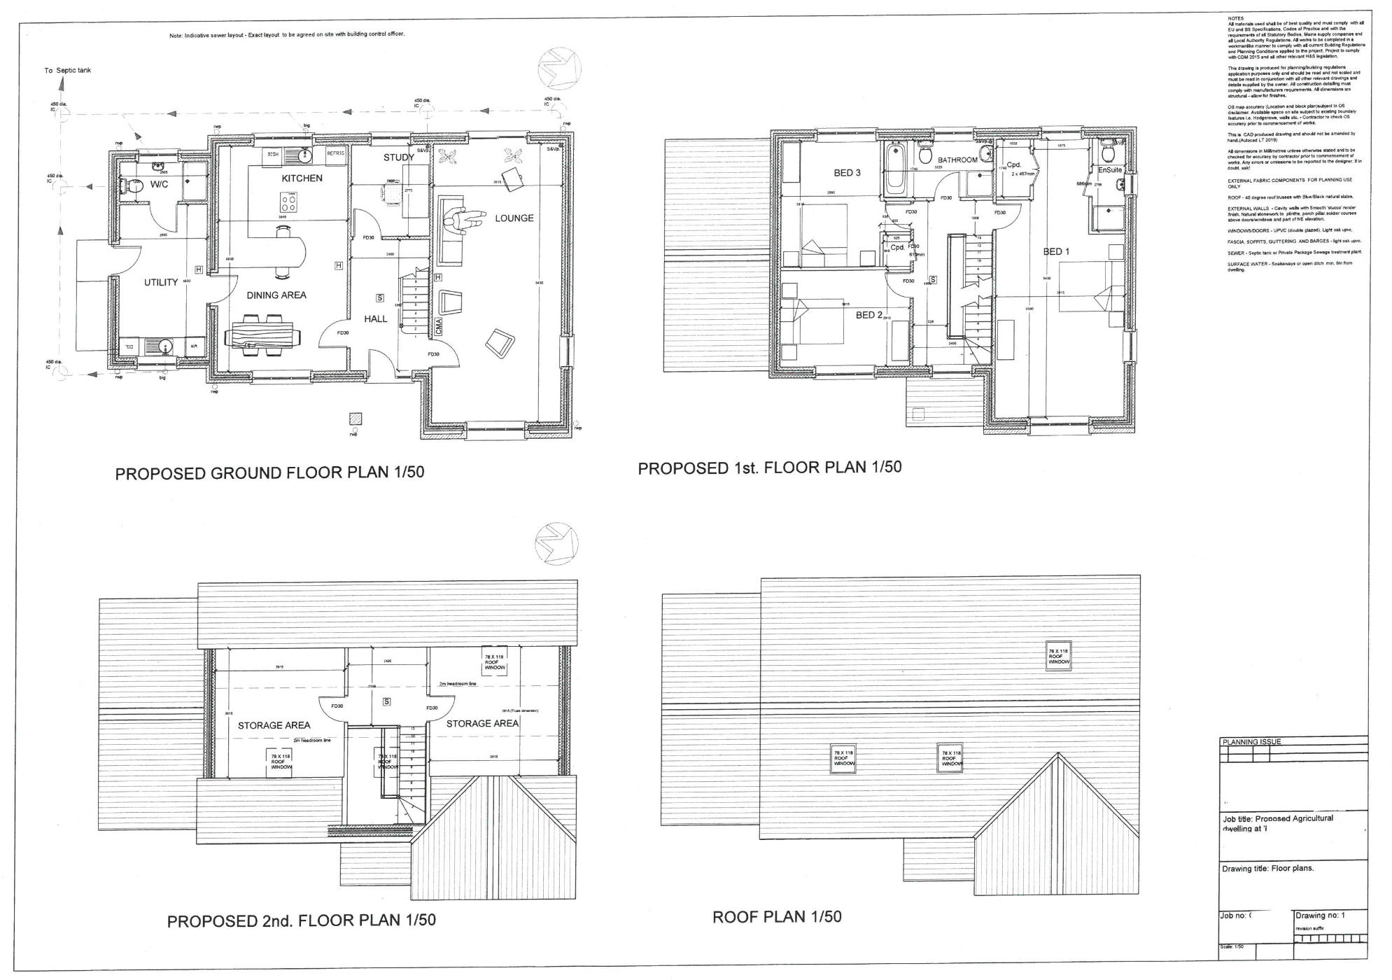

Part one

Schedule of work

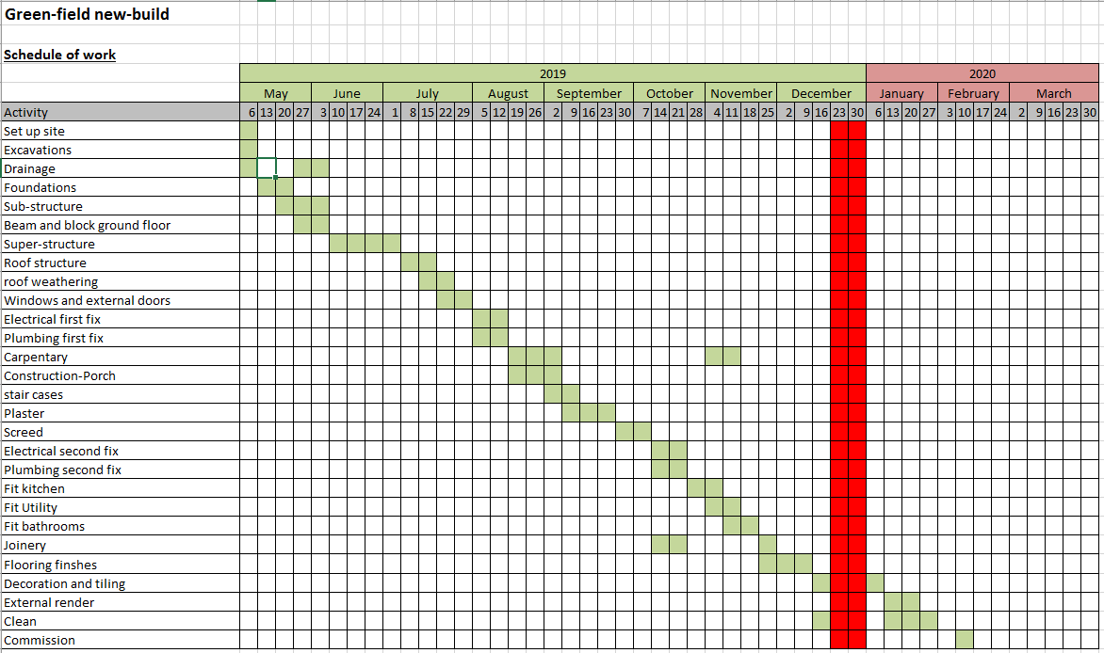

Part Two

Method Statements
Method Statement

Construction | New-build

Brief Description of the Works, Task or Process:

Excavations

SEQUENCE OF OPERATIONS:

Take top soil off and level site
Excavate foundation trenches
Excavate working space around trenches
Drainage excavations
EQUIPMENT AND PROCEDURES:
Plant/Tools needed | JCB, CAT, wheel barrow, shovel

PPE required | Hi Vis jacket  Safety footwear  Eye protection  Head protection  Hearing protection  Gloves

Materials to be used | N/A

Operatives required | Labourers  Trained operators

Specific Training needed – give details | Manual handling training  CPCS  Trained to use cable location tools

Permits to Work needed | Yes

Machinery Shutdown and Lock-Off Procedures | If machinery is left unattended the keys shall be removed and the excavator secured, minimum of 600mm shall be left between the outer radius of the machine and any structures/objects

Is Electricity needed | N/A

Mobile Phone use – any Restricted Areas | No use around excavations due to moving machinery and open excavations

Means of protection to other people | Handrail/barriers around site to prevent falls into excavations, banks man used to assist the machine operator when excavating and traversing

Site Access and Egress | Via Short track from highway

Access to Works Area | N/A

Means of Access to Height | N/A

Fall Prevention Measures | Don’t leave tools around open excavations top prevent trip hazards

COSHH Assessment Carried Out | Ground contamination assessment carried out

Suitable Welfare Arrangements – give details | Site office

Traffic Management in Place | N/A

First Aid Cover – give details | See site office

Accident Procedures – give details | See site office

Overhead Power Cables – are goalposts in place | Supervisors ensure identification of overhead services

Noise Issues | N/A

Dust Control | N/A

Vibration Control | N/A

Fire Plan in Place | See site office

Site Contact Details including Emergency Numbers Etc | See site office

Method Statement

Construction | New-build

Brief Description of the Works, Task or Process:

Foundations

SEQUENCE OF OPERATIONS:

Pour concrete into trenches against earth face either 250mm thick with 150mm either side of sub-structure when laid
Unset concrete to receive tamping and trowelling
EQUIPMENT AND PROCEDURES:
Plant/Tools needed | Steel concrete trowel, concrete float, shovel, concrete poker

PPE required | Hearing protection  Rigger gloves (or similar)  Safety footwear  Head protection

Materials to be used | GEN 3 concrete

Operatives required | Labourers

Specific Training needed – give details | Manual handling training

Permits to Work needed | N/A

Machinery Shutdown and Lock-Off Procedures | N/A

Is Electricity needed | N/A

Mobile Phone use – any Restricted Areas | No use around concrete mixer or open trenches

Means of protection to other people | N/A

Site Access and Egress | Via short track from highway

Access to Works Area | N/A

Means of Access to Height | N/A

Fall Prevention Measures | Don’t leave tools around open excavations top prevent trip hazards

COSHH Assessment Carried Out | N/A

Suitable Welfare Arrangements – give details | Site office

Traffic Management in Place | Provide passage for vehicles when cement mixer arrives

First Aid Cover – give details | See site office

Accident Procedures – give details | See site office

Overhead Power Cables – are goalposts in place | N/A

Noise Issues | N/A

Dust Control | If some concrete is mixed in-situ labourers are to make sure dust from cement bags are contained

Vibration Control | Limit time to using cement poker

Fire Plan in Place | See site office

Site Contact Details including Emergency Numbers Etc | See site office

Method Statement

Construction | New-build

Brief Description of the Works, Task or Process:

Block/Brick laying

SEQUENCE OF OPERATIONS:

Concrete blocks to be stacked along the length of working area
Labourers to bring mortar to spot boards
Lay sub-structure block and block walls with concrete infill up to hardcore
Lay super-structure as per drawings in accordance with services, beam and block floor and brick solider courses

EQUIPMENT AND PROCEDURES:
Plant/Tools needed | Hand tools  Hammer  Bolster  Laser level  Spirit level  Cement mixer

PPE required | Eye protection during block/brick cutting  Gloves for handling bricks/blocks  Safety footwear  Respiratory protection

Materials to be used | Cement, Bricks, Blocks, sand, lime

Operatives required | Bricklayers, Labourers

Specific Training needed – give details | Manual handling training  Bricklaying

Permits to Work needed | N/A

Machinery Shutdown and Lock-Off Procedures | N/A

Is Electricity needed | N/A

Mobile Phone use – any Restricted Areas | No

Means of protection to other people | N/A

Site Access and Egress | Via short track from highway

Access to Works Area | Ensure walkways are kept clean and tide with no obstructions

Means of Access to Height | N/A

Fall Prevention Measures | N/A

COSHH Assessment Carried Out | N/A

Suitable Welfare Arrangements – give details | Site office

Traffic Management in Place | Yes

First Aid Cover – give details | See site office

Accident Procedures – give details | See site office

Overhead Power Cables – are goalposts in place | N/A

Noise Issues | N/A

Dust Control | Labourers to try minimise dust

Vibration Control | N/A

Fire Plan in Place | See site office

Site Contact Details including Emergency Numbers Etc | See site office

Method Statement

Construction | New-build

Brief Description of the Works, Task or Process:

Working on scaffolding

SEQUENCE OF OPERATIONS:

Scaffold to be checked for safety before use
Incomplete or faulty scaffold not to be used
Toe boards and double handrails to be in place
Fans to be used over entrances
Suitable ladders to be used for access and fixed before use
Damaged ladders not to be used
Only designated areas to be used to store materials – bricks etc
Brickguards/netting to be used
EQUIPMENT AND PROCEDURES:
Plant/Tools needed | N/A

PPE required | Safety footwear  Harness and lanyard  Gloves  Head protection

Materials to be used | N/A

Operatives required | Competent and experienced scaffolders to erect

Specific Training needed – give details | Scaffolders shall hold a valid CITB/CSCB certificate

Permits to Work needed | N/A

Machinery Shutdown and Lock-Off Procedures | N/A

Is Electricity needed | N/A

Mobile Phone use – any Restricted Areas | Yes. Phone not to be used on scaffold

Means of protection to other people | Brick guards to prevent failing objects

Site Access and Egress | Via short track from highway

Access to Works Area | N/A

Materials needed | N/A

Means of Access to Height | Via suitably fixed ladders

Fall Prevention Measures | Edge protection – handrails etc in place

COSHH Assessment Carried Out | N/A

Suitable Welfare Arrangements – give details | Site office

Traffic Management in Place | N/A

First Aid Cover – give details | See site office

Accident Procedures – give details | See site office

Overhead Power Cables – are goalposts in place | N/A

Noise Issues | N/A

Dust Control | N/A

Vibration Control | N/A

Fire Plan in Place | See site office

Site Contact Details including Emergency Numbers Etc | See site office

Method Statement

Construction | New-build

Brief Description of the Works, Task or Process:

Ground floor

SEQUENCE OF OPERATIONS:

Hardcore base to be laid on soil
Beam and block flooring to be laid with junctions in walls and DPM laid on top
Insulation layer to be sat on top
EQUIPMENT AND PROCEDURES:
Plant/Tools needed | Disk cutter

PPE required  Delete and/or add as appropriate: | Hearing protection  Rigger gloves (or similar)  Safety footwear  Respiratory protection

Materials to be used | Concrete blocks, concrete beams, insulation, 1200 gauge DPM, rubble and masonry for hardcore

Operatives required | Labourers

Specific Training needed – give details | Manual handling training

Permits to Work needed | N/A

Machinery Shutdown and Lock-Off Procedures | N/A

Is Electricity needed | N/A

Mobile Phone use – any Restricted Areas | No

Means of protection to other people | N/A

Site Access and Egress | Via short track from highway

Access to Works Area | N/A

Means of Access to Height | N/A

Fall Prevention Measures | N/A

COSHH Assessment Carried Out | N/A

Suitable Welfare Arrangements – give details | Site office

Traffic Management in Place | Yes

First Aid Cover – give details | See site office

Accident Procedures – give details | See site office

Overhead Power Cables – are goalposts in place | N/A

Noise Issues | N/A

Dust Control | Contain as much a possible the dust produced from cutting blocks

Vibration Control | N/A

Fire Plan in Place | See site office

Site Contact Details including Emergency Numbers Etc | See site office

Method Statement

Construction | New-build

Brief Description of the Works, Task or Process:

Trussed roof carpentry

SEQUENCE OF OPERATIONS:

Crash deck or netting to be fitted to ceiling joists before rafters are installed
Lifting plan to be in place before any materials are raised
Materials to be raised to wall plate height by crane or HIAB and stacked securely prior to fixing
Extra cutting to be carried out at ground level wherever possible
Screw holes to be pre drilled using battery powered tools
Working/cutting area to be kept clear of trip hazards by clearing off cuts as they are produced
Trailing leads and cables to be kept tidy

EQUIPMENT AND PROCEDURES:
Plant/Tools needed | Hand and power tools

PPE required | Gloves to prevent cuts etc from sharp edges or splinters  Safety footwear  Eye protection while cutting  Harness

Materials to be used | Preformed timber trusses, nails, screws

Operatives required | Carpenters

Specific Training needed – give details | Manual handling training  Machine/tools training  Trade training

Permits to Work needed | N/A

Machinery Shutdown and Lock-Off Procedures | N/A

Is Electricity needed | Yes. 110v supplied into an inverter to produce 240v with RCD or cordless tools

Mobile Phone use – any Restricted Areas | No phones to be used on scaffolding

Means of protection to other people | No-one to work underneath scaffold

Site Access and Egress | Via short track from highway

Access to Works Area | N/A

Means of Access to Height | Access to scaffold via ladders

Fall Prevention Measures | Crash deck to be fitted to top of joists to prevent persons or materials falling through

COSHH Assessment Carried Out | N/A

Suitable Welfare Arrangements – give details | Site office

Traffic Management in Place | No-one to be in the vicinity of the crane during manoeuvring. Only designated persons to assist the crane operator

First Aid Cover – give details | See site office

Accident Procedures – give details | See site office

Overhead Power Cables – are goalposts in place | N/A

Noise Issues | N/A

Dust Control | N/A

Vibration Control | N/A

Fire Plan in Place | See site office

Site Contact Details including Emergency Numbers Etc | See site office

Method Statement

Construction | New-build

Brief Description of the Works, Task or Process:

Roof weathering

SEQUENCE OF OPERATIONS:

Operatives to sign in at site office and attend induction
Scaffold to be erected by others to agreed specifications with extra height handrails
Battens and rolls of felt to be raised to the works areas by hand by passing them through access holes in scaffold and stored
Only sufficient amounts for immediate works to be on scaffold due to restricted space
Felt to be unrolled by two or more operatives and fixed by hand using clout nails
Battens to be cut using hand tools and fixed using nail guns at specified heights
Due care to be taken to ensure no damage is done to the scaffold boards during cutting
Tiles to be raised to scaffold lifts by hired in mobile conveyor belt and stacked for use
Tiles to be hung and nailed as per drawings and specification
Tiles needing to be trimmed will be cut using disc cutter by trained operatives taking due care to ensure no damage is done to scaffold boards

EQUIPMENT AND PROCEDURES:
Plant/Tools needed | Hand and power tools, Gas powered nail guns, Mobile conveyor belt

PPE required | Hard hats  Gloves  Safety footwear  Eye protection  Hearing protection

Materials to be used | Timber battens, Felt, Nails

Operatives required | Labourers, Tilers

Specific Training needed – give details | Trade training.  Abrasive wheels training for use of disc cutter  Instruction on how to use tile conveyor

Permits to Work needed | No

Machinery Shutdown and Lock-Off Procedures | N/A

Is Electricity needed | Yes, for power tools and tile conveyor

Mobile Phone use – any Restricted Areas | No

Means of protection to other people | No-one to be permitted to work underneath tillers or under tile conveyor arm.  Netting to be fitted to scaffold

Site Access and Egress | Via short track from highway

Access to Works Area | Via internal scaffold ladders

Means of Access to Height | As above

Fall Prevention Measures | Extra height handrails to scaffold to prevent falls from ridges  Internal crash deck to be in place from joist fitting

COSHH Assessment Carried Out | N/A

Suitable Welfare Arrangements – give details | Site office

Traffic Management in Place | Yes

First Aid Cover – give details | See site office

Accident Procedures – give details | See site office

Overhead Power Cables – are goalposts in place | N/A

Noise Issues | Only while cutting. Operatives to wear hearing protection while cutting battens

Dust Control | N/A

Vibration Control | Very short term while cutting tiles

Fire Plan in Place | See site office

Site Contact Details including Emergency Numbers Etc | See site office

Method Statement

Construction | New-build

Brief Description of the Works, Task or Process:

Windows and external doors

SEQUENCE OF OPERATIONS:

Frames to be carried by hand to their final fitting location by two or more operatives and fitted.
Finished sealed units to be unloaded from the delivery lorry using suction pads and placed as close to the building as possible.
Scaffolders to create temporary opening on handrail to allow units to be passed through
Units to be raised up the outside of the scaffold by hand using multiple operatives to final fitting location
Doors installed and latches fitted
EQUIPMENT AND PROCEDURES:
Plant/Tools needed | Hand and power tools, rope and pulley

PPE required | gloves  Safety footwear

Materials to be used | N/A

Operatives required | Labourers, carpenters, window and door fitters

Specific Training needed – give details | Manual handling training  Machine/tools training  Trade training

Permits to Work needed | N/A

Machinery Shutdown and Lock-Off Procedures | N/A

Is Electricity needed | N/A

Mobile Phone use – any Restricted Areas | No

Means of protection to other people | N/A

Site Access and Egress | Via short track off highway

Access to Works Area | Pedestrian access

Means of Access to Height | Via ladders

Fall Prevention Measures | N/A

COSHH Assessment Carried Out | N/A

Suitable Welfare Arrangements – give details | Site office

Traffic Management in Place | N/A

First Aid Cover – give details | See site office

Accident Procedures – give details | See site office

Overhead Power Cables – are goalposts in place | N/A

Noise Issues | N/A

Dust Control | N/A

Vibration Control | N/A

Fire Plan in Place | See site office

Site Contact Details including Emergency Numbers Etc | See site office

Method Statement

Construction | New-build

Brief Description of the Works, Task or Process:

Electrical fittings

SEQUENCE OF OPERATIONS:

Feed cables through to electrical points as per drawings
Connect all up to fuse box
All electrical and lighting pointes to be connected
Fuse box connected to main feed and then tested
EQUIPMENT AND PROCEDURES:
Plant/Tools needed | Hand cart or sack barrow

PPE required | Gloves  Insulating mats  Head protection  Rubber soled shoes

Materials to be used | Cables

Operatives required | 18th Ed electricians

Specific Training needed – give details | Trade training up to 18th Ed

Permits to Work needed | Yes. Permits to be issued by Works Manager

Machinery Shutdown and Lock-Off Procedures | Yes. Lock off procedures to be in place before any live circuits are exposed

Is Electricity needed | No

Mobile Phone use – any Restricted Areas | No

Means of protection to other people | No-one other than electricians to be in working area

Site Access and Egress | Via short track off highway

Access to Works Area | Pedestrian access

Means of Access to Height | N/A

Fall Prevention Measures | N/A

COSHH Assessment Carried Out | N/A

Suitable Welfare Arrangements – give details | Works office

Traffic Management in Place | Yes

First Aid Cover – give details | See site office

Accident Procedures – give details | See site office

Overhead Power Cables – are goalposts in place | N/A

Noise Issues | N/A

Dust Control | N/A

Vibration Control | N/A

Fire Plan in Place | See site office

Site Contact Details including Emergency Numbers Etc | See site office

Method Statement

Construction | New-build

Brief Description of the Works, Task or Process:

Plumbing fittings

SEQUENCE OF OPERATIONS:

Install fittings for services
Connect up waste pipes to soil vent pipes
EQUIPMENT AND PROCEDURES:
Plant/Tools needed | Hand cart or sack barrow

PPE required | gloves  boots

Materials to be used | UPVC waste pipe and connectors

Operatives required | Plumbers

Specific Training needed – give details | Level 3 plumbing

Permits to Work needed | N/A

Machinery Shutdown and Lock-Off Procedures | N/A

Is Electricity needed | N/A

Mobile Phone use – any Restricted Areas | No

Means of protection to other people | N/A

Site Access and Egress | Via short track of highway

Access to Works Area | Pedestrian access

Means of Access to Height | N/A

Fall Prevention Measures | N/A

COSHH Assessment Carried Out | N/A

Suitable Welfare Arrangements – give details | Site office

Traffic Management in Place | N/A

First Aid Cover – give details | See site office

Accident Procedures – give details | See site office

Overhead Power Cables – are goalposts in place | N/A

Noise Issues | N/A

Dust Control | N/A

Vibration Control | N/A

Fire Plan in Place | See site office

Site Contact Details including Emergency Numbers Etc | See site office

Method Statement

Construction | New-build

Brief Description of the Works, Task or Process:

Carpentry

SEQUENCE OF OPERATIONS:

All trip hazards including off cuts to be removed from working and cutting areas
Materials to cut to size and carried to working area by one or more operatives
Route from cutting area to final location to be cleared of trip hazards etc

EQUIPMENT AND PROCEDURES:
Plant/Tools needed | Hand and power tools

PPE required | Safety footwear  Eye protection while cutting  Gloves to prevent cuts etc from sharp edges or splinters  Dust masks if using MDF  Head protection  Hearing protection

Materials to be used | N/A

Operatives required | Labourers/carpenters

Specific Training needed – give details | Manual handling training  Machine/tools training  Trade training

Permits to Work needed | N/A

Machinery Shutdown and Lock-Off Procedures | N/A

Is Electricity needed | Yes. 110v supplied into an inverter to produce 240v with RCD or cordless tools

Mobile Phone use – any Restricted Areas | No

Means of protection to other people | N/A

Site Access and Egress | Via short track from highway

Access to Works Area | Pedestrian access

Means of Access to Height | N/A

Fall Prevention Measures | N/A

COSHH Assessment Carried Out | Yes- MSDS

Suitable Welfare Arrangements – give details | Site office

Traffic Management in Place | N/A

First Aid Cover – give details | See site office

Accident Procedures – give details | See site office

Overhead Power Cables – are goalposts in place | N/A

Noise Issues | N/A

Dust Control | N/A

Vibration Control | N/A

Fire Plan in Place | See site office

Site Contact Details including Emergency Numbers Etc | See site office

Method Statement

Construction | New-build

Brief Description of the Works, Task or Process:

Fixing plasterboard and plastering

SEQUENCE OF OPERATIONS:

Materials to be carried to working area by hand by one or two operatives and stacked on the floor
Sheets to be cut to size using hand or power tools
Sheets for wall to be raised by hand and fixed using screws or nails at agreed spaces
Sheets for ceilings to be raised by genie lift and fixed using screws or nails at agreed spaces
Spot boards to be erected at working area
All trip hazards to be removed from working area
Suitable means of accessing higher levels to be available

EQUIPMENT AND PROCEDURES:
Plant/Tools needed | Hand and power tools

PPE required | Safety footwear  Eye protection  Gloves to prevent plaster/mortar irritation/burns

Materials to be used | Gypsum plasters/cement mortars

Operatives required | Plasterers/labourers

Specific Training needed – give details | Manual handling training  Trade training  Machine/tools training

Permits to Work needed | N/A

Machinery Shutdown and Lock-Off Procedures | N/A

Is Electricity needed | Yes. 110v supplied into an inverter to produce 240v with RCD or cordless tools

Mobile Phone use – any Restricted Areas | N/A

Means of protection to other people | N/A

Site Access and Egress | Via short track of highway

Access to Works Area | Pedestrian access

Means of Access to Height | Step ladders, drywall stilts

Fall Prevention Measures | Clear floor space

COSHH Assessment Carried Out | Yes - MSDS

Suitable Welfare Arrangements – give details | Site office

Traffic Management in Place | N/A

First Aid Cover – give details | See site office

Accident Procedures – give details | See site office

Overhead Power Cables – are goalposts in place | N/A

Noise Issues | Hearing protection needed

Dust Control | N/A

Vibration Control | N/A

Fire Plan in Place | See site office

Site Contact Details including Emergency Numbers Etc | See site office

Method Statement

Construction | New-build

Brief Description of the Works, Task or Process:

Screed

SEQUENCE OF OPERATIONS:

All trip hazards to be removed from working and mixing areas
Wheelbarrows to be checked for condition, tyre pressure etc
Works are to be secured
Mixed materials to be barrowed in from mixing area to placed in suitable locations
EQUIPMENT AND PROCEDURES:
Plant/Tools needed | Hand tools

PPE required | Safety footwear  Eye protection  Gloves to prevent plaster irritation/burns

Materials to be used | Latex/cement screeds

Operatives required | Plasterers/floorlayers

Specific Training needed – give details | Manual handling training  Trade training

Permits to Work needed | N/A

Machinery Shutdown and Lock-Off Procedures | N/A

Is Electricity needed | N/A

Mobile Phone use – any Restricted Areas | No

Means of protection to other people  Delete and/or add as appropriate: | N/A

Site Access and Egress | Via short track of highway

Access to Works Area | Pedestrian access

Means of Access to Height | N/A

Fall Prevention Measures | N/A

COSHH Assessment Carried Out | Yes - MSDS

Suitable Welfare Arrangements – give details | Site office

Traffic Management in Place | Yes

First Aid Cover – give details | See site office

Accident Procedures – give details | See site office

Overhead Power Cables – are goalposts in place | N/A

Noise Issues | N/A

Dust Control | N/A

Vibration Control | N/A

Fire Plan in Place | See site office

Site Contact Details including Emergency Numbers Etc | See site office
Part Three

Risk Assessments

CONSTRUCTION RISK ASSESSMENTS

Project Title: |  | Domestic green-field new-build |  |  | Risk Assess. No.: |  |  |  |  |  | 01
Task/Activity: |  | Block Laying
 |  |  |  |  | Date Prepared: |  |  |  |  |  | 27/02/19
Hazards |  |  |  |  | Likelihood |  |  |  | Severity |  |  |  |  |  | Risk Score
Ref. | Key hazards associated with the above task/activity. |  |  |  | Probable | Occasional | Remote |  | Catastrophic | Critical |  | Serious | Marginal | Negligible | Likelihood x Severity
Ref. | Score: |  |  |  | 3 | 2 | 1 |  | 5 | 4 |  | 3 | 2 | 1
1 | Manual/repetitive handling of blocks |  |  |  | X |  |  |  |  | X |  |  |  |  | 12
2 | Crushed/cut fingers |  |  |  | X |  |  |  |  |  |  |  | X |  | 6
3 | Failure/collapse of walls under construction |  |  |  |  | X |  |  |  |  |  | X |  |  | 6
4 | Dermatitis from contact with mortar |  |  |  |  | X |  |  |  |  |  | X |  |  | 6
5 | Slips/trips/falls |  |  |  |  | X |  |  |  |  |  | X |  |  | 6
6 | Entanglement with moving parts of concrete mixer |  |  |  |  |  | X |  |  |  |  |  | X |  | 2
7 | Inhalation of silica dust |  |  |  | X |  |  |  |  | X |  |  |  |  | 12
8
9
10
Risk Assessment Scores: |  |  | 10+ High Risk | 5-9 Medium Risk |  |  |  | 1-4 Low Risk

Persons Affected |  |  |  |  |  |  | PPE Requirements
Operatives | X | Members of Public |  | Site Visitors |  |  | Harness & Lanyard |  | Hi-Viz Clothing | X | Respiratory Protection | X
Other Workers | X | Managers |  | Young Persons |  |  | Hearing Protection |  | Eye Protection |  | Head Protection | X
Others |  |  |  |  |  |  | Gloves | X | Boots | X

Additional Control Measures
Information/Instruction/Training | Managerial Controls
- All staff to be trained in manual handling techniques  - All staff to be informed of the health hazards (Silicosis and Dermatitis) associated with inhaling brick dust and from contact with mortar  - All staff to be instructed on the safe systems of work | - Ensure large heavy blocks are not specified  - Ensure PPE is made available and used by all operatives  - Ensure appropriate welfare and hygiene facilities are made available  - Ensure adequate supervision is provided and that control measures remain valid for the duration of the work

Physical Controls | Procedural Controls
- Ensure the workplace is kept clean and tidy with walkways unobstructed  - Utilise mechanical handling to move large and heavy loads  - Ensure concrete mixers and other plant are regularly checked and inspected | - Buyers to purchase small (25kg) bags of cement  - Purchase blocks with in built hand holds

HSE & Other Guidance | Comments
- Manual Handling Operations Regulations

Residual Risk Rating  Considering the above control measures | Assessment Prepared by:
Low | Name: C Evans  Date: 14/03/19

CONSTRUCTION RISK ASSESSMENTS

Project Title: |  | Domestic green-field new-build |  |  | Risk Assess. No.: |  |  |  |  |  | 02
Task/Activity: |  | Excavations
 |  |  |  |  | Date Prepared: |  |  |  |  |  | 27/02/19
Hazards |  |  |  |  | Likelihood |  |  |  | Severity |  |  |  |  |  | Risk Score
Ref. | Key hazards associated with the above task/activity. |  |  |  | Probable | Occasional | Remote |  | Catastrophic | Critical |  | Serious | Marginal | Negligible | Likelihood x Severity
Ref. | Score: |  |  |  | 3 | 2 | 1 |  | 5 | 4 |  | 3 | 2 | 1
1 | Contaminated ground |  |  |  |  | X |  |  |  | X |  |  |  |  | 8
2 | Underground/buried services |  |  |  | X |  |  |  |  | X |  |  |  |  | 12
3 | Confined spaces |  |  |  | X |  |  |  | X |  |  |  |  |  | 15
4 | Collapse of the excavation |  |  |  |  | X |  |  |  | X |  |  |  |  | 8
5 | Undermining of adjacent structures |  |  |  |  |  | X |  |  | X |  |  |  |  | 4
6 | Water ingress/flooding |  |  |  |  | X |  |  |  |  |  | X |  |  | 6
7 | Noise/vibration |  |  |  | X |  |  |  |  | X |  |  |  |  | 12
8 | Toxic/flammable gases |  |  |  |  | X |  |  |  | X |  |  |  |  | 8
9 | Oxygen deficiency |  |  |  |  | X |  |  |  | X |  |  |  |  | 8
10 | Persons/Plant/Materials falling into the excavation |  |  |  |  | X |  |  | X |  |  |  |  |  | 10
Risk Assessment Scores: |  |  | 10+ High Risk | 5-9 Medium Risk |  |  |  | 1-4 Low Risk

Persons Affected |  |  |  |  |  |  | PPE Requirements
Operatives | X | Members of Public | X | Site Visitors | X |  | Harness & Lanyard |  | Hi-Viz Clothing | X | Respiratory Protection
Other Workers | X | Managers | X | Young Persons |  |  | Hearing Protection | X | Eye Protection | X | Head Protection | X
Others | X |  |  |  |  |  | Gloves | X | Boots | X

Additional Control Measures
Information/Instruction/Training | Managerial Controls
- Staff should be trained in the use of cable location tools  - Staff should be informed of when and how to use support equipment for excavations/trenches  - Staff to be trained in safe excavation procedures  - All Plant operators should be CPCS (or equivalent) qualified | - Ensure adequate supervision is provided and that control measures remain valid for the duration of the work

Physical Controls | Procedural Controls
- Ensure sufficient and appropriate equipment is available to support excavations and prevent collapse  - Use a cable detection tool and obtain copies of the service plans from the statutory authorities prior to proceeding with the excavations  - Carefully hand dig around buried services  - Do not stockpile excavated or other materials adjacent to the excavation  - Ensure safe access and egress is provided into the excavation  - Provide a handrail/barrier around the edge of all excavations to prevent persons falling into the excavation  - Where there is a risk of flooding from sewers, groundwater or surface runoff, a suitably sized pump should be provided to dewater the excavation  - Provide stop logs at the edge of the excavation to stop plant and machinery falling into the excavation or overloading the edges | - Excavation to be inspected each shift before the commencement of work – record of inspections to be maintained  - Implement a permit to work system for all excavations  - Where there is a considered risk of potential ventilation problems, a gas monitor should be utilised before entry and during the works

HSE & Other Guidance | Comments
- HSG 47 Avoiding Danger from Underground Services
- Construction Information Sheet No. 8 Safety in Excavations
- HSG185 Health and Safety in Excavations: Be Safe and Shore

Residual Risk Rating  Considering the above control measures | Assessment Prepared by:
Medium | Name: C Evans  Date: 14/03/19

CONSTRUCTION RISK ASSESSMENTS

Project Title: |  | Domestic green-field new-build |  |  | Risk Assess. No.: |  |  |  |  |  | 03
Task/Activity: |  | Roof Truss Erection
 |  |  |  |  | Date Prepared: |  |  |  |  |  | 27/02/19
Hazards |  |  |  |  | Likelihood |  |  |  | Severity |  |  |  |  |  | Risk Score
Ref. | Key hazards associated with the above task/activity. |  |  |  | Probable | Occasional | Remote |  | Catastrophic | Critical |  | Serious | Marginal | Negligible | Likelihood x Severity
Ref. | Score: |  |  |  | 3 | 2 | 1 |  | 5 | 4 |  | 3 | 2 | 1
1 | Lifting operations |  |  |  |  | X |  |  |  | X |  |  |  |  | 8
2 | Falls of the roof |  |  |  |  | X |  |  | X |  |  |  |  |  | 10
3 | Falls through trusses |  |  |  |  | X |  |  | X |  |  |  |  |  | 10
4 | Falling objects |  |  |  |  | X |  |  |  |  |  | X |  |  | 6
5 | Access and egress to the working area |  |  |  |  | X |  |  |  | X |  |  |  |  | 8
6 | Manual Handling |  |  |  |  | X |  |  |  |  |  | X |  |  | 6
7
8
9
10
Risk Assessment Scores: |  |  | 10+ High Risk | 5-9 Medium Risk |  |  |  | 1-4 Low Risk

Persons Affected |  |  |  |  |  |  | PPE Requirements
Operatives | X | Members of Public |  | Site Visitors |  |  | Harness & Lanyard |  | Hi-Viz Clothing |  | Respiratory Protection
Other Workers | X | Managers | X | Young Persons |  |  | Hearing Protection |  | Eye Protection |  | Head Protection | X
Others |  |  |  |  |  |  | Gloves | X | Boots | X

Additional Control Measures
Information/Instruction/Training | Managerial Controls
- All operatives to be made aware of the risks and hazards associated with working at height and to be instructed in the contents of the method statement and safe system work  - All staff to be trained in the use and inspection of their harnesses and lanyards  - All workers to be provided with training in safe manual handling techniques | - Ensure adequate supervision is provided and that control measures remain valid for the duration of the work

Physical Controls | Procedural Controls
- A crash deck or other suitable fall protection device (such as air bags, safety nets or polystyrene blocks) shall be placed within the rooms below where the trusses are to be erected  - Subject to a suitably designed roof of sufficient strength, consideration shall be given to the erection of the trusses at ground level, these can then be lifted into position thus reducing the time persons have to work at height  - All operatives carrying out roof works shall wear a safety harness which shall be securely connected to prevent falls of more than 2m, no lanyard greater than 2 m in length shall be used  - A full scaffold shall be provided to give safe access and egress to roof, this shall incorporate adequate edge protection including double toe boards and double guard rails  - Consideration shall also be given to reducing the spacing of the roof trusses or to the fitting of additional battens/purlins to the underside of the trusses in order to reduce the size of hole through which operatives may fall  - Temporary boarding should be placed within the trusses as the erection sequence progresses, this will not only limit the height of any fall, but will also provide a safe working platform for the fixing of battens and bracing etc | - In addition to the inspections before use, a formal recorded examination of each safety harness and lanyard shall be carried out every three month  - A sufficient number of operatives shall be provided to ensure the trusses can be safely handled and erected  - No materials or debris shall be allowed to be thrown from the roof

HSE & Other Guidance | Comments
- HSG33 Safety in Roof Work
- Work at Height Regulations 2005

Residual Risk Rating  Considering the above control measures | Assessment Prepared by:
Low | Name: C Evans  Date: 14/03/19

PART FOUR

H&S Legislation

Construction (design and Management) regulations 2015

Regulation |  | Duty holder/Responsible person
Regulation 17 Safe places of construction work | (1) There must, so far as is reasonably practicable, be suitable and sufficient safe access and egress from—  (a) every construction site to every other place provided for the use of any person whilst at work; and  (b) every place construction work is being carried out to every other place to which workers have access within a construction site.  (2) A construction site must be, so far as is reasonably practicable, made and kept safe for, and without risks to, the health of any person at work there.  (3) Action must be taken to ensure, so far as is reasonably practicable, that no person uses access to or egress from or gains access to any construction site which does not comply with the requirements of paragraph (1) or (2).  (4) A construction site must, so far as is reasonably practicable, have sufficient working space and be arranged so that it is suitable for any person who is working or who is likely to work there, taking account of any necessary work equipment likely to be used there. | Contractor plus staff
Regulation 18 Good order and site security | (1) Each part of a construction site must, so far as is reasonably practicable, be kept in good order and those parts in which construction work is being carried out must be kept in a reasonable state of cleanliness.  (2) Where necessary in the interests of health and safety, a construction site must, so far as is reasonably practicable, and in accordance with the level of risk posed, comply with either or both of the following—  (a) have its perimeter identified by suitable signs and be arranged so that its extent is readily identifiable; or  (b) be fenced off.  (3) No timber or other material with projecting nails (or similar sharp object) must—  (a) be used in any construction work; or  (b) be allowed to remain in any place, if the nails (or similar sharp object) may be a source of danger to any person. | Contractor plus staff
Regulation 19 Stability of structures | (1) All practicable steps must be taken, where necessary to prevent danger to any person, to ensure that any new or existing structure does not collapse if, due to the carrying out of construction work, it—  (a) may become unstable; or  (b) is in a temporary state of weakness or instability. (2) Any buttress, temporary support or temporary structure must—  (a) be of such design and installed and maintained so as to withstand any foreseeable loads which may be imposed on it; and  (b) only be used for the purposes for which it was designed, and installed and is maintained.  (3) A structure must not be so loaded as to render it unsafe to any person. | Contractor plus staff
Regulation 22 Excavations | (1) All practicable steps must be taken to prevent danger to any person, including, where necessary, the provision of supports or battering, to ensure that—  (a) no excavation or part of an excavation collapses; (b) no material forming the walls or roof of, or adjacent to, any excavation is dislodged or falls; and (c) no person is buried or trapped in an excavation by material which is dislodged or falls.  (2) Suitable and sufficient steps must be taken to prevent any person, work equipment, or any accumulation of material from falling into any excavation.  (3) Suitable and sufficient steps must be taken, where necessary, to prevent any part of an excavation or ground adjacent to it from being overloaded by work equipment or material.  (4) Construction work must not be carried out in an excavation where any supports or battering have been provided in accordance with paragraph (1) unless—  (a) the excavation and any work equipment and materials which may affect its safety have been inspected by a competent person— (i) at the start of the shift in which the work is to be carried out; (ii) after any event likely to have affected the strength or stability of the excavation; and (iii) after any material unintentionally falls or is dislodged; and  (b) the person who carried out the inspection is satisfied that construction work can be safely carried out there.  (5) Where the person carrying out an inspection informs the person on whose behalf the inspection is carried out of any matter about which they are not satisfied (under regulation 24(1)), construction work must not be carried out in the excavation until the matter has been satisfactorily remedied. | Contractor plus staff
Regulation 24 Reports of inspections | (1) Where a person who carries out an inspection under regulation 22 or 23 is not satisfied that construction work can be carried out safely at the place inspected, that person must—  (a) inform the person on whose behalf the inspection was carried out, before the end of the shift within which the inspection is completed, of the matters that could give rise to a risk to the safety of any person; and  (b) prepare a report which must include— (i) the name and address of the person on whose behalf the inspection was carried out; (ii) the location of the place of construction work inspected; (iii) a description of the place of construction work or part of that place inspected (including any work equipment and materials); (iv) the date and time of the inspection; (v) details of any matter identified that could give rise to a risk to the safety of any person; (vi) details of any action taken as a result of any matter identified in sub-paragraph (v); (vii) details of any further action considered necessary; and (viii) the name and position of the person making the report; and  (c) provide the report, or a copy of it, to the person on whose behalf the inspection was carried out, within 24 hours of completing the inspection to which the report relates.  (2) Where the person who carries out an inspection works under the control of another (whether as an employee or otherwise) the person in control must ensure the person who carries out the inspection complies with the requirements of paragraph (1).  (3) The person on whose behalf the inspection was carried out must—  (a) keep the report or a copy of it available for inspection by an inspector for the Executive— (i) at the site where the inspection was carried out until the construction work is completed; and (ii) after that for 3 months; and  (b) send to the inspector such extracts from or copies of the report as the inspector may from time to time require.  (4) This regulation does not require the preparation of more than one report where more than one inspection is carried out under regulation 22(4)(a)(i) or 23(2)(a)(i) within a 7 day period. | Contractor plus staff
Regulation 25 Energy distribution installations | (1) Where necessary to prevent danger, energy distribution installations must be suitably located, periodically checked and clearly indicated.  (2) Where there is a risk to construction work from overhead electric power cables—  (a) they must be directed away from the area of risk; or  (b) the power must be isolated and, where necessary, earthed.  (3) If it is not reasonably practicable to comply with paragraph (2)(a) or (b), suitable warning notices must be provided together with one or more of the following—  (a) barriers suitable for excluding work equipment which is not needed;  (b) suspended protections where vehicles need to pass beneath the cables; or  (c) measures providing an equivalent level of safety. (4) Construction work which is liable to create a risk to health or safety from an underground service, or from damage to or disturbance of it, must not be carried out unless suitable and sufficient steps (including any steps required by this regulation) have been taken to prevent the risk, so far as is reasonably practicable. | Contractor plus staff
Regulation 27 Traffic routes | (1) A construction site must be organised in such a way that, so far as is reasonably practicable, pedestrians and vehicles can move without risks to health or safety.  (2) Traffic routes must be suitable for the persons or vehicles using them, sufficient in number, in suitable positions and of sufficient size.  (3) A traffic route does not satisfy paragraph (2) unless suitable and sufficient steps are taken to ensure that—  (a) pedestrians or vehicles may use it without causing danger to the health or safety of persons near it;  (b) any door or gate for pedestrians which leads onto a traffic route is sufficiently separated from that traffic route to enable pedestrians to see any approaching vehicle or plant from a place of safety;  (c) there is sufficient separation between vehicles and pedestrians to ensure safety or, where this is not reasonably practicable— (i) other means for the protection of pedestrians are provided, and (ii) effective arrangements are used for warning any person liable to be crushed or trapped by any vehicle of its approach;  (d) any loading bay has at least one exit for the exclusive use of pedestrians; and  (e) where it is unsafe for pedestrians to use a gate intended primarily for vehicles, at least one door for pedestrians is provided in the immediate vicinity of the gate, is clearly marked and is kept free from obstruction.  (4) Each traffic route must be—  (a) indicated by suitable signs where necessary for reasons of health or safety;  (b) regularly checked; and  (c) properly maintained.  (5) No vehicle is to be driven on a traffic route unless, so far as is reasonably practicable, that traffic route is free from obstruction and permits sufficient clearance. | Contractor plus staff
Regulation 28 Vehicles | (1) Suitable and sufficient steps must be taken to prevent or control the unintended movement of any vehicle.  (2) Where a person may be endangered by the movement of a vehicle, suitable and sufficient steps to give warning to any person who is liable to be at risk from the movement of the vehicle must be taken by either or both—  (a) the driver or operator of the vehicle, or  (b) where another person is directing the driver or operator because, due to the nature of the vehicle or task, the driver or operator does not have full visibility, the person providing directions.  (3) A vehicle being used for the purposes of construction work must, when being driven, operated or towed be—  (a) driven, operated or towed in such a manner as is safe in the circumstances; and  (b) loaded in such a way that it can be driven, operated or towed safely.  (4) A person must not ride, or be required or permitted to ride, on any vehicle being used for the purposes of construction work otherwise than in a safe place in that vehicle provided for that purpose. (5) A person must not remain, or be required or permitted to remain, on any vehicle during the loading or unloading of any loose material unless a safe place of work is provided and maintained for that person.  (6) Suitable and sufficient measures must be taken to prevent a vehicle from falling into any excavation or pit, or into water, or overrunning the edge of any embankment or earthwork. | Contractor plus staff
Regulation 30 Emergency procedures | (1) Where necessary in the interests of the health or safety of a person on a construction site, suitable and sufficient arrangements for dealing with any foreseeable emergency must be made and, where necessary, implemented, and those arrangements must include procedures for any necessary evacuation of the site or any part of it.  (2) In making arrangements under paragraph (1), account must be taken of—  (a) the type of work for which the construction site is being used;  (b) the characteristics and size of the construction site and the number and location of places of work on that site;  (c) the work equipment being used;  (d) the number of persons likely to be present on the site at any one time; and  (e) the physical and chemical properties of any substances or materials on, or likely to be on, the site.  (3) Where arrangements are made under paragraph (1), suitable and sufficient steps must be taken to ensure that—  (a) each person to whom the arrangements extend is familiar with those arrangements; and  (b) the arrangements are tested by being put into effect at suitable intervals. | Contractor
Regulation 31 Emergency routes and exits | (1) Where necessary in the interests of the health or safety of a person on a construction site, a sufficient number of suitable emergency routes and exits must be provided to enable any person to reach a place of safety quickly in the event of danger.  (2) The matters in regulation 30(2) must be taken into account when making provision under paragraph (1).  (3) An emergency route or exit must lead as directly as possible to an identified safe area.  (4) An emergency route or exit and any traffic route giving access to it must be kept clear and free from obstruction and, where necessary, provided with emergency lighting so that it may be used at any time.  (5) Each emergency route or exit must be indicated by suitable signs. | Contractor
Regulation 32 Fire detection and fire-fighting | (1) Where necessary in the interests of the health or safety of a person on a construction site, suitable and sufficient fire-fighting equipment and fire detection and alarm systems must be provided and located in suitable places.  (2) The matters in regulation 30(2) must be taken into account when making provision under paragraph (1).  (3) Fire-fighting equipment or fire detection and alarm systems must be examined and tested at suitable intervals and properly maintained.  (4) Fire-fighting equipment which is not designed to come into use automatically must be easily accessible.  (5) Each person at work on a construction site must, so far as is reasonably practicable, be instructed in the correct use of fire-fighting equipment which it may be necessary for the person to use.  (6) Where a work activity may give rise to a particular risk of fire, a person must not carry out work unless suitably instructed.  (7) Fire-fighting equipment must be indicated by suitable signs. | Contractor
Regulation 33 Fresh air | (1) Suitable and sufficient steps must be taken to ensure, so far as is reasonably practicable, that each construction site, or approach to a construction site, has sufficient fresh or purified air to ensure that the site or approach is safe and without risks to health or safety.  (2) Any plant used for the purpose of complying with paragraph (1) must, where necessary for reasons of health and safety, include an effective device to give visible or audible warning of any failure of the plant. | Contractor plus staff
Regulation 39 Review | (1) The Secretary of State must from time to time— (a) carry out a review of regulations 1 to 36;  (b) set out the conclusions of the review in a report; and  (c) publish the report.  (2) In carrying out the review the Secretary of State must, so far as is reasonable, have regard to how Council Directive 92/57/EEC on the implementation of minimum safety and health requirements at temporary or mobile construction sites (which is implemented by means of regulations 1 to 36), is implemented in other Member States.  (3) The report must in particular—  (a) set out the objectives intended to be achieved by the regulatory system established by those regulations;  (b) assess the extent to which those objectives are achieved; and  (c) assess whether those objectives remain appropriate and, if so, the extent to which they could be achieved with a system that imposes less regulation.  (4) The first report under this regulation must be published before the end of the period of five years beginning with the day on which these Regulations come into force.  (5) Reports under this regulation are afterwards to be published at intervals not exceeding five years. | Contractor

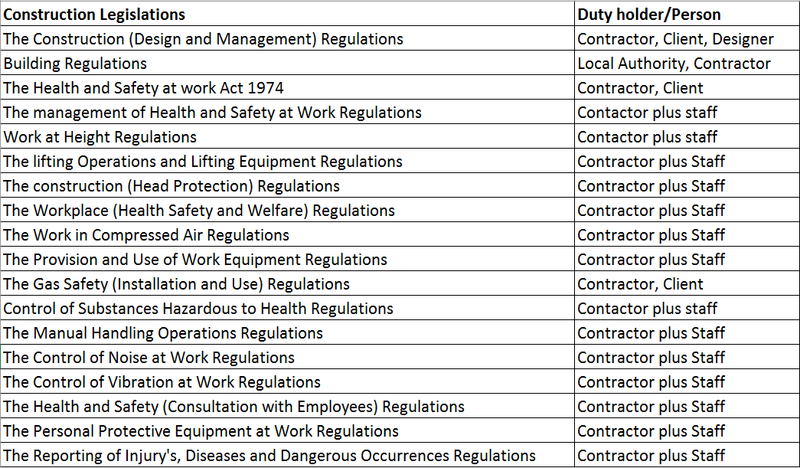

References

Designing Buildings Wiki (2019) Health and safety for building design and construction. Available at: https://www.designingbuildings.co.uk/wiki/Health_and_safety_for_building_design_and_construction (Accessed: 10th March 2019)

Health and Safety Executive (2017) Risk at Work – Personal protective equipment (PPE) Available at: http://www.hse.gov.uk/toolbox/ppe.htm (Accessed: 6th March 2019)
Health and Safety Executive (2015) Managing health and safety in construction – Construction (Design and Management) Regulations 2015. Available at: http://www.hse.gov.uk/pubns/priced/l153.pdf (Accessed: 14th March 2019)

Bibliography
Chudly, R. and Greeno, R. (2016) Building Construction Handbook. 11th Ed. Oxon: Routledge
Health and Safety Executive (2019) Risk management. Available at: http://www.hse.gov.uk/risk/ (Accessed: 1st March 2019)

Riley, M. and Cotgrave, A. (2018) Construction Technology: House construction. 3rd Ed. London: Palgrave

Designing Buildings Wiki (2018) Method statement for construction. Available at: https://www.designingbuildings.co.uk/wiki/Method_statement_for_construction (Accessed: 5th March 2019)

Designing Buildings Wiki (2019) Programme for building design and construction. Available at: https://www.designingbuildings.co.uk/wiki/Programme_for_building_design_and_construction (Accessed: 28th February 2019)

Designing Buildings Wiki (2018) Schedule of work for construction. Available at: https://www.designingbuildings.co.uk/wiki/Schedule_of_work_for_construction (Accessed: 28th February 2019)

HSDirect (2016) What is a Method Statement and How do I Write One. Available at: https://www.hsdirect.co.uk/free-info/method-statement.html (Accessed: 5th March 2019)

