Internet Ethics: Pharmaceutical Cross Border Trade

Karen Jones  Principal Lecturer  Swansea Metropolitan University, UK  Email: karen.jones@smu.ac.uk | Steve Griffiths  Principal Lecturer  Swansea Metropolitan University, UK  Email: steve.griffiths@smu.ac.uk
Stephen Hole  Senior Lecturer  Swansea Metropolitan University, UK  Email: stephen.hole@smu.ac.uk | Rhian Pole  Lecturer  Swansea Metropolitan University, UK  Email: rhian.pole@smu.ac.uk
Chris Gibbins
Research Student
Swansea Metropolitan University, UK
Email: chunkygibbins@hotmail.com

Abstract

Customers who wish to purchase drugs without prescription, based on self-diagnosis of medical complaint, and with no understanding of the implications to their health, can do so from cross-border internet pharmacies. This paper analyses the ethical risks to users of online pharmacies, and the mechanisms to control those risks. It reports the results of a qualitative content analysis of the web pages of a cross section of online pharmaceutical sites. An original framework was created for this purpose based on issues identified in a literature review; these include levels of customer anonymity, customer age verification, access to medical advice and published ethical/privacy policies. Cross border internet pharmacies were found to have higher ethical risk than UK based internet pharmacies.

Keywords: Ethics, internet ethics, pharmaceuticals, drugs

Introduction

Retail outlets/pharmacies in the drug retail market purchase prescription drugs and over the counter medicines (OTC) from suppliers such as drug manufacturers, wholesalers and distributors, then sell them directly to the end-user. This is big business. According to Datamonitor (2011), the global drug retail sector grew by 5.4% in 2010 to reach a revenue value (based on retail selling price) of $875.1 billion. This revenue growth is predicted to accelerate and by 2015, ‘the sector is forecast to have a value of $1,238.6 billion, an increase of 41.5% since 2010’.
Given the size and attractiveness of the market, and increased customer e-commerce adoption, many new pharmacies have entered the industry using the internet as a channel. The United States General Accounting Office (GAO, 2000) defines an internet pharmacy as ‘any business that uses the Internet as the primary access point for customers, as well as traditional corner drugstores and mail-order prescription drug services that use the Internet to supplement their direct public access’.
The range of internet pharmacy services varies; some pharmacies use the internet as an advertising tool while others, such as pharmacy2u, offer a variety of services including distribution of drugs, medical information, health care plans and baby care (Kayne, 2005).
While there are compelling reasons for people to use internet pharmacies, there are ethical concerns regarding the behaviour of some of the participants and providers. This paper outlines some of the ethical controversies associated with internet pharmacies, and the mechanisms to control the risks. It describes the results of a qualitative content analysis of the web pages of a cross section of online drugs retail sites.

Competition in the drugs retail industry

The first Internet pharmacies began service in early 1999. According to Datamonitor (2011), the drug retail market is highly fragmented and competitive. While the market comprises many potential individual customers (thereby weakening their buyer power), buyers can easily compare prices and can switch internet pharmacies if prices are too high. The purchasing trend towards undifferentiated generic (me-too) products, rather than branded goods, strengthens buyer power further. Similarly, there are many drug manufacturers/suppliers (only a small proportion of revenue is earned by large incumbents), thereby weakening supplier power. However, where customer brand loyalty does exist it is more likely to be to the manufacturer of drugs rather than to the retailer.
e-Commerce boosts the competition further, as internet pharmacies compete on the basis of convenience, as well as customer service, product selection/brand and price (Datamonitor, 2011).

Ethics and internet pharmaceuticals

The online drugs retail industry generates much controversy, and its critics charge some providers and participants with unethical behaviour. Ferrell, Fraedrich and Ferrell (2007) describe ‘ethics’ as the study and philosophy of human conduct, with an emphasis on the determination of right and wrong. Ethical behaviour conforms to generally accepted social norms (Reynolds, 2003). ‘Most ethical theories attempt to achieve the same goal: ‘to enhance human dignity, peace, happiness and well-being’ (Baase, 1997). Internet ethics considers the social and ethical impacts of ICT (Bynum, 2008) and De George (2003) contends that the same moral and ethical rules apply in cyber space as apply in other aspects of society. He argues that although some of the ethical issues found on the internet such as fraud and misleading information are familiar to society, others are new. Therefore, while the problems inherent in drugs retailing might not be new, the ethical risk issues in the internet context must be evaluated, to see if new dilemmas arise.

Cross-border pharmacies

Given differing drug regulations in different countries, the drug retail sector tends to operate on national rather than global platforms. Yet, online cross-border pharmacies have emerged that trade between countries that often have different pricing and/or drugs policies. A large cross-border market exists between Canada and the USA. Online pharmacies in Canada accept pharmaceutical orders over the Internet from customers in the USA, fulfil the orders with drugs sourced from Canada or elsewhere, and mail the drugs to the recipient in the USA (Quinn and Narayanan, 2006).
The proximity of Canada to the USA makes distribution relatively easy and prescription prices in Canada can be up to 40% cheaper than in its neighbour (Kayne, 2005). One of the reasons for the price difference is that Canada, like most developed countries, regulates drug prices, while the USA does not.
The chain of websites involved in the internet search and sale of drugs is depicted by CASA (2008) as a pyramid comprising four tiers (see Figure 1): search engine results; portal/advertising site; sale/anchor site; and internet pharmacies. CASA describes the websites that directly sell to consumers as ‘anchor’ sites (the third tier in the inverted pyramid). An individual advertising/portal site can point to several anchor sites that actually sell the drugs. Conversely, multiple portals may provide links to one anchor site. An online pharmacy fulfils and dispatches the order (tier 4 in Figure 1), which may be geographically distant to the anchor site that accepted the sale. Some online pharmacies operate their own anchor sites, while other pharmacies fill prescriptions and provide services for a range of anchor sites. Consequently, the physical locations of the actors in this scenario are difficult to discern (for instance, the computers serving the portal and anchor sites, the operators of these sites, the doctors issuing prescriptions online). Thus, it is not always possible to know the origin of the drugs, and should there be a problem, it may be very difficult to track and make accountable the website owners.
Rogue websites (that sell drugs without a prescription, for example) have an extremely high turnover and may attempt to avoid detection by changing their web names and addresses. Further, it is not unusual for sites to have multiple names. This exacerbates the difficulty of tracking and closing rogue sites (CASA, 2008).

Substitute products to branded and prescription drugs

The main substitutes to branded drugs are generics: imitator products sold at significantly lower prices, which have become more popular in recent years. Generics cost less to manufacture than their branded counterparts because they ‘rely on the safety and efficacy data provided by the innovator product, and they therefore do not have to conduct costly clinical trials’ (Datamonitor, 2010). Aligned with the growth of online pharmacies, there has been a surge in the export of generic drugs from low cost manufacturing environments, such as India and China (Datamonitor, 2011).
Problems with generics arise when they are manufactured to a poorer quality standard than the original drug and are therefore less effective. Hoffman (2009) contends that drugs bought via the internet may be ‘adulterated, counterfeit, contaminated, expired, or all of the above’. The World Health Organization estimates that up to 10% of medicines available globally are likely to be counterfeit, rising to one third in some developing countries (Medicines and Healthcare products Regulatory Agency (MHRA), 2011). ‘Aging populations, particularly in the US and Japan and increasing demand for low-cost prescriptions has increased the presence of counterfeit drugs in the marketplace’ (Datamonitor, 2011). Counterfeit medicines can contain too little, too much or no active ingredient at all. Some contain harmful ingredients such as rat poison, boric acid and lead based road paint. Between 50-90% of all medicines sold on websites which conceal their address are fake (MHRA, 2011). This problem of quality and efficacy adds to the more generally discussed challenge of generic distribution of drugs still within patent time and the need to defend the IP rights of developing companies.

Online Consultations

According to CASA (2008), internet pharmacies typically conform to the following three dispensing patterns. First, some dispense drugs only with a valid prescription. Second, despite the law prohibiting it, many internet pharmacies offer to sell ‘prescription-only’ drugs without a prescription. Third, some will dispense prescription-only drugs after a patient undertakes an online consultation. Rather than a face-to-face physical examination, this ‘consultation’ often involves the ‘patient’ completing an online questionnaire. Reportedly, this is then be reviewed by a ‘script doctor’ who, for a fee, will write a prescription to authorise the internet pharmacy to dispatch the drug to the patient. The Federation of State Medical Boards in the USA expresses its’ concern by stating that electronic technology ‘should supplement and enhance, but not replace, crucial interpersonal interactions that create the very basis of the physician-patient relationship’ (CASA, 2008).

Sale of Prescription-only Drugs with or without Prescription

It is difficult to determine the precise number of internet pharmacies, given the ease of website creation and deletion. In the United States in 2008, CASA identified a total of 365 websites advertising or selling controlled drugs: 206 of the websites advertised the drugs and 159 sites offered the drugs for sale. Licensed, legitimate and reputable Internet pharmacies can provide significant benefits to consumers. For customers buying or seeking information about OTC and prescription drugs, they offer a convenient and sometimes cheaper alternative to the traditional bricks and mortar pharmacy (GAO, 2000). However, only two of the pharmacy selling websites identified by CASA were certified as legitimate, the other 157 were ‘rogue sites’. Online pharmacies should operate much like traditional pharmacies where drugs are dispensed only on receipt of a valid prescription from the consumer. Yet, 85% of the websites selling prescription drugs did not require that the customer produce a doctor’s prescription. Of these, 42% explicitly stated that no prescription was necessary, 45% offered an online consultation and 13% made no mention of a prescription (CASA, 2008). More than 1 in 7 (15%) UK adults have admitted to purchasing prescription only medicine without a prescription (MHRA, 2011).
Of the 15% of websites that required prescriptions, half permitted the prescription to be faxed, potentially allowing a customer to tamper with a prescription or to fax a single prescription to several Internet pharmacies (CASA, 2008).
Most disturbing, there were no controls on any of these sites blocking access to children. Access to most websites is gained easily by typing in a fake age. CASA cite the case of a 13-year old who purchased the drug Ritalin by using her own true height, weight and age when filling out the online form.

Self-diagnosis

As consumers become more knowledgeable with regard to drugs such as paracetamol, many view OTC drugs as commodities. More consumers, particularly in the US, now self-medicate, which has promoted major growth within the US OTC sector (Datamonitor, 2011). According to Hoffman (2009), it is possible for customers to self-diagnose and treat themselves with prescription-only drugs from sites where prescriptions are not required, without full understanding of possible side effects, particularly when two or more drugs are taken together. They may base their ‘diagnosis’ on incorrect medical information gathered at sites they perceive to be legitimate sources of health information.

Anonymity

With ‘a credit card and the click of a mouse, the Internet has offered a convenient and private means of purchasing controlled prescription drugs completely lacking in scrutiny from parents, other family members, and frequently hidden from law enforcement’ (CASA, 2008).
Anonymity protects privacy. Visits to websites can be easily tracked and recorded, and the records used for a variety of purposes, not all of them necessarily in the best interests of the user. Visiting sites anonymously grants a degree of protection (Weckert, 2000). However, if internet users can anonymously log onto the websites to buy drugs there is no way of knowing the age of the customer, or tracking the nature and quantities of drugs purchased. Moreover, an anonymous person cannot be held accountable for his or her actions, which would make it easier for criminals to purchase and sell on prescription drugs without constraint (Weckert, 2000).

Ethics and legality

Some of the internet pharmacies have caused consternation where they are seen to promote the use of medicines where there is no underlying medical condition. For instance, Viagra is prescribed for erectile dysfunction but some websites promote its’ use as a ‘lifestyle’ drug without clearly stating the potential side effects. This raises the dichotomy between what is unethical and what is illegal. Henderson’s (1982) model in Figure 2 represents the Legal versus Ethical Classification of Actions. The framework has been adapted to illustrate examples of legal versus ethical online pharmacy issues. Quadrant 1, of Figure 1, illustrates an ideal, legal and ethical scenario. Quadrant 4, on the other hand, illustrates an example of both unethical and illegal practice. However, Quadrants 2 and 3 illustrate scenarios that are contentious. Although some online drugs websites may be seen as morally just, such as those for users of marijuana for pain relief, they are still illegal. Conversely, some online pharmacy websites may be regarded as unethical but relate to legal behaviour; the provision of dubious healthcare information, for instance.
As illustrated, ethical conduct may range beyond the limits of the law. While the requirements of law and morality may overlap at times they are not the same; legal requirements tend to forbid certain actions, whereas morality tends to encourage certain positive actions. Inherent problems arise when people believe laws represent morality (Kuratko, 2009). The global scale of the internet further complicates the analysis, as diverse ethical precepts and laws may be involved as drugs retail crosses national and cultural boundaries. The evolution of ethical standards of social acceptability tends to be more dynamic than legal reform, creating tension even for consensus apparent in quadrants 1 and 4.

Regulation and problems of jurisdiction

Drug retailers are subject to government laws and regulations that govern the purchase, sale and distribution of prescription drugs. Online pharmaceutical websites that operate within the UK, for example, are governed by the same laws that govern UK offline pharmacies, and should therefore operate legally and safely. The Royal Pharmaceutical Society of Great Britain (RPSGB) is the professional and regulatory body for pharmacists. However, the RPSGB only governs sites in Great Britain. Problems of jurisdiction arise when GB-based customers purchase drugs from online pharmacies outside GB (Kayne, 2005).
However, despite the difficulties inherent in regulating a global internet governed by local legislation, solutions must be sought. As well as the ethical risks specific to pharmaceuticals, there are general issues of internet regulation: ‘the protection of children, collection/storage of data with/without user’s knowledge, the sale of products from unlicensed sources and accuracy and reliability of website content’ (Kayne, 2005). Self-regulation, although often a tactical defence against legislative action, can be effective (Chandra et al, 2004). Voluntary rating or accreditation schemes, as implemented by the RPSGB and the Pharmaceutical Society of New Zealand may contribute towards a solution. Increasingly, internet service providers such as AOL and individual websites are adopting recognised rating schemes for a given site (Kayne, 2005). For example, the certification seal of the health on the net code of conduct (HONcode) for medical and health web sites demonstrates the intent of a website to conform to an ethical standard/code aimed at offering quality health information (see Table 1). Currently the HONcode is used by more than 5,000 certified websites in 72 countries (Health on the Net Foundation, 2011). Similarly, in the USA, a non-profit corporation, LegitScript, certifies internet pharmacies that comply with their standards, which are recognized by the National Association of Boards of Pharmacy.

Methodology of this study

Six drug retail websites/case studies were evaluated in terms of the ethical risk they demonstrate. A phenomenological research philosophy was adopted; the evaluation of the small sample of websites in their natural setting is based on the subjective perception of the researchers, suitable for exploratory, inductive research that aims to ‘understand’ the reality of the websites rather than trying to scientifically measure the sites or generate ‘facts’ (Saunders et al, 2007) The six drug retail websites were purposively selected as some representation of the different types of internet pharmacy (for example, UK focused or cross-border, high street presence or internet pure play). Screen shots were taken and the analysis conducted thereafter.
The content analysis used a framework of original criteria derived from the literature above (see table 2). Using the ten criteria, each website was evaluated and rated in terms of the extent of ethical risk evidenced. The rating was on a scale of 1 to 5, where 5 represented the least ethical risk and 1 the greatest. The scale can be viewed in Table 3. The results are summarised in Table 4.

Analysis of the Results of the Content Analysis

This section outlines the six case study websites and reports the results of the content analysis.

12.1 Boots Pharmacy (http://www.boots.com)

Boots Pharmacy is the leading UK based pharmacy, which limits its services to customers within the UK (see Figure 3). It is a well known bricks and clicks organisation with hundreds of high street stores as well as the internet presence. Boots displays the General Pharmaceutical Council (GPC) logo that indicates that it is a legitimate online pharmacy and is regulated and maintained in accordance with the RSPGB guidelines.
The website focuses on brand name medicines rather than generics, including Boots’ own label brand. Prescription drugs are dispensed only to customers who have a prescription for those drugs. The site offers OTC medicines for mild, general health complaints such as colds and flu where prescriptions are not necessary and a very wide range of health products. The website has many features, including witness testimonials, order tracker, home delivery, access to medical support, store locator. This website is particularly strong in terms of the medical information it provides. There is a section on health news where a customer can search up to the minute news that is released in the industry, whether it be on new drug releases or recalls. WebMD has a symptom checker and medicines A to Z, while there is an option for a health assessment to promote good health.
Boots online pharmacy was the highest scoring website in this study, scoring 43 points out of a possible 45. This score indicates that the website has the least ethical risk and the greatest risk control mechanisms when compared to the other websites evaluated. Information on the site is very detailed and it gave relevant, clear information to satisfy each of the criteria used for analysis. Boots was the only website that achieved a score of 5 in relation to health and safety guidelines and ethics/privacy policy; both provided detailed information that could be found easily from the links on the homepage. The website also requires a new user to agree to the terms and conditions of the website when they register to use the site.

12.2 Rowlands Pharmacy (http://www.rowlandspharmacy.co.uk)

Like Boots, Rowlands pharmacy is a UK based clicks and bricks organisation serving UK customers and displays the GPC logo of legitimacy (see Figure 4). The website focuses on brand name medicines rather than generics. Prescription drugs are dispensed only to customers who have a prescription for those drugs. The site offers OTC medicines for mild, general health complaints such as colds and flu where prescriptions are not necessary and a range of health products. The website has many features, including witness testimonials, customer care, contact us and a filled prescription delivery service. The website has an extensive advice centre for most medical ailments and what symptoms are linked with these ailments.
Rowlands pharmacy was the second highest scoring pharmaceutical website with a total points tally of 39 out of 45. The site was very similar in ratings to the Boots site, but in some instances, such as self-diagnostic tools, the information was less in depth.

12.3 Magicpharma (http://www.magicpharma.com)

Magicpharma (see Figure 5) is a pure internet pharmacy, targeting the US and UK markets via cross-border trade. They do not identify where they are based nor the country from which they ship the products though the site states that medicines will be delivered in discreet packaging. The website sells both the generic and brand name medicines, claiming that the generics are 80% cheaper. Prescriptions can be faxed or an online medical report completed in place of a prescription.
The website is not a registered pharmaceutical site and sells drugs potentially in high quantity. There is no option to access immediate medical advice but it is possible to leave a voicemail or email and wait for a response. There is no clear information on symptoms or self diagnosis guidance. However, there is fairly extensive information regarding each product, its’ uses and contraindications. Although the user is required to input their age when they register to the site there does not appear to be a verification check and as payment can be made by visa electron as well as visa there is an opportunity for young people between the ages of 16 and 18 to purchase the drugs. The website does not permit customers to remain anonymous as users are required to create a user account, including their name and address, before any medicines can be bought. Magicpharma scored third highest overall with a total of 28 points out of 45.

12.4 Pharmland (http://www.pharmland.net)

Pharmland (see Figure 6) is pure internet pharmacy based in Cyprus that targets the US and European markets via cross-border trade. The trading name and address are specified on the website. Pharmland deals solely in the generic medicine market. It allows the customer to buy OTC and prescription medicines without prescription. The website is basic and does not have as many features as other sites. However, at the time of analysis the website was offering an extra 20% of pills free on a customers’ next order. The medications are shipped from Pharmland's facility in India.
The website is not a registered pharmaceutical institution. Information on the site was limited, though there was a privacy policy and some information on the individual medicines. There was no access to medical advice though there was a ‘contact us’ section. The website insists that the user creates a user account which includes details such as name and address. Pharmland was the fourth placed website scoring 25 points out of 45.

12.5 Webmedshop (http://www.webmedshop.net)

Webmedshop (see Figure 7) specialises in selling generic medicines manufactured in India by an Indian state licensed, Indian FDA approved company. The orders are processed and despatched from India, however, no trading address is given. The site offers an extensive list of drugs for sale and explicitly offers prescription drugs without prescription: ‘you can place your order and receive the product without a prescription being required’. Marketing features of the site include testimonials where other users have left comments, as well as a live support ‘chat’ facility to resolve queries.
The website’s ethics/privacy policy had a clear link from the homepage but the policy itself was brief. The site scored poorly on many of the criteria. Webmedshop is not a registered pharmaceutical site. There was no age request at all. The A to Z of medications is very brief and does not identify when the drugs should be used or contra-indications. Webmedshop was the 2nd lowest scoring website with a total of just 17 points out of 45.

12.6 Legalgodhealth (http://legalgodhealth.com)

Legalgodhealth (see Figure 8) is an internet pharmaceutical website based in Nicosia, Cyprus but without specifying a trading address. The site offers generic drugs only, without the need for a prescription and the main target markets are the USA, Europe and Asia. Features of the site include testimonials, a track order function and online support; there is also a search function where a user can search for a specific medicine if they are unable to find it on the site.
Legalgodhealth had an ethics/privacy policy that was easy to locate from the homepage but it was brief. There was no information or control of ethical risk on the website in relation to age, health and safety guidelines, information on the medication and contraindications, and the site appeared to allow users to remain anonymous. Legalgodhealth achieved the poorest rating, scoring just 16 points. This website is no longer available.

Conclusion

It is evident from the content analysis that the UK domestic websites, registered with the General Pharmaceutical Council, are the websites with the least ethical risk. There are clearly ethical controversies to be addressed with regard to cross-border internet pure play pharmacies. Lessons can be learned from the solutions proposed for other internet ethical problems. Griffiths and Jawad (2008) in their consideration of internet gambling ethics, advocate: ethical codes of conduct to protect users; legal reform to prohibit unethical behaviour; market forces that promote ethical business for long-term sustainability; and the adoption of personal responsibility by providers and users to conduct themselves in an ethical manner. The last item requires knowledge, skill and training, which would benefit from a dialogue between all stakeholders (Stahl, 2001). However, while the other three items are fundamental to the solution they will be undermined by unethical code avoidance, legal discontinuity across nations and the amoral environment of market forces.

Figure 1 Chain of Web Sites in Internet Searches for Controlled Prescription Drugs (CASA, 2008, p.6)

Figure 2 The Legal Vs Ethical Classification of Actions
(adapted from Henderson, 1982)
ETHICAL
- Ethical but illegal  Selling controlled drugs/marijuana (without prescription) for severe pain relief | - Ethical and legal  Selling OTC or prescribed medicines (with prescription) for pain relief
- Unethical and illegal  Selling untested or adulterated drugs as ‘generics’ | - Unethical but legal  Providing ‘healthcare information’ from dubious sources for customer self-diagnosis

ILLEGAL LEGAL

UNETHICAL

Figure 3 Boots Pharmacy (http://www.boots.com)
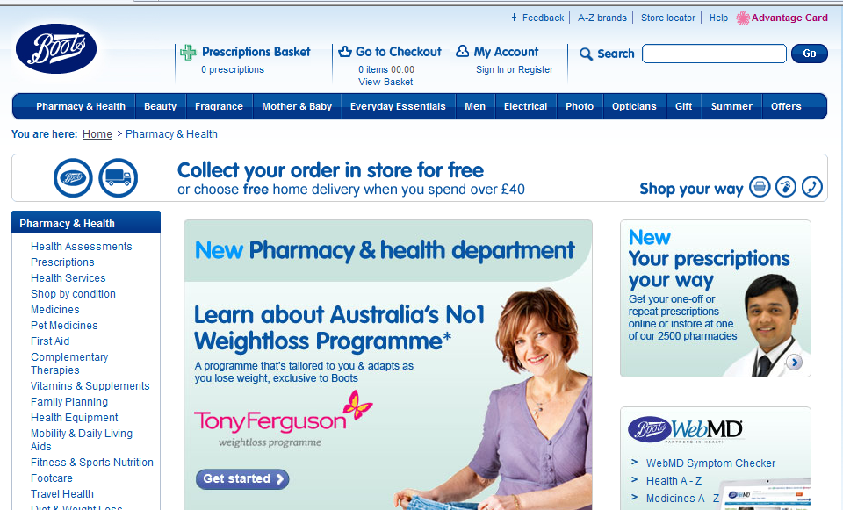

Figure 4 Rowlands Pharmacy (http://www.rowlandspharmacy.co.uk)
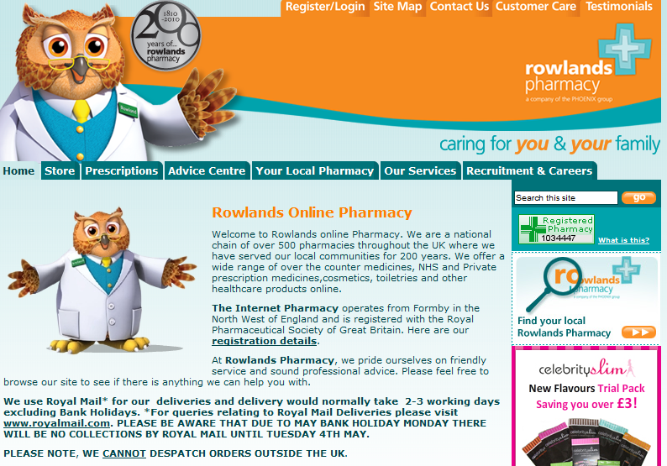

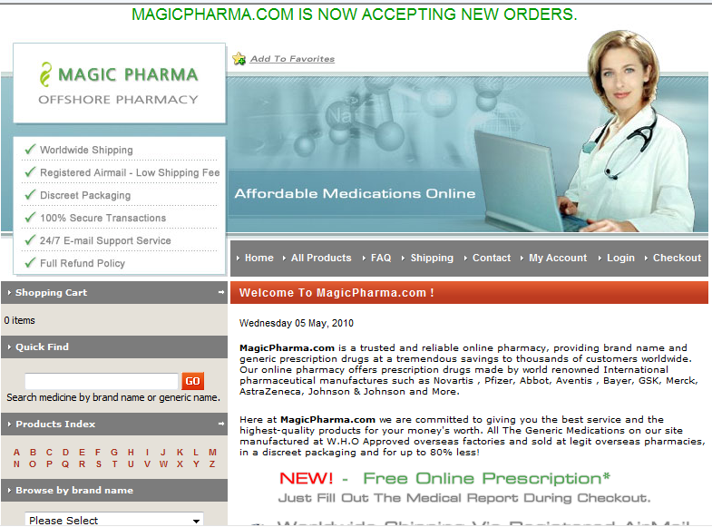
Figure 5 Magicpharma (http://www.magicpharma.com)

Figure 6 Pharmland (http://www.pharmland.net)
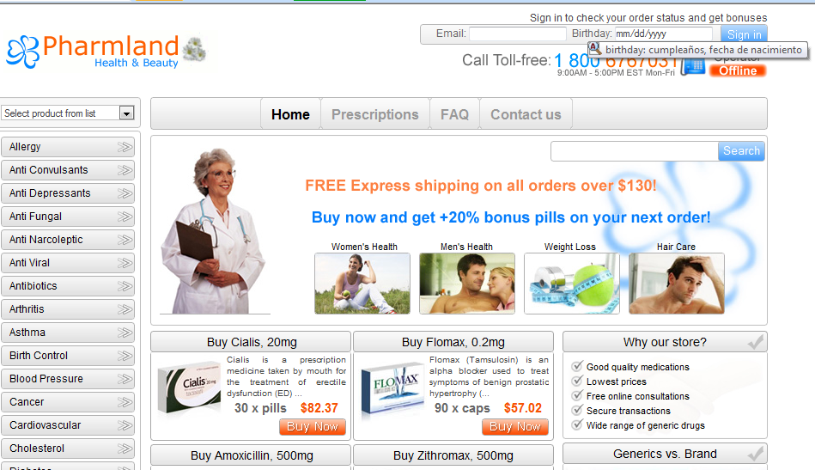

Figure 7 Webmedshop ( http://www.webmedshop.net)
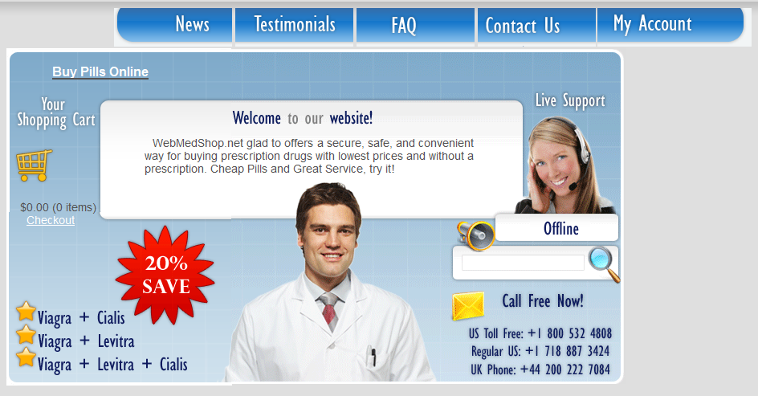

Figure 8 Legalgodhealth ( http://legalgodhealth.com)
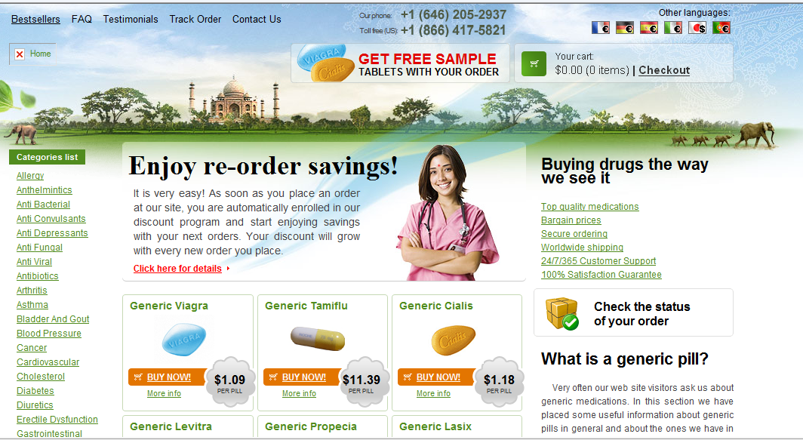
Table 1 The HON Code of Conduct for Medical and Health Web sites
(HONcode) (Health on the Net Foundation, 2011)
1. Authoritative | Medical/health advice provided and hosted on this site will only be given by medically trained, qualified professionals unless a clear statement is made that advice offered is from a non-medically qualified individual or organisation.
2.Complementarity | The information provided on this site is designed to support, not replace, the relationship that exists between a patient and his/her existing physician.
3. Privacy | Confidentiality of data relating to individual patients and visitors to a medical/health Website, including their identity, is respected by this Web site. The Web site owners undertake to honour or exceed the legal requirements of medical/health information privacy that apply in the country and state where the Web site and mirror sites are located.
4. Attribution | Where appropriate, information contained on this site will be supported by clear references to source data and, where possible, have specific HTML links to that data. The date when a page was last modified will be clearly displayed
5. Justifiability | Any claims relating to the benefits/performance of a specific treatment, commercial product or service will be supported by appropriate, balanced evidence in the manner outlined above in Principle 4.
6. Transparency | The designers of this Web site will seek to provide information in the clearest possible manner and provide contact addresses for visitors that seek further information or support. The Webmaster will display his/her E-mail address clearly throughout the Web site.
7. Financial disclosure | Support for this Web site will be clearly identified, including the identities of commercial and non-commercial organisations that have contributed funding, services or material for the site.
8. Advertising | Clearly distinguish advertising from editorial content

Table 2 Criteria used in the Content Analysis of the Websites
1 | Age verification present?
2 | Health and safety guidelines?
3 | Access to doctor/medical advice?
4 | Anonymity of customer?
5 | Is the website a registered Pharmaceutical institution?
6 | Quantity of drugs that can be purchased?
7 | Self diagnosis option?
8 | Creation of user account?
9 | Websites privacy/ethics policy?
10 | Do they offer cheaper generic drugs and/or branded drugs?

Table 3 Rating System used in the Content Analysis of the Websites
Rating | Reasoning examples
1 | - No information or hard to find information  - No control of ethical risk
2 | - Limited information. Information found within 11 – 15 minutes of accessing site  - Poor control of ethical risk
3 | - Small amount of clear information  - Information found within 6 – 10 minutes of accessing site  - Acceptable control of ethical risk
4 | - Clear and appropriate information found  - Information found within first 5 minutes of accessing site  - Good control of ethical risk
5 | - Detailed information found easily/immediately upon accessing site  - High control of ethical risk

Table 4 Results of the Content Analysis of Six Websites

Name of  website | Age verification | Health and safety guidelines | Doctor  medical advice | Level of Anonymity | Registered pharmaceutical institution | Quantity of drugs that can be purchased | Does the website offer self diagnosis? | Necessity of user account | Access to the website’s privacy/ethics policy | Do they offer cheaper generic drugs and/or branded drugs | Overall Score out of a maximum of 45 | Ranking  (highest to lowest)
BOOTS | 4 | 5 | 5 | 5 | 5 | 5 | 4 | 5 | 5 | Brand | 43 | 1
ROWLANDS | 4 | 4 | 4 | 5 | 5 | 5 | 3 | 5 | 4 | Brand | 39 | 2
MAGICPHARMA | 3 | 4 | 2 | 4 | 1 | 3 | 2 | 4 | 5 | Both | 28 | 3
PHARMLAND | 3 | 3 | 2 | 4 | 1 | 3 | 2 | 3 | 4 | Generic | 25 | 4
WEBMEDSHOP | 1 | 2 | 2 | 3 | 1 | 2 | 1 | 1 | 4 | Generic | 17 | 5
LEGALGODHEALTH | 1 | 1 | 2 | 2 | 1 | 3 | 1 | 1 | 4 | Generic | 16 | 6
TOTALS (30) | 16 | 19 | 17 | 23 | 10 | 21 | 13 | 19 | 26

References

Baase, Sara (1997) A Gift of Fire. Social, Legal and Ethical Issues in Computing,: Prentice-Hall: NJ
Bynum, T.W. (2008) ‘Computer And Information Ethics’, Stanford Encyclopedia of Philosophy, 23 October (online). Available at http://plato.stanford.edu/entries/ethics-computer/. Accessed 15 May 2009
CASA (National Centre on Addiction and Substance Abuse at Columbia University) (2008) You’ve Got Drugs! V: Prescription Drug Pushers on the Internet, July (online). Available at http://www.casacolumbia.org/articlefiles /531-2008%20You've%20Got%20 Drugs%20V.pdf. [11 May 2011]
Chandra, A., Sikula, A, and Paul, D.P. (2004) ‘Digital Marketing: Ethical Considerations in the Marketing of e-Health Products’, International Journal of Medical Marketing, Vol 4, 2, pp. 110-118
Datamonitor (2010) Industry Profile: Global Pharmaceuticals, November, (online). Available at www.datamonitor.com. [2 May 2011]
Datamonitor (2011) Industry Profile: Global Drug Retail, 15 April, (online). Available at http://360.datamonitor.com.v-ezproxy.smu.ac.uk/Product?pid= 44077B92 -7E1E-49ED-9F03-2F8584345930 [8 May 2011]
De George, R.T. (2003) The Ethics of Information Technology and Business. Blackwell: Oxford
Ferrell, O.C., Fraedrich, J. and Ferrell, J. (2007) Business Ethics: Ethical Decision Making and Cases, 7th Edition, Houghton Mifflin Company: Boston, USA
General Accounting Office (GAO) (2000). ‘Internet Pharmacies: Adding Disclosure Requirements Would Aid State And Federal Oversight’ GAO Report No. 01-69, Oct. Washington, DC: U.S. General Accounting Office. Available at http://www.gao.gov/new.items/d0169.pdf
Griffiths, S. & Jawad, C. (2008) ‘Internet Gambling Ethics Regulation: The UK Perspective’ in Toine Spapens, T., Fijnaut, C. and Littler, A. (eds), The Regulation of Gambling and the Role of Crime and Addiction, University of Tilberg Press: Tilberg, Holland
Hoffman, M. (2009) ‘An FDA Seal of Approval for Online Information?’ Pharmaceutical Technology, Volume 33, Issue 12, pp. 12, 2 December
Health On the Net Foundation (2011) The HON Code of Conduct for Medical and Health Web sites (HONcode) (online). Available at http://www.hon.ch/HONcode/Patients/Visitor/visitor.html [12 May 2011]
Henderson, V.E. (1982) ‘The Ethical Side of Enterprise’, Sloan Management Review, Spring82, Vol. 23 Issue 3, p37-47
Kayne, S.B. (2005) Pharmacy Business Management, Pharmaceutical Press
Kuratko, D.F. (2009) Entrepreneurship: Theory, Process, Practice, 8th Ed., Cengage Learning: USA
Medicines and Healthcare products Regulatory Agency (MHRA) (2011) ‘Fake Medicine: Do you know what you’re buying online? (online)’. Available at http://www.mhra.gov.uk/home/groups/comms-ic/documents/websiteresources/con060197.pdf. [14 May 2011]
Quinn, J. and Narayan, P. (2006) ‘International Trade in Pharmaceuticals - Is Online Out of Line?’ Blakes, 1 May. (online). Available at http://www.blakes.com/english /view_disc.asp?ID=222. [14 May 2011]
Reynolds, G. (2003) Ethics in Information Technology, 2nd Edition,Thomson Learning: Boston, USA
Saunders, M., Lewis, P. and Thornhill, A. (2007) Research Methods for Business Students, 4th Ed. Harlow: Financial Times/Prentice Hall.
Stahl, B.C. (2001) Responsibility in the Interconnected Economy, Business Ethics A European Review, Vol. 10, No 3, pp. 213-222
Weckert, J. (2000), ‘What is New or Unique about Internet Activities?’ In Langford, D. (Ed.) Internet Ethics, Macmillan Press Ltd

