Tom Sinclair (2104559)
2104559@student.uwtsd.ac.uk
How has policing evolved in the last 50 years following corruption and failings from the police service in the uk?
By Tom Sinclair
Declarations
Declaration 1
This work has not previously been accepted in substance for any degree and is not being concurrently submitted in candidature for any degree.

Signed: Tom Sinclair Date: 07/05/2024

Declaration 2
This dissertation is the result of my own independent work/investigation, except where otherwise stated. Other sources are acknowledged by footnotes giving explicit references. A bibliography is appended.

Signed: Tom Sinclair Date: 07/05/2024

Declaration 3
I hereby give consent for my dissertation, if accepted, to be available for photocopying, interlibrary loan, and for deposit in the University’s digital repository.

Signed: Tom Sinclair Date: 07/05/2024

Supervisor’s Declaration

I am satisfied that this work is the result of the student’s own efforts.
Signed:
Date:

Contents
Chapter One: Introduction 3
Background 3
Value 3
Aims and Objectives 5
Chapter Two: Literature Review 6
Objective 1 – Identifying the need for evolution throughout the police service. 6
Objective 2 – The findings and failings of the police service during the Stephen Lawrence Murder and Inquiry. 9
Objective 3 – The Murder of Sarah Everard and how it influenced a negative public perception on the police service. 12
Chapter Three: Methodology 15
Chapter 3.1: Introduction 15
Chapter 3.2: Research Strategy 16
Chapter 3.3: Data Collection 17
Chapter 3.4: Data Analysis 19
Chapter 3.5: Limitations 20
Chapter Four: Research Findings 21
Chapter 4.1: Introduction 21
Chapter 4.2: Structure of the survey 22
Chapter 4.3: Diversity of the survey 28
Chapter 4.4: General and Key findings 34
Chapter 4.5: Raw data (Appendices) 43
Chapter Five: Conclusion 43
Reference List 44

Chapter One: Introduction

Background

Throughout the history of the police service in the UK, there have been numerous evolutions, adaptations and changes made to policies and regulations. The police service in the UK often changes these to adapt with the evolution of technology however, they also change a vast majority of laws and regulations to better suit the reduction of crimes, criminal activities and offences. Although changes are made to policing frequently, some of the major changes are made through the previous police failings or corruption involved in cases that have previously happened. Over the last 50 years, there have been a number of cases some being more significant than others which have had a huge role in changes to numerous laws, policies and procedures. The Police Foundation (2024) emphasises the need for changes as they state the police service is not only dealing with crime, but also a vast majority of institutional issues such as funding cuts and service cuts. There are a large number of cases which have led to adaptations and evolution being made throughout the police service however, two of the most notable with significant impacts all over the UK had been the Stephen Lawrence Murder and Inquiry in 1999, and also the Sarah Everard Murder in 2021. These cases played a massive part in the overall evolution of policing as they both had led to deep investigations throughout various departments of police service over the UK.

Value

Evolution of policing in the UK has proven to be significant following events which have happened in the last 50 years. Over recent years, there has been numerous issues highlighted in the forces such as one of the main issues being the accountability and transparency in the UK police service. The Information Commissioner’s Office (2023) has stated that they have issued an enforcement notice to the Greater Manchester Police Force due to the repeated failures to respond to Freedom of Information Act requests. This issue has proceeded to emphasise the police failings as the freedom of information is a vital requirement for all police services to follow, and having a backlog of information for those who are requiring documents can hold up a variety of services, not just the police service. Angell (2023), who is the Head of FOI Casework at the Information Commissioner’s Office also states that “Greater Manchester Police has currently done little to address the response backlog”. This tells the public how the police are not prioritising their relationship with the public in which a lot of individuals will feel like the trust between policing and the public will have broken down. Angell (2023) also makes the following statement saying, “There is nothing more important than the police maintaining the trust and understanding of the public, but this is not the way to earn trust”. Over numerous years there it has been believed that there is a significant divide between the public and the police, as the public perception often deems the police service as corrupt, untrustworthy and institutionally failing. The statement made by Angell (2023) elaborates on the importance of having trust in the entire police force as by having connections and trust with the public makes policing easier and entirely possible. For example, with every crime it is required that evidence has been found against the offender and if there were no CCTV cameras or recorded proof or evidence, the next point of evidence would be forensics and witnesses. This elaborates the importance of the police service being accountable and transparent with every decision and key detail being made, as the public perception of the police service has a vital impact in recent years since the introduction of policing by public consent.

Aims and Objectives

The aims and objective for this research is to gain a better understanding and develop more knowledge for the importance of the evolution of policing, whilst also gaining a further insight on some of the police failings and corruption which have influenced or potentially led some of the changes. One of the main aims from this research project is to evaluate the effectiveness of previous methods used by the police service across the UK alongside research on how methods which have previous failed, have been either removed, improved or developed as the evolution of policing continues. Another main aim of this project is to primarily research the different methods currently used in policing and identify the positives and negatives to these methods. By doing this, it will elaborate on the need for policing to evolve as a whole showing that not only does policing conducts need to change, but also a large number of other policing issues and negative factors throughout the service.

Chapter Two: Literature Review

Objective 1 – Identifying the need for evolution throughout the police service.

Throughout the police service, there has been a variety of changes, some for positive introduction and others were implemented following a certain incident which allowed for an understanding that a change was to be made. However, what is the need for the police service to evolve if justice is being delivered in a successful and efficient working order?
Following the improvement of online services and technology, it has opened a door for a new era of crime. The Crown Prosecution Service (2024a) states that there are two main sources of technologically enhanced crime being Cyber-enabled crimes and cyber-dependant crimes. Cyber-enabled crimes are where technologically is being used to enhance a crime from happening, such as fraud. Cyber-dependant crimes on the other hand, are crimes committed which can only be committed through the use of technology, where the devices are both the tool for the crime and the target of the crime (National Crime Agency, 2024). With the evolution in technology comes the evolution in crime, this is a prime example of why the police service needs to continuously adapt to the upcoming challenges being produced by technology, being new crimes or the worsening of previous crimes, it elaborates the need for evolution throughout the service. The police services in the UK are also trying to implement the use of automated systems in order to make more time available for digital forensic units. The National Police Chiefs’ Council (2024) states that they have introduced this system in order to improve the provision and use of digital forensics across law enforcement as a whole. They implemented this system as a trial in one force across the UK and found that cases were processed 55% faster on average, resulting in 9.5 hours per case being saved (National Police Chiefs’ Council, 2024). This allows for digital forensics units to focus their work power on more difficult and important cases, allowing for the automated system to help reduce the workload and effectively solve and assist cases.
With technology developing, it often leads to criminals learning new ways to bypass certain systems as well as finding more efficient ways to commit crimes without getting caught. This also results in the police service across the UK focusing on discovering new methods to catch these criminals and if possible, prevent crime as a whole. One example of these new systems is the use of facial recognition technology. The Metropolitan Police (2024a) gives an example of this with their use of Live Facial Recognition, referred to as LFR for short. The Metropolitan Police (2024a) states that their LFR cameras are located in specific areas, and when individual’s pass through this area it becomes streamed directly to a live facial recognition system. The system in which the images get streamed to contains a watchlist of offenders who are wanted by the police/and or the courts or individuals who they deem as a risk to themselves or the public (The Metropolitan Police, 2024a). This policing system helps to discover and efficiently, effectively and successfully catch potentially wanted criminals and offenders. Offenders who commit serious crimes in the UK often flee to other countries, Interpol (2024) have created their own facial recognition system known as the Interpol Facial Recognition System, or the IFRS for short. This system was launched at the end of 2016 and works similar to the Metropolitan Polices’ facial recognition system. Interpol (2024) have stated that since the introduction of their IFRS, it has helped to identify several thousand, including terrorists, criminals, fugitives, persons of interest and missing persons. Both of these facial recognition systems have proven to be beneficial as they have helped locate individuals who are needed by police and/or courts, deemed a risk to themselves, or even a risk to others. Mental health calls for the police service due to individuals missing or being a risk to themselves have always been ongoing. The British Medical Association (2024) states that the percentage of adults between aged 16-74 with a common mental disorder who were accessing mental health treatment has risen from being 23.1% in 2000, to 39.4% in 2014. It shows that in 14 years, there has been a 71% increase for individuals who are seeking mental health treatment. This elaborates on the need for facial recognition system and the evolution of these services as if an individual who has been suffering from mental health goes missing, hasn’t turned up somewhere or has missed a scheduled welfare check, the police service can use these systems to find the missing individual and ensure their safety.

Objective 2 – The findings and failings of the police service during the Stephen Lawrence Murder and Inquiry.

The Stephen Lawrence case was a tragic case where an 18-year-old boy called Stephen Lawrence was murdered on the 22^{nd of} April 1993. The attack was labelled as an unprovoked racist attack, the killers didn’t know who he was, and Stephen didn’t know any of the killers (Stephen Lawrence Day Foundation, 2023). Following his murder, it had taken a total of 19 years for 2 out of the group of 5 or 6 individuals to get charged with the murder of Stephen Lawrence (Dodd, 2023). This led to outrage amongst communities at the time as everyone was in disgust at how the police service had failed in this investigation, leading to numerous articles and reports made about this event. One of the most notable and important reports in history was made due to the incident, the Stephen Lawrence Inquiry by Sir William Macpherson of Cluny however, it is more commonly referred to as the Macpherson report. The Macpherson report played a vital role throughout history as it represented most of the community in the feelings led towards the police services’, or lack of, actions. The UK Parliament (2021) states that the Macpherson report was truly groundbreaking at the time as it led to numerous changes in laws, in policing, and ultimately led to two convictions being made for the murder of Stephen Lawrence. In Chapter forty-six of the Macpherson Report (Macpherson, page 365, 1999), the following statement was made by Macpherson; “The investigation was marred by a combination of professional incompetence, institutional racism and a failure of leadership by senior officers”. This statement proceeded to have a huge impact on the police service as it highlighted an astronomical number of institutional issues which had been happening inside the police service. In the following of the Macpherson report, Meade & Nickolls (2023) have elaborated on the importance of the changes and adaptations which have been made leading to the arrests of the individuals who had taken part in the Stephen Lawrence murder. Meade & Nickolls (2023) state how the Metropolitan Police have been referred to as ‘institutionally racist’ in the Macpherson report and allows for an understanding that due to the Macphersons report high critical analysis of the situation, it has resulted in numerous law changes and evolutions in policing standards. One of the main changes which this case has influenced is the changing of the double jeopardy rule. Broadbridge (2009) stated that the double jeopardy rule was a general principle in English law stating that an individual may not be tried twice for the same crime, whether found innocent or guilty the first time. Broadbridge (2009) then follows by emphasising how the Macpherson report had listed numerous recommendations which should be added to making policing better overall, many of these recommendations were considered and have actually been implemented into modern day policing. Although there were numerous recommendations by Macpherson which have been implemented, it did come with some controversial suggestions which had been rejected for example Machperson suggested that consideration should be given to the court of appeal being given power to permit prosecution after acquittal where fresh and viable evidence had been given (Broadbridge, 2009).
Throughout the Stephen Lawrence case, there had been a considerable amount of thought into the prosecution of the four senior detectives who had been in charge of running the Stephen Lawrence case. Dodd (2023) shows the emotions throughout the case by the mother of Stephen Lawrence as she states that it is a “disgrace” for prosecutors to decide not to bring the charges against the four senior detectives who had been accused of bungling the first investigation into Stephen Lawrences murder. De Simone (2023) states that the Metropolitan Police Deputy Assistant Commissioner Matt Ward elaborated on this by stating he did not “underestimate the impact” the CPS decision would have. This emphasises the disappointment in which numerous individuals have suffered following the failure of the police service throughout the initial investigation. De Simone (2023) also states that the Metropolitan Police Deputy Assistance Commissioner Matt Ward already understood and acknowledged that too many mistakes had been made during the first investigation into the death of Stephen Lawrence. This clearly shows how significance of the police failings and the importance of the Macpherson report as it allowed for an understanding of what went wrong with the first investigation, alongside highlighting the institutional errors in which the Metropolitan Police had failed to previously fix. Overall, the reports following the Stephen Lawrence case had a substantial impact on the evolution of policing and the changes which had been made in laws and policies throughout the police service in the UK.

Objective 3 – The Murder of Sarah Everard and how it influenced a negative public perception on the police service.

The Sarah Everard case was a shocking case which happened in 2021. During this case, an off-duty police officer named Wayne Couzens had kidnapped, raped and murdered a 33-year-old woman named Sarah Everard. This case was truly shocking as Sarah had been missing from the 3rd of March 2021 until her body was found on the 12^{th of} March 2021. Ng, Hancock and Osbourne (2024) elaborate how Wayne Couzens had proceeded to abuse his power and the public trust as a police officer as he proceeded to show Sarah Everard his warrant card and put her in handcuffs in order to place her under a false arrest. This case had deeply affected the view of the police service throughout the entire UK, as the public believed that the police service had let down everyone due to this case. Numerous individuals believed that the police service is also responsible as this entire incident should have been prevented. This public outrage was extremely strong whilst the case had been ongoing, resulting in numerous statements being made by different police services, chief constables and the Metropolitan Police themselves. The Metropolitan Police (2024b) released a response statement online with the sentence which Wayne Couzens had received, but also how they are going to ensure that the correct, effective measures are in place in order to protect girls and women from any incidents happening in future. The Metropolitan Police (2024b) have included numerous implementations which have been put in place following the Sarah Everard murder such as deploying 650 new officers into public places, including those where women and girls often lack confidence that they will be safe. They have also proceeded to introduce specialist predatory offender units who will focus more on preventing similar incidents from happening. One of the main implements by the Metropolitan Police (2024b) had been the action plan which has been developed primarily for violence against women and girls and prioritising action against violent predatory offenders and sexual offenders. During this action plan, The Metropolitan Police (2024b) states that they will be primarily focusing on a few key factors such as, rebuilding the trust between the police service and the public and protecting women and girls in public spaces, at home or online. Another major factor spoken about are the partnership between the police service and partners as well as working with women to improve prevention and victim care. The final factor in the Metropolitan Police (2024b) action plan states that they will be also heavily working on bringing perpetrators to justice and improving criminal justice outcomes for victims. This factor is vital as by the police force implementing systems to support individuals and bring perpetrators to justice, it will allow for more public trust to develop which ultimately will help the police service prevent crime as a whole.
The Sarah Everard murder was a tragic event which has resulted in a lot of changes in the police service and implementations however, the question which still raises attention in the media is could the Sarah Everard murder been prevented? The Independent Office for Police Conduct (2023) states that they believe it was poor handling by the Metropolitan Police service and Kent Police Service as Wayne Couzens had two allegations against him. One of these allegations was an indecent exposure at a McDonalds restaurant in Swanley, February 2021 whilst the other allegations was an indecent exposure in Dover, June 2015 (Independent Office for Police Conduct, 2023). Both the Metropolitan Police Service and the Kent Police Service have received critical feedback as it is believed having the forces acted on these allegations and had launched effective investigations, the outcome of the entire Sarah Everard case could have been different.
The aftermath from the Sarah Everard case has been catastrophic for police forces all over the UK as it had severely broken trust between the public and the police service. The End Violence Against Women Coalition (2021) commissioned nationwide research to gain a better understand on how the Sarah Everard case had affected women across the UK. They found numerous statistics following this case such as 76% of women think the culture of policing has to change and evolve in order to be able to respond better to violence against women and girls. Another important statistic they found from the nationwide research is that 1 in 10 women have stated that they would be less likely to report a sexual assault to the police service following the Sarah Everard case (The End Violence Against Women Coalition, 2021). These statistics demonstrate how this case has led to a negative perception of the police service across the UK following the failings and corruption of an officer in the police force. It also elaborates and shows how the police service are currently evolving with every incident they deal with. Although they may not be able to prevent incidents from originally happening, they are adapting to situations effectively and attempting to prevent any similar scenario from happening.

Chapter Three: Methodology

Chapter 3.1: Introduction

The literature review has explained some of the key events in policing which has demonstrated the failings of the police services, alongside the corrupt aspects of the police service. There has been numerous information and statistics on why the police service needs to improve and how they have also proceeded to evolve. The main purpose of this research is to gain a better understanding of the evolution of the police force following the events of corruption and police failings in which has happened in the past. Furthermore, there has always been a very hostile public perception towards the police. As time has passed the police service all over the UK has continued to be abused verbally and physically which has led to younger generations continuing the hatred. This allows for an understanding of why the police service is constantly changing laws and adapting to the requirements being set by the public as the public have a massive role in policing due to the support, which is provided not only by individuals reporting crimes, but also through witnesses. This elaborates the need to the police service all over the UK to continuously evolve the methods of policing as they continuously try to regain the trust of the public which has been broken numerous times before, such as from the Stephen Lawrence murder and how the police had failed investigations, or the Sarah Everard murder where a police officer had abused his power in order to kidnap, rape and murder a 33-year-old woman.

Chapter 3.2: Research Strategy

In order to be able to obtain the data, which is necessary for this research, a survey will be created and sent out to a wide range of participants throughout the UK. Jones, Baxter and Khanduja (2013) state that an advantage of using surveys to gather information is that a large population of participants would result in a greater statistical power, meaning that the survey results would often be more accurate in comparison to other research methods. The participants who have been chosen to complete the survey are individuals who are based all over the UK, so it will allow for a more widespread result as it wouldn’t limit the survey to a certain geographical area. In the survey, there are two main case studies which have been mentioned being the Stephen Lawrence case and the Sarah Everard case. These have been mentioned in the survey in order to gain an understanding if the cases have any influence on the public’s perception on the police service. Hobbs & Brown (2023) elaborate the importance of trust for the police service and state that people are more likely to trust the police if they have positive evaluations and expectations including effectiveness, fairness and integrity in the police. These cases are a prime example of how the trust can be broken between the police service and the public.

Chapter 3.3: Data Collection

One method for collecting data is the qualitative research method which involves collecting and analysing non-numerical data to understand a variety of concepts, experiences or opinions (Bhandari, 2023). Cleland (2017) elaborates on the positives of the qualitative research method as it allows for an individual to ask questions which cannot easily be put into numbers to understand human experience. This method is beneficial throughout conducting a survey as an understanding can be gained of the participants experience, for example if the participant completing the survey has any positive or negative experiences with the police service, we can use this method to understand the experience more leading to a more successful survey. Morgan (2016) states that although there are numerous strengths to qualitative research, there are also some negatives. An example Morgan (2016) gives is that poor quality qualitative research work can lead to mislead findings, as well as it can be time consuming and labour-intensive depending on the survey method chosen.
Another method for collecting data is the quantitative research method which in contrast to a qualitative method, deals with data that is numerical or data that can be converted into numbers (Sheard, 2018). The Indeed Editorial Team (2022) states that there are numerous positives when using quantitative research such as the researcher can collect more accurate results due to it offering an outcome based on numbers rather than subjective judgements. Mander (2022) states that the main negative with using quantitative research is that you will get a less detailed picture in comparison to using qualitative research. This is a major factor when conducting research as in the survey there will be questions relating to an individual’s experience which will not be able to be turned primarily into numerical data.
There is a variety of different methods which can be used to collect data, some are more effective than others in certain scenarios however, for the purpose of this research, the mixed methods research is more effective and efficient. Shorten & Smith (2024) states that mixed methods researching is when a purposeful mixing of methods of data collection and data analysis is used. Shorten & Smith (2024) elaborates on this further saying that it is a strong research method to use as it allows for an individual to gain research and discover answers that nor quantitative or qualitative research methods would be able to gain by themselves. George (2022) supports this statement as they state that mixed methods can help you gain a more complete picture rather than if you were to use quantitative and qualitative research as it integrates both of these methods into one.

Chapter 3.4: Data Analysis

To construct the survey Google Forms was used as it’s very accessible for every participant to access, and it allowed for ease and efficiency when collecting responses from the survey. This software is a very good choice for a survey as it displays all quantitative and qualitative data separately and effectively, for example it will state the qualitative data clearly, allowing for a good understanding of the responses, whilst it also displays the quantitative data in the forms of charts or graphs allowing for an easy understanding of the survey responses alongside the ability to effectively compare these results to other findings. For the survey, mixed methods research was the research method as combining both qualitative and quantitative methods, they can balance out the limitations which each method would face if the method was used alone (Office for Health Improvement and Disparities, 2020).

Chapter 3.5: Limitations

This chapter has discovered numerous methods which could be used successfully and efficiently to gather information. It has also emphasised the strengths and the weaknesses of methods which could have been used however, there were numerous limitations which impacted the way the survey was put together. One of the main limitations was the simplicity and complexity of the survey. This proved to be a challenge when creating the survey because whilst trying to ensure the results were efficient and still relevant to the evolution of policing and how police failings and corruption have affected the evolution, it was a challenge keeping the survey basic and simplistic enough for everyone to understand. Another challenge which had proven to be difficult was the individuals who actually complete the survey for example, Andrade (2020) states that the majority of individuals who see the survey will most likely just skip past it or not complete it as it doesn’t necessarily refer to them or interest them in the topic. This could result in little to no responses if the survey was too complex or too specific on a certain topic. To combat this limitation, it resulted in the survey being quite broad but still relevant to the topic, allowing for more interest in the survey alongside the correct findings still being present.

Chapter Four: Research Findings

Chapter 4.1: Introduction

In this chapter, there will be a mixed method research survey containing responses regarded the evolution of policing, the police and public trust, the reliability of the police service alongside questions regarding the Stephen Lawrence case and the Sarah Everard case. This information will allow for a deeper analysis in the evolution of the police service over the last 50 years, and how events such as corruption and police failures have affected this.

Chapter 4.2: Structure of the survey

The survey contains a total of seventeen questions, with the very first question continuing from the introduction and ensuring that the participant consents to being part of the research and analysis. All responses were anonymous with no details of the participant being taken, besides their responses to the questions to ensure all of the research being conducted is ethical.
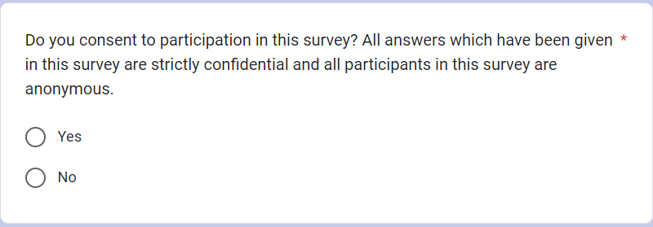

Following this question, The survey proceeds to ask five questions asking the participants about their:
- Gender
- Sexual Orientation
- Age
- Birthplace
- Ethnicity
These five questions are a vital part of the research as over recent years, there has been a lot of policing incidents, such as racial profiling. Gov.uk (2024) lists the main facts and figures about stop and searches from the year ending 2022. These facts and figures prove significant in the survey due to it showing that there were 27.2 stop and searches for every 1,000-black people, in comparison to 5.8 stop and searches for every 1,000-white people. This information is important for this research as it allows for an understanding of how many participants who take the survey are of different ethnic backgrounds, and how this may affect the survey results.

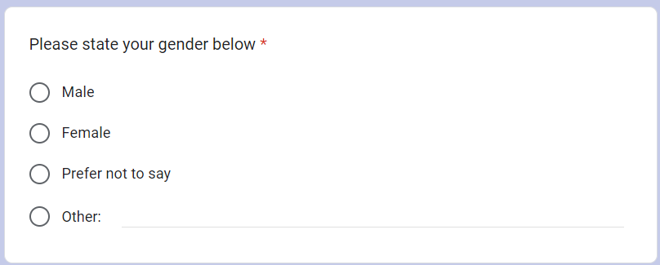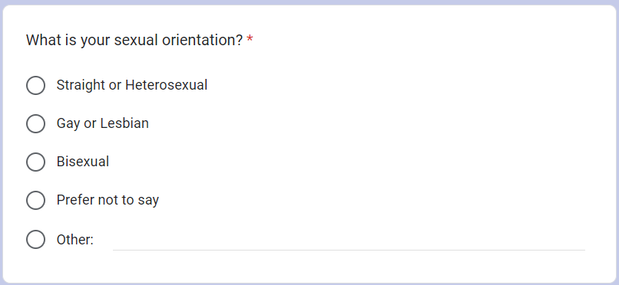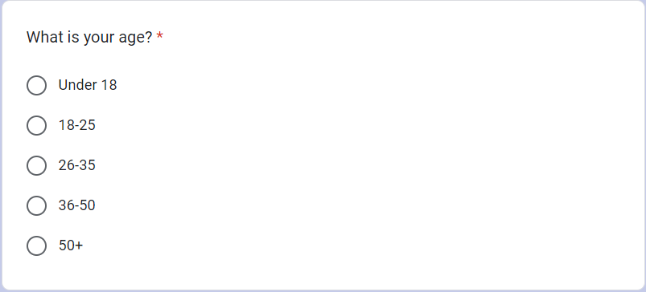
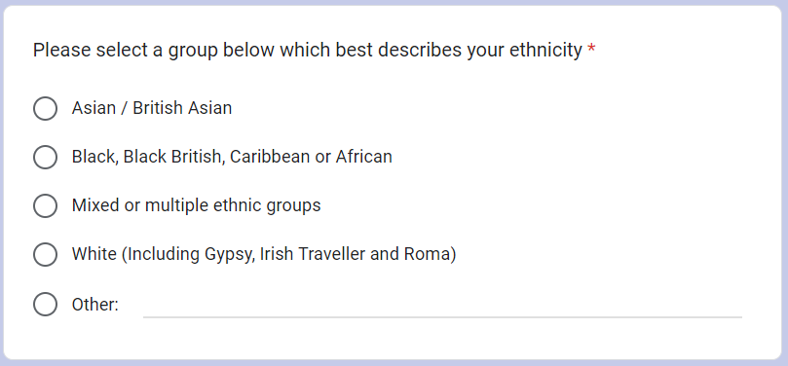

The next two questions are based on qualitative research information, asking the individual about which police force controls their area, and how much do they trust their service. CrimeRate (2024) elaborates on the importance of areas as they have statistics of the crime rates throughout England, Wales, Northern Ireland and even the UK as a whole. These questions are important because in different geographical locations around the UK, the crime is different. This can vary from the types of crimes being committed or even the crime rate. The Crown Prosecution Service (2024b) shows a great example of this as they state that in more rural areas, the crime committed will be more commonly things like machinery theft, fuel theft and livestock offences. However, in a more urban area the crimes committed commonly would be crimes like assault or theft. The Department for Environment Food & Rural Affairs (2022) states that average crime rates from police recorded crime are lower in rural areas than in urban areas.

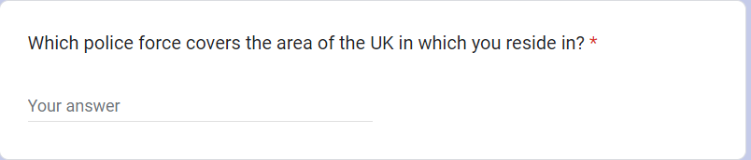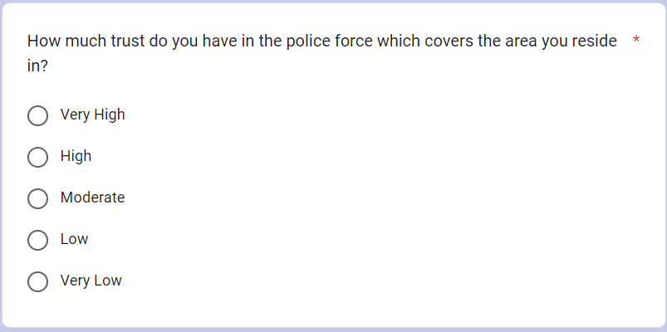

The next three questions are specifically to gain more knowledge and understanding on the public perception of the police service. Tudor (2023) elaborates the broken relationship between the police service and the public. Tudor (2023) states how there has been a series of high-profile cases of gross misconduct and illegal activities by police officer. With there being numerous issues throughout the police service and the public perception being so negative, these three questions allow us to gain a clearer understanding of the percentage of individuals that believe the police service is or isn’t evolving and if there should be change introduced to the police service. There is third question also gives the participant an opportunity to state specific issues which they feel like is ongoing throughout the police service.

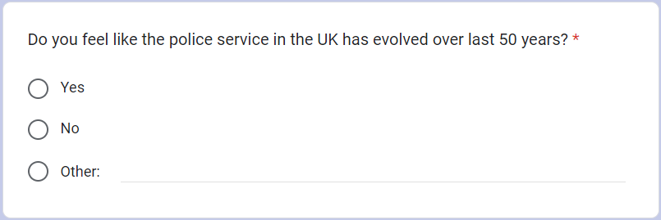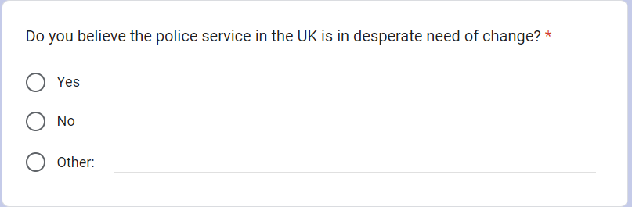
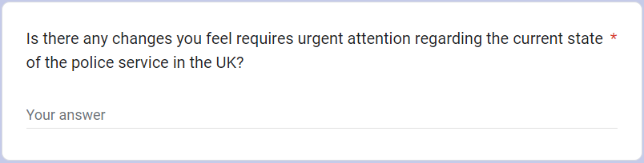

In the last 50 years there have been numerous cases however, the two most influential cases are the Stephen Lawrence case and the Sarah Everard case. These two cases have both had major impacts on the police service in recent years for example, the Stephen Lawrence case resulted in numerous laws being changed due to the Macpherson report. Although the Sarah Everard case resulted in minimal law changes in comparison to the Stephen Lawrence case, it had a national impact on all forces across the UK through the media, leading to severe criticism and negative judgement of the police service. The aim of these questions was to develop an understanding of the public perception and how it can influence an individual’s thoughts of the police service overall, regardless of their own experiences with the police service.

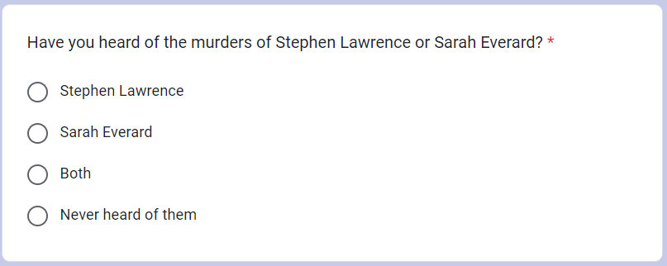
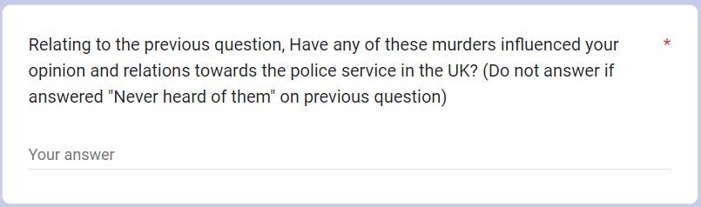
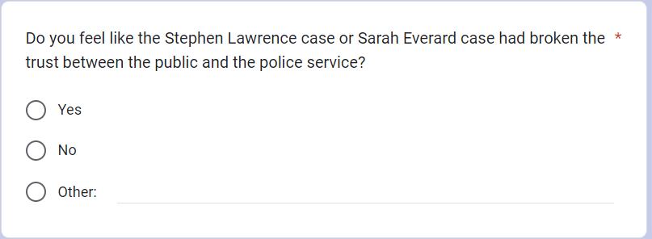

The aim of these two questions were helping to develop an understanding of why certain individuals may not trust the police service, or if some individuals have never had an interaction with the police service but due to social media and other aspects still do not trust the police service. These questions were also to help gain more knowledge on how the police service are potentially corrupt or failing the general public in smaller cases also.

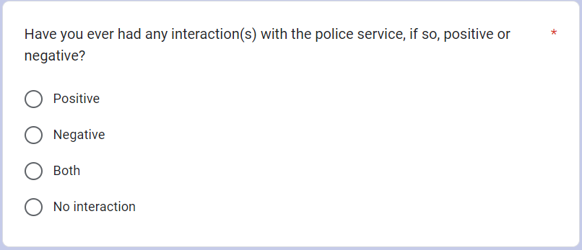


This final question had the aim to try and show the significance of the trust between the public and the police service. The police service often gets reports from various individuals which leads to reported crime however, if there is a percentage of individuals in the UK who would refuse to report a crime to the police service, it makes the police services’ job more difficult resulting in more police service failings.

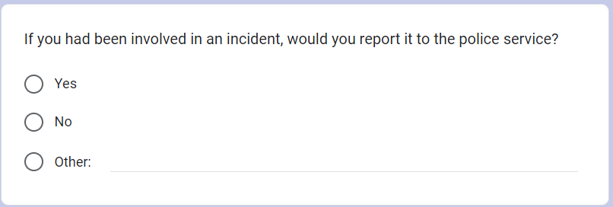

Chapter 4.3: Diversity of the survey

The results of the first question found that there had been 25 individuals who had completed the survey, all 25 individuals have agreed to their response being used in this research study.
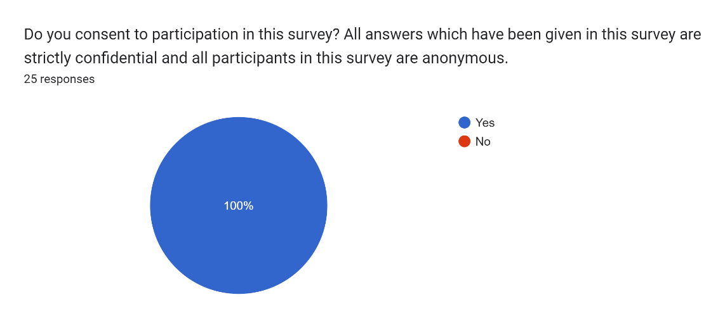

The next question allows for an understanding of which gender answered the survey. It is important that there is a good difference between males, females and individuals who prefer not to say participating in this survey as over recent years there have been numerous accusations and report of institutional misogyny throughout the police service. The University of Liverpool (2023) states that “Britain has witnessed a torrent of appalling examples of misogyny by those serving on the front line of public service in recent years”. This elaborates on the abuse which women and girls are still suffering regardless of previous cases dealt with by the police service, and how there is a need for evolution throughout the police service.

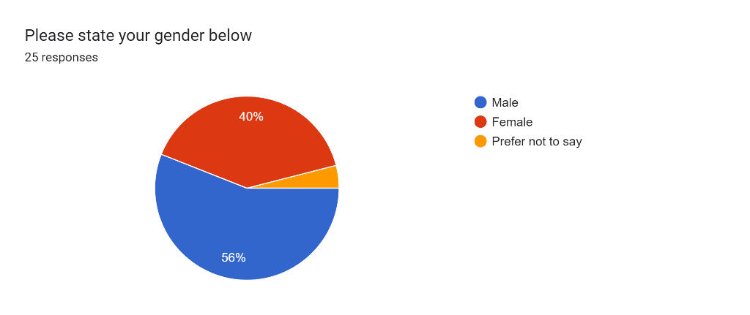

In the past, there has been numerous accusations of the police service not taking homophobic incidents seriously, and crimes being committed on individuals within the LGBTQ+ community were having their cases ignored. Elks (2018) states that the police service are letting down the LGBTQ+ community as hate crimes directed to these groups are soaring. Elks (2018) states that homophobic crimes rose by about 50 percent in two years to 10,015 in 2016/2017. Elks (2018) also states that transphobic incidents more than doubled to 1,510 according to police data.
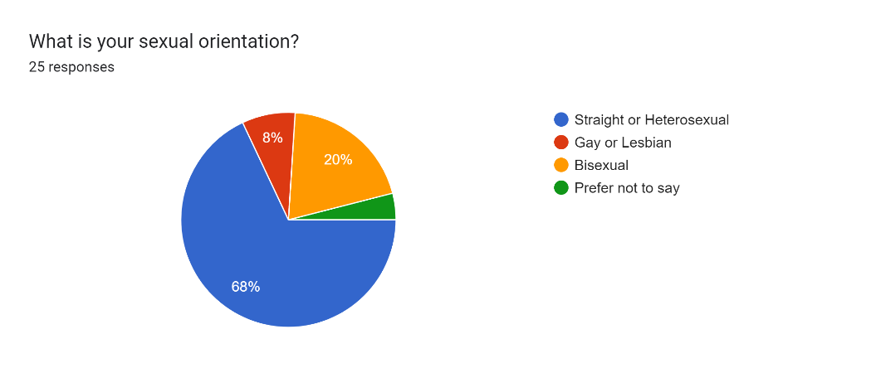

The participants in the survey were primarily aged 18-25 at 68 percent and 4 percent being below 18. This results in over 28 percent of the participants being over the age of 26. This is useful towards the research as the survey will contain answers from individuals who are from different generations. It proves beneficial due to the different incidents happening throughout the police service, it allows the research to gain an understanding from different perspectives.
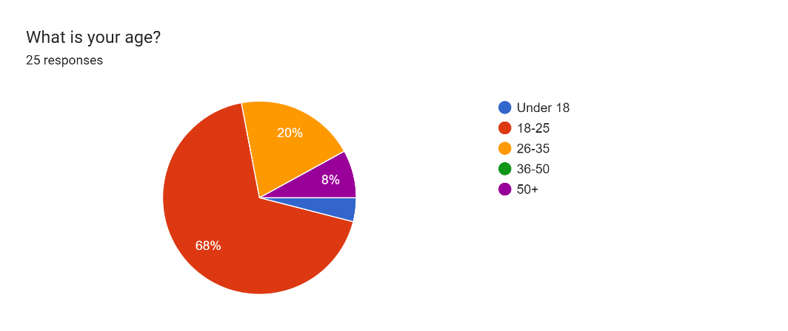

This question is allowing for an insight into individuals who were born and have lived in the United Kingdom, in comparison to individuals who may have moved to the UK. Cheatham & Maizland (2022) state that policing is completely different across the globe. Cheatham & Maizland (2022) also states that many countries, such as the United States, are struggling with police brutality and tense relations between law enforcement and minority communities. Although 88 percent of individuals were born in the United Kingdom, 12 percent were born outside of the United Kingdom meaning that they may understand how policing is in different countries therefore, the United Kingdom policing could be deemed as extremely corrupt or extremely fair in comparison to a country they may have witnessed prior to moving to the United Kingdom.

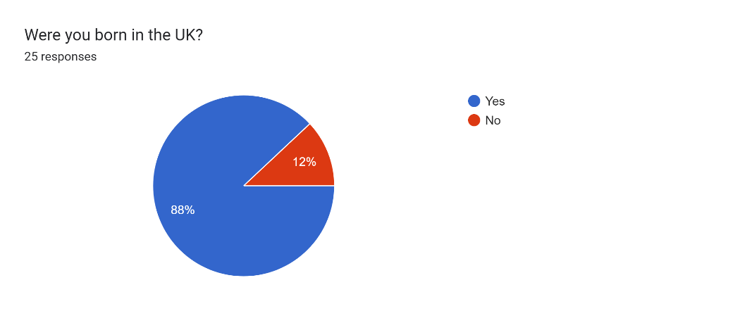

The question surrounding ethnicity is extremely significant in this survey. This is because of the different types of racism and discrimination which has been shown by the police service and other individuals over the years. Casey (2023) states that the metropolitan police service as “Institutionally Racist”. This quote was stated by Baroness Casey in 1999, and since has led to the implementation of numerous action plans and methods to prevent racism by the police service.

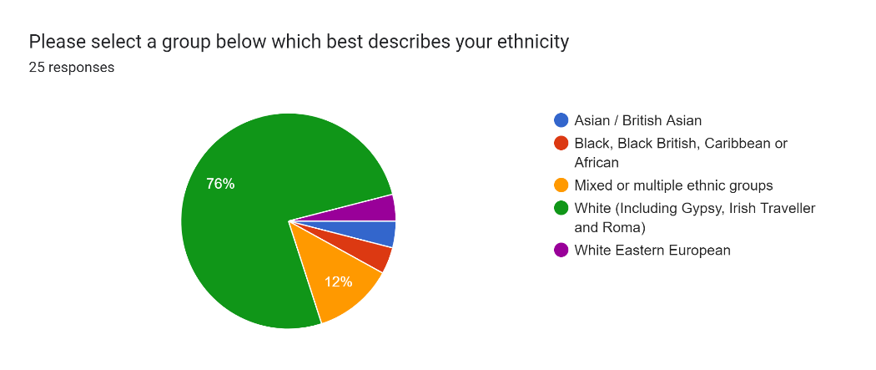

Chapter 4.4: General and Key findings

The first question indicates that participants in the survey are from a variety of different backgrounds and forces. This proves to be positive and beneficial for the survey as it allows for a general understanding of the overall responses in the UK, and not just the responses from individuals all living in the same area, relying on the same police force. Although this is beneficial, this could prove to lead to some differences. One example of this is the Casey (2023) report which elaborates that the Metropolitan Police stop more people for stop and searches per head of population than any other force.
The second question asked individuals how much trust the police force which covers the area in which they reside in. It is found that 28 percent have high trust in the police force, 48 percent have a moderate trust whilst 24 percent have low trust in their police force. A reason for the lack of trust in the police force could be due to the personal experiences an individual has in their area. For example, Hobbs & Brown (2023) states that trust can be affected by individual and group experiences of the police, police conduct, performances and media coverage of the police. Following this statement, it elaborates how media coverage of the police service can often influence individuals trust in the police service overall.

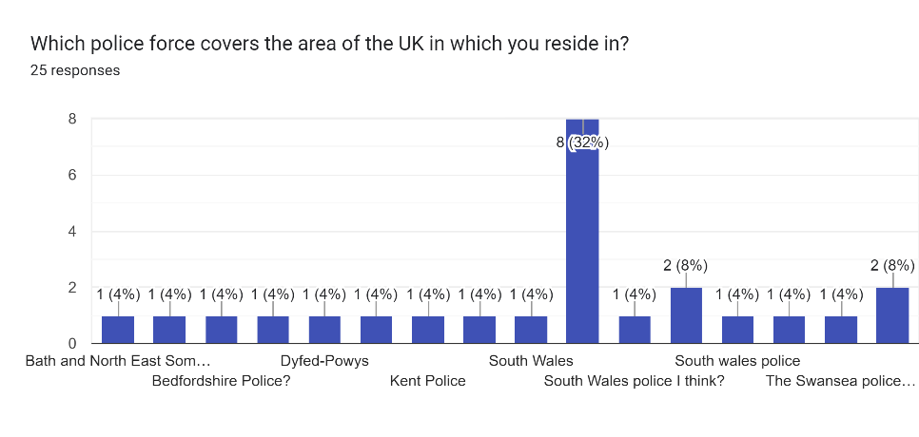
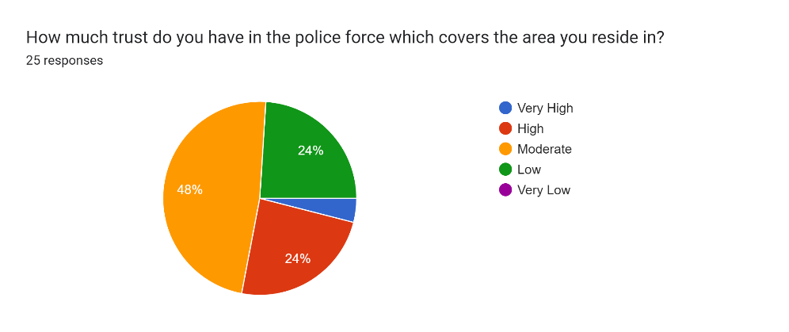

The first question has asked individuals if they feel that the police service has evolved over the years. This question has allowed an understanding of how many individuals believe the police service in the United Kingdom are on the correct path to evolving and becoming a better, more effective and efficient service.
The second question allowed the participant to state whether the police service is in desperate need of change. Although 80 percent of individuals believed that the police service has evolved over the last 50 years, we are also shown that 80 percent of individuals also think that there is desperate need for change in the UK police service. Thrive (2021) states that with communities growing in complexity, it results in a need for change and transformation in the police service in order to adapt with modern day policing. This survey response supports the need for the police service to continuously develop and evolve.
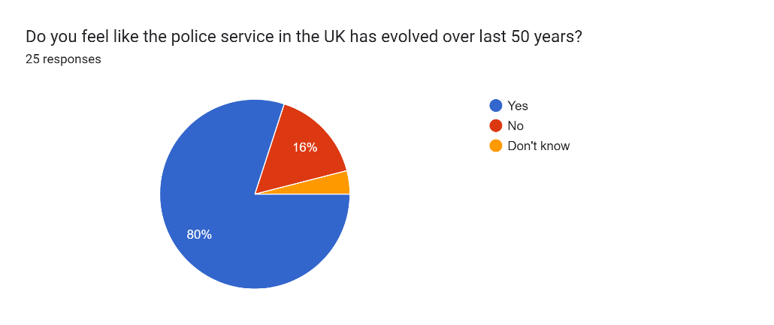
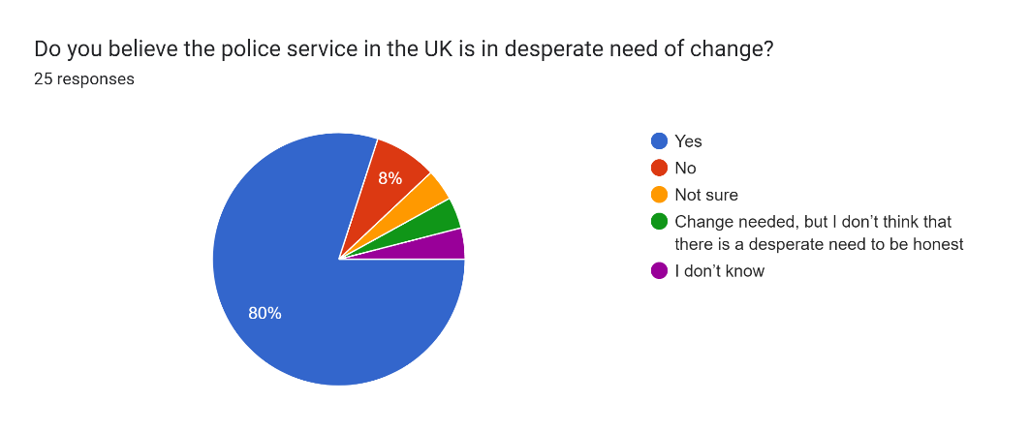

In this next question on the survey, It was asked if the participants feel there is any changes needed which they feel requires urgent attention regarding the current state of the police service in the UK. There were very mixed responses as numerous individuals have stated things such as:
- Racism
- More officers
- Corruption and Misconduct
- Diversity
- Better training in officers
This elaborates on the importance of evolution throughout the police service as every participant who had taken the survey, managed to give a minimum of one change which is needed, even the participants who said that there is no urgency to make changes listed some issues throughout the police. This emphasises the need for evolution in the police service as some of the issues found in the police service such as racism, discrimination and abuse of power are clearly still on going throughout some of the police forces.

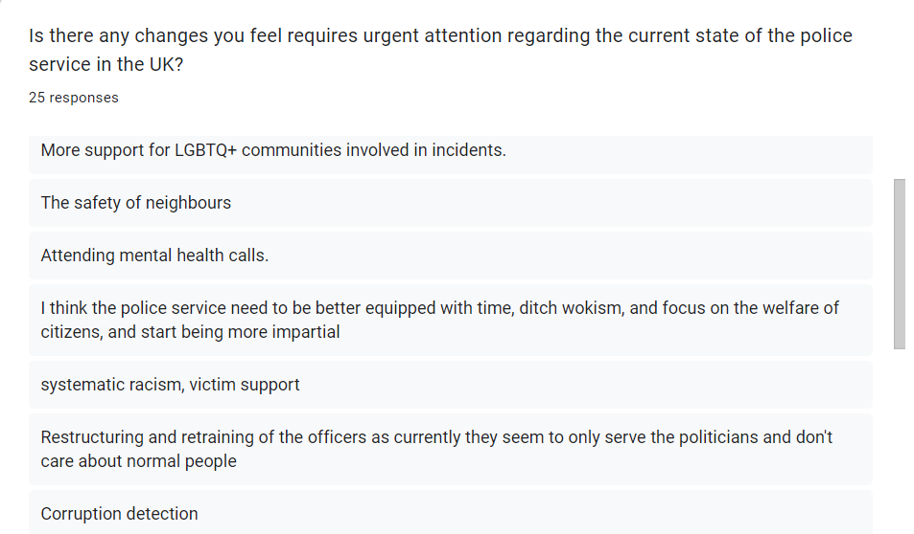
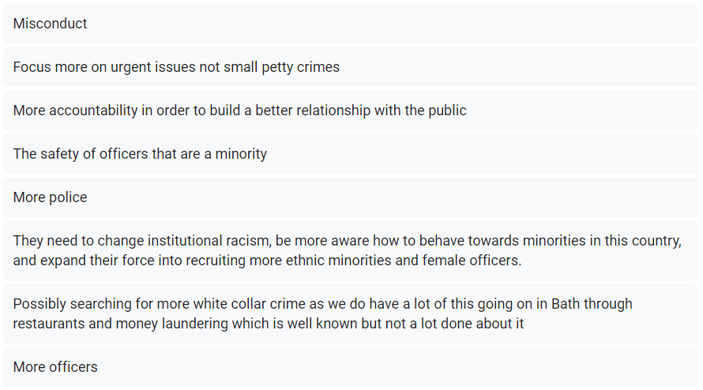
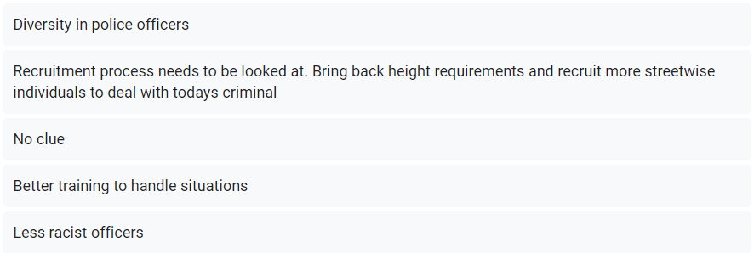

Following and highlighting the cases from chapter 2 in the literature review, The survey proceeded to the individuals if they had ever heard of the Stephen Lawrence case or the Sarah Everard case. 64 percent of the survey knew about the Stephen Lawrence case whilst 84 percent knew about the Sarah Everard case. 16 percent of the survey knew neither. Both of these cases had a significant impact on the police service as they both changed the view of the police service from the public perspective, and also led to certain laws, policies and regulations being changed or implemented. The Stephen Lawrence case demonstrated a strong case of institutional racism as Casey (2023) states in the report the failings of the police service during the investigation. The Sarah Everard case proceeded to have a strong social media influence against the police officer as one abusive and murderous officer made the entire police service lose the trust of the public. One example of this is the End Violence Against Women Coalition (2021) who state that nationwide research shows that 47 percent of women and 40 percent of men reported declining trust in the police service following the Sarah Everard murder.
The second question follows on from the first allowing the participant to state whether these cases have influenced or swayed their opinion and relations towards the police service in the United Kingdom. 13 of the 25 participants who answered stated that these specific cases have resulted in their opinion on the police service has been swayed. There were numerous statements in these responses which demonstrate the influence of their opinion for example one response states: “Yes, I lost trust in the Police, I am mostly speaking about Sarah Everard.” This shows the influence one case can have to the public. Although this statement elaborates the loss of trust, another response states: “Not really cause cops are human and we can't generalise everyone. But the most recent case is quite shocking. It's more the leadership in policing that is broken.” This response shows that they haven’t lost trust in the police service however, there is issues further up in the force which needs to be fixed. This emphasises the need for evolution throughout the force, and how cases similar to this involved corruption and police failings will lose public trust.
The third question specifically asks the participant whether they feel that the Stephen Lawrence case or Sarah Everard case had broken the trust between the public and the police service. 72 percent of participants stated that these cases had resulted in the trust between the public and the police service being completely broken. The Metropolitan Police (2024b) have stated their plans to regain the public trust following the murder of Sarah Everard, stating that they are bringing more officers to unsafe locations, more support for women and girls, more work towards justice and prevention for incidents like this.

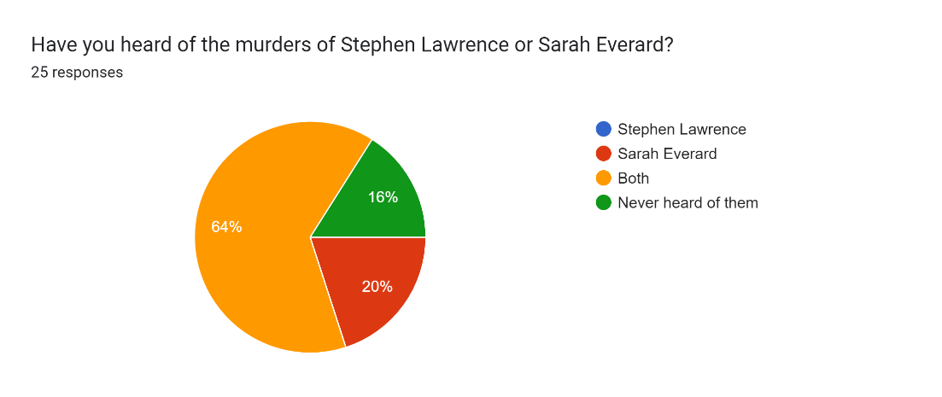
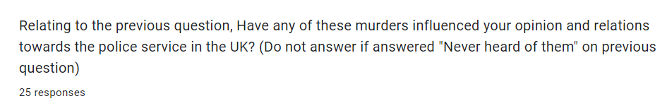
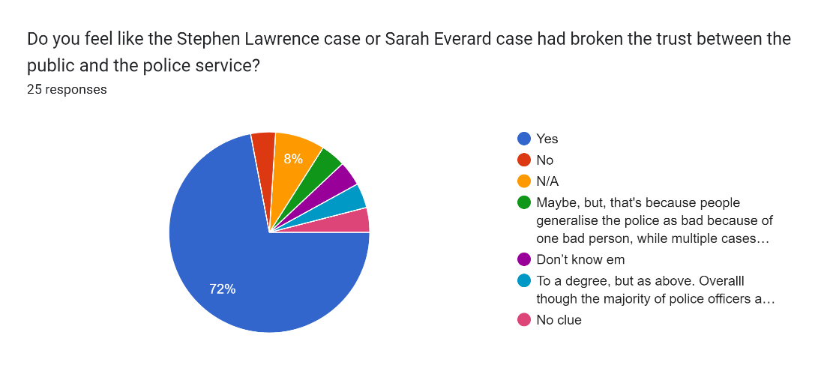
The next question in the survey asks the participant if they have had any interaction or interactions with the police service and if so were they positive or negative. This question elaborates how public perception and previous corruption cases or police failings incidents can affect the opinion on the police service. 64 percent stated they had at least a positive interaction with the police service, whilst 48 percent stated they had at minimum a negative interaction with the police service.
The second question follows the first by asking if the participant can give a brief description of their interaction with the police service. There were numerous responses stating events both positive and negative which had happened however, one response stated: “Positive was PCSO in public, Negative was racial profiling being stop and searched”. The negative interaction with the police racial profiling is supported by the statistics from Gov.UK (2024) stating that black individuals are stop and searched almost 4 times more than white individuals. The positive interaction however shows how the police service are proceeding to rebuild the trust within the public by working towards more positive communities.
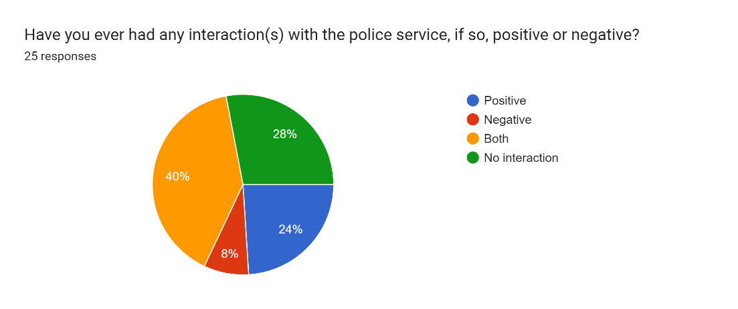


The final question asked in the survey was asking if the participant had been involved in an incident, would they report it to the police. 68 percent of individuals straight away said yes, they would report it. However, 20 percent of individuals all selected the option to type their own response stating that it is dependant of the scenario. This emphasises on the importance of trust within the police force and the requirement for the police to evolve following the numerous incidents as if individuals feel like they can deal with incidents themselves, it either may not be a serious crime or it can result into the crime being worsened instead of being entirely prevented.
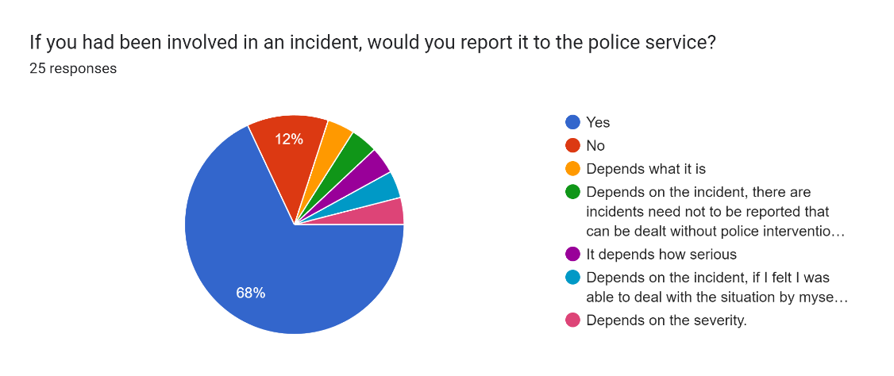

Chapter 4.5: Raw data (Appendices)

Follow the link to a Google Sheets document containing every participants answer on the survey.
https://docs.google.com/spreadsheets/d/1-cE12L7sSRHJwDETreUGWh3QNLMZ2skbbjaRaenoiY0/edit?usp=sharing

Chapter Five: Conclusion

Overall, Policing in the United Kingdom has evolved drastically over the last 50 years. There have been numerous technology changes which have had a significant impact on the police service alongside the changes in policies and laws. The police service also has to adapt and evolve with the evolution of crime. As criminals and offenders proceed to develop new methods of crime, the police service has to adapt and proceed to prevent it to the best of their ability. After a large amount of research, it is proven that the police service is proceeding to evolve following the corrupt incidents and police failings in the past. This has been made clear by the numerous acts, laws and action plans which have been implemented. It is also proven that there is a huge disconnect between the public and the police service in regard to the trusting of the police service following the corruption and the police failings in the past. Although there have been numerous police failings and high-profile cases which have broken the trust in the public throughout, it demonstrates and proves the active need for the police service to continuously adapt to further criminal activities and incidents which may occur. It is clear that the police service in the UK has evolved in the last 50 years and will continue to evolve through the police corruption and police failings which have happened in the past.

Reference List

Andrade, C. (2020). The Limitations of Online Surveys. [Online]. SageJournals. Last Updated: 13th October 2020. Available at: https://journals.sagepub.com/doi/10.1177/0253717620957496 [Accessed 7 May 2024].

Angell, P. (2023). “We are not seeing the improvement both we and the public need” – ICO issues enforcement notice to GMP over transparency failures. [Online]. Information Commissioner's Office. Last Updated: 20th December 2023. Available at: https://ico.org.uk/about-the-ico/media-centre/news-and-blogs/2023/12/we-are-not-seeing-the-improvement-both-we-and-the-public-need-ico-issues-enforcement-notice-to-gmp/ [Accessed 6 May 2024].

Bhandari, P. (2023). What Is Qualitative Research? | Methods & Examples. [Online]. Scribbr. Last Updated: 30th January 2023. Available at: https://www.scribbr.co.uk/research-methods/introduction-to-qualitative-research/ [Accessed 6 May 2024].

British Medical Association. (2024). Mental Health pressures in England. [Online]. British Medical Association. Last Updated: 3rd April 2024. Available at: https://www.bma.org.uk/advice-and-support/nhs-delivery-and-workforce/pressures/mental-health-pressures-data-analysis [Accessed 6 May 2024].

Broadbridge, S. (2009). Double Jeopardy. [Online]. Broadbridge, S. Last Updated: 27th January 2009. Available at: https://researchbriefings.files.parliament.uk/documents/SN01082/SN01082.pdf [Accessed 6 May 2024].

Casey, B. (2023). Baroness Casey Review. [Online]. Metropolitan Police. Last Updated: March 2023. Available at: https://www.met.police.uk/SysSiteAssets/media/downloads/met/about-us/baroness-casey-review/update-march-2023/baroness-casey-review-march-2023a.pdf [Accessed 7 May 2024].

Cheatham, A. Maizland, L. (2022). How Police Compare in Different Democracies. [Online]. Council on Foreign Relations. Last Updated: 29th March 2022. Available at: https://www.cfr.org/backgrounder/how-police-compare-different-democracies [Accessed 7 May 2024].

Cleland, J A. (2017). The qualitative orientation in medical education research. [Online]. The National Library of Medicine. Last Updated: 29th May 2017. Available at: https://www.ncbi.nlm.nih.gov/pmc/articles/PMC5465434/ [Accessed 6 May 2024].

CrimeRate. (2024). UK Crime Rates 2023-2024. [Online]. CrimeRate. Last Updated: 2024. Available at: https://crimerate.co.uk/ [Accessed 7 May 2024].

Crown Prosecution Service. (2024a). Cybercrime - prosecution guidance. [Online]. Crown Prosecution Service. Last Updated: 31st January 2024. Available at: https://www.cps.gov.uk/legal-guidance/cybercrime-prosecution-guidance [Accessed 6 May 2024].

Crown Prosecution Service. (2024b). Wildlife, Rural and Heritage Crime. [Online]. Crown Prosecution Service. Last Updated: 2024. Available at: https://www.cps.gov.uk/crime-info/wildlife-rural-and-heritage-crime [Accessed 7 May 2024].

De Simone, D. (2023). Stephen Lawrence case: Disgrace that detectives will not be charged - mother. [Online]. De Simone, D. Last Updated: 6th July 2023. Available at: https://www.bbc.co.uk/news/uk-66127025 [Accessed 6 May 2024].

DeFranzo, S E. (2024). 4 Main Benefits of Survey Research. [Online]. SnapSurveys. Last Updated: 2024. Available at: https://www.snapsurveys.com/blog/4-main-benefits-survey-research/ [Accessed 6 May 2024].

Department for Environment Food & Rural Affairs. (2022). Crime. [Online]. Gov.uk. Last Updated: 30th June 2022. Available at: https://assets.publishing.service.gov.uk/media/62bcb0628fa8f535b5ff0b14/Crime_Jun_22_final.pdf [Accessed 7 May 2024].

Dodd, V. (2023). Detectives accused of bungling first Stephen Lawrence inquiry will not face charges. [Online]. The Guardian. Last Updated: 6th July 2023. Available at: https://www.theguardian.com/uk-news/2023/jul/06/detectives-bungling-first-stephen-lawrence-inquiry-will-not-face-charges [Accessed 6 May 2024].

Elks, S. (2018). UK police 'let down' gay community as hate crimes soar. [Online]. Reuters. Last Updated: 19th July 2018. Available at: https://www.reuters.com/article/idUSKBN1K92JA/ [Accessed 7 May 2024].

George, T. (2022). Mixed Methods Research | Definition, Guide, & Examples. [Online]. Scribbr. Last Updated: 4th April 2022. Available at: https://www.scribbr.co.uk/research-methods/mixed-methods/ [Accessed 6 May 2024].

Gov.UK. (2024). Stop and search. [Online]. Gov.UK. Last Updated: 10th April 2024. Available at: https://www.ethnicity-facts-figures.service.gov.uk/crime-justice-and-the-law/policing/stop-and-search/latest/ [Accessed 7 May 2024].

Hobbs, A. Brown, R. (2023). Trust in the Police. [Online]. UK Parliament. Last Updated: 25th April 2023. Available at: https://post.parliament.uk/research-briefings/post-pn-0693/ [Accessed 6 May 2024].

Indeed Editorial Team. (2022). What Is Quantitative Research? (With Advantages and Disadvantages). [Online]. Indeed. Last Updated: 25th June 2022. Available at: https://www.indeed.com/career-advice/career-development/what-is-quantitative-research [Accessed 6 May 2024].

Independent Office for Police Conduct. (2023). IOPC learning on ‘Wayne Couzens failures’ after panel finds gross misconduct against ex-Met constable. [Online]. IOPC. Last Updated: 23 May 2023. Available at: https://www.policeconduct.gov.uk/news/iopc-learning-wayne-couzens-failures-after-panel-finds-gross-misconduct-against-ex-met [Accessed 6 May 2024].

Information Commissioner's Office. (2023). “We are not seeing the improvement both we and the public need” – ICO issues enforcement notice to GMP over transparency failures. [Online]. Information Commissioner's Office. Last Updated: 20 December 2023. Available at: https://ico.org.uk/about-the-ico/media-centre/news-and-blogs/2023/12/we-are-not-seeing-the-improvement-both-we-and-the-public-need-ico-issues-enforcement-notice-to-gmp/ [Accessed 6 May 2024].

Interpol. (2024). Facial Recognition. [Online]. Interpol. Last Updated: 2024. Available at: https://www.interpol.int/en/How-we-work/Forensics/Facial-Recognition [Accessed 6 May 2024].

Jones, TL. Baxter, MAJ. Khanduja, V. (2013). A quick guide to survey research. [Online]. National Library of Medicine. Last Updated: January 2013. Available at: https://www.ncbi.nlm.nih.gov/pmc/articles/PMC3964639/ [Accessed 7 May 2024].

Macpherson, W. Page 365 (1999). The Stephen Lawrence Inquiry. [Online]. Macpherson, W. Last Updated: February 1999. Available at: https://assets.publishing.service.gov.uk/media/5a7c2af540f0b645ba3c7202/4262.pdf [Accessed 6 May 2024].

Mander, J. (2022). How to use qualitative and quantitative research to your advantage. [Online]. GWI. Last Updated: 8th March 2022. Available at: https://blog.gwi.com/trends/qualitative-vs-quantitative/ [Accessed 6 May 2024].

Meade, L & Nickolls, L. (2023). Metropolitan Police investigation into the murder of Stephen Lawrence. [Online]. Meade, L & Nickolls, L. Last Updated: 9th July 2023. Available at: https://commonslibrary.parliament.uk/research-briefings/cdp-2023-0160/ [Accessed 6 May 2024].

Metropolitan Police. (2024a). Facial Recognition Technology. [Online]. Metropolitan Police. Last Updated: 2024. Available at: https://www.met.police.uk/advice/advice-and-information/fr/facial-recognition-technology/ [Accessed 6 May 2024].

Metropolitan Police. (2024b). Our response to issues raised by the crimes of Wayne Couzens. [Online]. Metropolitan Police. Last Updated: 2024. Available at: https://www.met.police.uk/notices/met/our-response-to-issues-raised-by-the-crimes-of-wayne-couzens/ [Accessed 6 May 2024].

Morgan, G. (2016). The Principles of Qualitative Methods. [Online]. Healthknowledge. Last Updated: 2016. Available at: https://www.healthknowledge.org.uk/public-health-textbook/research-methods/1d-qualitative-methods/principles-qualitative-methods-exercise2answers [Accessed 6 May 2024].

National Crime Agency. (2024). Helping you choose the right and legal path. [Online]. National Crime Agency. Last Updated: 2024. Available at: https://nationalcrimeagency.gov.uk/cyber-choices [Accessed 6 May 2024].

National Police Chiefs' Council. (2024). Digital Policing and Technology. [Online]. National Police Chiefs' Council. Last Updated: 2024. Available at: https://www.npcc.police.uk/our-work/Digital-policing-and-technology/ [Accessed 6 May 2024].

Ng, K. Hancock, S. Osbourne, S. (2024). What happened to Sarah Everard? Timeline of 33-year-old’s disappearance as Wayne Couzens report published. [Online]. Independent. Last Updated: 29th February 2024. Available at: https://www.independent.co.uk/news/uk/crime/sarah-everard-what-happened-wayne-couzens-report-b2504551.html [Accessed 6 May 2024].

Office for Health Improvement and Disparities. (2020). Mixed Methods Study. [Online]. Gov.uk. Last Updated: 2nd June 2020. Available at: https://www.gov.uk/guidance/mixed-methods-study/ [Accessed 7 May 2024].

Sheard, J. (2018). Quantitative data analysis. [Online]. ScienceDirect. Last Updated: 2018. Available at: https://www.sciencedirect.com/topics/social-sciences/quantitative-research [Accessed 6 May 2024].

Shorten, A. Smith, J. (2024). Mixed methods research: expanding the evidence base. [Online]. BMJ Journals. Last Updated: 2024. Available at: https://ebn.bmj.com/content/20/3/74 [Accessed 6 May 2024].

Stephen Lawrence Day Foundation. (2023). Stephen’s story. [Online]. Stephen Lawrence Day Foundation. Last Updated: 2023. Available at: https://stephenlawrenceday.org/stephens-story/ [Accessed 6 May 2024].

The End Violence Against Women Coalition. (2021). Almost half of women have less trust in police following Sarah Everard murder. [Online]. The End Violence Against Women Coalition. Last Updated: 18th November 2021. Available at: https://www.endviolenceagainstwomen.org.uk/almost-half-of-women-have-less-trust-in-police-following-sarah-everard-murder/ [Accessed 6 May 2024].

The Police Foundation. (2024). Police effectiveness in a changing world. [Online]. The Police Foundation. Last Updated: 2024. Available at: https://www.police-foundation.org.uk/project/police-effectiveness-in-a-changing-world/ [Accessed 5 May 2024].

Thrive. (2021). Key Challenges Facing UK Police Forces in 2022 and Beyond. [Online]. Thrive. Last Updated: 2021. Available at: https://blog.thrive.app/key-challenges-facing-uk-police-forces [Accessed 7 May 2024].

Tudor, S. (2023). Police standards and culture: Restoring public trust. [Online]. House of Lords Library. Last Updated: 27th April 2023. Available at: https://lordslibrary.parliament.uk/police-standards-and-culture-restoring-public-trust/ [Accessed 7 May 2024].

UK Parliament. (2021). The Macpherson Report: Twenty-two years on. [Online]. UK Parliament. Last Updated: 30th July 2021. Available at: https://publications.parliament.uk/pa/cm5802/cmselect/cmhaff/139/13903.htm [Accessed 6 May 2024].

University of Liverpool. (2023). What is institutional misogyny in policing and why does it matter?. [Online]. University of Liverpool. Last Updated: 4th September 2023. Available at: https://news.liverpool.ac.uk/2023/09/04/what-is-institutional-misogyny-in-policing-and-why-does-it-matter/ [Accessed 7 May 2024].

