

Name of Student: Camelia Amal Amran

Student Number: 2026695

Module Title and Code: Leading and Developing People – BMBM6012

Essay Title: Mark Zuckerberg: A Leadership Case Study

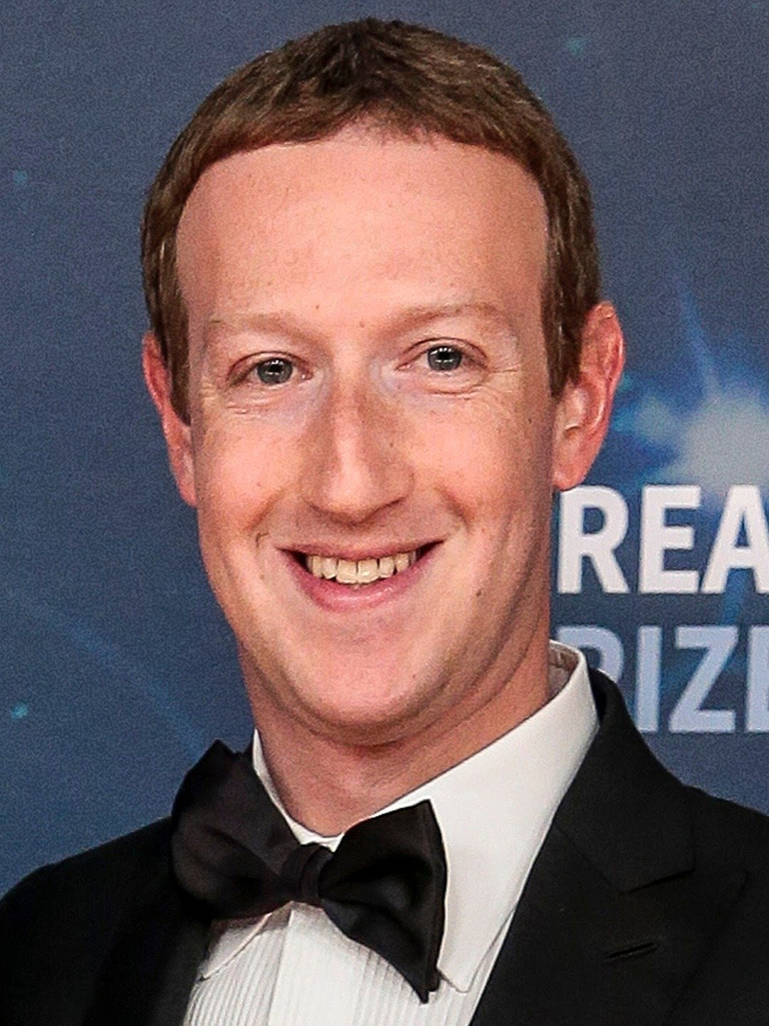

Mark Elliot Zuckerberg, by his full name, was born in White Plains, New York May 14, 1984, to parents working in health professions. Labelled as a precocious child, Zuckerberg developed an interest in computers and software at an early age. (Vargas, J, A, 2010). He would take up coding as a passion and hobby. Deemed The Face of Facebook, Zuckerberg has also earned a reputation as a skilled developer, whereby from the age of twelve (12) years old, he had recorded to have built and programmed several programming systems – among them are named “ZuckNet,” “Sypnase,” “CourseMatch,” and “Facemash.” (BIOGRAPHY, 2019).
A Harvard University dropout to devote himself to Facebook full-time in 2005 (BIOGRAPHY, 2019) has undoubtedly claimed even more success stories. Include Forbes estimates that as of July of 2023, Mark Zurkerberg's net worth has reached an impressive whopping $115.0 billion, which has positioned him as the 7th wealthiest person worldwide. Additionally, almost a decade ago, Zuckerberg was rewarded with the title ‘Youngest Billionaire’ (Forbes, 2023). But unfortunately, he was later surpassed by newcomers. Conversely, Mark Zuckerberg is known for a couple of particular approaches to leadership that is best-believed to be action centered and, captured in the following quote:

“We may not have the power to create the world we want immediately, but we can all start working on the long term today.” (Forbes, 2023).

In late October of 2021, the CEO of the “social network of the world” (Kraus, S, Kanbach, D.K., Krysta, P, Steinhoff, M, 2022) Zuckerberg announced Facebook a name changed to “Meta.” Furthermore, that also goes to say that it was a period when Zuckerberg not only rebranded and upgraded Facebook but also launched the so-called Metaverse, which had brought several well-known apps and technologies together, namely Instagram, WhatsApp, and so on to be under a single organization. (Meta, 2021). Despite its overwhelming triumph, Zuckerberg faces significant megatrends that are affecting the operation of the business leader.

For what is certain is that in today’s technologically and digitally driven economy, Mark Zuckerberg and Meta are under continuous unprecedented public scrutiny, widely in the area of data privacy or privacy in general. (Kozlowska, I, 2018). As stated, in today’s era, the context has undoubtedly been shape by digitalization. (Bharadwaj, El Sawy, Pavlou & Venkatraman, 2013). Notably, in this 21st Century, it has resulted in a more complicated and fast-changing environment in which Zuckerberg must navigate his organizations and adjust his leadership (Fitzgerald, Kruschwitz, Bonnet, & Welch, 2014) ways, styles, and models as suitable as possible.

After having considered the environment in which Mark Zuckerberg leads, this essay will analyze his leadership style in depth to evaluate whether it effectively encourages innovation, adaptation, and exceptional performance.

As expected, leadership is a complex topic, which, to date, still has no concrete designation for defining the concept, hence for this specific reason, a saying from (Stogdill, 1974) goes that there are almost as “many different definitions of leadership as there are persons who have attempted to define the concept.” Moreover, it also goes to say that “these attempts to define leadership have been confusing, varied, disorganized, idiosyncratic, muddled, and according to conventional wisdom, quite unrewarding” which was commented by (Rost, 1991).

After all, respectively, some researchers, philosophers, intellectuals, and even leaders themselves claim that “leadership remains an essentially contested concept.” (Keith Grint, 2005) and that there is no universally accepted definition of what it truly means, despite this being taken beyond the matter, it is arguable that leadership is as simple as an ongoing process (Leadership Theories and Studies, n.d, Stogdil, 1950; Jacod & Jacques, 1990; Malik, 2012; Kesting, Ulhol, Song & Niu, 2016) that leaders of any sort will learn and develop over time - Therefore, leadership is defined as a process by which a leader or leader (s) influences others toward the attainment of group or organizational goals (Leadership Theories and Studies, n.d). On a much simple note, leadership seems to be a matter of aligning people toward common goals and empowering them to take the actions needed to reach them or the ability to influence others toward the achievement of common goals. (Khan, M.S, Khan, I, Qureshi, Q, A, Ismail, H.M, Rauf, H, Latif, A, & Tahir, M (2015).
Alternatively, owing to the numerous leadership styles that exist, it is still a task to verify whether Mark Zuckerberg bears within a few of the criteria or not. In light of this, Democratic, Transformational, and Autocratic leadership styles will be used in the analysis of leader Mark Zuckerberg, alongside a critical evaluation of whether he demonstrates the characteristics associated with emotional and social intelligence and agility.

From what we can see through the success of Facebook, his choice of leadership style has indeed become the leading benefactor to the organization's overall victory, Zuckerberg's proclivity for emphasizing group interactions and empowering his employees to adapt their own projects and work schedules. Additionally, he is known to encourage and motivate those under him and alongside him to offer their thoughts, comments, and techniques rather than making and utilizing his own decision and plans.

The state of which Mark Zuckerberg is a democratic leader, he stimulates productivity and enriched job satisfaction founded on the context of innovation and creativity. In addition, Zuckerberg adopts the five P's - these P's are partnerships, people, products, purpose, and passion. (Chris, 2015). In the case where each of the five Ps has a distinct function that aids to illustrate why Zuckerberg is an accurate democratic leader. Firstly, passion is included because it is a crucial attribute for Zuckerberg as a leader, to retain and be a motivating piece that promotes steadiness. Because Zuckerberg is known to be passionate about what he does, he is likely to overcome any obstacles that would come his way and learn from his mistakes instead of giving up. Secondly, purpose specifically assists Zuckerberg in reminding him why he had built the organization it is a tremendous asset for him to eventually recruit more promising employees and create sounder products. Thirdly People, according to Zuckerberg himself, individuals should be given the freedom to be themselves and take calculated risks. The fourth P, product, is added to emphasize Zuckerberg's dedication to Facebook.

Another way to characterize Mark Zuckerberg is as a transformational leader, meaning Zuckerberg would rouse his employees to work harder by designating goals, awarding them if they do so, and offering them chances to advance even more. With a clear vision and goals set by Zuckerberg, the employees are easily guided by what needs to be done and dusted. At the same time, his employees were given taught lessons on coding methods that were assembled prior by the organization to help them finish their missions more effectively and efficiently. Zuckerberg as a transformational leader values intellectual stimulation (Wixson, 2016)

According to Weebly (2020), Zuckerberg stands as a transformational leader when it comes to bringing individuals on board with his business. His principal intent was to bring people jointly through a platform, which is likely to have somewhat of an effect on altering the world for the better. Yet, with just one idea, Zuckerberg was able to grasp people's attention and grant licenses to expand his business all over the world (Weebly, 2020). However, he does not acknowledge that he is the main and only person on Facebook. He has an assertive sense of confidence in his team and employees and will always cherish their ideas. He has always felt that building affinities with his employees will presumably drive forward the organization's vision. Zuckerberg has regularly produced an environment that fosters the development of new ideas., Zuckerberg is a game-changer. He inspires and drives his team by providing a crystal-clear vision of Facebook's future. He doesn't just list objectives; he also specifies each action that must be taken to get there. As mentioned previously he possesses bold confidence and revolutionary ideas. Because of this, he is the kind of boss that others want to follow.

Last but not least – on a short note, autocratic leadership is when leaders sort of dictate orders, policies, and procedures to others, that they must follow in conjunction with the outline running of the organization, for example. The idea of Mark Zuckerberg's autocratic leadership style may seem incongruous and is purely not an autocratic leader, however, he actually can depict times when is necessary to take control and ensure things get done when needed.

Thus to summarise, on the whole, identified leadership styles of this essay – between democratic, transformational, and autocratic leadership styles, it has formally agreed that Mark Zuckerberg’s transformational leadership is the best one yet out of these three because transformational leaders value intellectual stimulation (Wixson, 2016) that simply mean that beyond routine tasks, transformational leaders put more of an emphasis on building a strong team. Transformation leaders encourage employees through goal-setting, incentives, and chances for personal and professional growth rather than by checking things off of a daily to-do list. These, in fact, will very likely lead to high performance, new and pleasing innovations, and better adaptation to situations.
References:

Forbes (2023) Mark Zuckerberg: Cofounder, Meta Platforms. Available at: https://www.forbes.com/profile/mark-zuckerberg/?sh=6b5698e43e06 (Accessed: 1st August 2023)
Vargas, J, A (September 13, 2010) ‘THE FACE OF FACEBOOK Mark Zuckerberg opens up’, THE NEW YORKER, 1st August. https://www.newyorker.com/magazine/2010/09/20/the-face-of-facebook

BIOGRAPHY (October 25, 2019) Famous Business Leaders: Entrepreneurs Mark Zuckerberg. Available at: https://www.biography.com/business-leaders/mark-zuckerberg#synopsis (Accessed: 1st August).

Dike, Victor, E (August 17, 2015) Leadership and Management in the 21st Century Organization: A Practical Approach. Scholink Co, Ltd. DOI: 10.22158/WJSSR.V2N2P139 https://core.ac.uk/display/268085327?utm_source=pdf&utm_medium=banner&utm_campaign=pdf-decoration-v1

Kraus, S, Kanbach, D.K, Krysta, P, Steinhoff, M (January 2022) ‘Facebook and the creation of the Metaverse …. Research Gate, International Journal of Entrepreneur Behaviour & Research, 28(9), DOI:10.1108/IJEBR-12-2021-0984 . https://www.researchgate.net/publication/357635338_Facebook_and_the_creation_of_the_Metaverse_Radical_business_model_innovation_or_incremental_transformation

Meta (October 28, 2021) Introducing Meta: A Social Technology Company. Available at: https://about.fb.com/news/2021/10/facebook-company-is-now-meta/. (Accessed: 17th August 2023)

Hensellek, S. (2020) Digital Leadership: A Framework for Successful Leadership in the Digital Age. ResearchGate. Journal of Media Management and Entrepreneurs. 2(1): 55-59. DOI:10.4018/JMME.2020010104. https://www.researchgate.net/publication/338327379_Digital_Leadership_A_Framework_for_Successful_Leadership_in_the_Digital_Age

Kozlowska, I (2018) Facebook and Data Privacy … THE HENRY M. JACKSON SCHOOL OF INTERNATIONAL STUDIES. University of Washington. Available at: https://jsis.washington.edu/news/facebook-data-privacy-age-cambridge-analytica/. (Accessed: 17 August 2023)

Jackson, S. Sakuma, S. & Dr. Devol, P (n.d.) The Complexity in Defining Leadership … Available at: https://files.eric.ed.gov/fulltext/EJ1093043.pdf. (Accessed 18 August 2023)

Abid Malik, M & Azmat, S (2019) Leader and Leadership … ResearchGate. Available at:
https://www.researchgate.net/publication/337732933_LEADER_AND_LEADERSHIP_HISTORICAL_DEVELOPMENT_OF_THE_TERMS_AND_CRITICAL_REVIEW_OF_LITERATURE#:~:text=“Leadership%20can%20be%20defined%20as,group%20or%20organizational%20goals”%20(Leadership. (Accessed: 18 August 2018)

Fairhom Matthew, R (2015) Defining Leadership. ResearchGate. Available at: https://www.researchgate.net/publication/283048404_Defining_Leadership. (Accessed: 18 August 2023)

Langston.edu (n.d) Transformational Leadership. Available at: https://www.langston.edu/sites/default/files/basic-content-files/TransformationalLeadership.pdf. (Accessed: 19 August 2023)

Khan, M.S, Khan, I, Qureshi, Q, A, Ismail, H.M, Rauf, H, Latif, A, & Tahir, M (2015). The Styles of Leadership: A Critical Review. Public Policy and Administration Research. ISSN 2225-0972(Online) Vol.5, No.3. Available at: https://www.iiste.org/Journals/index.php/PPAR/article/viewFile/20878/21131. (Accessed: 19 August 2023)

Hammad, M (2020) Mark Zuckerberg- Leadership and Communication. ResearchGate. Available at: https://www.researchgate.net/publication/344177344_Mark_Zukerberg_-Leadership_and_Communication. (Accessed: 18 August 2023)

Stanton, M (n.d.) The leadership of Mark Zuckerberg. Available at: https://www.academia.edu/10320099/Leadership_of_Mark_Zuckerberg. (Accessed: 19 August 2023)

EduBirdie (n.d.) Mark Zuckerberg: Leadership Style and Qualities. Available at: https://edubirdie.com/examples/mark-zuckerberg-in-facebook-leadership-style-and-qualities/#citation-block (Accessed: 19 August 2023)

Management Training Specialist (n.d.) What is Mark Zuckerberg Leadership Style? Available at: https://www.mtdtraining.com/blog/mark-zuckerberg-leadership-style.htm#:~:text=Zuckerberg%20has%20shown%20that%20he,That%27s%20how%20you%20do%20it.” (Accessed: 19 August 2023)

Financhill (n.d) Mark Zuckerberg leadership style Available at: https://financhill.com/blog/investing/mark-zuckerberg-leadership-style#google_vignette (Accessed: 19 August 2023)

