  Component One:  What are the key skills required when working in the housekeeping team? 750 words (+/- 10%)  Contribution to Overall Module Assessment: 25% | Student No: | 2126671
 | Module Title: | Operating Hotel Facilities
 | Module Code: | BMIH4006
 | Lecturer: | Lola Villard  Laurence Blake
Hotels are providing accommodation and many more services therefore they main products are selling rooms to guest. Housekeeper team is responsible to keep rooms clean before new departure guest are arrive or refresh upon request. Also, they are the one who can notice any damages for example broken chair in the room attention to detail is keyword. As their main task to provide and maintain cleaning they have some weekly, monthly, or annual task to complete also regarding the hotels guidelines for example check any sign of bed bugs, rotate bed matrasses.
If guest has bad experience, they can leave feedback and it has negative impact on their future visit and it leads to bad brand reputation, it will affect the hotels market position and produce loss of profit. We can assume housekeepers has to be responsible also. (Pai, Manjunath, Kowshik, Ayedee, Malarout,& Naik 2020) (Thao, 2020)
Their skills has two main groups, hard skills which are learnable and measurable and soft skills which are general and person related. Both taking main part of this position. Housekeepers has not necessarily need qualification, but it is important to give them proper training. Part of hard skills and not just about the cleaning methods or how to react and follow regulations and laws for example fire safety, or health and safety.
Health and safety hazards can occur without professional knowledge, and it can affect not just the hotels staff but guests. Hazards can be physical for example heat or chemicals as poison, toxics other hazardous substances like dust, oil. Work under organisation as training, supervising, can occur violence and stress. (Ambardar & Raheja, 2017)
Housekeeping is involved loads of physical activity for example climbing stairs and lifting. It is important to be generally fit if you work in this position. Dependability and independency are two main point as they require to be able to work all day alone, it is important to be trustful and professional and punctual. During my placement day I experienced how hard is to stay all day on feet and provide the best cleaning standard within an exact time limit. Important to be quick and accurate. To provide good quality work you need job related hard skills knowledge and to be quick you need good time management, and it is a soft skill.

In many cases, the maids do not have a strong command of the language, but it is very important that they speak and write at the necessary basic communication level with the workers. Room attendant position requires to have good level of communication skills.
The housekeepers always report to the head housekeeper who is responsible to check if the rooms are done as the hotel standard is require. Once the hotel room is marked ready in hotel system the reception is able to process the check in to the guest. Head housekeeper is the most skilled person of the department. That person is responsible to successfully lead the team and it is required strong management skills with great communication and professional knowledge of cleaning and hygiene at work. (Batinić, 2015)
Leadership and to provide well organised teamwork are the main task of the supervisor or the head of housekeeping. Usually that thick most of the essential hard and soft skills from the list. They organise, listen, communicate well, and has creative mind and problem-solving skills. They are a team but mostly they work independently during their shift, however communication is important in this job role.

As digitalisation has been improved by now in hotel industry their job my included some computers work also. As information technology can increase their time management in housekeeping department for example handheld communication devices or housekeeping application. With the help of these new technologies housekeeping operations can smoot mor easily such as mark the clean rooms in the property management system or having guest preference information about room settings. The application of new technologies improves time efficiency during work, which leads to an increase in productivity and profit. That means even housekeepers has to improve their computer skills and technical skills. (Singh, 2015)

Word Count | 706

Component Two:
Contribution to Overall Module Assessment: 25%
In this scenario – You have just been promoted to team leader for a floor within the hotel. A guest complains that on their arrival, their room had not been properly cleaned. Create an action plan and answer the following questions.

Problem | Why did it happen? | What are you going to do? | How will you prevent this from happening in the future? | What measures would you introduce to improve team effectiveness?
Poor hard skills | Room attendant did not pay enough attention | Meeting with them and ask if they have any explanation or training support | Need to check all rooms before front of house let the guests in | Investigate on a meeting how can I support the room attendant during work to avoid the same situation in future  (Hendarman and Cantner, 2018)
Poor leadership my management | Training provider did not explain or showed hotels standards to clean | Meeting for housekeeping management to discuss for future prevention | Make sure all new starters has a professional training provided liable staff | They should complete a written test before they start about our standard cleaning points  (Kelloway, Sivanathan, Francis and Barling, 2005)
Reputation of hotel | Customers might lose their interest about this hotel as they had to complain on arrival | Make sure they have another ready room immediately | Head housekeeper or team leaders must accept the room before arrivals | Checking online reviews and feedbacks, profit, and financial reports  (Lai, I.K.W., 2019)
Time management | room attendant managing has weak time management skills | In case of busy day, I will take in my hand and finish the room myself | Ask the team to communicate more if they struggle, | Head housekeeper has to review if need more staff for the department  (Alvarez Sainz, Ferrero, and Ugidos, 2019)
Satisfaction | Bad experience | Offer compensation for example free breakfast for the following day, if they paid for it already, I process refund for them | Only rooms by checked properly can be marked in system as available | Checking online reviews and feedbacks, profit and financial reports  (Vukmir, 2006)

Component Three:
Contribution to Overall Module Assessment: 50%
Your task is to create and prepare a presentation following the detailed scenario provided below.

As the floor housekeeping manager and given the recent guest complaints you need to put together a basic training presentation for your colleagues within the housekeeping team to get the best out of them, ensure that brand standard is being achieved and that Health and Safety procedures are also being followed.

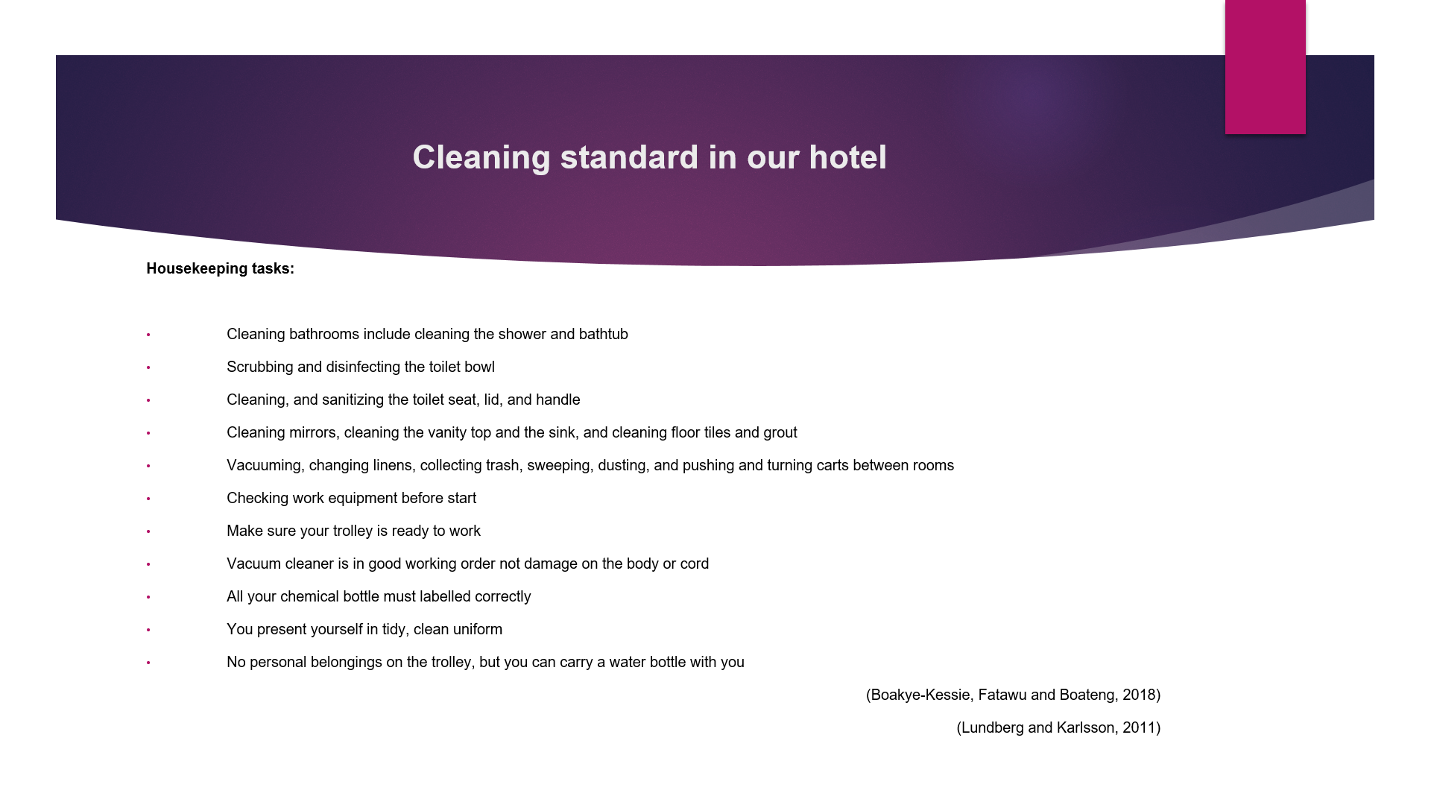

Training Notes:
Make sure the bedding is tidy in occupied rooms, empty the bin and replace the towels with fresh ones. Adjust the curtains, open the window to let in some fresh air and hoover it its necessary. Departure rooms have to be cleaned properly, changed bedding, sanitize and disinfect all the surfaces in the room. Leave sanitary products in the bathroom.
Always check if the guests have any special requests about the room set up and report if the room is ready so that your supervisor can mark the room available for arrivals.
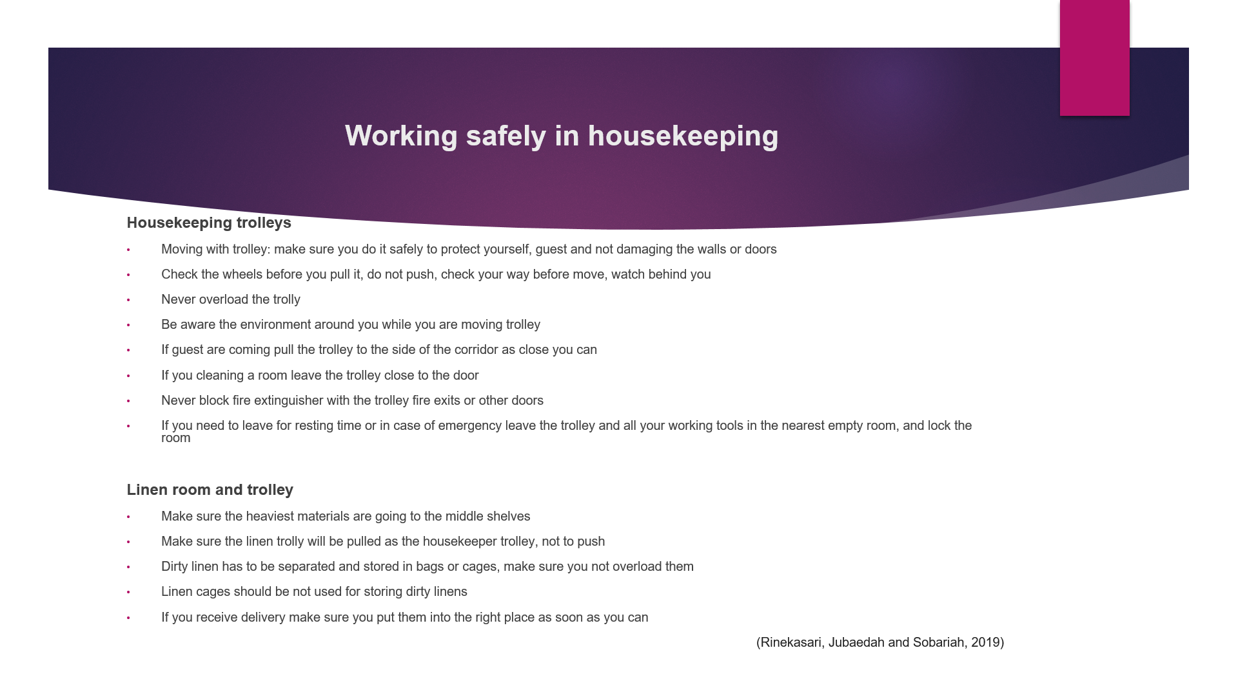

Training Notes:
Make sure at the beginning of your shift the trolley is in good working order. Prepare the trolley for the end of the day with necessary tools, chemicals, and linens.

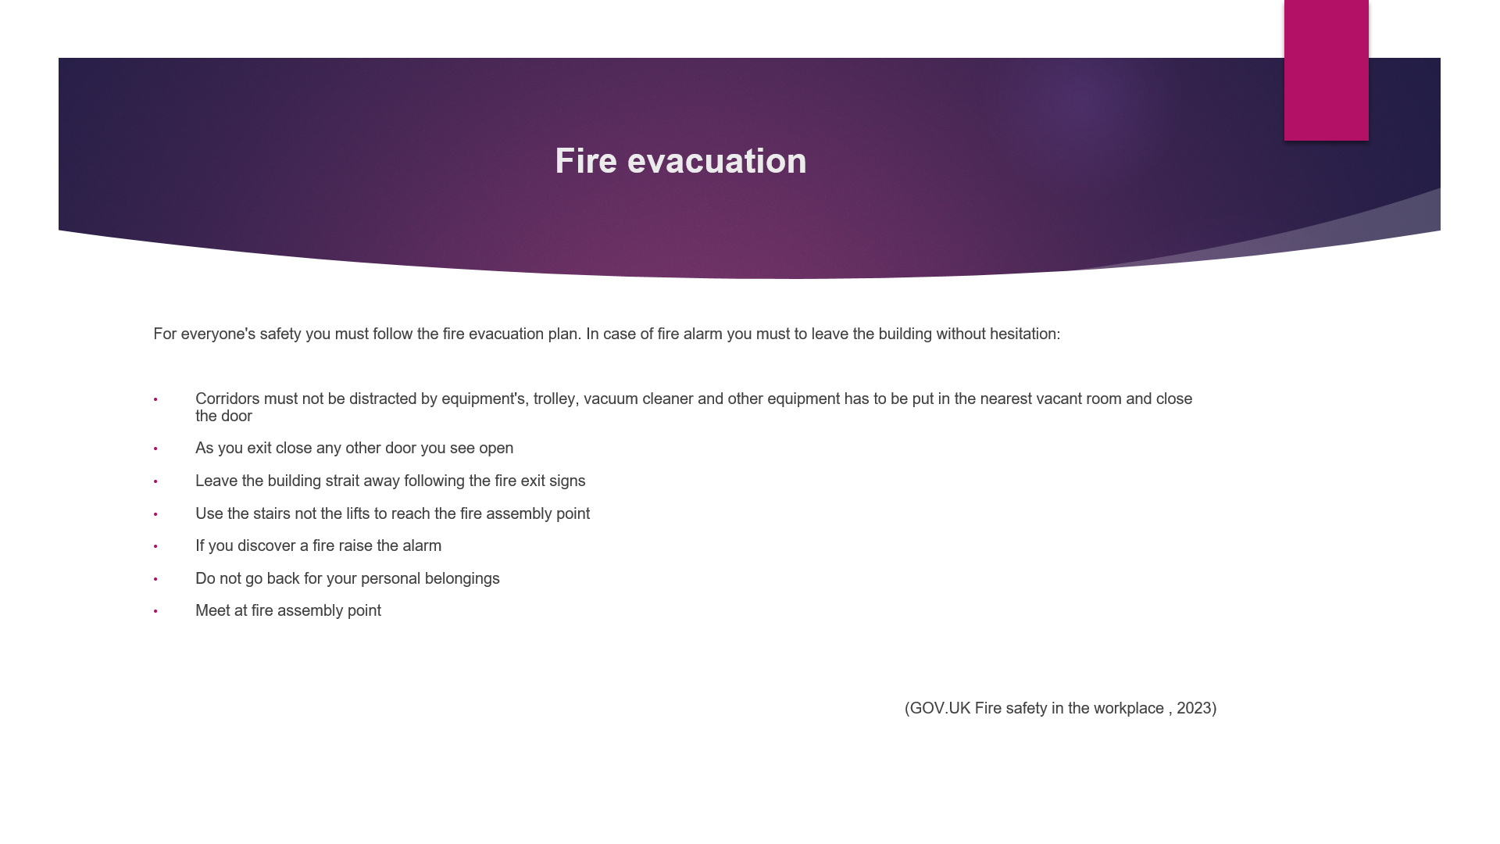

Training Notes:
Our hotel running a fire alarm test every Monday at 12pm. If it is not a test and you notice the fire alarm is on, you must leave the building across the nearest fire exit.
Evacuation map is available on every floor about the fire exits and evacuation route. You can find on the wall next to exit or entry areas. The fire assembly point is in front of the hotels main entrance.
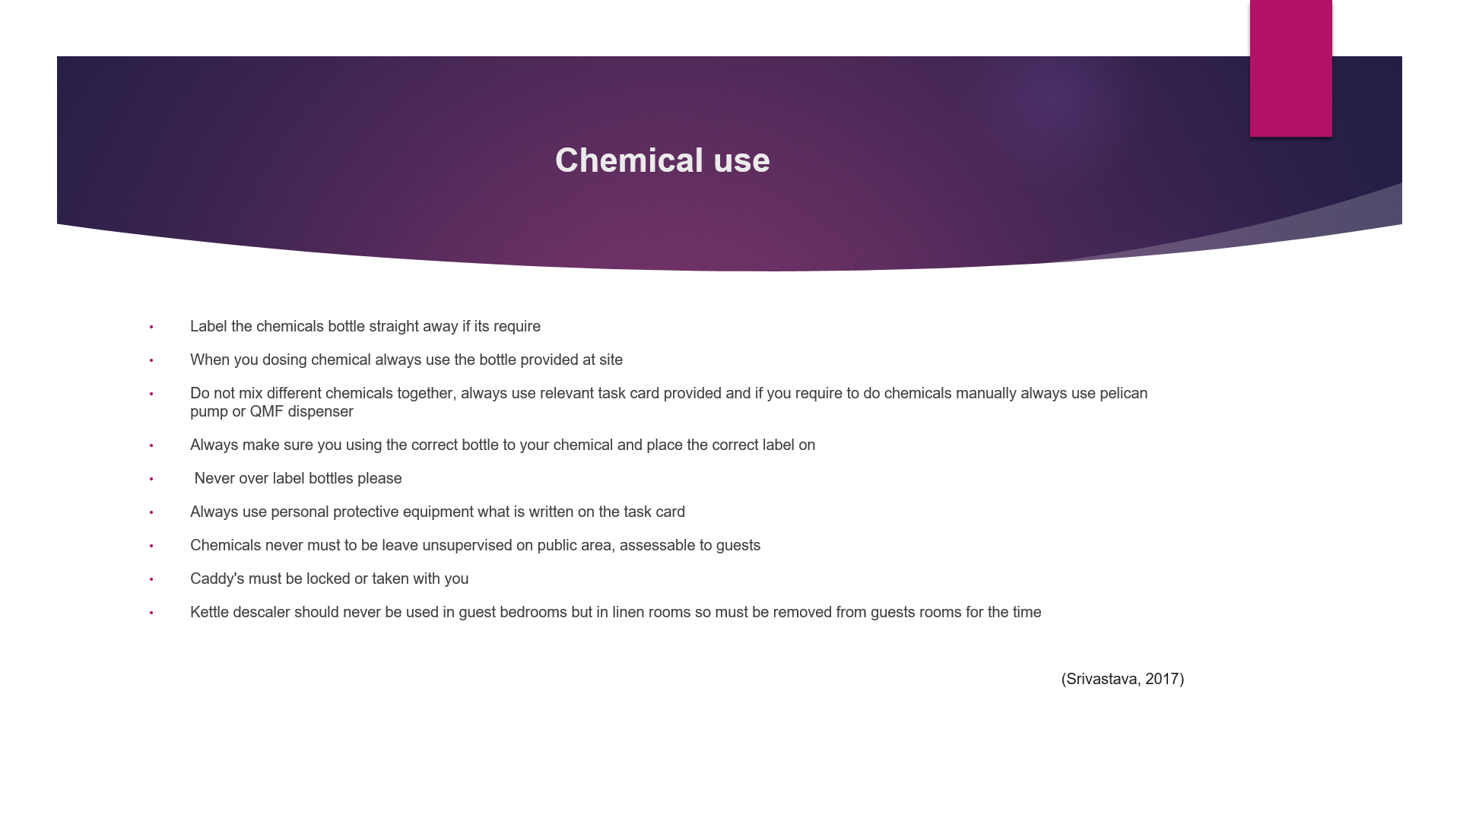

Training Notes:
There are many different types of chemical uses on hotel premises, since COVID-19 pandemic usage of hand sanitizers and disinfectants has become part of our daily routine. The most important to store and label them on the correct way for our and for guests safety. In case of delivery always make sure you put them immediately in a locked cupboard or cabinet. To find all information about chemicals in premises to how store, dilute, please always follow the relevant task card. Never store chemicals next to any food items. On shelf make sure you place chemicals on the bottom of the shelf to avoid spills on other items. Quick filling mechanism (QMF dispenser) automatically mix water and chemical in the correct ratio. In case we do not have on site manually first pour water in the bottle till the marked line than fill it up with chemical using pelican pump into the bottle. Exact amount of application is written on the task card.

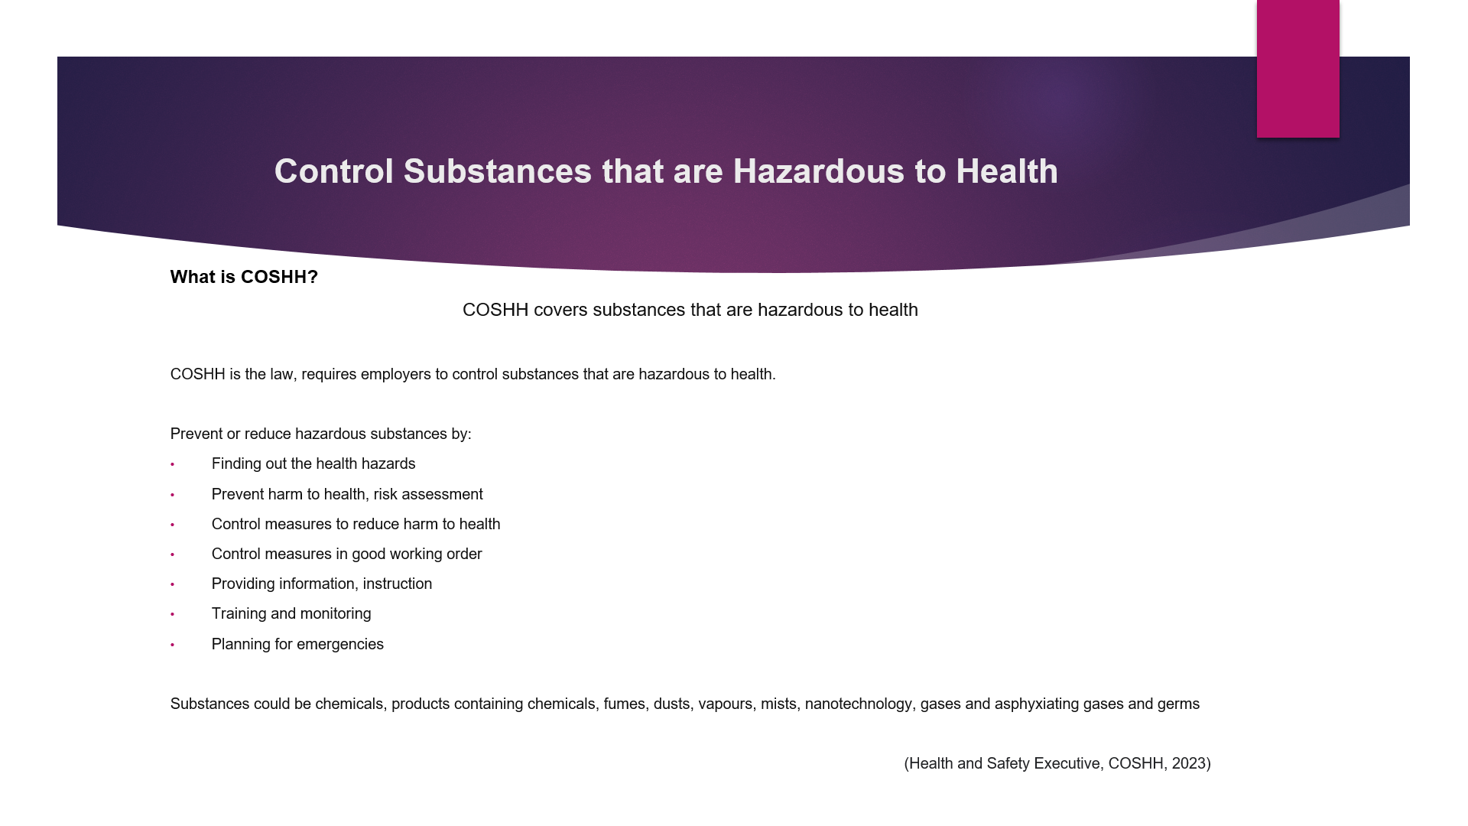

Training Notes:
COSHH is the law that requires employers to control substances that are hazardous to health. You must prevent or reduce exposure to hazardous substances during work by finding out what the health hazards are, deciding how to prevent harm to health. Chemicals if it is classed as a hazardous substance packaging has hazard symbols on. Some substances are easily recognised as harmful, most common substances such as paint, bleach.

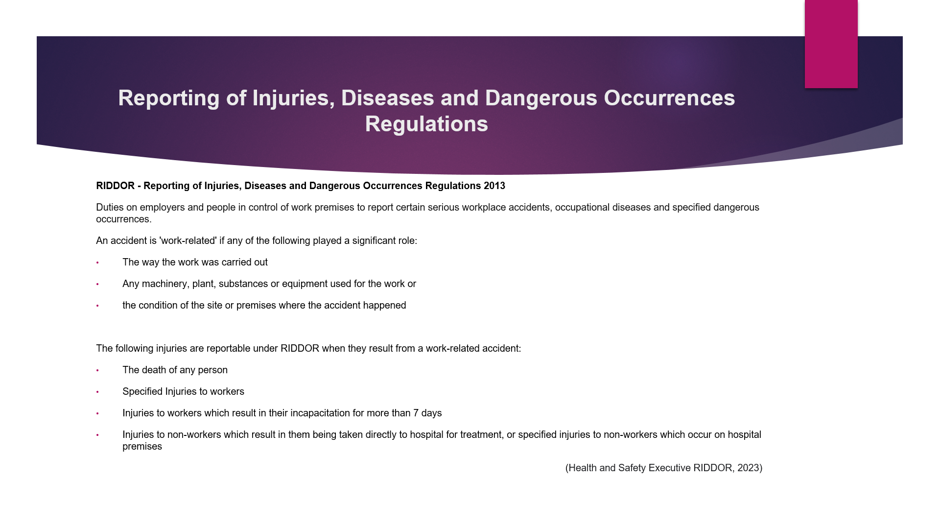

Training Notes:
RIDDOR system stands for employers and people in control of work premises to report certain serious workplace accidents, occupational diseases and specified dangerous occurrences. RIDDOR requires you to report accidents if they happen out of or in connection with work. Some accident at work premises does not mean that the accident is work-related. In case of work accident, you must report to the manager, and fill up the incident book. First aider is always available on site.

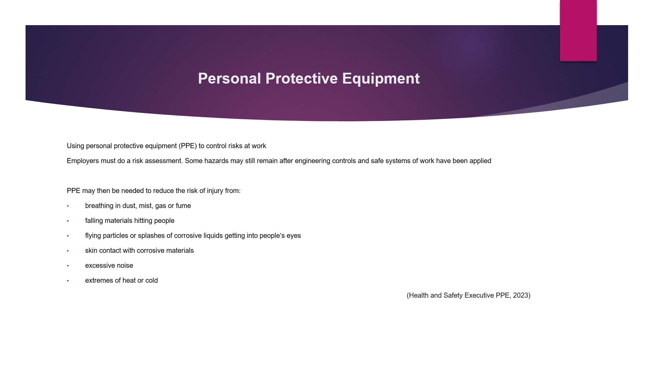

Training Notes:
If you wear PPE it helps you to minimalize or reduce of the chance of injuries or illnesses. Hazards can be physical, electrical, mechanical, chemical, or other workplace hazards. PPE equipment’s are for example gloves, masks, shoe cover, eye protection, face shield, hear protection or body protection.

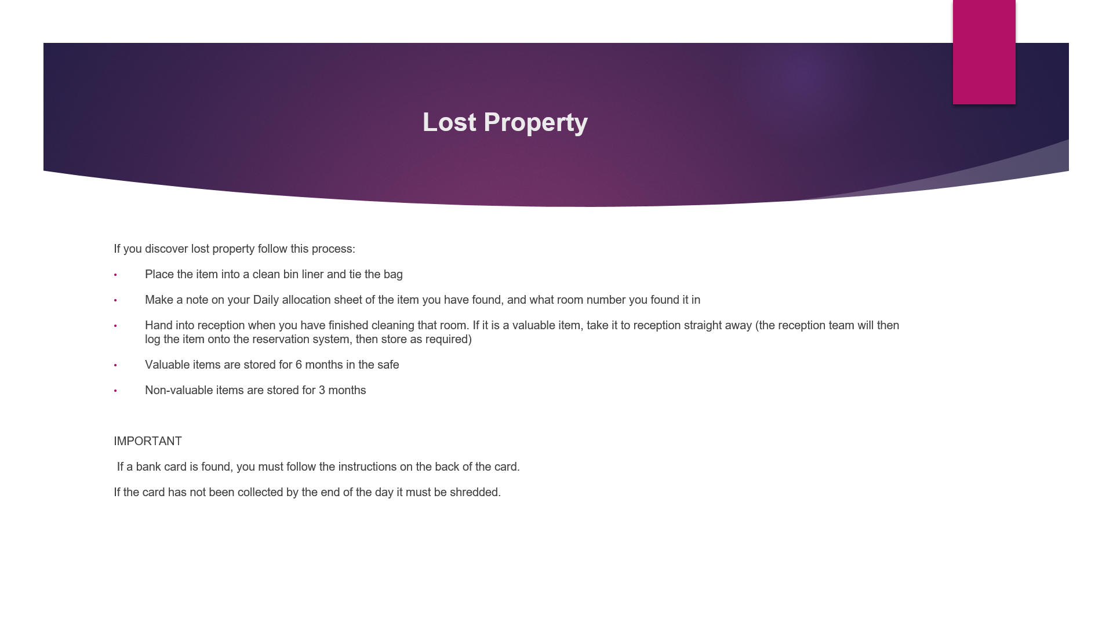

Training Notes:
From time to time, our Guests forget to take all their belongings when they leave their room, therefore it is important you know the correct process to follow if you find lost property.

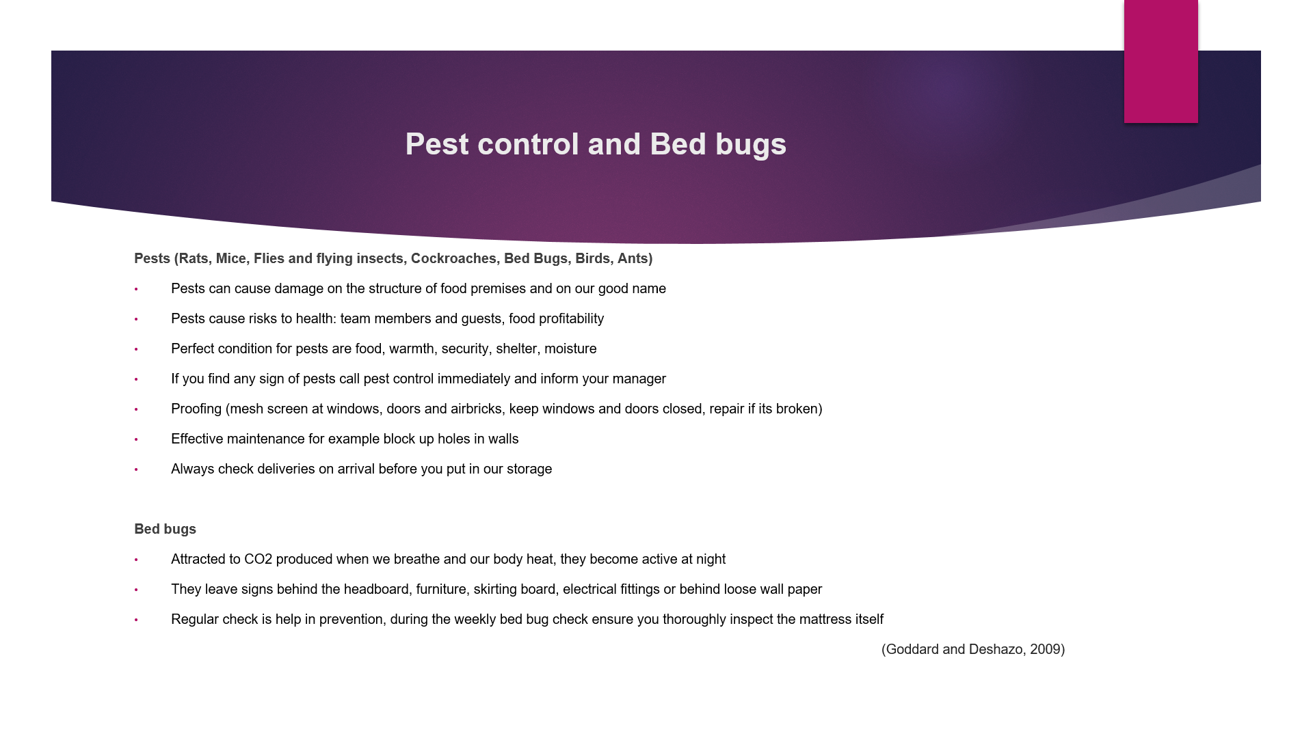

Training Notes:
Pest control is essential to keep pests out of the hotel premises and prevent them from spreading bacteria, that can contaminate food and cause illnesses.
Bed bugs are travelling around the world by catching a ride on clothing and getting into peoples’ luggage. Do check the rooms once a week, if you do see any signs of bed bugs, ensure you report this immediately to the management team. Check the sofa bed if you have in the room. They usually leave sing on mattress, behind headboard, pictures, and so on.
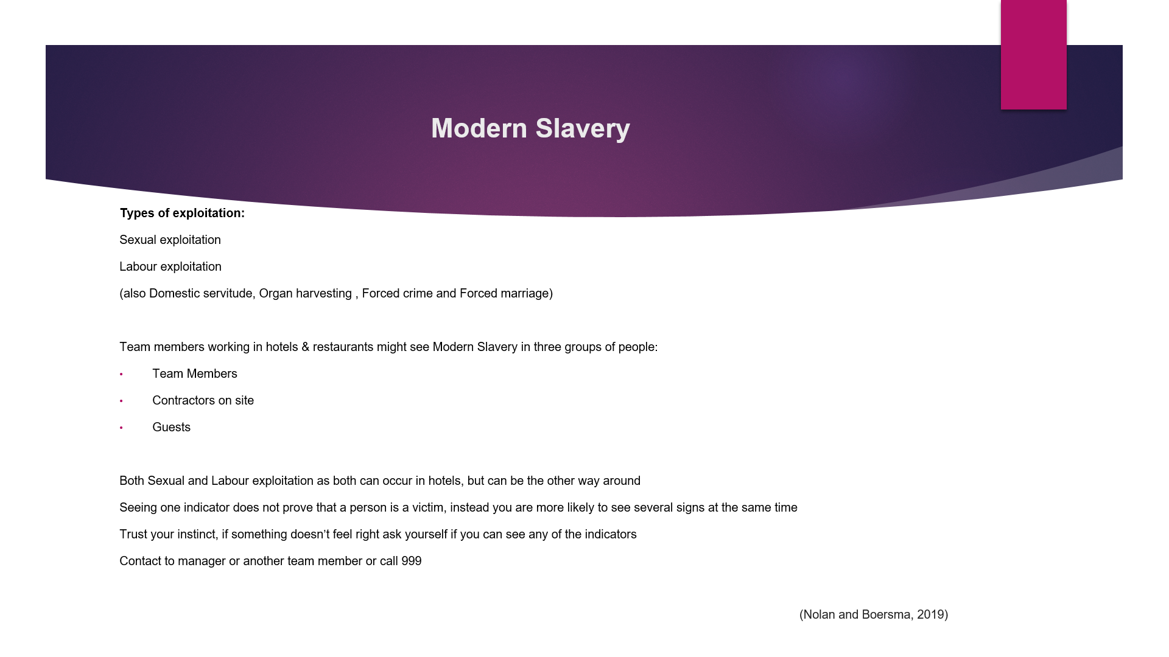

Training Notes:
Modern slavery means that a victim is either tricked or forced to do something that another person gains from financially. Let's look at different types of modern slavery:
Sexual exploitation victims might be forced to perform sexual acts, fox example sex worker. This can happen to both children and adults.
Labour exploitation victims might be forced to work long hours and they don not get employees right as they should. There could be different sings of exploitation for example guest's always using the ‘do not disturb’ sign to not let you enter to their room, paying with large amounts of cash. You can notice multiple visitors to a guest’s room. Evidence of drugs or alcohol in rooms where children are present.
If you suspect any sing of modern slavery, please report it. You are not responsible for saving a victim but be aware of the signs of modern slavery. If it is an emergency, you should contact safety and security to authorities, so we can pass this case to the police.

References

Alvarez Sainz, M., Ferrero, A.M. and Ugidos, A., (2019). “Time management: skills to learn and put into practice.” Education+ Training

Ambardar, A., & Raheja, K. (2017). “Occupational Safety and Health of Hotel Housekeeping Employees: A Comparative Study.” International Journal of Hospitality & Tourism Systems, 10(2).

Batinić, I. (2015). “Organization of business in hotel housekeeping.” Journal of Process Management and New Technologies, 3(1), 51-54.

Boakye-Kessie, V.A., Fatawu, A. and Boateng, R., (2018). “Assessing housekeeping practices among some two and three-star hotels in Accra and Kumasi.” ADRRI Journal of Arts and Social Sciences, 15(9), pp.1-34.

Hendarman, A.F. and Cantner, U., (2018). “Soft skills, hard skills, and individual innovativeness.” Eurasian Business Review, 8, pp.139-169.

Goddard, J. and Deshazo, R., (2009). “Bed bugs (Cimex lectularius) and clinical consequences of their bites. “ Jama, 301(13), pp.1358-1366.

GOV.UK Fire safety in the workplace (2023)
Available at: https://www.gov.uk/workplace-fire-safety-your-responsibilities
Accessed at 15.02.2023

Health and Safety Executive COSSH (2023)
Available at: https://www.hse.gov.uk/coshh/
Accessed at 15.02.2023

Health and Safety Executive RIDDOR (2023)
Available at: https://www.hse.gov.uk/riddor/index.htm
Accessed at 15.02.2023

Health and Safety Executive PPE (2023)
Available at: https://www.hse.gov.uk/ppe/overview.htm
Accessed at 15.02.2023

Kelloway, E.K., Sivanathan, N., Francis, L. and Barling, J., (2005). “Poor leadership. Handbook of work stress,” pp.89-112.

Lai, I.K.W., (2019). “Hotel image and reputation on building customer loyalty: An empirical study in Macau.” Journal of Hospitality and Tourism Management, 38, pp.111-121.

Lundberg, H. and Karlsson, J.C., (2011). “Under the clean surface: working as a hotel attendant. Work, employment and society.”

Nolan, J. and Boersma, M., (2019). “Addressing modern slavery.” UNSW Press, Sydney.

Pai, A., Manjunath, M., Kowshik, C. S., Ayedee, N., Malarout, N., & Naik, N. (2020). “Soft skills as a key competency for the future leaders of the hospitality industry. “ PalArch's Journal of Archaeology of Egypt/Egyptology, 17(9), 4341-4355.

Rinekasari, N.R., Jubaedah, Y. and Sobariah, S.N., (2019). “Standard Operating Procedure of Housekeeping Adaptation: The Development of Assessment Tools in Cleaning Bathroom Practices at Vocational High School.” KnE Social Sciences

Singh, A. (2015). “Hotels Housekeeping Innovative Trends and Modern Practices-An overview.” Journal for Studies in Management and Planning

Srivastava, M.E.E.N.U., (2017). “Potential health hazards of workers in hospitality industry. “ International Journal of Applied Home Science, 4 (7–8), pp.617-622
Tra, Thao. (2020). "Action plan for training new Housekeeping Employee: case: Hotel Indigo Helsinki."

Vukmir, R.B., (2006). “Customer satisfaction.” International Journal of Health Care Quality Assurance, 19(1), pp.8-31.

