QUALITY SYSTEMS AND MEASUREMENT INSTRUMENTATION

MEASURING AND QUALITY IN MANUFACTURING
STUDENT DETAILS:
ID: 2015736
Module:4012


REPORT

INTRODUCTION

This report will talk about quality control systems and look at how these systems work to improve quality in an engineering or manufacturing industry.
It will contain explanations and detailed accounts of what quality is and why it is essential to have procedures in place to achieve the desired outcome.
The report also goes on to briefly mention about the different departments that are required in order to test and pass products during it manufacturing process.
A discussion will also be made surrounding the subject of quality assurance and why quality control is vital in manufacturing.
The cost of quality is also included in this report giving a brief outlook to the consequence of waste and the methods used to achieve more economical outcomes.
Statistical quality control will also be touched upon with examples of how the process works in terms of the tools used by quality professionals.
The Vanier Caliper is one of the many tools, used in order to achieve and maintain high quality standards. It is one of the most important and critical tools used in the industry; up to today and will be mentioned and extensively described in the following report.

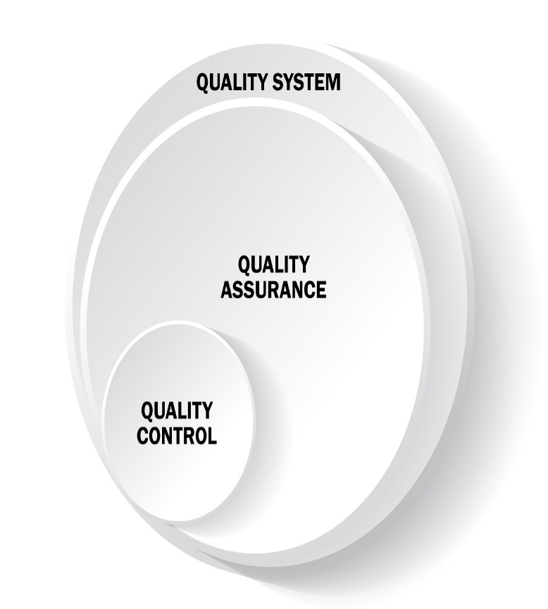

Contents

Introduction | 2
Quality Systems | 4
What is Quality | 4
What is Measurement | 4
Quality Assurance | 5
Quality control | 6
Cost of Quality | 7
Statistical Quality Control | 8
Vernier Caliper | 9
Vernier Caliper parts break down | 10

Task1

Quality systems

The term quality in an engineering or manufacturing context can encompass a range of activities. These activities are:
- Quality assurance
- Quality control
- The cost of quality
- Statistical quality control
When these systems are applied appropriately, the best and highest standard of the product being produced; may be achieved. Most manufacturing companies adopt this strategy.

What is Quality

According to William Edward Deming’s theory on Quality in engineering/Manufacturing the process of achieving the required quality of a product that will meet both internal and external approval (bl.uk/people/w-edwards-deming 2021) he suggested that there were 14 points of protocol what should be implemented in order to provide a framework to develop the best quality practices.
Some of these suggestions are:
- Create constancy of purpose towards improvements of product and service, with the aim of becoming competitive, staying in business and providing jobs
- Institute training and retraining
- Drive out fear so that everyone may work effectively for the company

This means that the product inevitably should pass high quality standard processes before it is distributed to the public or consumers.

What is measurements

In manufacturing or engineering setting there are many types of measuring instruments. It is critical to use the correct tool in order to get the best outcome of any product being manufactured. Tools such as a vernier caliper can be used as an essential engineering tool

QUALITY ASSURANCE

Quality assurance is defined as the part of quality management that focuses on insuring that quality requirements is achieved (Quality assurance vs Quality Control: Know the Differences | ReQtest, 2021). This is done by systematic activities that determine the procedure and standards to develop a product.
Quality assurance used in the context of manufacturing is the process used as part of a quality management system. This system is in place in order to maintain high quality and consistent levels on the items produced (Fogg, 2021).

Quality assurance is often paired with quality control, however quality assurance is part of ecological community that should secure or provide customers with a high-quality product. These products should ideally be devoid of any unexpected defects.
Product quality is achieved by manufacturers as they use quality assurance measures. They will do this rather than just accepting quality verification.

Quality assurance is beneficial to manufacturers who attentively implement it as a major priority. Cost savings is one of the pros in quality assurance as stated by Demming on his theory of quality. Cost savings is very important as manufacturers will not necessarily have to account for items such as returns, scrap part and bi products of items that are of poor quality (Manufacturing Quality Assurance Process and Best Practices - MRPeasy, 2021)

Customer satisfaction is also a bonus of quality assurance as the product will be long lasting, they will receive the product in good time, and consistency levels will remain high. There is a less likely outcome that a product will be defective when quality assurance is apparent. This will meet the customers expectations.

Quality Control

Quality control is described as, any effort made to ensure the quality of products. This is done in order to identify and eliminate any defects (Quality Control in Manufacturing, 2021). These defects will ultimately be found and fixed before the product is released to potential customers. However, in some circumstances the defected item will trigger a recall. This means that the manufacturer will make an effort to fix the product or replace it.

There is usually one department that is dedicated to handling quality control in most manufacturing companies. A variety of task are carried out by the workers for example awaiting report for defects, inspecting random products, and comparing quantity changes and many more (The Seven Quality Control Tools, 2021). Once the employees engage in the quality control system; quality of products may be improved.

Also part of the quality control system ensures that consumers are protected against faulty product that could bring them harm (Management, 2021) For example the manufacturers of electronic tablet will make sure that part such as the glass screen, battery port, and any external casing has thoroughly been check, tested and passed quality requirements.

In order to get the right strategy for quality control; takes effort and planning. There are different tools that businesses can use to achieve quality control. Some of these tools include graphs that are used to express data, check sheets which are tables with arranged to analyses data and pareto analysis this particular chart is used to find out the different kin5d of conformality from data figures this includes repair data maintenance data parts scraps rates and other sources

Quality control has many advances and disadvantages. Some of the disadvantages are it does not prevent waste of company resources, when or if the products are faulty (Studies, 2021) Also inspecting the goods or services can be costly. However, the advantages are good quality due to methods used brings about customer loyalty. There is also improved safety for consumers and increased profits that bring economical stability for the manufacturers. This is why Quality control is so important in engineering or manufacturing.

Cost of Quality

The cost of quality is a formular used by many organizations including engineering and manufacturing companies as a way to measure the amount of resources that are being used to maintain the highest standard of quality of a product. It is also a means to account for what cost are being incurred due to unexpected failures externally and internally, for example the cost of waste.

Some companies may refer to these two factors as COGQ or cost of good quality and COPQ which is cost of poor quality. The formular is usually penned as COQ= COGQ+COPQ (What is Cost of Quality and How to Calculate It?, 2021) this will give accurate readings of the company cost of quality standard as referred to in picture below.

It is quite rare to have a negative outcome whiles Implementing the use of cost of quality. This is because it follows a strict formula. However, mistakes may occur due to human error. Some of the positives of cost of quality include allowing the manufacturing company to find a measuring balance between the quality and price of this product.

Overall, the cost of quality is an important factor in quality management as it will increase the long term growth of manufacturing companies.

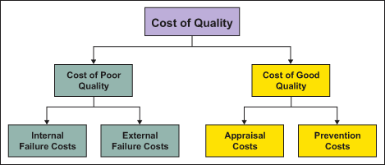

http://1.bp.blogspot.com/_LpvA4lv5DbE/SvcLuvyJipI/AAAAAAAAADQ/sVplZpWNlQI/s1600/COQ.gif

Statistical Quality control

In a manufacturing setting the terminology Statistical Quality Control is used to describe the set of tools used by quality professionals (Statistical Quality Control – IspatGuru, 2021). It can be divided into 3 broad categories
- Descriptive statistics or (DS)
This is used to describe the quality characteristics of viability and central tendency of observed data.

- Statistical Process Control or (SPC)
This is used to identify if a production process has quality issues. It also identifies if the process produces products with characteristic that comply within a predetermined range.

- Acceptance sampling (AS)
This is used as a tool that shows quality is achieved for a product, and weather there is a problem with the quality of the product.

There are several different tools to achieve statistical quality control for example histograms as seen in figure1, Pareto analysis as seen in figure2 and control charts as demonstrated in figure 3.

In conclusion to this it is evident that without these essential tools the quality standard of products will not meet the recommended standard for the release of goods in society.

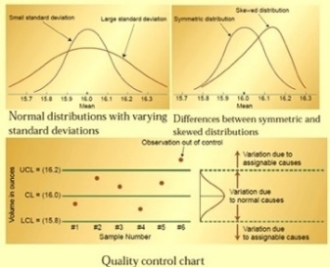
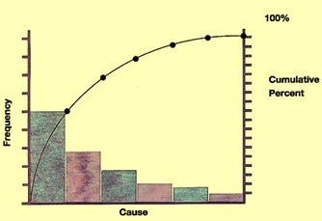
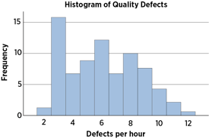

Figure 1 Figure 2 Figure 3

Task2

Vernier Calipers

A vernier caliper is an important measuring tool as it has the ability to measure and apprise components such as bolts, nuts, diameter of cylindrical objects and assemblies (How to Use a Vernier Caliper - Quick Guide | ShakeDeal, 2021). It is generally used to take low tolerance measurement readings. Most vernier calipers are normally made of steel, however in situations when it may cause scratches a carbon material such as plastic may be used (Mift H, 2021)

The tolerance of a vernier caliper is +-0.03mm (+-0.0015in) making it a very accurate precision measuring instrument in engineering or manufacturing. The VC can be used to take a variety of different measurement such as external dimensions using the main jaws, inner dimensions using the smaller jaws and depth using the stem.

There are many situations in which it would be appropriate to use a VC, for example to measure the thickness or length of an object such as a plank of wood or to measure a circular or oblique shaped object such as a gas pipe (Vernier Caliper Functions & Important Parts - Vernier Calipers, 2021).

Although a VC is a useful measuring equipment it comes with limitations. Some of these limitations are, a VC cannot be used to do large important measurements over 15mm or 6inch; for example, measuring the length of a window frame or the depth of a car rim. Another limitation is one will need to have knowledge about how to read VC in order to take accurate measurements (Vernier Caliper Common Advantages & Disadvantages for Users - Vernier Calipers, 2021) and prevent error of produced products in manufacturing or engineering.

When using the vernier caliper there are some precautionary steps the user could take in order to minimize errors. By taking these steps the user can obtain accurate measurements. Some of these steps are
- The user should position their eyes above the main and vernier scales when taking readings.
- Use of excessive force on jaws should be avoided when gripping object to be measured, especially on objects that are easily deformable for example wire.
- The Object surface that needs to be measured should be cleaned and dried in cleaning oil with a cloth.
- The vernier caliper cover should be cleaned before and after use with cleaning oil with a cloth.
- The locking key of VC should be loosened so that the user can make sure the is no friction between the scales whilst moving jaws.
- The upper and lower jaws of instrument should be cleaned and dried with cloth gently before and after use.

So, in conclusion, the vernier caliper is one of the best tools to use in an engineering or manufacturing setting as it works to give complete accuracy and efficiency intern of precision; with the ability to ensure quality is achieved and maintained.

2.
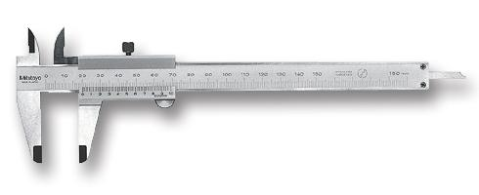
7.
6.

5.

4.
3.

https://canada.newark.com/productimages/large/en_GB/42346302.jpg

The main parts of the vernier caliper are the

- Internal Jaws: these jaws are used to measure internal measurements such as internal diameter.
- Locking Screw: this part of device can be used to tighten object being measured, it prevents object from moving.
- External Jaws: this is used to measure the external dimensions of an object such as outside diameter, width, length, and thickness.
- Vernier scale: this is the part of the scale used to measure with the metrics unit.
- Thumb screw: it is used to provide grip for user, in order to adjust the position of the jaws and depth rod while maintaining firm grip on object being measured.
- Main Scale: this is the large scale that runs across the body of the vernier calliper. It is stationary and is normally in millimetres, centimetres or inch.
- Depth rod: this is a feature of the vernier calliper which is very useful as it can be used to measure depth of objects such as stairs and holes. It is a thin rod that is located at the end of main scale.

References

1.bp.blogspot.com. 2021. [online] Available at: <http://1.bp.blogspot.com/_LpvA4lv5DbE/SvcLuvyJipI/AAAAAAAAADQ/sVplZpWNlQI/s1600/COQ.gif> [Accessed 12 August 2021].

Creaform3d.com. 2021. [online] Available at: <https://www.creaform3d.com/blog/pun5th75ef_wp/wp-content/uploads/imagerie-QC-vs-QA-vs-QS.jpg> [Accessed 12 August 2021].

Fogg, E., 2021. Quality Assurance in Manufacturing: Everything You Need to Know. [online] Machinemetrics.com. Available at: <https://www.machinemetrics.com/blog/quality-assurance> [Accessed 3 August 2021].

Shakedeal.com. 2021. How to Use a Vernier Caliper - Quick Guide | ShakeDeal. [online] Available at: <https://www.shakedeal.com/blog/how-to-use-a-vernier-calliper/> [Accessed 14 August 2021].

Asq.org. 2021. Letter Q - Quality Glossary of Terms, Acronyms & Definitions with Letter Q | ASQ. [online] Available at: <https://asq.org/quality-resources/quality-glossary/q> [Accessed 1 August 2021].

Management, Q., 2021. Quality Control in Engineering Management | A-State Online. [online] A-State Online. Available at: <https://degree.astate.edu/articles/engineering/quality-control-in-engineering-management.aspx#:~:text=puts%20it%2C%20%E2%80%9C%5Bquality%20control,even%20past%20the%20product's%20rollout.> [Accessed 9 August 2021].

Blog for Manufacturers and Distributors. 2021. Manufacturing Quality Assurance Process and Best Practices - MRPeasy. [online] Available at: <https://manufacturing-software-blog.mrpeasy.com/manufacturing-quality-assurance-process-and-best-practices/> [Accessed 4 August 2021].

ReQtest. 2021. Quality assurance vs Quality Control: Know the Differences | ReQtest. [online] Available at: <https://reqtest.com/testing-blog/quality-assurance-vs-quality-control-differences-2/> [Accessed 2 August 2021].

Creative Safety Supply. 2021. Quality Control in Manufacturing. [online] Available at: <https://www.creativesafetysupply.com/articles/quality-control-in-manufacturing/> [Accessed 7 August 2021].

Ispatguru.com. 2021. Statistical Quality Control – IspatGuru. [online] Available at: <https://www.ispatguru.com/statistical-quality-control/> [Accessed 13 August 2021].

https://getrevising.co.uk/grids/advantages-and-disadvantages-of-quality-control
www.thesaurus.com. 2021. Synonyms of ecosystem | Thesaurus.com. [online] Available at: <https://www.thesaurus.com/browse/ecosystem> [Accessed 5 August 2021].

www.thesaurus.com. 2021. Synonyms of ensures | Thesaurus.com. [online] Available at: <https://www.thesaurus.com/browse/ensures> [Accessed 6 August 2021].

Gemba Academy. 2021. The Seven Quality Control Tools. [online] Available at: <https://www.gembaacademy.com/school-of-lean/the-seven-quality-control-tools-course> [Accessed 8 August 2021].

Blog for Manufacturers and Distributors. 2021. What is Cost of Quality and How to Calculate It?. [online] Available at: <https://manufacturing-software-blog.mrpeasy.com/cost-of-quality/> [Accessed 11 August 2021].

2021. [online] Available at: <https://www.softwaretestinghelp.com/quality-assurance-vs-quality-control/> [Accessed 15 August 2021].

Mift H, B., 2021. What is Caliper? Benefits, Parts, & Types - FullyInstrumented. [online] FullyInstrumented. Available at: <https://www.fullyinstrumented.com/what-is-caliper/> [Accessed 14 August 2021].

Ngenda, S., 2021. Precautionary Steps While Taking Measurements By Vernier Caliper - Vernier Calipers. [online] Vernier Calipers. Available at: <https://vernierscaliper.com/precautionary-steps-while-taking-measurements-by-vernier-caliper-85.html> [Accessed 15 August 2021].

Ngenda, S., 2021. Precautionary Steps While Taking Measurements By Vernier Caliper - Vernier Calipers. [online] Vernier Calipers. Available at: <https://vernierscaliper.com/precautionary-steps-while-taking-measurements-by-vernier-caliper-85.html> [Accessed 15 August 2021].

Vernier Calipers. 2021. Vernier Caliper Functions & Important Parts - Vernier Calipers. [online] Available at: <https://vernierscaliper.com/vernier-caliper-functions-important-parts-784.html> [Accessed 15 August 2021].

Vernier Calipers. 2021. Vernier Caliper Common Advantages & Disadvantages for Users - Vernier Calipers. [online] Available at: <https://vernierscaliper.com/vernier-caliper-common-advantages-disadvantages-for-users-163.html> [Accessed 15 August 2021].

Asq.org. 2021. [online] Available at: <https://asq.org/-/media/Images/Learn-About-Quality/Histogram/histogram.png?la=en> [Accessed 15 August 2021].

The Engineers Post. 2021. Vernier Caliper | Parts, Types, Working, Least Count, Errors. [online] Available at: <https://www.theengineerspost.com/types-of-vernier-caliper/> [Accessed 15 August 2021].

Cdn.shortpixel.ai. 2021. [online] Available at: <https://cdn.shortpixel.ai/client/q_glossy,ret_img,w_334,h_229/http://www.ispatguru.com/wp-content/uploads/2013/09/pareto-analysis-chart.jpg> [Accessed 15 August 2021].

Ispatguru.com. 2021. [online] Available at: <http://www.ispatguru.com/wp-content/uploads/2013/09/Control-charts.jpg> [Accessed 15 August 2021].

2021. [online] Available at: <https://canada.newark.com/productimages/large/en_GB/42346302.jpg> [Accessed 16 August 2021].

