Saminah Chohan
1807436


This Photo by Unknown Author is licensed under CC BY-SA-NC

Introduction
In this assignment, we are going to talk about identifying an area of policy and historical considerations. We will describe how all the development impacts the lives of young children and families. The act that is spoken about will be the disability act. Disability is a condition of the body and mind. Having a disability makes it difficult for the person to do certain daily activities. It also effects on how they interact with society and the world around them. Disability conditions or impairment come in many forms, these include, cognitive, physical, mental, sensory or a combination of conditions. Disability under the Equality Act 2010, if you have a physical or mental impairment that has a ‘substantial’ and ‘long-term’ negative effect on your ability to do normal daily activities. (The equality act 2010).
Disabilities
There are many impacts disabilities can have, these include economic psychological, social, and political. Poverty such as issues of access. Social impacts affect how communities cope with an induvial disability. Families who care for and live with a person with a disability both experience positive and negative impacts. (Josphine 2003)
According to a study by (Tania Burchardt) “disability can increase risk of an individual falling into poverty.” Research has indicated that 14% of those studied had families fall into poverty risk. Families what have a person with a disability fall into poverty twice as fast than those who did not have a disability.
In the uk the reduction of poverty has become a big concern, this is because the rates are so high with people with disabilities than the rate of the population. Almost half the people in the uk are living in a household with a disabled person or are disabled themselves. They are falling into poverty risk.
The attitude towards disabilities has changed from many years ago. Back in the 1918s there wasn’t any vaccines or medication that could help towards diseases in this case this caused a huge amount of disabilities. There was a lack of free healthcare and support for those families affected. Disability institutions were set up for individuals with an impairment or disability, to be sent away from their families. This was so they could be away from society and away from mainstream lives. They were looked at as the deserving poor.
This all changed when the first world war started, many millions of British men lost lives, however millions came back home with a permanent disability from injuries. This then changed the views on Individuals who had disabilities and was a starting point. They were war heroes and not the deserving poor. No longer were they sick or burdens on society. This did not mean all people with disabilities were treated equally, civilians were still seen as the deserving poor and didn’t see any improvements towards their health and conditions. (Clarke 2018)

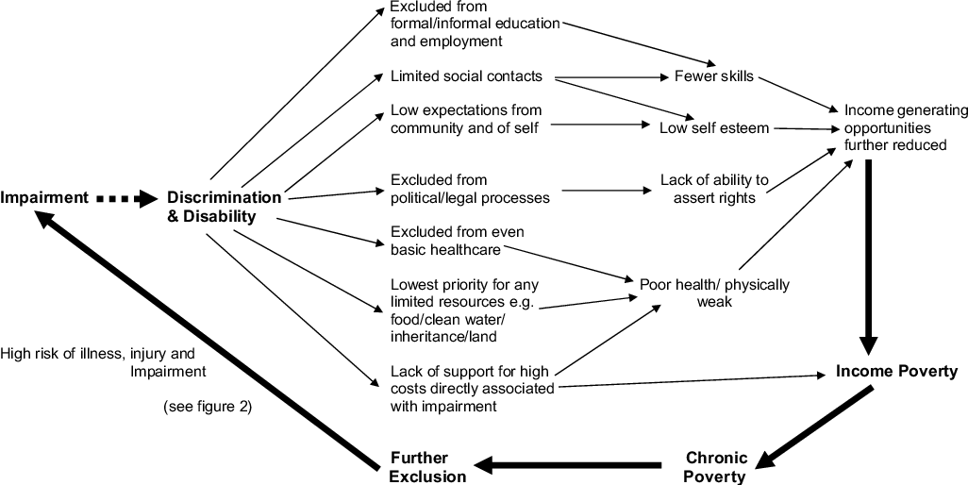

Definition of a child
A child is an individual who is dependent on an adult, they are vulnerable and still growing emotionally and physically. (Reader 1995) A family, when one thinks of a family the traditional nuclear and extended family that are biologically related comes to mind. However not all families are made up this way, a family can be made up of anyone who a person would want to consider as family. Families share common values, emotional bonds, responsibilities and contribute significantly to the wellbeing of each other. There are many different arrangements and family structures. Children may have one or more parents/carers. This may include grandparents, stepparents, aunties uncles adoptive and foster parents. It doesn’t generally mean only biological parents are classed as parents. The parenting and caregiving for children are done by one of the above. They can have many roles in a child’s life.
“Young children with disabilities are more likely to live in poverty than children without disabilities”, according to (Susan 2006). This leaves them vulnerable and puts them at risk of poverty in these conditions, such as by increasing the expense of children with disabilities. It can make it impossible for parenting jobs and caregiving commitments to be balanced.

The concept of childhood started to emerge in the 17th and 18th century. Children became a subject of greater interest in the eighteenth century, but the figure of the “juvenile delinquent” does not exist until the nineteenth century. So while the publication of the legal handbook, the Infants’ Lawyer, in 1697 recognized the necessity of treating children as sometimes separate from adults in the eyes of the law, the causes of childhood criminality were not clearly understood before the century was up. (defining 18th century childhood)
Going back to ancient Greek times if a child was born with disabilities this was interested ad a punishment on the parents by the ancient gods. By law an infant that as deformed or sickly had to immediately be abandoned. Also, if a child was to be found to be an “idiot” as they called them would also get abandoned. (Wright, D. (2011))
In the first half of the 18th century, children with disabilities were not accepted, they were classed as the “poor”. The charities that provided education for children of the poor, excluded all children with disabilities. Those children from families who were better-off could appreciate private tutoring or take their chance in mainstream school, but the disabled children of the poor were unlikely to receive an education. (historic England)
1970 Education (Handicapped Children) Act made education universal.
This act came into place for children with special needs that require close monitoring in restrictive environments. Before this act was introduced, children were shipped off to special schools or put into special classrooms, these children were not interacted with and this would leave a negative impact and give low self-esteem.
1970 Chronically Sick and Disabled Persons Act.
All the above acts came into place over the years acting on behalf of adults and children with disabilities.
A child with disabilities should have the right to voice their own opinions and interests, it is important for children to make decisions regarding their disability. Support must be individually tailored and resourced with time and staffing. (Jerome bickenbach 2010)

Back in the 1700 and 1800s adults and children with disabilities whether physical or cognitive were sent to “lunatic asylums. Beginning in the late 1800 doctors introduced what they called moral treatment. They discouraged the use of stray jackets and shackles, instead they tried to use a different approach. They focused on the emotional wellbeing believing this route would cure the patients more effectively.
By 1995 the disability act of discrimination was legalised. Direct discrimination, indirect, harassment and victimisation all are part of discriminating. Back in historical times there were no laws against this, the language that was used towards people with disabilities such as, idiots, lunatics, poor, deaf, and dumb. “ineducable” label was introduced in 1944 education act, used regarding people with disabilities.
1986 the disabled persons act was introduced, this required written assessments of what abilities of formal care would be needed for disabled people
2000: carers and disabled act: young disabled children aged 16 and above had the rights to recover their own payments to support their own mental and physical needs,

Interventions and support
Many early years settings have been covered by disability discrimination duties since the Disability Discrimination Act 1995 (DDA) was first implemented. The Special Educational Needs and Disability Act 2001 extended the DDA to include education and, from this point onwards, early years settings constituted as schools were also covered. In a series of changes between 2010 to 2012, the Equality Act 2010 (EqA) replaced the DDA (stobbs 2015)
The early years foundation stage
EYFS implemented the developmental standards of a child keeping all these points in mind. The framework of Early Years Foundation Stage was first implemented in England in September 2008. However, it was later revised, and that version came into effect in September 2012
“It’s vital we have the right framework to support high quality early years education. Our changes, including the progress check at age 2, will support early years professionals and families to give children the best possible start in life.” (Teather 2012)
The early years foundation act is available to all parents and carers. This is a service that supports all SEN children with disabled needs. This act focuses on delivering and improving all outcomes for Sen children. By closing the achievement gap by disadvantaged children. The EYFS service is accessed free to all children above the age of two. The government has prioritised disadvantaged and disabled children to help assist needs. All providers must meet this plan to ensure all the children involved keep healthy and are able to meet the needs. These requirements have a legal basis in section 39(1) of the Childcare Act 2006 and apply to all early year’s providers, maintained schools, on-maintained schools, independent schools.

The Children and Families Act 2014
The children’s and families act 2014 changes the way Sen works, this is a service that brings in responsibilities for local authorities that apply to Sen and disabled children. It is important for local authorities to have a set principle for including and recognising the feelings, views, and wishes of both parents and children. They must try and achieve the best possible educational and other outcomes. They must participate in decision making for the best outcomes for the child.
According to (Ferguson 2019) the children and families act bought together public and private law affecting all children. It was a culmination of many years grounding of dissatisfaction around children legalisation. Children where not a possession and have rights of their own. The act was seen at the time to be a major step forward, promoting the best interest of children. Vulnerable children need to be protected and safeguarded. Legalisation is critically important in setting benchmarks.

Recommendations
People with disabilities have always been a part of society, but as we do no, they have not always been welcomed and cared for. The views of society and how people with disabilities have been viewed have been framed by social constructs and ways of thought. These definitions and theories are still framing our culture and thought today about what disability is. (brauna 2018)
The laws and policies for children and adults with disabilities have come together to move forward. For instance, the Sen This legislation has helped so many children get the right amount of assistance in school environments, since the Sen law was legalized in 2014. But it's still not enough for some kids. I agree that all children with disabilities should be given an EHCP. As part of their regular offer to children, schools in England must provide help for children with special educational needs (SEN).

If a child needs extra assistance that goes beyond what a school, college, or nursery would normally provide from their own budgets or staffing, an Education Health and Care Plan (EHCP) may be needed. An EHC plan is a legally binding document detailing the special educational, health and social care needs of a child or adolescent. The document must list all of the special educational needs of the child, provide for each of the needs, and the provision must be precise, comprehensive, and quantified. The plan determines the school/setting to include the requirement and the plan is essentially legally enforceable by Judicial Review.
This government supports people with disabilities immensely and is dedicated to ensuring that people with disabilities are assisted during this difficult and troubling period. To ensure that the needs of disabled people are met, we will do everything in our capacity.
You may have seen that cross-party support has been given to introduce emergency legislation to enable the government to respond to the coronavirus. This included crucial steps to ensure that we retain frontline care and support, particularly for people who are vulnerable and disabled. We figured that some of the proposed improvements under the Coronavirus Act below would be helpful to explain. (disability unit 2020)
(Corona virus act 2020), The provisions of the Act are time-limited, to come into effect when necessary and to be repealed as soon as conditions permit. We're going to make sure that the Care Act can apply again after the crisis is over. We expect local authorities to do their best to sustain current services and to fulfil as many needs as possible, particularly for those with the most acute needs.

Conclusion
A big obstacle to the equality of persons with disabilities is negative attitudes. Numerous programmes have been initiated by governments and other organisations to improve views about people with disabilities. We evaluate published proof of the efficacy of such interventions using a system of interrelationship between three levels of policy intervention to change attitudes: personal level-directed to change people's attitudes; organizational level-directed to change attitudes. Concerning Attitudinal barriers in fields such as housing, education, and health; and at the level of government-legally mandating change in conduct. The study shows that the following types of policies can be successful if used together: policies requiring direct communication with people with disabilities; campaigns for information and awareness; disability education and training; and implementation of anti-discrimination. Good program experience for participants; multifaceted and extended interventions; and appropriate program resources are among the policy characteristics that contribute to effectiveness. At all three policy levels, the policy effectiveness of shifting behaviours depends on sufficient reinforcement. (Fisher 2017)

References
Definition of disability under the equality act 2010. (Available online at) https://www.gov.uk/definition-of-disability-under-equality-act-2010. (accessed on 11th November 2020)

Josphine, A, (2003). Social impacts of disability. Available at [online] https://www.theclassroom.com/high-school-diploma-important-future-6563.html ( Accessed on 11th November 2020)

Timson, A ,etl (2016) disabilty and poverty. Available at [online] https://www.npi.org.uk/publications/income-and-poverty/disability-and-poverty/ ( accessed on 11th November 2020)

Image https://ai2-s2-public.s3.amazonaws.com/figures/2017-08-08/62d29669fb6c35084f228b596f4ea5896c3b1d36/2-Figure1-1.png

Clark L, (2018) 100 Years on, how attitudes towards disability have changed. Available at [online]
https://diginclusion.com/industry-updates/100-years-on-how-attitudes-towards-disability-have-changed/ (accessed on 11th November 2020)

Defining 18th centuary childhood. Avaible at [online] http://www.nicoledeguzman.com/dangerousdaughters/defining-18th-century-childhood/#:~:text=18th%20Century%20Changes%20in%20Conceptions%20of%20Childhood%20Throughout,the%20optimism%20of%20capitalist%20middle%20class%20growth%20%28O%E2%80%99Malley%29. ( accessed on 11th November

P Reder, S Duncan - 1995 – Meaning of a child. Available at [online] https://books.google.co.uk/books?hl=en&lr=&id=BTvKAgAAQBAJ&oi=fnd&pg=PA39&dq=meaning+of+a+child&ots=xhiWGn6gmM&sig=5kz0pl_7c4xo0DpmV60dme78XSk#v=onepage&q=meaning%20of%20a%20child&f=false ( accessed on 12th November 2020)

Historic England. Specialist Education for Children with Disabilities - 'the Happiest Effect'. Available at [online] https://historicengland.org.uk/research/inclusive-heritage/disability-history/1660-1832/specialist-education/. (accessed on 12th November 2020)
Stobbs, p, (2015). Council for disabled children. Available at https://councilfordisabledchildren.org.uk/sites/default/files/field/attachemnt/equality-act-early-years_online.pdf (Accessed on 12th November 2020)

Teather,s,(2012) early years foundation stage. Avaible at https://www.gov.uk/government/news/new-early-years-framework-published ( accessed on 12th november 2020)

Wright, D. (2011) Social history of learning disability. https://langdondownmuseum.org.uk/the-history-of-learning-disability/social-history-of-learning-disability/#:~:text=In%20Ancient%20Greece%20the%20birth%20of%20a%20child,to%20be%20an%20%E2%80%98idiot%E2%80%99%20would%20also%20be%20abandoned.

Rescare. History of disability legalistaion. Available at [online] https://www.rescare.org.uk/history-of-legislation-on-disability-2/ accessed on 12th november 2020

F, Donna. 2019. Thirty years on, has the Children Act changed family life for the better? Available at https://www.theguardian.com/society/2019/nov/13/children-act-changed-family-life-children-better ( Accessed on 17th November 2020)
Fisher, Karen.N 2017 available at [online] https://www.sjdr.se/articles/10.1080/15017419.2016.1222303/ ( accessed on 17th November 2020)
Brauna ,K (2018) disability and society how have things changed avaibke at (https://welldoing.org/article/disability-society-how-have-things-changed)
Disability unit (2020) available at https://www.gov.uk/government/publications/supporting-disabled-people-through-the-coronavirus-outbreak/supporting-disabled-people-through-the-coronavirus-outbreak

