Assignment – Kate Morlidge – ECES4012 (Securing Successful Study Skills)
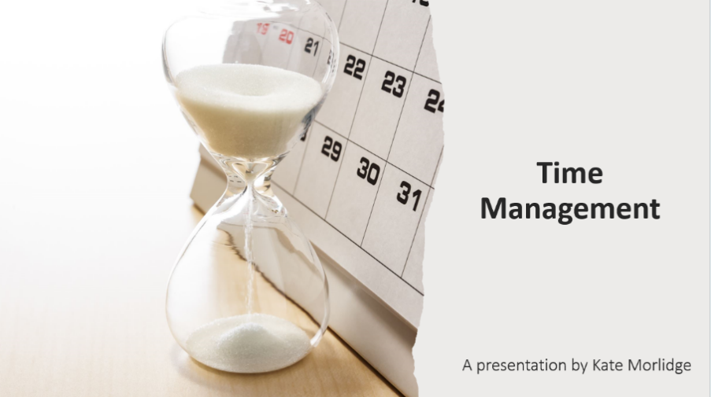
Powerpoint Slides
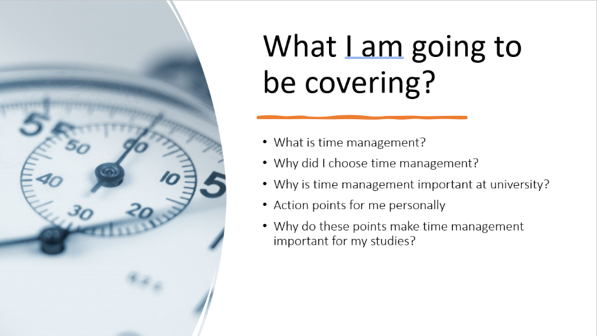

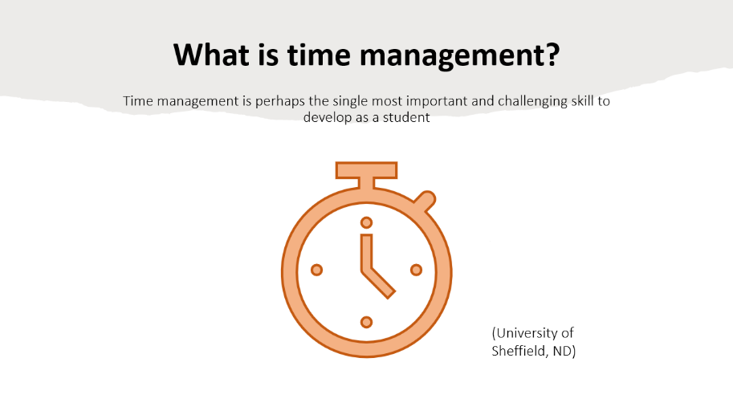
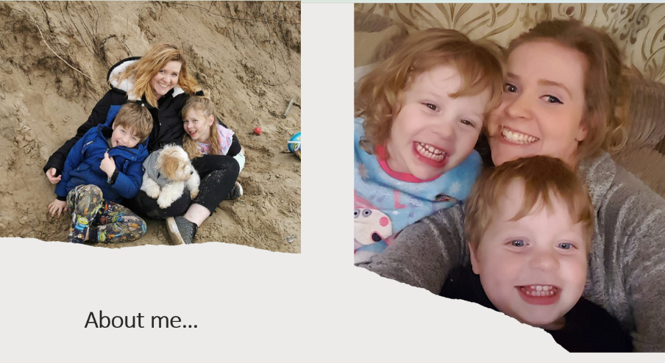

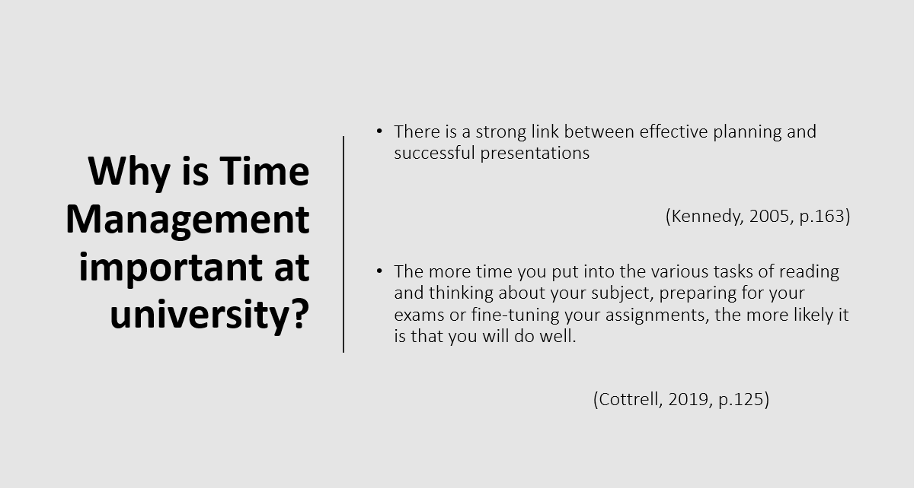
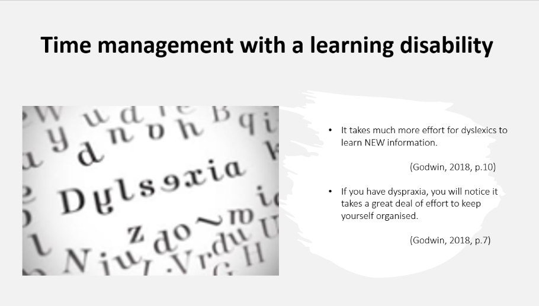


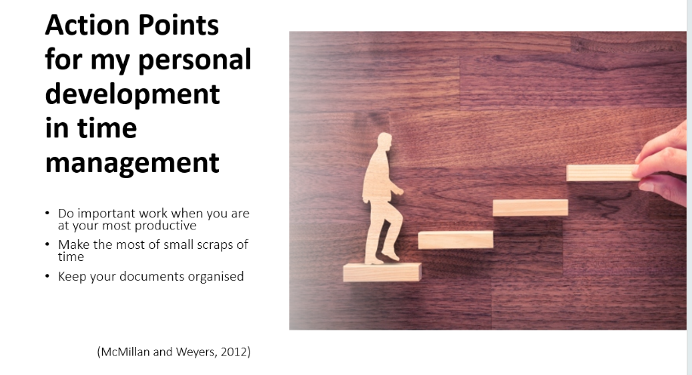

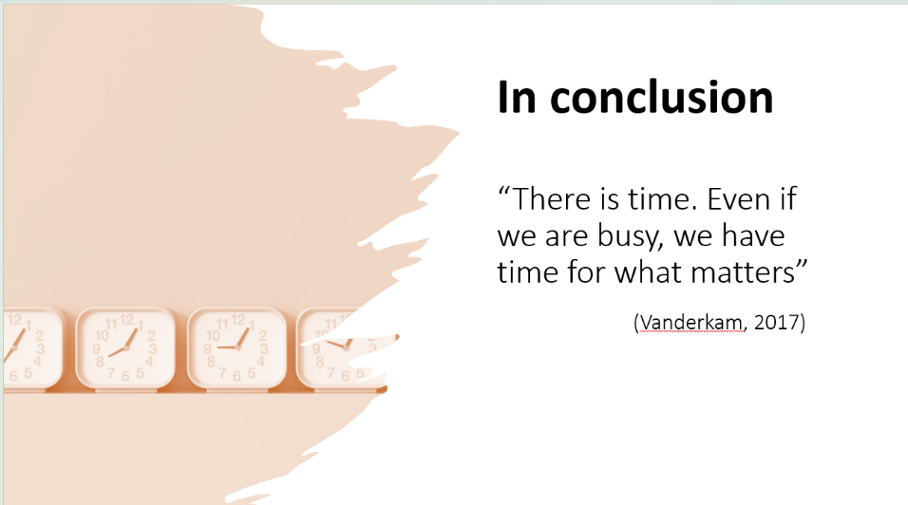
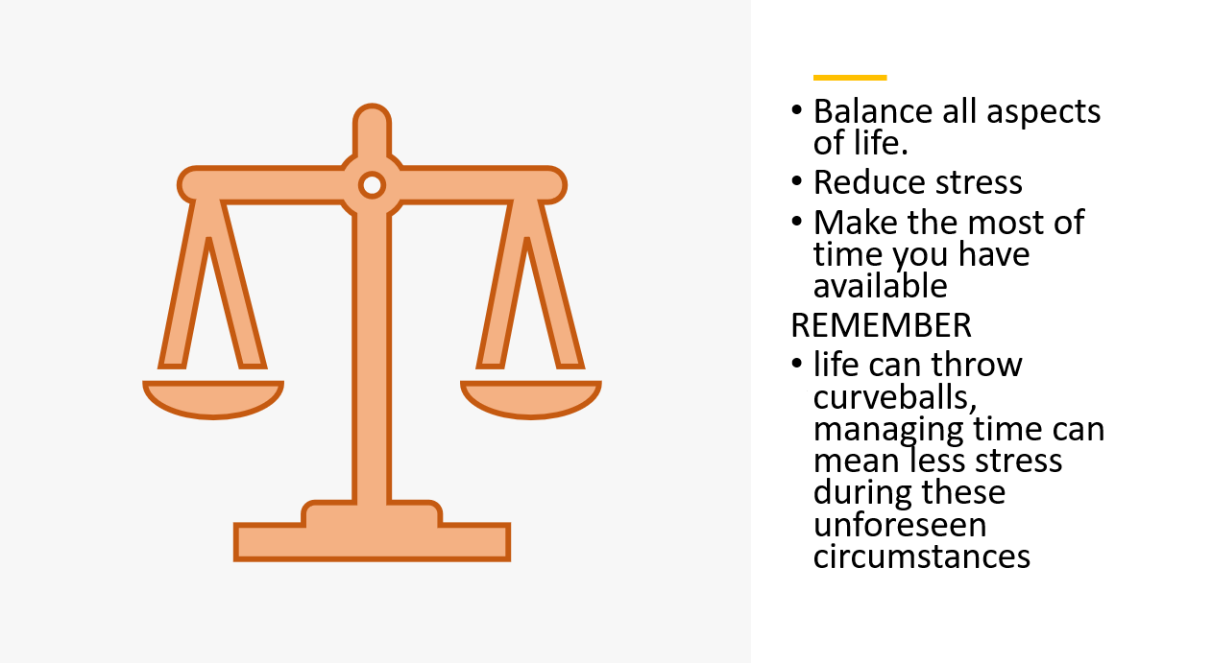

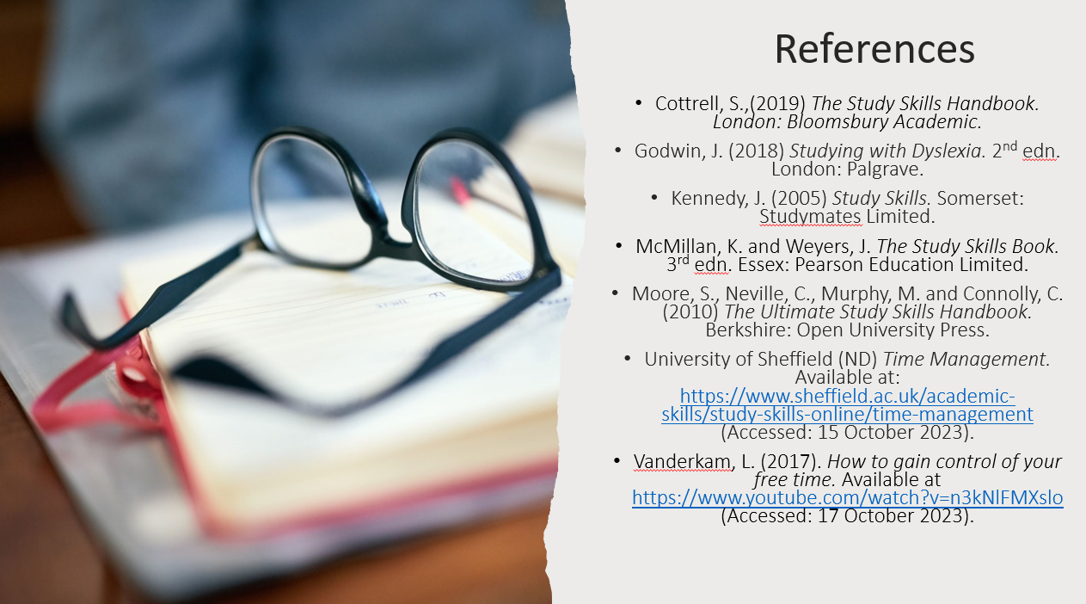

Link to Presentation:
https://uowtsd.sharepoint.com/teams/ECES4012SecuringSuccessfulStudySkills-SwanseaCohort_GRP-KateMorlidge/Shared%20Documents/Recordings/New%20channel%20meeting-20231025_105304-Meeting%20Recording.mp4?web=1

Presenter coach feedback:
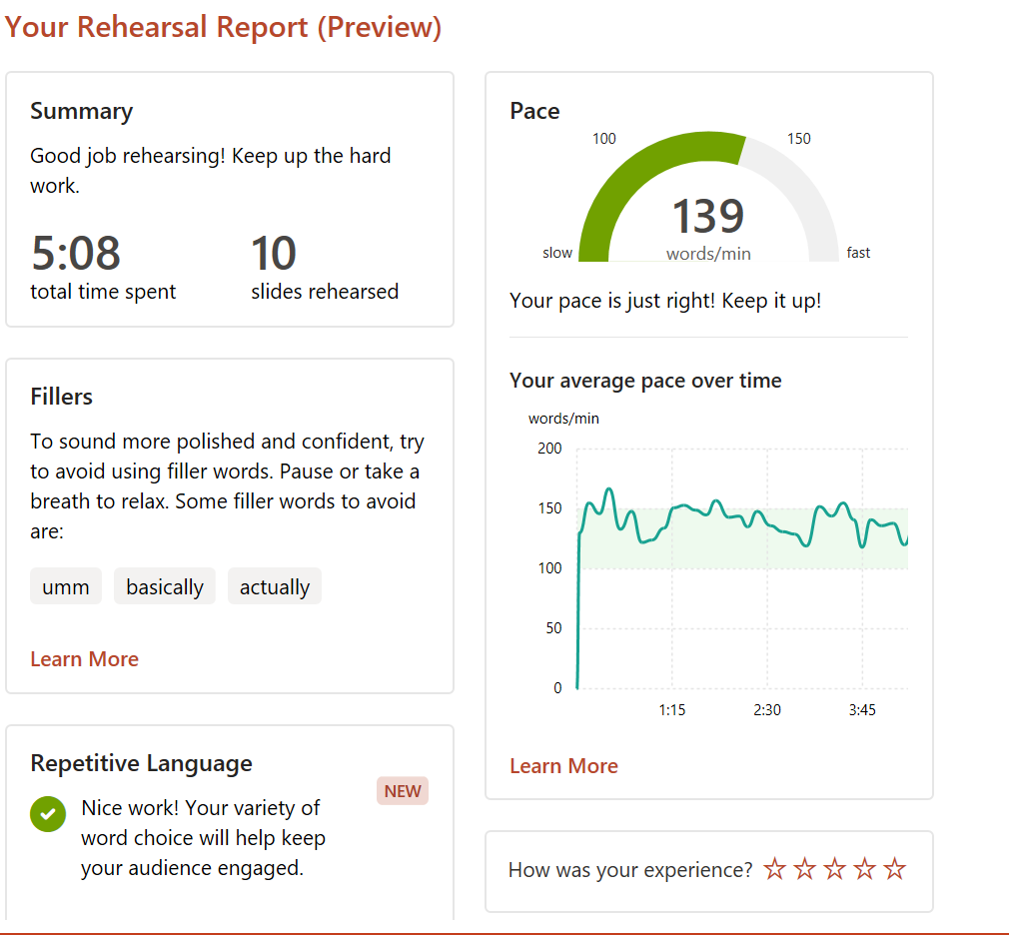

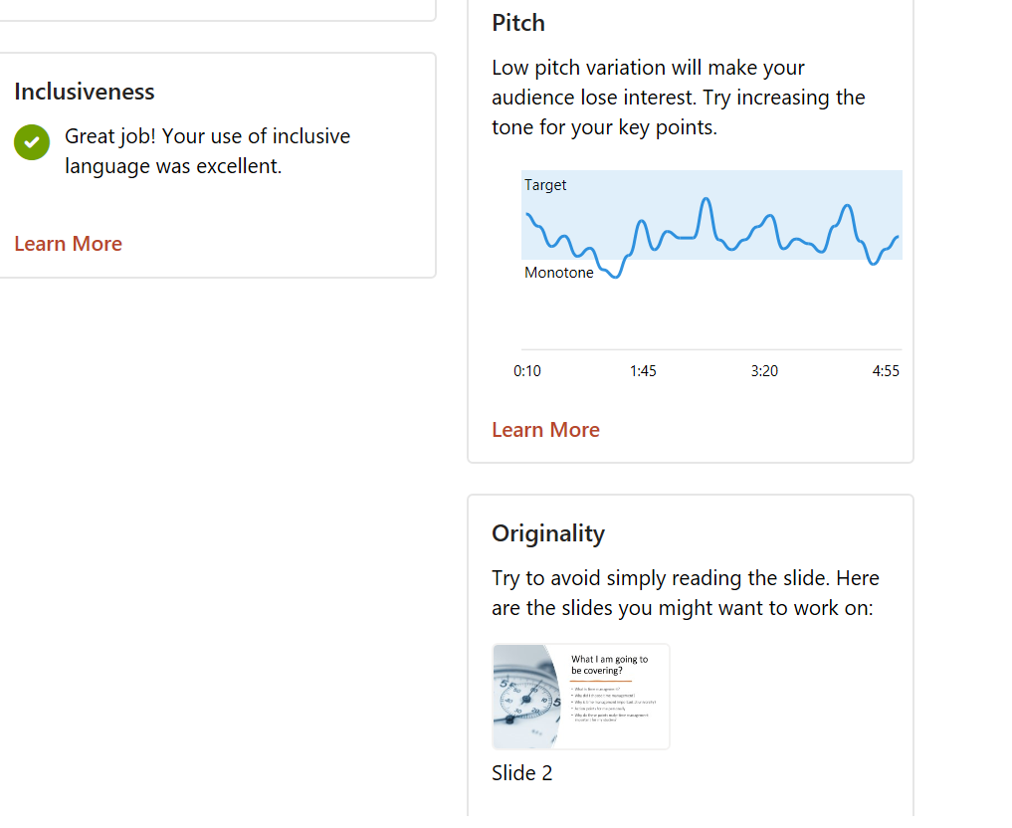

Reflective piece on study skill presentation

In my opinion, presentations are not an area that I thrive or succeed in easily. I will happily discuss my thoughts on a topic during a seminar and am not afraid to ask questions if I feel confused on a topic or have an opinion within class. Despite this, presentations are something I struggle with, I always have, and this presentation hasn’t been any different. For this part of the assignment, I will be reflecting on the strengths and weaknesses of my presentation, as well as discussing what I can implement to improve in the future. Reflection was something I did continuously throughout the preparation of the assignment, amending and retracting where I felt necessary. As Burns and Sinfield (2022, p.103) said, ‘without reflection there is no learning’ and ‘all learning requires reflection’.

The Presentation Coach Feedback was used throughout and indicated sections that are important in a presentation. Factors like pitch, originality, filler words and pace were all recorded, and some of these will be reflected upon for my personal development.

There were a few parts of the summary report which showed elements for me to improve and reflect upon going forward with my studies. The main feedback point it continuously showed throughout the presentation and flagged in the report was the use of filler words like ‘umm’, ‘basically’ and ‘actually’. Filler words are described as ‘words, phrases or sounds that fill up space in writing or conversation without adding substance’ (Indeed, 2022). The use of filler words, or speech disfluencies, have been shown to make an audience feel like the speaker is less competent compared to a speaker who doesn’t use them (Sereno & Hawkins, 1967). Audiences have gone as far as to describe them as distracting and even call them annoying in some circumstances (Rhodes & Frandsen, 1975). Clearly, this is something that I want to make a conscious effort to reduce in order to have a better executed presentation. I do want to be careful however, as something that Willems (1974) found during his research was that reducing the ‘uhh’s and ‘umm’s sometimes resulted in speakers repeating words. As a result, rather than filling that little bit of time with an ‘umm’, I will try and take a natural pause and breathe. Research supports the use of a natural pause - ‘there is an enormous amount of silence in any good presentation’ (Becker, 2009, p. 61). So this is the method I am going to try to put into action going forward.

One area I received positive feedback on was the use of my voice- both with pitch and pace. Both these elements are important foundations to a successful presentation, and ‘being alert to your voice and pace are key attributes to public speaking’ (Price and Maier, 2007, p169). On a few occasions the speaker coach alerted me and advised to reduce my speed, and I used the instant feedback and changed to adapt to the advice given. A successful presentation requires a pace which is ‘not too fast or too slow’ (Price and Maier, 2007, p169) and a tone that is ‘more interesting’ (Kennedy, 2005, p176). The importance of a suitable speed of speech in a presentation is huge. It helps with audience attention, as well ensuring the key points being portrayed are understood (Emden and Becker, 2016). This was something I had to try and actively concentrate on during the presentation as when you are nervous, your speech naturally speeds up (Becker, 2009). I certainly found this to be true. The issues with a monotonous voice are similar to that of a low or fast paced speech – the audience are likely to lose interest and ultimately, not listen. A singular pitched presentation ‘becomes a drone’ and brings confusion to those watching and listening (Price and Maier, 2007, p173). I’m pleased both these elements were in a good range for engagement, and this is something I was trying to focus on and will continue to throughout my time at university and beyond.

I felt like I could have spoken for about 10 minutes on time management, as it is such a broad and personal study skill. The elements of time management I decided to focus on improving are likely to be completely different to those chosen by another student doing the same assignment. This also meant finding appropriate literature to use as evidence was slightly more difficult than I imagined, as there were lots of non-peer-reviewed sites and points which were interesting but unfortunately not appropriate for an assignment. Reflecting on the presentation, I feel like there were things I could have included and things I would change moving forward. There was more time spent on my ‘why’ than I possibly should have when I could have spoken more about different strategies. Techniques such as ‘eat the frog’ (Tracy, 2013) and ‘the pomodoro technique’ (Cirillo, 2018) were interesting techniques I wish I had included. With hindsight, another possible element I question is the clarity and conciseness of my slides. Was there a clear enough structure? Did it flow or did it seem to jump between points? For future presentations, I will try and ensure that the slides all flow and have a clear format.
Having the use of the presenter coach has allowed me to receive instant feedback both during and after the presentation and is an amazing tool to use to prepare for presentations. It’s a tool I will continue to use during the rest of my studies and into my working life. It was able to highlight aspects of my speech, like when I was talking too quick, which meant I could make an immediate change to try and improve my delivery. Going forward, the points I noted about reducing my use of filler words, ensuring varied pitch and an appropriate speed to engage audiences are all points that I am conscious to remember for future presentations. They are crucial in ensuring I am delivering the best content in the most engaging, clear, and crisp way possible.

References

Becker, L. (2009) The Mature Student’s Handbook. Basingstoke: Palgrave MacMillan.

Burns, T. and Sinfield, S. (2022) Essential Study Skills. 5th edn. London: SAGE Publications.

Cirillo, F. (2018) The Pomodoro Technique: The Life-Changing Time-Management System. London: Virgin Books.

Emden, J.V. and Becker, L. (2016) Presentation Skills for Students. 3rd edn. London: Bloomsbury Academic.

Indeed Editorial Team (2022) What Are Filler Words? (Examples and Tips to Avoid Them). Available at https://www.indeed.com/career-advice/career-development/filler-word (Accessed: 25 October 2023)

Kennedy , J. (2005) Study Skills. Somerset: Studymates Limited.

Price, G. and Maier, P. (2007) Effective Study Skills. Essex: Pearson Education Limited.

Rhodes, S.C. and Frandsen, K.D. (1975) Some effects of instruction in feedback utilization on the fluency of college student’s speech. Speech Monographs, 42, pp. 83-89. Available at: https://doi-org.ezproxy.uwtsd.ac.uk/10.1080/03637757509375881

Sereno, K.K. and Hawkins, G.J (1967) ‘The effects of variations in speakers' nonfluency upon audience ratings of attitude toward the speech topic and speakers' credibility’, Speech Monographs, 34(1), pp.58-64. Available at: https://doi-org.ezproxy.uwtsd.ac.uk/10.1080/03637756709375520

Tracy, B. (2013) Eat That Frog!: Get More Of The Important Things Done – Today!. London: Hodder & Stoughton.

Willems, E.P. (1974) Behavioural Technology And Behavioural Ecology. Journal of Applied Behaviour Analysis, 7(1), pp. 151-165. Available at: https://onlinelibrary-wiley-com.ezproxy.uwtsd.ac.uk/doi/abs/10.1901/jaba.1974.7-151

