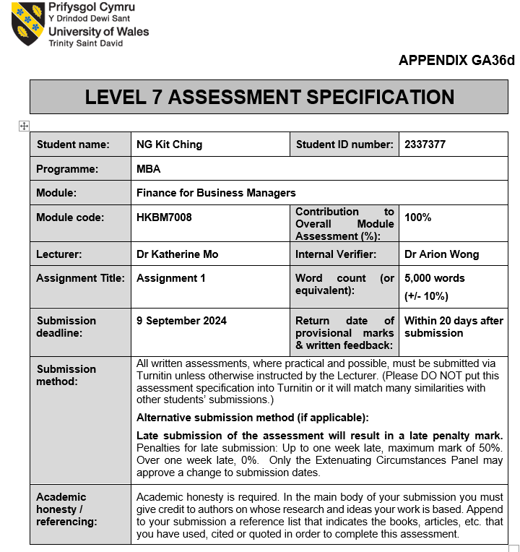

1

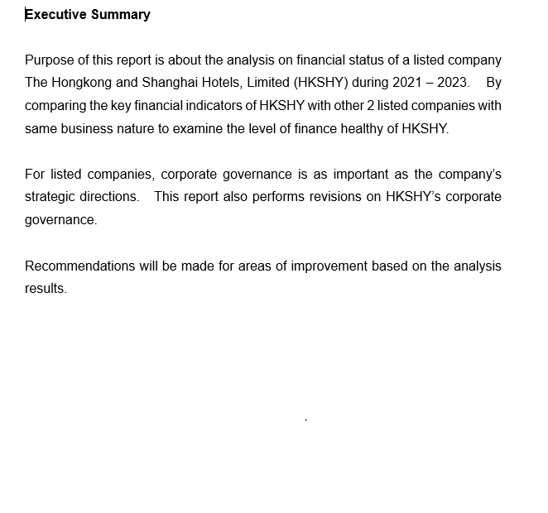

2

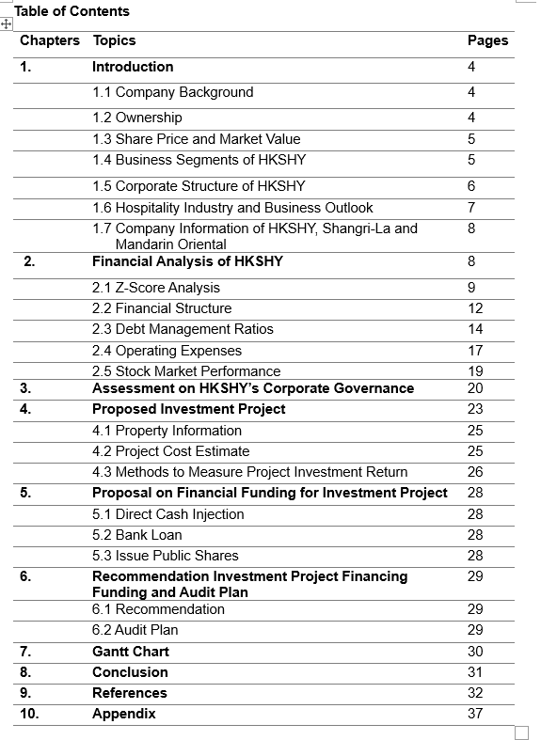

3
- Introduction

  - Company Background

The Hongkong and Shanghai Hotels, Limited (HKSHY) is a luxury hospitality and real estate group incorporated in 1866 and listed on the Hong Kong Stock Exchange (00045) with headquarter station in Central, Hong Kong (Hshgroup.com, 2019).

HKSHY is an owner-operator of a small number of luxury hotels in the world under the world-renowned Peninsula brand, together with luxury commercial and residential properties, they also provide club management and other hospitality-related services.

HKSHY has twelve operational Peninsula hotels in exceptional city centre locations in Asia, US and Europe. The company's assets comprises a small number of ultra-luxury hotels, strategic real estate assets and tourism assets, including The Peak Tram which is one of Hong Kong’s most popular tourist attractions.

  - Ownership

The major shareholders of HKSHY are Kadoorie Michael D Family (56.68%), they have been chairmen since 1937, when Elly Kadoorie was first appointed to the post. Following are Sino Hotels (Holdings) Ltd (5.1%), 3 wealth and fund management companies (Value Intelligence Advisors GmbH, Hauck & Authauser Fund Services SA and Olympia Wealth Management Ltd) (0.08%) and unknown shareholders (38%) (MarketScreener, 2024).

4
  - Share Price and Market Value

As of 29 December 2023, HKSHY’s stock price at 5.840 Hong Kong dollar (@YahooFinance, 2023), authorized share capital of HKD5,857 million, issued share capital of 1.649 million shares. The market value is 9,630 million Hong Kong dollar. There is a significant change on the market value of HKSHY during 2014 to 2023 (please refer to the following table for details), market value of 17,446 million Hong Kong dollar in Year 2014 compared with market value of 9,630 million Hong Kong dollar, equivalent to approximately 44.8% change in 10 years’ time (www.hshgroup.com, n.d.)

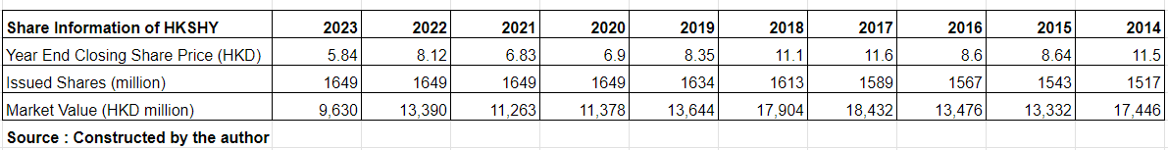

  - Business Segments of HKSHY

HKSHY operates its business through three segments. The Hotels segment engages in the ownership, development and management of prestigious hotels in key destinations in Asia, United States and Europe. The Commercial Properties segment engages in the development, leasing and sale of residential apartments, leasing of retail and office premises as well as operating food and beverage outlets in such premises. The Clubs and Services segment engages in the operation of golf courses, the Peak Tram, retailing of food and beverage products and laundry services and the provision of management and consultancy services for clubs.

5
The Hotels segment is the largest contributor of the group’s combined revenue. HKSHY operates 12 luxury Peninsula Hotels in Asia, United States and Europe.
Having 100% ownership (6 Peninsula Hotels) and partial ownership (6 Peninsula Hotels) is an important of the company strategy which allows HKSHY to maintain an appropriate degree of control over the design, quality, operations and capital spending in their hotels.

The Hotels segment of HKSHY contributed revenue of 6,032 million Hong Kong dollar in 2023, equivalent to a contribution of 74% share when compared with the total revenue of 8,112 million Hong Kong dollar for the year of 2023 (www.hshgroup.com, n.d.).

  - Corporate Structure of HKSHY

The Corporate Structure of HKSHY including Board of Directors, Senior Management Teams and the 13 main divisions for key functions of Research & Technology, Projects, Revenue Management, Hotel Operations, Design, Corporate Affairs, People and Culture, Finance and Investor Relations, Digital & E-Commerce, Sales, Audit and Risk Management, Group Security and Operational Risk, Corporate Responsibility and Sustainability. Number of full-time employees of HKSHY for the years of 2021 to 2023 recorded at 5,866, 5,885 and 7,695 respectively (Hshgroup.com, 2024).

6

  - Hospitality Industry and Business Outlook

The hospitality industry is a vast sector, it includes many different sub-sectors fall under this large umbrella, such as lodging, recreation, entertainment, food and beverage which are constantly evolving (Cvent, 2020).
According to Hospitality Global Market Report (EHL Insights, 2023), since the resurgence of global travel, the hotel industry has experienced impressive growth rates. The hospitality industry has experienced significant growth, from $4,390.59 billion in 2022 to $4,699.57 billion in 2023, at a compound annual growth rate (CAGR) of 7.0%. This significant expansion is testament to the industry’s resilience and ability to recover from the challenges of recent years.

Although international travel is expected to grow further in 2024, the challenging global economic environment may hinder the recovery. Concerns include continued high inflation, which increases travel and accommodation costs for tourists, and slower economic growth, which is often associated with lower international departures. This means markets that rely on international departures may lose momentum over the next six months (blog.bismart.com, n.d.).

The key feeder markets for HKSHY’s hotels segment are international leisure visitors, particularly from traditionally strong long-haul markets of US and Europe (www.hshgroup.com, n.d.). The above-said business outlook for hospitality industry has become a business warning for HKSHY. HKSHY needs to make relative adjustments in its business strategy based on the above prospect analysis.

7

  - Company Information of HKSHY, Shangri-La and Mandarin Oriental

This study is including the comparison of Shangri-La Asia Ltd (SHA) and Mandarin Oriental International Limited (M0) which with same nature of business with HKSHY (please refer to following table for more details). Relevant financial analysis and operational review can be done properly.

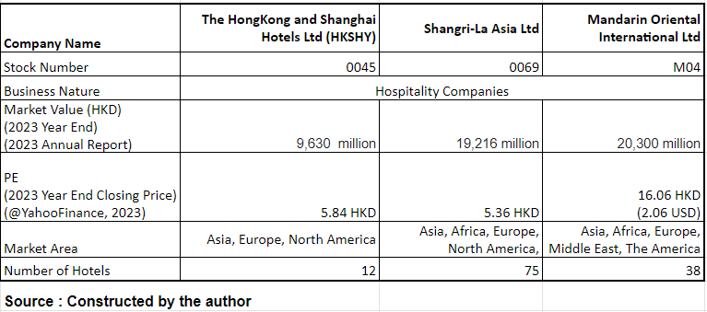

- Financial Analysis of HKSHY

The purpose of performing financial analysis of a company is aiming to evaluate its performance to make informed business decisions. Founders and senior executives use financial analysis to evaluate performance and make strategic decisions.

Externally, investors use financial analysis to decide which companies are good investments. Financial analysis may also be used by potential lenders (such as banks) when reviewing loan applicants to evaluate your ability to repay the loan (blog.hubspot.com, n.d.).

8

By reviewing the previous 3 years’ financial statements, including balance sheets, income statements, and cash flow statements of HKSHY, SHA and MO to calculate and analyze key financial ratios to evaluate the company's profitability, liquidity, solvency, efficiency, and valuation.

2.1 Z-Score Analysis

According to Altman Z-score (Kenton, 2022), Z-score is the output of a credit-strength test that gauges a publicly traded manufacturing company's likelihood of bankruptcy. An Altman Z-score close to 0 indicates that the company is likely to go bankrupt, while a score close to 3 indicates that the company is financially sound.

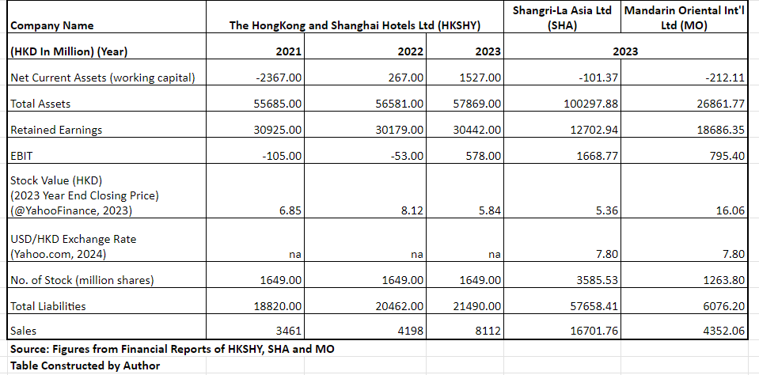

9

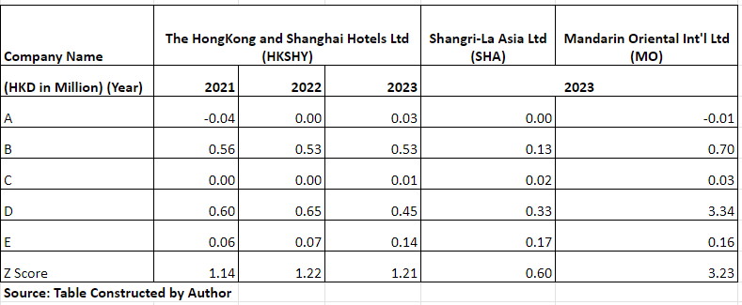
Formulation of Z-Score: Z=1.2A + 1.4B + 3.3C + 0.6D + 0.999E
A = Working Capital/Total Assets
B = Retained Earnings/Total Assets
C = EBIT / Total Assets
D = Stock Value x Total Number of Stocks/RMB&HKD ex rates / Total Liabilities
E = Sales/Total Assets

The insolvency index analysis shows HKSHY has Z-score of 1.14, 1.22 and 1.21 over the years of 2021 - 2023, indicating that HKSHY is in distress zones. However, when comparing SHA has a Z-score of 0.60 and MO has a Z-score of 3.2 for the year of 2023, HKSHY stands in a medium position.

It is better to further understand and analyze whether HKSHY’s Z-score is in distress zones, or the general Z-score data of hospitality industry is different with other industries.

By referring to the Z-score data on the online analysis platform to have a clearer understanding of the industry average on Z-score of hospitality.

10

The Hongkong and Shanghai Hotels (HKSHY), Altman Z-Score at 1.19 and competitive companies are chosen from companies within the same industry, with headquarter located in same country, with closest market capitalization as of 6 September 2024 (Gurufocus.com, 2023).

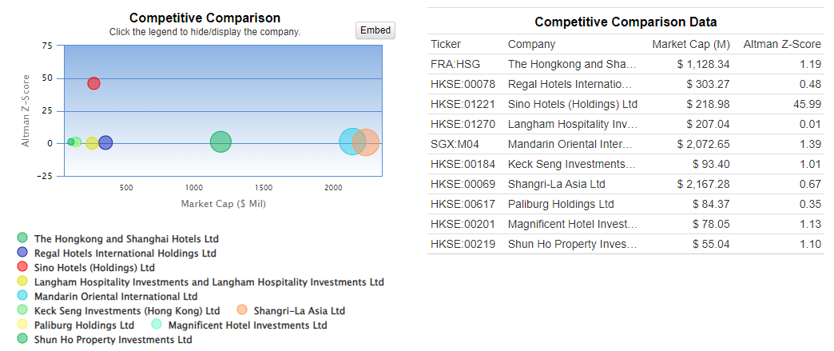
Source: (Gurufocus.com, 2023)

Among the 10 competitive companies, the highest Z-score at 45.99, the lowest at 0.01. Taking out the highest (45.99) and the lowest (0.01). The industry average is 0.915.

Over the past 13 years, HKSHY’s highest Z-score was 1.61. The lowest was 0.74. And the median was 1.17 (Gurufocus.com, 2023).

Considering the findings of industry average of Z-score at 0.915 and the historical figures of HKSHY’s Z-score over the past 13 years, the latest Z-score of HKSHY at 1.21 for the year of 2023 is within the acceptable range.

11
2.2 Financial Structure

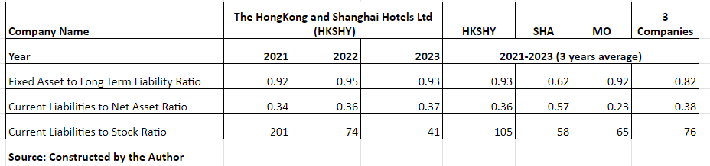

Fixed Asset to Long Term Liability Ratio: This ratio complements an assessment of a company's ability to cover its debt. It shows the extent to which a company's tangible fixed assets (such as land and buildings, plant and machinery, equipment, and vehicles) can cover its long-term liabilities (such as mortgage loans, bonds payable, and other long-term leases or loans). Tangible fixed assets constitute a potential source of debt financing for a company.

The interpretation of this ratio is the greater the value of this ratio, the greater the company's ability to repay long-term liabilities and its greater debt capacity (the greater the chance of acquiring new long-term liabilities in the future) (Inc, n.d.).

HKSHY has an average ratio of 0.93 over the years of 2021-2023 which is higher than the industry average of 0.82, indicating its ability in bearing long-term liabilities.

Current Liabilities to Net Asset Ratio: This ratio is a financial measure used to help understand the extent to which a company's operations are funded by debt. It is one of many leverage ratios that can be used to understand a company's capital structure.

12
The ratio close to 1 (or 100%) is an extremely high percentage of debt financing. This is unsustainable over the long term as the company may face solvency issues and risk triggering an event of default. Whereas problems can also arise if the debt-to-asset ratio is too low. While unlikely to lead to solvency issues, it could indicate poor capital structure decisions by management, resulting in a suboptimal return on equity for the company's shareholders (Peterdy, n.d.).

HKSHY has an average ratio of 0.36 over the years of 2021-2023 which is in line with the industry average of 0.38, stands on a better position than the industry level.

Current Liabilities to Stock Ratio: This ratio is a financial metric used to evaluate a company's ability to cover its short-term liabilities with its stock (refers to guest room inventories in hospitality industry). A high ratio indicates that the business is operating inefficiently, or that the business's assets are not operating to their full potential. However, there is no one-size-fits-all definition of a ratio that is too high, and a ratio that is too high depends on your business and the industry in which it operates (www.legalzoom.com, n.d.).

Referring to the comparison of HKSHY, SHA and MO, the industry average point at 76. HKSHY has an average of 105 over the period of 2021 – 2023, higher than the industry average by 38%, represents HKSHY’s efficiency in managing its inventories and liabilities was at a low level compared to its competitors. Also indicating a signal of potential liquidity risk that HKSHY may have difficulties in covering its immediate liabilities.

13

2.3 Debt Management Ratios

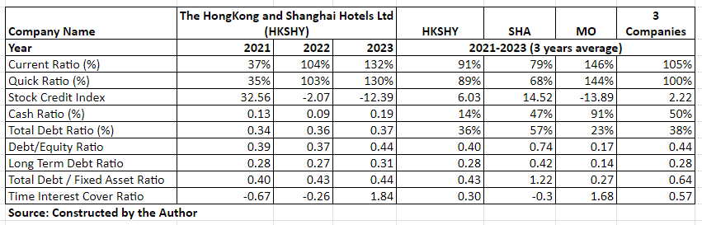

Current / Quick Ratio: Both the current ratio and quick ratio measure a company's short-term liquidity, or its ability to generate enough cash to pay off all debt as it comes due. Although they are both measures of a company's financial health, they are slightly different. The quick ratio is considered more conservative than the current ratio because there are fewer factors in its calculation (Folger, 2023).
Keeping the ratio at least 1 (or 100%) is generally ideal. This means that the company is in a strong position to pay their current obligations without taking on additional debt or needing a cash infusion from shareholders or investors. In contrast, if the ratio less than 1 (or 100%) could indicate that the business has liquidity problems and may not be financially stable (Investopedia, 2024).
Both the average current and quick ratios of HKSHY (91% and 89%) during the period of 2021 – 2023 was behind the industry average of 105% and 100%. The main reason for the low average current and quick ratios of HKSHY was due to the 2021 performance (37% and 35%) significantly different with the other two years.

14

The difference was caused by the fact that HKSHY has no “properties under development for sale” counted under Current Assets in the 2021 balance sheet. In 2022 and 2023, there were amount of 5,169 million Hong Kong dollar and 4,362 million Hong Kong dollar of “properties under development for sale” recorded under current assets which in result of the performance on Current / Quick Ratio of HKSHY exceed 100%, it can be determined HKSHY’s Current / Quick Ratio still within an acceptable range.
Stock Credit Index: HKSHY has an average stock credit index of 6.03, higher than the industry average of 2.22, demonstrating healthy situation on their current asset.
Cash Ratio: The cash ratio is most used to measure a company's liquidity. This metric shows a company's ability to pay all current liabilities immediately without selling or liquidating other assets. A cash ratio of 1 (or 100%) or greater generally indicates that the company has enough cash and cash equivalents to fully repay all short-term debt. Ratios above 1 are generally favored. A ratio below 0.5 is considered risky because the entity has twice as much short-term debt as cash (Kenton, 2022b).

Average cash ratio of HKSHY during the period of 2021 – 2023 at an extremely low level of 14% when compared with the industry average of 50%. HKSHY should find ways to improve their cash ratios by holding more cash to cover short-term liquidation or payment needs. This includes turning their guestroom inventory faster, holding less inventory or reduce the paying of upfront costs. Alternatively, HKSHY can reduce its short-term liabilities by reviewing their credit terms with business partner.

15

Debt Ratio and Equity: The debt-to-equity ratio is a type of financial leverage ratio that is helpful when trying to understand the economic health of a company and whether the investment is worthwhile. It is considered a gearing ratio that compares owner's equity or capital to debt or funds borrowed by the company. The optimal debt-to-equity ratio tends to vary by industry, but the general consensus is that the ratio should not be higher than a level of 2.0. While some sizable companies in fixed-asset-heavy industries (such as mining or manufacturing) may have ratios higher than 2, these are considered an exceptional case (Boyle, 2023).
In average, HKSHY’s two ratios 0.40 and 0.28 for the period of 2021 – 2023 in line with the industry average of 0.44 and 0.28. It represents a healthy credit position and indicates that HKSHY does not financing its growth highly rely on debt.

Total Debt / Fixed Asset Ratio: It is a leverage ratio that defines how much debt a company takes on compared to the value of the assets it owns. Using this metric, analysts can compare a company's leverage to that of other companies in the same industry. This information can reflect the company's financial stability. The higher this ratio, the higher the degree of leverage (DoL). Based on industry averages, investing in this company may be riskier than another company (Hayes, 2024).

The average Total Debt/Fixed Asset Ratio of HKSHY over the period of 2021 – 2023 was 0.43 which lower than the industry average of 0.64. HKSHY has favorite debt position when compared with its peer group.

16

Time Interest Cover Ratio: This is a debt to profitability ratio that indicates how easily a company can pay interest on its outstanding debt. It is calculated by dividing a company's earnings before interest and tax (EBIT) by its interest expense in a given period. It helps lenders, investors and creditors determine the risk of a company's future borrowings. Interest coverage ratios vary greatly across industries (Hayes, 2024b)

The average time interest cover ratio of HKSHY during 2021 to 2023 was 0.30, behind the industry average by 0.27 (or 47%), a warning signal for HKSHY that they are not currently making enough profits to pay off its outstanding debt. HKSHY should have some strategies on revenue management (e.g. dynamic pricing on guest room rates, increase upselling and cross-selling etc), cost management (e.g. streamline operations to reduce costs, such as energy management and inventory control) and negotiation (e.g. negotiate better terms with suppliers and service providers.

2.4 Operating Expenses
. 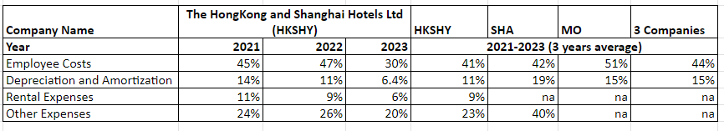
For hospitality industry, the average employee cost ratio should be around 25% (Le Bijou, 2022). It can be understood that HKSHY, SHA, MO have bit higher ratio than 25% considering they all position themselves as worldwide luxury hotel groups and aim to provide extra-ordinary stay experience to their guests.

17

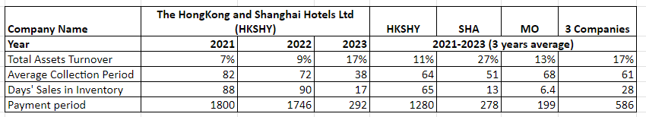

Total Assets Turnover: This ratio measures the value of a company's sales or revenue relative to the value of its assets for how efficiently a company uses its assets to generate revenue. The higher the ratio, the more efficient a company is. Conversely, if a company has a low asset turnover ratio, it means it is not efficiently using its assets to create revenue (Hayes, 2024a).

In hospitality industry, this ratio indicates the effectiveness of the promotional approach for a hotel to sell their guestrooms to their target segments. Among the competitive set, HKSHY has the lowest ratio (11% vs 17%) and they should take immediate actions to review their guestroom promotional plan to improve the ratio.

Average Collection / Payment Period: Assumed abnormal figures for years of 2021 and 2022 were derived from the changes in business models during the epidemic.

Days’ Sales In Inventory (DSI): This ratio measure how much time is required for a company to turn its inventory into sales. The shorter DSI means the company has effective strategies on pricing and sales & marketing areas (Wall Street Prep, n.d.).

18

The interesting part is that hospitality industry has different view on the evaluation of this indicator. DSI equals to “Booking Lead Time” in hospitality, the longer DSI
Means the hotel guests tend to book their stay with hotel far ahead of their travelling dates and hotel will benefits from effective booking forecast and cost control. This will in result of high level of optimization revenue management.

The key feeder markets of HKSHY are guests from US and Europe (long-haul market), therefore, they have a longer DSI (Booking Lead Time) than the others.

2.5 Stock Market Performance

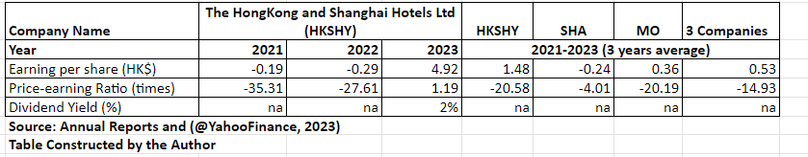

Earning per Share (EPS): EPS is the ratio of net profit generated by a company to the total number of common shares outstanding. A company has a positive market perceived value by a higher EPS.

HKSHY’s 3 year average EPS at HKD1.48, represents a 64% higher than the industry average.

19

- Assessment on HKSHY’s Corporate Governance

Financial scandals reported by high-profile companies (e.g., Adelphia, Enron, Global Crossing, Qwest, Tyco, WorldCom) have sparked renewed interest in corporate governance and accountability. Ineffective corporate governance and unreliable financial reporting are widely blamed for the loss of investor confidence and stock market slump in the wake of these scandals. Professional organizations such as the National Association of Corporate Directors (NACD), the Business Roundtable (BRT), the Financial Executive International (FEI), New York Stock Exchange (NYSE), and the Conference Board have also made recommendations for improving corporate governance which have become part of listing requirement for public companies. The ultimate results of the recommendations are reinforcing corporate accountability; establishing professional responsibilities; improving quality, reliability, and transparency of financial reports; enhancing the effectiveness and credibility of audit functions; and restoring investor confidence and public trust in public financial information (Rezaee, 2004).

Comparing National Association of Corporate Directors’ recommendations for corporate governance, followings are the findings about HKSHY’s Corporate Governance reported in their 2023 Annual Report (www.hshgroup.com, n.d.).

Boards should be comprised of a substantial majority of “independent” directors: HKSHY has 18 members in their Board. Among the 18 members, 7 independent non-executive directors, 7 non-executive directors and 4 executive directors (2023 Annual Report, page 113).

20

Audit, compensation, and governance/ nominating committees should be composed entirely of independent directors, and are free to hire independent advisors as necessary: Committees of HKSHY consist of 4 independent non-executive directors and 2 non-executive directors (2023 Annual Report, pages 113, 114, 142,145, 148)

Each key committee should have a board approved written charter detailing its duties: Job responsibilities of key committee are clearly stated in the corporate governance report (2023 Annual Report, page 118)

An independent director should be designated as chairman or lead director:
The Chairman of HKSHY is The Hon. Sir Michael Kadoorie, he is a Non-Executive Director (2023 Annual Report, page 113)

Boards should review the adequacy of their companies’ compliance and reporting systems at least annually: Relevant Operations of HKSHY are required to perform annual compliance and privacy checks and provide confirmations to Group Legal on statutory or best practices compliance (2023 Annual Report, page 125).

Boards should adopt a policy of holding periodic sessions of independent directors only: HKSHY has established channels for their independent non-executive directors (INEDs) to express their independent views and input to the Board and its Committees. The Chairman meets INEDs annually to seek their independent views, and these views are then discussed at the Board (2023 Annual Report, page 130).

21

Audit committees should meet independently with both the internal and independent auditors: The Chairman of the Audit Committee of HKSHY meet with the Group General Manager, Audit & Risk Management Department and the external auditor regularly (2023 Annual Report, page 144)

Boards participate in companies’ strategies: Chairman and some of the Non-Executive Directors (NEDs) had attended the 2023 Strategic Meeting (2023 Annual Report, page 110).

Boards should provide new directors with a director orientation program: Board of HKSHY provide all new directors a comprehensive onboarding program which is tailored for individual roles and responsibilities. The program includes meetings with the Chairman, Executive Directors, Company Secretary and Senior Management for the new directors to have understandings of the group, the purpose, culture, values, strategy, corporate governance and the markets that HKSHY operate.

Based on the above assessment, even though there is no big issue on HKSHY’s corporate governance, there is still some areas for Improvement:

- Increase to at least 9 (currently 7) Independent Directors in the Board

- All committees of Audit, Compensation, Governance and Nominating should be Independent Directors (currently 4 only among the 6 committees)

- The Chairman of the group should be an independent director (currently the Chairman is a Non-Executive Director)

22

- Proposed Investment Project

To propose a renovation project on The Peninsula Hong Kong to convert guest rooms to “Themed Room” such as business, family, leisure and romance etc to attract new customer sources. The proposed renovation project is based on the following considerations:

- The Hotels segment is the largest contributor of the group’s combined revenue

- The Peninsula Hong Kong contributed largest revenue (18% shares) during 2021-2023 among the other operating hotels under HKSHY (please refer to following table for exact figures)
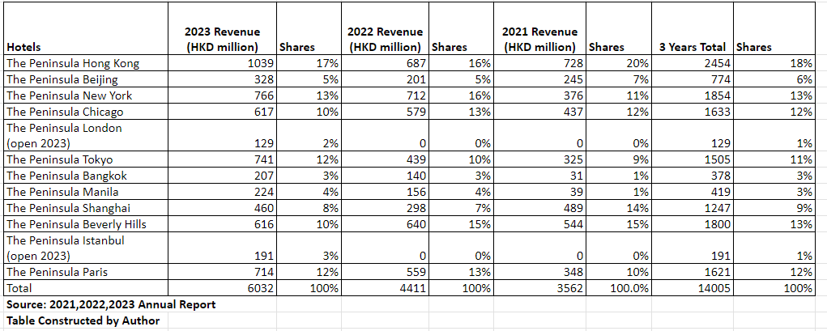

- The Peninsula Hong Kong has great RevPAR performance (+226%), second higher in 2023 (Please refer to following table for exact figures).
Remarks: Revenue per available room (RevPAR) is the hospitality industry's gold standard for measuring the performance of hotels. RevPAR combines average daily rate and occupancy to allow hoteliers and industry stakeholders to understand performance success and potential revenue gains or losses in any given period, regardless of hotel size or type. The higher the better (STR, 2019).

23
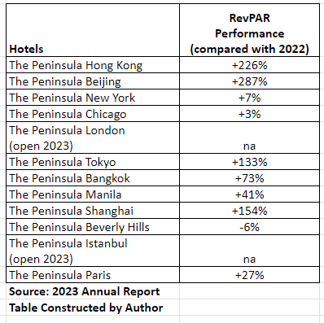
- Positive tourism result and outlook for Hong Kong. Total 21 million tourists to Hong Kong in first half of 2024, represents 64% jump from last year (South China Morning Post, 2024b).

- China Government allow more mainland Chinese tourists to visit Hong Kong by expanded solo traveller scheme to extra 8 cities in China (Taiyuan in Shanxi; Hohhot in Inner Mongolia; Harbin in Heilongjiang; Lhasa in Tibet; Lanzhou in Gansu; Xining in Qinghai; Yinchuan in Ningxia; and Urumqi in Xinjiang). These cites have a combined population of more than 33 million (South China Morning Post, 2024a).

24

4.1 Property Information

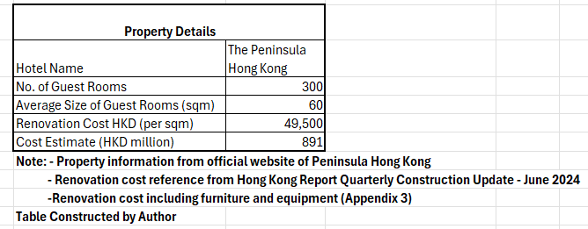

4.2 Project Cost Estimate

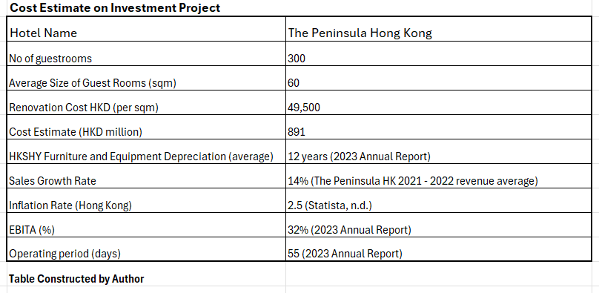

25

4.3 Methods to Measure Project Investment Return
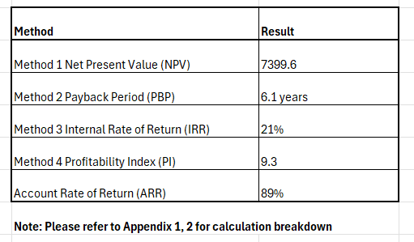
Based on the analysis result show in the above table, the PBP of the investment project is 6.1 years, NPV is positive and PI is greater than 1, indicates green light to proceed.
Net Present Value (NPV): NPV analysis is used to help determine the value of an investment, project, or any series of cash flows. It's a catch-all metric because it considers all revenues, expenses, and cost of capital associated with investing in free cash flow. In addition to considering all revenues and costs, it also considers the timing of each cash flow, which can have a significant impact on the present value of an investment.

26

A positive NPV means that the expected benefits generated by the investment exceed the expected costs and assumed that an investment with a positive net present value will be profitable. An investment with a negative NPV will result in a net loss. This concept is the basis of the NPV rule, which states that only investments with a positive net present value should be considered (Fernando, 2024).

Payback Period (PBP): Payback period is a method commonly used by investors and business to calculate return on investment. It indicates how long it will take to recoup the initial costs associated with an investment. This indicator is very useful before making any decisions, especially when investors need to make a quick judgment about an investment business.

Drawback of this method that it does not consider the time value of money, but determined by calculating the number of years it takes to recover the invested capital. And it does not consider what happens after the investment is recovered, ignores the overall profitability of the investment. Therefore, managers and investors prefer to use NPV as a tool for investment decisions (Kagan, 2024).

Internal Rate of Return (IRR): Internal rate of return (IRR) is the annual growth rate an investment is expected to generate. The calculation of IRR uses the same concept as net present value (NPV), except that it sets the NPV to zero. The higher an IRR, the more desirable an investment is to consider (Fernando, 2024a).
Some corporations will compare IRR with ROA, if IRR higher than ROA means the investment is a favorable one.

27

Profitability Index (PI): It uses to measure the ratio of the present value of future cash flows to the initial investment. The index is a useful tool for ranking and choosing between projects when capital is rationed. If PI greater than 1 means the project generates value and is fine to proceed with the investment. In contrast, PI less than 1 means the project destroys value and the company should not proceed with the investment (Corporate Finance Institute, n.d.).

- Proposal on Financial Funding for Investment Project

5.1 Direct Cash Injection: Considering there is big gap on cash ratio of HKSHY for years of 2021-2023 compared with the peer group (14% vs 50%), cash injection should not be considered under this circumstance.

5.2 Bank Loan: As stated in 2023 Annual Report that HKSHY’s credit ratings of the financial institutions is A (S&P) or A1 (Moodys). HKSHY can negotiate a better interest rate of 3% (compared with currently at 4.8%) for bank loan with business counterparts (www.hshgroup.com, n.d.).

5.3 Issue Public Shares: As stated in 2023 Annual Report that accordance with Section 135 of the Companies Ordinance, the ordinary shares of the company do not have a par value (i.e. no cap or maximum number of issued shares) (www.hshgroup.com, n.d.). Average Total Debt / Fixed Asset Ratio of HKSHY for 2021 – 2023 lower than industry average (0.43 vs 0.64) and also enjoy higher Earning Per Shares (1.48 vs 0.53) within the peer group.

28

- Recommendation Investment Project Financing Funding and Audit Plan

6.1 Recommendation: Based on the above, both bank loan and issue public shares are feasible, HKSHY can equally share the costs of the investment project with these two suggestions. Before issuing public shares, HKSHY required to disclose their share capital and shareholding information in their annual return, which is filed with the Companies Registry (CR). This information is publicly available and can be accessed through the CR’s online database.

6.2 Audit Plan:

- The audit plan of the investment project should focus on optimizing the efficiency of key business processes group’s operating efficiency and performance. And, ARM continues to apply systematic processes to make sure the current status and implementation of all recommendations operations are on track.

- A 5-year internal audit plan should be commencing upon the completion of renovation to focusing on revenue management, human resources, asset management and procurement process.

- Regular review on the external audit plans from KPMG (external auditor) on the areas of audit scope, approach, areas of focus, IT audit plan and timeline.

29

- Gantt Chart
The following Gantt Chart including project details and timeline of the Investment Project – Guestrooms Renovation of The Peninsula Hong Kong.
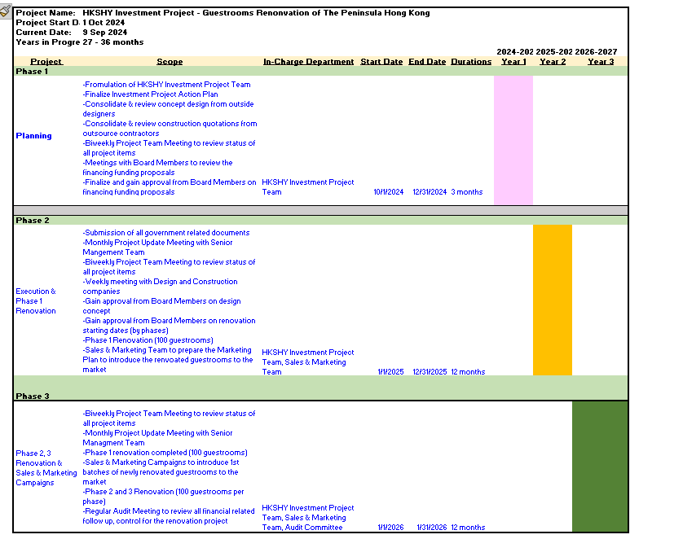

30

- Conclusion

Based on the above analysis, it is concluded that HKSHY experienced a very challenging financial situation in years of 2021 and 2022 due to COVID-19 pandemic. With border opening and easing of travel restrictions in 2023, there was improvement in business result of HKSHY and performed better than competitors as per some financial indicators such as z-score, fixed asset to long term liability ratio, current liabilities to net asset ratio, stock credit ratio and days’ sales in inventory which all in good position or level. Future focus will be the planning and execution of the investment project and improvement in financial indicators, cash and time interest cover ratios as well as total assets turnover.

31

9
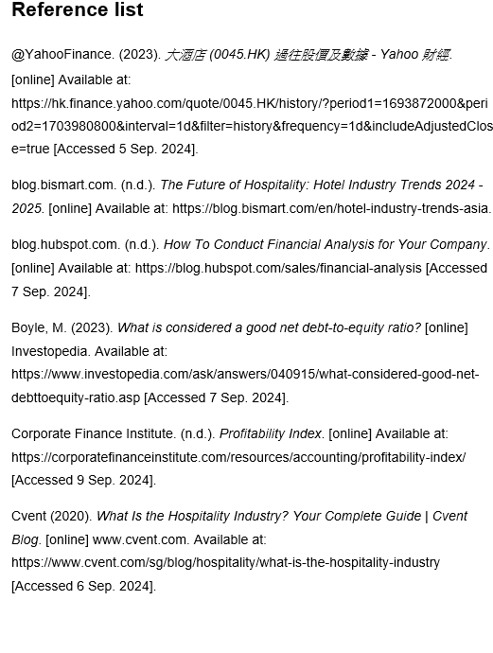
32

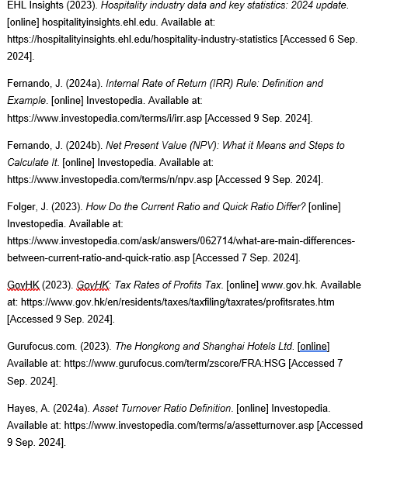

33

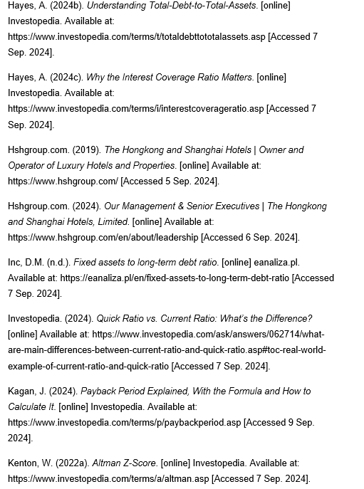

34

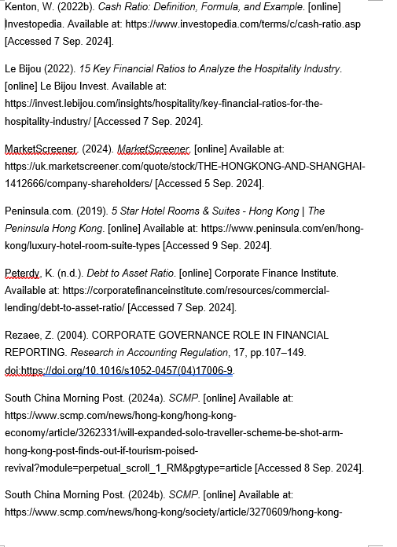

35

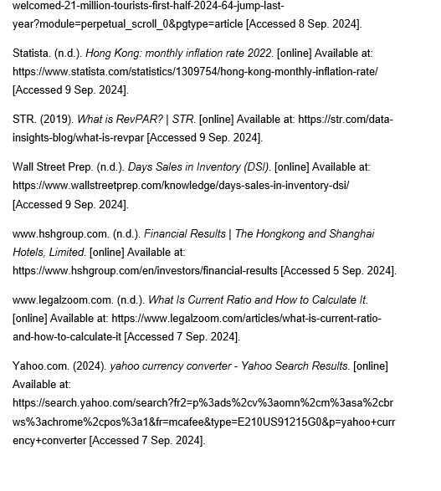

\

36

- Appendix 1

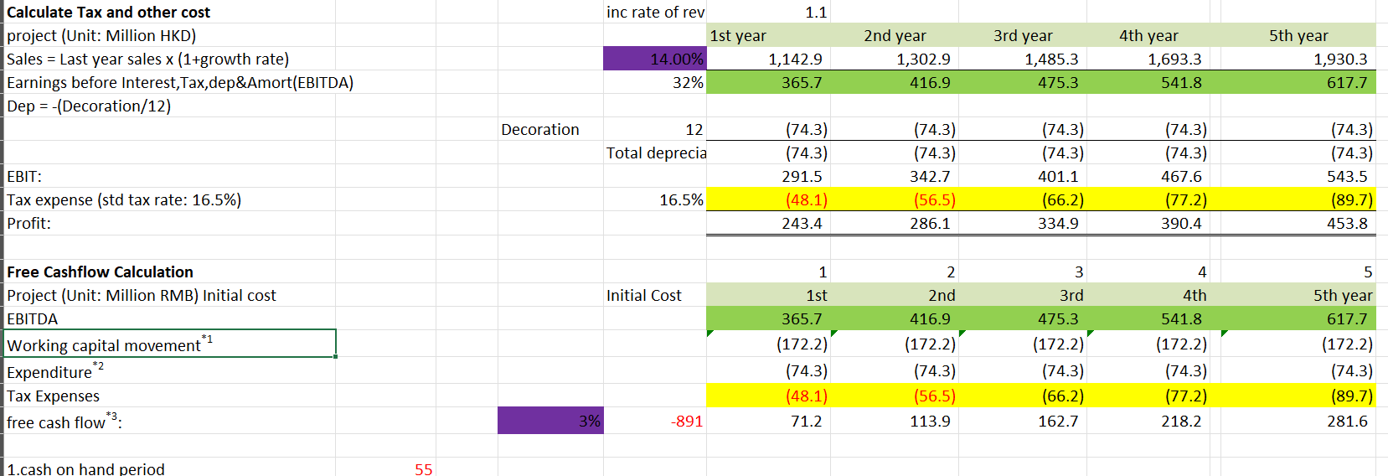

37

Appendix 2
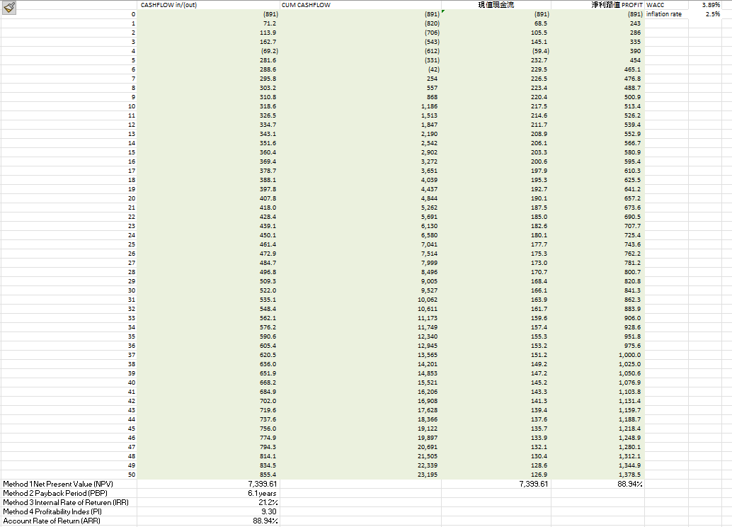
38

Appendix 3

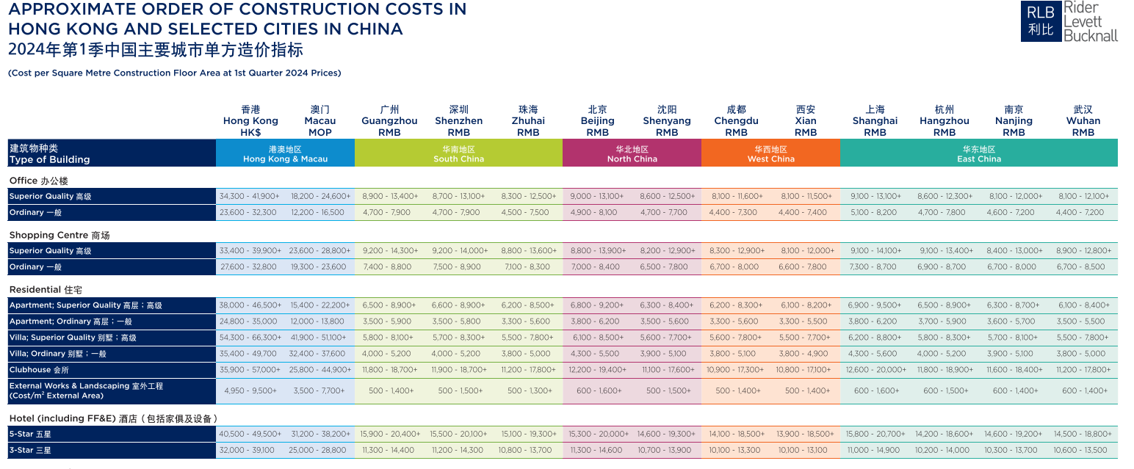

39

