

BSc (Hons) Professional Police Practice

LEVEL 4 - 40 Credits

Workbook title: Competency Based Workbook 1 (PCDA)

(SOUTH WALES POLICE, GWENT POLICE AND UWTSD)

Learner name: Charlie Hinder PC 8645

Learner’s University Registration Number:
_______________________________

FACULTY OF BUSINESS AND MANAGEMENT
PUBLIC SERVICE PROGRAMME

Module title: Professional Police Practice 1 (PCDA)

Workbook Guidance

Please read these notes carefully; they provide essential information.

What is the workbook for?

The purpose of this workbook is to enable learners to demonstrate and provide evidence of how they meet the learning outcomes set by the College of Policing, for the BSc programme. Essentially, you are being asked to outline your experiential learning based upon your theoretical understanding in a range of operational situations.

Area of Professional Practice covered, (called elements in your module descriptor):

- Wellbeing and Resilience
- Communication Skills
- Managing Conflict
- Valuing Difference and Inclusion
- Criminal Justice
- Decision making, discretion
- Conducting Investigations
- Criminal Justice (Managing offenders)

You may wish to use the same incidents as you’ve outlined in the Occupational Competence Portfolio.

How should the workbook be presented?

Blank electronic copies can be found on Moodle of this workbook. You must submit this document electronically therefore it is important that you save your work regularly and upload the final typed version through Turnitin on Moodle.

Word count policy can be found in chapter 7 of the Academic Quality under section 7.7 (this applies to presenting work above and under the specified word count).
(https://www.uwtsd.ac.uk/media/uwtsd-website/content-assets/documents/academic-office/aqh-chapters/chapters---en/Chapter_07_Assessment_Taught_Programmes_Pages_72-79-UPDATED-05-11-2019.pdf)

Reflective practice is a core aspect for your workbooks and although there is a variety of useful resources on Moodle, there is one particular book, that is specifically based on reflective practice in policing, here is a link to one chapter from Selina Copley’s Reflective Practice for Policing Students:
https://moodle.uwtsd.ac.uk/pluginfile.php/298870/mod_resource/content/1/Reflective%20Practice%20for%20Policing%20Students%20-%20Selina%20Copley%20Chapter5.pdf

How is the workbook assessed?

Advice and support about the completion of this workbook will be provided by university staff as part of your initial training day. Your tutor constable and in-force training staff will not be involved in assessing or marking your workbook after it has been submitted.

Dates of workbook submission will be made available during the initial training day and posted on Moodle.

Once submitted your workbook will be assessed and marked independently.

Confidentiality

It is important that no individual can be identified either directly or indirectly from the information in the workbook. Therefore, you must:

- adhere to guidance in the Student Handbook about unfair practice and plagiarism;
- not identify individuals including witnesses, victims or offenders by name;
- not write information that enables any individual to be identified indirectly through the description you provide. This includes references to names, colleagues, places (including hospitals, schools, town, villages, streets) specific incidents which were high profile and could be identified due to past publicity, other professionals or any other personal information including medical or other conditions;
- take personal responsibility for adhering to confidentiality rules.
- not include any dates of any incidents or anything that specifically identifies an actual incident.

Please be aware that any content that is deemed to be inappropriate, disrespectful, or abusive will not be tolerated. Following review of any content of this nature the information will be shared with the employer of the student responsible.

The content of this workbook should be your own work. Do not allow anyone else to see your work or use your work for their own submissions.

Should any health and wellbeing concerns be raised because of disclosures made by the student within this workbook, the employer of the student will be informed.

NOTE

Your workbook will be submitted electronically via Turnitin on Moodle. Guidance on this is in the Student Handbook.

Remember that the workbook is YOUR responsibility you must not rely on the assessor or anyone else to pick up any confidentiality breaches as this is your work and you must accept full responsibility for confidentiality. Meeting all the confidentiality requirements is very important.

Dyslexia and other special circumstances

If you have any condition that you feel may affect your ability to deal with any part of the programme, please see the Student Handbook for further guidance. The University has a Student Services Unit that may be able to help but it is the learner’s individual responsibility to contact them.

Guidance:

- Your workbook must contain the items specified in the table below (clearly identified and in the order given);
- You should use this particular document to insert your text / answer within each section of this workbook;
- You should upload your completed document as a saved pdf of this workbook; if this is not possible then a Worddoc file is acceptable. Do not send a scanned file from a photocopier, an apple.dot file, or a Microsoft publisher file as Turnitin will not be able to assess them despite you being able to upload them.

Contents:

Workbook | Area of Professional Practice | Word count
Task 1 | Wellbeing and Resilience | 1000
Task 2 | Communication Skills, Managing Conflict, Valuing Difference and Inclusion | 1500
Task 3 | Criminal Justice, Valuing difference and inclusion | 1500
Task 4 | Decision making and discretion, Conducting Investigations and Criminal Justice (Managing offenders) | 1500
 | Bibliography
Task 5 | Development Plan | 500
 | Total | 6000
Confirmation of Confidentiality and Plagiarism
This is confirmed by submitting through Turnitin

Task 1

Relevant areas of the National Policing Curriculum:
Wellbeing and Resilience

Guidance:

Focussing on your initial 6 months of learning and since being attested as a Police Constable, outline the coping strategies you have applied to develop resilience and minimise stress.

1000 words (+/- 10%: include your actual word count at the end of each section)

ANSWER:

Introduction

During my time as a Student Police Constable, with my initial training since being attested, there have been various points across these l 6 months where learning has become stressful. It has become important to build and develop personal resilience to the new ideas, exams, and the new ways of working I have been exposed to. In this section of my workbook, I will be talking about the many different methods I have implemented to reduce my overall stress levels, work-life balance and how I have begun developing a strong resilience to setbacks and criticism. I will also be highlighting how important it is to be mindful of previously stated techniques and to work on them consistently for the betterment of my own mental health. Stress is caused by the brain chemical cortisol, which when released causes excess worry. This can be triggered in response to difficult situations and is a human’s natural response to ideas and actions that threaten or challenge us (World Health Organisation, Stress 2023). Resilience is defined as being strong within yourself even when there has been a bad or difficult situation or event has triggered high or constant levels of stress. (Cambridge Dictionary, Resilience).

The importance of reducing stress is key to a positive mental attitude, and overall holistic wellbeing. Being able to minimise the impact of stress on my working and personal life will be important in preventing serious issues such as occupational and overall depression and anxiety. Allowing depression and anxiety to set in could directly impact the quality of my work and my ability to communicate effectively with both colleagues and the public.
On a personal level, allowing these symptoms of stress to manifest could also directly affect my personal life. It could affect my relationship with friends, family or a partner, which can then in turn cause myself to become low. Like a domino effect, this could then trigger a downward spiral, impacting not only myself but everyone around me. The importance of building resilience cannot be understated. The ability to bounce back from the different setbacks and challenges that can arise within and outside of work is essential to the role of an officer. Developing a mental resilience aid in maintaining a work/life balance and the ability to process, overcome and manage situations as they happen.

A coping strategy that has helped me out during my initial period within the role has been meditation. Meditation has helped me put my body into a calming state, even after hectic and busy days (Keltner et al., Getting started with mindfulness 2023 Mindful). I have found that putting myself into a quiet room at home and sitting on a mat or just lying on the floor, I am able to explore the inner works of my mind helping to process the emotions that have been with me throughout the day. When I am meditating, I have found that I am able to deal with any stress and overwhelming emotions without judgement, and I am able to be kinder to myself. It has helped me to ground and live in the present moment rather than dwelling on past experiences such as bad performances in policing practical’s, future events such as policing exams on the horizon or hypothetical situations that could cause stress and anxiety if thought about for too long. I spend between 15-20 minutes per day on mindfulness and mediation, as this is an achievable amount of time to put aside for my own mental well-being. It allows me more time afterwards to truly reflect on my day, my thoughts and consider the changes I could make to improve and develop into my role. This practice is a positive thing I have developed to be kinder and more realistic with myself, and it is something I do solely for myself with any remaining time I have in a day.

Another coping strategy that I have used is taking the time to be physically active, whether through going to the gym or as part of an organised event such as football training and exercise classes. Being stressed causes fatigue and low mood, so a natural way to combat this is to put your body in motion. I found that by being active it allows me to take any stress or frustration I feel and channel that into something that is positive for both the body and mind. Medical studies have proven that exercise has positive affect of brain chemistry through the release of endorphins and serotonin. These effects also have a direct impact on the body’s ability to be more resilient to stress and depression (NHS choices, Exercise for depression 2021). Going to external places such as the gym or a football field have their own positive contributions also. Being away from work or the house (where it is easy for the stresses of life to wear down on you) you are instead going to a place of betterment with others that have similar goals to yourselves. With football and team exercise there is also an additional layer of support and motivation from teammates and coaches, which allows you to deal with physical and mental setbacks that can come from work or family life.

These coping mechanisms alongside the support from family and friends has allowed me to maintain both my physical and mental wellbeing and build resilience during stressful situations throughout my initial period within police training. It has allowed me to maintain a healthy work life balance and has prevented negative thoughts and feeling from impacting my learning and professional development. It is important to keep up with these strategies throughout my time as a police officer, as due to the nature of the role, learning and dealing with challenging behaviour will be a regular occurrence. Developing these existing strategies will be key to managing my emotions as new and different stresses and emotions become apparent when I start to deal with more challenging and unknown situations throughout work. Being resilient to these factors will allow me to develop into this career as an officer, and to do so healthily without sacrificing my overall wellbeing.

Word Count:1023

Task

Relevant areas of the National Policing Curriculum:
Communication Skills, Managing Conflict, Valuing Difference and Inclusion

You must choose a policing incident involving conflict in which you played a significant role with an offender/service user/victim and reflect on what happened.

Give a brief description of the incident including social and legislative contexts and any relevant cultural, ethnicity and language issues.

Review the fundamental elements of effective communication used (verbal, non-verbal, active listening skills, open and closed questions, building rapport and negotiation skills).

Describe the process for determining whether the use of force was necessary in a conflict situation (including any theories or models underpinning the causes of conflict within policing interventions – e.g. Betari’s Box, The Drama triangle, Emotional versus rational brain) and provide a reflection on the outcome of the incident.

Your reflection must illustrate your understanding and application of core principles of ethics, equality, diversity and human rights, as well as any relevant Code of Practice considerations, culturally sensitive practice and language preference.

1500 words (+/- 10%: include your actual word count at the end of each section)

ANSWER:

In this section of the workbook, I will be discussing and defining conflict. In the following parts of this Workbook, I will give examples of my use of different communication skills and analysing how well I have used these to manage conflict. I will be analysing my performance, the different actions taken by myself and the academic models that I have used during the incidents described and comparing the different methods used, and how each can benefit or change an incident. Finally, during this Workbook, I will be looking over the reflections and personally identifying areas of improvement and current strengths I have gained using the current models and skills I possess and use.

Conflict is a perceived disagreement in wants, interests, or objectives characterising conflict as a condition or state of human interaction (Bhasin, what is conflict? definition, types and causes 2022). Conflict can happen in any place or setting, making it a difficult task to predict or apprehend as no person is the same, no person thinks the same way.

I will now be describing an incident that I have attended during my time as a response officer. For the purpose of this workbook, I will be leaving out Personal Data and other information to comply with the General Data Protection act 2018:
During the late hours of the evening, a call had come into the Police control centre. This call was described as an ongoing domestic incident occurring on the street of the reporting person. The reporting person could see a female sitting on the front garden wall of a property a few doors down. The female and a male not seen could be heard shouting at one another, and this had been escalating over a period of 30 minutes. Reporting person didn’t have details of either the male or female and didn’t know what the cause of the argument was about.

This call was assigned to myself and my colleague, we proceeded to attend the address due to the domestic concerns. When my colleague and I arrived at the address, nobody was outside of the property. After knocking the door of the property, a male answered the door. We explained to the male that we had received a report of a disturbance coming from the property and were attending due to this. We told the male that due to this report we had cause to enter the address as part of section 17 of the Police and Criminal evidence act 1984 (PACE,1984), the male understood and allowed us entry with full compliance.
In the property was a female that was hysterical, sat in the living room. My colleague and I spoke to each involved person separately to gather further information. After gathering information and conferring with each party, information that the female was suspected of assaulting the male had been divulged. My colleague and I both approached the female and explained that she was under arrest due to the allegation of domestic assault. At the time of arrest the grounds for the arrest, the caution and the necessity for the arrest were given to the female, who failed to reply to this. Before taking the female into the back of the marked police vehicle we conduct a person’s search under Section 32 of PACE which is under Code G of PACE. Once this search was completed Officers conveyed her to SWANSEA central Police station Custody unit to process and be interviewed.

The involved male in the assault suffered no physical injury or bruising from the incident that took place. The male disclosed to me that they had been watching rugby that afternoon, that the female accused the male of cheating on her, which led to an elevated altercation. This argument then escalated further with the female offender punching the male in the stomach twice with her right hand in a fist. Due to Unlawful force being used but without the presence of injury sustained this would be the offence of Common Assault under Section 39 Criminal Justice Act 1988.

“Any act (and not mere omission to act) by which a person intentionally or recklessly causes another to suffer or apprehend immediate unlawful violence.”

Domestic abuse according to the UK Home Office is defined as any instance or pattern of violent, abusive, coercive, or threatening behaviour amongst people 16 years of age or older, this includes, but is not restricted to psychological, physical, sexual or financial (Home Office, 2013). Domestic Abuse can be inflicted on people of all ages, ethnicities, genders, and sexualities and can affect people from all social class backgrounds. Domestic abuse doesn’t tend to be a singular occurrence and will normally be a series of events that often don’t come to light until a third party reports it or the abused has reached breaking point (Men's Advice Line, Recognising abusive behaviours: Men's Advice Line UK 2021). Domestic abusive is thought to have many different longer lasting effects on a person, such as diminished mental and physical health, Depression, Dependence, Anger etc (De Benedictus, T. and Jaffe, J., (2004)).

During this Incident I had to communicate with different people throughout. In this section will be explaining why I communicated in certain ways and the different models and ways of thinking I used:
When my colleague and I first arrived on scene, we both agreed that it was paramount to gather information and establish what had occurred from both parties separately, without the influence of one another. I stayed in the property with the male and my colleague took the female outside but in view of the window, so myself and the other officer could keep eyes on one another as a safety precaution.
The model that I had chosen to use with the male was the ‘LEAPS’ Model. This is a method of communication which allows the way I deal with a person to be flexible whilst still maintaining a structured approach in the situation (College of Policing 2020). Using this method allowed the male to have free speech regarding his series of events and to tell his side of the story allowing me to listen to what was being said without interruption (College of Policing 2020)
This in turn allowed the male to relax his body language and speak more freely than before. Listening to his side of events, I made sure to be open-minded and non-judgemental, not using my experience at previous calls to influence the way I approach the person. Once I had heard the initial count, I made sure to ask further details to flesh out the whole picture that had happened, to gather a better understanding of events. This included paraphrasing elements of discussion back to him, allowing him to understand that I have been listening to his account and to trust me with the information he is providing. Paraphrasing also allows me to clarify and gather further details. Once all details were provided I would then, as per the model, summarise back in a concise manner (College of Policing 2020). Once all the above actions had taken place, my colleague and I had compared the two accounts taken from Victim and Perpetrator and from this we were able to establish that the offence of assault had taken place.

The next model that I decided to use was the ‘Betari Box’ when dealing with the perpetrator. The Betari box demonstrates that based on how their attitudes and behaviours react to one another, individuals might become trapped in a negative cycle of communication (College of Policing 2020). I understood that when telling the perpetrator, the action of arrest needing to be carried out by myself and the other officer present it could cause communication and compliance to break down. Using this model, I decided that my attitude towards the perpetrator would be calm and understanding to increase the chances of a compliant arrest. I spoke with the female at length about the process that was going to happen from a search of her person, the journey to the custody suite, the booking-in and interview timescales. By doing this the female was calmer than she had been previously upon being told she was to be arrested. Her response to us had changed, and she was appreciative of the information she was told. This also allowed the process of arrest and conveying her to custody a much easier process. By adopting a professional but calm attitude from the outset, it allowed the situation to improve drastically and become well-managed by us.

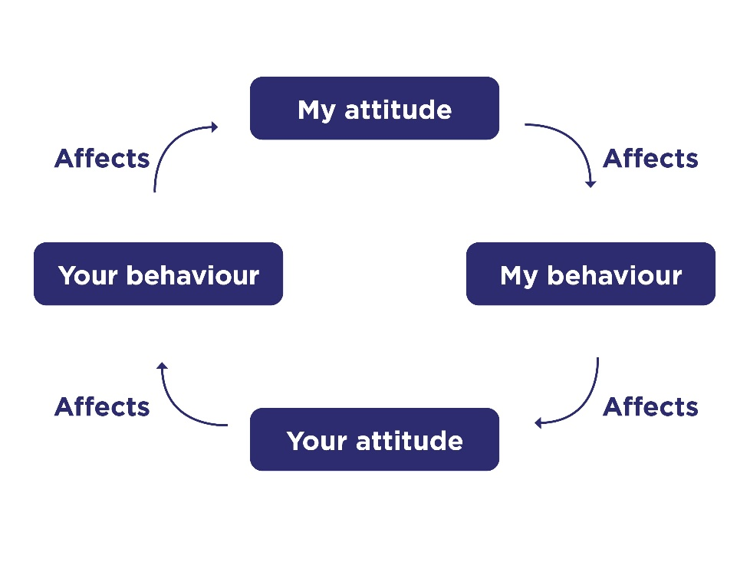

Another model that can be used to combat conflict is the ‘Thomas Kilmann’ model. This model is used to evaluate a person's conduct in conflictual circumstances, or when two people's concerns don't seem to align well (Thomas, K.W., 2008). This model looks at the assertiveness (How much an individual person will try to look after the own concern) and the cooperativeness (How much an individual person will try to look after another or third parties concern). The model defines 5 methods of the dealing with that person and any conflict.

These 5 Modes are:

Competing – This mode would be used with somebody who is Assertive but Uncooperative.

Collaboration - This mode would be used with somebody who is Assertive and Cooperative

Avoidance- This mode would be used with somebody who is Unassertive and Uncooperative

Accommodating- This mode would be used with somebody who is Unassertive but Cooperative

Compromising- This mode would be used with somebody who is intermediate in both Assertiveness and Cooperativeness

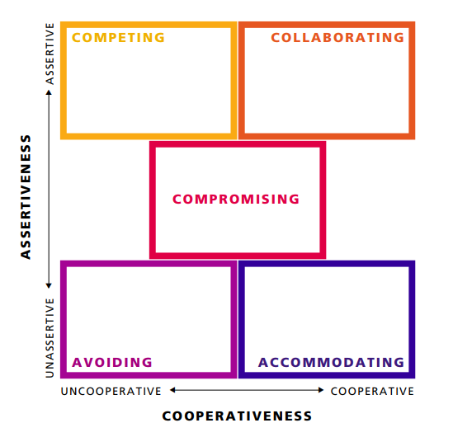

These approaches have been incredibly useful during my limited time as a police officer. Personally, I believe that ‘Betari Box’ model is the most useful model out of all I have mentioned, as it aids in de-escalating situations and allows for compliant police measures to be used when dealing with members of the public. There is however a drawback to using this method if a person has had previous negative experiences with police as it can cause people to have a negative reaction to police in uniform and the Betari Box model will not change the situation. This is due to the inherent fear or aggression a person may have towards an officer, more than a change in attitude on our part would be needed to change this opinion. Every method used within policing will have its pros and cons, this change and very in effectiveness depending on the individuals they are being used upon.

Word count 1736

Task 3

Relevant areas of the National Policing Curriculum:
Criminal Justice, Valuing difference and inclusion

You must choose a policing incident in which you played a significant role with an offender/service user/victim and reflect on what happened.

Give a brief description of a relevant incident including social and legislative contexts and any relevant cultural, ethnicity and language issues.

Explain and reflect on your responsibilities and procedures in line with the relevant Codes of Practice to support victims and witnesses through the criminal justice system.

Illustrate how policing values were engaged, as well as any other considerations including culturally sensitive practice and language preference.

1500 words (+/- 10%: include your actual word count at the end of each section)

ANSWER:

In this section of the workbook, I will be talking about the victim codes of practice and how this can be used to support members of the public that may become subject to criminal acts such as Hate Incidents. All citizens of England and Wales have access to the Victim Codes of Practice (available on the government website, URL: www.gov.uk/government/publications/the-code-of-practice-for-victims-of-crime). This legislative guidance is designed to ensure that victims of crime are given priority in the Criminal Justice System (CJS) by establishing a minimal standard of care that must be maintained (College of Policing, 2021).
I will be explaining an incident and the victim codes that I have utilised throughout the incident itself. A victim is defined as an individual that has been affected by an act or incident and as a result has suffered harm, either Physical or Mental (Ministry of Justice, 2023). These codes allow policing action to prioritise the victims' best interests.

The following incident I will be outlining is one that has been attended to during my initial time as a response officer for South Wales Police Force. For this workbook, I will be eradicating any sensitive or confidential personal data and details from the incident to comply with the General Data Protection act 2018.
The incident I attended was called in by a female, that had reported that her ex-partner, a male, was shouting homophobic abuse at her, due to separating from him and since identifying as Bi-Sexual. The female’s ex-partner had parked his vehicle outside of the female's property and was shouting at the female (who was in the front garden of the property), discriminatory slurs to the effect of “LESBO” and “DIKE”. The female felt like this was aimed at herself, due to being the only person in the street at the time. Due to this altercation the female decided to call the police. The female decided that she would like to make a statement of complaint against the male and proceed further within the criminal justice system.

A hate crime is hostility towards a person based on the nine protected characteristics such as race, religion, sexual orientation, disability e.t.c (CPS, Hate crime). This incident fulfils this definition, as the male suspect involved displayed directed hostility due to the use of the discriminatory language. The victim’s sexual orientation (perceived or actualised) is a protected characteristic. Regarding this incident the male was arrested under Section 4A of the Public Order Act 1986: defined as acts intended to cause intentional harassment, alarm, or distress.

“(1) A person is guilty of an offence if, with intent to cause a person harassment, alarm or distress, he—

- uses threatening, abusive or insulting words or behaviour, or disorderly behaviour, or

- displays any writing, sign or other visible representation which is threatening, abusive or insulting,

thereby causing that or another person harassment, alarm, or distress.”

As of March 2022, the number of hate crimes reported to the police in England and Wales in the year was 155,841, a 26% increase from the year before (Home Office, 2022). Hate-motivated incidents have a terrible effect on those who are hurt and their family. When victims experience these kinds of events repeatedly, the cumulative impact can be fatal, causing long-term stress and emotional harm which can have a massive day to day impact on how somebody lives their life. People can feel that they need to change the way they are as they feel it is the only way to stop these situations from happening again, they frequently alter their lives or start doubting who they are and what they belong to (Neighbourhood Watch, Impact of hate crime).

I will now be discussing the varying parts of the Victim Codes of Practice that I have used, maintaining the standard of my investigation and to provide the best possible service to the victim throughout the Criminal Justice System.

Whilst writing this, the incident is yet to go as far as court. This means rights 8, which is the giving of information to the victim regarding the trial, the trial process and their role as the victim/witness,9 the right to appeal and outcome of the case and 10 which is to be paid for any expenses for going to court. I am unable to be offered to the victim at this current time, but this will be provided when the case reaches that section of Criminal Justice System. Right 5, which is the right to compensation due to loss or damage is also unavailable to the victim due to there being no damage to property, regarding this incident.

The 1st right is for the victim to understand and to be understood, what this means that any information that is relevant to the victim should be put in the easiest format that will allow the victim to understand it (College of Policing, 2021). Regarding the victim involved with this incident there were no language barriers as the victims first language was English but if there were any difficulties then services such as an interpreter, so there won’t be a barrier to understand what information was needed from the victim or vis-versa. Even though the victim had English as her first language, it was still important to exclude jargon when speaking with her, as this sort of speak is not familiar to all and could confuse the victim about processes and what is to be done next.

The 2nd right is to have the details of the crime recorded without unjustified delay (College of Policing, 2021). Circumstances of the incident were taken down at the victims address on the initial attendance. These were added to the NICHE occurrence log for crime recording. NICHE is a police record management system with allows police forces to manage information for incident from People to locations and vehicles (HMICFRS, Niche 2023).

The 4TH right to be referred to victim support programmes that offer services and support specifically designed to meet their needs (College of Policing, 2023) Regarding this incident and the victim I felt it was necessary to refer them to the Victim focus referral with the victim’s consent. They are providing free, personal help to those impacted by crime in South Wales.

The 6th right is for the victim to be given information about the investigation and any prosecution (College of Policing, 2023). How this applied to my incident, was making sure that the victim was informed of the current state of the incident and any outstanding actions within 5 working days of any crucial point in the investigation. I made sure to contact the victim regularly, to keep her in the loop of investigation. An example of this was updating the victim via their Mobile to confirm that CCTV has been received and reviewed and that a suspect has been arrested. Even small updates like this, help to build a rapport with the victim and gain the trust that we are making forward steps in the investigative process.

The 7th right is to be able to make a victim personal statement (VPS) (College of Policing, 2023). A VPS can help people comprehend how a crime has affected the victim, giving victims a voice in the criminal justice system. If a person is found guilty, the court will consider the VPS in addition to all other available evidence when determining the right sentence (Ministry of Justice, Victim personal statement 2018). During the statement taking process with the victim, I was able to explain what a VPS was and how this could help the court understand how the Homophobic abuse that she has experienced and how this has impacted her day-to-day life.

I feel like I made positive contribution to the incident. Due to my inexperience, only have a limited experience in the Officer role and hadn’t dealt with a hate crime previously. I understand that during my role I will have further exposure to similar incident, and I will be able to be more familiar with all the services available to victims on hate crime. The rapport I was able to build with the victim helped to make that gathering on information and material such as CCTV from the victim easier. Explaining the process and providing regular updates also allowed the victim to understand what outstanding actions were required to keep the investigation progressing.

Word count: 1386

Task 4

Relevant areas of the National Policing Curriculum:
Decision making and discretion, Conducting Investigations and Criminal Justice (Managing offenders)

You must choose a policing incident in which you played a significant role with an offender/service user/victim and reflect on what happened.

Give a brief description of the situation including social and legislative contexts and any relevant cultural, ethnicity and language issues. Reflect on how you applied the National Decision Model (NDM) to assist in resolving this incident. Consider the role of discretion in the decision-making process.

Explain your responsibilities with regards to the provision of the CPIA when conducting this investigation including when managing the offender and suspects and recording and retaining significant information.

Illustrate how policing values were engaged particularly through an analysis of the potential impact of bias on the decision-making process.

1500 words (+/- 10%: include your actual word count at the end of each section)

ANSWER:

In this section of the workbook, I will be discussing the National Decision Model (NDM) and the part it has played in an incident that I have been involved in. I will also be discussing how the Criminal Procedure and Investigation ACT 1996 (CPIA) is involved with the following incident.

For this workbook, I will be leaving out Personal Data and other information to comply with the General Data Protection act 2018. The incident that I will describing in detail was due to an individual driving whilst unfit through the use of drink or drugs. Whilst on duty, my colleague and I were patrolling the local area, when we noticed a vehicle driving 50% under the speed limit and struggling to stay within the marked lines of the road. This resulted in my colleague and I pulling the vehicle over in a marked vehicle. When the Offender rolled the window down and began speaking, we noticed that their speech was slurred, and their eyes were noticeably dilated. I began conversing with the offender, gathering information of their previous whereabouts, whether they had been drinking and where they were travelling to. The offender explained that he had only consumed a couple of drinks at the pub, and he was traveling home. Due to this disclosure, I explained to the male that we believe that he was driving whilst unfit through drink or drugs and require a preliminary breath test in accordance with the Road Traffic Act 1998. I conducted the breath test with the male using a breathalyser which is standardly carried in police vehicles, and this recorded a result over the prescribed limit.

As part of requesting a specimen of breath, the following questions need to be asked: Has the person taken any medication?, has the person smoked recently?, has the person consumed alcohol?, has the person used mouthwash recently etc. All of these can affect the results of the breath test and therefore could produce incorrect readings. (DrinkDriving.org, Police procedure: Evidential breath testing)
I will now by describing the NDM and its function. The NDM is a model used by the police and its employees to create a structure for rational decisions, so that the right decisions are made in operation and non-operational situations (College of Policing, 2013). The model helps to break down and simplify the approach to a decision, whilst also allowing officers to use the discretion. Additionally, it is acknowledged that the modelmight not always be able to divide thinking or response actions each step of the model in a fast-moving and rapidly developing occurrence. In these situations, decision-makers' priority is to remember their overriding goal in acting honourably to defend and assist the public interest (College of Policing, 2013).

The NDM is made up of six different principles that an officer will have to look at individually. These are as follows:
1. Code of Ethics
2. Gather Information and Intelligence
3. Assess threat and risk and develop a working strategy
4. Consider powers and policy
5. Identify options and contingencies
6. Take action and review what happened.
Each section is as vital as the last as they work together with the Code of Ethics which underpins the entire model. All areas of the NDM are made to be consistent with the 10 Policing Principles, which is in place to maintain and improve the public's perception and confidence in the police (College of Policing, 2013).

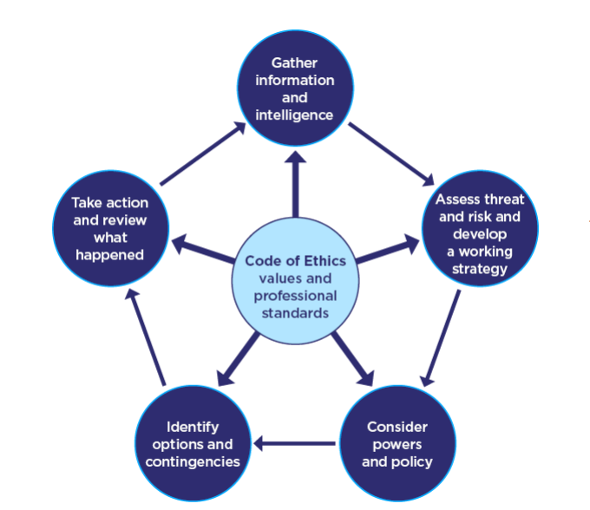

In this section I will be explain how I used the NDM within the previously stated incident I outlined in this workbook. The first section of the NDM that I applied to the incident was ‘Information’ and ‘Intelligence’. Upon initially noticing the vehicle on the road, prior to pulling the vehicle over, I had used the Police National Computer (PNC) to gather further information the vehicle such as previous and current owner/s and registered address/es. PNC is a national database used by all Police forces, which holds information on people’s criminal records and vehicles, this is used to carry out checks for policing purposes (His Majesty’s Inspectorate of Constabulary and Fire & Rescue Services (HMICFRS, 2018). By checking this system, I was able to find out who the registered owner of the vehicle was and any persons who are insured to drive the vehicle.

The next part of the NDM considered was the ‘Threat and Risk’ involved with the action my colleague and I were going to conduct by pulling the vehicle over and developing a working strategy. When initially spotted, the vehicle was travelling on a busy main road, so it was imperative to pull the vehicle over to a safe place to prevent any risk to the public. As part of the working strategy, we had the vehicle pull over into the available hard shoulder, but we also positioned the marked police vehicle off centre with the hard shoulder and slightly into the first lane. This was the able to create space between the pulled over vehicle and any other vehicle that needed to pass.

The next part of the NDM utilised was looking at the ‘Powers’ and ‘Policies’ available to us as officers. The most relevant supporting legislative policy available regarding this incident was the The Road Traffic Act 1998. Due to information that the male had disclosed regarding drinking before driving and driving dangerously, I have the power to perform a preliminary breath test using a breathalyser to see if the alcohol contained in his breath is over the prescribed limit which is set out by Section 6(3) of the Road Traffic Act 1988. The Limit for alcohol in the breath is 35 Microgrammes of alcohol per 100 millilitres of breath. The male breathed a result of 70 Microgrammes of alcohol, and due to this was arrested under Section 4 of the road traffic road 1988.

“A person who, when driving or attempting to drive a [F1mechanically propelled vehicle] on a road or other public place, is unfit to drive through drink or drugs is guilty of an offence.” (Section 4, RTA, 1998)

The next part to be considered from the NDM is the different options and contingencies available when making the decision to arrest. At the time my colleague and I felt that the most proportionate action was to arrest the male to preserve public safety. Due to the male driving a mechanically propelled vehicle whilst under the influence of alcohol, there is no saying what could have happened as his perception behind the wheel was clearly affected by the influence of alcohol. I felt that there was no other alternative than to arrest the individual due to the danger posed to the public.

The next element that was to be considered from the NDM was to act and to review that action. All previous observations and the result of the breath test clearly indicated it was a lawful action to arrest the male. For the review element of this, it is important to look at all relevant data and information presented to us, to clarify if anything needs to be improved upon in future. The other side of the review portion allows me to reflect on the incident, ask for feedback and carry the things that worked well forwards for future incidents. I decided to reflect on my actions upon returning to the station, as it is an environment where I can objectively discuss and review my actions in a supportive environment. I was able to compare with my colleagues, gain feedback and a different outlook on the techniques that could be used in the future.

The final element of the NDM is the ‘Code of Ethics’, which sits at the centre of the NDM. The code of ethics establishes and clarifies the model behaviour expectations for all law enforcement personnel (College of Policing, 2014). With in the Code of Ethics are 9 policing principles which are in place to uphold the standards of professional behaviour within policing. These principles are Accountability, Integrity, Openness, Fairness, Leadership, Respect, Honesty, Objectivity and Selflessness. I feel throughout this incident, I have worked within the Code of Ethics and have kept public interest at the heart of my actions and the rationale that fuels them.

Upon reflection of the incident, I feel that I have conducted myself in line with the core policing principles, whilst following the NDM as intended with all actions taken during the incident. Previously, I did not have much exposure to traffic related offences but feel like I have conducted myself in the interest of the public during this incident and will carry the experience gained with me throughout my career moving forwards.

Word Count: 1438

Task 5

Personal Development Plan (PDP) / Learning Plan.

As part of your reflective process, please use this table to aid you in identifying the next steps for development. This is equivalent to 500 words. Please note that this not the actual number of words you need to use, the wordcount reflects the thought and research you put into it.

Identified area for development | How it will be achieved | Who can provide support? | Timeline
To keep on top of Workbooks and to not leave work until its due date to be completed. | I feel like this is a realistic and achievable for myself if I am honest with my own difficulties with the work. I will set a side two evenings a week to look over and add words to the workbook.  By doing regular but small sessions with the workbook it will allow me to not get overwhelmed with the work.  I will be able to see this over time as I add to the Workbook. | The University can help me. I can speak and have one to one session if I feel like I am struggling with the work and feel like I am unable to add anything within my own sessions.  I can also speak to my tutor as he has recently completed the 3-year course. So, it would be beneficial to ask for tip on staying on top of the workbooks. | For the date my workbook is set and until the Submission date.
To create a balance between the demands and responsibility during work and my personal life. | This is measurable by my happiness and fatigue levels during my probation period. This is an achievable goal as long don’t bring work issues back home with me. It is important for me to have hobbies and interests outside of work to create separation from personal life and work. | I can speak to my Sergent or the University about my wellbeing and mental health. I can also speak about my workloads and how this maybe affecting me day to day. | I will be giving myself until September next year once I have gotten familiar with systems and University work.  I feel like it would be unfair to judge this before then, as being in a new environment is difficult and it can take time to settle.
To be comfortable speaking to people from all different back grounds, so I can connect with more people and in turn be a better police officer. | I will put myself forward for any public outreach programmes that might come my way. I will also try to take the lead on a variety of calls, so I able to get use to speaking to many different types of people | My tutor and SGT will be able to help me by giving me tips and supporting me. | My target is until the beginning in 2024. I will make a conscious effort over the coming shifts to put myself forward to take the lead. By the beginning of 2024 I should be able to see an improvement.

Bibliography
The bibliography should only include sources referenced within the workbook using the Harvard referencing system. Information about referencing in written assignments and how to avoid plagiarism can be found on Moodle. It is important that you are aware of the importance of ensuring that the work submitted is your original work.

- Code of ethics - college of policing (2014) College of Policing. Available at: https://assets.college.police.uk/s3fs-public/2021-02/code_of_ethics.pdf (Accessed: 02 November 2023).
- Code of practice for victims of crime in England and Wales (victims’ code) (2023) GOV.UK. Available at: https://www.gov.uk/government/publications/the-code-of-practice-for-victims-of-crime/code-of-practice-for-victims-of-crime-in-england-and-wales-victims-code#introduction (Accessed: 03 November 2023).
- Conflict - Bhasin, H. (2022) What is conflict? definition, types and causes, Marketing91. Available at: https://www.marketing91.com/conflict/ (Accessed: 31 October 2023).
- Conflict management skills (2020) College of Policing. Available at: https://www.college.police.uk/guidance/conflict-management/conflict-management-skills (Accessed: 31 October 2023).
- De Benedictus, T. and Jaffe, J., (2004). Domestic violence and abuse: Types, signs, symptoms, causes, and effects. Help guide: Mental Health Issues. (Accessed: 31 October 2023).
- Definition of domestic violence and abuse: Guide for Local Areas (2013) GOV.UK. Available at: https://www.gov.uk/government/publications/definition-of-domestic-violence-and-abuse-guide-for-local-areas (Accessed: 31 October 2023).
- Exercise for depression (2021) NHS choices. Available at: https://www.nhs.uk/mental-health/self-help/guides-tools-and-activities/exercise-for-depression/ (Accessed: 23 October 2023).
- Hate crime (no date) The Crown Prosecution Service. Available at: https://www.cps.gov.uk/crime-info/hate-crime (Accessed: 03 November 2023).y
- Hate crime, England and Wales, 2021 to 2022 (2022) GOV.UK. Available at: https://www.gov.uk/government/statistics/hate-crime-england-and-wales-2021-to-2022/hate-crime-england-and-wales-2021-to-2022 (Accessed: 03 November 2023).
- Impact of hate crime (no date) Impact of hate crime | Neighbourhood Watch Network. Available at: https://www.ourwatch.org.uk/impact-hate-crime#:~:text=Incidents%20motivated%20by%20hate%20have%20a%20devastating%20impact,lives%20through%20emotional%20damage%20and%20long%20term%20trauma. (Accessed: 09 November 2023).
- Keltner, D. et al. (2023) Getting started with mindfulness, Mindful. Available at: https://www.mindful.org/meditation/mindfulness-getting-started/ (Accessed: 23 October 2023).
- Ministry of Justice (2018) Victim personal statement, GOV.UK. Available at: https://www.gov.uk/government/publications/victim-personal-statement (Accessed: 09 November 2023).
- National decision model (2013) College of Policing. Available at: https://www.college.police.uk/app/national-decision-model/national-decision-model (Accessed: 02 November 2023).
- Niche (2023) His Majesty’s Inspectorate of Constabulary and Fire &amp; Rescue Services. Available at: https://hmicfrs.justiceinspectorates.gov.uk/glossary/niche/ (Accessed: 09 November 2023).
- Police National Computer Inspections (2018) His Majesty’s Inspectorate of Constabulary and Fire &amp; Rescue Services. Available at: https://hmicfrs.justiceinspectorates.gov.uk/our-work/article/police-national-computer-inspections/ (Accessed: 02 November 2023).
- Police procedure: Evidential breath testing Police Breathalyser Procedure: Evidential Alcohol Breath Testing. Available at: https://www.drinkdriving.org/police_breath_alcohol_test_evidential.php (Accessed: 04 November 2023).
- Recognising abusive behaviours: Men’s Advice Line UK (2021) Men’s Advice Line. Available at: https://mensadviceline.org.uk/male-victims/what-is-domestic-abuse/ (Accessed: 31 October 2023).
- Resilience, Cambridge Dictionary. Available at: https://dictionary.cambridge.org/dictionary/english/resilience#google_vignette (Accessed: 14 October 2023).
- Road traffic act 1988 (1988) Legislation.gov.uk. Available at: https://www.legislation.gov.uk/ukpga/1988/52/section/4#:~:text=4%20Driving%2C%20or%20being%20in%20charge%2C%20when%20under,drink%20or%20drugs%20is%20guilty%20of%20an%20offence. (Accessed: 02 November 2023).
- Thomas, K.W., 2008. Thomas-kilmann conflict mode. TKI Profile and Interpretive Report, 1(11). (Accessed: 31 October 2023).
- Victims’ code for policing (2021) College of Policing. Available at: https://www.college.police.uk/guidance/victims-code/victims-rights-policing (Accessed: 01 November 2023).
- WHO Team (2023) Stress, World Health Organization. Available at: https://www.who.int/news-room/questions-and-answers/item/stress (Accessed: 25 September 2023).

CONFIDENTIALITY and PLAGIARISM – Will be confirmed through Turnitin.

Recognition and Confirmation of the progress on the Occupational Competency Portfolio (OCP).

By signing the section below you are acknowledging your progress on O.C.P. This is recognised by the university as work that is fully supporting this module and is equivalent to 500 words towards the overall wordcount.

I confirm that I am progressing with the Occupational Competency Portfolio (OCP) in accordance to the regulations.

Signed: _ _ _ _ _ _ _ _ _ _ _ _ _ _ _ (Learner - Electronic signature or type name)

Date: _ _ _ _ _ _ _ _ _ _

