University of Wales Trinity Saint David
Wales Institute of Science and Art


Electronic Circuits Testing and Applications

Electrical Control Systems
ACHA4010

Aeron Tollett
2305464
19/03/2024
Contents
1 Task 2 1
1.1 Scope Time Division Calculations (4) 1
1.2 Function Generator output sine wave (3) 1
1.3 Unsmoothed Rectifier Wave (3) 1
1.4 Smoothed Rectifier Wave with capacitor (3) 1
1.5 Drop in Voltage Question (4) 1
1.6 Different Voltage Readings Question (5) 1
1.7 Rectifiers use in Automotive applications Question. (4) 1
1.8 Probing Question (4) 1
2 Task 3 2
2.1 Scope Time Division Calculations (4) 2
2.2 Function Generator output square wave (3) 2
2.3 Capacitor charge and discharge wave marked at correct points. (3) 2
2.4 Basic Capacitor Calculations (3) 2
2.5 Capacitor discharge table (4) 2
2.6 Gradient Plot and calculations (4) 2
2.7 Capacitor Uses (5) 2
2.8 Inaccuracies Question (4) 2
3 References 3

Task 2

Scope Time Division Calculations (4)

Function Generator output sine wave (3)
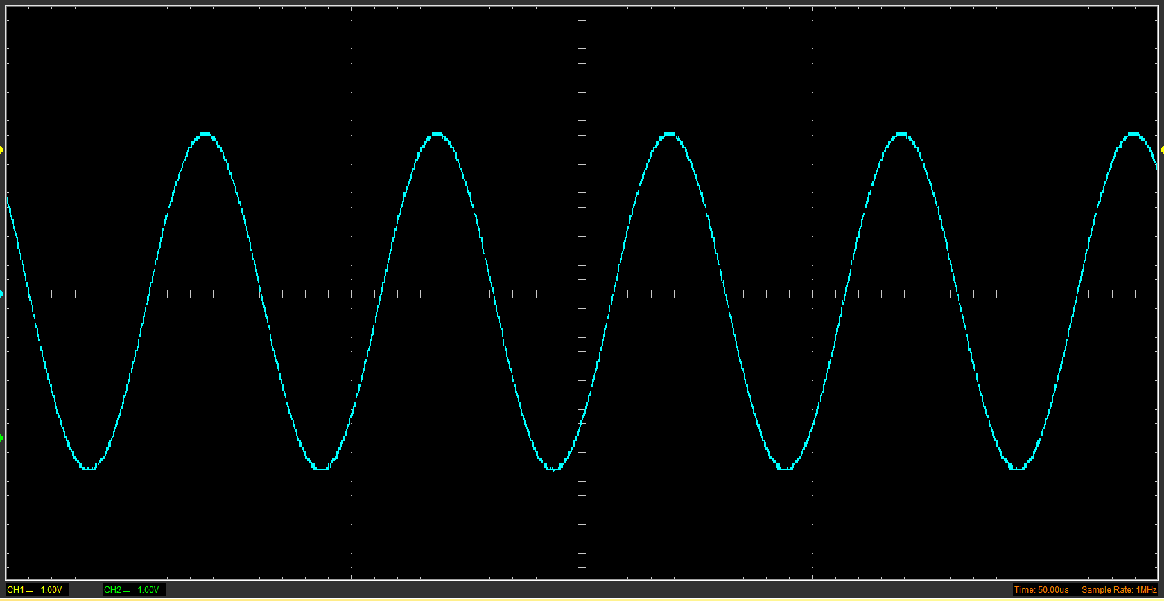

Unsmoothed Rectifier Wave (3)
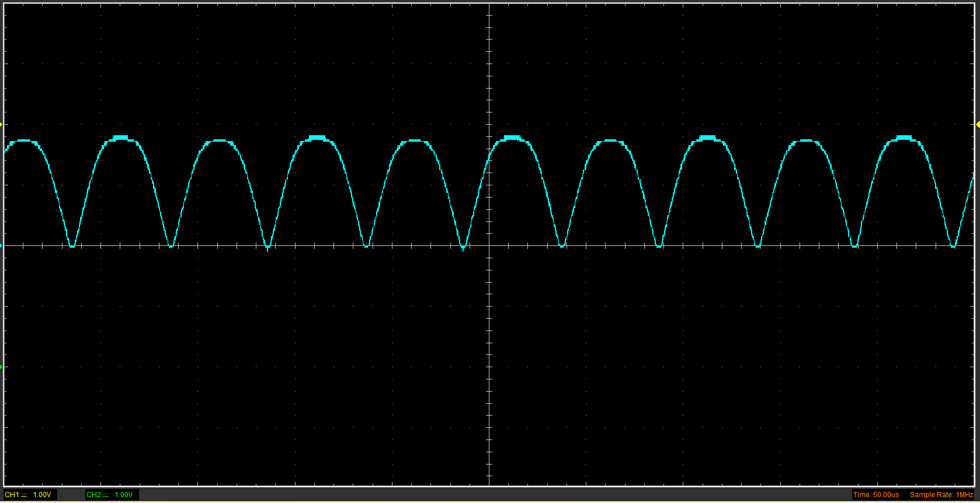

Smoothed Rectifier Wave with capacitor (3)
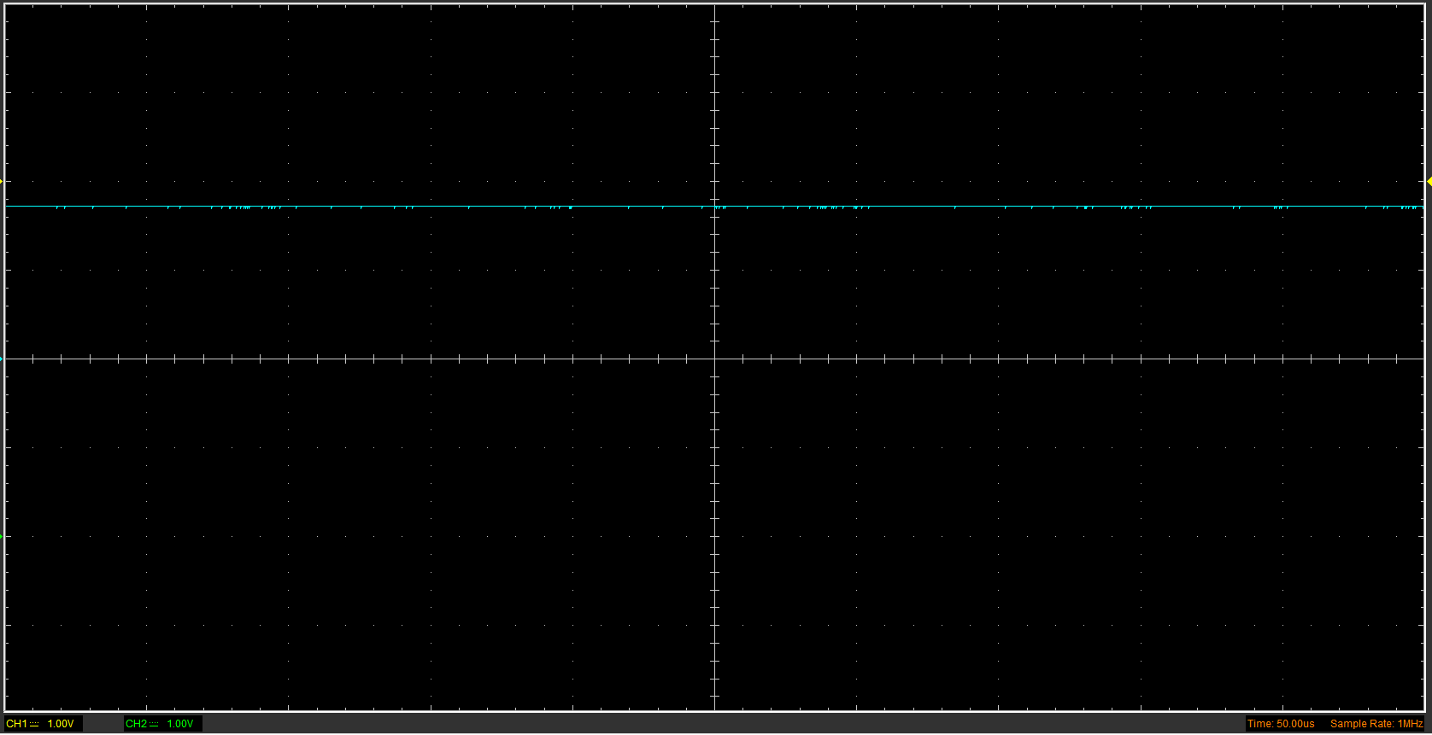

Drop in Voltage Question (4)
The voltage for the rectified circuit is noticeably lower than the peak voltage for the function generator’s sine wave. This is because there was a resistor contained within the full bridge rectifier which was not present within the circuit that produced a sine wave. This meant that the peak voltage in the rectifier circuit was significantly lower.

Different Voltage Readings Question (5)

Rectifiers use in Automotive applications Question. (4)
Rectifier circuits can be found in numerous places in the automotive industry, one of the more obvious places being in the electric vehicle (EV) industry. A DC current is required to charge the lithium-ion batteries which are so commonly used in EVs to store energy, and most EVs don’t contain rectifier circuits between the batteries and the charging port. Therefore, the vast majority of EV charging stations require the use of a rectifier circuit within them, to change the power source of the national grid from AC to DC.
Rectifier circuits of one form or another are also used within ordinary vehicles (internal combustion engine vehicles). The generators used within traditional alternators are spun by the engine usually via the alternator belt. This generator produces an AC current which needs to be converted to DC to power anything electrical that needs it (lights, heater, sensors, radio, etc.). The only way to achieve this is to pass the AC current which comes from the alternator through a rectifier circuit in order to produce the DC current which is necessary for many components within the car to run.

Probing Question (4)

Task 3

Scope Time Division Calculations (4)
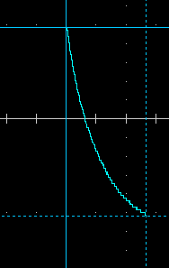
Time division = 50ms/div
5 mini divisions/division
Therefore 1 mini division = 10ms
Mini divisions taken = 2.7
Therefore: time taken = 2.7*10 = 27ms.

Function Generator output square wave (3)

Capacitor charge and discharge wave marked at correct points. (3)

Basic Capacitor Calculations (3)

Capacitor discharge table (4)
Time (s) | Voltage (V) | ln (V) | dy = y2 – y1  dy = ln(V)2-ln(V)1 | dx = x2- x1  dx = Time2 – Time1 | dy/dx
 |  |  | x | x | x

Gradient Plot and calculations (4)

Capacitor Uses (5)

Inaccuracies Question (4)

References
(Format to Harvard style as per handbook)

