Rhodri Wiiams - 1910918

Major Project Proposal
Development of Fast-Make, single use HPT Blades

Contents

1) Reasons for and Relevance of the Project 2

2) Aims of the Project 2

3) Provisional Work Plan 3

4) Background Research 4

5) Details of facilities required 5

6) Details of any cooperative industrial partners. 5

- Reasons for and Relevance of the Project
The expansion of capabilities within the casting business to penetrate new market sectors, including Defence, is driven by the need for strategic diversification and profitable growth. The current market sectors are proving inadequate in terms of profitability, potentially due to intense competition, market saturation, or evolving customer preferences. By venturing into new sectors like Defence, the company aims to mitigate profit constraints, reduce risk, and unlock higher-margin opportunities.
The project's significance lies in its strategic alignment with the company's expansion goals. This move enables the company to diversify its customer base, reducing reliance on a single market and enhancing its long-term sustainability. Furthermore, the project addresses the challenge of profitability by capitalizing on sectors with better profit margins, ensuring improved financial health, and enabling investment in innovation and growth.
The relevance is also underscored by its responsiveness to current market trends. For instance, the Defence sector's potential growth due to geopolitical shifts or technological advancements presents a prime opportunity for the company to establish itself as a trusted supplier. Additionally, the project aids in risk management by diversifying risk across different sectors and bolstering the company's overall resilience.
Ultimately, the project's pertinence lies in securing the company's long-term viability. It positions the business to adapt to changing market dynamics while safeguarding against potential threats posed by underperforming market sectors. By expanding capabilities and entering new sectors, the company is poised for sustained growth, competitiveness, and success in a volatile business landscape.

- Aims of the Project
The aims of the project encompass the advancement of low-cost manufacturing methods for high-integrity components, particularly focusing on engine components used in defence applications. The project's multifaceted goals revolve around embracing agile practices, digitalization, and exploratory research to drive efficient and innovative processes.
The project seeks to transform high-integrity component manufacturing through cost-effective methods. Simultaneously, it adopts a "Fast Make" strategy, expediting Minimal Viable Product (MVP) production for defence engine components. This approach accelerates development timelines while upholding component quality and functionality.
The project seeks to establish a suitable material for the HPT Blades, develop the best practice for manufacture of these parts. This involves the adoption of additive waxes, fast make tooling and methods for burnout and dewaxing will be developed to expedite the process.
- Provisional Work Plan
Below is a simplified Gantt Chart illustrating the tasks to be carried out for this project. For this project I will be looking to use Microsoft Projects for planning, however as I am currently on paternity leave, I do not have access to this software and have had to use a free online planner for the time being.
The Gantt chart below shows the initial planned tasks, however with the development of these parts there will certainly be more to be added as the project progresses as the components are put into manufacture.

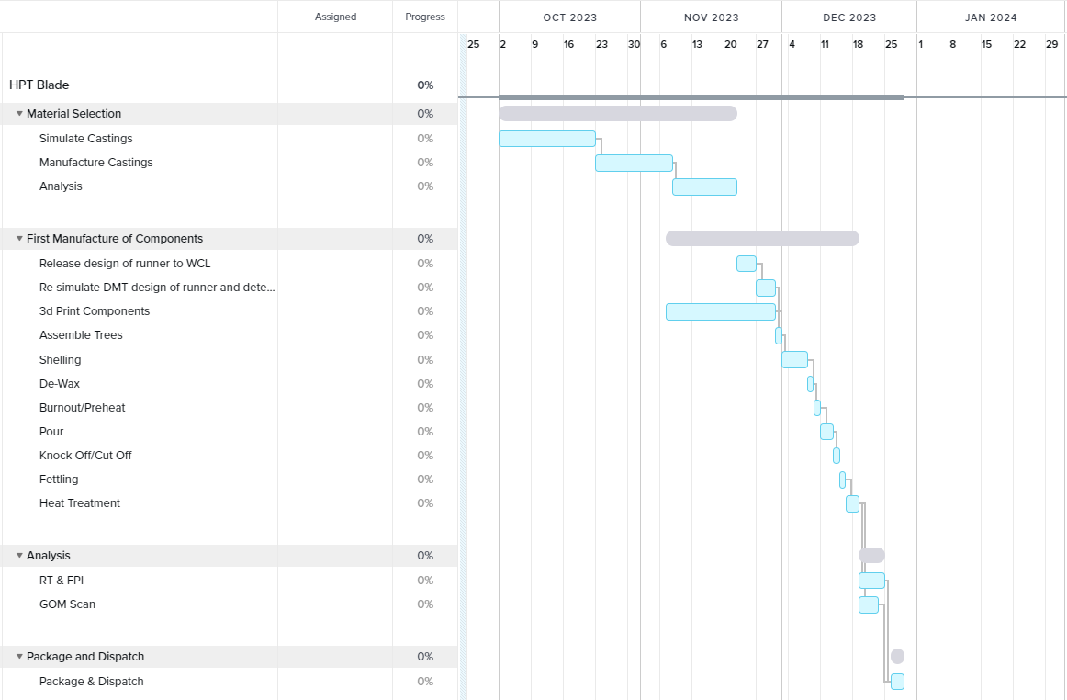

- Background Research
John Campbell – Complete Casting Handbook: Metal Casting Processes, Techniques and Design. This book is extensively used withing the castings department in Wall Colmonoy, and I will be drawing from its wealth of knowledge throughout the project.
- Campbell, J. (2011) Complete casting handbook: Metal casting processes, techniques and Design.: Elsevier Science & Technology.
Below are 3 citations from scientific journals that I will be using for the material selection and analysis section.
- Starink, M.J. and Thomson, R.C. (2001) ‘The effect of high temperature exposure on dendritic segregation in a conventionally cast Ni based superalloy’, Journal of Materials Science, 36(23), pp. 5603–5608. doi:10.1023/a:1012513615622.
- Panigrahi, S.K., Satpathy, S.R.K. and Sahoo, B. (2018) ‘Effect of aluminising on the low cycle fatigue life of a directionally solidified nickel-base alloy used for manufacturing turbine blade’, International Journal of Materials and Structural Integrity, 12(1/2/3), p. 58. doi:10.1504/ijmsi.2018.10014935.
- Dahal, C., Tharu, J.K. and Dura, H.B. (2020) ‘Thermo-structural analysis of high-pressure turbine blade’, Journal of the Institute of Engineering, 15(3), pp. 78–82. doi:10.3126/jie.v15i3.32018.
Below are 2 links from the nickelinstitute.org which contain the data sheets for the two materials that will be trialled.
- ni_inco_534_machiningandgrindingseveralcastnickel_basehigh_temperaturealloys.pdf (nickelinstitute.org)

- MergedFile (nickelinstitute.org)

Details of facilities required including computer software and laboratory support needed to complete this project.

Throughout the project various software packages will be used. Office 365 will be used for Microsoft word, for the word processing, Excel for any spreadsheets and Power Point for the Vivas. Microsoft project will be used to create Gantt charts for planning, however, as explained previously this is not current available to me.

ProCast simulation software will be used to simulate the casting process, along with Autodesk to create component and casting models to import into ProCast for simulation.

Wall Colmonoy’s foundry capacity will be utilised during the project, with the casting being poured using vacuum induction furnace.

Wall Colmonoy’s heat treatment furnace will be utilised to heat treat components.
GOM Inspect Suite is a 3D inspection and measurement software will be used to evaluate the overall quality of the components through comparing CAD models against 3D scan data and creating complete inspection plans through its comprehensive list of inspection tools.
Radiographic Testing equipment will be used for non-destructive testing, as well as fluorescent penetrant inspection where fluorescent dye is applied to the surface of the component in order to detect defects that may compromise the integrity or quality of the parts.

Details of any cooperative industrial partners.

1 - Wall Colmonoy Ltd (WCL), Pontardawe, UK
2 - Rolls Royce, Future Projects, Filton, Bristol

Due to the nature of this project being routed in defence with sensitive information to be enclosed an NDA or academic bar is required to keep this project confidential.

