Discuss the role of astrology in the European medieval world using at least two primary sources from either literature or art.

3560 words

Introduction

The translation of works by Ptolemy, Aristotle and Arabic astrologers in the 12th century had what Campion calls ‘revolutionary consequences… on European cosmology – and intellectual thought in general.’ He states that they ‘offered the medieval world an overarching organizing principle of quite extraordinary power.’ This essay will discuss this ‘overarching principal’ in the European medieval world through the ‘window’ of two primary sources: The Creation of the World, by Giusto de’ Menabuoi c.1375 and the Room of the Arts and Planets, painter unknown, in Foligno, 1410. Both these sources are artworks and are used here in light of Gunzburg’s assertion that ‘non-textual documents, such as images, can and should also influence how we understand a period or culture.’ Discussion will focus in particular on the new model of an ordered cosmos offered by Astrology and Astrology’s role as an organizer of Time, as revealed by these sources. It will also propose that one of the roles of astrological images in these works was to inspire the viewer and lead them to a contemplation of the Divine.

Background
Evans has stated that ‘Documents are always written from somebody’s point of view, with a specific purpose and audience in mind, and unless we can find all that out, we may be misled. P80’. Although, to some extent, the purpose of this essay is to discover those ‘points of view’ through the ‘document’ – in this case the artworks – the question of ‘audience’ can be addressed here by referencing Padua during this time as, according to Canova ‘one of the most important cultural and scientific centres in Europe’ where ‘astrology….flourished.’ She states that, in response to the ‘new astrological doctrines… the most important painters chose or were asked to evoke the images of stars, planets and their properties.’ Equally, the Trinci family held a court, that was, according to Dunlop, ‘a small but important centre of the new antique learning’. Hence it seems safe to assume that astrological images were used in a deliberate and sophisticated manner in the artworks under discussion, to be viewed by an audience that would have understood the intricacies and implications of astrological symbology and thought.

Introduction to Primary Sources: The Creation of the World

The Creation of the World is part of a large fresco cycle in the baptistery of Padua Cathedral. The pictorial program includes Paradise (in the bell of the dome) Scenes from Genesis (of which The Creation forms part) around the upper segment of the vault surrounding Paradise, and The Lives of Jesus and John the Baptist, Miracle of Pentecost and motifs from the Apocalypse. Menaboui was commissioned to decorate the Baptistery by Fina di Pataro Buzzacarina, wife of Francesco I da Carrara, lord of Padua from 1350 to 1388, probably for her tomb, which was situated against the West wall and towards which the Creator in Paradise and the figure of the Virgin Mary are oriented.
The Creation shows the Creator against a golden sphere, surrounded by and perhaps supported by angels, (see fig) his right hand is raised, blessing the newly created cosmos, towards which his left hand gestures, as if offering his creation to the viewer’s gaze. Only God’s head, surrounded by a gold halo, enters the dark blue space beyond. At his feet are a series of concentric circles. The outermost circle is dark blue containing the images of the zodiac, inside of which different colored circles follow depicting the planetary spheres. Below the 7 planetary spheres is a red circle – for the sun – and a blue circle with 8 cloud-like shapes depicting the winds. The innermost circle contains a realistic map of the world, one of the first realistic maps to be used in a Creation scene.

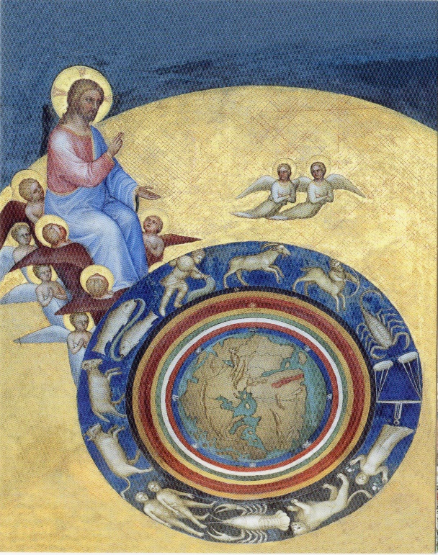
Giusto de’Menabuoi, The Creation of the World

Room of the Stars and Planets
About 400 km south of Padua in Foligno is the Palazzo Trinci. The palace’s painted rooms are dated to around 1410-1415; the artist is unknown, but may have been Gentile da Fabiano. The Room of the Arts and Planets (a modern name for the room, which may initially have been named the Camera delle Rose) has frescoes on all four walls, depicting the Liberal Arts - personified as women sitting on elaborate thrones – and the zodiacal planetary Gods. The sequence is as follows, left to right on entering through the loggia: Rhetoric, Arithmetic, Astronomy, Philosophy (the identity is lost, but it is assumed to be Philosophy), Geometry, Music, Dialectic, Grammar (see fig), The Moon, Mars, Mercury, Jupiter, (see fig) Venus, Saturn, and finally the Sun on the other side of the loggia entrance. (see fig) Below the figures, in a frieze that runs all around the room, are verses in Latin, Greek and French. Small roundels of varying sizes and positions seems to float next to each of the Planetary gods; in each is a depiction of one of the 7 ages of man. (see fig) Around the outside of this image is a green sphere, followed by a sphere half white, half dark, within which is a golden sun, and finally a blue sphere for the circumference.
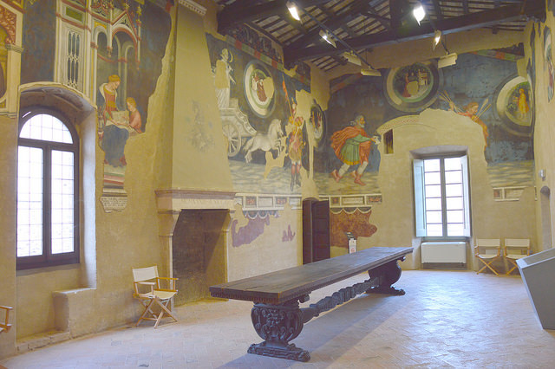
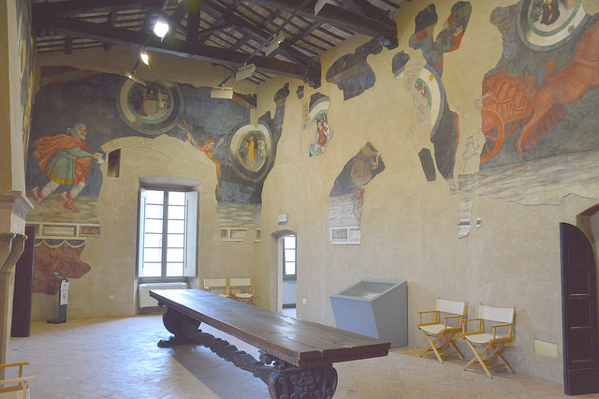

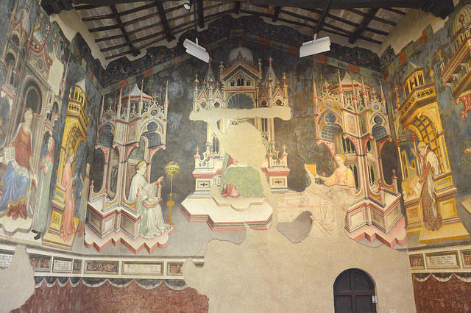

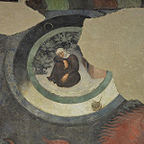

IMPORTANCE
That astrology had an important role is suggested by the centrality of astrological symbols in these two works. In the Baptistery, The Creation stands out amongst the other scenes surrounding Paradise, due to its position in a direct line between The Crucifixion, The Virgin Mary and Paradise (see fig), with the common use of gold providing another visual link. The identical gesture of the Pantokrator’s right hand in The Creation and Paradise is a further emphasis, directing attention not just to The Creation as a whole, but to the object that the Creator is blessing – that is, the zodiacal wheel and planetary spheres with the earth at its centre – the wheel and spheres highlighted visually by the way they echo the circles of Saints around the Pantokrator in Paradise. Astrological imagery here is not just present, it seems to have been accentuated.
In The Room of the Arts and Planets astrological symbols and references dominate, not only in the dynamic planetary gods who race around the room, but also in the emphasis on the figure of Astronomy, who is enthroned next to the central figure of Philosophy, mirrored by Geometry on the other side. These figures would have been ‘brightest of all the figures’, according to Dunlop, due to the layout of the room, positioned as they are opposite the sole source of natural light. She states that they were ‘literally illuminated for the viewer entering the room.’ It should be noted here that although astrology and astronomy were sometimes separated as different – albeit intimately connected – - subjects, the division, even when applied, was not rigid; Moyer notes that, even in scholarly circles, ‘a scholar might use the two terms 'astronomy' and 'astrology' in ways consistent with modern usage, but might also reverse them.’

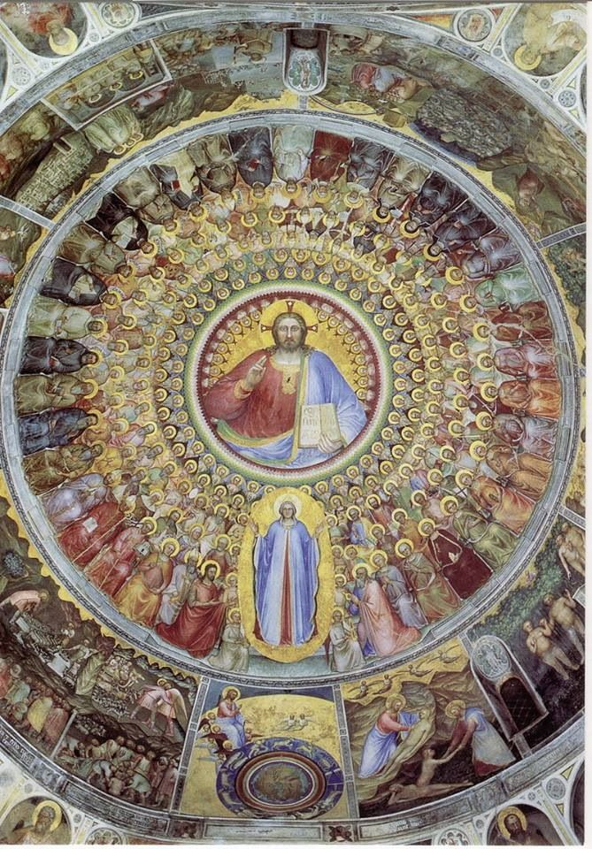

Astrology’s role as science

In The Creation, the cosmos is depicted according to Aristotelian/Ptolemaic tradition and its marriage with Christian tradition, . Thorndike stressed the scientific role of astrology at this time, stating that … during the long period of scientific development before Sir Isaac Newton … [the] universal natural law was astrological.’ Thus in The Creation of the World we have a ‘scientific’ map of the cosmos, perhaps emphasised, if any were needed, by the new realistic map of the world drawn from observation from explorations.
As an illustration of how the cosmos was created, it shows God setting the cosmic spheres in motion. He is both Aristotle’s ‘Prime Mover’ and the God of the Bible. Campion states that this was, at times, an uneasy marriage;
Aristotle’s statement, for example, that ‘For the celestial element as source of all motion, must be regarded as first cause.5’ was, ‘for the medieval mind… a fairly shocking statement.’ But one that could potentially be reconciled by a Platonic reading or by Aristotle’s concession that ‘his First Mover, which initiated all motion in the cosmos, was equivalent to the highest divinity of what he called ‘the more popular philosophical works’.’6
Whether seen as the Prime Mover, God or a synthesis, the figure blesses and seems to offer Creation to the viewer – a view of a new ordered universe. This order includes the ‘incorruptible’ planetary spheres, which act on all beneath them. Although the extent of the power of the planets was a crucial religious point of debate, having potential impact on man’s free will and hence redemption, that there was an influence was potentially acceptable to Christianity through Thomas Aquinas’s statement that ‘matters pertinent to bodily things, whether they are internal or external, when they come through the use of man, are governed by God by means of the angels and celestial bodies. ….

The Aristotelian elements are represented beneath the planetary spheres, Fire (the red sphere of the Sun), Air (the light blue sphere with the winds representing the compass directions) ), Water (the surrounding sea), and Earth, all of which were influenced and bound in a series of connections to the planets. Albertus wrote in 12? ‘The stars… have the power to alter the elements, to change the complexion of men, to affect human mutations, and moreover, to provoke an inclination to action and even to determine the issue of battles’.
Notably God’s head is outside the final sphere (the sphere of the fixed stars or the Empyrean), indicating, perhaps that God was outside of the influence of the planetary spheres and was not bound by ‘scientific’ laws.
The Creation also shows when the universe was made. If the zodiacal wheel is read like a natal chart, the sign of Aries is on the Ascendant, a placement highlighted by the bottom-most edge of an angel’s robe touching the sign. Lipincott states that this is ‘consistent with the Graeco-Latin tradition [where] the Creation of the World was most often linked to the vernal equinox and the zodiacal sign of Aries.’ P7 (but is this Lipincott?) Aries was earlier in the Medieval calendar than now, falling in late February, early Spring, which Lipincott? states would ‘also indicate the time of the Feast of the Annunciation (March 25), which happens within a few days of the vernal equinox’.
Thus one of the roles of astrology, as seen in The Creation, is as a science that explains the very structure of the Cosmos and the forces affecting life on earth.

Astrology’s ROLE as a model of TIME
In Book X of the Timaeus, Plato states that ‘the sun and moon and five other stars, which are called the planets, were created … in order to distinguish and preserve the numbers of time’ and it is to astrology’s role as both symbol and tool of Time keeping in particular, to which this discussion will now turn in greater detail, examining the Room of the Arts and Planets.
If the Creation is in part a map of the cosmos, the Sala can be seen as a map of the cycles of time. Time is a central theme of the Room of the Arts and Planets and is described astrologically, either directly – in the portraits of the gods themselves – or indirectly through the complex system of associations. Here, instead of a depiction the frozen moment of Creation, there is an image of time racing and flowing. The vividly colored planetary gods all face the same way and the course of their movement is begun and ended with the charging horse-drawn chariots of the Sun and Moon.
The Room depicts a complex web of time periods; the passing year is perhaps most immediately apparent, as represented by the Planetary Gods that rule the 12 zodiac signs of the year, but other time motifs are layered in. The days of the week are indicated by the hebdomenal rather than astronomical/astrological order of the Planets, that is, they are in a sequence relating to the days of the week (see below). In the roundels, next to their associated planets, are depicted the 7 Ages of Man. Sears states that ‘Man, the microcosm, was believed to have a sympathy with the planets, to be daily affected by their movements’ and that therefore ‘the idea emerged that each planet had dominion over a single phase of man. Ptolemy, for example, lays out these correspondences in Chapter X of the Tetrabiblos. Speaking of the first age, infancy, he writes:
‘Hence, the first age of infancy, which endures for four years, agreeing in number with the quadrennial period of the Moon, is consequently adapted to her; being in its nature moist and incompact, presenting rapidity of growth, being nourished by moist things, and possessing a highly variable habit. Its mental incompleteness is likewise in accordance with its familiar relation to the Moon, and her operative influence.’
Within the outer circumference of each roundel, the associated symbolic position of the sun is shown, marking one day from dawn to dusk. The sequence is as follows:
Moon, Monday, 7 o’clock, Senescence
Mars, Tuesday, 9 o’clock, Infancy
Mercury, Wednesday, 11 o’clock, Adolescence
Jupiter, Thursday, noon, Youth
Venus, Friday, 1 o’clock, Maturity
Saturn, Saturday, 2 o’clock, M?
Sun, Sunday, 8 o’clock, Old Age
Intriguingly, however, in this Room, the ages of Man do not link up with traditional associations. Only Mercury, associated by Ptolemy with the ages 4-14, could be recognised in ‘Adolescence’, the roundel next to Mercury in the Room. This lack of order in a room that seems to be a celebration of order, raises questions and highlights Evans’ statement that ‘the language of historical documents is never transparent, and historians have long been aware that they cannot simply gaze through it to the historical reality behind.’ 104. Perhaps the schema was simply dictated by the fact that, having chosen to place the planets in hebdomenal order it was impossible to have the ‘traditional’ associations of ages with each planet, if the ages were to read chronologically. The painter could, nonetheless, have begun the cycle with Moon’s traditional association of infancy – instead he chose to begin with old age. Blume has documented how these roundels were influenced by Francesco da Barberino’s cycle of the ages of man, which they closely resemble, and Sears has suggested that perhaps it was fidelity to Alberto’s illustrations that dictated this schema. Dunlop states that ‘The program is essentially that of a codex,’ and later concludes it was a poetic choice. While this may indeed be the case, perhaps there is an underlying rationale, as yet undiscovered, such as that proposed by Gunzburg to explain the astrological motifs of the Palazzo della Ragione in Padua, which had been assumed by Canova and others to be simply ‘creative confusion’ and ‘fantasy rather than … scientific rigour’ p122. 127
The Room of the Arts and Planets bears witness to astrology’s power as an organizing and linking principal; the central figures of the planetary gods link the microcosm to the macrocosm, a single day to a year, a human life to the great cycles of planetary time. Even sacred time is noted in the canonical hours – the traditional hours for monastic prayer - which are also layered in to the schema, referenced in the text underneath the images. Prime, for example, is associated with the first prayer of the morning and is next to the figure of the Moon. In this way the round of Christian prayer and the Christian day also form part of the all-encompassing astrological system of cosmic order.

5. TIME TO ORDER - TRANSCEND

The final section of this essay will look at the role of Astrological thought as a source of inspiration and transcendence in the Medieval period, suggesting evidence of this role in both the primary sources. That Astrology had a transcendent role in Classical thought is explicitly stated by Ptolemy:
‘With regard to virtuous conduct in practical actions and character, this science [astronomy], above all things, could make men see clearly; from the constancy, order, symmetry and calm which are associated with the divine, it makes its followers lovers of this divine beauty, accustoming them and reforming their natures, as it were, to a similar spiritual state.’
Aristotle similarly stated that ‘God devised and bestowed upon us vision to the end that we might behold the revolutions of Reason in the Heaven and use them for the revolvings of the reasonable that is within us'. Hence in The Creation, Giusto may have intended the image of the regular, harmonious spheres to inspire its Medieval audience to a similar state of vituous contemplation. In the Room of the Arts and Planets, the misery of old age and inevitable death are emphasised in the texts under the images. Even the text under Infantia speaks of the “misfortune and misery of life,”’ whilst the text under the final text speaks of cruel death extinguishing everything. If a lifetime speeds by, as the planetary gods do in this room, then perhaps the painter meant to emphasise that which doesn’t move - the still figures of the enthroned Arts, in particular Astronomy and Geometry, which as was noted earlier, are literally and figuratively central sources of illumination in the room.
A very particular source of visual inspiration might have been intended in the Creation through the map of the world and an implied association to Astrology’s traditional role in determining the sacred calendar. Jacob describes cartography in the early Medieval era, noting that maps were primarily used as illustrations in computas documents – the complex calculations undertaken to establish the date of Easter. He states that
‘The idea of the map was gradually pulled by its association with the computus materials into representing time, so that the two aspects of the physical world-time and space-are presented in harmony with one another. As they looked up to the stars and reflected on the great slow cycles of time … computists turned, in a similarly contemplative state of mind, to the terrestrial ball on which they stood. Their sweeping world view of time, eternity and the world from the Creation to the Last Judgement is to be found on the maps included in the medieval computus manuscripts.’
Without contemporary reports, it is impossible to know if such a link was made in the mind of the medieval viewer who stared up at the Baptistery ceiling and whether they would have been moved to a similar state of wonder by astrological and Biblical associations made to the map of the world. It is perhaps a tenuous link, but one that seems possible, given the themes of death and resurrection already established visually (as discussed above and shown in fig) in the linked vertical layout of The Crucifixion, The Creation and Paradise. As the scenes face the commissioner’s tomb, the theme of the Resurrection, hinted at perhaps through an association of the map of the world with computas and Easter, might have been apt.

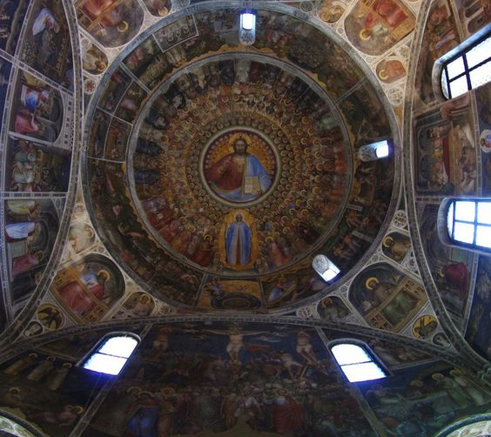
big one pippa-pppx.deviantart.com

6. CONCLUSION

Two primary source documents were used, both artworks, to discuss the role of astrology in the Medieval Age: Giusto de The Creation of the World in the Padua Baptistery and The Room of the Arts and Planets, painter unknown, in Foligno. Both artworks were shown to have been made in a milieu that was steeped in the new astrological learning that flooded European cultural centres in the 12th century and it was therefore assumed that these artworks not only represented this learning but were made to be understood by their audience.
The role of Astrology as medieval science was discussed through the representation of the structure of the universe and planetary influences on mankind in The Creation as well as some aspects of astrology’s ‘marriage’ with Christian theology. Also discussed was Astrology’s role in the functioning – and understanding – of Time in all its manifestations, through the compositions in the Room of the Arts and Planets, as well as the potent power of astrological concepts to unite seemingly disparate elements. Finally it was suggested that the astrological references in both works served to inspire the viewer to rise above the mundane in contemplating Aristotle’s ‘Revolutions of the Reasonable in Heaven,’ which was noted as a primary purpose of astrology in classical texts, and which in the Medieval period was merged with contemplation of the Christian God who stood outside the astrological influences and laws. In conclusion, these works demonstrate what Campion called the ‘extraordinary power’ of astrology in the Medieval ages as an overarching organizing principle, as well as a rich and potent symbolic language.

BIBLIOGRAPHY
Aquinas, Thomas, Summa Contra Gentiles, trans James F. Anderson, Notre Dame and London: University of Notre Dame Press, 1975, books two and three, extracts.
Book 3, chaps 84 – 100, 104.
http://dhspriory.org/thomas/ContraGentiles3b.htm

Bonatus, Guido, 'Considerations' trans. William Lilly, London 1676.
http://www.hermetics.org/pdf/astrology/Guido_Bonatus_-_Anima_Astrologiae.pdf
Paras 1,2,3, 7, 10, 11, 12,

Campion, Nicholas, A History of Western Astrology Volume II, The Medieval and Modern Worlds, (London: Continuum, 2009)

Canova, Giordana Mariani Canova, ‘Padua and the Stars: Medieval Painting and Illuminated Manuscripts’, The Inspiration of Astronomical Phenomena VI, ASP Conference Series, Vol. 441. San Francisco: Astronomical Society of the Pacific, 2011) p.111
Edited by Enrico Maria Corsini.
Bonatti

Dunlop, Anne, Painted Palaces: The Rise of Secular Art in Early Renaissance Italy, (Pennsylvania: Pennsylvania State University Press, 2009)
Edson, Evelyn, World Maps and Easter Tables: Medieval Maps in Context, Imago Mundi, Vol. 48 (1996), 25-42
Evans, Richard, In Defence of History, (London: Granta Books 1997)
Gunzburg, Darrelyn, ‘Giotto’s Sky: The Fresco Paintings of the First Floor Salone of the Palazzo della Ragione, Padua, Italy’, Journal for the Study of Religion, Nature and Culture, Vol 7, No 4 (2013)
Gunzburg, Darrelyn, ‘The Perugia Fountain: an encyclopedia of sky, culture and society’. Accessed June 29, 2018 https://www.academia.edu/4437780/The_Perugia_Fountain_An_Encyclopaedia_of_Sky_Culture_and_Society
Isidore of Seville

Laistner, M. L. W., ‘The Western Church and Astrology during the Early Middle Ages’, The Harvard Theological Review, Vol. 34, No. 4 (Oct., 1941) 251-275
Lippincott, Kristen, ‘Giovanni di Paolo’s ‘Creation of the World’ and the Tradition of the ‘Thema Mundi’ in Late Medieval and Renaissance Art’, The Burlington Magazine, Vol. 132, No. 1048 (Jul., 1990) 460-468

Plato, Timaeus, trans. R.G.Bury, Cambridge Mass., London: Harvard University Press, 1931.
http://classics.mit.edu/Plato/timaeus.html

Ptolemy, Claudius, Tetrabiblos, trans. F.E.Robbins, Cambridge Mass., London: Harvard University Press, 1930, esp. Book 1.
Book 1 Chap 1-18; Book 2, chaps 1-11; Book 3, chaps 1 to 13.
http://www.kronosofia.dk/frames/side/biblioteket/tetrabiblos/tetrabiblos.html

McCluskey, Stephen C., ‘Gregory of Tours, Monastic Timekeeping, and Early Christian Attitudes to Astronomy’, Isis, Vol. 31, No. 1 (Mar., 1990), 8-22
Poeschke, Joachim, Italian Frescoes: The Age of Giotto 1280-1400, (New York, London: Abeville Press Publishers, 2005)

Sears, Elizabeth, The Ages of Man: Medieval Interpretations of the Life Cycle, (New Jersey: Princeton University Press, 1986)

Gunzburg Giotto, p408.
Canova, Giordana Mariani, ‘Padua and the Stars: Medieval Painting and Illuminated Manuscripts’ p111.
Dunlop p85
Italian Frescoes, p404
P405
Italian Frescoes p405
P210 Siena, Florence, and Padua: Interpretative essays edited by Diana Norman Yale University Press, 1995 Chapter 10 Astrology, antiquity and empiricism: art and learning Diana Norman P210 Siena, Florence, and Padua: Interpretative essays edited by Diana Norman Yale University Press, 1995
Spiazzi 2000 wherever that is. and Poeschke
Painted Palaces page 75
Dunlop p74
Painted Palaces p74
P228, 229 The Astrologer’s Game
Is this in the thema mundi paper?
Map paper
THOMAS AQUINAS1 Nick p48
Timaeus http://classics.mit.edu/Plato/timaeus.html GET BETTER TIMAEUS
Sears page 48
Evans, p104
Blume, Dieter, p20, 21
(Timaeus 47B-C) Nick chapter 4 p43.
Sears p106
The Sovereign Map: Theoretical Approaches in Cartography Throughout History, University of Chicago Press (google books) By Christian Jacob, p 111 speaks of the 8 winds

