Vehicle to grid technology

Greig Western 1804348
Abi Summerfield
UWTSD Swansea

22/11/21

Automotive materials and sustainability
ACHA6012
Table of Contents

Abstract 3
Introduction 3
Current climate 4
Current V2G 4
Feasibility for Swansea bus depot 6
Costs 9
Conclusion 10
Bibliography 11

Abstract

This analysis reviews the feasibility of using a Vehicle to Grid (V2G) system for the Swansea bus depot, focusing on the current global climate, technology available, incentives and costs involved in implementing the system. Evidence was sourced from studies into fuel usage of buses, V2G programmes, current UK and local grid capabilities, and a cost analysis using up to date data. The analysis concluded that V2G is not currently a viable option for road going public transport due to the nature of peak hour demand being at the same time as peak requirement for buses during the working day. Accompanying this is the vast sums of money required to implement the system through additional or upgraded infrastructure, installation costs of V2G charging points, and the cost of the batteries themselves, alongside the cost of converting the buses, or buying new buses. V2G is, however, more likely to be used by companies such as First Bus to charge the grid from their employee’s vehicles during working hours. This utilisation of the technology could not only pay for itself providing a common charging system is agreed upon by EV manufacturers but could also reduce overheads for companies afterwards allowing for increased future investment and decreased rates for passengers. Agreeable side effects of this would be a reduction in required vehicles on the roads, requiring less lithium mining and less charging requirement from the grid.

Introduction

In a bid to reduce the load on the national grid during a time of increasing automotive electrification there has been a focus on vehicle to grid (V2G) technologies. This system would allow previously charged vehicles to boost the grid whilst plugged in during times of greatest need by the grid. The boost in available energy not only reduces the requirements of power stations to produce higher peak power levels, in turn reducing the reliance on fossil fuel-based energy, but also reduces the storage requirement in the system, as vehicles will be used as storage instead.
Here, the feasibility of this system will be analysed, with focus on a theoretical V2G system used by a local bus depot in Swansea.

Current climate

The climate is a top priority for governments and companies around the world. At the time of writing COP26 (26th Conference Of the Parties) is the latest global meeting of governments to try to reduce the rate of global warming to 1.5 degrees Celsius. The goals of this meeting included the acceleration of the phase-out of coal, curtailing deforestation, to increase the uptake of electric vehicles and to protect and restore ecosystems (COP26 Goals - UN Climate Change Conference (COP26) at the SEC – Glasgow 2021, 2021). These goals can be easier met with a system in which new power stations are not required to deal with additional loads of peak use, in terms of not only the raw materials and fossil fuels used in the building of such structures, but also the fuels used to create the energy once built. New areas of land will not need to be cleared to create structures of power generation or storage, and, with monetary incentives for plugging in an electric vehicle to the grid during peak periods and discounts on charging during off peak, along with the ever-increasing cost of fuel at the pumps, people should make the change to electric vehicles in a timely fashion.
Electric vehicles, however, are coming under scrutiny for the mining of the raw materials required to make the batteries required to power the vehicles. Lithium, nickel and cobalt are among the materials required, however, the production of these is often ruinous to water, land, people and wildlife (Penn and Lipton, 2021) as local ground water is used to flush the Lithium through, with the possibility of a 300-year long contamination. Miners are now taking to extracting Lithium from salt lakes to reduce the impact on the environment, such as the plans to extract Lithium from the Salton Sea in California through the use of high temperature liquid and coated beads. There will come a time, however, when batteries must be made from a more sustainable source, as the current estimate is of 14 million tonnes worldwide in Lithium reserves, and with mining rates ramping up with the expansion of electrification, todays Lithium mining figure of 85000 tonnes per year is sure to increase exponentially. Indeed, the increase in Lithium production increased by 335% between 2008 and 2018 (Lithium mining: What you should know about the contentious issue, 2021).

Current V2G

In April 2018 the Office for Low Emission Vehicles (OLEV) funded Project Sciurus to roll out V2G to homes across the UK (Case study (UK): Electric vehicle-to-grid (V2G) charging, 2021). Whilst the only vehicle eligible for this test was the Nissan Leaf due to restrictions in charging technology, reducing the take up of the scheme, it was shown that the recharge rate of 30p per KWh to the customer could net an average of £725 per year per customer as an incentive to use the system, however, the cost of installation of a V2G charging point was approximately £3700 more than a regular charging point, but it is expected that this differential will fall to £1000 in the near future. The results of this project showed that as technology advances and potential incentives increase for customers, there is potential to entice customers to V2G to bolster the grid, with the potential to save £3.5 billion per year in storage, generation, infrastructure and reinforcement.

Fig 1. (cenex.co.uk, 2021)

V2G can also be used in times of crisis. Indeed, in 2010 electric vehicles were sent to the Fukushima region of Japan to provide power to residents for heating and electricity in their homes after the nuclear reactor fault (Why V2G holds the key to the electric vehicle revolution | Reuters Events | Sustainable Business, 2021).

Feasibility for Swansea bus depot

The electrical power demand of a bus can be assumed from the energy requirements from the fuel used by a bus during a day of work. Rohani, M studied the fuel consumption of 2 types of buses during the working day based on different driving styles. These figures will give a range of required power requirements for each bus, with a best and worst case scenario. Table 1 shows the fuel economy for each bus and driving style.

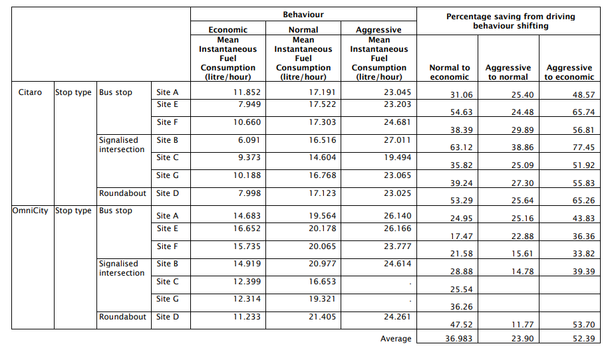
Table 1. Mean of instantaneous fuel consumption and percentage of fuel consumption saving from driving behaviour shifting (Rohani, 2012)

From this study the average economy can be calculated:

Omni city average 13.99 l/hr economical
Citaro average 9.15 l/hr economical

From these figures the energy requirement can be calculated for each bus. Diesel has a specific energy of 45.5MJ/kg (Differences between diesel and petrol explained, 2021). This must then be calculated to litres from kg. Diesel has a specific mass of 0.82kg per litre (Conversions :: Commercial Fuel Solutions Ltd, 2021). So, for the Omni City:

13.99*0.82=11.47 kg/hr

11.47*45.5=521.89MJ/hr=144.969KW average output.

To evaluate the bus for a full day, this must be multiplied by the hours worked. The example used is for the route 24 bus in Swansea. The bus route schedule shows the first and last stop times as 0820hrs and 1828hrs (Timetables | South & West Wales | First Bus, 2021). This gives a day of 10 hours 8 minutes without travel to and from depot. An assumption of 11 hours has been made.
(Timetables | South & West Wales | First Bus, 2021)
Due to drivers’ hours regulation a 45 minute break has also been removed from this time to give an overall time of 10hrs 15 minutes.

521.89*10.25=5349.37 MJ of energy used.

The fastest EV charger found is the CCS type at 350KW (Learn about different EV connections | Smart Home Charge, 2021). 350KW converts to =350000 J/s. With this information and the energy requirement the charging time can be calculated:

5349370000/350000= 15283.9 seconds

15283.9/60=254.73 mins

254.73/60=4.2 hours recharge.

The CCS charger, however, only is only rated at 350KW as a maximum, it is rated from 50KW at the lower end, so for 50KW:

5349370000/50000=106987.4 seconds=1783.1minutes=29.7 hours recharge.

Rohani, M found the average fuel consumption of the bus to be 92.92 litres diesel daily. Using the specific energy of diesel to verify the above calculations:

45.5/0.82=55.49MJ/l
55.49*92.92=5156.13MJ

This figure closely resembles the figure calculated above based on the Swansea timetable, confirming assumptions.

If the vehicle is on the road for 11 hours per day, then 13 hours remain in any 24-hour period. As the calculated 50KW charging time is in excess of this figure it cannot be deemed suitable. Using the available downtime, the minimum power output of the charger can be calculated:
13 hours=46800seconds, 5349MJ/46800=114.3kW just to satisfy the charging demand, with no downtime for vehicle maintenance etc.

This report is looking at V2G, however, so there must be time to recharge the grid from the vehicle, yet also have enough energy in the battery for the next day’s work. Therefore, the system must be able to fully charge, fully discharge, and fully charge again to ensure that the bus can carry out it’s duties the next day.

The 350kW charging rate will allow a full charge, discharge and full charge again if required at 4.2 hours*3=12.6 hours. However, at present, only ChAdeMO chargers are viable for V2G as they are birectional (UK Electric Vehicle public charging infrastructure 2021, 2021). At present, these chargers are limited to 50KW. The continued calculations will, however, assume that with future progress in technology, the 2-way system will work at 350KW.

The Swansea depot has 56 buses, 53 of which run all day, the other 3 services one route per day, and as such, these will be discounted (Swansea Services | South & West Wales | First Bus, 2021).

Using this information, the energy requirement for the depot can be calculated:
Circa 5500MJ*53=291500MJ daily energy requirement.
Divide by 46800 for 13 hours overnight charging = 6.22MW power requirement
Multiply by 3 for full charge/discharge/charge cycle = 18.66MW

For reference, Hinckley point B 1&2 output = 945MW (UK nuclear power stations: operational capacity 2020 | Statista, 2021) if both generators working, however, on 20/10/21 the output was 459MW as one generator was offline. (Power station daily status, 2021)

To correctly check for feasibility, the energy requirement must be deliverable by the substation closest to the depot. There are 22 substations in Swansea (Western Power Distribution - Network Capacity Map Application, 2021) of which 5 had the substation demand headroom available on 4/11/21 at 13:30 hrs. As the requirement for EV charging stations grows in the city, this number will reduce without further expenditure on infrastructure.

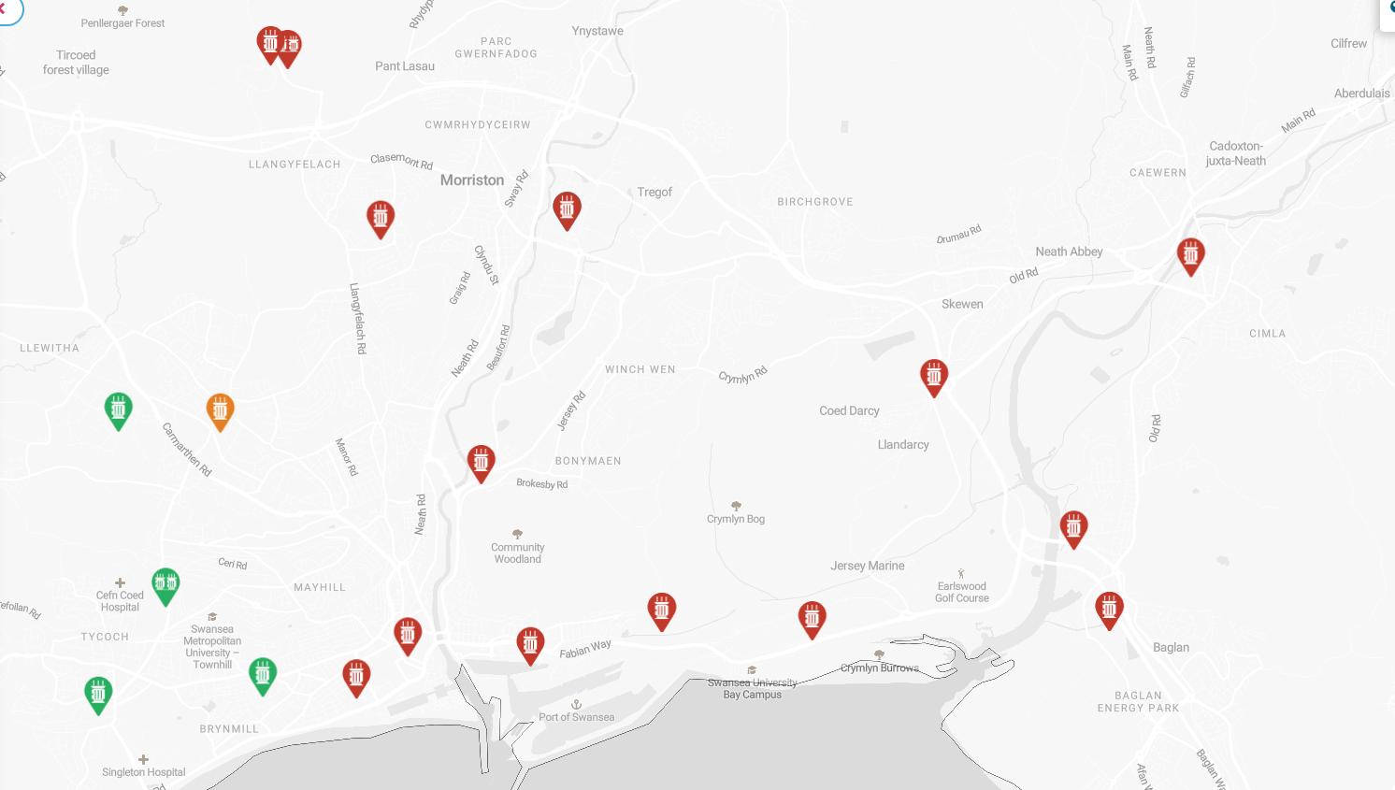
Fig 2. Swansea substation locations (Western Power, 2021)

Costs

Table 2 shows the cost of additional infrastructure required if the bus depot were to have its own supply. To convert from MVA to MW, the general conversion factor is 0.8 (How Do I Convert Amps to Kw 3 Phase?, 2021), therefore the requirement here is 18.66/0.8= 14.93MVA. This should be rounded to 15MVA in this case, making the cost of installation between £1.05 million and £1.8 million based on £70000-120000 per MVA.

Table 2. (A guide on electric vehicle charging and DNO engagements for local authorities, 2021)

The cost of batteries in 2020 was $137/kWh (Edelstein et al., 2021)), and with each vehicle requiring approx. 5500MJ of energy the cost of each battery can be ascertained:

1 KWh= 3.6MJ
5500/3.6=1527.8.KWh
137*1527.8=$209,305.56 battery cost for each vehicle. This equates to approx. £154,920 (209,305.56 USD to GBP - US Dollars to British Pounds Exchange Rate, 2021) as of 4/11/21.
The depot would therefore require 53 of these batteries at a total cost of £8.21 million.

Each vehicle charger would also cost £5000 at todays’ rates (Why V2G holds the key to the electric vehicle revolution | Reuters Events | Sustainable Business, 2021) which would equate to an overall cost of £265000 for one system per vehicle.

The cost to convert each bus to electric is €300000-€350000 (Retrofitting instead of new-built: conversion from diesel to electric buses - Urban Transport Magazine, 2021) which is approximately half the cost of a previously converted vehicle. The cost for the depot would be circa £13.5 million (xe.com, 2021)

Conclusion
Whilst there are valid reasons to utilise V2G for vehicles which will lay otherwise dormant during periods of the peak demand hours, or for temporary energy requirements after electrical blackouts due to natural or technological disasters, the system is not a universally sound model for public transport currently. The high cost of installation of not only the chargers, but the infrastructure and vehicle conversion costs would currently be likely to discourage a bus company from investment. The total cost for this one depot would be in excess of £23.75 million. The total revenue for First Bus in 2020 was £835.9 million (FirstGroup: annual revenue by segment | Statista, 2021) meaning that short of a substantial investment from the government it would be unlikely to be cost efficient at this time to invest over £20 million per depot. If the buses were to be plugged into the V2G system during on peak hours, there could be a potential of £23000 revenue per day from the 30p per KWh incentive. However, as the buses are required to work during these times this would not be a valid reason to convert the vehicles.
V2G could potentially be installed at a work address for employees to charge their own vehicles during the daytime, with the company recouping the incentive in order to pay for the installation costs. This, however, would be dependent on either the employees all driving vehicles with the same charging ports, or, as has become the norm in other technologies such as IT and the USB port, a consensus by manufacturers on a common charging port type. Should this system be integrated into the workplace it has the potential to decrease the cost of bus travel due to an increase in revenue. This in itself would be an incentive for passengers to use buses more often, again, reducing the need for vehicles to be driven during peak hours, increasing the number of vehicles plugged into the V2G system and a reduction in the requirement for ownership of multiple vehicles per household. This would reduce the raw material requirements, which have their own issues due to the limitations on global lithium reserves of approximately 14 million tonnes (Lithium mining: What you should know about the contentious issue, 2021) and of the damage that the mining can have on local habitats and ecosystems through contaminated water sources (Nast, 2021).
V2G does have the potential to assist in the goals of the global community to reduce emissions and protect the planet from further harm and climate change, and, used correctly could help with the aims of COP26 and further conferences in the future.

Bibliography
ACEA - European Automobile Manufacturers' Association. 2021. Differences between diesel and petrol explained. [online] Available at: <https://www.acea.auto/fact/differences-between-diesel-and-petrol/#:~:text=The%20calorific%20value%20of%20diesel,to%2033.7%20MJ%2Flitre).> [Accessed 20 October 2021].

Commercialfuelsolutions.co.uk. 2021. Conversions :: Commercial Fuel Solutions Ltd. [online] Available at: <https://www.commercialfuelsolutions.co.uk/conversions.html> [Accessed 20 October 2021].

Firstbus.co.uk. 2021. Timetables | South & West Wales | First Bus. [online] Available at: <https://www.firstbus.co.uk/south-west-wales/plan-journey/timetables/?day=1&source_id=2&service=24&routeid=23852309&operator=24&source=sp> [Accessed 20 October 2021].

Firstbus.co.uk. 2021. Timetables | South & West Wales | First Bus. [online] Available at: <https://www.firstbus.co.uk/south-west-wales/plan-journey/timetables/?day=1&source_id=2&service=24&routeid=23852309&operator=24&source=sp> [Accessed 20 October 2021].

Statista. 2021. UK nuclear power stations: operational capacity 2020 | Statista. [online] Available at: <https://www.statista.com/statistics/438980/operational-capacity-uk-nuclear-power-stations/#:~:text=Of%20the%20UK%E2%80%99s%2015%20nuclear%20power%20plants%2C%20the,was%20recorded%20at%20the%20Sizewell%20B%20nuclear%20plant.> [Accessed 20 October 2021].

EDF. 2021. EV: Batteries. [online] Available at: <https://www.edfenergy.com/electric-cars/batteries> [Accessed 20 October 2021].

EDF. 2021. Power station daily status. [online] Available at: <https://www.edfenergy.com/energy/power-station/daily-statuses> [Accessed 20 October 2021].

Rohani, M., 2012. Bus driving behaviour and fuel consumption. Doctorate. University of Southampton.

Smart Home Charge. 2021. Learn about different EV connections | Smart Home Charge. [online] Available at: <https://www.smarthomecharge.co.uk/features/ev-basics-electric-car-charging-connections-explained/?it=guides/ev-basics-electric-car-charging-connections-explained/> [Accessed 4 November 2021].

Western Power Distribution. 2021. Western Power Distribution - Network Capacity Map Application. [online] Available at: <https://www.westernpower.co.uk/our-network/network-capacity-map-application> [Accessed 4 November 2021].

Deloitte United Kingdom. 2021. UK Electric Vehicle public charging infrastructure 2021. [online] Available at: <https://www2.deloitte.com/uk/en/pages/energy-and-resources/articles/uk-ev-charging-infrastructure-update-show-me-the-money.html> [Accessed 4 November 2021].

2021. A guide on electric vehicle charging and DNO engagements for local authorities. Western Power Distribution.

Sciencing. 2021. How Do I Convert Amps to Kw 3 Phase?. [online] Available at: <https://sciencing.com/do-amps-kw-3-phase-8613652.html> [Accessed 4 November 2021].

Edelstein, S., Edelstein, S., Writer, S., Edelstein, S., Edelstein, S., Halvorson, B., Halvorson, B., Edelstein, S., Edelstein, S., Halvorson, B., Wong, B., Edelstein, S., Edelstein, S., Halvorson, B., Edelstein, S., Editor, B., Writer, S., Editor, B., Writer, S. and Manager, J., 2021. EV battery pack prices fell 13% in 2020, some are already below $100/kwh. [online] Green Car Reports. Available at: <https://www.greencarreports.com/news/1130681_ev-battery-pack-prices-fell-13-in-2020-some-are-already-below-100-kwh> [Accessed 4 November 2021].

Xe.com. 2021. 209,305.56 USD to GBP - US Dollars to British Pounds Exchange Rate. [online] Available at: <https://www.xe.com/currencyconverter/convert/?Amount=209305.56&From=USD&To=GBP> [Accessed 4 November 2021].

Ofgem. 2021. Case study (UK): Electric vehicle-to-grid (V2G) charging. [online] Available at: <https://www.ofgem.gov.uk/publications/case-study-uk-electric-vehicle-grid-v2g-charging> [Accessed 15 November 2021].

Cenex.co.uk. 2021. [online] Available at: <https://www.cenex.co.uk/app/uploads/2021/03/Project-Sciurus-Infographic.pdf> [Accessed 15 November 2021].

Reutersevents.com. 2021. Why V2G holds the key to the electric vehicle revolution | Reuters Events | Sustainable Business. [online] Available at: <https://www.reutersevents.com/sustainability/why-v2g-holds-key-electric-vehicle-revolution> [Accessed 15 November 2021].

UN Climate Change Conference (COP26) at the SEC – Glasgow 2021. 2021. COP26 Goals - UN Climate Change Conference (COP26) at the SEC – Glasgow 2021. [online] Available at: <https://ukcop26.org/cop26-goals/> [Accessed 15 November 2021].

Statista. 2021. FirstGroup: annual revenue by segment | Statista. [online] Available at: <https://www.statista.com/statistics/955430/firstgroup-annual-revenue-by-segment-uk/> [Accessed 15 November 2021].

Urban Transport Magazine. 2021. Retrofitting instead of new-built: conversion from diesel to electric buses - Urban Transport Magazine. [online] Available at: <https://www.urban-transport-magazine.com/en/retrofitting-instead-of-new-built-conversion-from-diesel-to-electric-buses/> [Accessed 15 November 2021].

Volkswagenag.com. 2021. Lithium mining: What you should know about the contentious issue. [online] Available at: <https://www.volkswagenag.com/en/news/stories/2020/03/lithium-mining-what-you-should-know-about-the-contentious-issue.html> [Accessed 15 November 2021].

Nast, C., 2021. The spiralling environmental cost of our lithium battery addiction. [online] WIRED UK. Available at: <https://www.wired.co.uk/article/lithium-batteries-environment-impact> [Accessed 15 November 2021].

Penn, I. and Lipton, E., 2021. The Lithium Gold Rush: Inside the Race to Power Electric Vehicles. New York Times, [online] Available at: <https://www.nytimes.com/2021/05/06/business/lithium-mining-race.html> [Accessed 16 November 2021].

