

Module name: Organisational Consultancy
Module Code : BMIH6005
Title: Moxy Bucharest Old Town Report
Student name: Monica Clementina Radu
Student number: 2209717
Lecturer’s name: Jaliya De Silva
Word Counted: 6405

Executive Summary
The problem or issue at stake
The consultancy report has been developed in terms of identification of issues that are being faced by Moxy Bucharest Old Town in their business operation. It is being witnessed that the hotel is facing issues in terms of their offered service including poor staffing and cleanliness. However, the hotel also lacks facilities like an elevator, no water pressure in the shower, no bell carts for carrying luggage and no safety in the room, which is a manifestation of poor customer service. Additionally, the employees of ‘Moxy Bucharest Old Town' lack the necessary training to provide high-quality services. Senior management must also be concerned with hotel amenities, such as the availabulity of lifts in proportion to the building's size and making sure that in-room services are hygienic.
However, the negative feedback has the potential to destroy the reputation of ‘Moxy Bucharest Old Town', which could lead to a decline in business. Loss of market share, financial capital, and social capital are all instances of reputational loss. This element may have a detrimental effect on ‘Moxy Bucharest Old Town' reach and income level due to the poor customer service.
Findings
In this report, frameworks such as PESTLE, SWOT and TWOS have been used in order to analyse the internal as well as the external factors that are affecting the business operation of ‘Moxy Bucharest Old Town’. From the PESTLE analysis, it is indicative that factors such as political, social, technological as well environmental are posing opportunities for ‘Moxi Bucharest Old Town' in terms of conducting their business operations. It can be witnessed that in Romania, the political condition is considered stable, which defines less intervention of the Romanian gouverment in the business operation of ‘Moxy Bucharest Old Town'. Furthermore, the technological market of Romania is well developed and therefore, it is posing a significant strength to the company to integrate distruptive technologies that can be beneficial for getting customer-centric insights. While, from PESTLE analysis, it is also evident that the social factor is also providing opportunities to ‘Moxy Bucharest Old Town' as the consumers are likely to invest in the hoteliers which is beneficial for the hotel brands to bring improvement in their sales volume. Conversely, the economic condition of Romania is condidered to be a threat to the hotel brands, while legal factors are also a key determinant, indicating a loss in their brand reputation. Apart from the external framework, the SWOT and TWOS have proven beneficial for analysing the internalfactors that are affecting the business operations of the hotel brands. It is indicative that the geographic location and the facilities offered are the key strengths of the company. On the other hand, fierce competition, and poor customer service are considered to be weaknesses of the hotel. A strong online presence can be an opportunity for the hotel brand to bring growth to its sales margin.
Analysis of these findings
After analysing the external and internal environment, it can be concluded that a good political condition is a key strength for the company. While, after a prolonged period of the COVID-19 pandemic recesses, customers are now spending in hotels, which is considered to be a positive side to witness growth in the sales margin for ‘Moxi Bucharest Old Town’. Furthemore, since Romania is wintnessing growth in the technological market in terms of AI and IoT, therefore, it can also be proven as a key opportunity for the hotel brand in terms of bringing efficiency to their mode of operation. Conversely, the drop in inflation can be a threat to the hotel brand as Roman populace can deviate and look for other affordable options.
Besides the PESTLE framework, the SWOT framework has analysed the key strengths, weaknesses, threats and opportunities of the hotel brands. Therefore, analysing the factors and based on the key strengths and weaknesses, strategic recommendations can be made based on which the business operations of the hotel brand can be improved.
Recommendations to the client
In this phase, specific recommendation have been provided based on the identification of problematic business issues. Following the prior recommendations, the identification of standardising a proper cleanliness protocol for this hotel with a modern-day solution of sanitisation has been discussed while adding a change management theory like Herzberg's Two-Factor Theory to highlight its impact on strategic improvement. In the second recommendation, employees' motivational factors identification and offering various improvement scopes through an employee engagement program has been discussed in which employees' self-esteem and efficiency have been focused on to increase effective performance on organisational growth. Following the third recommendation, a particular strategy of setting a dynamic price range with value-added services through a simple service pricing structure has been discussed in which a particular amalgamation of the Price elasticity on demand theory has been identified while discussing its potential benefits to increase overall business profitability. Besides, an action plan has also been developed with the help of measuring and achievable points by which the addition of a targeted period and estimated budget has been recognised while focusing on considering specific goals.
Conclusion
In conclusion, specific key findings have been highlighted from problem identification to provided recommendations in which the background of the organisation and key aspects have also been highlighted. Frameworks like PESTLE, SWOT and TOWS have also been constructed in terms of analysing the potential impacts of macroeconomics in this particular business while discussing improvement strategies through prior recommendation. Moreover, the evaluation of success measures with an estimated budget range has also been highlighted through an action plan while discussing potential business opportunities for this particular organisation.

Table of content
- Introduction..................................................................................................6
- Background of the company..........................................................................6
- Background of the consultancy report.........................................................6
- Key areas this report will cover....................................................................7
- Analysis.......................................................................................................8
- Issue identified by the hotel.........................................................................8
- PESTLE analysis.......................................................................................13
- SWOT analysis..........................................................................................18
- TOWS analysis to highligh the possible future direction............................19
- Recommendations and Change Management.............................................21
- Action Plan.................................................................................................28
- Conclusion..................................................................................................31
- Reference list..............................................................................................33

Introduction
Background of the company
Uncertainty in business generally relates to unpredictability and growing risk making it a more volatile environment (Subramaniam et al. 2011). In this report, ‘Moxy Bucharest Old Town' is the chosen site of Marriott. This report will analyse the key challenges in their service department. ‘Moxi Bucharest Old Town' has an open and bright lobby layout and it is paired with contemporany furniture that provides modern ergonomic seating for the customers ( Marriott, 2024a). The company size of ‘Moxy Bucharest Old Town' consist of 501-1000 employees (Linkedin, 2024a). ‘Moxy Bucharest Old Town’ provides rooms and suites featuring free Wi-Fi, restaurant services, meeting space, fitness centre and daily housekeeping service.
Background of the consultancy report
This report is going to discuss the current challenges that ‘Moxy Bucharest Old Town' is facing in their service department. It is the role of a professional organisational consultant to identify the key challenges. However, small consultancies face challenges in investing time in business development (O’Mahoney, 2021). Consultancies themselves are creating new business models for responding to competition (Mavridopoulou and O'Mahoney, 2020). In this report, the consultancy firm will collect data from their own company which is ‘Moxi Bucharest Old Town'. It will help them to identify the key challenges that currently ‘Moxy Bucharest Old Town' is facing in their service department. In this way, the root cause behind the issue will be identified and it can propose the best solution for addresing the challenges.

Key areas this report will cover.
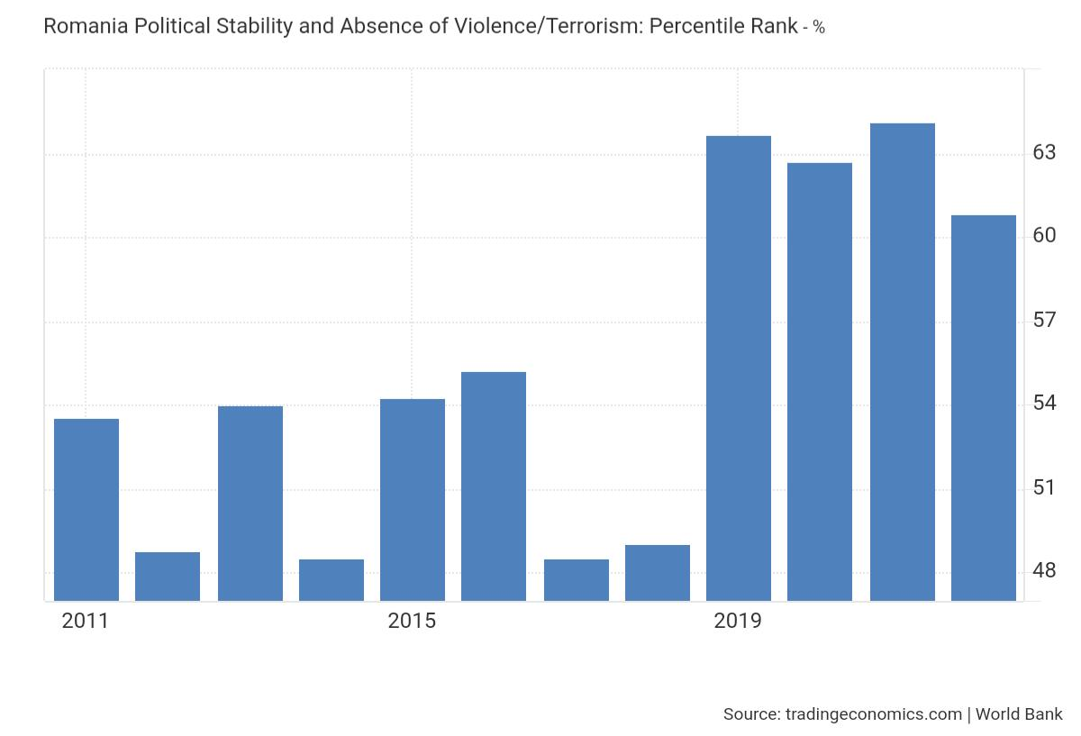

Figure 1: Political Stability: Percentile Rank of Romania
(Source: Tradingeconomics, 2024)
Customer engagement is driving a deep dive in the hospitality sector ( Brandon-Jones et al. 2016). Staff services are crucial to address the expectations of the customers in the hotel industry. The quality of service provided by the employees affects loyalty and customer satisfaction towards the hotel company (Al-Hyari et al. 2023). Moreover, customer saisfaction fostered steady growth in the hospitality industry (PJ et al. 2023). In fact, the facilities offered by the hotels and customer satisfaction have a mediating effect on the perception of the customers ( Baquero, 2023). Based on these premises, this report will identify the key challenges that ‘Moxy Bucharest Old Town' is currently facing in their service departament. It has been analysed that ‘Moxy Bucharest Old Town' has faced negative reviews mainly on hygiene factors, poor staff services and overpricing (Tripadvisor, 2024). Despite their quality services, the customers are still not yet satisfied with the staff services. Negative feedback affects the positive purchase decisions of consumers in the hotel industry (Li et al. 2023). The employees should be encouraged to satisfy their customers rather that being controlled by the supervisor (Kipping and Clark, 2012). In that consideration, it can be inferred that ‘Moxy Bucharest Old Town’ is facing negative feedback on their online review page and it can directly influence the customer's behaviour and attitude towards puchasing their services. Therefore, this consultancy report will collect data and information from ‘Moxy Bucharest Old Town'. It is important to identify the external and internal factors that determine the business opportunity or threat of ‘Moxy Bucharest Old Town'. PESTLE analysis consists of ‘Political, Economic, Social, Technological, Legal and Environmental' factors that help to analyse the current business environment of a particular industry (Soares et al. 2023). Thus, a range of frameworks will be used to evaluate the external and internal factors of ‘Moxi Bucharest Old Town'. This framework includes PESTLE analysis, SWOT and TOWS analysis.
Recommendation will be provided for ‘Moxy Bucharest Old Town' after identifying the root causes of the issue that they are currently facing in their services department. Change management theory or model will be considered for proposing the best possible solutions for ‘Moxi Bucharest Old Town'. An action plan will be developed for ‘Moxi Bucharest Old Town' and it will represent the breakdown of the problems and solutions. The action plan will provide the desired outcome, as well as the cost and time scale of the proposed solutions. It is crucial for ‘Moxy Bucharest Old Town' to consider the budget when planning and organising the suggested recommendations for addressing specific issues in their service department.
Analysis
Issue identified by the hotel
Explain the issues faced by ‘ Moxy Buchatrtest Old Town' and feedback reflecting challenges in their service segment.
It has been analysed that numerous issues have been faced by ‘Moxi Bucharest Old Town' in their service department. For example, the online reviews mark the dissatisfaction level of the customer that they receive from staff service in ‘Moxy Bucharest Old Town'.
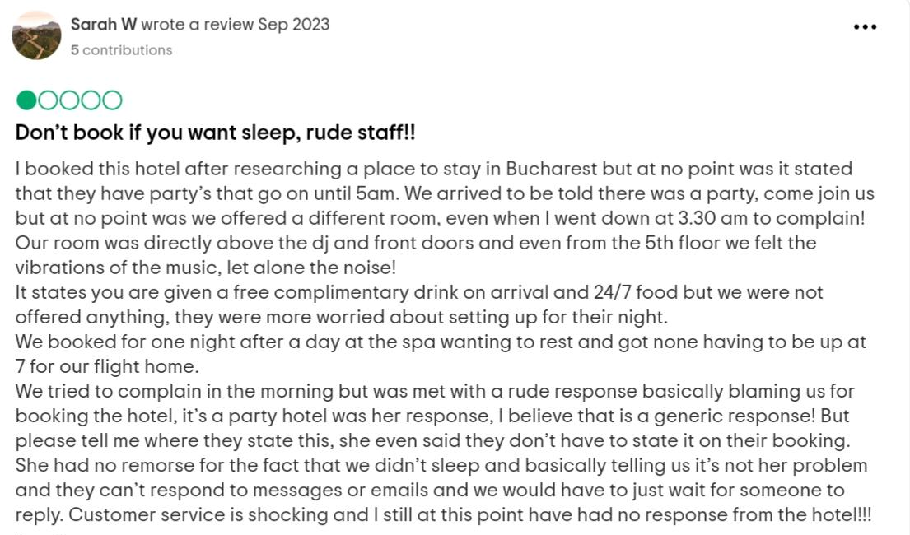

Figure 2: Negative feedback 1
(Source: Tripadvisor, 2024)

Figure 2, depicts the hotel facilities and arrangements that reveal sleeping issues for the customers. The DJ room and front door were so close that it made the room noisy and vibrant. It acts as a distributing element for the customers and negatively impacts the guest experience.

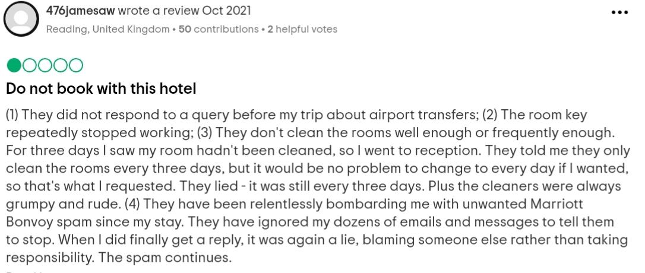

Figure 3: Negative feedback 2
(Source: Tripadvisor, 2024)

Figure 3 depicts hygiene issues and inconsistent quality as the rooms were not cleaned by the staff frequently. At the same time, the staff were rude in Moxy Bucharest Old Town'. However, it was promised to keep the room clean regulary but the staff did not perform their task on a daily basis.
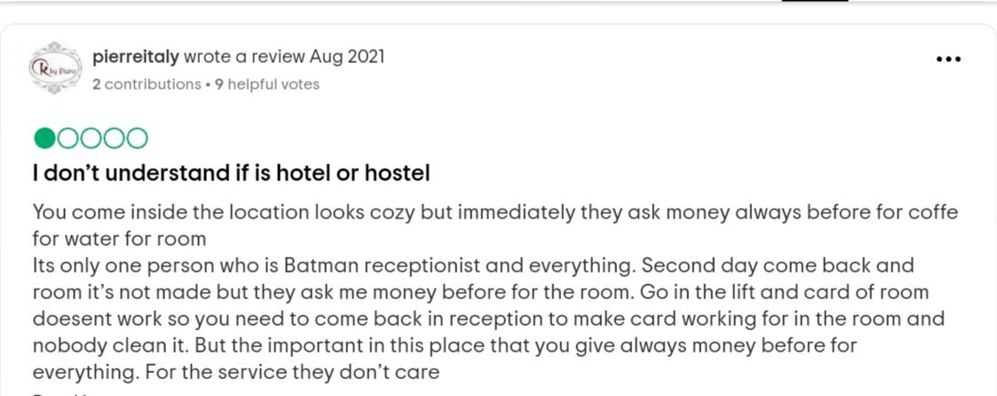
Figure 4: Negative feedback 3
(Source: Tripadvisor, 2024)
The above picture highlights the customers' dissatisfaction due to poor staff service. The customers have mentioned that money has been asked before everything but they have not received the same level of satisfaction.
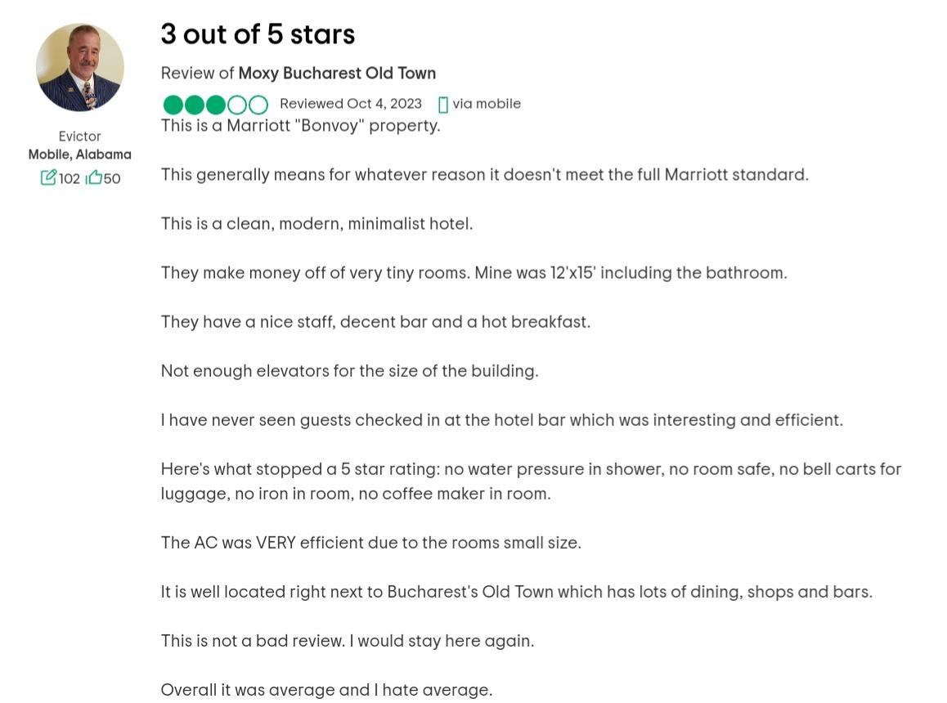

Figure 5: Negative Feedback 4
(Source: Tripadvisor, 2024)
This review also highlights the lack of hotel facilities in ‘Moxy Bucharest Old Town'. The lack of an elevator, no water pressure in the shower, no bell carts for carrying luggage and no safety in the room marks a poor rating in customer service experience.
Considering the above negative feedback, it is clear that ‘Moxi Bucharest Old Town' has failed to address the customer's expactations and they are dealing with negative feedback. Negative feedback has a direct influence on the consumers's perception, which significantly impacts the value of co-destruction of hotel companies. (Arica et al. 2023). Hence, it can be inferred that ‘ Moxy Bucharest Old Town' is dealing with negative consumer perception due the poor feedback on online platforms.
How it is affecting the hotel
A negative review affects the consumer's perception towards the hotel's service quality. It has been identified that Marriott Bonvey has received a complain due to a Wi-Fi issue at the Westin London City (Linkedin, 2024b). It has developed a negative consumer perception that Marriot International does not care about customers’s opinions. Similarly ‘Moxy Bucharest Old Town' is dealing with negative feedback and they might face the same challenges that might result in losing customers.
The root cause behinf the issue
Considering the negative feedback, it is clear that poor staff services are the root cause behind customer dissatisfaction in ‘Moxy Bucharest Old Town'. The quality of education and training positively influences employee performance and their commitment to hotel industry (Al-Sabi et al. 2023). Hence, it can be inferred that the staff of ‘Moxy Bucharest Old Town' are not trained enough to deliver quality services. Moreover, the senior management is required to be concerned about the hotel facilities like the availability of elevators as per the size of building and ensuring proper sanitation in-room services. The impact of negative comments is likely to destroy the reputation of ‘Moxy Bucharest Old Town’ which can result in losing customers. Damage to reputation includes loss of social capital, financial capital and loss of market share. This factor can negatively influence the scope and income level of ‘Moxi Bucharest Old Town'.

PESTLE analysis

Factors | Description | Impact
Political | In Romania, political stability was recorded at 60.85% as per the survery of 2022 (Tradingeconomics, 2024). Furthermore, the latest value from 2022 is 0.49 and reported a decline from the year 2022 that stands out to be 0.58 (The Global Economy, 2022). | High
Economic | Romania's inflation rate for 2023 stands out to be 10.4% recording a 3.4% decline from the year 2022 (Macrotrends, 2024). | High
Social | It is due to the COVID-19 outbreak, Romania's hotel market has recorded the lowest revenue to the lowest consumer spending, totalling around ‘861 million euros' (Statista, 2023). Conversely, as per the recent survery made by Statista, the total spending on hotels in Romania was forecasted to increase between 2024 and 2029, total amounting to ‘2.1 billion euros' (Statista, 2024). | High
Technological | The ICT market in Romania grew by 8% annually in a record between 2017 and 2021(Trade, 2024). Moreover, the IoT market of Romania has been forecasted to expand by more than 12% resulting in a market volume to stand out to be ‘3747.00m in 2029’ (Statista, 2024b). Additionally, the AI market of Romania has reached ‘£557.90 in 2024’ which is expected to grow by 28.63% resulting in a market volume to reach ‘£2527.00m by the end of 2030’ (Statista, 2024c). | Moderate
Legal | The Hotels Of Romania are regulated by ‘order no 65 dated June 10, 2013, of the National Tourism Authority', focused on a star-based rating system (Dlapiper, 2024). Apart from that Romania is set to enforce mandatory rehabilitation, in the case of the hotel owners (Wolftheiss, 2020). | High
Environmental | Romania is taking steps to reach the net Zero target and for that new tecnological regulation have been set up to look after the energy performance (Europaproperty, 2023). For instance, Radisson Hotel Group is initiating a stronger commitment towards decarbonisation and is setting and ambitious target to reach net zero by the end of 2050 (Property-forum, 2024). | Moderate

Table 1: PESTLE analysis
Opportunities
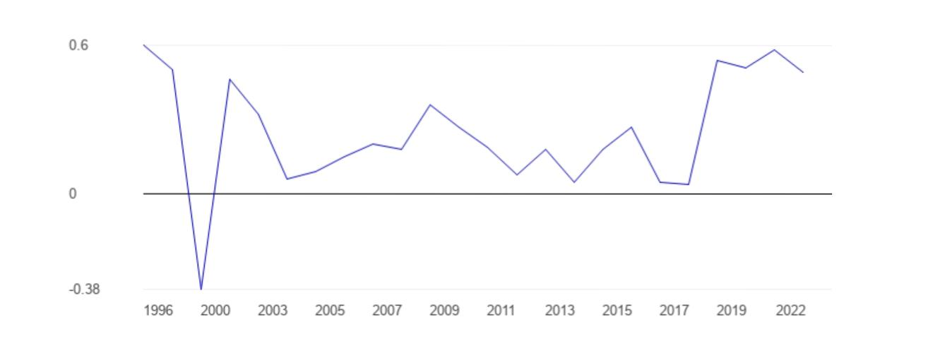
Political: Though the political stability index value has shown a drop from 0.58 points to 0.49 points, the political condition is still considered to be stable and free from terrorism (The Global Economy, 2022). A good political index value is considered to be an opportunity for ‘Moxy Bucharest Old Town' as it signifies less intervention of the government in the business functionalities.
Figure 6: Political Stability of Romania
(Source: The Global Economy, 2022)
Social: Based on the above table, it is witnessed that consumer spending in the case of hotel in Romania is estimated to enhance between the period 2024 to 2029 after the COVID-19 recess. It is even estimated to reach a billion 2.1 euros (+24.11 per cent) (Statista, 2024a). Even after the ninth consecutive increasing year, hotel-related spendings are estimated to reach ‘10.7 billion euros' and therefore estimate a new peak in 2029 (Statista, 2024a). Hence, it is considered an opportunity for ‘ Moxy Bucharest Old Town' to bring significant growth in their revenue structure.
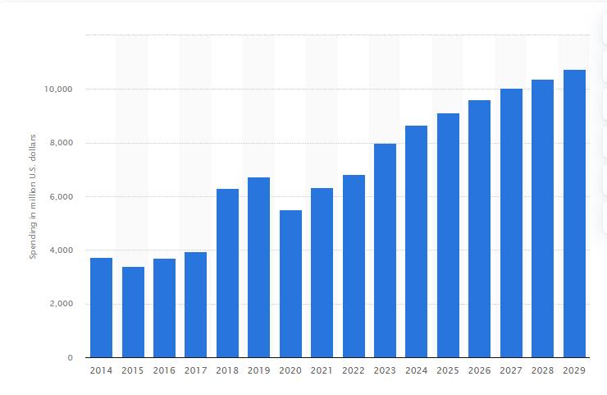

Figure 7: Consumer spending on hotel in Romania
(Source: Statista, 2024a)

Technology
It is being witnessed that the AI market of Romania is expanding and estimated to ‘£2,527.00m by the end of 2030’ (Statista, 2024c).
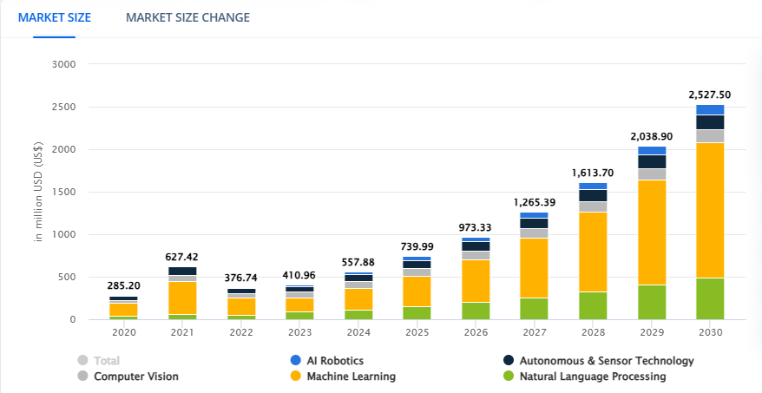

Figure 8: AI market in Romania
(Source: Statista, 2024c)

In this aspect, as the AI market is witnessing significant growth, therefore, it will pose an opportunity for ‘Moxy Bucharest Old Town' to enhance its efficiency and productivity. Further, choosing modern-day technologies will also prove beneficial for the respective hotel to generate customer-centric data, in turn generating more revenue for the company.
Environmental: Putting a focus on the Net Zero target by the end on 2050, can be considered to be an opportunity for ‘Moxy Bucharest Old Town', especially in terms of building their brand image in front of the Roman Government. It will be beneficial in front of the eco-friendly customers as well resulting in an increase in sales margin.

Threats
Economic
The inflation rate of Romania has witnessed a significant drop counting to nearly 3.4% (Macrotrends, 2024). A drop in price results in an increase in the price of commodities at a slower rate. This is considered to be a threat to the company, to generate revenue resulting in a decline in business performance.
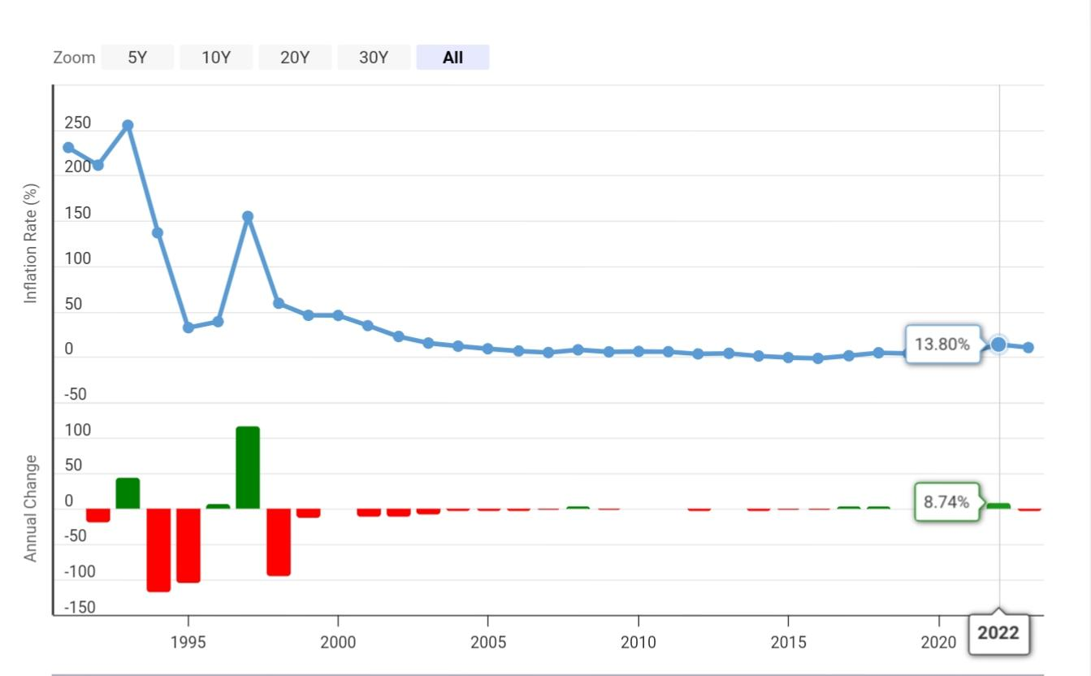

Figure 9: Inflation Rate of Romania
(Source: Macrotrends, 2024)
Legal
From the above PESTLE table, it can be witnessed that the Romanian Government follows a ‘star-based rating system'. In this case, negative reviews obtained from the consumers are potential threats for ‘Moxy Bucharest Old Town' in terms of deteriorating their brand image, thus impacting their overall performance.

SWOT analysis

Strengths | Weaknesses
- The location of ‘Moxy Bucharest Old Town' is considered to be the biggest strength, as it is located at the heart of the old town, within walking distance from the city center (Marriott, 2024b).  - The Hotel is integreted with the latest amenities, such as a ‘fitness centre, evening bar, bright and open lounge with a video wall' which is considered to be the key strength of the Hotel brand ( Booking, 2024). | - Romania's hotel industry is signifying significant growth due to enhanced tourism and foreign investments manifesting huge competition (Statista, 2024d). In this case, huge competition from similar brands is considered to be a significant weakness as it might affect their sales volume.  - ‘Moxy Bucarest Old Town' is failing to meet customer expectations due to poor service offered by the hotel, in terms of no elevator, water pressure in the shower, bell carts for carrying luggage and safety in the room indicating poor customer service (Tripadvisor, 2024).
Threats | Opportunities
- The hotel industry of Romania is projected to expand and reach a market volume of £1.06bn (Statista, 2024d). Therefore, an increased revenue results in fierce competition that can be considered to be a threat to ‘Moxi Bucharest Old Town’ to increase their sales volume.  - Rapid change as well as unmet customer needs can be considered to be a significant threat to the ‘Moxy Bucharest Old Town' to maintain their brand reputation in the Romania market. | - The promising location of ‘Moxy Bucharest Old Town' is considered to be an opportunity to reach out to a large pool of customers resulting in an increase in sales structure.  - As per the recent statistical evidence, it is predicted that about 87% of the total revenue in the hotel market in Romania will be generated through online sales by 2029 (Statista, 2024d). Therefore, the strong online presence of ‘Moxy Bucharest Old Town' is considered to be an opportunity for expanding its sales volume.

Table 2: SWOT analysis

TOWS analysis to highlight the possible future direction
 | Strength | Weakness
Opportunity | Strength/Opportunity  - In terms of the total number of online users, the hotel market in Romania is expected to increase by 6.0 million users (Statista, 2024d). It is therefore, through a strong presence in the online platform as well as due to the promising location of the brand, it can attract a large pool of customers that can be found effective to boost their sales volume. | Weakness/Opportunity  - Despite fierce competition from similar brands, the modern amenities offered by the hotel brand such as a ‘fitness center, evening bar, bright and open lounge with a video wall' can be considered to be proven beneficial in attracting a large pull of customers.
Threat | Strength/Threat  - Although ‘Moxy Bucharest Old Town' is integrated with modern amenities, the unmet customer expectations are considered to be a threat to the hotel brand in terms of drawing customers towards them resulting in affecting the sales margin. | Weakness/Threat  - Poor customer review and huge growth in the hotel industry resulting in fierce competition, can result in declining sales volume. It can also result in switching customers to opt for other options, in which they are getting their needs met.

Table 3: TOWS analysis

Recommendation and Change Management
Recommendation 1: Setting a standard cleanliness protocol with modern sanitisation technologies
In recommending particular strategies to improve hygiene factors for the ‘Moxy Bucharest Old Town', hygiene factors can be identified as the core of a better sustainable experience and customer satisfaction parameters. Based on the observation of Szentesi et al. (2021), developing a rigorous cleaning schedule for the staff including specific areas to counter high traffic with multiple cleaning steps can be helpful for a hotel to maintain its customer satisfaction rate. Following this particular statement, certain adherence to staff training related to cleaning and maintaining hygiene factors can be recognised in which adoption of strict guidelines based on proper sanitation can be effective. To increase guest comfort level with a high degree of cleanliness inside the hotel premises, ‘Moxy Bucharest Old Town' has to adopt a modern-day sanitisation system with effective and affordable cleaning technologies. As opined by Wang et al. (2022), the integration of better technologies including UV-C lights and HEPA filters, especially in maintaining air and water purification, a business establishment can reduce certain chances of allergic reactions along with airborne pathogens inside the guest rooms. Integration of these moderne yet convenient technologies can be advantageous for this particular business in terms of developing the present condition of the overall ambience in which particular hygiene factors can be enhanced to increase customer engagement level. However, for the implementation of staff training and employee satisfaction related to maintaining proper cleanliness inside the premises, the hotel management has to implement dedicated change management strategies following a relevant theory.

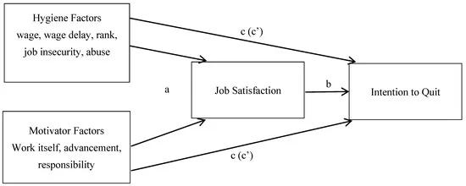

Figure 10: Herzbrerg's Two-factor Theory model
( Source: Nagpaul et al., 2022)
Nagpaul et al. (2022) stated that by focusing on ‘Herzberg's Two-factor Theory', an employer can be beneneficial in understanding both motivators and hygiene factors for the employees while taking necessary steps to meet their requirements. Following this statement, a necessity of understanding employee motivators like increments in salaries, improvised organisational policies and hygienic factors like working conditions and cleanliness protocol can be recognised. Following this particular theory, the maximisation of maintaining proper sanitisation along with providing training with modern-day solutions amoung the employees can be helpful in meeting their service criteria (Benitez et al., 2021). On the other hand, motivation factors like providing incentives for the cleaning staff, especially setting a target for customer ranking can be helpful while introducing individual recognition with promotional scopes.
Roina-Ramirez et al. (2021) argued that offering detailed and comprehensive training for all the staff from different management systems can also be helpful in maintaining proper guidelines of sanitisation in which ‘proper waste disposal' and personal hygiene standards can be maintained. It can be recognised that scheduling a routine cleanliness workshop with certified programs from the hotel management can be helpful while giving the chance to increase their motivational factors in maintaining proper hygiene (Gorgenyi-Hegyes et al., 2021). On the other hand, the application of a better waste management system inside the hotel, especially in highly ‘Guest-accessible areas' can be recommended while having the advantage of maintaining proper hygiene guidelines (Chawla et.al., 2022). Besides, an amalgamation of cleanliness schedules based on a change of duty plans in collecting wastages from the guest room can also reduce work pressure from the cleaning staff while emphasising their hygiene factors according to change management theory. Following a medium-sized business organisation with a room number of approximately 119 rooms, this hotel can invest a budget of £2000 in accomplishing the overall recommendations. A desired key measure like increasing customer satisfaction scores through its dedicated websites and changes in guest complaints can also be recognised (Kang et al., 2020). Besides, having a better score in cleanliness audits along with noticeable changes in customer reviews can also be a counted measuring parameter.
Recommendation 2: Identification of employees' motivational factors with a comprehensive enhancement programme
In the case of improving poor staff service inside the ‘Moxy Bucharest Old Town', this certain problematic issue can reduce overall brand reputation and impact profitability. As opined by Dorta-Afonso et al. (2021), in improving overall workforce performance, endurance fair compensation along with provided service benefits can be purposive. Analysing this statement, the application of a ‘compensation package' for individual staff from various departments based on evaluating a periodically reviewed chart from clients can be recommended. In the case of increasing performance with behavioural changes, implementation of a peer-supported workplace environment can be recommended, especially in improving efficiency ( Abolnasser et al., 2023).
Based on the view of Sibian and Ispas (2021), improvised protocols within organisational values with adequate safety and health-related benefits can be helpful for the employees while giving them efficient services.This statement can be used to recommend strategies like providing better health and work-safety-related insurance along with promotional scopes in which proficient knowledge can be shared in resolving problems. However, Yu et al. ( 2020) argued that fostering ‘team resilience' within a diversified workplace can be purposive for an organisation in developing employees' nature to flexibility and team- building activities while changing overall behavioural patterns in assisting guests. Following this particular statement, strategic recommendation related to open and effective communication with the hierarchy along with departmental heads can be considered in which a quick mitigation of problems can be ensured to reduce anger factors. Oh et al. ( 2021) reviewed addressing ‘self-esteem' among employees with a ‘value recognition process' in which individual confidence can be emphasised in performing a particular task. This certain process can also increase employees' morale to accomplish corporate tasks while fostering a change in management tactics from the decision-makers of this particular hotel. Besides, proper identification of psychological needs related to their particular job can also be recommended in which the employers can implement a change management strategy in resolving this particular issue (Park, 2020).
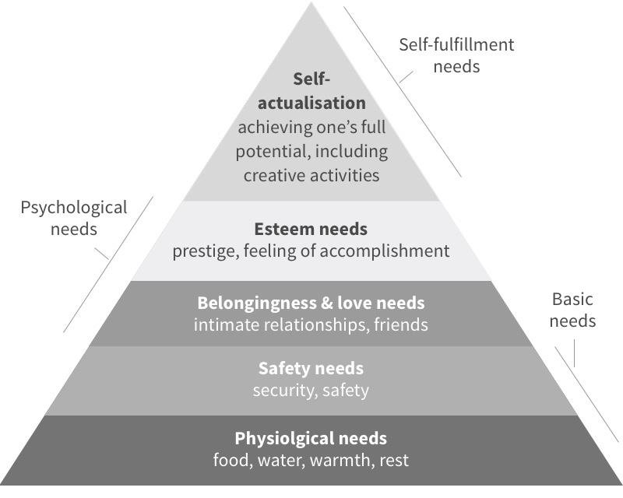
Figure 11: Maslow's Hierarchy of Needs framework
(Source: Vinh et al., 2022)
As per the view of Vinh et al. (2022), following the strategies of employee engagement, the application of ‘Maslow's Hierarchy of Needs' can be purposive while helping the organisation to recognize psychological, social and self-improvement needs in enhancing performance. Based on Maslow’s Hierarchy of Needs, certain identification of individual recognition along with reducing workplace pressure can be recorded while resolving these issues to grow employees' performance and behavioural changes. Based on the views of Ghani et al. (2022), in emphasising employees' performance, developing certain service promotional scopes related to salary increments can be helpful in fulfilling employees' social needs while increasing satisfaction and reducing turnover rates. Focusing on this particular statement, recommended strategies loke increasing guest interactions and public recognition can be followed by which employees' self-esteem can be increased while providing efficiency in their dedicated job role. On the other hand, fostering an employee development programme with the help of providing constructive feedback can also be recommended in which the employees can change their performance accordingly. Besides, clarification of motivational factors related to employee engagement along with acknowledging potential strengths and weaknesses of individual employees can be helpful in ensuring particular change in their behavioural patterns. In terms of fostering these recommendations with the change management criteria, this medium-sized organisation can invest £3500 while predicting noticeable changes. Certain measuring parameters can be recognised including betterment of employee retention as well as improvement in brand reputation. Besides, growth in hotel bookings and marginal growth in profitability can also be considered while targeting better team cohesion (Agag et al., 2022). However, higher productivity from the employees along with efficient performance, especially in tourism seasons can be considered while analysing overall guest satisfaction to evaluate better implementation of recomended strategies.
Recommendation 3: Settings a dynamic pricing strategy with value-added services
In terms of recommending strategies for resolving issues of overpricing, this particular issue can create business barriers like reduced brand preference and unsustainable business position. As per the view of Petricek et al. (2021), integration of dynamic pricing in various services through analysing customer demand can be helpful in mitigating issues like overpricing. Following this particular statement, stratregies like analysis of guest requirements and trendy marketing insights can be recommended while focusing on competitor pracing strategies to attract customers. On the other hand, following the demand patterns of the guests, especially in the peak tourist season can be helpful for this hotel in avoiding price-sensitivity issues while focusing on overall profitability (Morrison, 2022). Gordan et al. (2022) argued about setting a benchmark with a certain analysis of local market prices in which potential competitors can be handled with a particular competitive advantage. Specific recommendation including equivalent services in a competitive price range along with providing amenities based on customer preferences can be set with a highlighted uniqueness (Denizci Guillet, 2020). As opined by Hu and Song (2022), targeting a sustainable business position with a competitive price range can be purposive in enhancing guest preference rates in which an organisation can provide equally better amenities while considering its potential competitors. Following this statement, certain recommendation can be recognised in providing variuos value-added services, especially for potential clients in which customer satisfaction can be emphasised while increasing the chances of electronic word of mouth (eWOM). However, value-added services with a discount price range can be advantageous for better client engagement in which recommended services like spa, breakfast, internet connection and airport shuttles can be provided in the discount price range. Widz et al. (2022) argued about customer preferences for higher price ranges while highlighting customers’ intention of receiving services against their paid prices in recognising a premium organisation. Based on certain arguments, strategies including better room qualities with proficient room services and various complimentary service additions can be recommended while understanding customers’ expenditure patterns as well as their preferences. On the other hand, Rezaei et al. (2024) highlighted that transparent pricing and transactions can be developed with the help of reducing various hidden charges and complex pricing structures while offering pricing benefits for customers in increasing repetitive service bookings.
Based on the view of Serrano-Baena et al. (2021), fostering transparency in the transaction process with a simplified pricing structure can be helpful for the customers along with service providers in maintaining active communication while reducing negative thoughts from the customers in choosing services. Analysing this particular statement, implementation of change management with the help of understanding price elasticity can be considered while mitigating issues like overpricing. As opined by Shekari et al. (2021), enhancement of services by following the Price elasticity theory, an organisation can be purposive in determining price elasticity and price inelasticity factors to set service prices. In the case of ‘Moxy Bucharest Old Town', this particular organisation can also follow this particular theory while setting its service prices to get competitive advantages. Strategies like including parking accessibility and reduced timing for VIP checking can be considered in the case of targeted customers in which an amalgamation of selected tier services can also be recommended. On the other hand, analysing customer feedback with a dedicated operational team, especially in creating value alignment with dynamic price can also be recommended in reducing this issue.
Fostering promotional offers through online booking platforms along with offering loyality scores to reduce service prices can be recommended while influencing customers to choose this particular hotel over its competitors. In terms of measuring particular benefits from the recommendations, the management can analyse the overall occupancy rate with a comparison of previous fiscal years. Besides, repetitive booking scores can also be followed by the core management teams in deciding particular growth in overall performance. On the other hand, analysis of price sensitivity amoung the customers along with customer satisfaction rates can also be measured in terms of assuring success. Moreover, tracking customer feedback and opinions in profound review sites like ‘TripAdvisor' can also be followed in which the decision-makers can understand particular insights to follow recommendations. Having a medium-sized business structure, this organisation can invest £3000 to procure these structural changes while following these recommendations to improve overall services.

Action Plan
Specific | Measurable | Achievable | Relevant | Time-Based | Targeted Budget
Development of particular hygiene guidelines along with defining a standard cleanliness protocol. | This particular strategy can be measured with the customer's reviews from online sites. Besides, better performance in cleanliness audits can also be focused on understanding growth. | Establishing a cleaning schedule for cleaning staff with specifications of duties can be helpful in achieving clean and hygienic hotel premises and guest accessible areas. | As opined by Atan et al. (2021), scheduled cleanliness and maintained hygienic protocol can be helpful for an organisation in increasing guest satisfaction rate while targeting to achieve better revenue throughout the service. | 1-3 Months | £2000
Establishing a particular goal in improving employees' motivation through employee engagement programs and analytics of performance metrics. | In terms of measuring this particular goal, the evaluation of employee assessment with performance efficiency can be recorded. Besides, changes in customer feedback through online platforms can also be considered as the prior measure of this particular goal. | Following performance metrics along with an appraisal system on guest satisfaction, noticeable change in employee turnover rates and repetitive guest booking can be achieved while having the benefits of better profitability in the current fiscal year. | Based on the views of Xu et al. (2022), providing proficient services in the hospitality industry can be helpful for an organisation to sustain its business position along with increasing brand reputation as compared to its potential competitors. | 3-6 months | £3500
Setting a specific target to offer a dynamic price range in service focusing on price-value alignment in client engagement. | In the case of measuring its effectiveness, analysis of customer satisfaction score, repetitive booking rates within a current fiscal year and reduced price sensitivity among the potential clients can be recognised  (Denizci Guillet, 2020). | In terms of setting a competitive benchmarking with dynamic service pricing, this particular establishment can be purposive in achieving a better brand reputation with a marginal growth of financial status. | As per the view of Di Persio and Lalmi (2024), setting a particular pricing with a certain analysis of the local market can be adventurous for a certain organisation in improving its overall revenue while targeting better profitability and competitive advancement. | 2-4 months | £3000

Table 4: Action Plan

Conclusion
In conclusion, key finding like certain discussions on organisational background and consultancy reports have been developed while focusing on determining key problematic issues related to business management. In this report, ‘Moxi Bucharest Old Town' has been considered as an example to identify its problematic issues related to client satisfaction and sustaining a better business position. On the other hand, problematic issues like poor service quality of the workforce, unhygienic issues and overpricing have been recognised by which this particular business establishment has been facing critical business issues within a particular fiscal year. Unexpected changes in employees' behavioural patterns and customers' negative feedback through dedicated online and offline business sites have been recorded while focusing on various business factors related to the change in these insights. A particular identification of root causes related to these problematic situations has been analysed in which certain connections of macroeconomic factors have also been discussed. In discussing macroeconomic factors related to business disruption, a renewed framework like PESTLE has been developed with a certain evaluation of amalgamated factors on which this particular business establishment could focus while implementing change management for overall development. Besides, a specific SWOT analysis framework has been developed with a certain identification of potential strengths and weaknesses of ‘ Moxy Bucharest Old Town’ in which a particular analysis of opportunities and threats for upcoming business years has also been discussed.
Key findings from both PESTLE and SWOT have been identified with potential business impacts and consequences, especially in enhancing business services while discussing potential issues to be mitigated through prior recommendations. In the recommendations, evaluation of strategies has been considered to provide business enhancement ideas from which a potential benefit for the organisation has also been discussed. Identification of problematic business issues like unhygienic factors has been highlighted in the first recommendation in which consideration of fostering standard cleanliness protocol and standard sanitisation guidelines have been constructed. On the other hand, change management systems through a profound theory, Herzberg's Two-factor Theory have been highlighted by which identification of key motivational factors and hygienic hotels have been discussed. In the second recommendation, enhancement of poor employee performance and behavioural change have been highlighted with provided strategies like identification of employees' psychological and societal needs while accomplishing particular corporate goals.
A key identification of change management theory, Maslow's hierarchy of needs has been highlighted in which recognition of team building and growth opportunity development have been found. In the third recommendation, a certain development of pricing strategies in mitigating overpricing issues has been highlighted in which a particular amalgamation of dyamic pricing has been identified. This particular section has included a change management theory of the price elasticity of demand to ensure proper identification of customers' requirements and the necessity of providing value-added without a complex price structure. A specific action plan has been developed with a detailed formation of specific goals and their measurements while discussing relevant time and estimated budget on deciding organisational structure and overall business size.

Reference
Abolnasser, M.S.A., Abdou, A.H., Hassan T.H. and Salem, A.E., 2023. Transformational leadership, employee engagement, job satisfaction, and psychological well-being among hotel employees after the height of the COVID-19 pandemic: a serial, meditation model. International journal of environmental research and public health, 20(4), p.3609.
Agag, G.M., Khashan, M.A., Colmekcioglu, N., Almamy, A., Alharbi, N.S., Eid, R., Shabbir, H. and Abdelmoety, Z.H.S., 2020. Converting Hotels Website Visitors into buyers: How online hotel web assurance seals services decrease consumers’ concerns and increase online booking intentions. Information Technology & People, 33(1), pp.129-159.
Al-Hyari, H.S.A., Al-Smadi, H.M. and Weshah, S.R., 2023. The impact of artificial intelligence (AI) on guest satisfaction in hotel management: An empirical study of luxury hotels. Geo Journal of Tourism and Geosites, 48, pp.810-819.
Al-Sabi, S.M., Al-Ababneh, M.M., Masadeh, M.A. and Elshaer, I.A., 2023. Enhancing innovation performance in the hotel industry: the role of employee empowerment and quality management practices. Administrative Sciences, 13(3), p.66.
Arica, R., Çakir, O. And Sesliokuyucu, O.S., 2023. Examining reviews on hotels' measures about COVID-19 from a value cocreation and value construction perspective. Journal of Hospitality and Tourism Insights, 6(1), pp.263-285.
Atan, A., Ozgit, H. and Silman, F., 2021. Happiness at work and motivation for a sustainable workforce: evidence from female hotel employees. Sustainability, 13(14), p.7778.
Baquero, A., 2023. Is customer satisfaction achieved only with good hotel facilities? A moderated meditation model. Administrative Sciences, 13(4), p.108.
Benitez, M., Leon-Perez, J.M., Orgambídez, A. And Medina, F.J., 2021. Interpersonal conflicts in the unit impact the service quality rated by customers: The mediating role of work-unit well-being. International Journal of Environmental Research and Public Health, 18(15), p.8137.
Booking, 2024. Moxy Bucharest Old Town. [Online] Available at: https://www.booking.com/hotel/ro/moxy-bucharest-old-town.html [Accessed: 25 October, 2024]
Brandon-Jones, A., Lewis, M., Verma, R. And Walsman, M.C., 2016. Examining the characteristics and managerial, challenges of professional services: An empirical study of management consultancy in the travel, tourism, and hospitality sector. Journal of operations management, 42, pp.9-24.
Chawla, G., Lugosi, P. and Hawkins, R., 2022. Factors influencing hospitality employees' pro-environmental behaviours toward food waste. Sustainability, 14(15), p.9015.
Denizci Guillet, B., 2020. An evolutionary analysis of revenue management research in hospitality and tourism: is there a paradigm shift?. International Journal of Contemporany Hospitality Management, 32(2), pp.560-587.
Di Persio , L. And Lalmi, E., 2024. Maximizing Profitability and Occupancy: An Optimal Pricing Strategy for Airbnb Hosts Using Regression Techniques and Natural Language Processing. Journal of Risk and Financial Management, 17(9), p.414.
Dlapiper, 2024. Hotel classification: Romanian standards and implications. [Online] Available at: https://www.dlapiper.com/en/insights/publications/real-estate-gazette/real-estate-gazette-hotels-and-leisure/hotel-classification-romanian-standards-and-implications [Accessed: 25 October, 2024].
Dorta-Afonso, D., González-de-la-Rosa, M., Garcia-Rodriguez, F.J. and Romero-Domíniguez, L., 2021. Effects of high-performance work systems (HPWS) on hospitality employees'outcomes through their organisational commitment, motivation, and job satisfaction. Sustainability, 13(6), p.3226.
Europaproperty, 2023. Romania, takes important step towards net zero energy building. [Online] Available at : https://europaproperty.com/romania-takes-important-step-towards-net-zero-energy-building/ [Accessed: 25 October, 2024].
Ghani, B., Zada, M., Memon, K.R., Ullah, R., Khattak, A., Han, H., Ariza-Montes, A., and Araya-Castillo, L., 2022. Challenges and strategies for employee retention in the hospitality industry: A review. Sustainability, 14 (5), p.2885.
Gordan, M.I., Peț, E., Popescu, G., Brad, I., Milin, A.I., Adamov, T.C., Ciolac, R., Pascariu, A.R. and Iancu, T., 2022. Factors Influencing the Accommodation Prices of Romanian Rural Tourism. Sustainability, 15(1), p.191.
Gorgenyi-Hegyes, E., Nathan, R.J. and Fekete-Farkas, M., 2021. Workplace health promotion, employee wellbeing and loyality during COVID-19 Pandemic-Large scale empirical evidence from Hungary. Economies, 9(2), p.55.
Hu, T. and Song, H., 2022. Analysis of influencing factors and distribution simulation of budget hotel room pricing based on big data and machine learning from a spatial perspective. Sustainability, 15(1), p.617.
Kang, J.H., Ji, Y.H., Baek, W.Y., and Byon, K.K., 2020. Structural relationship among physical self-efficacy, psychological well-being, and organisational citizenship behaviour among hotel employees: Moderating effects of leisure-time physical activity. International Journal of Environmental Research and Public Health, 17(23), p.8856.
Kipping, M. And Clark, T. eds., 2012. The Oxford handbook of management consulting. OUP Oxford.
Li, H., Meng, F. and Hudson, S., 2023. Are hotel guests altruistic? How positive review disconfirmation affects consumers' online review behavior. Journal of Hospitality & Tourism Research, 47(3), pp.528-548.
Linkedin, 2024a. Moxy Bucharest Old Town. [Online] Available at: https://in.linkedin.com/company/moxy-bucharest-old-town?trk=%20-pages_result-card_full-click [Accessed: 26 October, 2024].
Linkedin, 2024b. Sabine VanderLinden's Post. [Online] Available at: https://www.linkedin.com/posts/sabinevanderlinden_world-of-hyatt-hotels-corporation-real-life-activity-7192230216411348992-JtgQ [Accessed: 27 October, 2024].
Macrotrends, 2024. Romania Inflation Rate 1991-2024. [Online] Available at: https://www.macrotrends.net/global-metrics/countries/ROU/romania/inflation-rate-cpi [Accessed: 24 October, 2024].
Marriott, 2024a. Experience modern comfort at our hotel in Bucharest Old Town. [Online] Available at: https://www.marriott.com/en-us/hotels/buhox-moxy-bucharest-old-town/overview/ [ Accessed: 26 October, 2024].
Marriott, 2024b. Moxy Bucharest Old Town. [Online] Available at: https://www.marriott.com/en-us/hotels/buhox-moxy-bucharest-old-town/rooms/ [Accessed: 24 October, 2024].
Mavridopoulou, I. And O'Mahoney, J., 2020. Elitism in strategy consulting: How institutional prestige influences recruitment. Management Consulting Journal, 3(1), pp.12-22.
Morrison, A.M., 2022. Hospitality and travel marketing. Routledge.
Nagpaul, T., Leong, C.H., Toh, C.S., Amir, A.B., Chin, R. And Tan, S., 2022. Exploring job satisfaction and intentions to quit among security officers: The role of work hygiene and motivator factors. Social Sciences, 11(11), p.497.
O'Mahoney, J., 2021. How small consultancies grow: Challenging problem-based theorising. Management Consulting Journal, 4(1), pp.5-20.
Oh, K.S., Han, J.R., and Park, S.R., 2021. The influence of hotel employees' perception of CSR on organisational commitment: The moderating role of job level. Sustainability, 13(22), p.12625.
Park, S., 2020. Marketing management. (Vol.3). Seohee Academy.
Petricek, M., Chalupa, S. And Melas, D., 2021. Model of price optimization as a part of hotel revenue management-stochastic approach. Mathematics, 9(13), p.1552.
PJ, S., Singh, K., Kokkranikal, J., Bharadwaj, R., Rai, S and Antony, J., 2023. Service quality and customer satisfaction in hospitality, leisure, sport and tourism: an assessment of research in web of science. Journal of Quality Assurance in Hospitality & Tourism, 24(1), pp.24-50.
Property-forum, 2024. Radisson Hotel group commits to net-zero by 2050. [Online] Available at: https://www.property-forum.eu/news/radisson-hotel-group-commits-to-net-zero-by-2050/11845 [Accessed: 24 October, 2024].
Razaei, F., Raeesi Vanani, I., Jafari, A. and Kakavand, S., 2024. Identification of influential factors and improvement of hotel online user-generated scores: a prescriptive analytics approach. Journal of Quality Assurance in Hospitality & Tourism, 25(4), pp.1070-1109.
Robina-Ramirez, R., Medina-Merodio, J.A., Moreno-Luna, L., Jimenez-Naranjo, H.V. and Sánchez-Oro, M., 2021. Safety and health measures for COVID-19 transition period in the hotel industry in Spain. International Journal of Environmental Research and Public Health, 18(2), p.718.
Serrano-Baena, M.M., Hidalgo Fernández, R.E., Carranza-Cañadas, P. and Triviño-Tarradas, P., 2021. How the Implementation of BREEAM in hotels could help to achieve the SDGs. Applied Sciences, 11(23), p.11131.
Shekari, M., Arasteh, H., Sheikhi Fini, A. And Vahidinasab, V., 2021. Demand response requirements from the cultural, social, and behavioral perspectives. Applied Sciences, 11(23), p.11456.
Sibian, S.R. and Ispas, A., 2021. An approach to applying the ability-motivation-opportunity theory to identify the driving factors of green employee behavior in the hotel industry. Sustainability, 13(9), p.4659.
Soares, C.A., Shendrikova, D., Crevani, G., Silinto, B. And Colombo, E., 2023. Enabling factors for the development of mini-grid solution in Mozambique: A PESTLE- based analysis. Energy Strategy Reviews, 45, p.101040.
Statista, 2023. Hotel market in Romania-statistics & facts. [Online] Available at: https://www.statista.com/topics/7557/hotel-market-in-romania/ [Accessed: 26 October, 2024].
Statista, 2024a. Total consumer spending on restaurants and hotels in Romania from 2014 to 2029. [Online] Available at: https:// www.statista.com/forecasts/1164290/restaurants-and-hotels-consumer-spending-forecast-in-romania [Accessed: 26 October, 2024].
Statista, 2024b. Internet of Things- Romania. [Online] Available at: https://www.statista.com/outlook/tmo/internet-of-things/romania [ Accessed: 26 October, 2024].
Statista, 2024c. Artificial Inteligence-Romania. [Online] Available at: https://www.statista.com/outlook/tmo/artificial-intelligence/romania [Accessed: 27 October, 2024].
Statista, 2024d. Hotels-Romania. [Online] Available at: https://www.statista.com/outlook/mmo/travel-tourism/hotels/romania [Accessed: 26 October, 2024].
Subramaniam, N., Collier, P., Phang, M. and Burke, G., 2021. The effects of perceived business uncertainly, external consultants and risk management on organisational outcomes. Journal of Accounting & Organisational Change, 7(2), pp.132-157.
Szentesi, S.G., Cuc, L.D., Feher, A. And Cuc, P.N., 2021. Does Covid-19 affect safety and security perception in the hospitality industry? A Romanian case study. Sustainability, 13(20), p.11388.
The Global Economy, 2022. Romania: Political stability. [Online] Available at: https://www.theglobaleconomy.com/Romania/wb_political_stability/ [Accessed: 25 October, 2024].
Trade, 2024. Information & Communications Technology (ICT). [Online] Available at: https://www.trade.gov/country-commercial-guides/romania-information-communications-technology-ict [Accessed: 25 October, 2024].
Tradingeconomics, 2024. Romania-Political Stability And Absence Of Violence/Terrorism: Percentile Rank. [Online] Available at: https://tradingeconomics.com/romania/political-stability-and-absence-of-violence-terrorism-percentile-rank-wb-data.html [Accessed: 26 October, 2024]
Tripadvisor, 2024. Moxy Bucharest Old Town. [Online] Available at: https://www.tripadvisor.co.uk/Hotel_review-g294458-d20357186-Reviews-Moxy_Bucharest_Old_Town-Bucharest.html#REVIEWS [Accessed: 25 October, 2024]
Vinh, N.Q., Hien, L.M. and Do Q.H., 2022. The relationship between transformation leadership, job satisfaction and employee motivation in the tourism industry. Administrative Sciences, 12(4), p.161.
Wang, C.N., Tran, K.M., Huang, C.C., Wang, Y.H. and Dang, T.T., 2022. Supporting Luxury Hotel Recovered in Times of COVID-19 by Applying TRIZ Method: A Case Study in Taiwan. Systems,10(2), p.33.
Widz, M., Krukowska, R., Walas, B. and Kruczek, Z., 2022. Course of values of key performance indicators in the city hotels during the COVID-19 pandemic: Poland case study. Sustainability, 14(19), p.12454.
Wolftheiss, 2020. Romania is set to enforce mandatory rehabilitation works for hotel owners. [Online] Available at: https://www.wolftheiss.com/insights/romania-is-set-to-enforce-mandatory-rehabilitation-works-for-hotel-owners/ [Accessed: 25 October, 2024].
Xu, Y., Jie, D., Wu, H., Shi, X., Badulescu, D., Akbar, S. And Badulescu, A., 2022. Reducing employee turnover intentions in tourism and hospitality sector: The mediating effect of quality to work life and intrinsic motivation. International journal of environmental research and public health, 19(18), p.11222.
Yu, J., Ariza-Montes, A., Giorgi, G., Lee, A. And Han, H., 2020. Sustainable relationship development between hotel company and its employees: Linking job embeddedness, job satisfaction, self-efficacy, job performance, work engagement, and turnover. Sustainability, 12(17), p.7168.

