Principles of Teaching, Learning and Emergent Technologies (PTLET)

Module Code: M6X02268/PCET6001
By: JONATHAN LOWE
Lecturer: Caroline Usei

The main purpose of this reflective piece is to conduct a self-assessment and evaluation of a forty-five-minute micro-teach as part of a peer-reviewed assessment. For me, this has been a beneficial and enjoyable experience. According to Rastegari (2018):

In a time where deliberately false information is continually introduced into public discourse, and quickly spread through social media shares and likes, it is more important than ever for young people to develop their critical thinking. That skill… consists of three elements: a capacity to spot weakness in other arguments, a passion for good evidence, and a capacity to reflect on your own views and values with an eye to possibly change them.
The lesson was planned to incorporate the use of contemporary pedagogies, an integration of cross-cutting themes and a variety of assessment methods. The experience will be evaluated for effectiveness and reflected on using Kolb’s experiential learning cycle. A review of current literature will add argument and depth. Recommendations based on the experience will be presented for personal development.
According to Ferguson et al. (2017), “This year’s innovative pedagogies include some that have an urgency about them. They are addressing problems of today’s world”. Knowles (1980) originally promoted the concept of andragogy (“the art and science of helping adults learn”) as differing from pedagogy (“the art and science of teaching children”). He theorised a set of five assumptions about adult learners and four principles of andragogy (eLearning Industry, 2018). Infographics representing these assumptions and principles have been included in Appendix 1.
Contemporary pedagogies can influence and promote concepts and innovations, exploring new forms of teaching: for example, students learning through assessments and enhanced interaction in the classroom, facilitating a more engaged learning experience. This can also aid teachers and policy makers in delivering productive innovation (Knowles, 1980).
According to GOV (2017), “The teacher ensures that learners reflect upon the extent to which they have stretched themselves and been resilient in solving problems and challenges in their learning”. The full potential of teaching can often depend on creating relationships with the learners and understanding their diverse needs. It is, therefore, necessary to adapt to the conditions of the classroom environment, carefully utilising a range of pedagogical approaches where needed to ensure the best learning outcome for the students.
I was assigned the task of creating a forty-five-minute micro-teaching session. I was also required to provide a detailed lesson plan, with materials and visual aids to be used in class accompanied by duplicates for my peer assessors to examine.
My peer-assessed micro-teaching lesson was presented to the class using an online platform called ‘Prezi’. Prezi is an online Adobe Flash-based presentation program. NACTA (2018) states that Prezi
differs from traditional presentation programs like Microsoft PowerPoint and Apple Keynote in that it is not based on slides. Instead, Prezi presentations exist on a canvas. The presentation is navigated by zooming in and out of different points on the canvas, as needed by the presenter.
When operating this package, I could control the presentation remotely using my mobile phone. However, in hindsight, I wish I had taken the decision to use PowerPoint; I feel that this could have reduced my preparation time due to the simplicity of using PowerPoint. In addition, you cannot print directly from Prezi without subscribing for this option.
However, I felt that by using Prezi, I was able to deliver a more creative and unique presentation to increase engagement.
Prior to the assessment, my peers were made aware of my disability with regard to standing. I greeted those attending the micro-teach lesson in English and Welsh, to address potential cultural differences with regard to the audience. While logging into Prezi for my online presentation, there was a respectful atmosphere in the classroom. However, as I proceeded through the session, I could detect some negativity and discontent. I continued to provide complementary handouts to assist with my subject. By using current emerging technology, I felt this would stimulate the class to become more susceptible to absorbing the marketing topic: ‘promoting a brand’. I anticipated that this might inspire further discussions in the classroom. I also promoted the use of online technology that can support and enable students to access lectures and resources (ed.gov, 2010).
The first part of my presentation introduced an overview of my lesson objectives, informing the students there would be tasks later in the lesson. I then delivered a short lecture on the topic of ‘promoting a brand’. The following activity provided a student-led task, creating discussion in groups, as stated in my lesson plan objectives. The task was intended to allow the learners to recognise the importance of brand straplines as a marketing strategy for promoting a brand.
As I delivered the lesson, I was constantly evaluating my pace and challenge while I was teaching, which constantly played in the back of my mind. Prior to the activity, I felt concerned with regard to overloading the learners, recognising that this could lead to a decline in engagement, listening and participating skills. However, the group activity proved to be a success, creating a discussion between the students within the classroom, forming a collaborative approach when tackling the group activity.

In addition, the video I selected to show to the class (an Audi R8 car advertisement) was, I felt, a valid use of material to demonstrate how the Audi was showcased as a product, highlighting its internal and external appeal. While the video played, I verbally explained the psychological connection that marketers can convey to a customer visually in a one-minute television advert. My peers suggested that my choice of video was more male orientated and suggested more variety as a recommendation for the future
I feel that this experience taught me that the use of technology can be very assistive when teaching. However, creating content designed to ensure learners stay engaged has proven to be much more challenging. Reflecting on this experience, I am aware there is room for improvement when compiling lecture material, such as providing a wider range of television advertisements to promote a balanced case. It may be worth considering reducing the time spent lecturing and increasing the number of activities, as these proved more successful.
I observed and encouraged exploratory talk around the subject area during my micro-teaching session. I also witnessed an increase in knowledge and enjoyment among the students as they worked together collectively. Gokhale (1995) highlights that a collaborative learning style enhances students’ communication, from the use of social language to academic conversation, with a positive impact on their confidence, writing abilities and styles. This is an important factor to consider as there may also be students unfamiliar with the English language.
Having already created a lesson plan for a previous micro-teach, I was able to build from this experience, reflecting on this process for the successive lesson plan. I considered embedded cross-cutting themes and the benefits of this from a learner’s perspective. In addition to the utilisation of contemporary pedagogies, this would also provide ongoing reference for personal and professional development.
When creating the lesson plan, I found using the goals and objectives framework very useful with regard to how I would tailor my lesson to meet the learners’ needs and enhance the presentation to engage with my audience throughout.
Cross-cutting themes were integrated in the design of the teaching session, supporting the attainment of supplementary skills and broadening the learning outcomes. When creating the content for my micro-teach on ‘promoting a brand’, I used careful deliberation with regard to the choice of materials and activities. This approach was intended to avoid overloading the students or potentially hindering their achievement of the initial learning objectives (GOV, 2017).
Developing SMART goals was more challenging than I had originally thought. This skill takes time to research and apply; however, I am now able to recognise the importance of implementing SMART goals as a strategy to support both teaching and learning. Focusing on smaller, more specific goals can make a contribution to the success of a much larger overall aim. Clear objectives help define the target of the lesson and assist in providing a precise lesson plan. Objectives are demonstrated to promote a more highly motivated classroom setting. If objectives have a positive or negative outcome during the lesson, teachers can reflect upon and incorporate the necessary changes in future objectives/lesson plans. This will ensure continuous progress and learning achievements, enabling the best possible outcomes for learning (CMI, 2011).
The lesson objectives used in my lesson plan are as follows:
- To educate learners about the opportunities of advertising and branding a business.
- To understand the importance of colour.
- To use creativity when designing.
Bloom's Taxonomy – Learning in Action, included in Appendix 2, has been developed from Bloom’s original hierarchical framework structure to learning: to stimulate and encourage a higher-order thought process in learners, there is a requirement to develop the lower-level cognitive skills students have already attained. It is conceived that Bloom’s behavioural and cognitive learning objectives are to be considered and incorporated into larger-scale educational goals or guidelines (Bloom, 1956). I implemented a ‘Create a Combination Learning blend’. This strategy was used in my lesson to cover most angles of marketing and branding, adding some basic numeracy to a task based on Starbucks and explaining how their branding is able to demand a premium price. Kibin (2017) states that “Starbucks had managed to take one of the world's oldest commodities and turn it into a differentiated, lasting, value-laden brand”. This task gave me the opportunity to explain how Starbucks could attract customers to pay premium prices by utilising a unique selling point (USP), thereby justifying a higher price.
This experience has taught me that the consideration of Bloom’s framework is paramount in creating a lesson plan, and ultimately achieving the desired learning outcomes. For example, Bloom (1956, p54) states: “Before you can understand a concept, you must remember it”. I recapped my knowledge on marketing using books and media, which allowed me to reinforce what I already knew and to share current information on the topics surrounding marketing, and to create and apply subject material to the best of my ability. Using this process of evaluation and analysis, I felt confident in my delivery of accurate and current material to the learners.
This experience has made me recognise that thorough preparation prior to a lesson can reduce awkward situations and issues, such as random student responses or questions I may have been unable to answer without having developed my current world knowledge related to marketing.

I see myself as a relaxed person and, therefore, decided to promote and implement a student-centred approach to learning in my classroom through formative assessment. According to Cymru.co.uk (2010),
Formative and summative are functions, not types of assessment. The key difference is in the use made of the evidence and information gathered. Both are forms of teacher assessment and should make a positive contribution to learning.
Utilising a formative assessment approach enabled me to explore and measure the students’ understanding and tailor a way of increasing this understanding. This approach provides a system of ongoing feedback, to improve teaching and develop learning. However, according to Martin (2017),
This type of assessment is very time consuming for teachers because in addition to planning the assessments to use daily, teachers also need to take time to analyse the results and provide detailed feedback to each student (which may be 35 students per class in the U.S.). So realistically it just takes up too much time for teachers to do this consistently, accurately and thoroughly. Such a shame because when it is done and done well, it is one of the most powerful and impactful methods for improving student learning ever studied.
Formative assessments can increase and have a positive impact on student motivation, self-belief and, ultimately, knowledge and understanding. However, as stated above, formative assessments could become increasingly time consuming. This negative outcome does not have a particular impact on me, as I view teaching as my chosen vocational occupation and it is, therefore, insignificant when mastering the technique of supporting others to succeed.

Professional standards criteria (Appendix 3) were contemplated in depth while constructing the lesson plan, to ensure these were met throughout the ‘promoting a brand’ micro-teach.
The purpose of incorporating professional teaching standards is to provide support for teachers and trainers, further aiding teaching professionals to improve the standards of their teaching practice continuously and acquire better outcomes for learners. A combination of six professional standards were used in my micro-teaching lesson, illustrating the depth added within the teaching strategy to be developed by the learners (Welsh Government, 2018).
Professional standards (P/S) were implemented in the classroom and tailored to the needs of the students. I started the lesson by greeting the students both in Welsh and English, initiating reference to Welsh culture (P/S3). While preparing the lesson plan, I was also aware of the challenges of having a variety of learners with differing skill sets and knowledge bases.
By delivering a well-structured lesson and making reasonable adjustments during the session, I was able to encourage interest in the subject matter and offer support when required. This developed interest, and consistent support allowed me to address a variety of individual learning needs by implementing additional support during group activities and on a one-to-one basis, as required (P/S1). After liaising with Caroline Usei (PGCE tutor), I was aware that there may have been students with dyslexia needs. This highlighted the potential need for more direction/support where required and was considered in the preparation of tasks and delivery methods, such as using video (P/S2).
Setting a group task enabled the learners to share responsibility for their own learning by reflecting on and discussing the task in hand with their peers. According to Payne et al. (2004), “Supplementing lectures with group work helps students feel engaged and subsequently learn more… group work helps students develop teamwork skills and social interactions as well as learning about various backgrounds, culture, beliefs, and attitudes”. This will allow learners to measure their own learning outcomes and empower them to set personal targets for future learning (P/S9). The use of media was planned effectively and implemented through utilising Prezi, thus enhancing the students’ learning through the illustrations and quotations projected using an interactive platform (P/S7). At the end of the lesson, students were able to reflect on their learning and the skills developed to progress using my feedback (P/S4). Unfortunately, I did not incorporate Kahoot! as I felt I did not have enough time to implement this into my teaching session. However, I plan to use more emerging technology in my next session.

For my second micro-teaching lesson, I felt there was a progression from the first micro-teach that I had presented four weeks earlier. Overall, I am very pleased with the attainment of learning outcomes presented by my peers and reflected in their feedback. However, producing this reflective essay has helped me identify areas for improvement. In turn, I feel this experience can aid me in becoming a better PGCE student by delivering higher-quality lessons to learners.
Keeping pace and challenge while delivering my micro-teach was a concern with regard to learners remaining engaged throughout the forty-five minutes. Personally, I think it has become evident that a high skill set is necessary to enable good classroom delivery, particularly when piloting multiple tasks to meet classroom objectives and deliver bespoke learner outcomes.
I have discovered the consequences of material not being tailored to the students’ tastes, with regard to the short video clip I presented. However, I feel the preparation efforts were to a high standard in honing and enhancing the skill of channelling the material to suit the class. I would adjust the amount of time spent on each presentation slide in future and use more classroom exercises to facilitate a more engaged and student-led environment. Another segment of this lesson I would change would be to add slightly more waiting time per slide to allow students to digest the topics discussed.
With hindsight, I also think giving the students more time to read/write the coffee cup exercise might have improved student response in this area. I also feel Bloom’s taxonomies were incorporated well into this exercise, with an opportunity for the learners to reinforce their knowledge through literacy and numeracy challenges, reading and writing, and, finally, discussing the activity as a group. Unfortunately, the forty-five-minute micro-teach went surprisingly quickly and proved that time management is a great skill when utilised effectively.
I feel that my peer students perhaps needed more time to process the lesson material than I provided. However, I allowed them to show their work, discuss their answers, and receive feedback.
I found this to be an enjoyable experience that has provided me with the practical knowledge required to enhance my development when adapting to a classroom environment. The feedback from my peers has been mainly positive. However, the negative aspects of the feedback can provide a pathway to becoming a better teacher.
Continuous professional development is a key value to adapt strategically within changing environments and re-evaluate areas for improvement accordingly. Overall, I believe that my lesson went very well. I am proud of this experience. I believe that regardless of how long teachers have been teaching, they will make mistakes. That is why it is so important for teachers to reflect on what they have done. A teacher who reflects will see what is and is not working and change accordingly. I believe that the reflection method provides the best learning experience for the students.
The most important information I have taken from this experience is learning the ability to reflect on my experiences, have the opportunity to change what is not working in the classroom, and adapt according to the environment.

References

Bloom, B., 1956. Bloom's Taxonomy of learning domiains. [Online]
Available at: https://www.nbna.org/files/Blooms%20Taxonomy%20of%20Learning.pdf
[Accessed 11 11 2018].
Chappius, J., 2009. Seven Strategies of Assessment for Learning. Boston: Pearson Education Inc..
CMI, 2011. Setting SMART Objectives Checklist. [Online]
Available at: https://www.managers.org.uk/~/media/Files/Campus%20CMI/Checklists%20PDP/Setting%20SMART%20objectives.ashx
[Accessed 2018 11 10].
Council for the Curriculum, Examinations & Assessment (CCEA), 2018. What is Formative Assessment?. [Online]
Available at: http://ccea.org.uk/curriculum/assess_progress/types_assessment/formative
[Accessed 8 October 2018].
Cymru.co.uk, 2010. A curriculum for all learners, Cardiff: Welsh Assesmbly Government.
ed.gov, 2010. Use of Technology in Teaching and Learning. [Online]
Available at: https://www.ed.gov/oii-news/use-technology-teaching-and-learning
[Accessed 8 10 2018].
eLearning Industry, 2018. The Adult Learning Theory Andragogy of Malcome Knowles. [Online]
Available at: https://elearninginfographics.com/wp-content/uploads/The-Adult-Learning-Theory-Andragogy-Infographic.jpg
[Accessed 04 11 2018].
Ferguson, R. et al., 2017. Innovating Pedagogy. [Online]
Available at: https://iet.open.ac.uk/file/innovating-pedagogy-2017.pdf
[Accessed 2 11 2018].
Forbes, 2018. How Education And Technology Are Evolving Together. [Online]
Available at: https://www.forbes.com/sites/quora/2018/05/04/how-education-and-technology-are-evolving-together/#5ad8820d7806
[Accessed 7 10 2018].
gov.wales, 2018. Professional standards for further education teachers and work-based learning practitioners in Wales. [Online]
Available at: http://learning.gov.wales/docs/learningwales/publications/171129-fe-wbl-professional-standards-en.pdf
[Accessed 5 10 2018].
Gov, 2017. Professional standards for teaching and leadership. [Online]
Available at: http://learning.gov.wales/docs/learningwales/publications/170901-professional-standards-for-teaching-and-leadership-en.pdf
[Accessed 17 Nov 2018].

GOV, 2017. Welsh Government. [Online]
Available at: https://gov.wales/funding/eu-funds/2014-2020/wefo-guidance/cross-cutting-guidance/?lang=en
[Accessed 18 11 2018].
Harvard University, 2018. TAXONOMIES OF LEARNING. [Online]
Available at: https://bokcenter.harvard.edu/taxonomies-learning
[Accessed 7 10 2018].
Kenneth, . T. M. & Kilmann, R. H., 2010. Thomas–Kilmann Conflict Mode Instrument. [Online]
Available at: https://www.skillsone.com/Pdfs/smp248248.pdf
[Accessed 5 10 2018].
Knowles, M. . S., 1980. The modern practice of adult education: From pedagogy to andragogy. first ed. s.l.:Follett.
Kolb, D., 1984. Experiential Learning. In: Experience as the Source of Learning and Development. Englewood Cliffs, NJ: Prentice-Hall.: s.n., p. p. 38.
Martin, Ed.D., T., 2017. What are the disadvantages of a formative assessment?. [Online]
Available at: https://www.quora.com/What-are-the-disadvantages-of-a-formative-assessment
[Accessed 15 November 2018].
NACTA, 2018. Teaching Tips & Notes. [Online]
Available at: https://www.nactateachers.org/images/Dec11_2_Using_Prezi_in_the_Classroom.pdf
[Accessed 18 Nov 2018].
OpenViewVenture, 2010. What is Market Segmentation?, s.l.: YouTube https://www.youtube.com/watch?v=pxcNVrwkroU.
Payne, , B. K., E, . M. T., Smith, D. & Sumter, D., 2004. Improving group work:. In: voices of students. . s.l.:Education, pp. 126 (3), p. 441-448..
Persaud, C., 2018. Bloom’s Taxonomy: The Ultimate Guide. [Online]
Available at: https://tophat.com/blog/blooms-taxonomy-ultimate-guide/
[Accessed 24 November 2018].
RASTEGARI , I., 2018. Harvard graduate School of Education. [Online]
Available at: https://www.gse.harvard.edu/news/18/01/harvard-edcast-developing-critical-thinking
[Accessed 17 11 2018].
SAGE, 2017. Using Kahoot! in the Classroom to Create Engagement and Active Learning:. A Game-Based Technology Solution for eLearning Novices, Volume 2, pp. 151-158.
Schaubhut, N. A., 2007. THOMAS-KILMANN CONFLICT MODE INSTRUMENT. [Online]
Available at: http://www.cppasiapacific.sg/wp-content/uploads/2016/09/TKI_Technical_Brief.pdf
[Accessed 8 10 2018].
The Policy, Ethics and Human Rights Committee, 2012. The Code of Ethics for Social Work, s.l.: Copyright © British Association of Social Workers.
Welsh Government, 2018. Professional standards for further education teachers and work-based learning practitioners in Wales. [Online]
Available at: http://learning.gov.wales/docs/learningwales/publications/171129-fe-wbl-professional-standards-en.pdf
[Accessed 24 November 2018].

Bibliography

Becker, K. (2001). Teaching with games: The minesweeper and asteroids experience. Journal of Computing in Small Colleges, 17(2), 23-33.
Becker, K. (2007). Digital game-based learning once removed: Teaching teachers. British Journal of Educational Technology, 38(3), 478-488. doi:10.1111/j.1467-8535.2007.00711.x
Bergin, S., & Reilly, R. (2005, June). The influence of motivation and comfort-level on learning to program. Paper presented at the proceedings of the 17th Workshop on Psychology of Programming, Brixton, UK.
Boller, S. (2012, October 20). Game based learning: Why does it work? BLP News—Lessons on Learning Blog. Retrieved from http://www.bottomlineperformance.com/gamebasedlearn- ing/#_edn2
Burguillo, J. (2010). Using game theory and competition-based learning to stimulate stu- dent motivation and performance. Computers & Education, 55, 566-575. doi:10.1016/j. compedu.2010.02.018
Clark, R., & Mayer, R. (2008). eLearning and the science of instruction: Proven guidelines for consumers and designers of multimedia learning. San Francisco, CA: Pfeiffer.
Gagne, R., & Driscoll, M. (1988). Essentials of learning for instruction (2nd ed.). Englewood Cliffs, NJ: Prentice Hall.
Blowers, D.F. (2000). Canada: The Story of Prior Learning Assessment and Recogni- tion. In N. Evan's (Ed) Experiential Learning Around the World: Employability and the Global Economy (pp 83- 102). London, England: Jessica Kingsley Publications.
Csernica, J., Hanyka, M., Hyde, D., Shooter, S., Toole, M., & Vigeant, M. (2002). Practical guide to teamwork, version 1.1. College of Engineering, Bucknell Univer- sity.
Connery, B. A. (1988) Group Work and Collaborative Writing. Teaching at Davis, 14(1), p. 2-4. (Publication of the Teaching Resources Center, University of California at Davis)
Cooper, J. (1990). Cooperative learning and college teaching: tips from the trenches. Teaching Professor, 4(5), 1-2.
Davis, B. G. (1993). Tools for Teaching. Jossey-Bass Inc., San Francisco: California. Elgort, I., Smith, A. G., & Toland, J. (2008). Is wiki an effective platform for group course work? Australasian Journal of Educational Technology, 24(2), 195-210.
Felder, R.M. and Brent, R. (2001). Effective strategies for cooperative learning. Journal of Cooperation & Collaboration in College Teaching, 10(2), 69–75.
Fiechtner, S. B., & Davis, E. A. (1992). Why some groups fail: A survey of students' ex- periences with learning groups. In A. Goodsell, M. Maher, V. Tinto, and Associates (eds.), Collaborative Learning: A Sourcebook for Higher Education. University Park: National Center on Postsecondary Teaching, Learning, and Assessment, Pennsylvania State University.
Finson, K. D., & Ormsbee, C. K. (1998). Rubrics and their use in inclusive science. In- tervention in School and Clinic, 34(2): pp. 79-88.
ed.gov, 2010. Use of Technology in Teaching and Learning. [Online]
Available at: https://www.ed.gov/oii-news/use-technology-teaching-and-learning
[Accessed 8 10 2018].

Forbes, 2018. How Education And Technology Are Evolving Together. [Online]
Available at: https://www.forbes.com/sites/quora/2018/05/04/how-education-and-technology-are-evolving-together/#5ad8820d7806
[Accessed 7 10 2018].

gov.wales, 2018. Professional standards for further education teachers and work-based learning practitioners in Wales. [Online]
Available at: http://learning.gov.wales/docs/learningwales/publications/171129-fe-wbl-professional-standards-en.pdf
[Accessed 5 10 2018].

GOV, 2018. Professional standards for further education teachers and work-based learning practitioners in Wales. [Online]
Available at: professional standards for further education
[Accessed 30 09 2018].

Harvard University, 2018. TAXONOMIES OF LEARNING. [Online]
Available at: https://bokcenter.harvard.edu/taxonomies-learning
[Accessed 7 10 2018].
Kenneth, . T. M. & Kilmann, R. H., 2010. Thomas–Kilmann Conflict Mode Instrument. [Online]
Available at: https://www.skillsone.com/Pdfs/smp248248.pdf
[Accessed 5 10 2018].

Kolb, D., 1984. Experiential Learning. In: Experience as the Source of Learning and Development. Englewood Cliffs, NJ: Prentice-Hall.: s.n., p. p. 38.
McLeod , S., 2013. simplypsychology. [Online]
Available at: http://cei.ust.hk/files/public/simplypsychology_kolb_learning_styles.pdf
[Accessed 30 09 2018].

Payne, , B. K., E, . M. T., Smith, D. & Sumter, D., 2004. Improving group work:. In: voices of students. . s.l.:Education, pp. 126 (3), p. 441-448.

SAGE, 2017. Using Kahoot! in the Classroom to Create Engagement and Active Learning:. A Game-Based Technology Solution for eLearning Novices, Volume 2, pp. 151-158.

Schaubhut, N. A., 2007. THOMAS-KILMANN CONFLICT MODE INSTRUMENT. [Online]
Available at: http://www.cppasiapacific.sg/wp-content/uploads/2016/09/TKI_Technical_Brief.pdf
[Accessed 8 10 2018].

Schunk, D. H., 2009. Learning Theories. In: An Educational Perspective. Greensboro: The University of North Carolina, p. p.265.

The Policy, Ethics and Human Rights Committee, 2012. The Code of Ethics for Social Work, s.l.: Copyright © British Association of Social Workers.

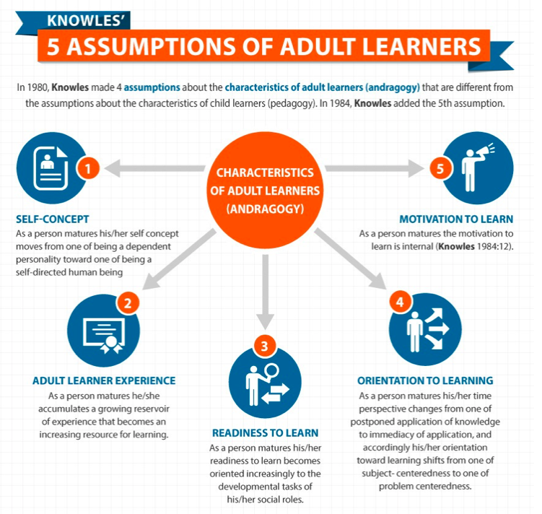
Appendix 1

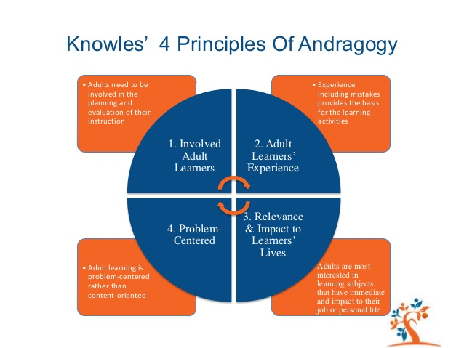
(eLearning Industry, 2018).
(Pappas, 2013)
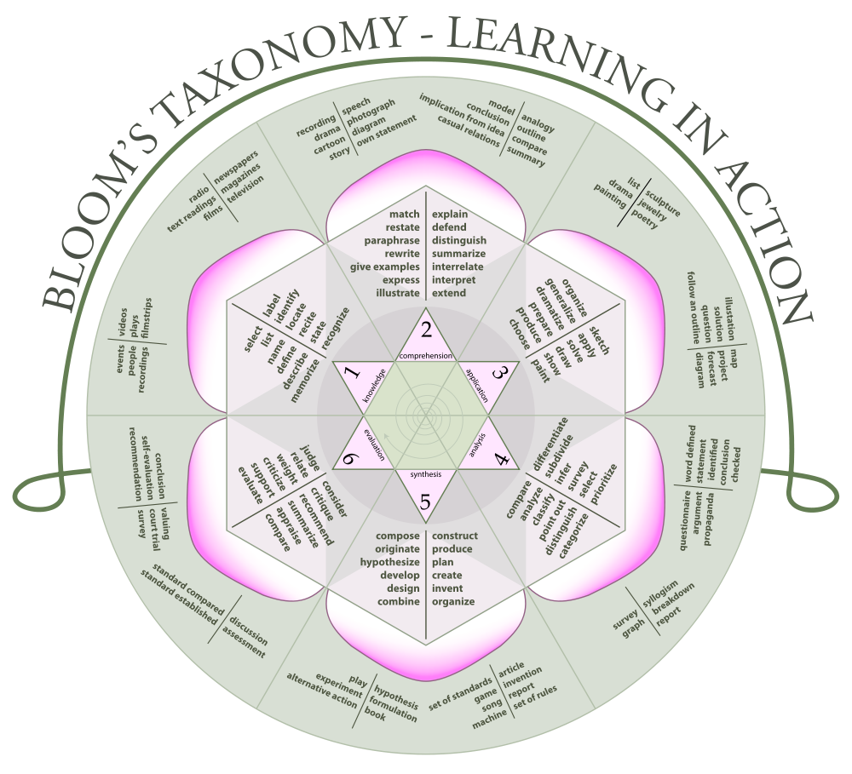
Appendix 2

(Persaud, 2018)
Appendix 3

Professional standards for further education teachers and work-based learning practitioners in Wales
The new professional standards for Wales are expressed in the form of a series of personal commitments as follows:
- Demonstrate commitment to learners, their learning, safety and well-being
Inspiring, supporting and stretching learners, taking account of their starting points and progression options
Working with others to ensure learners are fully supported
- Value and promote diversity, equality of opportunity and inclusion
Embracing diversity and advocating inclusion
Challenging discrimination in all forms
- Understand the importance of the Welsh culture and language as a bilingual nation
Taking opportunities to celebrate the culture of Wales and its place in the world
Pursuing opportunities for my own Welsh language development and promoting its importance to others

- Demonstrate dignity, courtesy and respect towards others
Listening to and respecting other people’s views, opinions and ideas
Acting as a role model for fair, courteous and respectful behaviours
- Maintain and update knowledge of my subject(s) and how best to teach and assess them
Keeping abreast of my subject or vocational area and of effective teaching and assessment methods
Using assessment of and for learning to support learner progress
- Know how to use evidence and research to improve my practice
Accessing and experimenting with research from a range of sources
Reflecting on the latest theories and research with colleagues and exploring their relevance to my teaching and learning context
- Plan and deliver effective learning, teaching and assessment
Identifying, preparing, delivering and assessing learning programmes
Using a range of media, including digital, effectively to enhance the learning process
- Build positive and collaborative relationships
Working to build and maintain relationships with learners, colleagues, employers and others as appropriate
Exercising leadership through all aspects of professional practice and participating in and contributing to professional learning networks
- Enable learners to share responsibility for their own learning and assessment
Working with all learners to empower them to set challenging goals and targets and to evaluate their own progress against these
Communicating effectively with all learners, employers and others as appropriate
- Critically reflect on own values, knowledge and skills to improve learning
Developing my own literacy, numeracy and digital literacy skills along with other appropriate professional skills
Critically appraising my own practice and adapting it in the light of reflection and feedback, including feedback from learners.

