University Of Wales Trinity Saint David

Wales institute of science and arts



Analysis and Simulation of a Centrifugal Clutch

Stress Analysis and Dynamics (ACMA5010)

Jacob Christian Jones

2005053

December 2023

Table of contents

Contents
Table of contents 2
Task A 3
1. Introduction 3
2. Development of Centrifugal Clutches 4
3. Advantages of using Centrifugal clutches 6
4. Current applications of Electromagnetic Clutches 7
Task 2 8
1. What is the outer diameter of the drum? 8
2. The Engagement speed of the centrifugal clutch 8
3. Radial Force acting on the clutch face at 550 RPM. 9
4. The transmitted torque to the driveshaft at 550 RPM. 9
5. Calculations and Graph plotting the transmitted torque at the driven shaft against the driving shaft speed. 10
6. Calculating Torque using varying coefficients of friction 11
7. Angular acceleration of the drum of 750g when maximum torque is achieved. 13
References 14

Task A

Introduction

Centrifugal clutches are devices used in mechanical power transmissions that operate using centrifugal force to engage and disengage. These clutches can be found in various applications within machinery, from small engines in lawnmowers and go karts to industrial sized equipment where automatic clutch engagement is advantageous (How does a centrifugal clutch work? what are the pros and cons? 2023). Centrifugal clutches operate on the principle of rotational speed, where the clutch automatically engages when the desired engine RPM is met, allowing power to the drive shaft.

The operation of a centrifugal clutch relies on weights or ‘shoes’ attached to a pivoting mechanism. At lower speeds, the shoes remain close to the centre of the clutch, allowing minimal power output. When the RPM rises, the centrifugal force causes the weights to be pushed outward, engaging with the friction lining. Thus, connecting the engine to the driven load.

The Figure below depicts a simplified diagram of a centrifugal clutch with its specific parts. As spoken about above, the shoes or weights move outward from the spider to connect with the friction lining. Some centrifugal clutches are made from a different number of shoes. Although there is a different number of shoes used, the outcome is still the same.
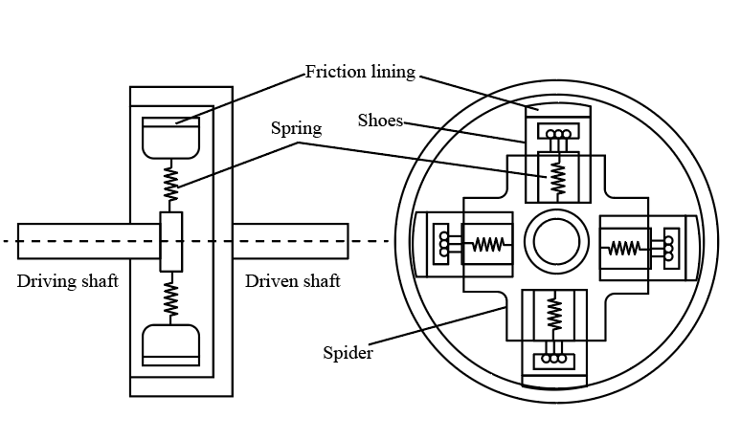
Figure 1: Diagram of Centrifugal clutch (Bartleby, 2022)

Development of Centrifugal Clutches

The centrifugal clutch was developed to simplify the process of engaging and disengaging the engine from the drivetrain automatically. Centrifugal clutches can be traced back as early as the 19th century in the locomotive industry. As for the automotive industry, one of the first know applications of the centrifugal clutch is by the Armstrong Siddeley engineering group (MechStudies, 2023). Armstrong siddeley first used the centrifugal clutch in their cars in 1936, which at the time was revolutionary. But, along with Armstrong, Thomas Fogarty is also credited with the application of centrifugal clutches in small motor applications. These are now the most used applicants of the centrifugal clutch.
In the early days of centrifugal clutch development, readily available materials such as cast iron and basic alloys were used in the manufacturing of clutch components. Materials like cast iron were suitable for the engineering practices of the time. Properties that would benefit the manufactures would be the high wear resistance of cast iron. A clutch will obtain a high amount of stress while operating therefore a material with a high wear resistance is desirable (Mohammed Mohaideen et al., 2023). Another benefit for manufacturers would have been the price of iron. The below figure shows the average price of iron per hundred pounds in the United States from 1897 through 2010. Looking at the year 1936 on the table, it shows a value of $1.92. If this was converted to price per metric tonne, the value would show $42.38. In today’s money that would equal $611.44. A company such as Armstrong Siddeley could manufacture a vast number of clutch plates with a metric tonne of iron.

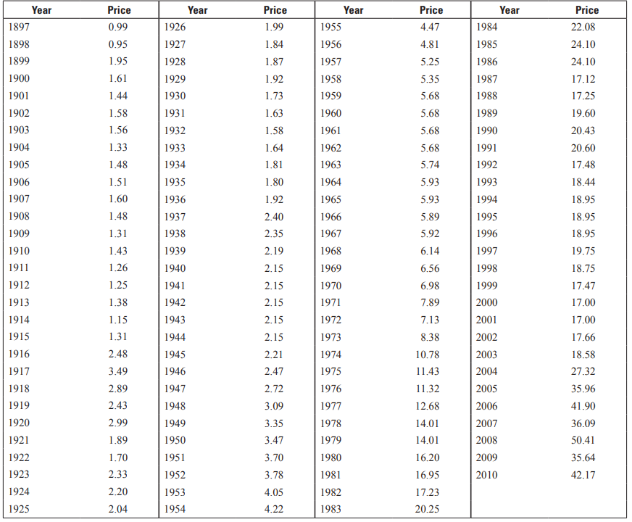
Figure 2: Average steel price per year (1897 through 2010)
(Metal prices in the United States through 2010 ,2013)

The benefits of heat-treating steel are the improvement in both hardness and strength.
Nowadays, Centrifugal clutches are made of mainly steel and high strength alloys. Manufacturers have the funds and technology to research and test materials to their absolute limit. The technology and software's used allow companies to simulate real life circumstances and evaluate how such material reacts to the stress under load. An example of a high strength alloy used in manufacturing would be a heat-treated steel. The benefits of heat-treating steel are the improvement in both hardness and strength. To do so the material must be heated slowly to a specific temperature, kept at that uniform temperature for said time and then finally quenched. Quenching consists of rapidly cooling a material by plunging it in water. (Spira, N.2021). Heat treating steel improves the wear resistance massively. As a clutch is subjected to a consistent high working load, it is beneficial for clutch manufacturing companies to manufacture using heat treated steels.

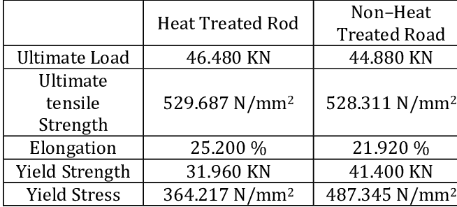
Figure 3: Heat treated steel chart.
(Samatham, 2017)

Figure 3 shows the improvements in mechanical properties when heat treating steel. The chart clearly shows that heat treating steel improves a steels strength.

Advantages of using Centrifugal clutches

When looking at the applications of centrifugal clutches in machinery, the advantages are clear. From lower costs to minimal maintenance, there are several reasons for the use of centrifugal clutches. The obvious standout advantage of using a centrifugal clutch is its automatic engagement ability. This type of device does not require any form of control mechanism to engage or disengage (Team, 2021). This feature enhances user convenience and reduces the risk of stalling, making centrifugal clutches easily operational.

Another advantage of this specific clutch is its lightweight and compact design. This contributes to the overall efficiency of the device by reducing weight. With the reduction in weight and size, the centrifugal clutch is almost an ideal fit for small engine applications such as chainsaws and lawnmowers. On the topic of chainsaws, another benefit of using a centrifugal clutch in manufacturing would be its ability to gradually engage and disengage smoothly. As this clutch has a controlled power transfer, sudden jerks or shocks in power are eradicated. This is almost expected in a device such as a chainsaw, for obvious safety reasons.

Additionally, centrifugal clutches are cost effective and somewhat easy to maintain compared to other varying clutch types. When looking at their design, there is an uncomplicated approach to the design. There are only a few parts to make up the clutch, therefore the risk of malfunction or breakdown is reduced. In comparison to the reduction in breakdown probability, there is also a reduction in maintenance cost.

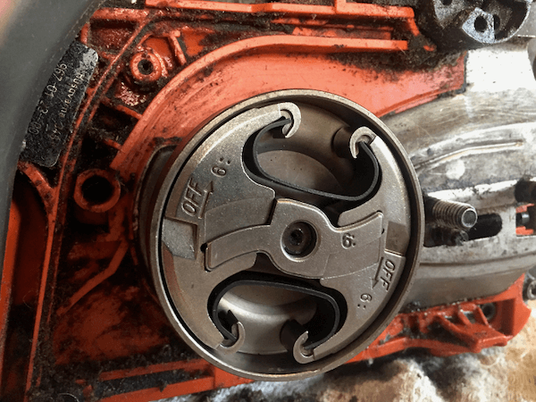
Figure 4. Centrifugal clutch in Husqvarna 345 chainsaw (How to replace a chainsaw clutch and sprocket)

Current applications of Electromagnetic Clutches

An electromagnetic clutch is an efficient device used in various mechanical systems such as automotive and industrial machinery. These clutches utilise the principles of electromagnetism to engage and disengage power transmissions. To operate, an electromagnetic coil is used to create a magnetic field. This coil then releases a friction plate which connects or disconnects the driving components of the drive shaft. (Electromagnetic clutch 2023). Initially, the clutch is disengaged, resulting in a gap between the rotor and hub parts of the clutch. The engine’s activation is required to start the rotation of the rotor. A Direct Current is then transferred to the clutches winding, creating an electromagnetic field. The attractive force created by the winding creates pressure on the friction plate, causing the rotation of the hub. As the hub undergoes rotation, there is a maximum torque applied to the drive shaft.
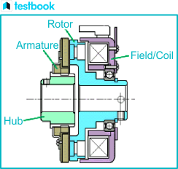
Figure 5. Electromagnetic Clutch Diagram (Electromagnetic clutch 2023

Unalike centrifugal clutches, electromagnetic clutches provide quick engagement and disengagement. Even though this type of clutch offers a quick response time, there is minimal jerk and shock when operating. This is due to the smoothness of the engagement and disengagement. Another advantageous property of an electromagnetic clutch is the ability to transmit a high torque value efficiently. This is ideal for heavy-duty applications that require a high torque to operate. An example of such application would be agricultural machinery like a tractor. These vehicles are of large mass and additionally are used to tow large masses. Therefore, a clutch that produces a high torque is suitable.

Task 2

What is the outer diameter of the drum?

$$95mm+9mm+4mm=108mm Radius$$
$$108mm ×2=216mm Diameter$$
$$Convert to SI units :216mm ×{10}^{-3}=0.216m Diameter$$

The Engagement speed of the centrifugal clutch

$$m^{2}.r^{2}.ω^{2}=k.x.μ.mg$$

Transpose to make Angular Velocity the subject.

$$ω= \sqrt{\frac{k.x+μ.mg}{m.r}}$$

Use data given:
$m=0.275kg, r=0.104m, k=7.5×{10}^{3}Nm, x=0.009m,μ=0.35, g=9.81m/s$

$$ω= \sqrt{\frac{7.5×{10}^{3}×0.009+0.35×0.275×9.81}{0.275×0.104}}$$

$$ω=48.58 rad/s$$

Convert angular velocity to RPM:
$$RPM= \frac{ω}{2×π}×60$$

$$RPM= \frac{48.58}{2×π}×60$$

$$RPM=463.91$$

464 RPM to the nearest whole number

Radial Force acting on the clutch face at 550 RPM.

$$F radial=m.ω^{2}.r$$

Use data given:
$$m=0.275kg, r=0.095m, RPM=550$$

The RPM needs to be converted to angular velocity:
$$ω= \left(\frac{2×π×RPM}{60}\right)$$

$$ω= \left(\frac{2×π×550}{60}\right)$$

$$ω=57.59 rad/s$$

$$∴$$
$$F radial=0.275 ×{57.59}^{2}×0.095$$

$$F radial=86.6 N$$

The transmitted torque to the driveshaft at 550 RPM.

The equations required to calculate the Torque:

$$Torque=Frictional Force ×Radius ×Number of shoes$$
$$Frictional Force=Coefficient of Friction ×Resultant Force$$
$$Resultant Force=Centrifugal Force-Spring Force$$
$$Spring Force= -spring constant ×displacement$$
$$Centrifugal Force=mass × {angular velocity}^{2} ×radius$$

Use the data given and calculated in above equations:

$$Centrifugal Force=0.275 × {57.59}^{2} ×0.104$$
$$Centrifugal Force=86.6N$$

$$Spring Force=7.5×{10}^{3} ×0.009$$
$$Spring Force=67.5N$$

$$Resultant Force=86.6-67.5$$
$$Resultant Force=19.16N$$

$$Frictional Force=0.35 ×19.16$$
$$Frictional Force=9.58N$$

$$Torque=9.58 ×0.104 ×4$$
$Torque=3.99NM$

Calculations and Graph plotting the transmitted torque at the driven shaft against the driving shaft speed.


Figure 6. Calculations required for Torque.


Figure 7. Constant variables used to calculate Torque.

Figure 8. Graph Plotting Transmitted Torque to the driveshaft against the driveshaft speed (RPM)

Calculating Torque using varying coefficients of friction

Coefficient of friction of 0.3


Figure 9. Calculations required for Torque (Coefficient of friction of 0.3)

Figure 10. Graph Plotting Transmitted Torque to the driveshaft against the driveshaft speed RPM (Coefficient of friction of 0.3)

Coefficient of friction of 0.4


Figure 11. Calculations required for Torque (Coefficient of friction of 0.4)

Figure 12. Graph plotting Transmitted Torque to the driveshaft against the driveshaft speed RPM (Coefficient of Friction of 0.4)

When looking at figures 6 through 12, it is clear that the coefficient of friction has an effect on the torque transmitted to the driveshaft. As the coefficient of friction is reduced the amount of torque transmitted also reduces. The opposite can be seen for the increase of friction. These results are expected, as the higher the coefficient of friction, the higher the fictional force.

Angular acceleration of the drum of 750g when maximum torque is achieved.

First the max Torque value must be found: 14.34Nm (Figure 11)
The corresponding Force: 137.889N

Use the force equation to find the angular velocity required:
$$Force=Mass ×Angular Velocity^{2} ×Radius$$
Trasnpose to make Angular Velocity the subject:
$$ω^{2}= \frac{F}{m×r}$$

$$ω^{2}= \frac{137.889}{0.750×0.104}$$

$$ω^{2}=1767.81 rad/s$$

$Use ω^{2} to calculate α$:

$$Angular Acceleration=Angular Velocity^{2} ×Radius$$

$$α={1797.81}^{2} ×0.104$$

$$α=183.85 rad/s^{2}$$

References

- How does a centrifugal clutch work? what are the pros and cons? (2023) Engineering Designer. Available at: https://www.engineeringdesigner.co.uk/how-does-acentrifugal-clutch-work-what-are-the-pros-and-cons/ (Accessed: 08 December 2023).
- MechStudies (2023) Centrifugal clutches - definition, parts, types, working, application, www.mechstudies.com. Available at: https://www.mechstudies.com/centrifugal-clutches-parts-types-working/ (Accessed: 10 December 2023).
- Mohammed Mohaideen, M. et al. (2023) A study on single plate clutch disc using finite element method, Materials Today: Proceedings. Available at: https://www.sciencedirect.com/science/article/abs/pii/S2214785323021661#:~:text=Normally%20clutch%20plate%20is%20made,ceramic%20based%20composite%20%5B2%5D. (Accessed: 10 December 2023).
- Figure 1 - Bartleby (2022) The clutch is described as a machine element used to connect or disconnect two shafts together to transmit torque or power. the clutch works on the principles of friction. the clutch is commonly used in automobiles to transfer power from the driving shaft to the driven shaft., bartleby. Available at: https://www.bartleby.com/subject/engineering/mechanical-engineering/concepts/clutches-brakes-couplings-and (Accessed: 17 December 2023).
- Figure 2 - Metal prices in the United States through 2010 (2013) Metal prices in the United States through 2010. Available at: https://pubs.usgs.gov/sir/2012/5188/sir2012-5188.pdf (Accessed: 14 December 2023).
- Spira, N. (2021) The 4 types of heat treatment steel undergoes, Kloeckner Metals Corporation. Available at: https://www.kloecknermetals.com/blog/the-4-types-of-heat-treatment-steel-undergoes/ (Accessed: 15 December 2023).
- Figure 3 - Samatham, M. (2017) Comparison of heat treated and non-heat treated rod tensile test ..., Comparison of Heat Treated and Non-Heat Treated Rod tensile test . Available at: https://www.researchgate.net/figure/Comparison-of-Heat-Treated-and-Non-Heat-Treated-Rod-tensile-test_tbl4_314081177 (Accessed: 15 December 2023).
- Team, T.B. (2021) Advantages and disadvantages of centrifugal clutches, BLM Automatic Clutch. Available at: https://www.blm-cm.com/blog/advantages-disadvantages-centrifugal-clutches/ (Accessed: 17 December 2023).
- How to replace a chainsaw clutch and sprocket (no date) Firewood For Life. Available at: https://www.firewood-for-life.com/replace-a-chainsaw-clutch.html (Accessed: 17 December 2023).
- Electromagnetic clutch: Diagram, working, advantages, and uses. (2023) Testbook. Available at: https://testbook.com/mechanical-engineering/electromagnetic-clutch (Accessed: 17 December 2023).

