Developing Workplace Critical Thinking] [2021]
How Individual’s Beliefs, Attitudes and Values Impact on Workplace Behavior



Student ID 1919419
Zujaja Tabassum Kharal

Executive Summary
This report is being written as an assignment for BA (Hons) Leadership and Management Skills in the Workplace to Develop Workplace Critical Thinking on how Individual’s Beliefs, Attitudes, and Values impact workplace behavior under the light of classical (old) and modern theories.

For this report, the RED model is used and the reader can find the implementation all through the conclusion is not drawn on a personal basis as the value aspect would be lost, rather the picture of PVA is placed in conclusion.

Max Weber (classical theory) and McGregor’s Theory (Modern Management Theory) could be seen parallel to clarify the difference for the reader's understanding.

Max Weber is one of the most important social theorists of the past century. According to his bureaucratic theory, bureaucracy is the basis for the systematic formation of any organization and is designed to ensure efficiency and economic effectiveness. (Hanke et al., 2020)

Whereas McGregor’s Theory Y describes the importance of optimistic opinion for the managers and employees so the workforce can be encouraged to participate in more collaborative and trust-based relationships to design an effective team. (Leena et al., 2015)

There are 3 types of skills for managerial and Leadership roles, such as Technical skills, Interpersonal Skills, and Decision- Making skills. Technical skills are the ability to use methods and techniques, Interpersonal skills, focus solely on the ability to understand, communicate and work well with individuals and groups through developing effective relationships and decision-making skills involve the ability to conceptualize situations and select alternatives to solve problems and take advantage of opportunities. How every all these skills can only be effective if individual and companies’ values align.

Virgin Media is the chosen organization and this report benefits from Mr. Branson’s old but modern techniques and précis quotes explains that clearly.

Contents
Executive Summary 2
1.0 Introduction 4
2.0 Findings 6
D 10
3.0 Conclusion 10
References 12

Introduction

Virgin Media is the chosen organization for this report, the findings are that the company is a sub to a multinational group of companies and is set up by a sole owner Mr. Richard Branson.

The RED model is applied in the report looking at critical techniques analyzing the evidence of implementation of the values within the organization. Management theories will be explored by using these critical techniques to evaluate the benefits they provide the organization in achieving success particularly looking at its employees and sustainable initiatives

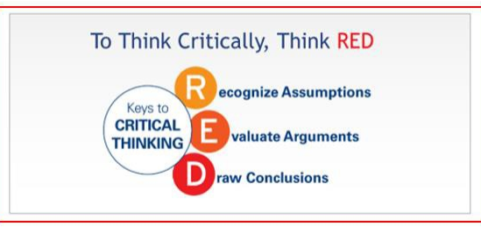

R
Max Weber (Old Classical Theory)

An organization must have a defined hierarchical structure, clear rules and regulations, and lines of authority
Following are the words of Mr. Branson under the shades of McGregor’s theory y

“Surround yourself with people that are smarter than you, give them everything they need to grow, and your business will thrive.”
(Branson, 2021)
McGregor’s Theory (Modern Management Theory)

According to McGregor better reward system and self-actualization motivates employees to become a better team to achieve organizational goals
.
The company's core values are to build a connection that matters, help people do what they love to do to create positive change in society. Virgin Media made three promises to stakeholders for the next five years which are as follows:

- Better for its stakeholders (customers and Employees) to make them feel belonged Better for communities by supporting organizations helping put an end to loneliness
- Better for the planet by setting a big goal to reach net-zero carbon and zero west all through the business process by the end of 2025.

Following are the theories being explored for this report with the help of the Red model.

When managers act as coaches to their underlying workers rather than commanding individuals or groups in a traditional meaner of superior to inferior, it creates a sense of organizational value which then passes to an individual as an employee of such organization and create a positive harmony which helps employees to align their values with of that organization (Sullivan et al., 2001)

There is a significant benefit to both the organization and an individual if a common set of values are achieved and practiced Personality traits that virgin media look for in job candidates what is meant by personality? Enduring Characteristics (Personality Traits) that describe an individual’s behaviour. The virgin media lookup for some good job candidates with good personality traits. (Robins, Judge, and Vohara, 2013)

E

Findings

Classical Theory:
The refinement of this theory occurred between the 19th and 20th centuries when factories appeared, posing many challenges for management in terms of managing people, production, and processes, which had not been encountered earlier.
A set of principles for an "ideal" bureaucracy was developed by Max Weber. According to Weber, civilization is changing to seek technical optimal results while disregarding humanistic content. (Dash & Padhi, 2020).
To address the above issue in the modern-day Mr. Branson says and I quote,

“If your eyes are fixed on the rear-view mirror, you'll miss that important turn coming up.”
(Branson, 2020)
During 1900-1920, the concept of scientific management raised quickly due to the philosophical industrial sector Enlargement and High-Tech sector bloom. An emphasis was placed on methods that help improve the productivity, efficiency, effectiveness, and performance of workers. To be accurate this theory concentrated much on the division of work, training of workers, and specialization in addition to tangible incentives.
Virgin Media understands that engaging and motivating its employee’s benefits the company as well as the individuals involved and therefore considers the welfare of employees a priority but one of the comments out of many from employees challenge this statement as it says,
“Management refuses to take responsibility and belittles its employees. I was named employee of the month, only to be thrown out a few weeks later for taking a few days off sick." (Customer Resolutions Officer (Former Employee) - Birmingham - 17 November 2021 et al., 2021).
As an organization or individual, it is important to invest smartly in time and management. Individual values can be upgraded to match the organizational values; however, motivational techniques can make the employees more willing to perform.
Similarly, individual values can add up to organization values and play a huge part in team improvement as well as bringing innovation.

Recognition is the other vital key any organization can use to unlock the door of success, when the hard work of an employee is rewarded the team improves and when the hard work of the team is recognized the organization thrives, by rewarding and recognizing techniques ascetical individuals come on surface and their knowledge and expertise can be used to create an organizational culture.
Clear and revised communication is vital to keep the values alive, reminders, workshops, and social gathering plays a great part in exchanging common values from an organization to an employee and vice versa which improve morals.
To get the above results an organization (Virgin Media) would
· Find a great idea that helps people and fulfils a need
· Respect people and treat them well
· Value your ideas
· Be brave
· Have a plan
· Be stubborn
· Do the impossible
(Fertig, 2012)
“We spend most of our waking lives at work, so it's important that we do what we love and love what we do.”

(Branson, 2020)
The organization needs to religiously practice when it comes to values as if stakeholders' see the difference in what is being said and what is happening creates a cynicism for example Lack of accountability, a lack of honesty, unable to keep up with set standards.
An organization must be transparent in reflecting what makes it successful, its culture and most importantly what it takes to succeed while one is employed for that particular organization. Organizational values must be consist of and strictly practiced by when processing such as strategies, selections, rewards, performance management, etc. (Carucci, 2017).
As the classical theory emphasizes the rational economic view and the neoclassical theory emphasizes the social person view, the modern management theory emphasizes a convoluted employee view. Worker needs, motives, aspirations, and potential vary from organization to organization. When compared to classical management theory, which emphasizes the rational economic view, and neoclassical management theory, which emphasizes a person-centered view, modern management theories are much more focused on the complex employee viewpoint. In this theory, an organization is made up of manpower with varying perspectives, aspirations, potentials, and needs. Therefore, we need to approach them with custom-made principles rather than common ones, which not only makes them irritable but also demoralizes them. but also lose their potentials. But managerial strategies are important in such complex scenarios in an organization. This Modern management theory approaches this complexity of organizations and individuals.
Virgin highly appreciates diverse communities to add up to its cultural values and not seek individuals to just fit in the organizational culture but to bring innovation to create a sense of belonging. (Virgin, 2021)

“It doesn't matter if you are David facing Goliath, if you have a clear purpose you can achieve great things.”
Richard Branson

The organization needs to religiously practice when it comes to values as if stakeholders' see the difference in what is being said and what is happening creates a cynicism for example Lack of accountability, a lack of honesty, unable to keep up with set standards.
An organization must be transparent in reflecting what makes it successful, its culture and most importantly what it takes to succeed while one is employed for that particular organization. Organizational values must be consist of and strictly practiced by when processing such as strategies, selections, rewards, performance management, etc. (Carucci, 2017)
As the classical theory emphasizes the rational economic view and the neoclassical theory emphasizes the social person view, the modern management theory emphasizes a convoluted employee view. Worker needs, motives, aspirations, and potential vary from organization to organization. When compared to classical management theory, which emphasizes the rational economic view, and neoclassical management theory, which emphasizes a person-centered view, modern management theories are much more focused on the complex employee viewpoint. In this theory, an organization is made up of manpower with varying perspectives, aspirations, potentials, and needs. Therefore, we need to approach them with custom-made principles rather than common ones, which not only makes them irritable but also demoralizes them. but also lose their potentials. But managerial strategies are important in such complex scenarios in an organization. This Modern management theory approaches this complexity of organizations and individuals.
Virgin highly appreciates diverse communities to add up to its cultural values and not seek individuals to just fit in the organizational culture but to bring innovation to create a sense of belonging. (Virgin, 2021).
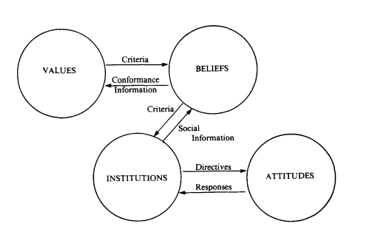

(Hayden, 1988)

Virgin is a large and multinational company with more than 40 sub-companies all around the world, carrying a whole world of opportunities.
The Virgin Group hierarchy believes that everyone should feel like they can be 100% themselves at work. This can only be achieved by having a diversity of employees. The Virgin Group strives to ensure that all of its companies offer an inclusive workplace to all employees, regardless of age, gender, race, religion, disability, sexual orientation, and belief or non-belief.
The Virgin Group believes in and acts upon McGregor’s theory and emphasis that collective differences make them stronger. Inclusion and diversity play a positive part in the improvement of a business. Virgin not only focuses on its people when it comes to inclusion but also the customers and wider community the company work with is weighed on the same scale. Virgin Media’s apprentice scheme and Scope partnership is just one example of a licensee actively encouraging inclusion within their businesses.
Opinions, attitudes, preferences, desires, fears, etc are all translucent images of an individual and can be seen through once personal or professional performance, organization not taking values into account would be classed as a bad organization as the job leavers rate would be high due to no job satisfaction. (Posner, 2010).

D

Conclusion
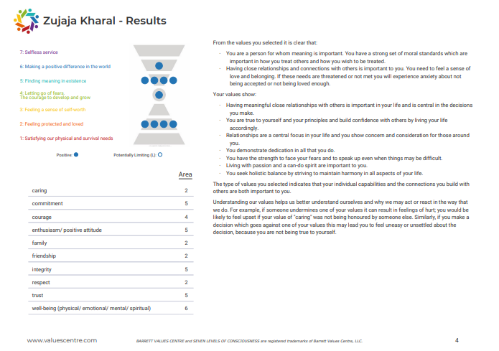

A match of organizational and individual values such as respect, honesty, and trust along with hardworking can result in achieving a dream of success and no outer source can undermine that organization and its team.

Management theories are a systematic grouping of interdependent concepts and principles that give a framework for managers to take responsibility for taking actions that will make it possible for individuals to make their best contributions organizational goals by planning, organizing, staffing, leading and problem-solving and coordinating, establishing an environment in which people can accomplish and be productive. Managers are hence the dynamic leader whose performance will have a direct impact on the success of the business.

Importance is not a match in values but the adoption of values and respect both ways, individuals can find meaning in their work and companies can find a satisfied and productive workforce, by recognizing what individual values companies can engage employee’s hearts at work and rewards based around those values can improve quality of work.
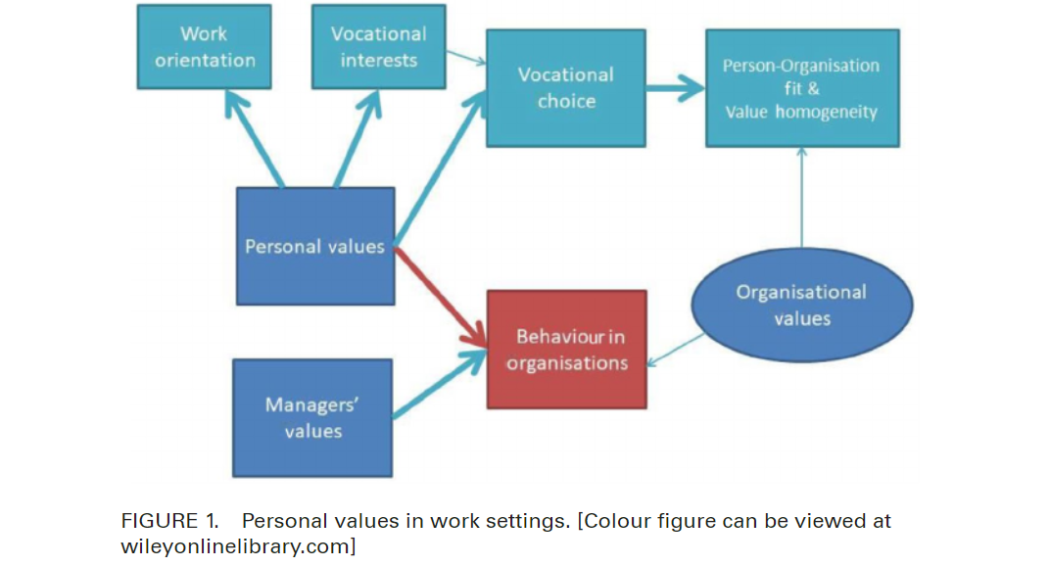
(Arieli et al., 2018)

References

Anon, Meaningful connections plan. Virgin Media. Available at: https://www.virginmedia.com/corporate/sustainability/meaningful-connections-plan [Accessed December 1, 2021].
Arieli, S., Sagiv, L. & Roccas, S., 2018. Values at work: The impact of personal values in organisations. Applied Psychology, 69(2), pp.231–231.
Branson, R., 2020. Modern slavery act: Virgin. Virgin.com. Available at: https://www.virgin.com/modern-slavery-act [Accessed December 5, 2021].
Branson, R., Our approach to business: Virgin. Virgin.com. Available at: https://www.virgin.com/about-virgin/virgin-group/overview [Accessed December 2, 2021].
Branson, R., Work for virgin: Virgin. Virgin.com. Available at: https://www.virgin.com/about-virgin/virgin-careers [Accessed December 7, 2021].
Carucci, R., 2017. How Corporate Values Get Hijacked and Misused.
Customer Resolutions Officer (Former Employee) - Birmingham - 17 November 2021 et al., 2021. Virgin media. Indeed.com. Available at: https://uk.indeed.com/cmp/Virgin-Media/reviews [Accessed December 7, 2021].
Dash, S.S. & Padhi, M., 2020. Relevance of Max Weber’s rational bureaucratic organizations in Modern Society. management revue, 31(1), pp.3–4.
Fertig, D., 2012. How to become an entrepreneur. In Richard Branson. UK: Raintree, pp. 42–43.
Hanke, E., Scaff, L.A. & Whimster, S., 2020. The Oxford Handbook of Max Weber, New York: Oxford University Press.
Hayden, G.F., 1988. Values, beliefs, and attitudes in a sociotechnical setting. Journal of Economic Issues, 22(2), pp.424–424.
How to Write an Executive Summary That Grabs the Reader's Attention. 2004. Design Firm Management & Administration Report, 04(2), pp. 7.
Leena, L., Richard, K.E. & David, P.J., 2015. McGregor's Theory X/Y and Job Performance: A Multilevel, Multi-source Analysis, 27 , pp.84–101.
Posner, B.Z., 2010. Another look at the impact of personal and organizational values congruency. Journal of Business Ethics, 97(4), pp.535–541.
Sales, S., 2017. Fixer: How can we inspire staff to live our values? https://www.peoplemanagement.co.uk/experts/advice/fixer-inspire-staff-live-values.
Sullivan, W., Sullivan, R. & Buffton, B., 2001. Aligning individual and organisational values to support change. Journal of Change Management, 2(3), pp.250–250.
Virgin, V., 2021. Work for virgin: Virgin. Virgin.com. Available at: https://www.virgin.com/about-virgin/virgin-careers [Accessed December 5, 2021].
Yohn, D.L., 2018. Organizational Culture. Ban These 5 Words From Your Corporate Values Statement.

