

MODULE: HUMAN RESOURCE MANAGEMENT
MODULE CODE: LCMB7000

Student Name:- Kamlesh Laherubhai Mali
Student Id: - 2236966
Assignment Title:- Assessment 1 (Human Resource Management)
Lecturer Name:- Mohamed Asim
Submission Date:- 22th August 2023

Executive Summary
The study has included that human resource management has been the strategy to support and nurture the employees and ensure a positive environment for working. Jaguar land rover has been involving human resource management in their workplace to provide a good working environment and ensure high-quality performance. The study has also included the current state of the labour market in the UK. The emerging changes in the strategies of human resourcing have been shown in the post-Covid and Post-BREXIT external environment. The conclusion on the overall study has been given at last of this study.
Table of Contents
Introduction 4
Background of the company 4
Analyse the current state of the labour market in the UK 5
Critically evaluate the managerial and business environment of the company 6
Identify and critically analyse the resourcing of an organisation 6
Analyse the internal and external factors affecting the human resource of an organisation 7
Impact of policies, procedures and processes adopted by the organisation on human resource 10
Evaluate the emerging changes in human resourcing strategies in the post-Covid and post-Brexit external environment 11
Conclusion 12
Reference List 13

Introduction
Human resource management (HRM) is the process of employing people, training them, compensating them, developing policies relating to them, and developing strategies to retain them. Moreover, Human resource management has been the strategy to support and nurture the employees and ensure a positive environment for working. Using Jaguar as a case study can provide concrete insights into the labor market and HR strategies. This focused approach allows for a thorough analysis of how the company navigates the challenges posed by the post-Covid and post-Brexit environment, enhancing the depth and relevance of the report. Jaguar Land Rover has implemented human resource management practices to foster a positive work environment and enhance productivity. This study aims to examine the current status of the UK labor market and the evolving approaches to human resourcing amidst the post-Covid and post-Brexit external environment. It will include the analysis of internal and external factors that impact the human resource of an organization.

Background of the company
Jaguar has been a luxurious vehicle brand situated in Whitley, UK as the company has been famous for its designs and manufacturing. In 2022, the automotive company generated 18.3 billion pounds in sales revenue and has been marked as a long-standing car for the first time (Statista.com, 2022). The company has been accelerating towards digital transformation and they have been contributing 200 million pounds for the digitalization.
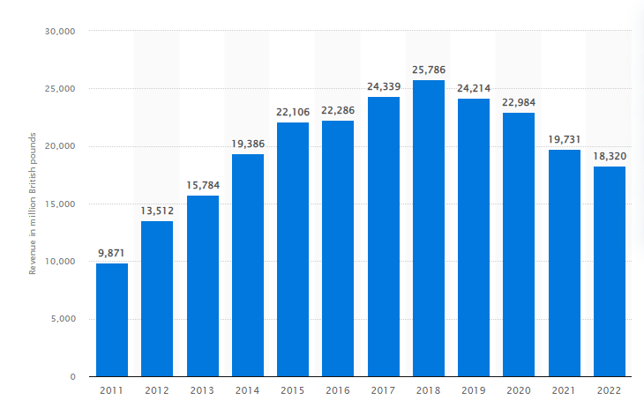
Figure 1: Jaguar land rover global sale revenue 2011-22
(Source: Statista.com, 2022)
Jaguar Land Rover has committed to producing a pure electric Jaguar portfolio by 2025 with zero tailgate emissions for all vehicles by 2035 and zero emissions in the supply chain by 2039. The company has high demand in the global market and in 2020 they have been sold 425,974 vehicles in more than 127 countries.

Analyse the current state of the labour market in the UK
The labour market has referred to the supply and demand of labour in companies or industries to fulfil the organisational requirements. As stated by Brown (2020), the labour market has included the demand for the employees and supply of employment in the industries. The importance of the labour market in the countries has been to provide competitive advantage and development for the companies. The labour market has been the place where employees and workers can interact with each other and provide economic development to an organisation. The UK automotive industry has been performing well in labour productivity, flexible labour market and labour costs. In the UK, the employment rate has increased by 0.2% in January 2023 from November 2022 and has been estimated at 76% from February to April 2023 (Ons.gov.uk, 2023). The employment rate and self-employed workers rate have been increasing in the UK across the economy. The employment rate in the UK automobile industry has increased from 2013 to 2020. In 2021, the British automobile industry employed 781,800 employees (Statista.com, 2022). In the labour market of the UK, workers have been engaged in the production process of different parts of automobile vehicles. The labour market has been beneficial for companies or industries as it increases efficiency and productivity in an organisation that enhances productivity level.
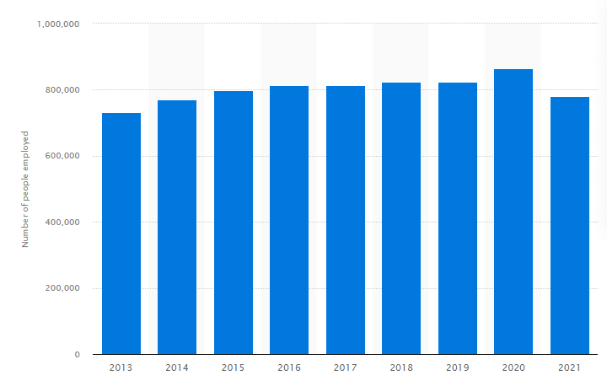
Figure 2: Increased employment rate in the automobile industry in the UK
(Source: Statista.com, 2022)
A labour market develops a high employment economy in the countries and makes the production level faster. As stated by Brell (2020), the labour market has been the place of supply and demand for jobs to meet and provide service to an organisation. The labour market such as employment and wages has been used to increase the broad development of capabilities to support belongings of social sense. However, the automotive industry in the UK has been facing increasing pressure due to the shortage of labour and rising inflationary costs. During the Covid-19, the automobile industry has faced heavy challenges as a result some 10,000 jobs have been lost in the UK automotive sector in 2020 (Statista.com, 2020). Jaguar Land Rover has an employee worth 44,101 people in 2019 and recently they have provided 5000 more jobs to the people. The labour market has been used to provide benefits to an organisation as it ensures competitive compensation to its workers. High demand for employment can create an environment with heavy insight into the workforce. The flexibility in the labour market has allowed companies to provide changes in their working environment related to employee hiring, compensation, working hours and conditions.

Critically evaluate the managerial and business environment of the company
The managerial and business environment refers to the collection of internal and external factors such as employees, customer needs and expectations, supply chain, technology, government and many more. As stated by Ikram (2019), environment management has been a set of good practices used to provide effectiveness to an organisation and develop end-to-end management services. The managerial and business environment of Jaguar land rover has been growing in sustainability and decreasing the operational impact of its manufacturing process. As argued by Sajjad (2020), the managerial environment has allowed organisations to share values, beliefs and assumptions to create innovative development. The company has been developing human resource management for their organisation development. Jaguar land rover has been created consolidating and integrating application and data that allows HR to manage the entire development effectively. The company tends to practice zero carbon emissions and support human resources to ensure a positive environment in the workplace (Jaguar.co.uk, 2023). The business environment of the company has been their strong brand recognition enhances its reputation and attracts more customers. The company has been developing collaboration with human resources and other resourcing to enhance its product offerings and develop a larger sales network. Shortage of semiconductors has been affecting their production capacity and intense competition affecting their sales.

Identify and critically analyse the resourcing of an organisation
There have various resources included in an Organisation such as machinery resources, technology resources, financial resources and human resources. Human resources have been the most valuable resource for an organisation and also a highly volatile resource. The human resource has been beneficial for an organisation as it mostly focused on employee productivity to generate effective profitability for an organisation. As stated by Anwar (2021), human resources have been used to manage the payments and benefits of an organization to generate effective revenue. HR has been used to improve the bottom line of an organization and it drives employee engagement, job satisfaction and staff retention. HR has helped provide a productive and healthy working environment for employers and workers. Financial resources have been an important aspect of an organisation as it helps in managing cash inflows and outflows. As argued by Bartolacci (2020), financial resources are used to help in continuous transactions, managing and monitoring the requirements. It has been used to carry out the main operations of an organisation and helps in acquiring the materials. Technology resources have been beneficial for an organisation as it increases the efficiency of products and services. It helps in tracking and streamlining processes, maintains the flow of data and manages the employee and contracts records.

Analyse the internal and external factors affecting the human resource of an organisation
VRIO ANALYSIS
VRIO analysis has been the resource that focused on strategic analysis tools to build a sustainable competitive advantage for the business.
Resources | Valuable | Rarity | Imitation | Organisation | Competitive advantage
Loyal customer base and network | Yes | No | Yes | Yes | Moderate competitive advantage
Marketing Expertise | Yes | No | No | Yes | Low competitive advantage
Portfolio of products | Yes | No | Yes | Yes | Moderate competitive advantage
Financial resources of the company | Yes | No | Yes | Yes | Moderate competitive advantage
Legal risk management | Yes | No | No | Yes | Low Competitive advantage
Effective pricing strategy | Yes | No | Yes | Yes | Moderate competitive advantage
Global presence | Yes | Yes | Yes | Yes | Sustainable competitive advantage
Table 1: VRIO Analysis
(Source: Myself-Created)
The impact of a loyal customer base has enhanced the growth of an organisation and developed the value proposition. Financial resources have been impacting the overall planning and budgeting of an organisation and creating job satisfaction. Legal risk management has been evaluating processes and operations based on potential risks. Global presence has increased the visibility of an organization and improved revenue.
PESTLE ANALYSIS
Jaguar Land Rover has been estimating PESTLE analysis to analyse the external environment of automotive industries of the UK for their business development.
Political | - Politically stable  - The automobile industry provides 2% tax rates in the UK (Autoexpress.co.uk, 2023)
Economical | - The GDP contribution of the automobile industry in the UK increased from 5% to 10%  - 20% Goods and Service Tax on the automobile industry (Gov.uk, 2023)
Social | - There have been 780,000 employees working in the automobile industry of the UK  - The automobile industry of the UK has generated revenue of 74 billion pounds
Technological | - Artificial Intelligence has been used in the automobile industry such as machine learning (Consultancy.uk, 2019)  - IoT, automation and 3-D printing technology have been used in the automobile industry
Legal | - The Road Vehicle (Approval) Regulation of 2009 has been followed by the automobile industry in the UK (Legislation.gov.uk, 2023)
Environmental | - The Environmental Act of 1990 has been followed by the industry to protect the environment
Table 2: PESTLE analysis of the automobile industry
(Source: Myself-Created)

Political factors have been impacting the human resource of an organization as the changes in policies and rules can change the entire business and human resources have to develop different strategies for mitigating the risk factors. Economic and Social factors have an impact on human resources as high-level growth in the economy leads to creating a need for more staff hence HR has to provide the right decision-making process. Human Resource has been impacted by technological factors as the new technologies need proper planning and implementation process that can be provided by Human resource management. Legal and environmental factors have been impacting the HR practice of an organisation as the new acts have to be implemented in the organisation that has been managed by human resources.

Impact of policies, procedures and processes adopted by the organisation on human resource
The policy has been used to provide direction to the business employees and organizational departments for development. It has helped in bringing consistency and compliance within the company for the vision, mission, and strategic goals such as equal opportunity policy according to the Equality Act of 2010. As stated by Bali (2021), policies have provided guidance to human resource decisions for organizational development and to avoid legal risks. The impact of policies on human resources has been to promote equity for supporting and building the desired organizational culture. Policies help human resources to grow faster for meeting the company's goals and operations. The impact of policies on human resources has been to guide the employees and managers to take down their responsibilities towards an organization and create effectiveness.

Figure 3: Policies/ Procedure/ Processes
(Source: Myself-Created)
The procedure has been provided step-by-step instructions to an organisation for performing a specific task to meet the organisational goals and vision. As stated by Howlett (2021), the procedure has been used to maintain a general understanding of the various circumstances to complete the mission. The procedure has been beneficial for an organisation as it improves the security and improves the quality of the product and service such as standard operating procedure. The impact of procedure on the human resource has been it helps in addressing complaints and properly solves them. It has been used to help in maintaining discipline in the workplace to create innovation among human resources. The procedure has an impact on human resources as it ensures fairness, equity and uniformity in generating organisational practices.
The process has been the method of following the rules or policies of an organisation such as business process management. The process has been used to provide a way to communicate and apply consistent standards within an organisation. As stated by Lewis (2021), a good process helps in saving time and increasing overall efficiency to build the planning for meeting customer needs and expectations. The impact of the process on human resources has been that it brings consistency and visibility to the HR department and makes the interaction easier.

Evaluate the emerging changes in human resourcing strategies in the post-Covid and post-Brexit external environment
The human resourcing strategies of HRM have been identified to face challenges in the post-Covid and post-Brexit environments. As stated by Azizi et al. (2021), the post-Covid era has brought new normal that has been very difficult to cope up with by the HRMs. The resourcing strategies have changed a lot such as recruiting on a project basis and not permanently. This has been known as Flex working, while Teleworking has been another process that demands highly skilled HR managers. As argued by Dirani et al. (2020), vigorous and frequent training and programmes of development have become necessary in the organisations. These training have been important as the frequent recruitment of employees based on projects need to be trained properly. Thus, the cost regarding the improvement and development of temporarily recruited workers has been found to be too costly.
The temporary workforce has been found to change the process of providing perks and full time pay to workers. As opined by Przytuła et al. (2020), the post-Covid era has brought the concept of virtual workforce. Thus, HR managers have to work towards getting new devices to manage virtual employees efficiently. The remote working culture has to be tracked with appropriate technologies to keep the workforce engaged in organisational rules. The governments of different countries have to enforce some laws to address the needs of the organisations in the new era. The new normal has been fully remote working conditions, change and flexibilities on working hours and not firing and hiring employees at will. As argued by Margherita and Heikkilä (2021), the HR managers have to conceptualise new structures of reporting. This has to be done as the workers working remotely need the agile methods which can be there only in organisations with flat and flexible structures.
The UK has been considered as no longer a member of the EU after the BREXIT vote happened. According to Bailey et al. (2023), in the period of transitions no negotiations had been done between the UK and EU, thus, on 1st January 2021 the UK left the EU. The common scenario that has been seen after the BREXIT effect is a war for talent in the UK market. This has emerged from the uncertainty of finding appropriate talent for work among the UK organisations. The changes in the legislation have caused pressure over the HR people in recruiting. As argued by Li et al. (2019), the management of the workforce has been found to be the most important activity that every organisation is engaged in. The most challenging elements that the BREXIT situation has raised are the issues in free movement of attractive talent, rigorous employee regulations and market strength.

Conclusion
From the above study it can be concluded that the labor market in the current times has been the supply of laborers in the industries. The automotive industry of the UK has been found to be performing better in labor productivity. The rate of employment has been increasing in the automobile industry of the UK drastically from 2013 to 2020. The Covid 19 and BREXIT vote have affected all the business sectors including the automotive industry in various ways. The changed working conditions have created issues in the working systems of the industries. The BREXIT has evolved the UK automotive industry with issues in the free labour movement and changed employee regulations.

Reference List
- Anwar, G. and Abdullah, N.N., 2021. The impact of Human resource management practice on Organizational performance. International journal of Engineering, Business and Management (IJEBM), 5.
- Autoexpress.co.uk, 2023. Company car tax guide 2023/2024: everything you need to know. Available at: https://www.autoexpress.co.uk/tips-advice/90125/company-car-tax-guide-20232024-everything-you-need-know#:~:text=Company%20car%20tax%20for%20electric,the%20rate%20frozen%20until%202025. [Accessed on: 13.08.2023]
- Azizi, M.R., Atlasi, R., Ziapour, A., Abbas, J. and Naemi, R., 2021. Innovative human resource management strategies during the COVID-19 pandemic: A systematic narrative review approach. Heliyon, 7(6).
- Bailey, D., De Propris, L., De Ruyter, A., Hearne, D. and Ortega-Argilés, R., 2023. Brexit, trade and UK advanced manufacturing sectors: a Midlands’ perspective. Contemporary Social Science, pp.1-16.
- Bali, A.S., Howlett, M., Lewis, J.M. and Ramesh, M., 2021. Procedural policy tools in theory and practice. Policy and Society, 40(3), pp.295-311.
- Bartolacci, F., Caputo, A. and Soverchia, M., 2020. Sustainability and financial performance of small and medium sized enterprises: A bibliometric and systematic literature review. Business Strategy and the Environment, 29(3), pp.1297-1309.
- Brell, C., Dustmann, C. and Preston, I., 2020. The labor market integration of refugee migrants in high-income countries. Journal of Economic Perspectives, 34(1), pp.94-121.
- Brown, P. and Souto-Otero, M., 2020. The end of the credential society? An analysis of the relationship between education and the labour market using big data. Journal of Education Policy, 35(1), pp.95-118.
- Consultancy.uk, 2019. UK automotive companies lead in implementing AI at scale. Available at: https://www.consultancy.uk/news/20859/uk-automotive-companies-lead-in-implementing-ai-at-scale [Accessed on: 13.08.2023]
- Dirani, K.M., Abadi, M., Alizadeh, A., Barhate, B., Garza, R.C., Gunasekara, N., Ibrahim, G. and Majzun, Z., 2020. Leadership competencies and the essential role of human resource development in times of crisis: a response to Covid-19 pandemic. Human resource development international, 23(4), pp.380-394.
- Gov.uk, 2023. VAT rates. Available at: https://www.gov.uk/vat-rates [Accessed on: 13.08.2023]
- Ikram, M., Zhou, P., Shah, S.A.A. and Liu, G.Q., 2019. Do environmental management systems help improve corporate sustainable development? Evidence from manufacturing companies in Pakistan. Journal of Cleaner Production, 226, pp.628-641.
- Jaguar.co.uk, 2023. Responsibility. Available at: https://www.jaguar.co.uk/about-jaguar/responsibility/index.html#:~:text=ZERO%20EMISSIONS&text=Since%202007%2C%20the%20average%20amount,neutral%20by%20the%20Carbon%20Trust. [Accessed on: 13.08.2023]
- Legislation.gov.uk, 2023. The Road Vehicles (Approval) Regulations 2009. Available at: https://www.legislation.gov.uk/uksi/2009/717/contents/made [Accessed on: 13.08.2023]
- Li, D., Shishank, S., de Ruyter, A., Ali, S., Bailey, D., Hearne, D. and Salh, S., 2019. Brexit and the auto industry: Understanding the issues for supply chain management. In Brexit Negotiations After Article 50: Assessing Process, Progress and Impact (pp. 173-191). Emerald Publishing Limited.
- Margherita, A. and Heikkilä, M., 2021. Business continuity in the COVID-19 emergency: A framework of actions undertaken by world-leading companies. Business horizons, 64(5), pp.683-695.
- Ons.gov.uk, 2023. Labour market overview, UK: September 2022. Available at: https://www.ons.gov.uk/employmentandlabourmarket/peopleinwork/employmentandemployeetypes/bulletins/uklabourmarket/september2022 [Accessed on: 13.08.2023]
- Przytuła, S., Strzelec, G. and Krysińska-Kościańska, K., 2020. Re-vision of future trends in human resource management (HRM) after COVID-19. Journal of Intercultural Management, 12(4), pp.70-90.
- Sajjad, A., Eweje, G. and Tappin, D., 2020. Managerial perspectives on drivers for and barriers to sustainable supply chain management implementation: Evidence from New Zealand. Business Strategy and the Environment, 29(2), pp.592-604.
- Statista.com, 2020. Automotive manufacturing industry in the UK - statistics & facts. Available at: https://www.statista.com/topics/5457/automotive-manufacturing-industry-in-the-uk/#:~:text=The%20COVID%2D19%20pandemic%20was,UK%20automotive%20sector%20in%202020. [Accessed on: 13.08.2023]
- Statista.com, 2022. Annual global sales revenue of the British brand Jaguar Land Rover from FY 2011 to FY 2022. Available at: https://www.statista.com/statistics/386886/jaguar-land-rover-global-revenue/ [Accessed on: 13.08.2023]
- Statista.com, 2022. Number of people employed in the automotive industry in the United Kingdom (UK) from 2013 to 2021.Available at: https://www.statista.com/statistics/867642/automotive-industry-employment-figures/#:~:text=The%20United%20Kingdom's%20employment%20in,the%20previous%20year's%20employment%20figure. [Accessed on: 13.08.2023]

