

Student Name: Dhruv Girishbhai Shingala.

Student ID: 2530033

Module: Marketing Management

Module Code: LCMB7024

Lecturer’s Name: Laila Maazouz (London)

Word Count: 2549

Term 1

Table of Contents
Element 2: STDP Analysis for Apple HomeHealth+ 4
STDP overview 4
Segmentation 5
Targeting 5
Differentiation 6
Positioning 6
Element 3: Marketing Mix (7Ps) for Apple HomeHealth+ 7
Product 7
Price 7
Place 8
Promotion 8
People 9
Process 9
Physical Evidence 10
Element 4: Reflection using Kolb’s Experiential Learning Model 11
Concrete experience 12
Reflective observation 12
Abstract conceptualisation 12
Active experimentation 13
References 14
Poster References 14
Report References 14
Appendix: Element 1: 16

Element 2: STDP Analysis for Apple HomeHealth+

STDP overview
Kotler and Keller argue that an effective strategy begins by segmenting the market, selecting the most attractive target, differentiating the offer clearly, and positioning it around superior value (Kotler and Keller, 2016). In the case of Apple HomeHealth+, this procedure must be done with criticality since the extension lies between consumer technology, digital health, and household care. Apple had a Q1 2026 revenue of $143.8 billion, an installed base of over 2.5 billion active devices, and a record in Services, which implies that the extension should add value to the ecosystem instead of pursuing low-margin volume growth (Apple, 2026). Meanwhile, the digital health demand is growing. The wearable growth in 2025 is 611.5 million units, up 9.1% and in 2030, one in 6 people worldwide will be aged 60 or above, making the idea of preventive and home-based support that much more relevant (IDC, 2026; World Health Organisation, 2025).
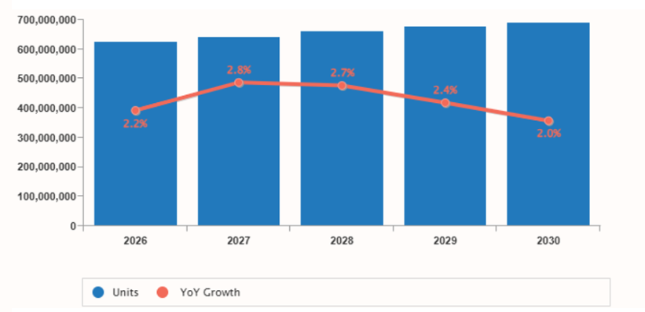
Figure 1: Total Wearable Device Market Size and Growth
(Source: IDC, 2026).

Segmentation
Recent studies suggest that segmentation in technology markets needs to transcend the basic age or income groups and acknowledge how devices, routines, and contexts influence consumption behaviour (Syrjälä et al., 2025). Apple HomeHealth + needs to be segmented, therefore, with a combination of geographic, demographic, psychographic and behavioural variables. The geographic locations of the most promising first markets are urban and high-income and digitally mature areas, where Apple ownership, subscription spending and health app usage are already normalised. The most relevant demographics include adults in the age range of 35-64, older adults in the age range of 60+, and family caregivers who take care of medication, sleep, and routine health visibility within households. Psychographically, the best opportunities are those consumers who perceive prevention, convenience, autonomy and privacy and not necessarily clinical intervention. Best segment, behaviourally, is existing iPhone and Apple Watch users who are already dependent on the Apple Health ecosystem. It is more commercially robust than an extensive all-health consumers strategy since the extension is based on ecosystem familiarity, trust, and the desire to purchase integrated support.

Targeting
According to Kotler and Keller, good target segments should be measurable, accessible, substantial, differentiable, and actionable (Kotler and Keller, 2016). In the case of Apple HomeHealth+, the key target group would be wealthy current users of Apple products who are between the ages of 35 and 64 years, live in urban areas and are willing to spend on high-quality preventive services. This is a more powerful target than a mass market audience since it is consistent with Apple's premium pricing, installed base and service-driven growth logic. It is also supported by recent evidence. A JMIR study in 2025 discovered that 36.3% of adults in the United States had adopted healthcare wearables and 78.4% of wearable users were willing to provide healthcare providers with wearable information, although only 26.5 percent had provided it. The usage was as well considerably greater in higher income groups (Chandrasekaran, Katapally and Wang, 2025). Older adults and caregivers should also be targeted secondarily, as ageing puts more demands on remote visibility, medication support, and regular monitoring, but must remain secondary to ensure that the extension does not become limited in its frame to elder care.

Differentiation
Differentiation should be based on advantages that cannot be easily imitated by competitors. Apple HomeHealth+ is not to play the competition game based on health metrics only, given the fact that wearable features may be imitated. Instead, it ought to make a distinction based on integration on the ecosystem, control over privacy, and high-end reliability. According to Apple, the Health app will integrate iPhone, iPad, Apple Watch, health records, and apps data in one place, and users decide what they share and store (Apple, 2026b). Apple further adds that health data uploaded to iCloud is encrypted in transit and at rest, and when two-factor authentication is turned on, it is end-to-end encrypted data, meaning that Apple cannot access it (Apple, 2026c). It is a strategic issue since privacy concerns are a barrier to health technology adoption. Hence, the strength of Apple is not merely technical functionality, but the capacity to bring together reliable privacy architecture, connected devices, health records aptitude, and brand prestige into a unified service.

Positioning
Apple HomeHealth+ must position itself as a luxury, privacy-focused, ecosystem-based home health service that allows users and families to take preventive wellbeing care with fewer frictions and a higher level of confidence. This stance is more robust than health to everybody since it is more commercially articulate and justifiable. It also connects to the current brand meaning of seamless integration, trusted technology, and quality service offered by Apple, and is also responding to a rapidly expanding market that is being shaped by the use of wearables, ageing, and the need to have a connected health routine (Apple, 2026; IDC, 2026; World Health Organisation, 2025). Positioning Apple HomeHealth+ as a digital bridge between daily health activities, household care, and the Apple ecosystem at large should not be viewed as a competitor to medical care, but rather as the most reliable one. That provides the extension with a plausible path to recurring revenue and long-term differentiation.

Element 3: Marketing Mix (7Ps) for Apple HomeHealth+

Product
The product needs to be positioned like a high-end preventative health service, and not as one more Apple Watch capability. Research in service marketing demonstrates that healthcare value grows when the offer decreases complexity and enhances ongoing user control, which makes an integrated platform a strategic advantage compared to a standalone tool (Ghabban, 2025; Oudbier et al., 2025). Apple HomeHealth+ should therefore combine Apple Watch, iPhone, the health app, medication reminders, sleep insights, family alerts, and optional provider sharing into one subscription service. This reinforces the extension strategy, as already in place, Apple boasts over 2.5 billion active devices, and the growth potential here is to enhance ecosystem utility, and not to add new isolated hardware capabilities (Apple, 2026a). Clarity is the key problem: HomeHealth+ should pledge coordinated preventive wellbeing, rather than some sort of health innovation.

Price
Apple needs to build on its premium logic of service by pricing instead of market penetration by discounting. Empirical evidence on subscription pricing demonstrates that all-inclusive bundles enhance willingness to purchase due to increasing perceived value and price fairness, but fragmented add-on pricing undermines both (Kang et al., 2024). Apple HomeHealth+ ought to then proceed to employ a tiered monthly subscription, including a single plan and a family plan with extended sharing and warnings. This correlates with the extension strategy since Apple already makes record Services revenue, and recurring income and retention are more important than low price acquisition (Apple, 2026a). Most importantly, the premium price should be justified by the fact that the service has proven to make the work easier, more visible, and safer than a cheaper wellness application. One benchmark that is useful is the bundling logic of Apple itself in services, where integrated value is an easier way to retain than standalone offers.

Place
In the case of HomeHealth+, place is not only physical distribution but also architectural design. Omnichannel studies indicate that combined experiences enhance involvement and repurchase intentions in case clients can traverse digital and physical touchpoints in an unfixed way (Rahman et al., 2025). Apple should consequently market HomeHealth+ via the health app, App Store, Apple ID ecosystem, Apple site, and Apple Stores with the subscription activation integrated into onboarding among iPhone and Apple Watch consumers. This meets the extension strategy since Apple has control over hardware, software, payments, retail and support, and it is more integrated in its channels than most health tech competitors. The point is that Apple must not pursue maximum channel breadth. It must focus on the frictionless continuity of ecosystems. One real-world case example is Apple Fitness+, which is reinforced by being an integral part of the Apple ecosystem and not scattered across fragmented third-party channels.

Promotion
Advertisement must focus on trust, prevention, privacy, and reassurance of the family, rather than technological novelty. Privacy in mHealth is still a barrier to adoption, whereas trust and transparent control capabilities enhance the willingness to use mHealth (Shojaei, Vlahu-Gjorgievska and Chow, 2025). Apple already enjoys a better promotional foundation than most of its competitors since it says that health information is encrypted on the device, encrypted during transit and at rest in iCloud and with default two-factor authentication turned on is encrypted end-to-end, implying that even Apple can never access it (Apple, 2026b; Apple, 2026c). This enables promotion to transcend abstract claims of innovation. The most powerful message is the one that is practical: HomeHealth+ makes it easy to control medications, sleep, alertness, and visibility to the family in a single secure setting. That is more convincing than to promise to revolutionise healthcare, which would exaggerate the role of the extension.

People
The key focus is on people since HomeHealth+ is not an app download but a trust-dependent service. As demonstrated by Ghabban (2025), customer satisfaction in healthcare facilities is influenced heavily by people and process. The service quality cannot be diluted into interface design. Apple is thus advised to supplement HomeHealth+ with Apple Store specialists, digital onboarding teams, online support staff and partnership managers capable of clarifying permissions, family sharing, and routine use. This is particularly important to the older adult and caregiver, whose use can be based on reassurance and facilitated configuration as opposed to technological inquisitiveness. The key issue is consistency: when support personnel cannot convert complex privacy and health functions to simple value, premium positioning becomes undermined. An example which is relevant internally is the current retail support model in Apple, where explanation and demonstration simplify the perceived complexity at the point of purchase and onboarding.

Process
Process is arguably the most important P because poor service flow would destroy trust quickly. The evidence in healthcare marketing suggests that the greatest influence on customer satisfaction is process, particularly in sectors that involve uncertainty and sensitive data (Ghabban, 2025). Apple HomeHealth+ must consequently adopt a straightforward procedure established on Apple ID sign-in, directed permission, clear consent, adjustable family notifications, optional provider sharing, and an explicit privacy dashboard. This helps the extension strategy since the Health framework of Apple already gives the user control over what is on record and shared, and encrypted syncing ensures continuity across gadgets (Apple, 2026b; Apple, 2026c ). Flexibly, the usability and privacy should collaborate. Most mHealth services flood users with permissions and vague messages. Apple ought to rather demonstrate controllability at all levels such that convenience is not achieved at the expense of confidence.

Physical Evidence
Despite HomeHealth+ being digital, physical evidence remains important since consumers perceive the credibility of the service based on obvious signs. Literature on service marketing considers these cues to be significant indicators of quality (particularly in healthcare environments where perceived risk is elevated) (Ghabban, 2025). In the case of Apple HomeHealth+, the physical evidence must consist of the Apple Watch and iPhone interface, the health app dashboard, in-store demonstrations, privacy explanation, and clean onboarding images. These signals render the immaterial service reliable and high-end. They also fit into the broader sustainability story of Apple. According to Apple, the company has already decreased the number of emissions by more than 60% and is committed to reducing them by 75 percent compared to the situation in 2015 as part of Apple 2030 (Apple, 2025; Apple, 2026d). That reinforces the extension strategy since HomeHealth+ can be positioned as low-impact, service-based growth based around an existing ecosystem and not hardware replacement.

Element 4: Reflection using Kolb’s Experiential Learning Model
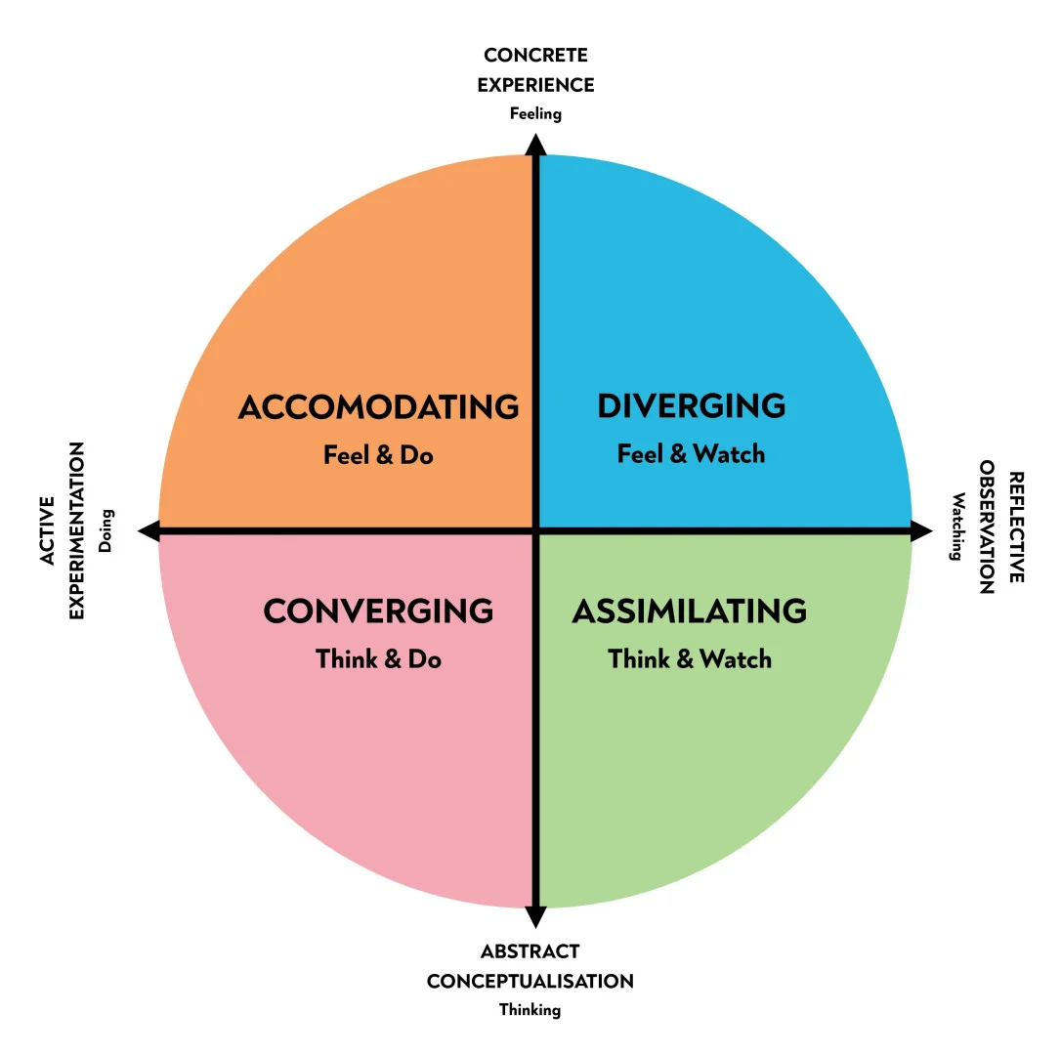
Figure 2: Four stages of the Kolb reflective model
(Source: Self-developed).

Concrete experience
To create Apple HomeHealth+, I needed to leave behind the practice of describing a well-established brand and build a growth strategy that is defensible. The research of experiential learning by Kolb is also applicable in this case, since learning is enhanced when the activity at hand is analysed, theorised, and enhanced in the future by action (Henríquez et al., 2025; Rook, 2025). Initially, I made the task too small in the form of a product proposal. However, the assignment required more than a creative idea. It needed a viable brand extension which was backed by segmentation, differentiation, pricing rationale, and sustainability alignment. This was aggravated by the fact that the poster was to be prepared, and the poster was to convey value in a convincing format within a limited space, and yet still evidence based. That rendered the experience commercially and academically challenging as opposed to descriptive.

Reflective observation
The greatest flaw in my first strategy was the excessive dependence on the brand strength of Apple. My initial assumption was that the extension would become automatically persuasive by the mere mention of Apple and its size. That was a weak assumption. The strategy was only credible when I connected the proposal with certain evidence, including the active devices numbering above 2.5 billion and the Services performance record, as these figures indicated why a service-led extension would be a commercially viable option instead of a speculative one (Apple, 2026). I also realised that I had initially paid too much attention to innovation and too little to barriers to adoption, in particular, privacy, user trust and family relevance. Another weakness revealed in the poster development is that I attempted to fit too much information. This demonstrated that poster communication is not about the most content, but about what is selected, how it is arranged by hierarchy, and the clarity of the message.

Abstract conceptualisation
The process enhanced my knowledge of the collaboration of strategic marketing structures. I also got to know that STDP is not a mechanical study process. It identifies the presence of a commercially coherent audience, value proposition, and market position of a brand extension. I also learned better why a 7Ps approach was more appropriate than 4Ps, since HomeHealth+ is a service system where process, people, and trust are the key factors. Scholarly studies on experiential learning in business education reveal that applied projects enhance critical thinking, diagnostic performance, and strategic intuition when students are required to relate theory to actual decisions (Daniels et al., 2025; Kim et al., 2025). This has professionally trained my skill to not just judge opportunities based on their attractiveness, but on strategic and defensibility and the possibility of implementation. That is more managerial thinking than just coming up with ideas.

Active experimentation
I would enhance my performance in three aspects in the same projects. To begin with, I would develop the evidence base earlier, where the market size, customer behaviour, and brand capability can influence the idea early on, rather than being introduced at a later stage. Second, I would preview the poster before and check whether the main idea can be grasped in a few seconds, as the visual communication that is based on simplicity is not simplified accidentally but is simplified intentionally. Third, I would evaluate at least two different extension concepts before deciding on one of them, to make the final decision justifiable relative to realistic strategic alternatives. All in all, this assignment reinforced my strategic analysis, choice of evidence, visual communication, and professional judgement. More importantly, it demonstrated to me that great marketing work relies not on creativity but on the disciplined convergence of evidence, theory, and persuasive performance.

References

Poster References
Apple (2026a) Apple reports first quarter results. Available at: https://www.apple.com/newsroom/2026/01/apple-reports-first-quarter-results/.
Apple (2026b) Environment. Available at: https://www.apple.com/in/environment/.
Grand View Research (2025) Digital health market size and share industry report, 2030. Available at: https://www.grandviewresearch.com/industry-analysis/digital-health-market.
IDC (2026) Wearable Devices Market Insights. Available at: https://www.idc.com/promo/wearablevendor/ .

Report References
Apple (2026). Apple reports first quarter results. Available at: https://www.apple.com/in/newsroom/2026/01/apple-reports-first-quarter-results/.
Daniels, M. et al. (2025) ‘Global perspectives, local impact: Facilitating responsible experiential learning’, The International Journal of Management Education. Available at: https://www.sciencedirect.com/science/article/pii/S1472811725001132 .
Henríquez, V.V. et al. (2025) ‘Applying Kolb’s experiential learning cycle for deep learning’, International Journal of Educational Research Open, 8, 100437. Available at: https://www.sciencedirect.com/science/article/pii/S2590291125008253 .
Kim, L. et al. (2025) ‘Does experiential learning matter to strategic intuition skills?’, The International Journal of Management Education. Available at: https://www.sciencedirect.com/science/article/abs/pii/S1472811725000084 .
Rook, L. (2025) ‘Student feedback for integrating reflection into the higher education curriculum’, Higher Education Research & Development. Available at: https://www.tandfonline.com/doi/full/10.1080/07294360.2025.2548274 .
Apple (2026a) Apple reports first quarter results. Available at: https://www.apple.com/in/newsroom/2026/01/apple-reports-first-quarter-results/ .
Apple (2026b) Health App & Privacy. Available at: https://www.apple.com/in/legal/privacy/data/en/health-app/ .
Apple (2026c) Apple Health. Available at: https://www.apple.com/in/health/ .
Apple (2026d) Environment. Available at: https://www.apple.com/in/environment/ .
Apple (2025) Apple surpasses 60 percent reduction in global greenhouse gas emissions. Available at: https://www.apple.com/in/newsroom/2025/04/apple-surpasses-60-percent-reduction-in-global-greenhouse-gas-emissions/ .
Ghabban, M. (2025) ‘The impact of marketing mix (7Ps) on customer satisfaction in the healthcare sector: A study of demographic and professional correlations’, International Journal of Healthcare Information Systems and Informatics, 20(1), pp. 1–30. Available at: https://www.igi-global.com/article/the-impact-of-marketing-mix-7ps-on-customer-satisfaction-in-the-healthcare-sector/369155 .
Kang, J., Su, C., Lan, J. and Chen, L. (2024) ‘Effects of the subscription-based partitioned pricing strategy of digital content platforms on user willingness to purchase’, Journal of Theoretical and Applied Electronic Commerce Research, 19(4), pp. 3305–3330. Available at: https://www.mdpi.com/0718-1876/19/4/160 .
Oudbier, S.J., de Wit, M., Hoekstra, R.A. et al. (2025) ‘Health apps: a cross-sectional study exploring patient motivations and experiences’, Digital Health, 11. Available at: https://pmc.ncbi.nlm.nih.gov/articles/PMC12462329/ .
Rahman, S.M., Carlson, J., Chowdhury, N.H., Gudergan, S. and De Luca, L.M. (2025) ‘How do omnichannel customer experiences affect customer engagement? Theory and empirical validation’, Journal of Business Research, 189, 115330. Available at: https://www.sciencedirect.com/science/article/pii/S0148296325000190 .
Shojaei, P., Vlahu-Gjorgievska, E. and Chow, Y.-W. (2025) ‘Enhancing privacy in mHealth applications: A user-centric model identifying key factors influencing privacy-related behaviours’, International Journal of Medical Informatics, 198, 105782. Available at: https://www.sciencedirect.com/science/article/pii/S1386505625001248.

Appendix: Element 1: 

