

NAME OF STUDENT: VANSHIKA

STUDENT ID: 2224637

NAME OF LECTURER: OGOCHUKWU AGUNENYE

MODULE NAME: DISSERTATION

MODULE CODE: LCMB7020

SUBMISSION DATE: 13 FEBRUARY 2024

EVALUATE THE IMPACT OF INFLUENCER MARKETING ON CONSUMER PURCHASING DECISIONS AND BRAND PERCEPTION ACROSS DIFFERENT SOCIAL MEDIA PLATFORMS

Acknowledgement
I would like to show my gratitude to my teachers for providing me all the required facilities to support me in completing the research in a constructive manner.
Abstract
Purpose: The purpose of the study was to analyse the impacts of influencer marketing on the purchasing behaviour of customers by exploring brand perception practices of different social media platforms.
Design/ Methodology: A Primary quantitative method has been followed in this research work to acknowledge the impacts of influencer marketing on the purchasing behaviour of customers in the European and Indian fashion market. An online survey has been run to collect the primary quantitative data from 83 participants.
Findings: Acceptability of influencers among the customers plays a crucial role in influencing purchasing decisions of consumers. Incorporating celebrity influence creates a positive perception on the consumers and makes the consumer rely on the brand that is promoted by renowned celebrities.
Practical implication: The management of Indian and European fashion brands to manage the business performance and influence customer behaviours to manage sales performance can use the research. Apart from this, the finding of this research work can be used by developing effective social media marketing strategy for the businesses to manage the customer behaviour.
Originality: The paper has collected primary data from the people experienced in the Indian and UK fast-fashion market.
Keywords: Indian fashion industry, social media trends, European fashion, Consumer’s purchasing behaviour, social influencers
Paper Type: Research Paper
Table of Contents
Chapter 1: Introduction 7
1.1 Chapter Introduction 7
1.2 Research Background 7
1.3 Research Aim 9
1.4 Research Objectives 9
1.5 Research Questions 9
1.6 Problem statement/hypothesis 10
1.7 Research Rationale 10
1.8 Research significance 13
1.9 Research structure 14
1.10 Chapter Summary 15
Chapter 2: Literature Review 16
2.1 Chapter introduction 16
2.2 Conceptual Framework 16
2.3 Significance of influencer marketing on consumer purchasing decisions across different social media platforms 17
2.4 Role of influencer marketing in the Development of brand perception and consumer purchasing decisions 19
2.5 Evaluation of challenges faced by fashion organisations in developing influencer marketing and influencing purchasing decisions 22
2.6 Strategies for improving influencer marketing effectiveness in the fashion industry 23
2.7 Theoretical perspective 25
2.8 Research Fit 27
2.9 Literature gap 28
2.10 Chapter Summary 28
Chapter 3: Methodology 29
3.1 Chapter Introduction 29
3.2 Research Onion 29
3.3 Methodology Flowchart 30
3.4 Research Philosophy 31
3.5 Research Approach 31
3.6 Research Design 32
3.7 Research Strategy 32
3.8 Inclusion and Exclusion Criteria 33
3.9 Search Strategy 34
3.10 Data Collection Method 34
3.11 Sampling Method 35
3.12 Data Analysis Method 35
3.13 Ethical Considerations 36
3.14 Research Timeline 36
3.15 Overview of methodology 37
Chapter 4: Findings and Analysis 39
4.1 Chapter Introduction 39
4.2 Findings 39
4.3 Analysis 45
4.4 Discussion 53
4.5 Chapter Summary 57
Chapter 5: Conclusion 59
5.1 Conclusion 59
5.2 Linking with Objectives 60
5.3 Limitations 62
5.4 Future scope 62
5.5 Recommendation 62
References 65
Appendices 74
Appendix 1: Survey Questionnaire 74
Appendix 2: Survey Results 77

List of Figures
Figure 1.1: Increasing use of influencer marketing in the Indian fashion industry 7
Figure 1.2: Online influencer marketing growth in the UK fashion industry 8
Figure 1.3: Customer engagement in the UK fashion industry 10
Figure 1.4: Customer engagement in the Indian fashion industry 11
Figure 1.5: Influencer marketing investment in the European fashion brands 12
Figure 1.6: Structure of the research 13
Figure 2.1: Conceptual Framework 15
Figure 2.2: Spending of the fashion marketers on different social media platforms 17
Figure 2.3: factors of influencer marketing in influencing purchase intention 19
Figure 2.4: Persuasion of influencers on purchasing intention 20
Figure 2.5: Challenges of implementing influencer marketing 21
Figure 2.6: Strategies for Enhancing Influencer marketing effectiveness 23
Figure 2.7: Social Influence Theory (SIT) 25
Figure 2.8: Theory of Reasoned Action (TRA) 26
Figure 3.1: Research Onion 29
Figure 3.2: Flowchart 29
Figure 4.1: Response to Question 1 37
Figure 4.2: Response to Question 2 38
Figure 4.3: Response to Question 3 38
Figure 4.4: Response to Question 4 39
Figure 4.5: Response to Question 5 40
Figure 4.6: Response to Question 6 40
Figure 4.7: Response to Question 7 41
Figure 4.8: Response to Question 8 41
Figure 4.9: Response to Question 9 42
Figure 4.10: Response to Question 10 43

List of Tables
Table 3.1: Inclusion and Exclusion Criteria 32
Table 3.2: Timeline 36
Table 4.3.1: Analysis of the first question 43
Table 4.3.2: Analysis of the second question 44
Table 4.3.3: Analysis of the third question 45
Table 4.3.4: Analysis of the fourth question 45
Table 4.3.5: Analysis of the fifth question 46
Table 4.3.6: Analysis of the sixth question 47
Table 4.3.7: Analysis of the seventh question 47
Table 4.3.8: Analysis of the eighth question 48
Table 4.3.9: Analysis of the ninth question 49
Table 4.3.10: Analysis of the tenth question 50

Chapter 1: Introduction

1.1 Chapter Introduction
Customer purchasing decision helps in analysing behavioural traits of customers towards the brands that lead companies to maintain brand perception in the competitive industry. Moreover, purchasing decisions among customers can be determined in the fashion industry along with influencer marketing through different online platforms. It further helps fashion brands to increase brand reputation in the competitive market by following the trends of influencer marketing. The current study highlights the impact of influencer marketing in the fashion industry to identify the purchasing decisions of customers towards the companies to improve brand perception. In addition, the study also compares the impact of influencer marketing on the Indian and European fashion industry by analysing key determinants of purchasing decisions of customers.

1.2 Research Background
Brand perception helps in indicating the business position of social media platforms by increasing the purchasing behaviour of consumers. As per the reports, 76.36% of the global population is considering social media platforms to show purchasing behaviour by considering brand perception (Butler, 2023). Moreover, social media platforms have increased brand perception by managing direct communication with customers. Moreover, in the Indian fashion industry consumer purchasing decisions are influenced by cultural differences due to influencer marketing. For example, Zara has received 32% loyal customer attention in the Indian fashion industry by exploring Bollywood celebrity promotion to maintain cultural attraction in business (Thomas, 2023). In contrast, the European fashion industry consumer’s purchasing behaviour is influenced by social media trends. As per the reports, 75% of the local fashion brands in the UK are receiving purchasing decisions from consumers with the application of social media trends (Ranipeta, 2023). Therefore, it can be stated that social influencers have been identified as a major determinant in the fashion industry to incorporate influencer marketing to maintain stable brand perception.
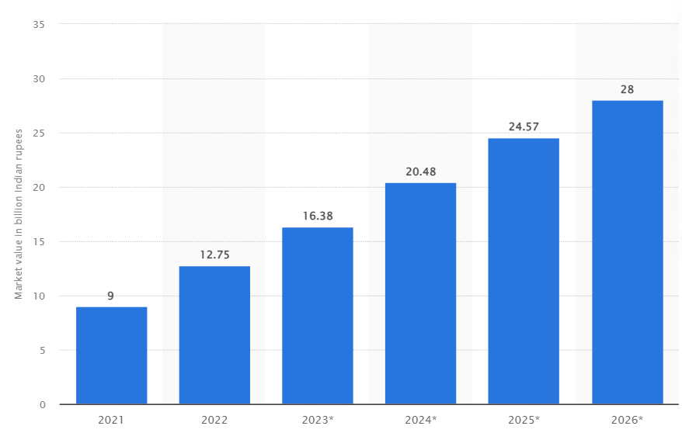

Figure 1.1: Increasing use of influencer marketing in the Indian fashion industry.
(Source: Basuroy, 2023)
Influencer marketing has been identified as a common trend in both the Indian and European fashion industries that leads companies to maintain strategic brand perception among competitors. It has been identified that 79% of global fashion brands are considering influencer marketing to achieve strategic purchasing decisions of consumers to maintain stable brand perception (Nguyen, 2023). However, the lower interest of customers towards influencer marketing has been identified as an impact on Indian fashion companies to achieve purchasing behaviour from customers on social media platforms. For instance, Fabindia’s customer retention rate in social media has declined by 27% due to the lack of interest of consumers towards influencer marketing (Raj, 2023). In contrast, UK fashion industry customers are showing purchasing behaviour based on the quality consistency of products, which can be a potential challenge for managing brand perception through influencer marketing. For example, Boden’s customer turnover rate increased by 37% in the UK market due to the declined quality consistency during influencer marketing through social media (Blair, 2022). Henceforth, it can be stated that the quality of products has been identified as a major practice for European countries to achieve brand perception through the integration of influencer marketing.
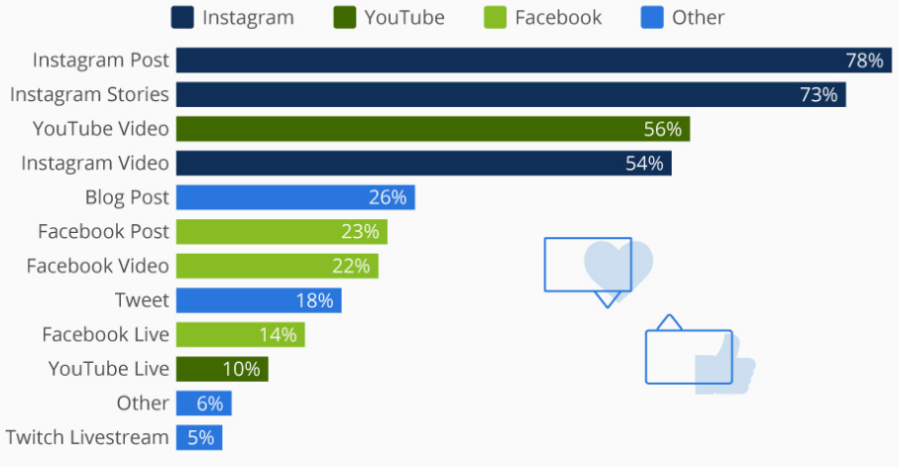

Figure 1.2: Online influencer marketing growth in the UK fashion industry
(Source: Clark, 2019)

1.3 Research Aim
The aim of the study is to analyse the impacts of influencer marketing on the purchasing behaviour of customers by exploring brand perception practices of different social media platforms.

1.4 Research Objectives
- To evaluate significance of the influencer marketing for achieving purchasing decisions of consumers on the social media platforms.
- To analyse impact of the influencer marketing on developing brand perception of the different social media platforms for managing decisions of purchasing behaviour of consumers.
- To identify the challenges of incorporating influencer marketing for achieving stable brand perception to receive purchasing decisions from consumers.
- To recommend strategies for social media platforms to adopt influencer marketing for achieving product purchasing decisions of consumers.

1.5 Research Questions
- What is the significance of influencer marketing for achieving the purchasing decisions of consumers on social media platforms?
- How does influencer marketing impact the purchasing decisions of consumers for managing brand perception?
- Why is incorporating influencer marketing a challenge for social media platforms to increment the purchasing behaviour of consumers for managing brand perception?
- What are the strategies for managing influence marketing to increase purchasing behaviour of consumers to achieve brand perception of the different social media platforms?

1.6 Problem statement/hypothesis
The problem statement in the study is the declined purchasing behaviour of customers in the Indian and European fashion brands to explore potential outcomes during influence marketing.
Research Hypothesis
H0: Influencer marketing strategies of fashion brands has no positive impacts on the customer purchase behaviours.
H1: Influencer marketing strategies of fashion brands has positive impacts on the customer purchase behaviours.

1.7 Research Rationale
Consumers purchasing behaviour in the Indian and European fashion industries has been influenced by the cost and quality of products during influencer marketing in social media. As per the reports, 42% of UK fashion brands' influencer marketing has failed due to a lack of quality consistency in the products (Crawford, 2023). In contrast, Indian consumers from the fashion industry are making purchasing decisions based on the cost of the product. It further helps in analysing the lack of cost-effective product offence causes failures of the influencer marketing practices of Indian fashion brands. For instance, Allen Solly’s consumer purchasing decision has declined by 25% due to the lack of cost-effective products causing the failure of influencer marketing of the brand (Economictimes.indiatimes.com, 2023). Furthermore, increasing competitive margin has been identified as a major challenge for UK fashion brands to explore strategic purchasing decisions from customers through influencer marketing. As per the reports, the Indian fashion market is growing at 14%.25% CAGR rate, whereas this rate in the UK is 24.36% with the application of influencer marketing (Globaldata.com, 2023). It further helps in analysing increasing options in the fashion brands is a major challenge for the potential companies to maintain stable purchasing decisions through social media-based influencer marketing. For instance, the Indian fashion brand Mufti’s customer purchasing decision has declined by 23% due to the high competition margin in the fashion industry (Sahin, 2023). Therefore, Indian consumers are showing limited purchasing behaviour towards fashion brands due to the variants of exclusive products that causes failure of influencer marketing practices.
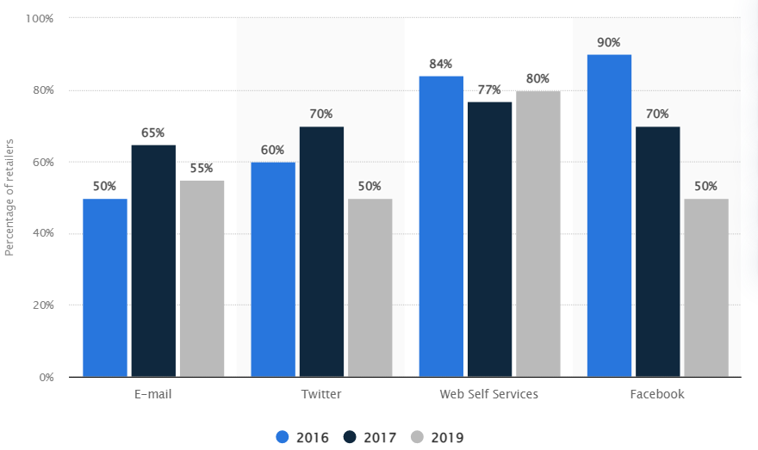

Figure 1.3: Customer engagement in the UK fashion industry
(Source: Smith, 2023)
The UK fashion brands are focusing on online trends to explore strategic influencer marketing through social media platforms. However, social barriers such as the negative reputation of influencers have been identified as a potential barrier for fashion brands to achieve purchasing decisions from customers. For instance, Clarks faced a 22% decline in product purchasing behaviour from consumers due to the negative PR reputation of Raheem Sterling (Forbesindia.com, 2023). It further helps in analysing social determinants are impacting the purchasing decisions of UK consumers from the fashion industry that cause failure of influencer marketing due to negative PR promotions. On the other hand, Indian fashion industry consumers’ purchasing decisions can be influenced by psychological needs such as discount policies during influencer marketing. As per the reports, 79% of the local fashion brands in India are facing difficulties during influencer marketing due to a lack of discount policies in business (Maheshwari, 2023). It further impacts the brand value of Indian fashion brands due to declined customer purchasing decisions to manage influencer marketing due to lack of customer satisfaction. Furthermore, the UK fashion industry customers purchasing decisions have been influenced by considering declined brand reputation during influencer marketing due to the high price of the products. It can be derived that 52% of the fashion industry customers are showing indulgent behaviour towards the brands due to the high cost of products during influencer marketing (Sahin, 2023). Hence, the lack of cost-effective pricing during influencer marketing has been identified as a potential challenge for fashion brands in the UK to achieve purchasing decisions from customers.
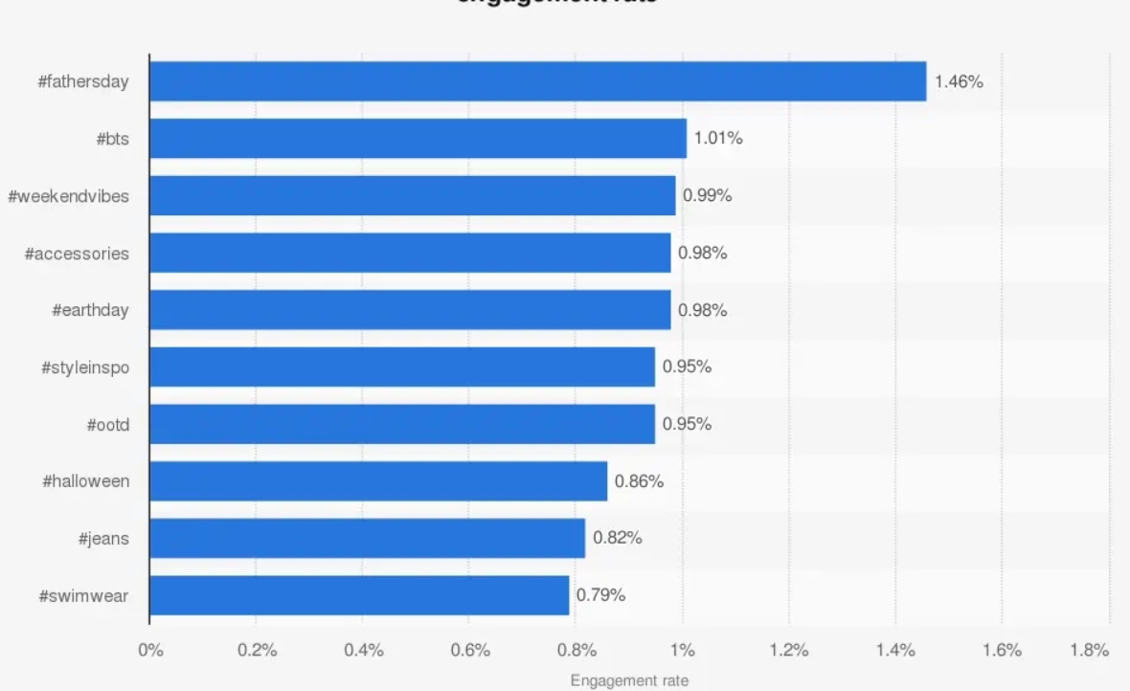

Figure 1.4: Customer engagement in the Indian fashion industry
(Source: Basuroy, 2023)
The study has analysed that influencer marketing stands for providing validation on developing trust and loyalty of customers that lead companies from the fashion industry to maintain brand perception in online platforms. However, Indian fashion brands are unable to gain the trust of customers through influencer marketing due to religious barriers. For example, Calvin Klein received 21% declined customer loyalty in the Indian market through influencer marketing due to the lack of interest of Muslim consumers (Conlon, 2019). It further helps in analysing brands' perception of Indian fashion companies has been impacted due to the cultural barriers to active stable purchasing decisions of customers. On the other hand, European customers are showing optimistic purchasing decisions towards fashion brands due to increasing demands for premium clothes. As per the reports, 48% of the customers from the UK fashion industry are in demand for premium quality products to show purchasing decisions towards the brands (Nelson, 2022). However, UK fashion brands are unable to offer premium quality products to customers due to declined cost-effectiveness during influencer marketing. Moreover, it has been identified that fashion brands in the UK are investing 19% higher cost in influencer marketing, which causes declined cost-effectiveness of the products (Crawford, 2023). It further has been identified high cost of products is a potential barrier for UK fashion brands to maintain strategic purchasing decisions of customers to maintain brand perception in online platforms. Henceforth, the lack of cost-effective products due to high investment in influencer marketing has been identified as a potential challenge for UK fashion brands in achieving purchasing decisions from customers.
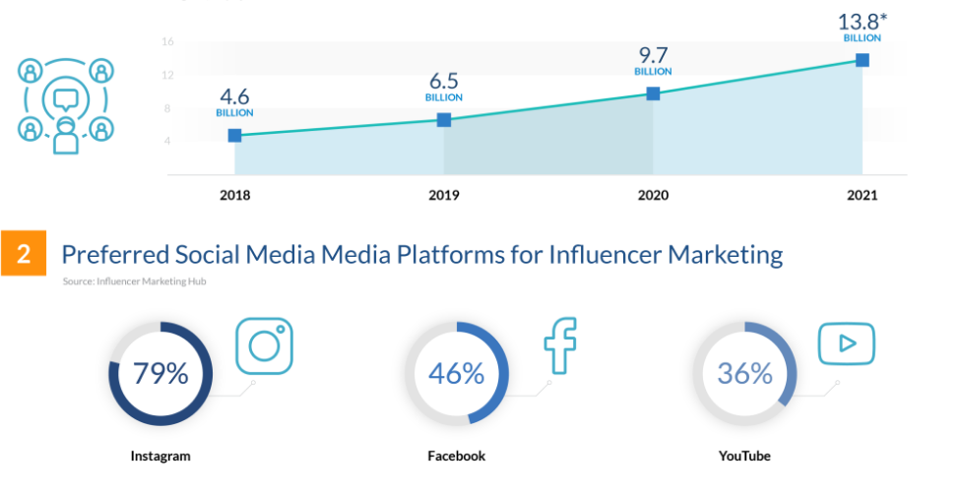

Figure 1.5: Influencer marketing investment in the European fashion brands
(Source: Globaldata.com, 2023)

1.8 Research significance
The research is significant as it focuses on the comparative analysis between fast fashion brands of India and UK to increase the consumer resonance. Fast fashion brands operating distinctively in India and the UK have intended to make a sustainable impact on the fashion society for the purpose of influencing consumer’s purchasing decisions and brand perception, respectively. The research is significant as it can drive different distinctive fast fashion brands of India and the UK to collaborate with multiple fashion influencers to raise brand awareness and build brand loyalty. The research may assist in driving the increased conversions regarding fast fashion brands to influence consumer behaviour and purchase decisions of the UK. The research is significant as the conclusive insights can assist in increasing sales rate along with creating new market trends for fashion-shoppers. The research can be helpful for digital marketing researchers to implement digital marketing technologies in the fast fashion brands of India to drive persuasive brands in the global fashion markets. Thus, the research can also assist in developing appealing user-generated content for fast-fashion to develop higher business-value propositions in the digital world.

1.9 Research structure
Chapter 1 illustrates the introduction segment of the research that highlights the research aim and objectives with a clear research rationale.
Chapter 2 focuses on the literature review to analyse existing views regarding influencer marketing in consumer purchasing decisions. The chapter also illustrates the literature gap derived from the existing literatures that are intended to be explored in this research.
Chapter 3 emphasises methodological paradigms such as positivism philosophy, deductive approach, and descriptive design to execute the quantitative survey in both Indian and UK markets.
Chapter 4 illustrates the data interpretation from the quantitative survey to develop a comparative analysis with the existing literature regarding influencer marketing in fast fashion brands.
Chapter 5 derives the conclusion of the study with multiple recommendations for the future betterment of the research along with illustrating the future scope of the findings.
Chapter 1: Introduction
Chapter 2: Literature Review
Chapter 3: Methodology
Chapter 4: Findings and Analysis
Chapter 5: Conclusion and Recommendations

Figure 1.6: Structure of the research
(Source: Self-Created)

1.10 Chapter Summary
It can be summarised that fashion brands are working on influencer marketing to gain the trust and loyalty of customers to increase purchasing decisions. Lack of strategic customer motivation has been identified as a potential challenge for companies to increase the purchasing decisions of customers. Furthermore, Indian brands are struggling due to cultural barriers to maintaining stable potential purchasing decisions of customers during influencer marketing. In contrast, social barriers have been identified as the key determinants of the influencer marketing practices of UK fashion brands during influencer marketing practices. It further helps in analysing that the application of customer satisfaction can be a potential approach for fashion brands to achieve purchasing decisions from customers through influencer marketing practices.

Chapter 2: Literature Review

2.1 Chapter introduction
The literature review chapter sheds light on the existing literature on influencer marketing and the consumer purchasing decision process. Evaluation of influencer marketing and its impact on the purchasing decisions of customers and brand perception through different platforms will be conducted in this part. Lê Giang Nam (2018) stated that the marketing sector is evolving alongside the digital world, and social media influencer marketing might be a viable alternative to traditional forms of promotion. Consumers have a high level of confidence in influencers, and their purchase intentions are highly influenced by four aspects: influencer-trust, content-quality, influencer-product-relevance, and consumer-engagement. It will help in gaining ideas of existing literature and conducting well-organised research with prior knowledge of research variables. Diverse perspectives of the research variables will be evaluated in the chapter that can help to conduct further research.

2.2 Conceptual Framework
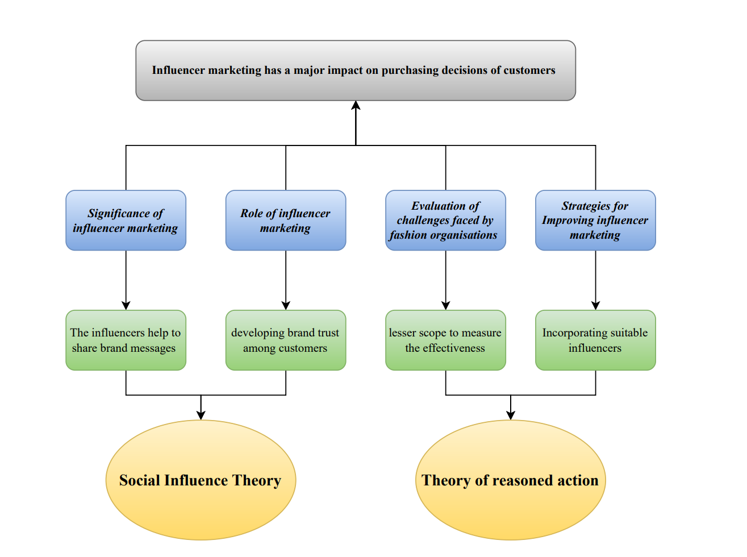

Figure 2.1: Conceptual Framework
(Source: Self-generated)

2.3 Significance of influencer marketing on consumer purchasing decisions across different social media platforms
Influencer marketing has become popular in the present time as a part of social media marketing that helps engage a large base of customers to fashion brands. As per the view of Zak and Hasprova, (2020, p.2), “influencer marketing is an important tool to influence buying behaviour and can be defined as the process of exploring, identifying, supporting and engaging people involved in high-impact conversations”. Hence, fashion organisations prefer to rely on influencer marketing using different social media platforms like Instagram, Facebook or YouTube that provide scope for enhancing marketing reach. As opined by Kha et al. (2021), Instagram is an effective platform that provides image and video content-making options that can be used as a strategy for product marketing. Audio and visual content developed on Instagram attract customers and subsequently create a perception regarding the brand to customers that can influence customer purchasing decisions. On the other hand, Acikgoz and Burnaz (2021) highlighted that enhanced bandwidth and diminished access costs make YouTube a global platform for advertisement, marketing, and communication strategies. Fashion brands prefer to reach customers through influencer videos that can help to encourage customers in purchasing products. Thus, social media platforms such as Instagram and YouTube enable in developing a perception regarding brands and influence purchasing decisions.
The influencers help to share brand messages with followers that create a positive perception regarding the brand on followers. As opined by Ambarwati et al. (2019, p.211), “digital influencer has a role as a communicator who influences the purchase decision of the viewers”. Effective communication ability of influencers plays a cardinal role in creating a brand perception of customers that can influence purchasing decisions. In the opinion of Yodi et al. (2020), the value of advertising has increased globally with the interaction of influencers through social media. Influencer provides opportunities in articulation of brand messages to customers that can ensure effective marketing of fashion brands. On the other hand, Martínez-López et al. (2020), highlight the role of content in influencing purchasing decisions of customers through influencer marketing. Influences develop target customer-oriented content that enables brands to connect with customers and influence pricing decisions. Thus, development of relevant content according to the fashion brands plays an effective role for brands to attract customers to the brand and influencing consumer purchasing decisions.
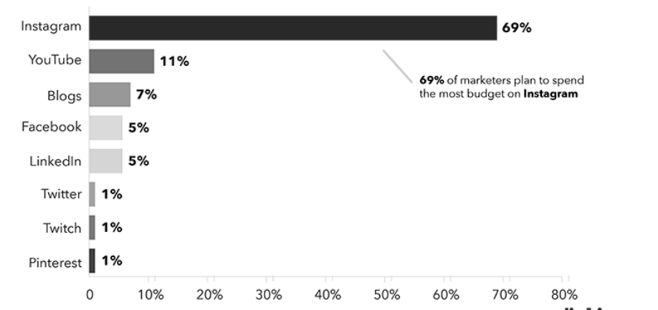

Figure 2.2: Spending of the fashion marketers on different social media platforms
(Source: Inspired by Nurfadila and Riyanto, 2020)
Fashion brands can directly evaluate the response of customers to marketing campaigns through incorporation of influencer marketing. According to the view of Chetioui et al. (2020), Influencer marketing enables brands to get access to the number of views, comments, likes, posts, and feedback related to the products. Therefore, fashion brands get the idea of the consumer perception regarding the brand that can help to modify the marketing approach to ensure greater engagement. Haenlein et al. (2020), highlighted that Instagram and TikTok can attract customers through short and interactive content. It aids in sharing brand messages with customers rapidly through influencers to create a chance of repeated viewing of the content that can influence purchasing decisions for customers. On the other hand, Nurfadila and Riyanto (2020), stated that customers instinctively desire social proof that influencers provide customers. Hence, the customers are more likely to purchase the product or service recommended by trusted influencers that denotes the direct role of influencers in impacting customer purchasing decisions.
The trust of customers in influencers is a prior factor that controls the level of success in the influencer marketing process. As per the study by Jin et al. (2019), the trustworthiness of influencers depicts the level of customer dependence that can be influencers for marketing effectiveness. Customers prefer trustworthy influencers and prefer to follow recommendations regarding products that highlight the need to include reliable influencers to influence consumer purchasing decisions effectively. Lin et al. (2019, p.34), highlighted “Amongst the multitude of platforms on which influencer marketing takes place, Instagram plays an important role”. Thus, it can be highlighted that the visually engaging nature of the content on Instagram influences consumer purchasing decisions positively. On the other hand, Gomes et al. (2022), highlight YouTube as an effective social media platform for sharing messages through video content that can positively influence the purchasing decisions of customers. In the YouTube videos customers can view the practical usage of products that incites them to use the products for prior needs. Thus, an explanation of the usage of products through social platforms becomes effective for fashion brands to influence the pushing decisions of the customers and develop a positive brand perception.

2.4 Role of influencer marketing in the Development of brand perception and consumer purchasing decisions
Influencer marketing plays an essential role in developing brand trust among customers. According to the view of Lee and Kim (2020), credibility of the brand exerts a greater influence on determination of consumer brand perception through influencer marketing. Higher brand credibility makes customers integrated into the brand and creates a positive brand perception that can influence purchasing decisions. The research by Nash (2019), highlighted the UK fashion market and role of influencer marketing in the UK fashion industry. The UK-based fashion organisation prefers to influence the purchasing decisions of Gen Y and Gen X can help to develop word of mouth regarding products and that can help to indirectly attract new customers. On the other hand, Chopra et al. (2021), highlighted that in India the preference for Instagram is high due to the presence of 6 million influencers on the platform. The Indian influencer tends to influence Gen Z through development of an attractive perception of brand. Thus, social media platforms can be utilised for developing brand perception to influence fashion customers.
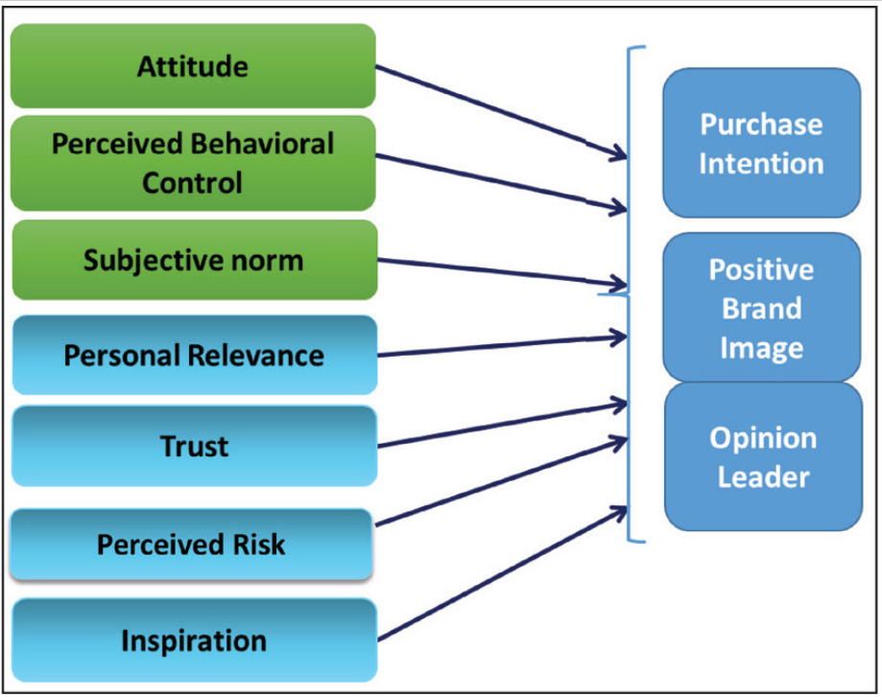

Figure 2.3: factors of influencer marketing in influencing purchase intention.
(Source: Inspired by Chopra et al. 2021)
Trust of influencers is the crucial factor that plays a cardinal role to influence purchasing decisions of customers through development of positive brand perception. As per the statement of Bognar et al. (2019), inclusion of celebrities in influencer marketing increases trust of customers as celebrities are admitted and followed by the customers. Engaging celebrities enables fashion brands to create a good image of the brand among customers. Moreover, celebrity incorporation enables in developing reach of marketing as it includes followers of the celebrity and the brand both. As opined by Belanche et al. (2021), celebrity-based mass-demand advertising influences consumer purchasing decisions due to the ability of developing a sense of close relationship with customers. Customers feel connected to their favourite celebrities that enable customers to choose the recommended product by the celebrities that influence customer purchasing decisions. However, Kim, and Oh (2020), highlighted that clarification of the brand perception regarding fast fashion is important to retain strong perception among customers. Differences in proposed fashion products and real products might create a negative impact on customers' minds regarding fashion brands. Thus, perforating transparent action is important through influencer marketing that can help in developing brand perception and influencing customer purchasing decisions.
Fashion brands can share the perspective of the brand to the customers that can create a connection that can influence the perspective of customers. As per the view of Karagür et al. (2022), influencer marketing enables disclosure of perception of the brand and customers through advertising initiatives. Fashion brands can share views and gather customers' responses against this which might be effective for fashion brands to develop effective marketing initiatives. Sharma et al. (2020) described the situation of the Indian fashion market and stated that purchasing behaviour of Indian customers relates to behaviour, perception, and attitude. Strong brand perception enables customers to rely on the brand and influence purchasing decisions regarding fashion products. On the other hand, Zhou et al. (2021), researched the influence of Instagram on the UK Gen Z customers. The impulse purchasing behaviour of UK customers depends on influencer marketing that creates a positive perception of the brand in the customers. Thus, perception plays an essential role in influencing purchasing intention of customers in the UK and India through influencer marketing.
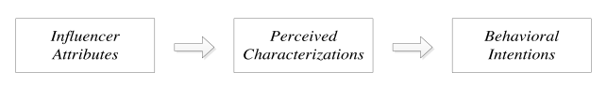

Figure 2.4: Persuasion of influencers on purchasing intention.
(Source: Inspired by Lou and Yuan, 2019)
The social media influencer has persuasive power over the young followers that influence the purchasing decision. Koay et al. (2021), highlight that social media influencer create an impact on the youth customer regarding brands and products. Youth customers rely on preferred influencers and follow to use the products promoted by the influencers in social media that is an example of influencing customer purchasing intention. In this regard, Lou and Yuan (2019, p.3), stated that “influence of followers positively impacted customers’ perceptions of recommended brands and their brand purchase intentions”. Influencer marketing creates a positive brand perception in followers that generates word-of-mouth through brand recommendation among other customers and increases purchase intention. On the other hand, De Veirman et al. (2019), highlighted followers of influencers are more inclined to purchase products endorsed by attractive, expert, and trustworthy influencers. Trustworthy influencers make customers rely on the recommendation of the influencers before making a purchase. Thus, influencers create a brand perception of customers and help in influencing consumer purchasing behaviour.

2.5 Evaluation of challenges faced by fashion organisations in developing influencer marketing and influencing purchasing decisions.
Identification of relevant influencers is the prior challenge that might influence the development of influencer marketing campaigns for fashion brands. As per the view of Schouten et al. (2021), evaluation of expertise and credibility of influencers in the market is a key factor in ensuring marketing effectiveness. Inability to identify expert influencers prevents fashion brands from connecting with the targeted customers. As opined by Lou et al. (2023), presence of fake influencers is a prior concern that stages the follower's numbers and responses on social media. The fake numbers will deceive the fashion brand and prevent the brand from reaching the targeted customers which can create challenges regarding influencing purchasing decisions of customers. In another context, Martínez-López et al. (2020), highlighted that sharing control of the brand image with influencers is a risky factor that creates challenges in development of influencer marketing. Involving influencers might cause brand dilution due to the control of influencers on representing the brand to customers. Thus, the concern of maintaining brand image controls prevents development of influencer marketing.
Challenges

Identification of relevant influencers

The presence of fake influencers

Difficulties in determining ROI

Lack of clarity regarding advertisement performance

Managing marketing expenses

Figure 2.5: Challenges of implementing influencer marketing.
(Source: Self-created)
Influencer marketing provides lesser scope to measure the effectiveness of the marketing content and evaluate the performance of influencers in changing customer brand perception. Santiago and Castelo, (2020), have highlighted difficulties in measuring ROI and differentiating influencers according to performance as a prior challenge for developing influencer marketing. Absence of specific measurement tools for success of the developed content makes it difficult for brands to measure the ROI and identify appropriate influencers. As opined by Cartwright et al. (2022), brands often struggle to identify the optimal influence to represent products in a complex business environment. Difficulties in determining ROI prevent the fashion brand from identifying optimal influencers and create challenges in developing influencer marketing. In support of this Nadanyiova et al. (2020), stated that the challenge of low-level representation in the target group arises due to ineffective identification of the right influencers. Selection of the wrong influencer creates difficulties in reaching the target customers reducing the efficiency of the marketing campaigns. Thus, challenges regarding measuring performance of influencers to identify influencer competency create challenges in development of organised successful influencer marketing.
Lack of clarity regarding advertisement performance makes it difficult for the brands to evaluate effectiveness of the influencer marketing. As per the view of Tateossian, (2021), the idea of endorsing products needs relevance with the attribute, products, markets, mission, and brand concepts that can create clarity regarding advertisement in customer's mind. In the case of influencer marketing, fashion brands might face difficulties in aligning advertisement performance with the organisational attributes and concepts that influence marketing success. On the other hand, Lin et al. (2019), stated that lack of clarity regarding the experiences of influencer marketing is the prior challenge that creates difficulties in ensuring marketing success. Absence of a cost slab for the influencers creates vague ideas regarding probable cost of marketing which is a patio challenge for fashion brands. As opined by Lou and Yuan, (2019), cost of influencer marketing depends on the credibility and follower number of the influencers which is a volatile factor. It cannot be measured accurately for certain advertisements or influencers that can help to identify impact of influencer advertisement on changing customer purchasing intention. Thus, the marketing expense identification is the prior challenge that can pose a challenge to implementation of influencer marketing.

2.6 Strategies for improving influencer marketing effectiveness in the fashion industry.
Incorporating suitable influencers according to the target market is the prior strategy that can help fashion organisations develop effective influencer marketing. Arora et al. (2019), stated that evaluation of social media presence of influencers is beneficial for identification of suitable influencers. Assessing social media enables keeping track of interaction, communication and engagement that might help fashion brands to segment influencers as per connection with the brand-targeted customers. It might help fashion organisations to identify and involve the relevant influencers in the organisation to enhance influencer marketing effectiveness. On the other hand, Taillon et al. (2020) stated that evaluating the attitude of influencers towards the customer is a prior factor that can help to understand relevance of influencers in the brand promotion process. The well-defined and constructed attitude of influencers will be effective for brands to articulate messages to the targeted customers that can help in the development of influencer marketing. Thus, focussing on the performance and activity of the influencer might aid with the fashion brands to improve influencer marketing efficiency.
Strategies
Incorporating suitable influencers according to target market
Elevating engagement of the brand
Clarified articulation of brand expectation
Tracking customer engagement in the posts
Creation of budget strategy

Figure 2.6: Strategies for Enhancing Influencer marketing effectiveness.
(Source: Self-created)
Elevating engagement of the brand with the influencers in the different parts of the marketing development might be effective for the fashion brands to influence customer purchasing decisions through influencer marketing. Duh and Thabethe (2021), suggested that credible marketing development is supportive of developing engagement of influencers with the brand. Sharing information regarding marketing needs creates scope for brands to develop engagement with influencers and enhance effectiveness of marketing campaigns. As per the view of Rungruangjit and Charoenpornpanichkul, (2022), sharing product information with fashion influencers helps in articulation of transparent marketing messages. Sharing relevant information regarding the product helps in attracting customers and enhancing customer post-purchasing experience that can help to improve influencer marketing effectiveness. On the other hand, Van Driel and Dumitrica, (2021), stated that influencers prefer to proactively balance the follower's expectations with the advertisement. Influencers prioritise gathering authentic information regarding the brand before promotion of products that can maintain credibility of influencers. Thus, maintenance of two-way information sharing regarding marketing helps brands to develop effective influencer marketing.
Tracking customer engagement in the posts is effective strategies that can help fashion brands identify affection for the influencer marketing process. As per the view of Santiago and Castelo, (2020), creating and enhancing the custom relationship with the brand helps in development of customer engagement. Evaluating the response of customers to social media posts can help fashion brands identify the level of relationship of customers with the brand. It might help the fashion brands to identify effectiveness of the content to attract customers and modify the approach to enhance marketing effectiveness. Lin et al. (2019), stated that response of customers to the key content of marketing enables brands to understand the engagement levels. Fashion brands might focus on enhanced content attractiveness that will be effective in enhancing customer engagement. On the other hand, Santiago and Castelo, (2020), stated that creation of a budget strategy for content marketing is an effective way to organise influencer marketing. Idea of budget marketing will be effective for fashion brands to reduce challenges regarding the abstract budget. Thus, fashion brands will be able to design influencer marketing in an organised manner that can help to enhance marketing effectiveness and influence the purchasing decision of customers.

2.7 Theoretical perspective
Social influence theory (SIT)
Kelman's SIT defines the effect of social influences regarding the needs, preferences, and behaviours of consumers in terms of enhancing brand equity. As per the illustration of Hwang et al. (2023), Kelman’s SIT aims to establish a societal foundation in the online or offline community to influence the perceived behaviours and thoughts towards new products or market trends. The fundamentals of SIT align with influencer marketing in terms of developing the consumer community to manipulate the perceived thoughts towards fashion products or services. In contrast, the rise of social networking sites (SNS) such as Facebook, YouTube and Instagram have changed the way of conducting and communicating businesses globally (Abbas Naqvi et al. 2020). The contemporary rise of social networking in fast fashion brands has influenced the fundamentals of SIT to understand the changing consumer purchase intentions towards fashion products. Thus, the fundamentals of SIT can be implemented in the fast fashion brands of India and UK to investigate the consumer buying decisions towards fashion products.
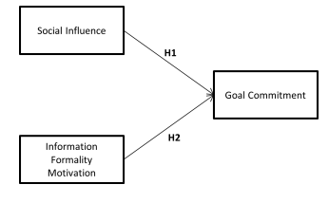

Figure 2.7: Social Influence Theory (SIT)
(Source: Hwang et al. 2023)
The principles of SIT affect the brand identity-cognitive style in the large brands to influence the consumer-based brand equity. As per the opinion of Alvarado-Karste and Guzmán (2020), Kelman’s SIT influences the psychological view with the consumer to understand the perceived value of the brand. The integration of SIT influences the brand identity of the organisations to align the psychological perspectives of consumers with the brand. Henceforth, the fundamentals of SIT can be implemented in the fast-fashion brands of India and UK to increase the congruence of brand value with consumers’ purchase intentions.
Theory of reasoned action (TRA)
TRA focuses on extending the range of consumer behaviours to increase the brand engagement rate. As per the illustration of Ajzen and Kruglanski (2019), TRA understands and predicts the behaviour occurrence of consumers to contemplate the organisations’ efforts to influence consumers’ purchase decisions. The principle of TRA relies on expectancy-value-formation to emphasise the formation of attitude, subjective norms, and perceived value control to influence consumer purchase decisions.
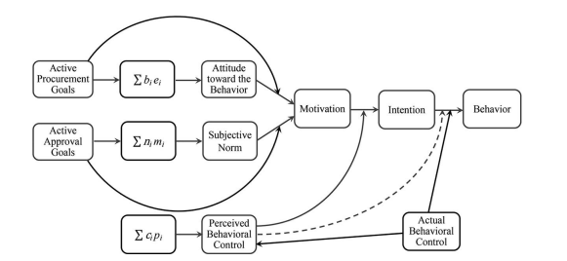

Figure 2.8: Theory of Reasoned Action (TRA)
(Source: Ajzen and Kruglanski, 2019)
TRA can be implemented in fast-fashion brands to evaluate the behavioural beliefs of the consumers towards the fast fashion products distinctively in India and the UK. In contrast, Khan and Idris (2019) asserted that TRA evaluates the consequences of organisational action in evaluating the consumer behaviours towards the brand. The outcomes of the organisational action align with human behaviour and attitudes towards the brand in terms of understanding the rate of self-efficacy. Thus, the principle of TRA can be implemented in fast fashion brands to assess separately the self-efficacy of the fashion consumers in purchasing fast-fashion products from India and the UK.

2.8 Research Fit
Multiple viewpoints of authors such as Kha et al. (2021); Acikgoz and Burnaz (2021); Haenlein et al. (2020) and Chopra et al. (2021) highlighted that through influencer marketing, the company's trustworthiness has a stronger effect on determining customer brand perception. Instagram is popular in India and UK due to the existence of 6 million influencers on the site. The Indian and UK influencer prefers to impact Gen Z by developing an appealing brand perception. On the other hand, SIT principles promote brand identity-cognitive style in major brands, influencing consumer-based brand equity. TRA focuses on expanding the spectrum of customer behaviours to improve brand engagement. As a result, both theories highlight the importance of brand perception and customer purchasing intents in rapid fashion. The existing researchers have focused on different perceptions of influencer marketing that supports the growth of Indian and UK fast-fashion consumer base.

2.9 Literature gap
The prior gap regarding lack of relevant sources regarding influencer marketing effectiveness in the Indian and UK context has been identified that can prevent the comparative analysis process. The research of Chopra et al. (2021), explored meagrely regarding influencer marketing and its impact on Indian customers which can be considered as the prior gap in the research. However, a weak exploration of influencer marketing development in a brand-directed way has been identified. This creates a gap in identification of relation between influencer marketing and brand perception development process. This research will focus on developing the relation of influencer marketing in influencing consumer perception that can address the gap.

2.10 Chapter Summary
It can be summarised that existing literature evaluated influencer marketing effectiveness and its role in developing brand perception. Influencer marketing aids in development of brand perception that is influential in enhancing customer purchasing decisions. The active participation of individual influencers explains the need for developing customer engagement for influencing customer purchasing decisions. Ineffective identification of influencers creates challenges for the fashion brand in articulating product information to the targeted customers and prevents fashion brands from influencing customer purchasing decisions. Consonant articulation of brand information is the prior process that helps in developing effectiveness of influencer marketing process.

Chapter 3: Methodology

3.1 Chapter Introduction
A well-defined research methodology aids in ensuring the validity and reliability of research topics such as impact of influencer marketing on purchasing behaviour of consumers. The primary aim of this chapter is to establish a methodological framework for a suitable data collection process. In this chapter, the theoretical assumptions of SIT and TRA are going to be evaluated through an appropriate research approach to characterise the impact of influencer marketing on consumer behaviours. Suitable inclusion and exclusion criteria are going to be considered before selecting the appropriate data collection process. The sampling is also going to be considered in this chapter to select appropriate sample size for studying the impact of influencer marketing.

3.2 Research Onion
Research onion is widely used in the social sciences for a construction of the theoretical framework of the research. According to Saunders et al. (2015), research onion is concerned with developing cohesive and justifiable characteristics of the study subject. The research onion was used in this study to align multiple methodological layers of philosophy, approach, and strategy while investigating the impact of influencer marketing on consumer purchase decisions. As per the view of Saunders et al. (2015), the initial layer of the research onion delineates the philosophy to establish a profound logic of the research subject. Thus, the selection of appropriate philosophy, gradually the approach and strategy has been considered to characterise the attributes of influencer marketing such as interaction, pricing decisions and accessibility.
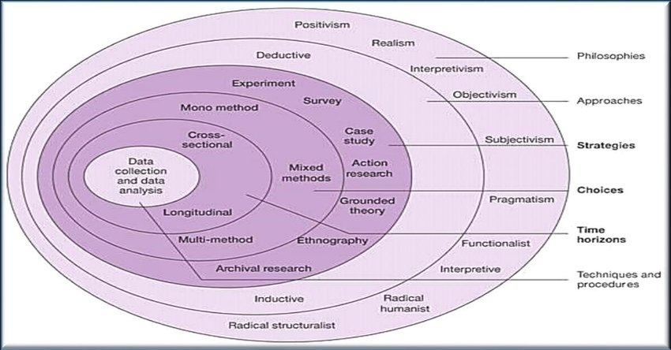

Figure 3.1: Research Onion
(Source: Saunders et al. 2015)
The research onion incorporates distinctive ontological and philosophical beliefs that influence the selection of strategies and data gathering methodologies. Saunders et al. (2015) asserted that adaptation of research onion determines the appropriateness of the methodology for future studies to make logical conclusions. In this regard, research strategies such as quantitative and data collection methods such as a survey have been considered to analyse the impact of influencer marketing. Therefore, the consideration of the research onion has discovered a cause-and-effect mechanism to characterise influencer marketing and consumer purchase decisions in the fast-fashion sector.

3.3 Methodology Flowchart
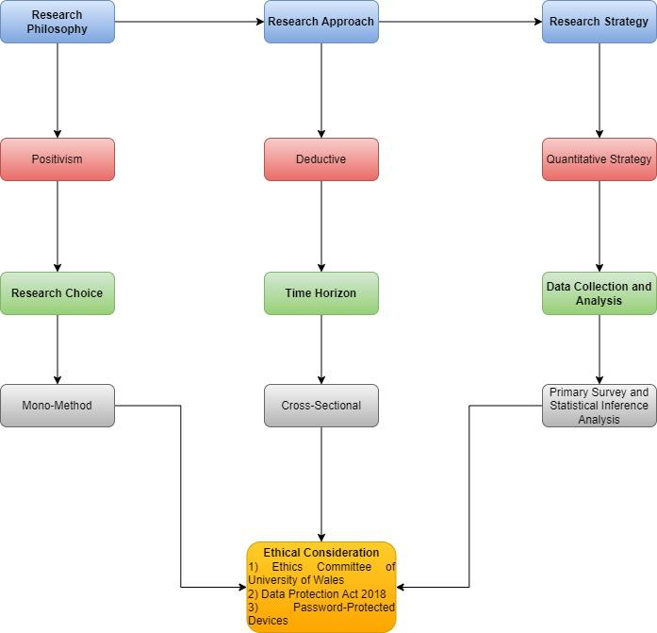

Figure 3.2: Flowchart
(Source: Self-Created)

3.4 Research Philosophy
Research philosophy is conceptualised as the state of beliefs concerning the nature of reality such as the impact of influencer marketing on consumer purchase decisions that are needed to be investigated. Kirongo and Odoyo (2020) classified research philosophy into three types: positivism, interpretivism, and pragmatism. In this research, the positivism philosophy has been considered to interpret existing viewpoints through numerical facts regarding the impact of influencer marketing. Park et al. (2020) illustrated that the advantage of positivism philosophy is to focus on the knowledge of previous work through quantitative measurements to establish gradual accumulation of ideas based on changing trends. In this regard, the consideration of positivism philosophy established a cumulative effect to analyse the existing quantitative knowledge regarding influencer marketing and its influence on consumer purchase decisions in fast fashion. On the other hand, positivism has been selected over interpretivism as interpretivism philosophy discards the essentiality of empirical observations and quantitative data collection. Alharahsheh and Pius (2020) stated that positivist research paradigm supports quantitative research in terms of gathering numerical data as the philosophy is objective based and detached. Positivism philosophy often focuses on assessing the rich contextual details with numerical data by considering human perception towards the research subject. Therefore, positivism has been selected to analyse real world data through a survey regarding the influence of fashion consumer purchasing decisions through influencer marketing.

3.5 Research Approach
The research approach is described as the research subject's roadmap for defining the specific phenomena to be explored by working with existing literatures. According to Hall et al. (2021), there are two forms of research approaches for synthesising information to answer research questions: deductive and inductive. The deductive research approach has been considered to justify the impact of influencer marketing on consumer purchase intentions based on a couple of existing theories such as SIT and TRA. Grinchenko and Shchapova (2020) stated that deductive approach benefits research by establishing causes and effect links between variables based on existing theoretical assumptions. Thus, deductive approach has developed a linkage between influencer marketing with the help of the principles of SIT and TRA.
The consideration of deductive approach focused on evaluating the concept of influencer marketing based on the theories such as SIT and TRA. Vears and Gillam (2022) opined that the inductive approach prefers to uncover new insights and discoveries by exploring the areas where existing knowledge is limited. The deductive approach has been selected by rejecting inductive as the inductive approach seeks to establish new theoretical perspectives to characterise the impact of influencer marketing. Therefore, the adoption of deductive approach by discarding inductive has explored the dynamic impact of influencer marketing on fashion consumer purchase intentions based on theoretical perspectives of SIT and TRA.

3.6 Research Design
Research design is considered as an appropriate framework for establishing significant decisions regarding the research subject. According to Sileyew (2019), research designs are classified into four types: descriptive, exploratory, explanatory, and experimental, that characterise significant parts of phenomena from an individual perspective. The descriptive research design has been adopted in this research to analyse the effects of influencer marketing on consumer purchase intentions and brand perception in the fast fashion sector. Doyle et al. (2020) asserted that descriptive research design benefits research by establishing straightforward descriptions of experiences and perceptions regarding the research subject. The consideration of descriptive research design highlighted the subjective nature of influencer marketing such as brand fit and authenticity on the fast-fashion consumers based on survey responses. The exploratory and explanatory design has been rejected as it discards the direct implication of influencer marketing on consumer purchase intentions. As per the illustration of Casula et al. (2021), exploratory and explanatory design focuses on qualitative procedure to discover new insights and results by discarding existing knowledge. Henceforth, the consideration of descriptive design has helped to analyse the response of fast fashion consumers towards influencer marketing campaigns through a comparison of India and UK.

3.7 Research Strategy
Research strategy is defined as a planned and systematic blueprint of research to provide answers for crucial research questions. Clark and Causer (2020) stated that research strategy is segregated into three types such as qualitative, quantitative, and mixed method. In this research, quantitative strategy has been adopted to generate refined knowledge of influencer marketing in the fast fashion sector based on numerical data. Mohajan (2020) asserted that quantitative strategy explains phenomena by collecting numerical detailed data. Thus, the consideration of quantitative strategy has benefited in establishing logical stances such as brand loyalty and customer persuasion regarding the impact of influencer marketing to increase customer attention.
Regarding the quantitative strategy, an online survey has been considered to gather human perceptions of both the Indian and UK market regarding the influencer marketing on the fast fashion sector. Grodal et al. (2021) stated that qualitative strategy discards the systemic comparison and statistical testing to determine the significant differences of research. The consideration of survey in terms of quantitative strategy helps to establish system comparison of Indian and the UK market for influencer marketing. Therefore, the consideration of quantitative strategy over qualitative has established a broader understanding of the relationship between influencer marketing and consumer purchase intentions in fast fashion.

3.8 Inclusion and Exclusion Criteria
Inclusion | Exclusion
- Population has been included from the Indian and UK fast fashion market.  - The online fashion shoppers have been considered as the population to make the research specific.  - Population who are hyper-active in Instagram, YouTube and Facebook have been included to make a comprehensive knowledge regarding influencer marketing. | - Population beyond the fast-fashion market of India and UK have been excluded.  - The population not active in social media platforms have been excluded from the research.

Table 3.1: Inclusion and Exclusion Criteria
(Source: Self-Created)
Regarding the analysis of the impact of influencer marketing on fast fashion, consumer purchase intentions, inclusion and exclusion criteria play a crucial role to increase the relevance of the data. The inclusion and exclusion criteria defined the specific parameters such as consumer demographics and social media platforms based on which the population has been considered to execute the online survey. Regarding the online survey, the online fashion shoppers from the Indian and the UK market have been considered as the primary population. The inclusion and exclusion criteria increase the transparency of the research in terms of maintaining internal consistency. Based on the inclusion and exclusion criteria, the viewpoints of Indian and UK fast fashion customers have been contrasted to better understand the significance of influencer marketing efforts in forming fashion brand perceptions.

3.9 Search Strategy
The key terms such as influencer marketing, consumer, purchasing decisions, social media platforms and brand perception have been screened. Gradually the growth of fast fashion markets has been evaluated from which India and UK has been considered for the research. The social media platforms such as Instagram, Facebook and YouTube have been segregated in terms of the growth of influencer marketing. Based on the social media platforms, the population of the Indian and UK market have been considered to identify the perception of influencer marketing on the purchase intentions of fast fashion shoppers.

3.10 Data Collection Method
Primary quantitative method has been considered as the data collection process to analyse the impact of influencer marketing on fast fashion, consumer purchase intentions. Verd (2023) stated that primary quantitative data deals with the collection of numerical facts to establish a precise measurement and analysis of a research subject. In this regard, the primary quantitative method analyses metrics such as consumer purchasing decisions and brand perception to analyse the significance of influencer marketing campaigns in the fast fashion sector. Regarding the primary quantitative process, an online survey through Google Form has been performed. Andrade (2020) asserted that the online survey is beneficial for easy administration, cost-effectiveness and develops a conclusion within a short period. The extraction of quantitative data from the online survey assisted in establishing different stances regarding the role of influencer marketing and its ability to structure consumer purchase intentions. The selection of the online survey as a quantitative data collection method helps to reach a large and diverse audience of the Indian and UK fashion market. Therefore, the consideration of the primary quantitative survey helped in establishing the dynamic nature of influencer marketing to influence consumer purchase intentions and brand perceptions.

3.11 Sampling Method
The simple random sampling method has been considered to obtain information for assessing the problems related with influencer marketing of quick fashion firms in the UK and India. Shahzad et al. (2021) stated that simple random sampling benefits in delivering equal chances to the population of being selected for the research. In this research from the population of India and UK, the fast fashion market, a sample size of 83 has been considered to establish a diverse perspective regarding the influencer marketing campaigns. 83 fast-fashion consumers have been considered from the market who have high engagement in online shopping. Shahzad et al. (2021) also opined that simple random sampling minimises the selection by us to establish accurate conclusions. The goal of the research is to analyse the impact of influencer marketing that often highlights a broad statement regarding consumer behaviour and brand perception. In this regard, simple random sampling contributes to the general liability of the findings regarding influencer marketing campaigns. Henceforth, the consideration of simple random sampling facilitated in comparing population parameters for ensuring a balanced representation of influencer marketing in both the Indian and UK fashion market.

3.12 Data Analysis Method
Statistical inference analysis has been considered as the primary data analysis method to evaluate the impact of influencer marketing and consumer purchasing decisions. Tong (2019) asserted that statistical inference analysis benefits in establishing effective conclusions regarding the entire population based on responses of a particular sample. In this regard, statistical inference analysis assisted in establishing an actionable conclusion regarding influencer marketing based on the responses of 83 samples. Tong (2019) also opined that statistical inference analysis establishes a robust causal relationship between the data and the research subject. In this regard, the adoption of statistical inference analysis focuses on establishing the relationship of influencer marketing campaigns and consumer purchasing decisions in the fast fashion markets. Thus, statistical inference analysis has established a systematic and objective data-driven framework to optimise the strategies for influencer marketing in the fast-fashion sector.

3.13 Ethical Considerations
- Ethical consideration in primary quantitative research focuses on the involvement of regulatory mechanisms for handling human participation (Sobočan et al. 2019).
- In this research, the approval from the ethics committee of “University of Wales: Trinity Saint David” have been considered before proceeding with the online survey.
- The "Data Protection Act of 2018" has been followed to guarantee survey respondents' privacy and research anonymity (Legislation.gov.uk, 2024).
- The survey data has been preserved on a password-protected device along with an encrypted database to mitigate the risks of data loss.
- A consent form has been distributed to the participants, to use it as a guide for the verbal description of this research.
- This research has been conducted in accordance with University of Wales’s norms and avoiding the use of a paraphrase tool such as ChatGPT to fulfil ethical constraints.

3.14 Research Timeline
Activities | Week 1 | Week 2 | Week 3 | Week 4 | Week 5 | Week 6 | Week 7
Identifying research topic
Developing research aim and objectives
Conducting literature review
Analysing research methodologies
Performing quantitative survey
Interpreting the results
Deriving conclusion and recommendations
Submission of research

Table 3.2: Timeline
(Source: Self-Created)
The cross-sectional time horizon has been considered in this research due to the execution of a quantitative survey. Spector (2019) the cross-sectional time horizon focuses on analysing the dynamics of variable changes to establish a comprehensive understanding of the research subject. In this regard, the cross-sectional time horizon focuses on the influencer marketing trends and the behavioural changes of fast fashion consumers over the time. Furthermore, the cross-sectional time horizon illustrated the adoption of changes in influencer marketing strategies and its implication on different social media platforms over time. Therefore, the cross-sectional time horizon evaluated the effectiveness of influencer marketing campaigns, overtime based on the trends and consumer patterns in the fast fashion market.

3.15 Overview of methodology
The chapter depicts that the positivism philosophy has been used to analyse current perspectives on the impact of influencer marketing using numerical data. The deductive approach has been considered to justify the impact of influencer marketing on customer purchase intentions using existing theories such as SIT and TRA. Based on the descriptive design, a sample size of 83 has been selected to provide a broad viewpoint on influencer marketing initiatives using an online survey. Regarding83 sample answers, statistical inference analysis helped to get an actionable conclusion on influencer marketing. The "Data Protection Act of 2018" ensures survey respondents' privacy and confidentiality. The cross-sectional time perspective focuses on examining the dynamics of variable changes to gain a thorough grasp on influencer marketing campaigns.

Chapter 4: Findings and Analysis

4.1 Chapter Introduction
This chapter is related to analysing the collected dataset using the statistical tool to identify the core area of focus. The findings from the collected primary data regarding influencer marketing and its impact on consumer purchasing will be evaluated in the part that can help to compare the relevance of different social media platforms. Furthermore, this chapter will discuss the results along with comparing the analysis with the existing literature to strengthen the interpretation in an organised manner.

4.2 Findings
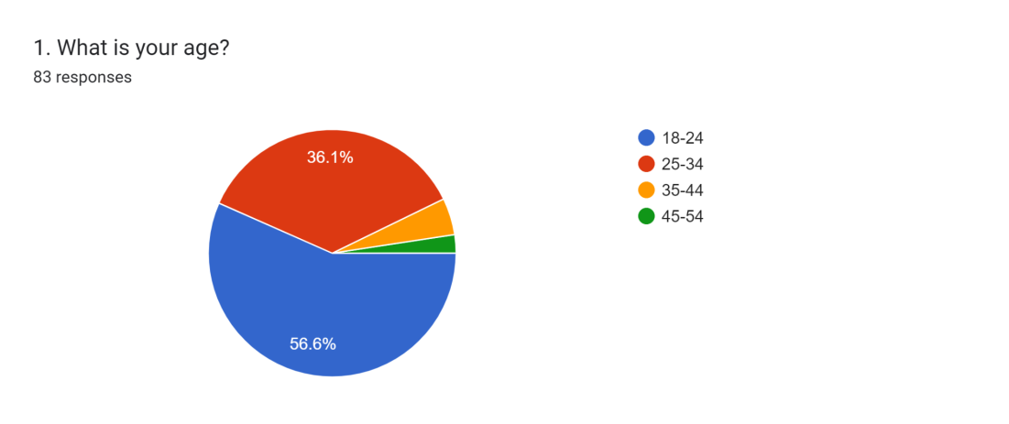

Figure 4.1: Response to Question 1
(Source: Google Form)
Most of the participant's responses are from the age group of 18-24 and only 2.4% of participants are from the age group of 45-54. Approximately, 36% of the participants are from the age group of 25-34. The majority proportion of participants from the age group of 18-24 might be effective for assessing the purchasing behaviour of Gen-Z along with Gen-Y from both India and the UK. Therefore, the research can be conducted eyeing the selected group to identify the impact of influencer marketing.
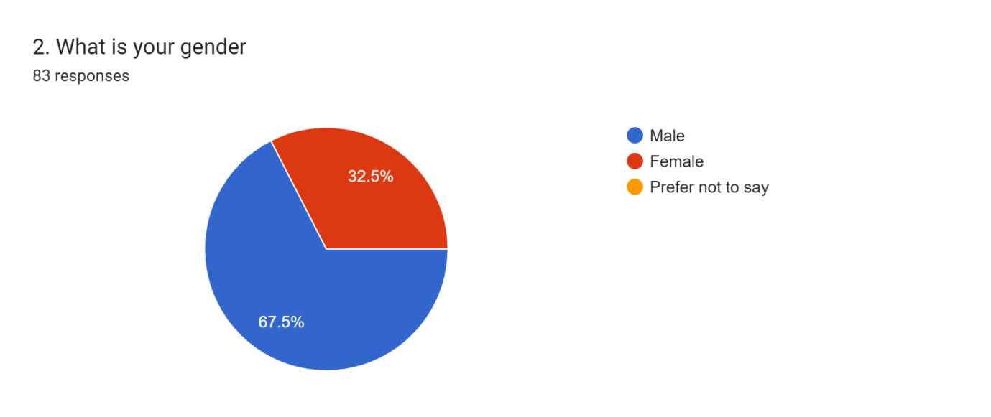

Figure 4.2: Response to Question 2
(Source: Google Form)
Among the respondents approximately 67% are male and around 33% are female. It denotes many male respondents in the research that might influence the research analysis and create a chance of bias.
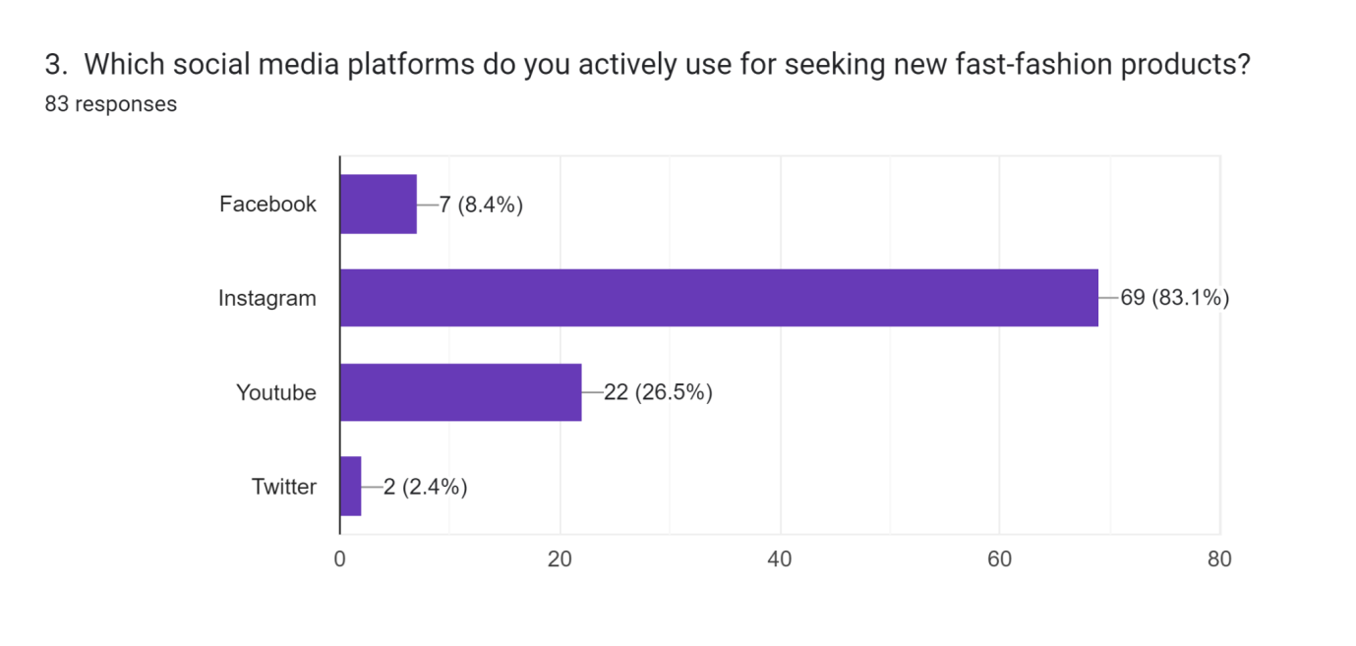

Figure 4.3: Response to Question 3
(Source: Google Form)
A higher acceptance of Instagram has been identified through the survey as approximately 83% of the responses are in favour of Instagram. YouTube is second in the position with only around 26% of responses. There is a huge gap between Instagram and YouTube in the sector that denotes the consumer's preference for Instagram rather than another social media platform. The lowest response has been given to Twitter which denotes consumers of the UK and India do not prefer to use Twitter for seeking new fast fashion products. Thus, a uniformity of responses has been identified for Instagram as the preferable social media platform for seeking new fast fashion products.
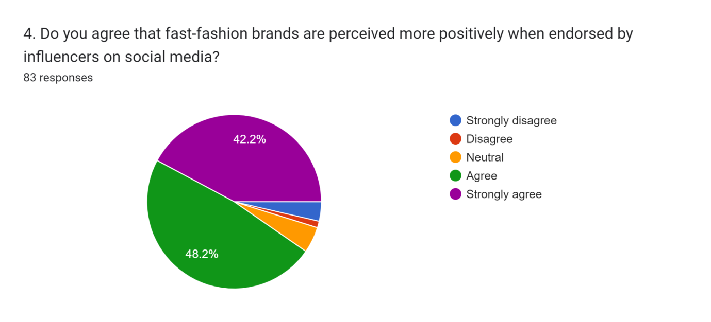

Figure 4.4: Response to Question 4
(Source: Google Form)
Approximately 86% of the participants responded positively to the factor that fast-fashion brands are perceived more positively when endorsed by influencers on social media. Only 4.8% of the participants disagreed with the matter and around 5% showed their neutrality. The clustered responses to question 4 denote the presence of positive perceptions among consumers of the UK and India regarding social media influencers. Thus, endorsing fast-fashion products by social media influencers might be effective in influencing the intention of the consumers as per the responses of the participants.
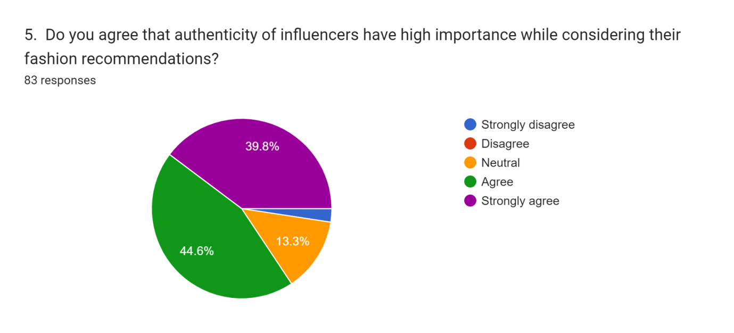

Figure 4.5: Response to Question 5
(Source: Google Form)
In response to the fifth question, approximately 40% of participants strongly agreed and 44% of participants agreed that the authenticity of influencers plays a crucial role in the recommendation of fashion. Around 13.3% of participants showed neutrality that denotes the chances of confusion among the minds of the participants regarding the impact of authenticity of influencers. A minimum rate of disagreement with the matter denotes the acceptability of influencer trust in the minds of the consumers of both India and the UK. Thus, consumers might prefer the influencer recommendation in the case of fast fashion considering the authenticity of the influencers regarding the matter.
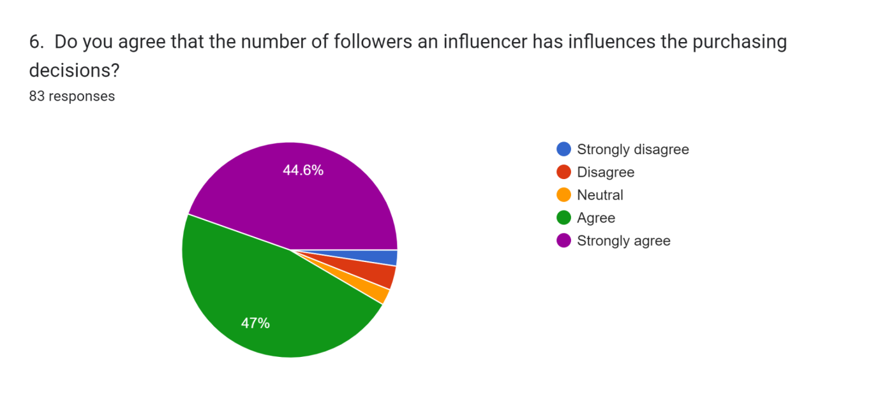

Figure 4.6: Response to Question 6
(Source: Google Form)
Approximately 94% of the participants agreed with the factor that the number of followers of influencers influences participants' purchasing decisions. Majority of the acceptance in the factor denotes that consumer might prefer to see the follower's number before making recommendations regarding fast fashion. Moreover, the higher number of social media followers makes the participants influencers regarding the purchasing decision (Duh and Thabethe 2021). Hence, it can be depicted that consumers of the UK and India are influenced by the number of followers for considering the recommendation of influencers.
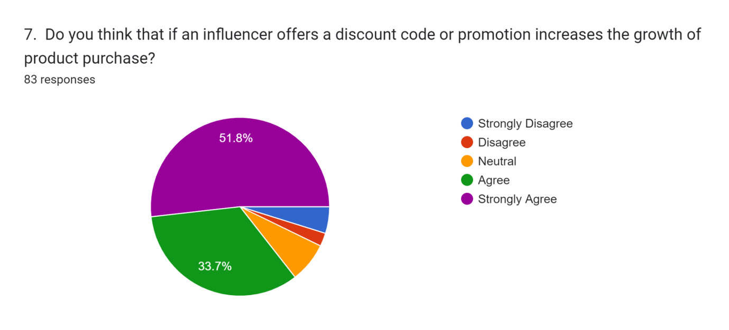

Figure 4.7: Response to Question 7
(Source: Google Form)
Many of the participants support that offering discount codes or promotions might influence the growth of the products. Only approximately 7% of the participants disagreed that discount codes influence the growth of products and 7.2% of participants gave neutral responses to it. A positive response of approximately 85% of participants denotes that UK and Indian consumers prefer discount codes from the influencers in making a purchase decision. Thus, the importance of discount codes by influencers increases in terms of the fast fashion industry of India and the UK for increasing growth of product purchases.
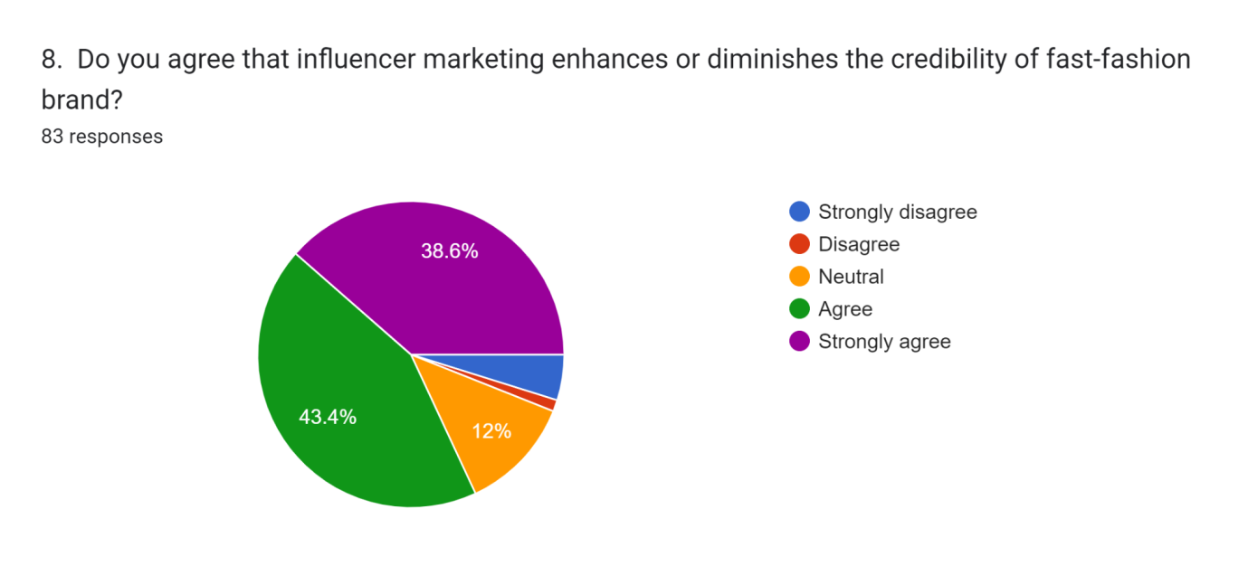

Figure 4.8: Response to Question 8
(Source: Google Form)
In the response to the eighth question, approximately 43.4% of participants agreed and 28.6% of participants strongly agreed, highlighting consumer’s supportive opinions regarding the influencer marketing influence on the credibility of fashion brands. Around 6% of the consumers disagreed with the question that denoted the participants' belief that influencer marketing has minimal impact on the credibility of the fast fashion brands. Thus, considering the support of the majority of UK and Indian consumers, it can be highlighted that influencer marketing might enhance and diminish the fast-fashion brand credibility.
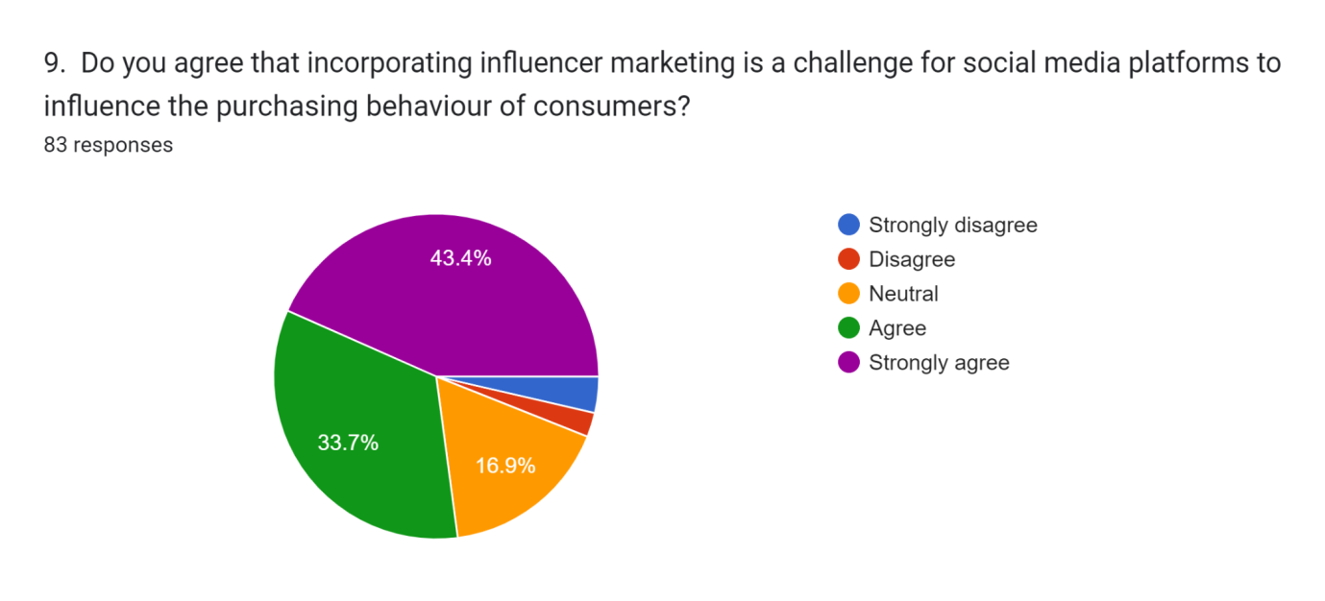

Figure 4.9: Response to Question 9
(Source: Google Form)
A significant portion of the participants think that influencer marketing incorporation is a challenge for social media platforms. Approximately 43% strongly agreed and 33.7% agreed regarding the presence of challenges for the social media platforms in implication of social media marketing. Around 17% of the participants gave a neutral response that denotes absence of a clarified opinion of the respondents regarding the question reduces uniform acceptance of the factor. Thus, it can be depicted that consumers in the UK and India consider the implication of influencer marketing as a challenging factor for influencing the purchasing decisions of consumers.
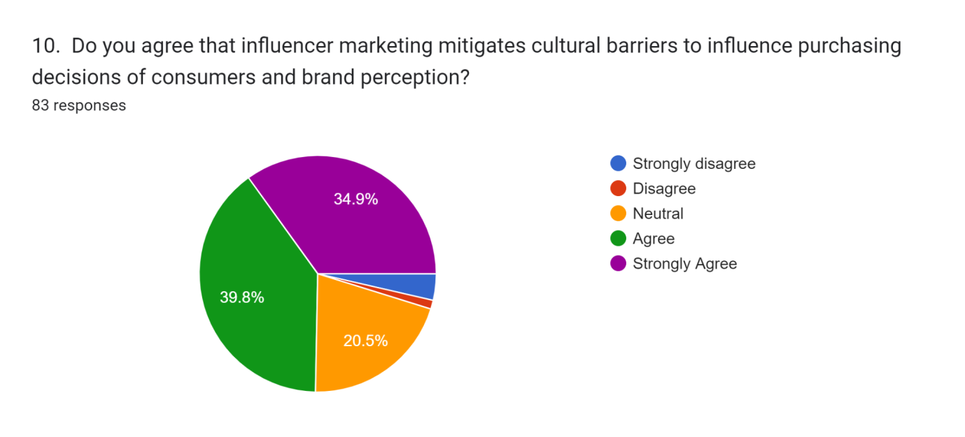

Figure 4.10: Response to Question 10
(Source: Google Form)
A mixed response for question ten has been identified where around 21% of participants were given a neutral option. On the other hand, approximately 40% agreed and 35% strongly agreed with the factor that influencer marketing mitigates cultural barriers. However, countries share different cultures regarding fashion and in the era of social media and consumers can see influencer content from different locations (Santiago and Castelo, 2020). Thus, considering the majority response it can be extracted that influencer marketing might reduce cultural barriers and influence purchasing decisions of consumers.

4.3 Analysis
4.3.1 Question 1
Options | Percentage of respondents | Number of participants
18-24 | 56.6% | 83
25-34 | 36.1% | 83
35-44 | 4.8% | 83
45-54 | 2.4% | 83

Table 4.3.1: Analysis of the first question
(Source: Self-developed)
The above table helps in analysing the survey responses of the first demographic question that focuses on the age group of the survey participants. The result helps in analysing that 56.6% of the participants belong from the 18-24 age group that helps in analysing Gen Z are showing purchasing behaviour online platforms. It further helps in identifying that most of the customers that are showing repurchasing behaviour in different social media platforms are young adults. Furthermore, 36.1% of the participants are from the 25-34 age group, which helps in analysing that the customers from this age group are finding online platforms reliable for buying products.
4.3.2 Question 2
Options | Percentage of respondents | Number of participants
Male | 67.5% | 83
Female | 32.5% | 83
Prefer not to say | 0% | 83

Table 4.3.2: Analysis of the second question
(Source: Self-developed)
The analysis of the second demographic question helps in analysing the gender orientation of the survey participants. It further helps in analysing that 67.5% of the participants are male, whereas only 32.5% are female. The result of the analysis helps to identify that male customers are showing positive behaviour for online product purchasing as compared to female customers.
4.3.3 Question 3
Options | Percentage of respondents | Number of participants
Facebook | 8.4% | 83
Instagram | 83.1% | 83
YouTube | 26.5% | 83
Twitter | 2.4% | 83

Table 4.3.3: Analysis of the third question
(Source: Self-developed)
The third survey question helps in identifying the most used social media platforms that leads customers to show a positive attitude towards online product purchasing. As per the result of the survey 8.4% of the customers are using Facebook for online product purchasing. On the other hand, 83.1% of the customers are using Instagram for purchasing products online. It further helps to analyse that customers are finding Instagram as the reliable platform for showing positive consumer behaviour by considering online product purchasing practices. Moreover, 26.5% are using YouTube and 2.4% are using Twitter for online product purchasing by considering the reliability of platforms both in India and UK. Thus, it can be stated that customers prefer the Instagram platforms to purchasing products online by considering the high reliability of the platform.
4.3.4 Question 4
Options | Percentage of respondents | Number of participants
Strongly disagree | 3.6% | 83
Disagree | 1.2% | 83
Neutral | 4.8% | 83
Agree | 48.2% | 83
Strongly agree | 42.2% | 83

Table 4.3.4: Analysis of the fourth question
(Source: Self-developed)
The fourth survey question helps in analysing the importance of celebrity endorsement for fast fashion brands to maintain stable customer engagement. It has been identified from the result that 5% of the customers think that celebrity promotion is unable to develop trust in UK and Indian fast fashion brands due to lack of trust. Moreover, as per the result of the survey customers are unable to identify brands reliable in the online platforms due to the lack of trust on celebrity promotion. However, the result helps in analysing approximately 90% of the customers identified that celebrity promotion of fast-fashion brands helps to gain trust and loyalty. It further helps to identify that celebrity endorsement can be a potential strategy for the fast-fashion companies to gain trust and loyalty of customers to increase online product purchasing behaviour.
4.3.5 Question 5
Options | Percentage of respondents | Number of participants
Strongly disagree | 2.4% | 83
Disagree | 0% | 83
Neutral | 13.3% | 83
Agree | 44.6% | 83
Strongly agree | 39.8% | 83

Table 4.3.5: Analysis of the fifth question
(Source: Self-developed)
The fifth survey question helps in analysing authenticity of influencers to develop awareness among customers of the fast fashion brands. The analysis helps to identify that 2.4% of customers disagreed with the fact that authenticity of influencers impacts gaining trust of customers to show online purchasing behaviour of customers. On the other hand, 13.3% of customers are showing a neutral response to the fact that the authenticity of influencers helps the fast fashion brands to gain trust and loyalty of online shoppers. It helps to identify that online fast fashion companies are unaware of the use of influencer marketing practices to determine loyalty of customers in the online platforms. However, more than 85% of customers agree with the fact of collaborating with authentic influencers for showing research behaviour towards fast fashion brands on online platforms. Thus, the analysis helps to identify that positive customer behaviour can be determined within the fast fashion industry by managing partnership with the authentic influencers during advertisement campaigns.
4.3.6 Question 6
Options | Percentage of respondents | Number of participants
Strongly disagree | 2.4% | 83
Disagree | 3.6% | 83
Neutral | 2.4% | 83
Agree | 47% | 83
Strongly agree | 44.6% | 83

Table 4.3.6: Analysis of the sixth question
(Source: Self-developed)
The sixth question of the survey highlights the fact that the number of followers of the influencers helps the fast fashion brands to achieve an increment in online customer interaction. Moreover, 16% of customers are thinking that product purchasing decisions of online customers are unable to influence through the number of social media followers of the influencers. It further helps in analysing that UK and Indian fast fashion brands are unable to gain attention of customers in the online influencer marketing practices. However, 94% of the participants have identified that fast fashion companies are able to gain customers through the influencer marketing practices. It helps in analysing that the number of followers of the influencers is showing stable purchasing behaviour towards the fast fashion brands in the UK and Indian market by considering strategic marketing practices. Hence, UK and Indian fast-fashion brands can determine stable customer engagement in online platforms by engaging with online influencers for online product promotion practices.
4.3.7 Question 7
Options | Percentage of respondents | Number of participants
Strongly disagree | 4.8% | 83
Disagree | 2.4% | 83
Neutral | 7.2% | 83
Agree | 33.7% | 83
Strongly agree | 51.8% | 83

Table 4.3.7: Analysis of the seventh question
(Source: Self-developed)
The seventh question highlights the impact of influencer’s discount codes for increasing growth of the product purchase from the fast fashion brands. Fast fashion brands are considering promotion codes for offering discounts to the customers that are directly involved through the influencer marketing practices. It further helps in analysing that influencer marketing is a potential need for the fashion retail brands to improve customer engagement using discount policy. The analysis helps to identify that 7% of the customers responded that offering influencer promotion code is unable to help the fast fashion brands to increase customer engagement. It further helps to identify that UK and Indian fast fashion brands are unable to gain trust of online customers by providing discounts through the influencer promotion code strategy. However, 7% of customers are showing a neutral attitude towards the use of influencer promotion codes for purchasing products from fast fashion brands through online platforms. Lack of communication transparency is a major challenge for the fast fashion brands to ensure purchasing behaviour of customers through influencer marketing y considering lack of customer attention. In contrast, 86% of the customers have agreed with the fact that influencer discount codes help to increase reliability of fast fashion brands to increase loyal customer purchasing decisions. It further helps in analysing discount policy as a potential strategy that leads fast fashion companies to achieve an increment in product purchasing behaviour of customers in online platforms. Therefore, it can be stated that UK and Indian fast fashion brands need to consider promotion discount codes to ensure stable customer engagement in online platforms.
4.3.8 Question 8
Options | Percentage of respondents | Number of participants
Strongly disagree | 4.8% | 83
Disagree | 1.2% | 83
Neutral | 12% | 83
Agree | 43.4% | 83
Strongly agree | 38.6% | 83

Table 4.3.8: Analysis of the eighth question
(Source: Self-developed)
The eight-survey question helps in analysing the impact of influencer marketing for enhancing credibility of the fast-fashion brands. The result helps in identifying that 6% of customers disagree with the fact that influence marketing can be beneficial for the fast fashion brands to enhance credibility among customers. It helps to analyse that UK and Indian fast fashion companies are failed to increase online customer engagement in social media along due to the lack of trust and loyalty. The result further shows that 12% customers are providing neutral responses on the use of influencer marketing for managing customer engagement of the fast fashion brands. Moreover, it helps to identify that the lack of awareness among customers based on influencer marketing is a common challenge of the fast UK and Indian fashion brands to improve customer engagement. On the other hand, 85% of the customers have agreed that influencer marketing helps the fast fashion brands to increase the brand reputation of the fast fashion brands. It helps to identify that fast fashion companies can improve customer engagement in business along with the use of influencer marketing. Therefore, it can be considered that UK and Indian fast fashion brands need to incorporate influencer marketing practices to increase brand reputation in online platforms to improve customer engagement.
4.3.9 Question 9
Options | Percentage of respondents | Number of participants
Strongly disagree | 3.6% | 83
Disagree | 2.4% | 83
Neutral | 16.9% | 83
Agree | 33.7% | 83
Strongly agree | 43.4% | 83

Table 4.3.9: Analysis of the ninth question
(Source: Self-developed)
The ninth survey question helps in identifying that influencer marketing is a serious challenge for the fast fashion companies to improve customer engagement in online platforms. Influencer marketing has been identified as a major challenge for the fast fashion brands due to high-cost investment in the online advertising practices. The survey result helps to find that 6% of customers disagreed that influencer marketing is unable to provide challenges to fast fashion companies to improve customer engagement in social media. Furthermore, the result helps to identify that fast fashion companies are using influence marketing practices as a strategy for increasing customer engagement in online platforms.
As per the result of the survey 16.9% of the customers are providing neutral responses on the use of influencer marketing of the fast fashion brands. It further helps to identify that customers from the UK and Indian fast fashion industry are unaware of the use of influencer marketing for showing a positive attitude for product purchasing. On the other hand, 77% of the customers have agreed that influencer marketing is a challenge for the fast fashion companies to increase customer engagement in online platforms. It further identifies that lack of direct communication perspective in influencer marketing is a challenge for fast fashion brands to increase customer engagement in business. Hence, it can be considered that adaptation of influencer marketing can be a potential challenge for UK and Indian fast fashion brands to maintain direct communication with customers.
4.3.10 Question 10
Options | Percentage of respondents | Number of participants
Strongly disagree | 3.6% | 83
Disagree | 1.2% | 83
Neutral | 20.5% | 83
Agree | 39.8% | 83
Strongly agree | 34.9% | 83

Table 4.3.10: Analysis of the tenth question
(Source: Self-developed)
The tenth survey question sheds light on the use of influencer marketing for reducing cultural barriers in the UK and Indian fast fashion industry during the social media marketing process. Only 23% of the customers think that fast fashion companies failed to reduce cultural barriers in business through influencer marketing. However, 87% of customers have agreed that influencer marketing leads the fast fashion brands to mitigate the cultural barrier in online platforms by increasing customer perception towards brands. It further helps in analysing that both UK and Indian fast fashion brands have been able to determine diversity in the customer relationship management through online influencer marketing. Thus, it can be considered that UK and Indian fast fashion companies need to use influencer marketing practices to increase diverse customer engagement in the online platforms.

4.4 Discussion
Acceptance of influencer marketing is increasing due to higher usage of different social media platforms such as Instagram, YouTube, or Facebook. The preference of Instagram is higher among the customers of the UK and India in the case of fast-fashion products. Approximately 83% of the participants prefer Instagram for seeking new fast-fashion products. At the same time the consumer prefers the credibility and authenticity of the influencers before considering their recommendations. It denotes that authentic influencer can influence the purchasing decision of the consumers as approximately 85% of the participants prefer the authenticity of an influencer before making a purchasing recommendation. Connecting to the literature it can be highlighted that short and impactful audio-visual content developed in Instagram is an attractive factor for consumers. According to the view of Khan et al. (2021), Instagram provides image and video content-making options that are effective for product marketing. The influencer of Instagram promotes products mainly fast fashion that makes the consumer attracted to the brand and products. Hence, influencers can change the purchasing decisions of consumers effectively through interactive content.
Influencer marketing creates scope for the fast fashion brand to develop a direct connection with the customers that can help the fashion brands to evaluate purchasing decisions of customers. Afterwards developing interactive and attractive content through influencer marketing helps in elevating customer engagement in the UK and India. As per the view of Chetioui et al. (2020), influencer marketing enables brands to get access to the number of views, comments, likes, posts, and feedback related to the products. As a result, identifying consumer perception becomes convenient for developing interactive content using customer comment and feedback. It can be discussed that prioritising interaction with customers in the UK and India might be effective for the fast fashion brand in implicating an effective influencer marketing campaign to influence the pricing decisions of customers. Connecting to the literature review it can be highlighted that 69% of the fashion marketers invest in Instagram and only 7% in Facebook (Nurfadila and Riyanto, 2020). Thus, it can be depicted that preferring Instagram is the preferred option for effective influencer marketing programs. Thus, influencer marketing using Instagram might be effective for fashion brands in influencing Indian and UK customers.
Consumers prefer the endorsement of products by social media influencers that make influencer marketing significant for impacting the purchasing decisions of customers. Approximately 90% of the customers believed that fast-fashion brands are perceived more positively when endorsed by influencers on social media. It denotes the importance of promoting fast fashion products through social media that can help to reach many fashion-shoppers within the UK and India to encourage customers to purchase the products. Instagram has higher acceptability in this case than YouTube and Facebook due to making attractive content for customers. Linking to literature review highlights that Instagram helps in development of target customer market-based content to make custom integrated to products. As opined by Martínez-López et al. (2020), influencer marketing helps in reaching to custom through evaluation of the behaviour of customers through social media. In this case, Instagram provides higher chances of interaction than YouTube making Instagram accepted to the UK and Indian customers. Thus, Instagram is an effective platform that plays an important role in influencing purchasing decisions of customers regarding fast fashion products. It helps in analysing that the number of followers of the influencers is showing stable purchasing behaviour towards the fast fashion brands in the UK and Indian market by considering strategic marketing practices. Hence, UK and Indian fast-fashion brands can determine stable customer engagement in online platforms by engaging with online influencers for online product promotion practices.
Authenticity of the influencer is the impactful factor that helps to develop a proper perception of a brand among customers. Most of the customers accepted the preference of influencer authenticity in purchasing the recommended fashion brand by the influencers. Reliability of the influencer helps customers of India and UK to develop a positive perception regarding the recommended products that develop a better brand perception. In case of the Gen-Z and Gen-Y the recommendation of preferred influencers becomes more effective due to higher reliance on influencers. Connecting to the literature highlights the preference of developing word-of-mouth in the UK to influence the purchasing intention of the Gen-Y customers. Nash (2019) highlighted that social media plays a crucial role in attracting the consumers through influencer marketing. The influencer marketing helps in generating a positive word of mouth regarding fast fashion brands that might be effective for attracting customers. Hence, it can be discussed that influencer marketing helps in attracting customers to fast fashion brands that can create a positive brand perception.
The number of influencers impacts the consumers perception regarding the influencer or promoted brands effectively. Around 95% of the participants from the UK and India agreed that the number of social media followers of influencers impacts purchasing decisions. It can be discussed that along with authenticity of the influencer, customers prefer to evaluate the number of followers that increases credibility of the influencers. As a result, the impact of the influencer with high followers might be greater on the customers that can help to influence the purchasing decision of the customers effectively. Belanche et al. (2021), highlighted that celebrity-based advertising influences consumer purchasing decisions due to presence of a connection with customers. The higher credibility and authenticity of celebrities is a factor that can influence the purchasing decision of the customers in different social media platforms such as YouTube, Instagram, or Facebook. Hence, it can be highlighted that incorporating celebrity influencers might influence the purchasing decision of the UK and Indian customers regarding fast-fashion brands.
Providing discounts and promotional benefits by the influencer plays a supportive role in attracting consumers and influencing consumer behaviour. A significant number of the customers highlighted that discount codes can help to increase the product purchase rate. It can be depicted that promotional benefits and discounts are effective tools to make customers engaged and interested in purchasing fashion brands. It further helps to identify that customers from the UK and Indian fast fashion industry are unaware of the use of influencer marketing for showing a positive attitude for product purchasing. However, connecting to the literature review it can be highlighted that purchasing behaviour of Indian customers relates to behaviour, perception, and attitude (Sharma et al. 2020). Hence, in the case of the Indian customer, focusing on identifying the customer attitude along with the behaviour is effective for influencing the purchasing decision regarding fast fashion brands. The influencers play an essential role in communicating with the customers and help to identify the behaviour and perceptions of customers. Thus, influencer marketing is impactful in developing ideas of consumer behaviour and developing marketing initiatives to influence the purchasing behaviour of customers.
Implication of influencer marketing is a challenging factor as choosing the wrong influencer might diminish the credibility of the fashion brand in the market. Approximately, 82% of the participants agreed that influencer marketing can enhance and diminish the credibility of fast-fashion brands. Improper selection of the influencer without considering the target market can hamper the effectiveness of the influencer marketing and create an adverse impact on the brand credibility. Nadanyiova et al. (2020), highlighted that low-level representation of the target group through influencer marketing might reduce the efficiency of the marketing campaign. It highlights the need to select the right influencer to prevent challenges of implication of influencer marketing effectively. Schouten et al. (2021), stated that credibility and authenticity of the influencer play an essential role in ensuring marketing effectiveness. Hence, implication of credible and authentic influencers is effective for elevating the effectiveness of the marketing campaign and enhancing the brand credibility in the UK and India.
Absence of clarity in the fast fashion brands and the influencer regarding the marketing message is a prior challenge that can impact the implication of successful marketing campaigns for the UK and Indian customers. Sharing vague information regarding the products with the influencer creates difficulties for influencers in promoting the product to customers and impacts the credibility of the brand. Tateossian (2021) highlighted the importance of presenting attributes, products, markets, missions, and brand concepts in influencer marketing. Hence, it can be discussed that fast fashion brands might focus on sharing brand messages transparently with the influencer to develop an effective marketing campaign. On the other hand, Lin et al. (2019) stated that prioritising experience of the influencer is important to make an effective marketing campaign. Incorporating influencers without considering exercise might hamper the process of influencing customers. Thus, influencer activity might influence consumer behaviour adversely and impact the effectiveness of marketing programs.
Many of the influencers consider the influencer marketing implication as the challenging factor that can influence the purchasing behaviour of the customers. Approximately, 77% of the customers agree that it is difficult to create an impact on the consumer and resign from fast fashion brands without an organised influencer marketing program. Approach of the influencer in promoting fast fashion brands plays an essential role in influencing consumer purchasing behaviour. Connecting to the literature it can be highlighted that credibility of the influencer indirectly influences the followers and creates a positive impact (Lou and Yuan, 2019). However, measuring the credibility of the influencer is a challenging factor that creates difficulties in implication influencing marketing. Hence, selection of the influencer is the challenging factor that can hamper the influencer marketing development process to influence purchasing decisions of UK and Indian consumers.
Developing content prioritising the local culture of the UK and India might be an effective factor that can help in influencing the purchasing decisions of local customers. Approximately 75% of UK and Indian customers agreed that influencer marketing can influence cultural barriers. Developing marketing campaigns considering the cultural aspects might be effective for accumulating customers of diverse cultures and influencing purchasing behaviour effectively. Connecting to the literature it can be highlighted that credible marketing development considering the market need is effective for elevating influencer marketing efficiency. Duh and Thabethe (2021) stated that credible marketing helps in engagement of the influencers with market and brand. Thus, It can elevate the level of marketing efficiency by increasing the authenticity and credibility of influencers that influence the consumer purchasing behaviour.
Development of communication with consumers is an effective factor that can help to increase chance of influencing consumer purchasing intention. Connecting to the literature it can be highlighted that communication helps to create a brand perception and influence purchasing decisions of consumers. Ambarwati et al. (2019), highlighted that the role of a communicator helps influencers influence purchase decisions of the viewers. Development of strong communication through the influencer can help in making customers understand the importance of products that can encourage consumers to purchase the fashion products effectively. Thus, highlighting the development of interactive content might be effective for fast fashion brands in influencing purchasing decisions of the UK and Indian customers through influencer marketing.
Reducing the cultural barrier plays an effective role in accumulating a large base of customers from India and the UK. Instagram and YouTube can be utilised to reach a large base of customers that can help to share the brand message to make customers interested in the products. Focusing on the change of culture in the UK and India might be effective for incorporating the influencers that can create a positive perception of the brand in the consumers. Celebrity endorsement might be an effective option as celebrities have a higher number of followers and credibility. Approximately 85% of consumers prefer influencer credibility and 95% of customers prefer a higher number of followers of influencers. Thus, it can be discussed that incorporating celebrity fulfil the requirement of consumers that can elevate the level of influencing purchasing decision of the consumers for fast-fashion brands.

4.5 Chapter Summary
It can be summarised that influencer credibility, authenticity and the number of followers play an effective role in influencing the purchasing decisions of UK and Indian customers effectively. Development of communication with consumers is an effective factor that can help to increase chance of influencing consumer purchasing intention. Majority of the UK and Indian customers prefer to use Instagram to seek fast-fashion products that increase acceptance of the social media platform among the customers effectively. Consumers prefer short and interactive content in social media that can share brand information in an attractive way. Thus, Influencer marketing through Instagram can be considered effective for influencing purchasing decisions of UK and Indian consumers.

Chapter 5: Conclusion

5.1 Conclusion
Influencer marketing is an effective tool that can help fast-fashion brands reach their target customers through the help of relevant influencers. Adaptation of influencer marketing enables the brand to utilise the following base of influence along with loyal consumers. As a result, it might help organisations operating in the fast fashion industry of the UK and India to increase brand reach effectively. It can be described from the help of existing literature review that influencer marketing helps in changing the purchasing behaviour of the consumer by generating positive brand perceptions effectively. Social media platforms like Instagram, Facebook or YouTube are the preferable options for the fast fashion organisation to develop a strong base among the UK and the Indian customers. Consumers from India and the UK prefer Instagram for gathering product information before purchasing fast fashion products. This makes Instagram an effective option for the fast fashion brand to reach the target customers than YouTube and Facebook. Instagram provides the opportunity to develop short and interactive content that can help engage Indian and UK consumers to increase brand acceptance. Thus, it can be concluded that influencer marketing is a significant option to influence the purchasing decisions of consumers on social media platforms.
Acceptability of influencers among the customers plays a crucial role in influencing purchasing decisions of consumers. Incorporating celebrity influence creates a positive perception on the consumers and makes the consumer rely on the brand that is promoted by renowned celebrities. As a result, celebrity influencer marketing helps to create a positive brand perception in the minds of consumers using reliability factors effectively. The number of followers on social media plays an influencer role for India and UK customers to rely on recommendations of influencers. Higher acceptability and popularity of the influencer make consumers rely on the influencer that can actively influence the purchasing decision of consumers regarding fast-fashion products. The consumers of the UK and India accepted the preference of influencer authenticity in purchasing the recommended fashion brand by the influencers. It denotes that the reliability of the influencer helps to create a positive perception of the fast-fashion brands in the minds of UK and Indian consumers. Thus, It can be concluded that influencer marketing is supportive of fast-fashion organisations in managing the purchase behaviour of UK and Indian consumers.
Presence of discounts and promotional benefits are some influencer factors that can impact the purchasing decision of the fast-fashion profits consumer. Providing lucrative influencers is an attractive factor for the UK and Indian people that make consumers try fast-fashion products at a discounted price effectively. However, identification of a suitable influencer to promote the products is a challenging factor that might create challenges for the influencer marketing process. Alliteration review highlights the presence of fake influencers with false followers and like numbers that can generate misconceptions among fast-fashion brands. As a result, fast fashion brands fail to secure the expected reach to the customers that reduce efficiency of influencer marketing. Absence of an organised marketing program is an influential factor that can prevent influencers from generating a positive perception among the UK and Indian customs that can impact purchasing decisions. Thus, it can be concluded that fast fashion organisations might focus on selecting influencers based on the capability of influencing people that can make the consumers attracted to fast-fashion products.
Incorporation of local influencers might help to accumulate local culture in the promotional program that can help the fast-fashion brand to make customers more engaged with the brand. Influencer marketing using global celebrities helps to reach a large base of customers from different cultures. In addition to this, including the authentic local influencer might help to utilise the reliability of influencers in the local region of India and the UK to impact the pricing decision of consumers. Furthermore, sharing product information with fashion influencers helps in articulation of transparent marketing messages and product information to the consumers. Information sharing enables highlighting the benefits of the products that can influence individual needs of consumers. Fulfilling the needs of the consumers helps in development of a positive perception of the brand that can make the consumers attracted to products and change purchasing behaviour. Creating the scope of interaction of the brand with consumers helps in creating a better relationship and developing a positive perception of the fast fashion brand on the customers resulting in influencing purchasing intention. Therefore, it can be concluded that developing interactive content in influencer marketing might help the fast-fashion organisation in influencing the purchasing intention of the UK and Indian customers.

5.2 Linking with Objectives
Objective-1
The 2.3 section of the literature review highlights the significance of influencer marketing consumer purchasing decisions across different social media platforms. Instagram has been highlighted as an effective platform for sharing sheets and attractive content on social media. On the other hand, YouTube helps in sharing in-depth information regarding fast fashion brands and products among customers. The discussion part of chapter four highlights that the preference for Instagram is higher among the customers of the UK and India regarding fast-fashion products. Influencer marketing through different platforms enables the fast fashion brand to promote products to diverse consumers in the UK and India that is a prior significance of the marketing process.
Objective-2
Influencer marketing helps to develop brand trust that impacts the brand perception of the consumers. 2.4 points of the literature review showed that higher brand credibility makes customers engaged in fast fashion products that impact customer brand perception. The fourth chapter highlights that influencer marketing creates a positive impact on the youth customers. The youth consumers prefer recommendations of preferable influencers in the case of fashion products. As a result, it influences the brand perception and purchasing decisions of the consumers of fast fashion products. Thus, influencer marketing helps to generate positive influences on the consumers that can influence brand perception and purchasing behaviours.
Objective-3
The 2.5 point of Chapter 2 highlights that the inability to identify reliable influencers on social media platforms can create challenges in implementing effective influencer marketing. Filtering the influencers based on their effectiveness creates a supportive base for the fashion industry effectively. Chapter four highlights that inefficiency in sharing brand requirements with influencers might pose a challenge in the development of an effective influencer marketing. Relying on Instagram or Facebook influencers based on the follower's number instead of relevance of the influencer with the target market often creates challenges regarding implementation of successful influencer marketing. Thus, the third objective has been achieved through the discussion and literature review part of the research.
Objective-4
Incorporating influencers according to the target market might be effective for fashion brands in developing effectiveness of the influencer marketing. The 2.6 section of the literature review highlights the prior strategies that can help to implicate influencer marketing in the fast-fashion industry. Chapter four highlights that selecting influencers on Instagram based on the followers and YouTube based on the subscribers is supported by the UK and Indian customers. Thus, chapter four and the literature review help in identifying the strategies to achieve the fourth objective of the research.

5.3 Limitations
The constraint of resources is the prior limitation that prevents incorporation of a large sample size in the research. The research is based on a comparison of two countries that requires diverse responses from both countries to conduct analysis in a uniform way. However, the sample size is not optimum that prevents differentiating customer response in the case of the fast fashion industry. Furthermore, the research lacks incorporation of descriptive information that can relate the consumer behaviour change with influencer marketing. The quantitative information shows preference of customers regarding the social media platform and influencer marketing that lacks information regarding the change in consumer behaviour. The research intended to identify the perspective of consumers regarding fast-fashion products without considering the perspective of social media on generating the purchasing interest among consumers which is a major limitation of the research.

5.4 Future scope
The research centres future scope for assessing influencer marketing in different social platforms to assess the effectiveness in case of the fashion industry. Exploration of influencer marketing factors that can help to make customers attracted to the products can be evaluated in future research. An in-depth analysis of the result of influencer marketing in online social platforms provides scope for future research regarding importance of influencer marketing. The research highlights the prior challenges that can hamper the influencer marketing implementation process which can help to conduct future research that can focus on the strategies to reduce challenges regarding influencer marketing. Therefore, the process of developing effective influencer marketing can be explored in the future research for the UK and India.

5.5 Recommendations for future research
Monitoring the influencer content engagement to select suitable influencers.
Development of engagement of influencers with the consumers is important to create an impact on purchasing behaviours. Implication of engaging influencers is supportive of fast-fashion organisations to increase efficiency of the influencer marketing program. Paying attention to performance of influencers by analysing the engagement of previous content might help in identifying the effective influencer for the marketing process (Baldassarre, 2023). Influencers with constant engagement rates might provide advantages for the fast-fashion industry to utilise the influencer to reach target customers in the UK and India. The effective engagement rate might influence the reliance of consumers on the influencer that can make consumers follow the recommendation of influencers. Therefore, monitoring influencer activity before impacting marketing programs might be effective for fast-fashion organisations in effectively influencing the purchasing intention of UK and Indian consumers.
Building a long-term relationship with influencers to enhance marketing efficiency.
Development of a long-term relationship with the influencers makes consumers rely on the brand and the influencers and prefers the recommendation of influencers regarding the fast-fashion products. The long-term partnership of brands and influencers enables deeper brand integration and fosters stronger relationships between influencers and audiences (Ormos, 2023). The connection of long-term relations to development of consumer associations highlights the importance of developing long-term partnerships to enhance marketing efficiency. In the long-term partnership, the influencer becomes well-aware of the brand offerings and can develop relevant content that can directly share the brand message with targeted consumers. As an impact, the consumer feels more connected to the brand that can influence brand perception and make consumers intend to purchase the fast-fashion products. Hence, long-term relationships might help the fast fashion brand to transfer messages efficiently through influencers to impact the purchasing decisions of consumers and enhance marketing effectiveness.
Featuring influencer marketing initiatives and content considering the present trend to make customers connected.
Developing advertising content highlighting recent trends in the fashion industry is effective for making customers more involved in the influencer promotional process. Strong affiliation with the current situation helps influence making interactive content that can secure dynamic growth of consumer interest (Ehlers, 2024). The ability to convey a clarified message considering present context might create a benefit for the fast fashion organisations in the UK and India to influence marketing effectiveness. As an example, Burberry's Valentine’s Day campaign included an image of a model with a mastectomy scar to give motivation to cancer survivors through Instagram (Houston, 2023). It shows the intention of Burberry to reach many people by supporting women in the era of growing breast cancer cases. Hence, incorporation of present trends might help fast fashion organisations to enhance influencer marketing effectiveness.
Improving the research
Increasing the number of participants in the survey might be effective for the research to increase diversity in the response. Customers from the UK and India share different tastes in case of fashion brands and products, hence increasing sample size might benefit to get an in-depth idea regarding preferences of the consumers from the countries. On the other hand, incorporating various samples might help in assessment of the appropriate social media for implicating influencer marketing effectively. Furthermore, the research might incorporate secondary information that can help to align the research findings with existing knowledge to enhance research outcomes effectively.

References
Abbas Naqvi, M.H., Jiang, Y., Miao, M. and Naqvi, M.H., (2020). The effect of social influence, trust, and entertainment value on social media use: Evidence from Pakistan. Cogent Business & Management, 7(1), p.1723825.
Acikgoz, F. and Burnaz, S., (2021). The influence of influencer marketing on YouTube influencers. International Journal of Internet Marketing and Advertising, 15(2), pp.201-219.
Ajzen, I. and Kruglanski, A.W., (2019). Reasoned action in the service of goal pursuit. Psychological review, 126(5), p.774.
Alharahsheh, H.H. and Pius, A., (2020). A review of key paradigms: Positivism VS interpretivism. Global Academic Journal of Humanities and Social Sciences, 2(3), pp.39-43.
Alvarado-Karste, D. and Guzmán, F., (2020). The effect of brand identity-cognitive style fit and social influence on consumer-based brand equity. Journal of Product & Brand Management, 29(7), pp.971-984.
Ambarwati, M.F.L., Damaryanti, H., Prabowo, H. and Hamsal, M., (2019). The Impact of a Digital Influencer to the Purchase Decision. IPTEK Journal of Proceedings Series, (5), pp.220-224.
Andrade, C., (2020). The limitations of online surveys. Indian journal of psychological medicine, 42(6), pp.575-576.
Arora, A., Bansal, S., Kandpal, C., Aswani, R. and Dwivedi, Y., (2019). Measuring social media influencer index-insights from Facebook, Twitter and Instagram. Journal of retailing and consumer services, 49, pp.86-101.
Baldassarre, R., (2023). 10 Ways To Maximize Your Influencer Marketing Efforts. Available at: https://www.forbes.com/sites/forbesagencycouncil/2023/02/28/10-ways-to-maximize-your-influencer-marketing-efforts/?sh=48287834776c [Accessed on: 31/01/24]
Basuroy, T., (2023), Value of influencer marketing industry in India from 2021 to 2022, with projections until 2026. Available at: https://www.statista.com/statistics/1294803/india-influencer-marketing-industry-value/. [Accessed on: 21-12-2023]
Belanche, D., Casaló, L.V., Flavián, M. and Ibáñez-Sánchez, S., (2021). Understanding influencer marketing: The role of congruence between influencers, products, and consumers. Journal of Business Research, 132, pp.186-195.
Blair, S., (2022), Boden builds customer engagement with targeted email marketing strategies. Available at: https://www.experian.co.uk/assets/marketing-services/case-studies/case-study-boden-cm.pdf. [Accessed on: 21-12-2023]
Bognar, Z.B., Puljic, N.P. and Kadezabek, D., (2019). Impact of influencer marketing on consumer behaviour. Economic and Social Development: Book of Proceedings, pp.301-309.
Butler, S., (2023), Denim, dresses and more affordable food help lift sales and profits at M&S. Available at: https://www.theguardian.com/business/2023/may/24/marks-and-spencer-puts-profit-jump-down-to-better-clothing-styles-and-more-affordable-food. [Accessed on: 21-12-2023]
Cartwright, S., Liu, H. and Davies, I.A., (2022). Influencer marketing within business-to-business organisations. Industrial Marketing Management, 106, pp.338-350.
Casula, M., Rangarajan, N. and Shields, P., (2021). The potential of working hypotheses for deductive exploratory research. Quality & Quantity, 55(5), pp.1703-1725.
Chetioui, Y., Benlafqih, H. and Lebdaoui, H., (2020). How fashion influencers contribute to consumers' purchase intention. Journal of Fashion Marketing and Management: An International Journal, 24(3), pp.361-380.
Chopra, A., Avhad, V. and Jaju, A.S., (2021). Influencer marketing: An exploratory study to identify antecedents of consumer behaviour of millennial. Business Perspectives and Research, 9(1), pp.77-91.
Clark, J. and Causer, G., (2020). Introduction: Research strategies and decisions. In Handbook for research students in the social sciences (pp. 163-176). Routledge.
Clark, S., (2019), Instagram Is a Favourite for Influencer Marketing. Available at: https://www.statista.com/chart/19551/instagram-for-influencer-marketing/. [Accessed on: 21-12-2023]
Conlon, S., (2019), Calvin Klein to close luxury collections business. Available at: https://www.theguardian.com/business/2019/mar/07/calvin-klein-to-axe-luxury-collections-business. [Accessed on: 21-12-2023]
Crawford, A., (2023), Social media influencers warned against promoting fake brands. Available at: https://www.bbc.com/news/av/uk-53408637. [Accessed on: 21-12-2023]
De Veirman, M., Hudders, L. and Nelson, M.R., (2019). What is influencer marketing and how does it target children? A review and direction for future research. Frontiers in psychology, 10, p.2685.
Doyle, L., McCabe, C., Keogh, B., Brady, A. and McCann, M., (2020). An overview of the qualitative descriptive design within nursing research. Journal of research in nursing, 25(5), pp.443-455.
Duh, H.I. and Thabethe, T., (2021). Attributes of Instagram influencers impacting consumer brand engagement. International Journal of Internet Marketing and Advertising, 15(5-6), pp.477-497.
Economictimes.indiatimes.com, (2023), ALLEN SOLLY. Available at: https://brandequity.economictimes.indiatimes.com/tag/allen+solly. [Accessed on: 21-12-2023]
Ehlers, K., (2024). Influencer Marketing: 5 Tips for Success In 2024. Available at: https://www.forbes.com/sites/forbesagencycouncil/2024/01/05/influencer-marketing-5-tips-for-success-in-2024/?sh=61c7766333b4 [Accessed on: 31/01/24]
Forbesindia.com, (2023), Take 5: The surprising ways emotions shape consumer behaviour. Available at: https://www.forbesindia.com/article/kellogg-school-of-management/take-5-the-surprising-ways-emotions-shape-consumer-behavior/84489/1. [Accessed on: 21-12-2023]
Globaldata.com, (2023), UK Apparel Market Size and Trend Analysis by Category, Retail Channel, Supply Chain, Consumer Attitudes, Brands and Forecast to 2026. Available at: https://www.globaldata.com/store/report/uk-apparel-market-analysis/. [Accessed on: 21-12-2023]
Gomes, M.A., Marques, S. and Dias, Á., (2022). The impact of digital influencers’ characteristics on purchase intention of fashion products. Journal of Global Fashion Marketing, 13(3), pp.187-204.
Grinchenko, S. and Shchapova, Y.L., (2020). The deductive approach to Big History’s Singularity. The 21st Century Singularity and Global Futures: A Big History Perspective, pp.201-210.
Grodal, S., Anteby, M. and Holm, A.L., (2021). Achieving rigor in qualitative analysis: The role of active categorization in theory building. Academy of Management Review, 46(3), pp.591-612.
Haenlein, M., Anadol, E., Farnsworth, T., Hugo, H., Hunichen, J. and Welte, D., (2020). Navigating the New Era of Influencer Marketing: How to be Successful on Instagram, TikTok, & Co. California management review, 63(1), pp.5-25.
Hall, J., Gaved, M. and Sargent, J., (2021). Participatory research approaches in times of Covid-19: a narrative literature review. International Journal of Qualitative Methods, 20, p.16094069211010087.
Houston, A., (2023). Burberry in spotlight over ad showing model with double mastectomy. Available at: https://www.thedrum.com/news/2023/01/30/burberry-spotlight-over-ad-showing-model-with-double-mastectomy [Accessed on: 31/01/24]
Hwang, Y., Lin, H. and Shin, D., (2023). An Empirical Study on the Information Formality Motivation, Social Influence, and Goal Commitment of Knowledge Workers. International Journal of Enterprise Information Systems (IJEIS), 19(1), pp.1-17.
Jin, S.V., Muqaddam, A. and Ryu, E., (2019). Instafamous and social media influencer marketing. Marketing Intelligence & Planning, 37(5), pp.567-579.
Karagür, Z., Becker, J.M., Klein, K. and Edeling, A., (2022). How, why, and when disclosure type matters for influencer marketing. International Journal of Research in Marketing, 39(2), pp.313-335.
Khan, M.L. and Idris, I.K., (2019). Recognise misinformation and verify before sharing: a reasoned action and information literacy perspective. Behaviour & Information Technology, 38(12), pp.1194-1212.
Khan, M.L. and Idris, I.K., (2019). Recognise misinformation and verify before sharing: a reasoned action and information literacy perspective. Behaviour &amp; Information Technology, 38(12), pp.1194-1212.
Khan, M.R., Iqbal, M. and Lodhi, A.J., (2021). Influencer Marketing in Instagram: Effects of Promotional Posts on Purchasing Behaviour of Consumers. J. Pol. Stud., 28, p.119.
Kim, Y. and Oh, K.W., (2020). Which consumer associations can build a sustainable fashion brand image? Evidence from fast fashion brands. Sustainability, 12(5), p.1703.
Kirongo, A. and Odoyo, C., (2020). Research philosophy design and methodologies: A systematic review of research paradigms in information technology.
Koay, K.Y., Cheung, M.L., Soh, P.C.H. and Teoh, C.W., (2021). Social media influencer marketing: The moderating role of materialism. European Business Review, 34(2), pp.224-243.
Lê Giang Nam, H.T.D., (2018). Impact of social media Influencer marketing on consumer at Ho Chi Minh City. The International Journal of Social Sciences and Humanities Invention, 5(05), pp.4710-4714.
Lee, S. and Kim, E., (2020). Influencer marketing on Instagram: How sponsorship disclosure, influencer credibility, and brand credibility impact the effectiveness of Instagram promotional post. Journal of Global Fashion Marketing, 11(3), pp.232-249.
Legislation.gov.uk, (2024). Data Protection Act 2018. Available at:https://www.legislation.gov.uk/ukpga/2018/12/contents/enacted [Accessed on: 10th January 2024].
Lin, R.H., Jan, C. and Chuang, C.L., (2019). Influencer marketing on Instagram. International Journal of Innovation In Management, 7(1), pp.33-41.
Lou, C. and Yuan, S., (2019). Influencer marketing: How message value and credibility affect consumer trust of branded content on social media. Journal of interactive advertising, 19(1), pp.58-73.
Lou, C., Kiew, S.T.J., Chen, T., Lee, T.Y.M., Ong, J.E.C. and Phua, Z., (2023). Authentically fake? How consumers respond to the influence of virtual influencers. Journal of Advertising, 52(4), pp.540-557.
Maheshwari, A., (2023), Slow fashion- Thoughtful and intentional! Available at: https://timesofindia.indiatimes.com/blogs/adi-bytes/slow-fashion-thoughtful-and-intentional/. [Accessed on: 21-12-2023]
Marques, I.R., Casais, B. and Camilleri, M.A., 2021. The effect of macrocelebrity and microinfluencer endorsements on consumer–brand engagement in Instagram. In Strategic corporate communication in the digital age (pp. 131-143). Emerald Publishing Limited.
Martínez-López, F.J., Anaya-Sánchez, R., Fernández Giordano, M. and Lopez-Lopez, D., (2020). Behind influencer marketing: key marketing decisions and their effects on followers’ responses. Journal of Marketing Management, 36(7-8), pp.579-607.
Mohajan, H.K., (2020). Quantitative research: A successful investigation in natural and social sciences. Journal of Economic Development, Environment and People, 9(4), pp.50-79.
Nadanyiova, M., Gajanova, L., Majerova, J. and Lizbetinova, L., (2020), June. Influencer marketing and its impact on consumer lifestyles. In Forum Scientiae Oeconomia (Vol. 8, No. 2, pp. 109-120).
Nash, J., (2019). Exploring how social media platforms influence fashion consumer decisions in the UK retail sector. Journal of Fashion Marketing and Management: An International Journal, 23(1), pp.82-103.
Nelson, A., (2022), Gaining from Customer Satisfaction. Available at: https://www.cnbc.com/id/24616958. [Accessed on: 21-12-2023]
Nguyen, E., (2023), Are influencer partnerships the inevitable future of business? Available at: https://www.bbc.com/worklife/article/20231013-are-influencer-partnerships-the-inevitable-future-of-business. [Accessed on: 21-12-2023]
Nurfadila, S. and Riyanto, S., (2020). Impact of Influencers in Consumer Decision-Making: The Fashion Industry. Interdisciplinary journal on law, social sciences, and humanities, 1(2), pp.1-13.
Ormos, O., (2023). The Future Of Influencer Marketing And The Expanding Creator Economy. Available at: https://www.forbes.com/sites/forbesagencycouncil/2023/07/07/the-future-of-influencer-marketing-and-the-expanding-creator-economy/?sh=c44299358e64 [Accessed on: 31/01/24]
Park, Y.S., Konge, L. and Artino Jr, A.R., (2020). The positivism paradigm of research. Academic medicine, 95(5), pp.690-694.
Raj, Y., (2023), Fabindia’s business sees a revival as the company changes its tack; focuses where the customer is. Available at: https://www.financialexpress.com/business/brandwagon-fabindias-business-sees-a-revival-as-the-company-changes-its-tack-focuses-where-the-customer-is-3155482/. [Accessed on: 21-12-2023]
Ranipeta, S., (2023), Fashion-forward & pocket-friendly: Retailers eye value fashion to tap the young consumer. Available at: https://www.cnbctv18.com/lifestyle/trent-zudio-intune-pocket-friendly-fashion-takes-centrestage-17698041.htm. [Accessed on: 21-12-2023]
Rungruangjit, W. and Charoenpornpanichkul, K., (2022). Building stronger brand evangelism for sustainable marketing through micro-influencer-generated content on Instagram in the fashion industry. Sustainability, 14(23), p.15770.
Sahin, P., (2023), Under 30s in the UK: has your consumer behaviour changed, and if so, why? Available at: https://www.theguardian.com/money/2023/nov/07/under-30s-in-the-uk-has-your-consumer-behaviour-changed-and-if-so-why. [Accessed on: 21-12-2023]
Santiago, J.K. and Castelo, I.M., (2020). Digital influencers: An exploratory study of influencer marketing campaign process on Instagram. Online Journal of Applied Knowledge Management (OJAKM), 8(2), pp.31-52.
Saunders, M.N., Lewis, P., Thornhill, A. and Bristow, A., (2015). Understanding research philosophy and approaches to theory development.
Schouten, A.P., Janssen, L. and Verspaget, M., (2021). Celebrity vs. Influencer endorsements in advertising: the role of identification, credibility, and Product-Endorser fit. In Leveraged Marketing Communications (pp. 208-231). Routledge.
Shahzad, U., Al-Noor, N.H., Hanif, M. and Sajjad, I., (2021). An exponential family of median based estimators for mean estimation with simple random sampling scheme. Communications in Statistics-Theory and Methods, 50(20), pp.4890-4899.
Sharma, S., Singh, S., Kujur, F. and Das, G., (2020). Social media activities and its influence on customer-brand relationship: an empirical study of apparel retailers’ activity in India. Journal of Theoretical and Applied Electronic Commerce Research, 16(4), pp.602-617.
Sileyew, K.J., (2019). Research design and methodology. Cyberspace, pp.1-12.
Smith, P., (2023), Fashion retailers' level of customer service responsiveness online in the United Kingdom (UK) from 2016 to 2019*, by channel. Available at: https://www.statista.com/statistics/989477/fashion-retailers-level-of-responsiveness-online-uk/. [Accessed on: 21-12-2023]
Sobočan, A.M., Bertotti, T. and Strom-Gottfried, K., (2019). Ethical considerations in social work research. European Journal of Social Work, 22(5), pp.805-818.
Spector, P.E., (2019). Do not cross me: Optimizing the use of cross-sectional designs. Journal of Business and Psychology, 34(2), pp.125-137.
Taillon, B.J., Mueller, S.M., Kowalczyk, C.M. and Jones, D.N., (2020). Understanding the relationships between social media influencers and their followers: the moderating role of closeness. Journal of Product & Brand Management, 29(6), pp.767-782.
Tateossian, T., (2021). The Five Greatest Challenges Facing Instagram Influencer Marketing. Available at: https://www.forbes.com/sites/theyec/2021/11/08/the-five-greatest-challenges-facing-instagram-influencer-marketing/?sh=55feeeae5378 [Accessed on: 12/12/23]
Thomas, S., (2023), Retailers can build customer loyalty via sustainability discounts. Available at: https://www.consultancy.uk/news/33265/retailers-can-build-customer-loyalty-via-sustainability-discounts. [Accessed on: 21-12-2023]
Tong, C., (2019). Statistical inference enables bad science; statistical thinking enables good science. The American Statistician, 73(sup1), pp.246-261.
Van Driel, L. and Dumitrica, D., (2021). Selling brands while staying “Authentic”: The professionalization of Instagram influencers. Convergence, 27(1), pp.66-84.
Vears, D.F. and Gillam, L., (2022). Inductive content analysis: A guide for beginning qualitative researchers. Focus on Health Professional Education: A Multi-disciplinary Journal, 23(1), pp.111-127.
Verd, J.M., (2023). Using a hybrid data collection tool: Analysis of youth labour market trajectories integrating quantitative, qualitative, and social network data. International Journal of Social Welfare, 32(1), pp.9-19.
Yodi, H.P., Widyastuti, S. and Noor, L.S., (2020). The effects of content and influencer marketing on purchasing decisions of fashion erigo company. Dinasti International Journal of Economics, Finance & Accounting, 1(2), pp.345-357.
Zak, S. and Hasprova, M., (2020). The role of influencers in the consumer decision-making process. In SHS web of conferences (Vol. 74, p. 03014). EDP Sciences.
Zhou, S., Blazquez, M., McCormick, H. and Barnes, L., (2021). How social media influencers’ narrative strategies benefit cultivating influencer marketing: Tackling issues of cultural barriers, commercialised content, and sponsorship disclosure. Journal of Business Research, 134, pp.122-142.

Appendices

Appendix 1: Survey Questionnaire
1. What is your age?
- 18-24
- 25-34
- 35-44
- 45-54
2. What is your gender?
- Male
- Female
- Prefer not to say.
3. Which social media platforms do you actively use for seeking new fast-fashion products?
- Facebook
- Instagram
- YouTube
- Twitter
4. Do you agree that fast-fashion brands are perceived more positively when endorsed by influencers on social media?
- Strongly Disagree
- Disagree
- Neutral
- Agree
- Strongly Agree
5. Do you agree that authenticity of influencers have high importance while considering their fashion recommendations?
- Strongly Disagree
- Disagree
- Neutral
- Agree
- Strongly Agree
6. Do you agree that the number of followers an influencer has influences the purchasing decisions?
- Strongly Disagree
- Disagree
- Neutral
- Agree
- Strongly Agree
7. Do you think that if an influencer offers a discount code or promotion increases the growth of product purchase?
- Strongly Disagree
- Disagree
- Neutral
- Agree
- Strongly Agree
8. Do you agree that influencer marketing enhances the credibility of fast-fashion brands?
- Strongly Disagree
- Disagree
- Neutral
- Agree
- Strongly Agree
9. Do you agree that incorporating influencer marketing is a challenge for social media platforms to influence the purchasing behaviour of consumers?
- Strongly Disagree
- Disagree
- Neutral
- Agree
- Strongly Agree
10. Do you agree that influencer marketing mitigates cultural barriers to influence purchasing decisions of consumers and brand perception?
- Strongly Disagree
- Disagree
- Neutral
- Agree
- Strongly Agree

Appendix 2: Survey Results
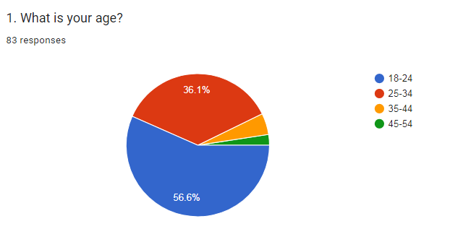
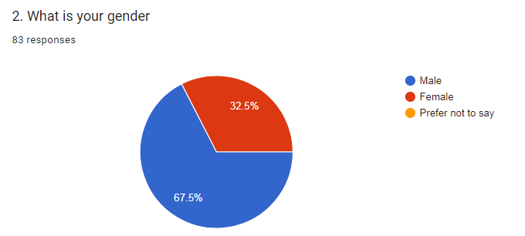
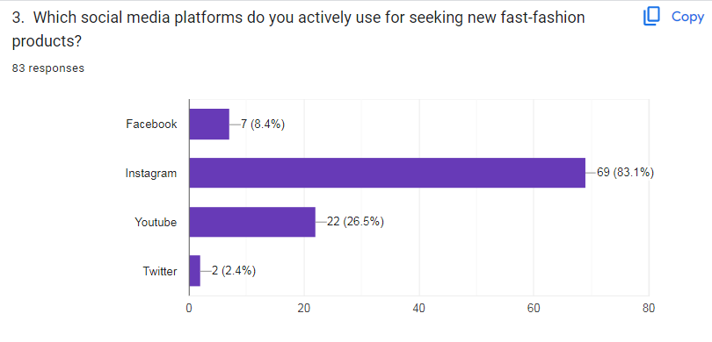
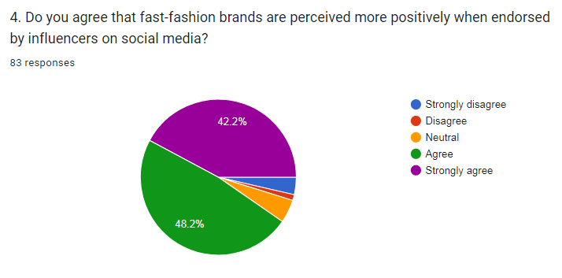
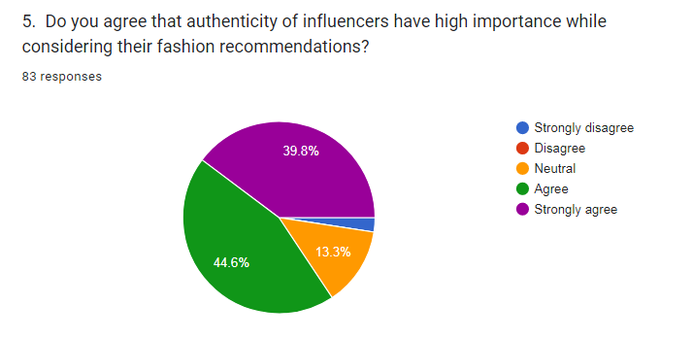
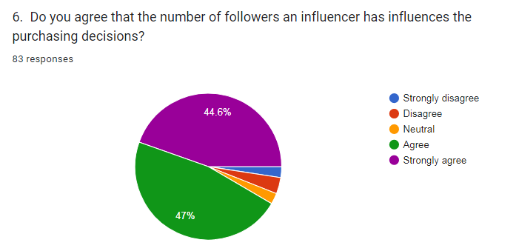
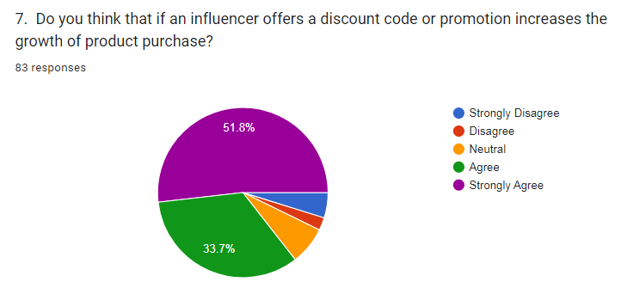
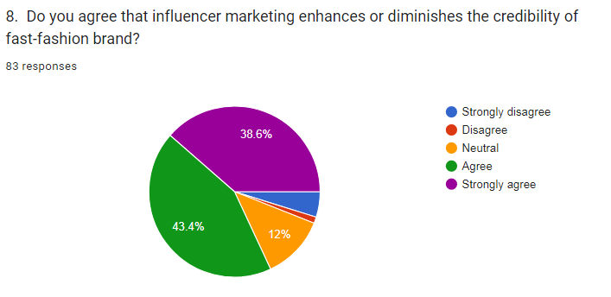
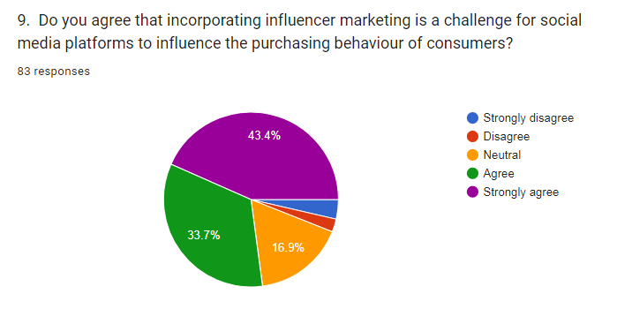
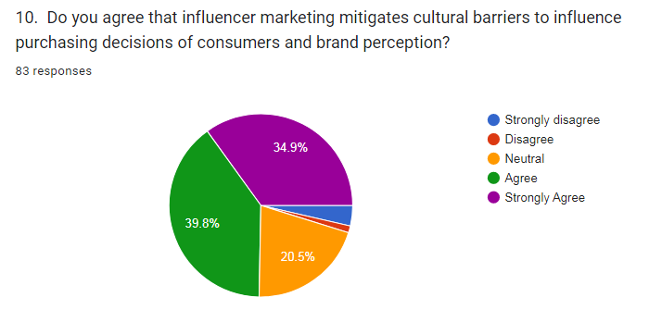


Master’s Degrees by Examination and Dissertation
Declaration Form.
1. This work has not previously been accepted in substance for any degree and is not being concurrently submitted in candidature for any degree.
Signed…….………VANSHIKA…………………………………………........................................
Date ………………13-02-2024………………………………………………….............................

2. This dissertation is being submitted in partial fulfilment of the requirements for the degree of Master in Business Administration.
Signed……………VANSHIKA……………………………………………………………………….
Date ………………13-02-2024………………………...…………................................................
3. This dissertation is the result of my own independent work/investigation, except where otherwise stated.
Other sources are acknowledged by footnotes giving explicit references.
A bibliography is appended.
Signed candidate: ………VANSHIKA…………….…………………………………………………
Date: …………13-02-2024……………………….………………………………………………….

4. I hereby give consent for my dissertation, if accepted, to be available for photocopying, inter- library loan, and for deposit in the University’s digital repository
Signed (candidate)...……VANSHIKA…………….………….…………........................................
Date………………………13-02-2024….…………….……………...............................................
Supervisor’s Declaration.

I am satisfied that this work is the result of the student’s own efforts.
Signed: …………………………………………………………………………………………………
Date………….13-02-2024…………………………………………………………..........................

