The Importance and Correlation of Health, Wealth, and Happiness
Beccy Burrows 2200741
Contemporary Challenges ACCA4027
According to WHO, 1 in 4 adults do not meet the recommended levels of activity on a day-to-day basis ^{[1]}. The 21st century has normalised the out-dated structure of following 9-5 workdays to earn money to fit capitalistic ideologies. However, it has been proven that long work hours and prolonged time sitting down at desks is incredibly harmful for our personal health ^{[2]}. Whilst higher income is often associated with better personal health ^{[3]}, typical jobs within today’s working world are prone to decreasing mental and physical health ^{[4]}. There are many factors to determine capability of health, wealth, and happiness, such as gender and occupation, however the 9-5 environment is detrimental to our human nature.
The main causes of depletion of personal health, wealth, and happiness within today’s culture, derives from the work structure we follow that was designed in the 19th century industrial era, when computers and machinery were yet to be invented ^{[4]}. With society pushing an ideology on striving for wealth, we are straining our mental and physical health by working for a majority of a day, often sitting down. But with inflation, the downfall of the British economy and the cost-of-living crisis, many of us have no choice but to endure the long hard-working week to provide for ourselves and our families, striving for a bare minimum. The situation is worsened as people not only work 9-5, but must commute to and from home which can sometimes take up significantly large portions of the day and refrain us from being physically active and able to go home and rest from the stresses of work.
With 5.1 billion public transport journeys in 2022, the daily average commute time and mode of transport, was 63 minutes by rail ^{[5]}. With around an hour for getting to work, another for getting ready and completing daily chores, most workers only see around 5 hours of free time after work to do whatever they please, providing they sleep for a minimum of 8 hours. A lack of free time can kill happiness and health from not having enough time to cook nutritious meals, feeling exhausted and needing time to rest after work, minimising communication, and productivity for other aspects in life that might start to be ignored.

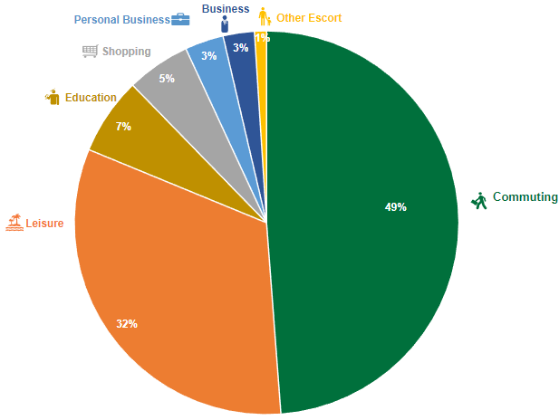
A pie chart analysing uses of public rail transport in the UK 2021.^{[6]}

Adults who are insufficiently physically active, have a 20-30% increase in a risk of death, when compared to the health of a sufficiently active adult ^{[1]}. Whilst there are many benefits to 40-hour work weeks, like a steady pay check and often opportunities for pay rises and company benefits ^{[7]}, they also deplete your energy and sustains prolonged periods of being sedentary, with physical inactivity costing the NHS around £1 Billion a year ^{[8]}. Burning out becomes inevitable with the 9-5 structure, as it does not comply to human cycles of productivity ^{[4]}.
It has been proven that the brain can only focus for around 45 minutes to an hour at a time, we go through daily cycles that are hardwired into our DNA, known as Ultradian Performance Rhythms. These rhythms provide our brain with the chemicals to provide peaks in productivity and fluctuates between working hard and giving our mind a rest from the high performance it has endured ^{[9]}. By working for multiple hours at a time with minimal breaks, we are disrespecting these rhythms which can cause harm to our health and happiness from overworking our brains. Increased blood pressure, mood swings, slowed metabolism and declines in memory and communication skills are only few of the many risks that the physiological overtime brings ^{[9]}.

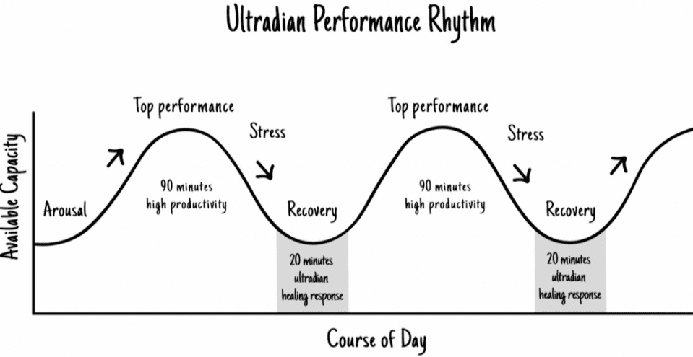

An illustrated graph on ultradian rhythms. ^{[9]}

Gender also plays an important role for personal health, wealth, and happiness. As capitalist society is proven in favour for males, women often struggle within the world of work. The male hormone cycle lasts roughly 24 hours, with peaks in morning time and a slow decline in productivity and mood near evening time. This means that males can withstand and cope with standard workday hours a lot easier than women, whose cycles are roughly 24 days. Which shows high productivity for a longer period but declining in productivity and mood for a matter of days rather than hours ^{[10]}. Mental health is often affected from the overstimulation of the mind. With low income and parenting women being the main victims of depression ^{[11]}, which may stem from the inability to cope with long shifts and being inactive.

There are a variety of potential solutions for the depletion of our health, wealth, and happiness, even when some problems are out of our control and stem from higher powers. A change of mindset and design thinking can help with overcoming this ‘wicked problem^{’ [12]}. By listening to our bodies needs and our ultradian rhythms, we can decrease the probability of overworking ourselves and generating problems such as stress and decreased mental health. This can be achieved from taking 20-minute breaks every hour or so. The WHO global action plan ^{[1]}, aims to achieve better health for individuals in the 21st century. The plan goes over community events to get fit and raise awareness, surveillance of individuals health and reconstruct the suggested requirements of weekly exercise per age category ^{[1]}. Due to Covid-19, working from home has become increasingly popular, and it is significantly better for your health for varying reasons. From not only cutting down on travelling time and cost but allowing you to work towards your own schedule and can be less sedentary. However, many have claimed that working from home may not be as beneficial as you believe, as there is an increased risk of low social interaction and distractions at home, along with no office perks and a struggle to keep a set routine from a home office. ^{[13]}
To summarise, there are many factors into the depletion of one’s health, wealth, and happiness. The structure of 9-5 workdays are detrimental to our mental and physical health from forcing workers to be sedentary for long periods of time and neglecting our brain’s ultradian rhythms. With an average commute time of 63 minutes by rail ^{[5]}, the 9-5 work hours are lengthened to accommodate for travelling. With physical inactivity costing the NHS more money, annually ^{[8]}, individuals should begin to think of the small changes that will benefit towards the resolution of this wicked problem. Potential solutions include trying to work from home where possible, respecting our ultradian rhythms and becoming more active throughout the week, aiming at, at least 150 minutes of exercise ^{[1]}.

Bibliography

[1] “Physical activity,” World Health Organization. [Online]. Available: https://www.who.int/news-room/fact-sheets/detail/physical-activity. [Accessed: 22-Feb-2023].
[2] T. Maddox, T. R. Staff, A. Abdullahi, M. Shacklett, K. Greenberg, and B. Stone, “Is sitting really the new smoking? an in-depth discussion with the experts,” TechRepublic, 06-Oct-2016. [Online]. Available: https://www.techrepublic.com/article/is-sitting-really-the-new-smoking-an-in-depth-discussion-with-the-experts/. [Accessed: 22-Feb-2023].
[3] “Relationship between income and health,” The Health Foundation. [Online]. Available: https://www.health.org.uk/evidence-hub/money-and-resources/income/relationship-between-income-and-health#:~:text=Across%20the%20entire%20income%20distribution,money%20correlates%20positively%20with%20health. [Accessed: 22-Feb-2023].
[4] A. the F. Friday, “Why the 9-5 schedule could be harming your health,” Vuka, 11-Oct-2022. [Online]. Available: https://vuka.co/blog/why-the-9-5-schedule-could-be-harming-your-health/. [Accessed: 22-Feb-2023].
[5] “Transport statistics great britain: 2022 Domestic Travel,” GOV.UK. [Online]. Available: https://www.gov.uk/government/statistics/transport-statistics-great-britain-2022/transport-statistics-great-britain-2022-domestic-travel#:~:text=The%20average%20usual%20commuting%20time,15%20minutes%20for%20walking. [Accessed: 22-Feb-2023].
[6] “Rail Factsheet: 2022,” GOV.UK. [Online]. Available: https://www.gov.uk/government/statistics/rail-factsheet-2022/rail-factsheet-2022. [Accessed: 25-Feb-2023].
[7] N. Webb, “The untold truth about the 9 to 5 job,” Millennial Magazine, 13-Jun-2019. [Online]. Available: https://millennialmagazine.com/2017/03/06/the-untold-truth-about-the-9-to-5-job/. [Accessed: 22-Feb-2023].
[8] “Reducing physical inactivity in the workplace,” HR Magazine. [Online]. Available: https://www.hrmagazine.co.uk/content/features/reducing-physical-inactivity-in-the-workplace/. [Accessed: 22-Feb-2023].
[9] A. Kotifani, “Use the science of Ultradian rhythms to boost productivity, energy, and Willpower,” Blue Zones, 22-Jun-2020. [Online]. Available: https://www.bluezones.com/2020/06/how-taking-breaks-can-increase-productivity-boost-energy-levels-and-help-you-show-up-in-your-life/. [Accessed: 22-Feb-2023].
[10] S. 24, Posted by Sarah Hodges on December 17, Posted by M on January 13, and Posted by A on February 9, “A comparison of the female vs male hormonal cycle: Spoiler alert, women have it worse,” TABOO Period Products, 24-Sep-2021. [Online]. Available: https://tabooau.co/blogs/blog/a-comparison-of-the-female-vs-male-hormonal-cycle-spoiler-alert-women-have-it-worse. [Accessed: 22-Feb-2023].
[11]- “Mental health and wealth: Depression, gender, poverty, and parenting.” [Online]. Available: https://www.annualreviews.org/doi/abs/10.1146/annurev-clinpsy-071219-022710. [Accessed: 22-Feb-2023].
[12] “What is design thinking?,” The Interaction Design Foundation. [Online]. Available: https://www.interaction-design.org/literature/topics/design-thinking. [Accessed: 22-Feb-2023].
[13] Mint, Written by Mint Mint is passionate about helping you to achieve financial goals through education and with powerful tools, W. by Mint, Mint is passionate about helping you to achieve financial goals through education and with powerful tools, and M. from Mint, “Pros and cons of working from home: Is it better for you and your wallet?,” MintLife Blog, 30-Jun-2022. [Online]. Available: https://mint.intuit.com/blog/remote-work/pros-and-cons-of-working-from-home/. [Accessed: 25-Feb-2023].

A. Villarreal, “This is how working long hours affects your mental health,” Ladders, 14-Oct-2019. [Online]. Available: https://www.theladders.com/career-advice/this-is-how-working-long-hours-affects-your-mental-health. [Accessed: 22-Feb-2023].
C. Ross, “There are huge differences between male and female hormonal cycles, and it turns out the clock literally works in men's favour,” Glamour UK, 08-Sep-2021. [Online]. Available: https://www.glamourmagazine.co.uk/article/male-female-hormone-cycles-differences. [Accessed: 22-Feb-2023].

Scroll for poster



