Qualification: CIPD Diploma in Applied Human Resources

Module Name: Contributing to Coaching and Mentoring

Activity 1: The impact of coaching and mentoring activity within Valero and make recommendations for further development

Word Count: 1,354 words

Activity 2: Support the implementation of coaching and/or mentoring programmes within Valero

Word Count: 1,513 words

Student Name: Melanie Gough
Student Number: 1910141
CIPD Membership Number: 54660544

By signing below, I confirm that the work/evidence presented is my own, unaided work. I understand the regulations pertaining to candidate malpractice and the action that may be taken as a result.

Signed: 

Date: 06/12/2021
Contents
CIPD Candidate Evidence Matrix 1
The impact of coaching and mentoring activity within Valero and recommendations for further development 3
Evidence 6
References 27
The implementation of a mentoring programme within Valero 28
Evidence 31
References 65

CIPD Candidate Evidence Matrix

Candidate name: Melanie Gough |  |  |  |  | CIPD Membership/registration No.:  54660544
Qualification title: CIPD Level 5 Diploma in Applied Human Resources |  |  |  |  | Unique Learner No. (ULN):  1910141
Unit code | Unit title |  | Assessment criteria no. | Evidence description | Evidence reference number |  |  | Assessor  initials | I/V initials if sampled
5ADCM | Contributing to Coaching and Mentoring |  | 1.1, 1.2 | Meeting with Richard Allen, Director Refinery Operations |  | EV 1
5ADCM | Contributing to Coaching and Mentoring |  | 1.1, 1.2 | Meeting with Karen Muehlbauer, Director Safety/Environmental Affair |  | EV 2
5ADCM | Contributing to Coaching and Mentoring |  | 1.1, 1.2 | Meeting with Tracey Bryant, Manager Learning & Development |  | EV 3
5ADCM | Contributing to Coaching and Mentoring |  | 1.1, 1.2 | 2021 Business Plan |  | EV 4
5ADCM | Contributing to Coaching and Mentoring |  | 1.1, 1.2, 1.3 | Email from SAHQ re new Performance Management System |  | EV 5
5ADCM | Contributing to Coaching and Mentoring |  | 1.1, 1.2, 1.3 | Supervisor Toolkit |  | EV 6
5ADCM | Contributing to Coaching and Mentoring |  | 1.1, 1.2 | Follow-up meeting with Tracey Bryant, Manager L&D & Jo James Manager Human Resources |  | EV 7
5ADCM | Contributing to Coaching and Mentoring |  | 1.1, 1.2 | Special Ops Training |  | EV 8
5ADCM | Contributing to Coaching and Mentoring |  | 1.1, 1.2 | Valero Guiding Principles |  | EV 9
5ADCM | Contributing to Coaching and Mentoring |  | 1.3 | Refinery workforce demographics |  | EV 10
5ADCM | Contributing to Coaching and Mentoring |  | 1.1, 1.2 | 2022 Business Plan |  | EV 11
5ADCM | Contributing to Coaching and Mentoring |  | 1.3, 1.4 | Women in Industry Lunch & Learn meetings |  | EV 12
5ADCM | Contributing to Coaching and Mentoring |  | 2.1, 2.2, | Women in Industry Lunch & Learn Mentoring Session |  | EV 13
5ADCM | Contributing to Coaching and Mentoring |  | 2.1, 2.2, | Email to Jo James, Manager Human Resources |  | EV 14
5ADCM | Contributing to Coaching and Mentoring |  | 2.1, 2.2, 2.3, | Lunch & Learn Mentoring session – PowerPoint presentation |  | EV 15
5ADCM | Contributing to Coaching and Mentoring |  | 2.1, 2.2, | Email to Women in Industry group about the mentoring programme | EV 16
5ADCM | Contributing to Coaching and Mentoring |  | 2.3 | Mentoring Form | EV 17
5ADCM | Contributing to Coaching and Mentoring |  | 2.3, 2.5 | Mentoring Agreement | EV 18
5ADCM | Contributing to Coaching and Mentoring |  | 2.1 | Email from Jo James, Manager HR endorsing the mentoring programme | EV 19
5ADCM | Contributing to Coaching and Mentoring |  | 2.3, 2.4 | Email to Tracey Bryant, Manager L&D re mentoring training sessions | EV 20
5ADCM | Contributing to Coaching and Mentoring |  | 2.3, 2.4 | Email to mentors and invite to mentor training session | EV 21
5ADCM | Contributing to Coaching and Mentoring |  | 2.4, 2.5 | Email & calendar appointments to mentors & mentees for initial meetings | EV 22
5ADCM | Contributing to Coaching and Mentoring |  | 2.5 | Mentor Evaluation Form | EV 23
5ADCM | Contributing to Coaching and Mentoring |  | 2.3 | Email from Supervisor re Coaching | EV 24
Candidate declaration:
- I confirm that the work/evidence presented for assessment is my own unaided work.
- I have read the assessment regulations and understand that if I am found to have ‘copied’ from published work without acknowledgement, or from other candidate’s work, this may be regarded as plagiarism which is an offence against the assessment regulations and leads to failure in the relevant unit and formal disciplinary action.
- I agree to this work being subjected to scrutiny by textual analysis software if required.
- I understand that my work may be used for future academic/quality assurance purposes in accordance with the provisions of the Data Protection Act 1998.
- I understand that the work/evidence submitted for assessment may not be returned to me and that I have retained a copy for my records.
- I understand that until such time as the assessment grade has been ratified through internal and external quality assurance processes it is not final.
Signature: |  |  |  |  | Date: |  |  | 06/12/2021


The impact of coaching and mentoring activity within Valero and recommendations for further development
A review of organisational information and meetings with key stakeholders highlighted the extent to which coaching and mentoring activity takes place within Valero’s Pembroke Refinery, and how effective the activities are in supporting the achievement of objectives. Although a written down policy is not currently in existence, the commitment to coaching and mentoring is evident through several formal and informal programmes. [EV 1] [EV 2] [EV 3]

A ‘high-potential’ coaching programme is in place, whereby the Refinery Leadership Team (RLT) coach potential successors. This is an informal arrangement that forms part of the Emerging Leaders programme. The RLT are encouraged to focus on developing the skills and behaviours necessary for leadership roles, such as influencing, communication and people management skills. Using high-performance coaching to complement and strengthen leadership programmes is recommended, and so reinforces the need for high-performance coaching alongside the Emerging Leaders programme. (Wheatley, (2016)) The programme includes a series of training sessions, including ‘the Art and Science of Coaching’, which is designed for attendees to practice their coaching skills and be shown different ways they can effectively coach their employees. High-potential employees are identified through workforce planning activities, such as succession planning. However, our approach to succession planning is traditional, and managerial judgement is typically used to identify successors. This approach is often criticised for being subjective, and historically there has been a ‘who you know’ culture at Pembroke Refinery, meaning in the past, employees may have been overlooked. However, this high-performance coaching programme contributes to achieving the 2021 Business Plan strategic objective to undertake ‘structured talent management through the identification and development of employees’ by preparing high-potential employees for leadership roles. [EV 4]

Pembroke Refinery is introducing an ongoing performance management process that all other Valero locations transitioned to in 2018. The new process is aligned to Valero’s performance management philosophy of “building key values by engaging in ongoing communication, goal setting, coaching and feedback, while also providing guidance on career development”. (Valero, n.d.) The new process includes a Coaching Guide, which is a tool that can be used by supervisors to prepare for coaching conversations and employee ‘check-in’ meetings. The guide includes questions and tips to consider during each step of the coaching model, and reminds supervisors that “the most important part of a formal coaching conversation is preparation” (Valero, n.d.) There is also a Coaching Questions Guide, that can be used by supervisors to help build the Valero culture, drive for results, and create success within their team. The guide stresses that “supervisors don't need to have all the answers: they just need to ask the right questions” (Valero, n.d.) Using the coaching model will help supervisors to understand what's going on in their employee’s role, what inspires their employee and what their employee would like to focus on in their development. This is a formal process, but its effectiveness relies on the Manager having regular check-ins, setting expectations, providing feedback and ongoing real-time coaching. An in-house training session for this ongoing performance management process, will be delivered to Supervisors in the first quarter 2022. [EV 5]

In 2019, the Supervisor Toolkit (STK) programme was introduced, which is designed to equip supervisors with the tools they need to succeed. Supervisors are coached through the programme by their manager over a 12-month period. As part of the STK programme, supervisors are encouraged to attend the ‘Frontline Experience’ course, which is designed to make their transition from the individual contributor role to the supervisor role successful. While the STK programme is supported by HR, the effectiveness of the STK programme relies on the Manager being actively involved in, and committed to the programme. [EV 6]

The apprenticeship programme has an informal ‘peer mentoring’ programme. Incoming apprentices are assigned a peer mentor who has been through the apprenticeship programme a few years earlier. A Forbes article considers peer-mentoring to be the best approach to introducing a new employee to the organisation. (Behesti, (2019)) However, a review by the new L&D manager has revealed that the programme as it is currently set up is not working. It is apparent that little consideration was given to matching mentee’s to mentor’s, and many mentors are not committed to the role, leaving mentees without an effective mentor. The programme is currently under review, with the intention of implementing a newly developed peer-mentoring programme ready for the next intake of apprentices in September 2022. [EV 7]

Process Operations use an informal mentoring programme to satisfy competence assurance. While an Operator is competent and ‘holding down’ a position, they mentor junior operators training in that position. This allows progression through positions, ensuring a full complement of competencies at all times, to satisfy the Health, Safety and Executive (HSE) requirements. Although this arrangement is not written down, it is customer practice, and it is recognised that an operator holding down a position is best placed to train their successor. Operators are encouraged to attend the ‘Special Ops Training – Mentor Version’ course, where they will learn basic skills to enhance on the job training, such as giving and receiving feedback and asking effective questions, which will help them facilitate learning with new operators. This arrangement is an effective way for Operations to achieve their manning levels and training targets. [EV 8]

A review of coaching and mentoring programmes at Pembroke Refinery, found that there are several programmes in existence, yet it is clear that there is room for further development. Some areas of the business are not involved in coaching and mentoring programmes, while other areas of the business are actively engaged. Valero foster a culture that “support diversity and inclusion”, (Valero, (2021)) however, female employees remain the minority across the global organisation. With only 3 female board members compared to 9 males, females represent only 25% of the board of directors. Valero are a member of ‘Inclusive Employers’, an organisation that is “committed to prioritising inclusion and creating truly inclusive workplaces” (Inclusive Employers, (2021)). Inclusive employers argue that inclusive mentoring programs have a positive impact on organisations, including attracting, retaining and developing talent. [EV 10]

The resource required and the financial implications of investing in further coaching and mentoring initiatives were considered. In 2020, Valero appointed a new Learning and Development (L&D) Manager, who is a qualified Coach-Mentor, a European Mentoring Coaching Council (EMCC) member and an EMCC European Quality Award (EQA) practitioner with over 20 years’ experience in coaching and mentoring. The L&D Manager is committed to developing employees who are interested in becoming coaches or mentors. The L&D Manager suggested that membership with an organisation like the European Mentoring and Coaching Council (EMCC) would provide assurance to our employees that we are committed to coaching and mentoring.

At Pembroke Refinery, the demographic profile indicates that 82 (17%) employees are currently at voluntary early retirement eligible age. This is a cause for concern as the loss of knowledge and experience could negatively impact the business. Those who are retirement eligible include engineers, subject matter experts, maintenance technicians and process operators. It is vital that measures are put in place to ensure these employees pass on their skills and knowledge to successors to ensure business continuity. Mentoring could help facilitate knowledge transfer to reduce the risk to the business. [EV 10]

Overall, coaching and mentoring activity can be developed to benefit Pembroke Refinery, and developing mentoring programmes that promote and support diversity and inclusion will be a positive step towards achieving the 2022 Business Plan objective to ‘improve diversity in recruitment and selection, providing equal opportunities for all’. [EV 11]

An objective of the HR Business Plan for 2022 is to “create and deliver a Refinery Development Plan that includes leadership training, structured talent management, and technical and professional development”. Implementing effective coaching and mentoring programs could contribute to achieving this objective too. The importance of developing employees is highlighted by Forbes, who argue that “an employer who doesn’t focus on learning is going to lose out — in performance, engagement and retention.” (Biro, 2018) [EV 11]

Additionally, a written down L&D policy relating to Coaching and mentoring would support our commitment to learning and development through coaching and mentoring programmes. The CIPD state that policies have several benefits to both the organisation and the employee, including creating “a positive organisational culture” (George, (2021))

Evidence
EV 1
Meeting with Richard Allen, Director Refinery
10 August 2021, 14:00

To discuss:
- High-potential coaching – RLT coach emerging leaders to get them ready for their next position

I asked RA about high-performance coaching as part of the emerging leaders programme. RA explained that 'high-potential' employees are identified early in their career, and are not placed on the emerging leaders programme straight away - they are moved around the business across a range of roles, usually for around 3 years - this gives them experience in and an appreciation for different areas of the business. For example, RA has over 30 years service at Valero, and explained that he had held several roles before being enrolled on the Emerging Leaders programme and being promoted to Director. RA started as an apprentice in maintenance and worked as a maintenance technician for a few years. He then moved to Technical and completed a chemical engineering degree, and worked as an area Process Engineer, before moving to Operations as an Operations advisor. He then moved back to maintenance as the Fixed Equipment Manager - he held this role for a few years, and was then promoted to Complex Manager for Cracking and Olefins, then laterally moved to Complex Manager for Refining. He was then promoted to Director Central Maintenance, and more recently Director Refinery Operations.

RA explained that the experience he gained during all these roles, helped to prepare him for his Manager and Director roles, but also explained that the coaching and mentoring he received over his career has been invaluable.

RA also explained that as he progressed through the organisation, he has coached and mentored many employees - both those working directly for him and those who have progressed to roles that he previously held.

When RA was maintenance Director, he promoted NJ to the role of Fixed Equipment Manager. Although NJ had been in the FE team for several years and had strong Technical knowledge, this was his first Supervisory role. At this time, the Supervisor Toolkit was not in existence, but RA met with him regularly to discuss managing his team.

RA is confident that coaching and mentoring is taking place across the business, with many not even realising that they are being coached and/or mentored. Every day, when a Technician needs help from a Sr Technician on a maintenance task, they are 'mentoring' that Technician, by improving their knowledge and experience, so next time they may not need help, and will one day show other how to complete that maintenance task.

RA stressed that all of his meetings with his direct reports are held in a coaching style and he is keen to transition from annual EPR's to the ongoing performance management process.

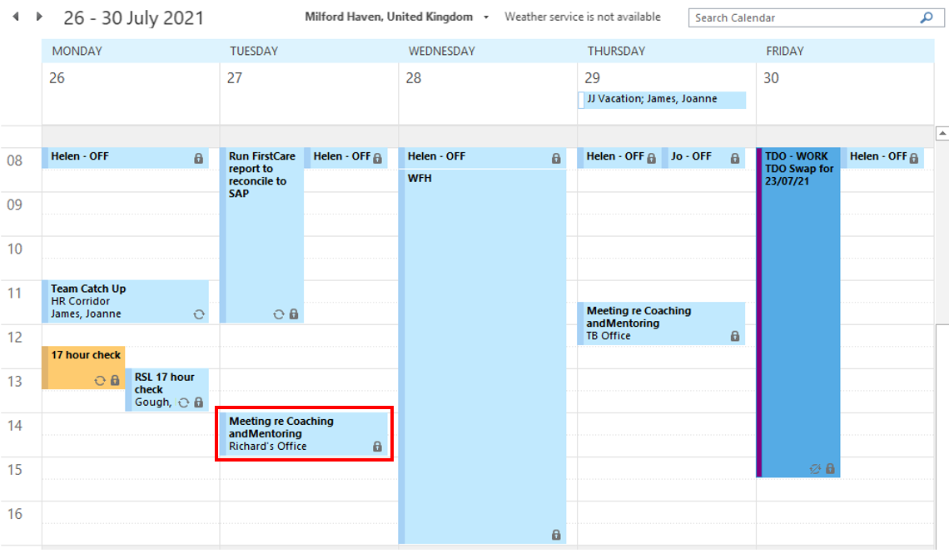

EV 2
Meeting with Karen Muehlbauer, Director Safety / Environmental Affairs
03 August 2021, 08:00

To discuss:
- High-potential coaching – RLT coach emerging leaders to get them ready for their next position

KM talked me through the process of high-performance coaching. As part of succession planning, RLT identify if potential successors are ‘ready now’ or ‘ready in 1-2 years’ – for those ready in 1-5 years, RLT must identify area for development. This could be technical development e.g., experience in Operations, experience in a supervisory role, or developing negotiation skills, handling difficult conversations, conflict, communication etc. There is no policy written down, but it is an expectation of the role of Director (and some Manager roles) to coach high-potential employees. KM stressed the importance of confidentiality in the coaching relationship.

KM explained that she mentored many junior engineers when she was in the US - it’s something she’ always enjoyed and finds fulfilling and rewarding as she enjoys passing on technical knowledge.

KM also discussed the coaching and mentoring she received when she was on the emerging leaders programme in the US. She was mentored by her Technical Director when she was based in the US Refinery. She then spent a couple of years in HQ to develop her leadership skills before being offered a director role at Pembroke. KM explained that one thing that was holding her back in the leadership development was public speaking and she was coached by the Director Training & Development in HQ to develop these skills.

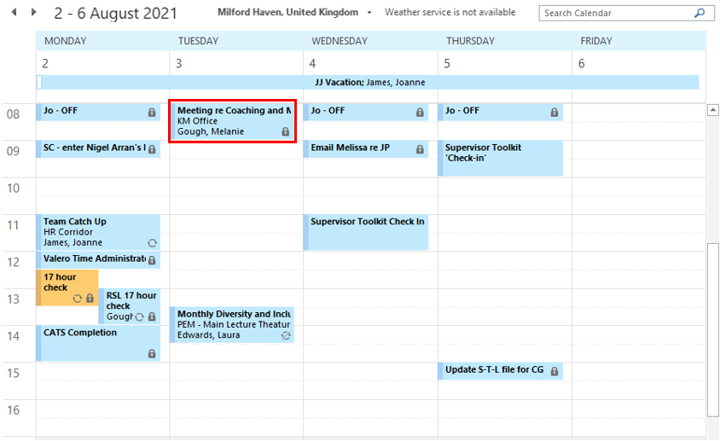

EV 3
Meeting with Tracey Bryant, Manager L&D
29 July 2021, 11:30

To discuss:
Current coaching and mentoring programmes in place
L&D Policy for coaching and mentoring

Coaching
  - High-potential coaching – RLT coach emerging leaders to get them ready for their next position – MG speak with the Directors to learn more about this.

Other programmes that refer to coaching include:
  - Supervisor Toolkit – Managers coach new supervisors through the Supervisor Toolkit (new process, introduced in 2020 – positive feedback received from Supervisors to date)
  - Performance Management – coaching style PM programme being rolled out in 2022 (PM training to be delivered to all line managers in preparation for the roll out)

Mentoring programmes
  - Operators mentoring programme – for example Butamer Operator will mentor an operator training in that position, so that he/she can move on to train in his/her next position (informal – process is not written down but is customer practice – it is recognised that the Op in that position is best placed to mentor)
  - Apprentice peer-to peer mentoring – note TB advised she is working on a formal mentoring programme for the apprentices that will be compulsory as a review of the current mentoring arrangement is not fit for purpose (informal – to be formalised)
  - Undergraduate mentoring programme – our industrial placement students are matched with experienced Engineers during their year placement (informal – but effective as both the mentor and the student appreciate the relationship)

TB is on board with developing and L&D policy in relation to C&M and sees this as a positive step for embedding coaching and mentoring at Pembroke. TB advise including the following:
  - The scope of the coaching and mentoring programmes
  - The role of the coach
  - The role of the mentor
  - The benefits of coaching and mentoring
  - Formal coaching
  - Formal mentoring
  - Informal coaching
  - Informal mentoring
  - The responsibilities of the coach and mentor
  - The responsibilities of the line manager
  - The responsibilities of the coachee and mentee
  - Coaching and mentoring training
  - Other training, learning and development initiatives

MG & TB to draft L&D policy – this could be a 2022 objective for HR and L&D

TB highlighted that several employees have approached her since she joined Valero asking for coaching and/or mentoring. She believes this is because she is a qualified Coach-Mentor, a European Mentoring Coaching Council (EMCC) member and an EMCC European Quality Award (EQA) practitioner. TB is currently coaching a few employees – and she has also successfully set up a few mentoring relationships with Associate Engineers and Sr Engineers in the Technical Department. TB feels that interest in coaching and mentoring has grown, which is positive. TB to reach out to RLT to gain endorsement to introduce more formal coaching and mentoring programmes.

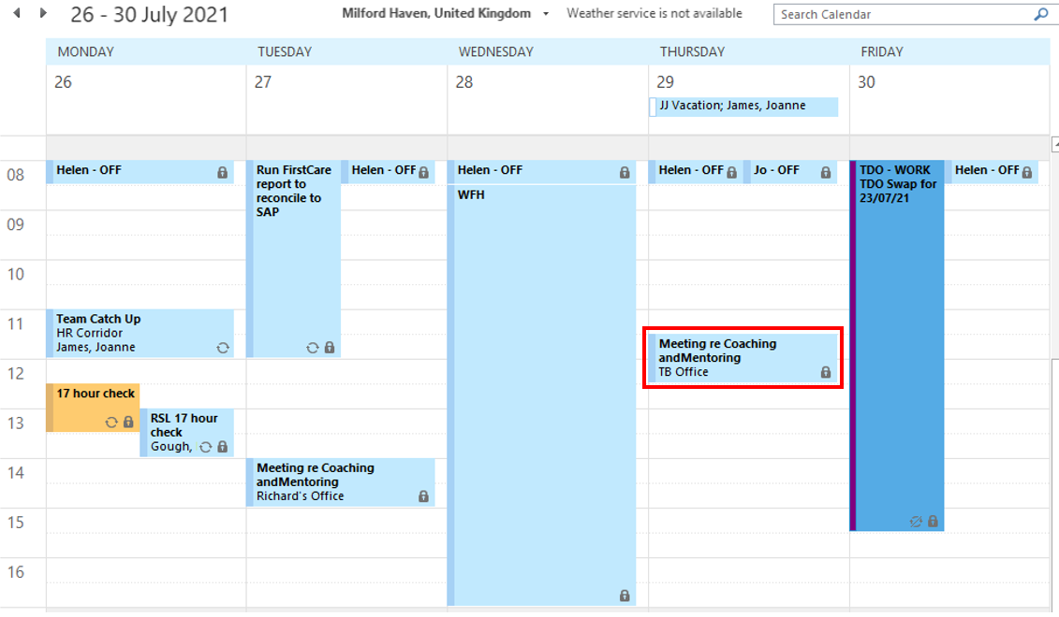

EV 4
2021 Business Plan

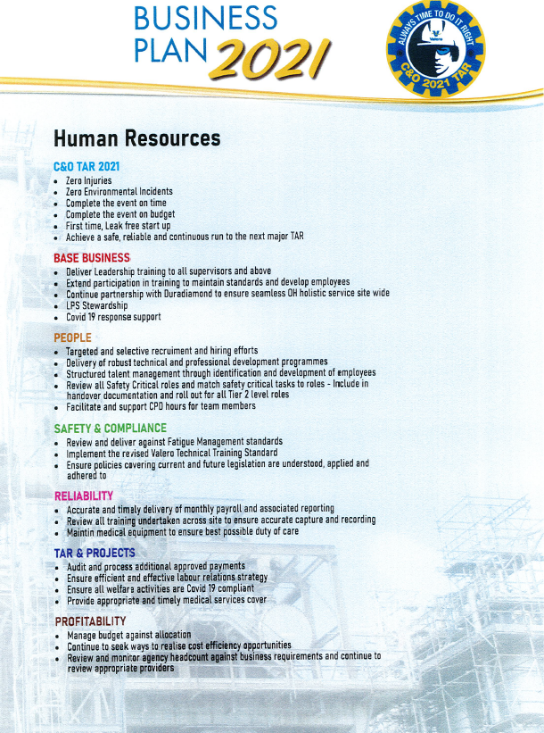
EV 5
Email from SAHQ re transition from Employee Performance Reviews to Performance Management

_____________________________________________
From: Muehlbauer, Karen
To: GR-PEM Valero Employees (014)<GR-PEMValeroEmployees014@valero.com>; Employees Operations (006) <GR-PEMValeroEmployeesOperations006@valero.com>
Sent: 24 November 2021 08:54
Subject: Move to 'Performance Management' System - All Employees
Importance: High

Dear All Valero Pembroke Employees,

For the last few years, Valero Corporate has been transitioning away from the Employee Performance Review (EPR) system. Over the last few months, the RLT and HR Team have reviewed the new program. As we continue to effectively integrate our Team Valero approach into everything we do, we have determined that a one-time annual review is not an effective coaching tool to drive performance improvement and requires a tremendous amount of time, disproportionate with its value. Our business moves much too quickly today for a one-time annual review to be effective.

We believe that ongoing, real coaching that moves our business goals forward is a more effective tool to drive performance, and we believe that this approach is already happening in real time in every part of our business. For these reasons, we determined that we will no longer use the EPR, and will not replace it with an alternative formal “system.”

Going forward, we will continue to expect all management to be a resource for their teams, providing clear performance expectations and the coaching necessary to achieve our business objectives. We will also continue to expect all Valero team members to understand performance expectations for their roles and be accountable to their teams to always perform at or above expectations. We expect these timely performance discussions to continue following the natural cycle of work with a focus on providing meaningful performance feedback and recognition.

Your supervisor will communicate expectations around performance management for you and your teams in the near term. We believe that this more practical approach will enhance performance in real-time, improve communication within our teams and provide greater opportunity for improvement in all aspects of our business.

What is Performance Management?
‘Performance Management’ provides a much more straightforward means of ensuring an ongoing communication process between you and supervisor and moves us away from the once yearly check ins that are often administratively burdensome and inflexible. Our business moves too fast to rely on an annual EPR to have performance discussion. Goals set at the beginning of the year may no longer be relevant at the end of the year. Effective performance management is ongoing. You should receive timely feedback on your performance to know how to improve and further your career. The new approach means there is no beginning and no end; there is no formal sign off process at the end of the year. It is an ongoing process. Many of you may already be doing elements of this already.

You will note from the attached guides that ‘Performance Management’ works around four simple principles:

- Setting Expectations
- Being clear about ‘The Results’ and what is expected of you
- Providing a Timeline and milestones for success
- Gaining mutual Commitment to the goals set

When will we revert to this new approach?
The transition in performance management will be implemented from Q4 2021 through to Q1 2022. To be clear, this is not a new performance management program, it is a transition to an overall approach that supports having ongoing interactions with your supervisor.

What’s next?
- Jan/Feb 2022- Supervisor and above training sessions to be held.
- By 31 March, 2022: Your supervisor will schedule your first ‘check in’ where you will follow the four principles set out above.
- After 1Q22, your supervisor will provide timely, ongoing performance coaching/check-ins and feedback on a formal or informal basis on a daily, weekly, monthly or quarterly basis, as appropriate.

What about my open EPRs?
- These will remain open in the system. You can still access the EPR system to review historical EPRs through the HR portal.

What about my career development?
Short and longer term career goals are to be documented in the MyProfile system and discussed on at least an annual basis. This tool should also be used for identifying training or special assignments that can support career development.

<< File: Employee FAQs.pdf >>

Please note that there will be no change for the workgroups that functionally report through Corporate (Business Services, HR, IT) as they moved to the Performance Management system a few years ago.

I look forward to this new approach to performance management and trust that you will embrace this change.

Best,

Karen Muehlbauer
Director Safety, Environmental and Human Resources

Valero Energy Ltd
Pembroke Refinery
Pembroke
Pembrokeshire SA71 5SJ
Tel +44[0]1646 649250
Mobile +44 [0] 7786 684404

Registered in England and Wales (reg. number 8566216), Registered Office: 27th Floor, 1 Canada Square, Canary Wharf, London, E14 5AA.

This message may contain confidential information and is intended only for the use of the parties to whom it is addressed. If you are not an intended recipient, you are hereby notified that any disclosure, copying, distribution or use of any information in this message is strictly prohibited. If you have received this message in error, please notify me immediately at the telephone number indicated above.

____________________________________________
From: Muehlbauer, Karen
Sent: 19 November 2021 09:07
To: GMfg - PEM Supervisors
Cc: James, Joanne <Joanne.James@valero.com>; Gough, Melanie <Melanie.Gough@valero.com>; Berry, Helen <Helen.Berry@valero.com>; Armytage, Nikki <Nikki.Armytage@valero.com>; Bryant, Tracey <Tracey.Bryant@valero.com>
Subject: Move to 'Performance Management' System - Leaders Note
Importance: High

Dear Tier 2 Leaders and Supervisors,

For the last few years, Valero Corporate has been transitioning away from the Employee Performance Review (EPR) system. Over the last few months, the RLT and HR Team have reviewed the new program. As we continue to effectively integrate our Team Valero approach into everything we do, we have determined that a one-time annual review is not an effective coaching tool to drive performance improvement and requires a tremendous amount of time, disproportionate with its value. Our business moves much too quickly today for a one-time annual review to be effective.

We believe that ongoing, real coaching that moves our business goals forward is a more effective tool to drive performance, and we believe that this approach is already happening in real time in every part of our business. For these reasons, we determined that we will no longer use the EPR, and will not replace it with an alternative formal “system.”

Going forward, we will continue to expect all management to be a resource for their teams, providing clear performance expectations and the coaching necessary to achieve our business objectives. We will also continue to expect all Valero team members to understand performance expectations for their roles and be accountable to their teams to always perform at or above expectations. We expect these timely performance discussions to continue following the natural cycle of work with a focus on providing meaningful performance feedback and recognition.

Your Division leadership will communicate expectations around performance management for your teams in the near term. You will have access to tools, resources and training to support our performance management strategy. We believe that this more practical approach will enhance performance in real-time, improve communication within our teams and provide greater opportunity for improvement in all aspects of our business.

I look forward to this new approach to performance management and trust that you will embrace this change.

What is ‘Performance Management’?
‘Performance Management’ provides a much more straightforward means of ensuring an ongoing communication process between you and your team and moves us away from the once yearly check ins that are often administratively burdensome and inflexible. Our business moves too fast to rely on an annual EPR to drive employee performance. Goals set at the beginning of the year may no longer be relevant at the end of the year. Effective performance management is ongoing. Your team should receive timely feedback on their performance to know how to improve and further their careers. The new approach means there is no beginning and no end; there is no formal sign off process at the end of the year. It is an ongoing process. Many of you may already be doing elements of this.

You will note from the attached guide below that ‘Performance Management’ works around four simple principles:

- Setting Expectations
- Being clear about ‘The Results’ and what you want from your direct reports
- Providing a Timeline and milestones for success
- Gaining mutual Commitment to the goals set

When will we revert to this new approach?
The transition in performance management will be implemented from Q4 2021 through to Q1 2022. Performance Management expectations will be determined and communicated by your RLT leads. To be clear, this is not a new performance management program, it is a transition to an overall approach that supports having ongoing employee interactions that focus on improving employee performance. Any employee that cause you concern should still be discussed with HR at the earliest opportunity.

Your main role as part of this approach is to clearly set expectations with your direct reports as to what is expected of them/their teams, which you likely already do. Please also discuss and agree with your RLT leader an appropriate level of ‘check in’s for your department. For example, in HR we are encouraging quarterly formal check ins, with other check in, coaching and feedback sessions happening in real time, as and when it is appropriate to discuss any particular element of a person’s role. It is always good to consider whether notes of the conversation would be useful to keep. Although this is not intended to be time consuming or burdensome, notes that reflect real time discussions with the team are often useful, where appropriate. Most people will be in a good habit of doing this already.

We will not be asking for EPR type annual feedback from anyone, but it is important that every supervisor starts this journey and keeps good notes of any performance related discussions they have with their direct reports.

What do I need to do now?
Please use the time that you would have otherwise spent on EPR’s this year preparing for this new way of working by doing the following:

- Read the Resource Guide attached to this email or in your Manager Centre (bottom right hand side of page when you log in to myHR- Manager Centre)
<< File: 01_2.2.2_ResourceGuide_UK_v Nov 2021.pdf >> << OLE Object: Picture (Device Independent Bitmap) >>

- Take time to explain the changes to your team;
- Discuss with your Tier 2/RLT leader what their performance expectations are and their expectations are for your ‘check in’ sessions with your team;

What’s next?
- Jan/Feb 2022- Supervisor and above training sessions to be held. Please note that the material used in these training sessions is very similar to the Supervisor Safety Sessions presented by Rob John, Kim Kay, Tony Jevons and Karen Muehlbauer 1Q2020 so this will be more of a refresh of that material. The material is attached above and can be found in your Manager Centre. If you would like a hardcopy, please contact Tracey Bryant or Marcus Blair.
- By 28 Feb, 2022:
- Prepare clear Expectations for each of your team members.
- Use attached guidance when setting expectation.
- In order to set expectations you will need to have clear detail on what you/your supervision/RLT member expect from the role. So set up time to discuss your RLT member’s expectations in January.
- By 31 March, 2022, schedule and plan your first ‘check in’ with your team by end of March 2022 where you will follow the four principles set out above.
- After 1Q22, going forward, provide timely, ongoing performance coaching/check-ins and feedback on a formal or informal basis on a daily, weekly or monthly basis, as appropriate.
- Schedule quarterly 1:1’s with each of your direct reports at a minimum and discuss performance during this meeting.

What about my open EPRs?
No need to do anything with these in the system. They can remain open.

What about personnel development conversations?
Short and longer term career goals are to be documented in the MyProfile system and discussed on at least an annual basis. This tool should also be used for identifying training or special assignments that can support career development.

It might seem complicated now, but it really is a much more straightforward way of managing your teams performance.

If you have any queries, please do not hesitate to contact HR.

FYI…Please see the note that will go out to all Valero Employees next week.

Dear All,

For the last few years, Valero Corporate has been transitioning away from the Employee Performance Review (EPR) system. Over the last few months, the RLT and HR Team have reviewed the new program. As we continue to effectively integrate our Team Valero approach into everything we do, we have determined that a one-time annual review is not an effective coaching tool to drive performance improvement and requires a tremendous amount of time, disproportionate with its value. Our business moves much too quickly today for a one-time annual review to be effective.

We believe that ongoing, real coaching that moves our business goals forward is a more effective tool to drive performance, and we believe that this approach is already happening in real time in every part of our business. For these reasons, we determined that we will no longer use the EPR, and will not replace it with an alternative formal “system.”

Going forward, we will continue to expect all management to be a resource for their teams, providing clear performance expectations and the coaching necessary to achieve our business objectives. We will also continue to expect all Valero team members to understand performance expectations for their roles and be accountable to their teams to always perform at or above expectations. We expect these timely performance discussions to continue following the natural cycle of work with a focus on providing meaningful performance feedback and recognition.
Your supervisor will communicate expectations around performance management for you and your teams in the near term. You will have access to tools, resources and training to support our performance management strategy. We believe that this more practical approach will enhance performance in real-time, improve communication within our teams and provide greater opportunity for improvement in all aspects of our business.

What is Performance Management?
‘Performance Management’ provides a much more straightforward means of ensuring an ongoing communication process between you and supervisor and moves us away from the once yearly check ins that are often administratively burdensome and inflexible. Our business moves too fast to rely on an annual EPR to have performance discussion. Goals set at the beginning of the year may no longer be relevant at the end of the year. Effective performance management is ongoing. You should receive timely feedback on your performance to know how to improve and further your career. The new approach means there is no beginning and no end; there is no formal sign off process at the end of the year. It is an ongoing process. Many of you may already be doing elements of this already.

You will note from the attached guides that ‘Performance Management’ works around four simple principles:

- Setting Expectations
- Being clear about ‘The Results’ and what is expected of you
- Providing a Timeline and milestones for success
- Gaining mutual Commitment to the goals set

When will we revert to this new approach?
The transition in performance management will be implemented from Q4 2021 through to Q1 2022. To be clear, this is not a new performance management program, it is a transition to an overall approach that supports having ongoing interactions with your supervisor.

What’s next?
- Jan/Feb 2022- Supervisor and above training sessions to be held.
- By 31 March, 2022: Your supervisor will schedule your first ‘check in’ where you will follow the four principles set out above.
- After 1Q22, your supervisor will provide timely, ongoing performance coaching/check-ins and feedback on a formal or informal basis on a daily, weekly, monthly or quarterly basis, as appropriate.

What about my open EPRs?
- These will remain open in the system. You can still access the EPR system to review historical EPRs through the HR portal.

What about my career development?
Short and longer term career goals are to be documented in the MyProfile system and discussed on at least an annual basis. This tool should also be used for identifying training or special assignments that can support career development.

<< File: Employee FAQs.pdf >>
I look forward to this new approach to performance management and trust that you will embrace this change.

Karen Muehlbauer
Director Safety, Environmental and Human Resources

Valero Energy Ltd
Pembroke Refinery
Pembroke
Pembrokeshire SA71 5SJ
Tel +44[0]1646 649250
Mobile +44 [0] 7786 684404

Registered in England and Wales (reg. number 8566216), Registered Office: 27th Floor, 1 Canada Square, Canary Wharf, London, E14 5AA.

This message may contain confidential information and is intended only for the use of the parties to whom it is addressed. If you are not an intended recipient, you are hereby notified that any disclosure, copying, distribution or use of any information in this message is strictly prohibited. If you have received this message in error, please notify me immediately at the telephone number indicated above.

From: Gurrola, Lety On Behalf Of Reinhart, Julia
Sent: Monday, January 8, 2018 12:47 PM
To: Gmfg - PEM Valero Human Resources
Subject: Performance Management - Here we go!

HR Team,

It’s official - we have moved away from the annual employee performance review as our primary tool for managing performance at Valero (See Gorder memo below). So, now what? That is a fair question. The answer, for many of you, is just honing what you already do as managers in providing ongoing coaching and feedback, and creating pathways for performance improvement. For those newer to management, you may be learning coaching and feedback models. This approach to performance management creates a responsibility for each member of management to effectively coach each team member and equally places responsibility on each team member to set goals to enable growth in their current role and beyond.

So, here is the scoop…
- Annual performance reviews – they are gone! That’s right! No formal process, system or HR legal documentation.
- Ongoing coaching and goal setting – it’s here! This is what moves teams and drives performance.
- Who’s the Coach? – each Supervisor, Manager, Director and VP is the Coach for their direct reports
- Supervisor training – Sign Up! to learn from the experts on your role as a Coach in leading your team to success. It’s all about communicating expectations and coaching to success. Please sign up to secure your spot if you have not already attended a class!
- What this is and is not – This is coaching. This is not a disciplinary tool. Coaching is a leadership responsibility to develop and guide a team to individual and shared success. Discipline is a completely different process. This is about building relationships and building on our strengths!
- What we are doing – Each coach/team member will meet at periodic intervals in order to track and report on your objectives and drive improvement in each team member.
- What others are doing – This new method of performance management is a company-wide initiative. However, each Department is given the flexibility to implement for their groups. Managers from all teams will attend coaching training and establish guidelines for communications.
- Your role – be an avid and passionate coach and an eager learner. Embrace this opportunity as you learn as much from others as they learn from you.
- What is next – Please attend Performance Management training in the very near future. Your direct supervisor will discuss with you his or her specific expectations regarding performance management.

I am looking forward to working with our awesome team to uncover ways that we can further grow in our success by improving performance for each and every HR team member!

__________________________________________________________________________
Julia Rendon Reinhart | Vice President Human Resources | Valero Companies | One Valero Way | San Antonio, TX 78249 | Phone: (210) 345-2088 | Mobile: (210) 219-9877

From: Gorder, Joe
Sent: Friday, November 10, 2017 11:52 AM
Subject: Important Performance Management Information

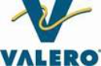

Date: November 10, 2017

From: Joe Gorder

To: Supervisors and Above – San Antonio

Subject: Important Performance Management Information

For the past year, we have been exploring alternatives to our Employee Performance Review (EPR) process. As we continue to effectively integrate our Team Valero approach into everything we do, we have determined that a one-time annual review is not an effective coaching tool to drive performance improvement and requires a tremendous amount of time, disproportionate with its value. Our business moves much too quickly today for a one-time annual review to be effective.

We believe that ongoing, real coaching that moves our business goals forward is a more effective tool to drive performance, and we believe that this approach is already happening in real time in every part of our business. For these reasons, we determined that we will no longer use the EPR, and will not replace it with an alternative “system.”

Going forward, we will continue to expect all management to be a resource for their teams, providing clear performance expectations and the coaching necessary to achieve our business objectives. We will also continue to expect all Valero team members to understand performance expectations for their roles and be accountable to their teams to always perform at or above expectations. We expect these timely performance discussions to continue following the natural cycle of work with a focus on providing meaningful performance feedback and recognition.

Your Division leadership will communicate expectations around performance management for your teams in the near term. You will have access to tools, resources and training to support our performance management strategy. We believe that this more practical approach will enhance performance in real-time, improve communication within our teams and provide greater opportunity for improvement in all aspects of our business.

I look forward to this new approach to performance management and trust that you will embrace this change.

EV 6
Supervisor Toolkit

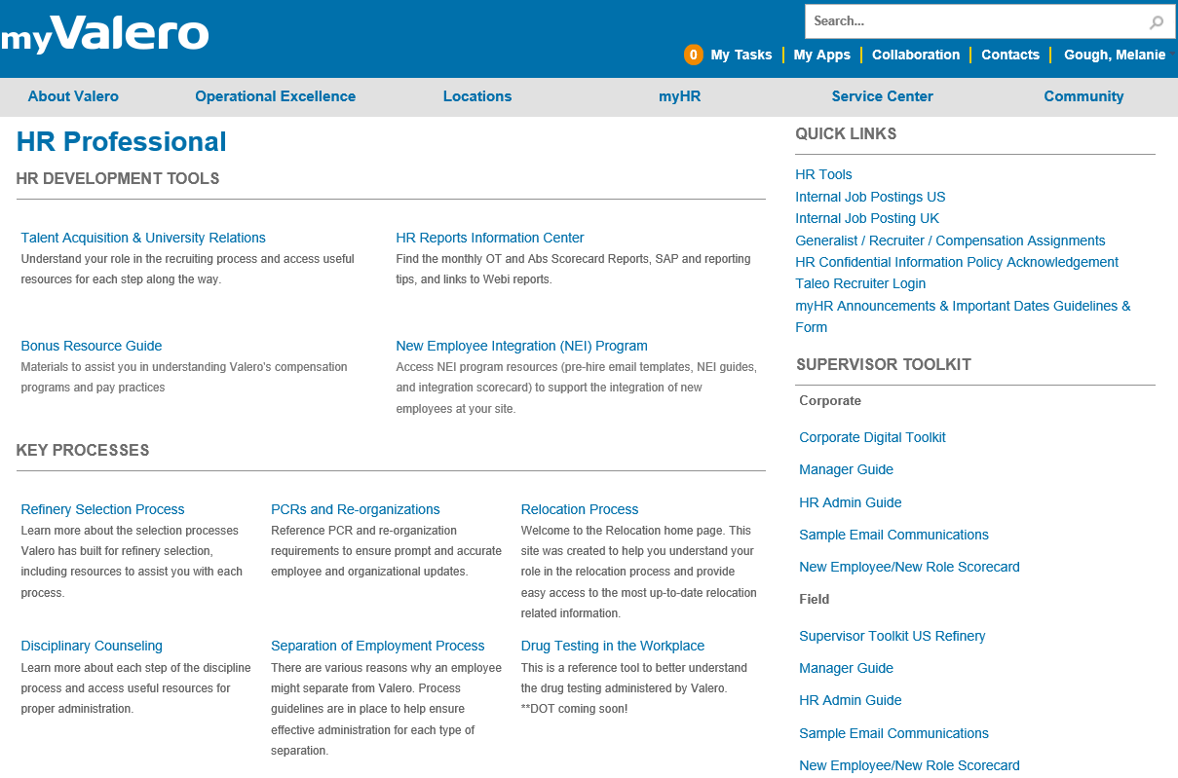

EV 7
Follow up meeting with Tracey Bryant and Jo James
23 September 2021, 13:00

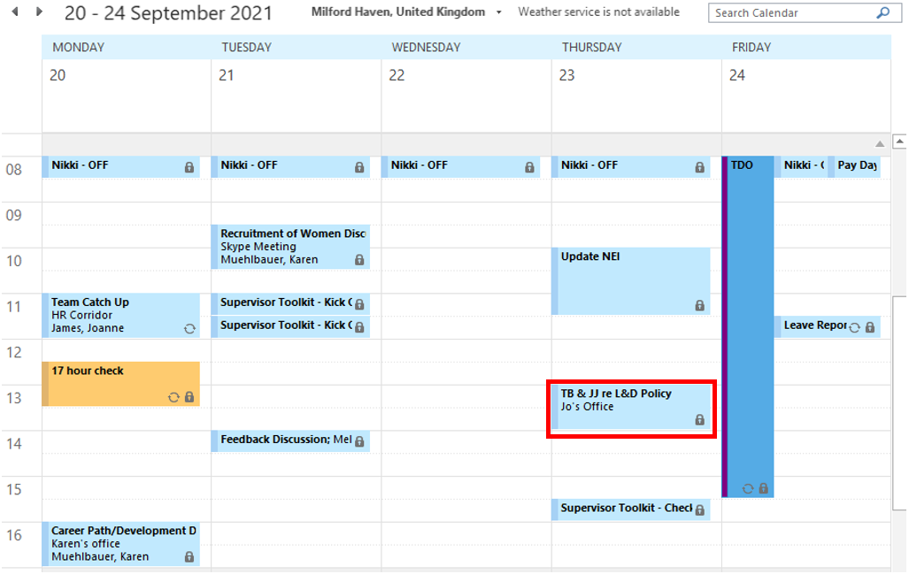

Developing a Learning and Development policy

Notes:

MG & TB discussed the development of a L&D policy relating to coaching and mentoring.

MG outlined the coaching and mentoring programmes currently in place.

TB explained that the peer mentoring arrangement currently in place for the apprentices is not working and that she intends to improve the programme before the next intake. The programme for the 2021 intake was adapted and year 1 apprentices have been 'buddied up' with year 2 apprentices.

JJ agreed that a L&D policy would be beneficial.

Action: JJ to seek endorsement from RLT to develop a L&D policy

MG discussed the request for a Women in Industry mentoring programme

Action: MG to work with TB to explore the possibility of a mentoring programme specifically for the Women in Industry group

EV 8
Special Ops Training

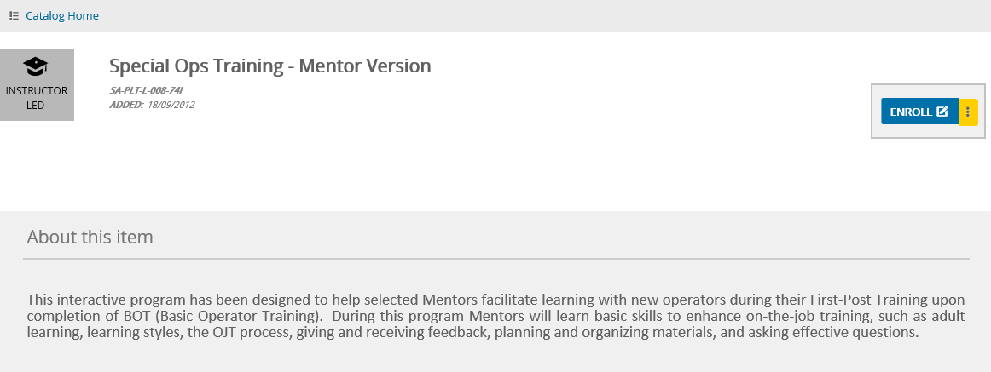

EV 9
Valero Guiding Principles

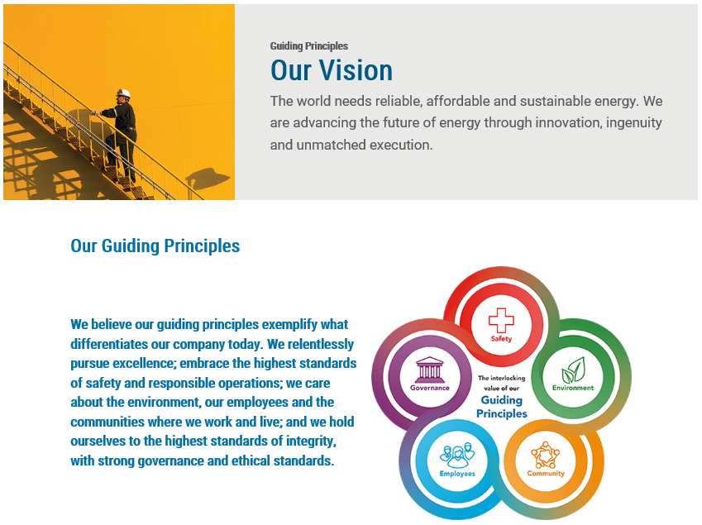
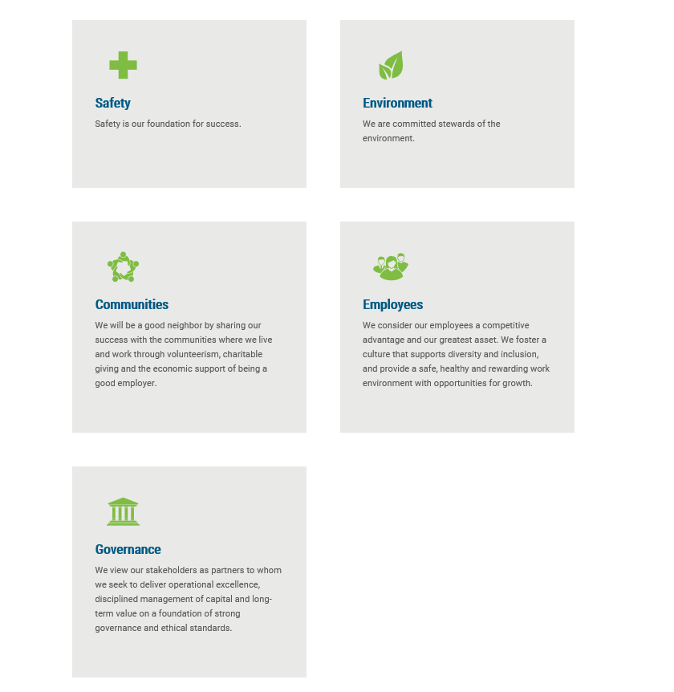

EV 10
Workforce Demographics

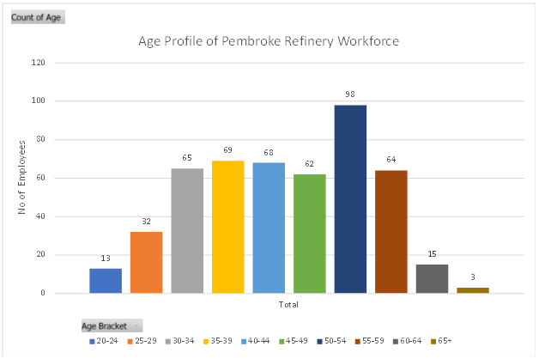

EV 11
2022 Business Plan Draft

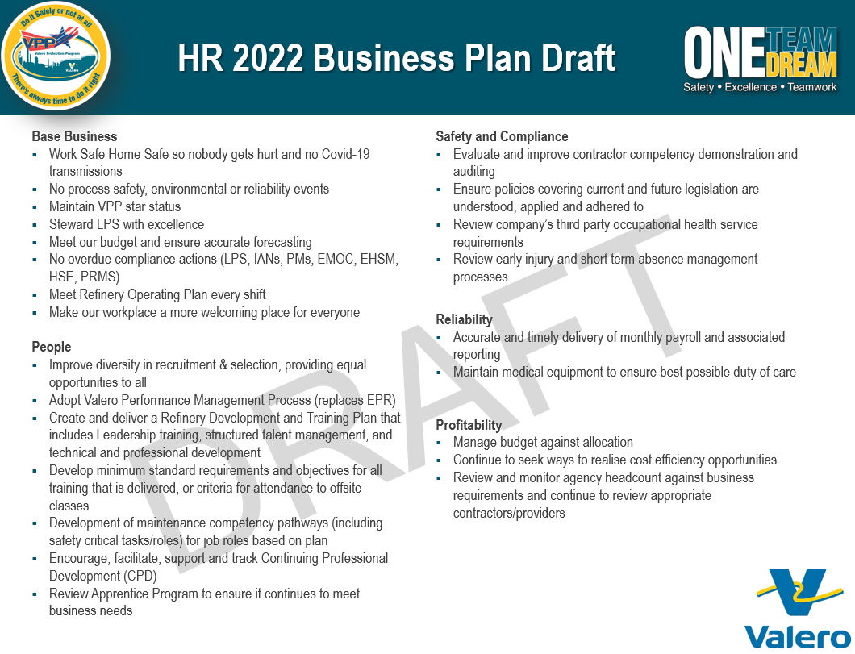

References
Behesti, N., (2019). Improve Workplace Culture With A Strong Mentoring Program. [Online]
Available at: www.forbes.com/sites/nazbeheshti/2019/01/23/improve-workplace-culture-with-a-strong-mentoring-program/
[Accessed 14 October 2021].
George, S., (2021). HR Policies. [Online]
Available at: www.cipd.co.uk/knowledge/fundamentals/people/hr/policies-factsheet#gref
[Accessed 04 October 2021].
Inclusive Employers, (2021). About Inclusive Employers. [Online]
Available at: www.inclusiveemployers.co.uk/about/about-inclusive-employers/
[Accessed 12 October 2021].
Valero, (2021). Guiding Principles. [Online]
Available at: https://www.valero.com/about/guiding-principles
[Accessed 04 October 2021].
Valero, n.d. Performance Management. [Online]
Available at: www.valero.com/en-us/Pages/Pembroke/MyHR/ManagerCenter/PerformanceManagementGuide.aspx
[Accessed 13 October 2021].
Wheatley, J., (2016). Coaching High Potentials: 4 Critical Steps. [Online]
Available at: www.linkedin.com/pulse/coaching-high-potentials-4-critical-steps-joanne-wheatley/
[Accessed 19 October 2021].

The implementation of a mentoring programme within Valero

Pembroke Refinery is a male dominated workforce, with the split of male and female employees at 90% and 10% respectively. The gender imbalance in the refining sector is significant and “while women are nearly half the workforce, they make up only 15% of the oil and gas industry”. (Mehnert, 2019) There are many initiatives to encourage females to consider careers in engineering, yet the sector remains underrepresented, therefore it is crucial to put measures in place that attract, retain and develop female employees. A LinkedIn article advises organisations that want to attract and retain female employees to “start internal mentoring and leadership programmes” (Dwyer, (2021)) as these can help women to boost their confidence and develop their leadership skills.

In September 2018 Pembroke Refinery established a ‘Women in Industry’ group at Pembroke Refinery. The group meet monthly in a ‘Lunch and Learn’ format, with a different group member presenting on pre-agreed topics of interest, such as confidence building, career development and public speaking. The group continued with remote meetings during the coronavirus pandemic (COVID-19), but then stopped between January and June 2021 due to the Cracking and Olefins turnaround. [EV 13]

At the Lunch and Learn session in July the group agreed common areas of development to be discussed at future meetings. The group was well attended, with members from across the business. There is also a wide range of experience within the group, from apprentices and undergraduates, through to senior employees. The L&D Manager suggested that a mentoring programme could help develop many of the areas that were discussed in the session, as the CIPD encourage the use of mentoring to develop and enhance “an individual’s skills, knowledge or work performance.” (Hayden, (2021))

I was asked to deliver the September Lunch and Learn session on mentoring. I agreed with my supervisor that I would deliver a short presentation to explain the role of the mentor and the benefits of being a mentee. Due to the range of experience within the group, I briefly explained the concept of reverse mentoring, where a younger or junior employee mentor’s an older or more senior employee to enhance professional development through skills and knowledge transfer. Reverse mentoring is becoming more popular, and is particularly useful where “older workers can learn from the technology-savvy younger generation”. (Personnel Today, (2016)) [EV 14]; [EV 15]

The group was encouraged to share any mentoring experiences they had. The Director of Safety / Environmental Affairs shared her experience of being mentored as an Engineer, and while a couple of other people shared their experience, it was apparent that very few had experience of a formal mentoring relationship. However, having explained how Sheryl Sandberg, Chief Operating Officer of Facebook described in her book ‘Lean-In’ that taking a moment “after a meeting or in the hall to ask advice from a respected and busy senior person”, ((2015), p. 70) is classed as mentoring, the group could relate to this as mentoring.

Overall, the session was very positive and the majority of the group showed interest in being involved in the programme. Members of the group that were interested in a mentoring programme completed a mentoring form, indicating whether they would like to ‘be a mentor’, or ‘have a mentor’. Those who would like to have a mentor, were asked to indicate any technical, professional and personal areas for development. Likewise, those who would like to be a mentor, were asked to indicate any technical, professional and personal areas of expertise. [EV 16]; [EV 17]

The mentoring forms were reviewed and mentors with mentees were connected, based on several factors, including the development needs of the mentee and the expertise of the mentor. A mentoring agreement was drafted for the mentee to complete during their initial meeting. Forbes argue that a mentoring relationship is more likely to be successful when the mentor makes the mentee accountable, boundaries are set, and goals and objectives are established, reviewed and assessed. (Kellogg, (2018)) [EV 18]

Implementing a mentoring programme required endorsement from the RLT. The HR Manager brought the proposal to the weekly RLT Meeting and highlighted the potential benefits that mentoring could bring to both the organisation and the employees. Research shows that those being mentored will benefit from enhanced skills and knowledge, meaning they will “perform better, advance in their careers faster and even experience more work-life satisfaction.” (Sharma, (2020)) making them a valuable asset. Employees are more likely to be loyal, committed, confident and motivated, which in turn could increase employee well-being, employee engagement and job satisfaction, and ultimately increase productivity and reduce staff absence and turnover. The RLT endorsed the mentoring programme for the Women in Industry group, and were also interested in extending the programme to other areas of the business in due course. [EV 19]

The majority of the connections are based on one-on-one mentoring, which is a traditional form of mentoring, which focuses on “relationship-building and individual skill-building”. (Creighton, (2018)) The mentors are more experienced or more knowledgeable and will provide advice, guidance and support to their mentees who are less experienced or less knowledgeable. The aim of the mentoring relationship is to help the mentee to develop and improve their skills, knowledge and behaviours. This is one of the more commonly used methods of mentoring, and while it is typically a long-term relationship, it can be flexible in terms of how often meetings take place.

As there were more mentees than mentors, we have a small group mentoring relationship, where the mentor will work with several mentees in a group setting. The mentor is a senior employee in the Process Engineering group, and the mentees are all Process Engineering Undergraduates who indicated very similar objectives on their form. It is common to use group mentoring “where the demand for mentors outstrips the supply”. (Clutterbuck, (2012)) There are also advantages to group mentoring in that employees can learn from each other as well as from the mentor, and they “can help keep one another on track” (Creighton, (2018)) which can also help to develop good teamwork skills and create a sense of belonging and trust amongst peers.

All mentees and mentors were contacted, informing them who they had been paired with, along with calendar invites for the initial meeting. The mentees were asked to complete a mentoring agreement at the initial meeting. [EV 18] [EV 22]

Mind Tools explain that very few people benefit from formal training in mentoring and tend to teach themselves the skills they need, and recommend using a proven technique, such as the GROW model to apply a simple yet structured approach to mentoring sessions. (Mind Tools, (2021)) As all but one of the mentors had not received any form of mentor training in the past, the L&D Manager delivered some training sessions, which covered areas such as the role of the mentor, the importance of confidentiality and the GROW model. [EV 20]; [EV 21]

The role of the mentor is to work with the mentee to encourage and support them through a development process, which requires listening skills that “improves mutual understanding, empathy, congruence and unconditional positive regard”. (Newton, (2020)) By drawing on their own learnings and experiences, the mentor will provide advice and guidance, as well as creating a positive learning experience with the personal and professional growth of the mentee at the heart of the mentoring relationship.

It is important that confidentiality is agreed before the mentoring relationship is implemented and mentors must ensure that personal data is safeguarded in compliance with the General Data Protection Regulation (GDPR). The CIPD advise establishing guidelines around “confidentiality and information flow in the implementation phase” (Hayden, (2021)) as a successful mentoring relationship is built on respect, trust and mutuality.

I worked with the L&D Manager to draft a feedback form so the mentoring programme could be evaluated. Research conducted by Reed suggests that while support for mentoring women to gain senior positions is strong, that three-quarters felt that their organisations mentoring programme was not effective. (Muller-Heyndyk, (2019)) However, The Nursing and Midwifery Council piloted an inclusive mentoring programme, following a review of its career progression data, called ‘Rising Together’. The programme is hugely successful, reporting 6 promotions as a direct result of the mentoring programme, and all mentees reporting an increase in confidence when considering applying for roles in the future This is a positive move given that research shows that “women feel they need to meet 100% of the criteria” (Ignatova, (2019)) before applying for a job, as opposed to men who apply after meeting approximately 60% of the criteria.

As part of this assignment, it was apparent that I coach and mentor people informally every day, from mentoring junior employees to coaching managers on HR policies. In August this year I coached a new supervisor through a difficult situation he had to handle. The Reliability Supervisor was new to a supervisory role, and although we are working through the Supervisor Toolkit together, the issue that was raised required immediate attention. I met with the Supervisor to explain the complaint, and spent time with him showing him relevant policies that he would need to refer to, and the main issues he needed to discuss with an employee. [EV 24]

Evidence
EV 12
Women in Industry

From: Zachary, Adeeba
Sent: 05 August 2021 07:51
To: Bryant, Tracey <Tracey.Bryant@valero.com>; Dashfield, Emily <Emily.Dashfield@valero.com>; Davies, Derryn <Derryn.Davies@valero.com>; Edwards, Katie <Katie.Edwards@valero.com>; Edwards, Laura <Laura.Edwards@valero.com>; Gough, Melanie <Melanie.Gough@valero.com>; Gwyther, Carley <Carley.Gwyther@valero.com>; John, Penny (Pembroke Refinery) <Penny.John@valero.com>; Jones, Elen <Elen.Jones@valero.com>; Jones, Holly (Contractor) <Holly.Jones@contractor.valero.com>; James, Elinor <Elinor.James@valero.com>; James, Frances <Frances.James@valero.com>; James, Joanne <Joanne.James@valero.com>; Ledwidge O'Brien, Aoife <Aoife.LedwidgeO'Brien@valero.com>; McNamara, Elizabeth <Elizabeth.McNamara@valero.com>; Merrony, Julie <Julie.Merrony@valero.com>; Muehlbauer, Karen <Karen.Muehlbauer@valero.com>; O'Brien, Jessica (Contractor) <Jessica.O'Brien@contractor.valero.com>; Omnet, Fay (Contractor) <Fay.Omnet@contractor.valero.com>; Owens, Hannah <Hannah.Owens@valero.com>; Phillips, Cerys <Cerys.Phillips@valero.com>; Preece, Rachel <Rachel.Preece@valero.com>; Raymond, Heather (Contractor) <Heather.Raymond@contractor.valero.com>; Shallcross, Bryony <Bryony.Shallcross@valero.com>; Simes, Nia (Contractor) <Nia.Simes@contractor.valero.com>; Steele, Molly (Contractor) <Molly.Steele@contractor.valero.com>; Williams, Georgia <Georgia.Williams@valero.com>; Wilson, Ellie <Ellie.Wilson@valero.com>
Subject: Women in Industry Meetings

Hi All,

Please find the updated presenter list below, the next meeting is scheduled for the Thursday 16th September.

Month | Presenter
Aug | N/A
Sep | Melanie Gough
Oct | Molly Steele
Nov | Katie Edwards
Dec | Aoife Ledwidge O'Brien
Jan | Hannah Owens

Last week I added you all to the Lean In resources, please let me know if you didn’t receive anything from them.

Following last month’s session on self-awareness, the next session lead by Mel will be on mentoring.

Group goals:

- Build Confidence
  - Communication
  - Networking
  - Self-Awareness

- Outreach/STEM
  - Presentation Skills

- Professional Development
  - Professional registration
  - Career progression
  - Professional risks

If you have any feedback on the sessions please feel free to get in contact.
Thanks again,
Adeeba

Adeeba Zachary MEng AMIMechE
Associate Inspection Engineer

Valero Energy Ltd.
Pembroke Refinery
Pembroke, Pembrokeshire, SA71 5SJ
Email: Adeeba.zachary@valero.com
Phone: 01646 649702

Registered office 27th Floor, 1 Canada Square, London E14 5AA
Place of Registration : England and Wales. Company No. 8589245

EV 13
Lunch & Learn Meeting 16/09/21 12-1pm
16 September 2021, 12:00

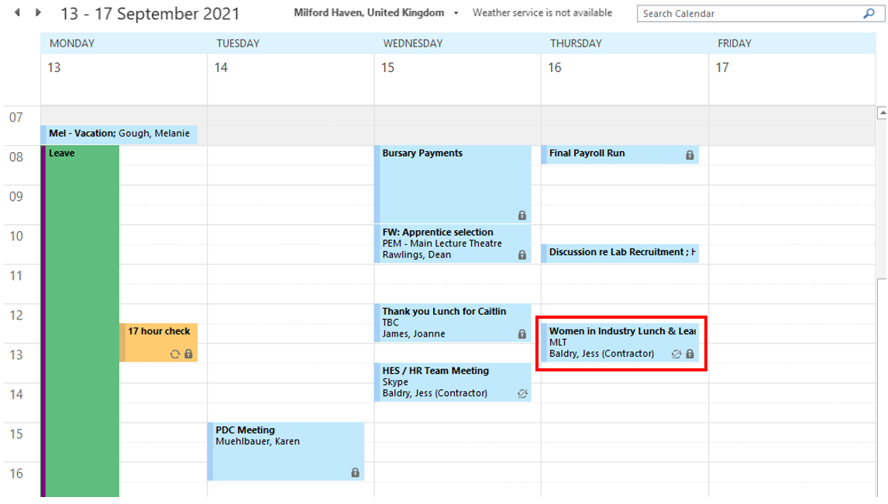

EV 14
Email with Jo James, Manager HR re Lunch & Learn session

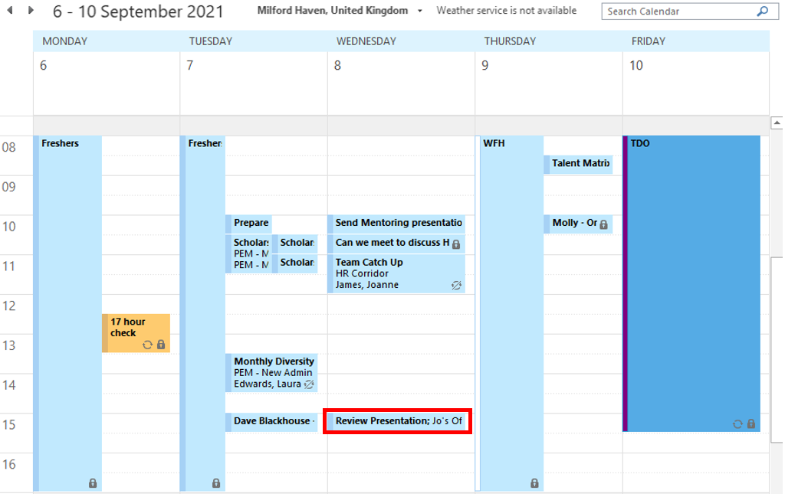

From: Gough, Melanie
Sent: 8 September 2021 10:07
To: James, Joanne <Joanne.James@valero.com>
Subject: FW: RE: Women in Industry - Mentoring Programme

Please find attached presentation for review at this afternoon's meeting

<<16 Sept Lunch & Learn - Mentoring.pptx>>

From: James, Joanne
Sent: 28 July 2021 18:01
To: Gough, Melanie <Melanie.Gough@valero.com>
Cc: Bryant, Tracey <Tracey.Bryant@valero.com>
Subject: RE: Women in Industry - Mentoring Programme

Wow, this sounds fab!!
Great idea to ask Tracey for help, I'm sure she will make time for you as you're always helping her out but let me know if there's anything I can do to help too.

Thanks, Jo

From: Gough, Melanie
Sent: 28 July 2021 14:31
To: James, Joanne <Joanne.James@valero.com>
Subject: Women in Industry - Mentoring Programme

Hi Jo

I just wanted to update you on the Lunch and Learn meeting Adeeba presented. The group have discussed setting up a mentoring programme. The discussion centred around areas of development and it was actually really interesting - where some of the members said they would benefit from development, others felt relatively comfortable in those areas (even confident - which is great!). One example is that Lizzy said she lacked confidence being a female engineer in a male dominated environment and Karen mentioned that she had felt the same early in her career in Texas, but had a Sr Engineer who mentored her, as well as Coaching from Pepper. Karen said she has mentored several junior engineers since she has been a Manager and more recently a Director, and offered to mentor Lizzy to build her confidence!

Tracey then suggested maybe we could set up a mentoring programme, which everyone was really on board with. Some were interested in being mentored, while others were happy to be the mentor. It's a shame you couldn't make it to the meeting as it was really positive and uplifting!

The topics the group have agreed to focus on over the next 12 months are:
- Self-awareness
- Confidence
- Communication
- Networking
- Presentation skills
- Professional registration
- Career progression
- Professional risks

Anyway, I am next on the list to present… Karen has asked me to pull together a short presentation for mentoring. There's no meeting in August due to so many in the group being on annual leave so I have plenty of time! I will probably ask Tracey to help if she can spare me some time.

I would also love to meet with Karen before the next Lunch & Learn to learn more about her experience of being a mentee and a mentor.

Let me know if you have any questions/suggestions. I will work on the presentation and run it by you before the meeting if that's ok?

Thanks,
Mel

EV 15
Lunch & Learn PowerPoint presentation

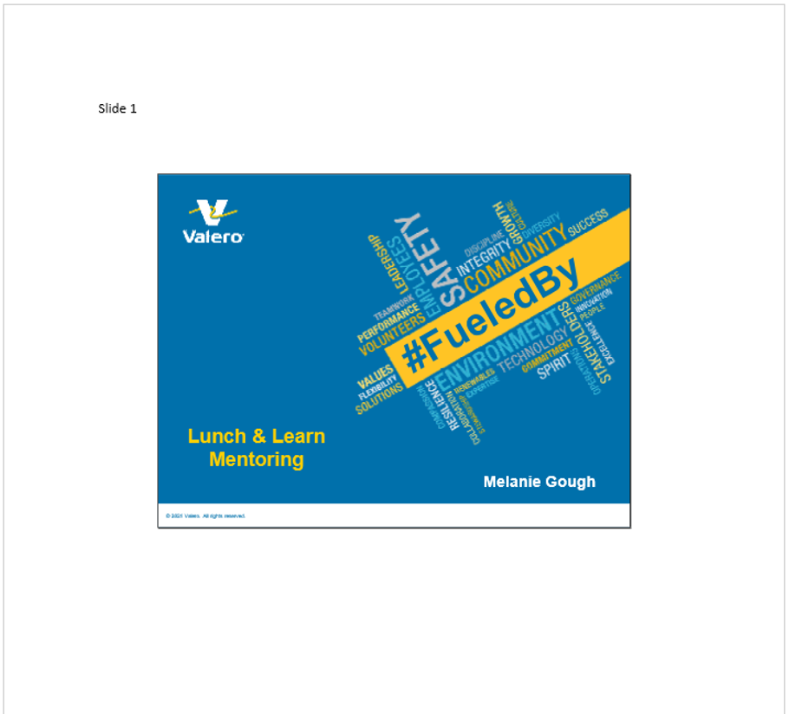
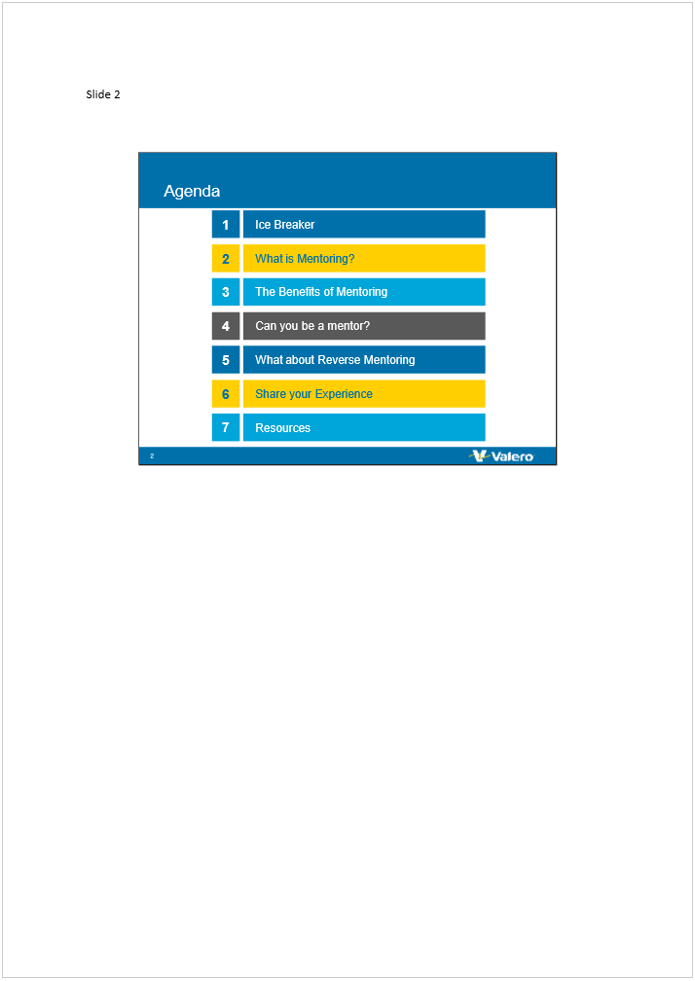

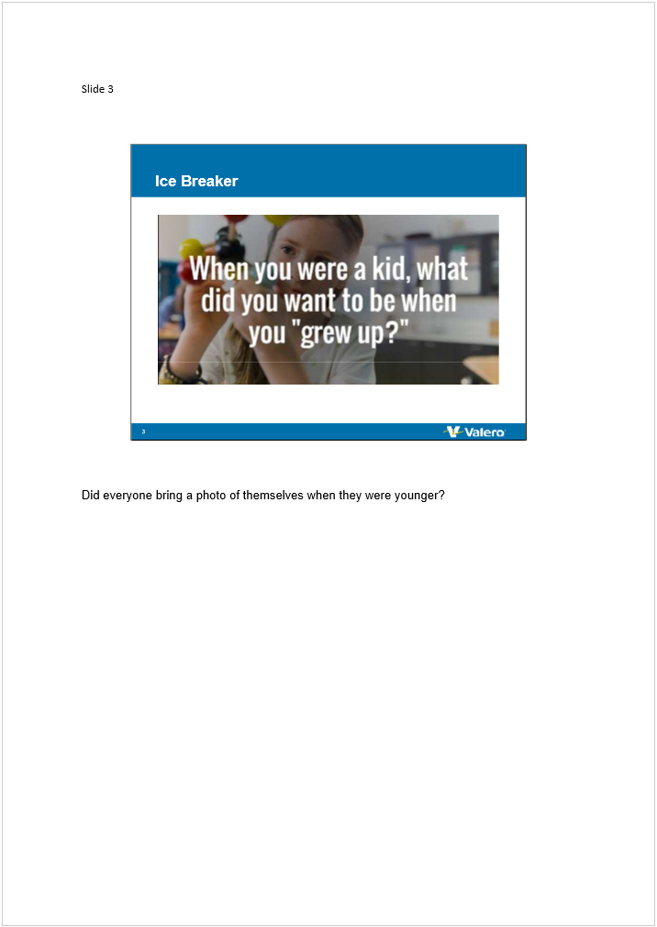

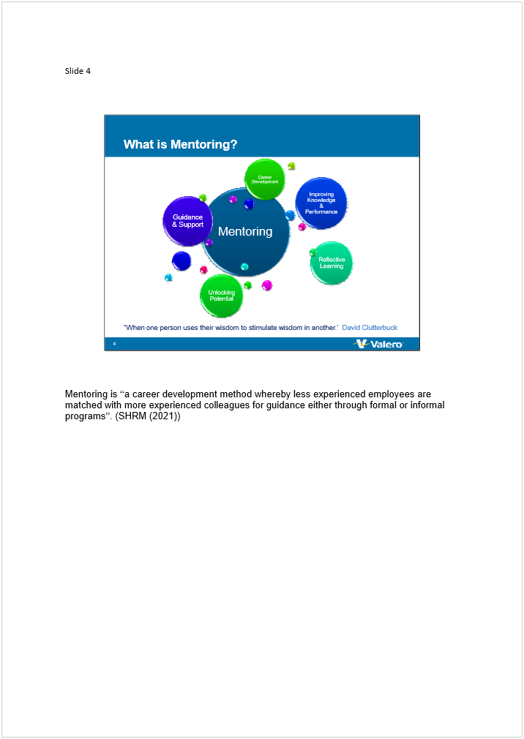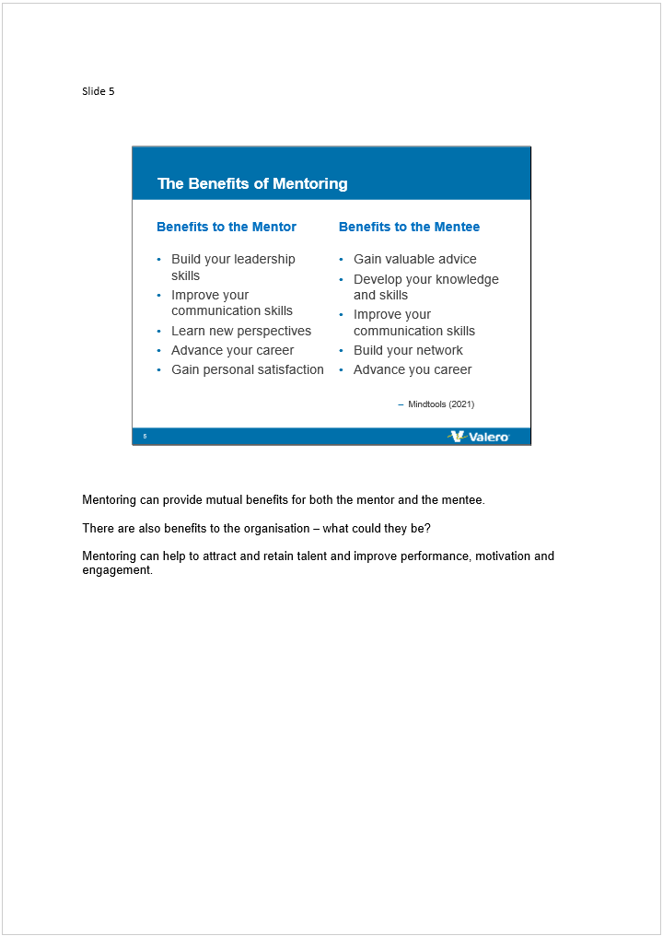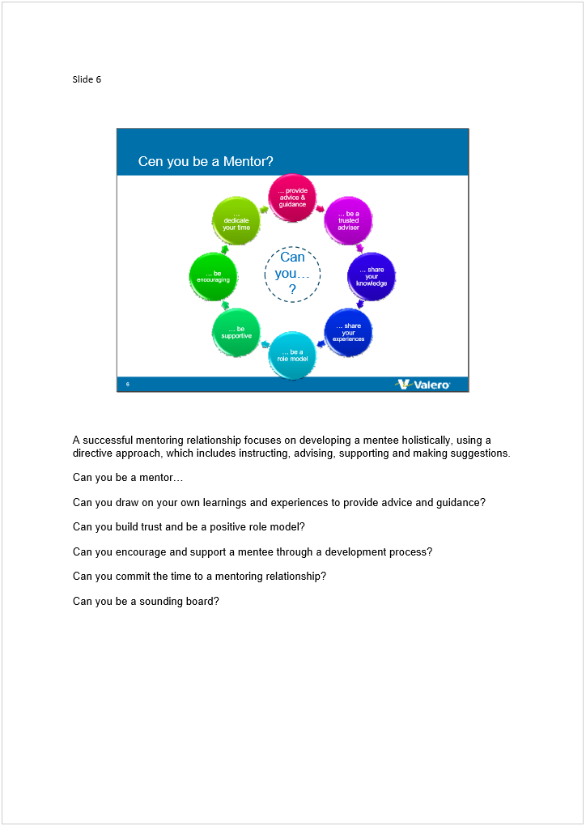

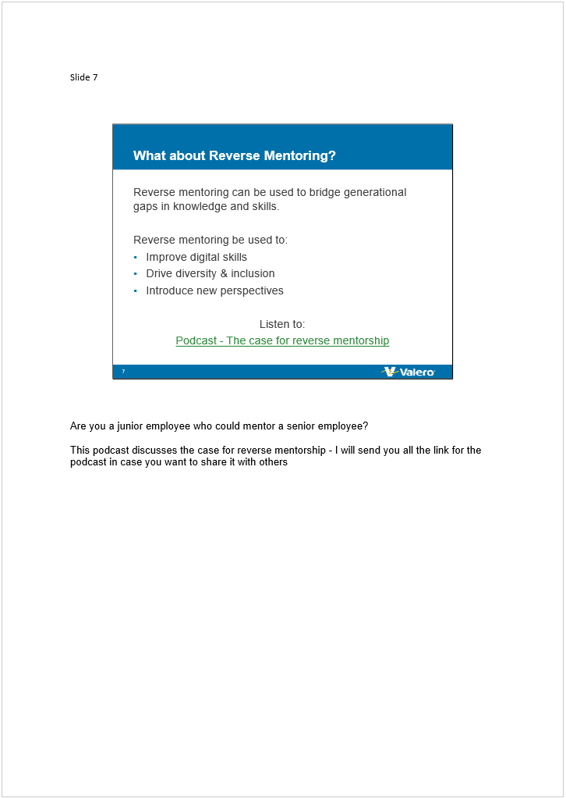

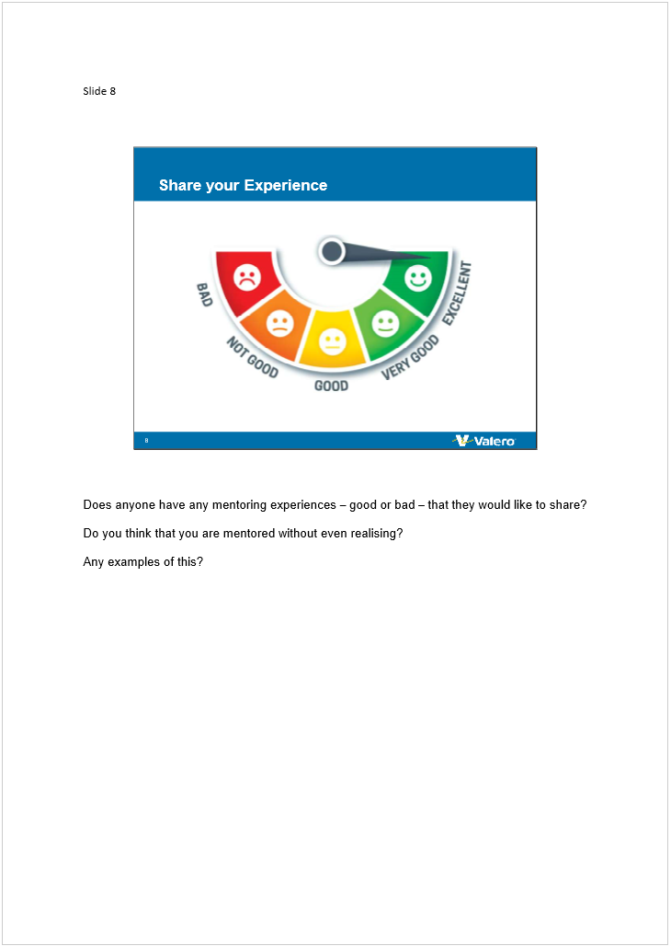

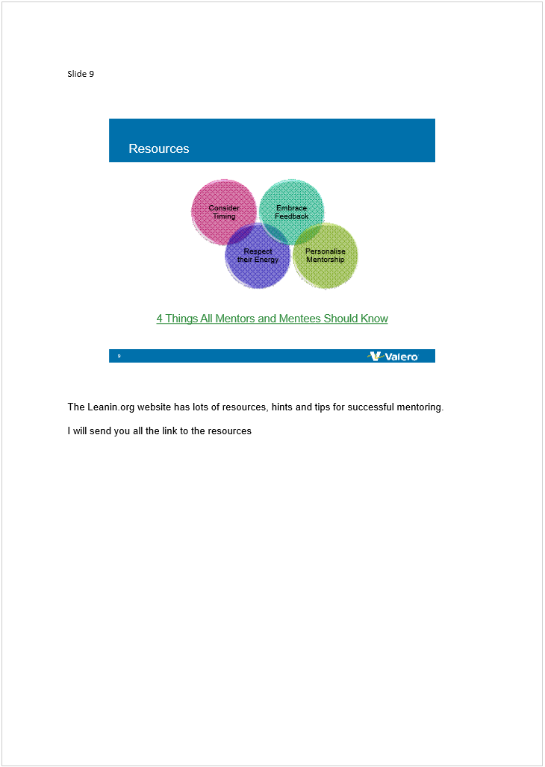

EV 16
Women in Industry: Lunch & Learn session - Mentoring

From: Gough, Melanie
Sent: 16 September 2021 16:13
To: Bryant, Tracey <Tracey.Bryant@valero.com>; Dashfield, Emily <Emily.Dashfield@valero.com>; Davies, Derryn <Derryn.Davies@valero.com>; Edwards, Katie <Katie.Edwards@valero.com>; Edwards, Laura <Laura.Edwards@valero.com>; Gough, Melanie <Melanie.Gough@valero.com>; Gwyther, Carley <Carley.Gwyther@valero.com>; John, Penny (Pembroke Refinery) <Penny.John@valero.com>; Jones, Elen <Elen.Jones@valero.com>; Jones, Holly (Contractor) <Holly.Jones@contractor.valero.com>; James, Elinor <Elinor.James@valero.com>; James, Frances <Frances.James@valero.com>; James, Joanne <Joanne.James@valero.com>; Ledwidge O'Brien, Aoife <Aoife.LedwidgeO'Brien@valero.com>; McNamara, Elizabeth <Elizabeth.McNamara@valero.com>; Merrony, Julie <Julie.Merrony@valero.com>; Muehlbauer, Karen <Karen.Muehlbauer@valero.com>; O'Brien, Jessica (Contractor) <Jessica.O'Brien@contractor.valero.com>; Omnet, Fay (Contractor) <Fay.Omnet@contractor.valero.com>; Owens, Hannah <Hannah.Owens@valero.com>; Phillips, Cerys <Cerys.Phillips@valero.com>; Preece, Rachel <Rachel.Preece@valero.com>; Raymond, Heather (Contractor) <Heather.Raymond@contractor.valero.com>; Shallcross, Bryony <Bryony.Shallcross@valero.com>; Simes, Nia (Contractor) <Nia.Simes@contractor.valero.com>; Steele, Molly (Contractor) <Molly.Steele@contractor.valero.com>; Williams, Georgia <Georgia.Williams@valero.com>; Wilson, Ellie <Ellie.Wilson@valero.com> Zachary, Adeeba <Adeeba.Zachary@valero.com>
Subject: RE: Women in Industry Lunch & Learn 16th September

Hi everyone,

Thanks to everyone who came to the session today, I thought we had some really good discussions around mentoring!

Just as a follow-up:

- Mentor scheme: I spoke briefly at the end of the session about getting endorsement from the RLT to set up a mentor programme if there is enough interest. I have linked a document below which you can fill in if you would like to be a mentor or have a mentor. Please could you aim to return the completed form to me by 23rd September. Once I have received all the forms, I will review them and match mentors and mentees based on areas of interest etc. Here is a link to the document (also attached)
V:\Women in industry\Mentor Scheme form.docx

A link to the resources we discussed today:
- https://leanin.org/tips/mentorship

- https://podcasts.apple.com/ca/podcast/the-case-for-reverse-mentorship-patrice-gordon/id470622782?i=1000523604627

Finally, if you have any feedback from today’s session or for the Women in Industry group in general, that would be a real help.

Many thanks,

Mel

<<Mentoring Agreement.docx>>

From: Gough, Melanie
Sent: 09 September 2021 13:37
To: Bryant, Tracey <Tracey.Bryant@valero.com>; Dashfield, Emily <Emily.Dashfield@valero.com>; Davies, Derryn <Derryn.Davies@valero.com>; Edwards, Katie <Katie.Edwards@valero.com>; Edwards, Laura <Laura.Edwards@valero.com>; Gough, Melanie <Melanie.Gough@valero.com>; Gwyther, Carley <Carley.Gwyther@valero.com>; John, Penny (Pembroke Refinery) <Penny.John@valero.com>; Jones, Elen <Elen.Jones@valero.com>; Jones, Holly (Contractor) <Holly.Jones@contractor.valero.com>; James, Elinor <Elinor.James@valero.com>; James, Frances <Frances.James@valero.com>; James, Joanne <Joanne.James@valero.com>; Ledwidge O'Brien, Aoife <Aoife.LedwidgeO'Brien@valero.com>; McNamara, Elizabeth <Elizabeth.McNamara@valero.com>; Merrony, Julie <Julie.Merrony@valero.com>; Muehlbauer, Karen <Karen.Muehlbauer@valero.com>; O'Brien, Jessica (Contractor) <Jessica.O'Brien@contractor.valero.com>; Omnet, Fay (Contractor) <Fay.Omnet@contractor.valero.com>; Owens, Hannah <Hannah.Owens@valero.com>; Phillips, Cerys <Cerys.Phillips@valero.com>; Preece, Rachel <Rachel.Preece@valero.com>; Raymond, Heather (Contractor) <Heather.Raymond@contractor.valero.com>; Shallcross, Bryony <Bryony.Shallcross@valero.com>; Simes, Nia (Contractor) <Nia.Simes@contractor.valero.com>; Steele, Molly (Contractor) <Molly.Steele@contractor.valero.com>; Williams, Georgia <Georgia.Williams@valero.com>; Wilson, Ellie <Ellie.Wilson@valero.com> Zachary, Adeeba <Adeeba.Zachary@valero.com>
Subject: Women in Industry Lunch & Learn 16th September

Hi everyone,

I will be running the next session for the Women in Industry Lunch & Learn next Thursday. The topic will be mentoring and mentee relationships.

For the ice breaker, please could you bring in a photo of you as a child - it doesn’t need to be a hard copy, it can just be on your phone. We’ll use these to start a discussion about ‘what did you want to be when you were younger?’ and tie into the theme of mentoring.

Hope you can all make it.

Mel

EV 17
Mentor Form

Mentoring Programme Form
Section 1: Mentor / Mentee Allocation:
Name:

Email:

Department:

I would like: To be a mentor ☐ To have a mentor ☐

SECTION 2: PLEASE COMPLETE THIS SECTION IF YOU WOULD LIKE TO HAVE A MENTOR:

I would like: a mentor from within my wider dept. ☐ or a mentor from outside my dept. ☐

Technical areas I would like to know more about/improve:

Professional development areas I would like to improve:

Any other requirements/notes you would like to add:

SECTION 3: PLEASE COMPLETE THIS SECTION IF YOU WOULD LIKE TO BE A MENTOR:

I would like: a mentee from within my wider dept. ☐ or a mentee from outside my dept. ☐

I would have time to mentor: 1 mentee ☐ 2 mentees ☐ a group of mentees ☐

Technical areas of expertise:

Professional development of expertise:

Any other requirements/notes you would like to add:

Thank you for competing this form!

EV 18
Mentoring Agreement

Mentoring Agreement Form
Mentor
Mentee
Start Date
Expected Duration
To be completed by the mentee:
What are your goals?
1.

2.

3.

4.

5.

What does success look like?
When do you want to achieve your goals by?
What is the most useful support your Mentor can provide?
How often do you and your mentor plan to meet i.e. weekly, fortnightly, monthly etc.
How will progress be recorded?

Mentee signature _______________________________ Date _____________________

Mentor signature _______________________________ Date _____________________

Date of initial meeting _______________________________

EV 19
Email from Jo James, Manager HR re endorsement from RLT

From: Gough, Melanie
Sent: 29 September 2021 18:29
To: James, Joanne <Joanne.James@valero.com>
Cc: Bryant, Tracey <Tracey.Bryant@valero.com>
Subject: FW: RE: Women in Industry - Mentoring Programme

Amazing news, thanks Jo. Let's get the Women in Industry mentoring up and running before we start to look at maintenance!

From: James, Joanne
Sent: 29 September 2021 18:07
To: Gough, Melanie <Melanie.Gough@valero.com>
Cc: Bryant, Tracey <Tracey.Bryant@valero.com>
Subject: Women in Industry Mentoring

Mel,

This is confirmation that the RLT have endorsed the mentoring programme and development of a policy for L&D, which is great news.

There was a question on the mentoring programme - would this be extended to other groups? Tony was keen to having some sort of mentoring programme for the Associate Techs, but didn’t know how this would work in reality. I said we would revisit this suggestion in time, but if you and Tracey could look into this that would be great.

Please work with Tracey in the New Year to draft the policy and then I will set up a meeting with London to work with us to get final sign off from the US.

Thanks, Jo

From: Gough, Melanie
Sent: 28 September 2021 15:57
To: James, Joanne <Joanne.James@valero.com>
Cc: Bryant, Tracey <Tracey.Bryant@valero.com>
Subject: FW: RE: Women in Industry - Mentoring Programme

Hi Jo

Further to my last email, Tracey and I have reviewed the forms received and can confirm we have:
8 mentors / 11 mentees

We have set up connections based on the mentees technical / professional needs and the mentors technical knowledge / professional experience. We also considered length of service and roles held. Some mentees requested a mentee from outside their direct department too, so we had to consider this when connecting people.

A couple of examples, to explain:

Bryony Shallcross will been connected up with Elen Jones - Bryony has expressed an interest in moving out of the lab and has always shown an interest in the Environmental team. We didn't have any volunteer mentors from the Environmental, but Elen worked in Environmental for a few years before she moved to Process Safety, so we thought this would be a good relationship.

Heather Raymond is a 2nd year instrument apprentice - Heather will been connected with Fran James as we didn't have any volunteer mentors from maintenance. Fran started with us as an instrument apprentice 15 years ago and has great experience in maintenance and HES. Fran is also currently on the Emerging Leaders programme so it would be great for her to get some experience in mentoring.

We have more mentees than mentors, so Karen has been connected with 2 (Lizzy & Ellie) and Laura Edwards has been connected with 2 (Jessica & Molly) - Interestingly Jess and Molly's development needs are similar so I will suggest to Laura maybe doing a group mentoring session.

I have attached the spreadsheet with the details of how people have been selected - please review and let me know if you want to discuss further.

Please could you take this proposal and the L&D Policy to the RLT meeting tomorrow?

Many thanks,

Mel

<<Mentors and Mentees.xlsx>>

From: Gough, Melanie
Sent: 17 September 2021 07:39
To: James, Joanne <Joanne.James@valero.com>
Cc: Bryant, Tracey <Tracey.Bryant@valero.com>
Subject: FW: RE: Women in Industry - Mentoring Programme

Ah thanks Jo, yes I think it went well - there seems to be a good deal of interest, which is pleasing. I'm quite excited now!
Tracey and I will meet the week after next to review the forms, and I will get back to you with the numbers.
Hopefully RLT will be on board - they are usually very supportive of the Women in Industry group.

Many thanks,
Mel

From: James, Joanne
Sent: 16 September 2021 17:43
To: Gough, Melanie <Melanie.Gough@valero.com>
Subject: Women in Industry Mentoring

Great session today Mel, well done!!

There seems to be a fair bit of interest in the mentoring programme, which is great. Let me know how many forms you get back - once we know how much interest there is, we can ask RLT to endorse a Women In Industry mentoring programme.

Thanks, Jo

EV 20
Email with Tracey Bryant, Manager L&D re delivering mentoring training sessions in-house

From: Gough, Melanie
Sent: 30 September 2021 12:56
To: Bryant, Tracey <Tracey.Bryant@valero.com>
Cc: James, Joanne <Joanne.James@valero.com>
Subject: RE: Coaching and Mentoring

Thanks Trace, you're a star! I'm here all day and tomorrow so pop in when you're passing or drop me an IM when you have 5 mins and I'll pop down to you.

Thanks

Mel

From: Bryant, Tracey
Sent: 30 September 2021 12:34
To: Gough, Melanie <Melanie.Gough@valero.com>
Cc: James, Joanne <Joanne.James@valero.com>
Subject: RE: Coaching and Mentoring

Hi Mel

Yes, I'm happy to provide mentoring development sessions - you know I love an opportunity to put my coach-mentor hat on!! I think this would be the best way forward for the time being, rather than exploring external training providers just yet.

It might be worth looking into VLO subscribing as a member with the EMCC - there's different member levels, but the Premium membership includes a free CPD event per year which is really good for coach mentor development.

Here's a link https://emccuk.org/Public/Join/Organisation/Public/Join/Organisation_Membership_Options.aspx?hkey=7537005d-2bfa-4c75-83cc-d81754caf369

Maybe Jo can bring it to RLT to see if there's any interest in this.

Let's catch up later this afternoon or tomorrow, just to make sure we're on the same page with the training session.

Tracey Bryant – Manager, Learning & Development
Valero Energy Ltd
Pembroke Refinery
Pembroke
Pembrokeshire
SA71 5SJ
Tel: +44 1646 649359
Mobile: 07961609607
Tracey.bryant@valero.com

From: Gough, Melanie
Sent: 30 September 2021 11:09
To: Bryant, Tracey <Tracey.Bryant@valero.com>
Subject: Coaching and Mentoring

Hi Tracey

Thank you for helping me pair the mentors with the mentees, I will send out emails shortly so everyone is aware who their mentor / mentee is. I think we have some fantastic connections, and I'm really excited to see how things develop. Anyway, I'm after some more advice from you if possible…

I spoke with Jo earlier and she mentioned training for our mentors would be a good idea - would you recommend us looking into an external training provider for mentoring or would you be able to deliver some in-house mentoring training sessions?

I don’t think it would be many sessions - we definitely need one before the initial meeting just to raise awareness of things like GDPR etc. we can then consider further meetings at a later date if we think they are necessary.

What's your thoughts? Happy to meet to discuss if easier.

Thanks,

Mel

EV 21
Email to mentors and invite to mentor training session

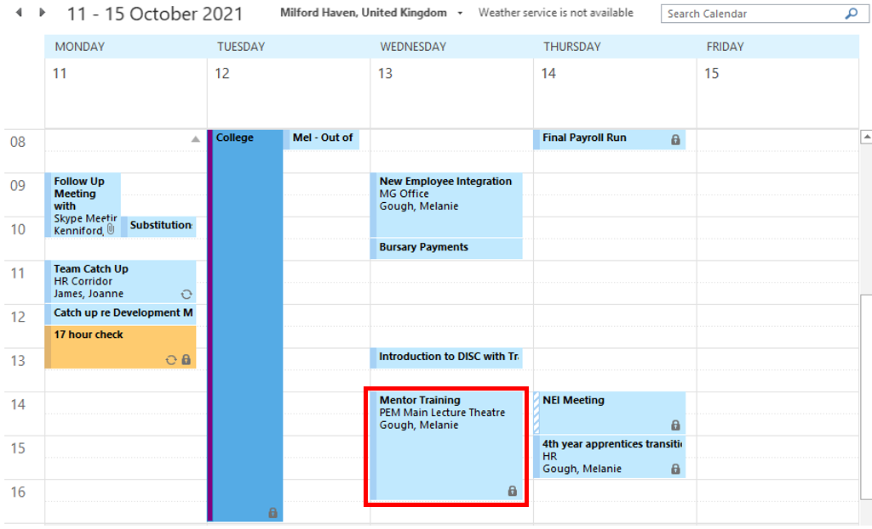

From: Gough, Melanie
Sent: 4 October 2021 10:39
To: Edwards, Katie <Katie.Edwards@valero.com>; Edwards, Laura <Laura.Edwards@valero.com>; Gwyther, Carley <Carley.Gwyther@valero.com>; John, Penny (Pembroke Refinery) <Penny.John@valero.com>; Jones, Elen <Elen.Jones@valero.com>; James, Frances <Frances.James@valero.com>; Muehlbauer, Karen <Karen.Muehlbauer@valero.com>; Preece, Rachel <Rachel.Preece@valero.com>;
Cc: James, Joanne <Joanne.James@valero.com>; Bryant, Tracey <Tracey.Bryant@valero.com>
Subject: Mentoring Training

Hi everyone

Thank you for volunteering to be a mentor. Tracey and I have reviewed the forms and I will be in touch shortly to let you know who you will be mentoring, but in the mean time we would like to invite you to a short training session on Wednesday 13th October PM.

The aim of the training is to explain:

The role of the mentor
The importance of confidentiality (GDPR)
Building trust
The GROW model (please see attached)

We hope you can all make it - I will send out a calendar invite shortly.

Many thanks,

Mel

<<GROW Model.docx>>

EV 22
Confirming mentor & mentee connections, and set up initial meetings
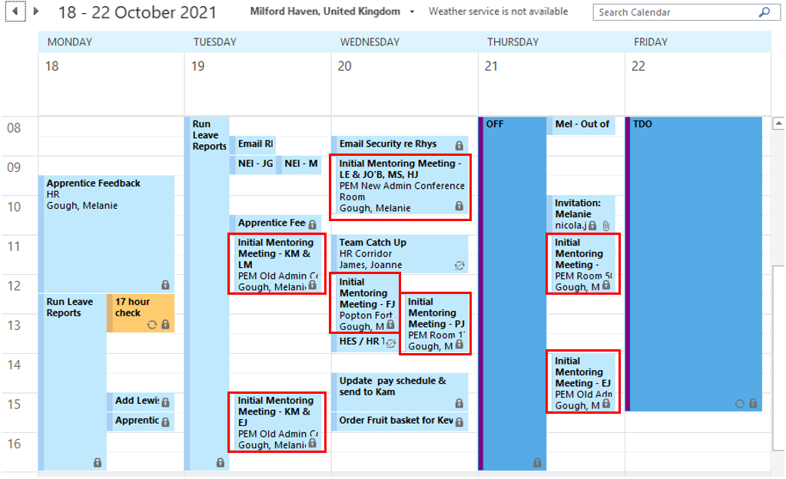

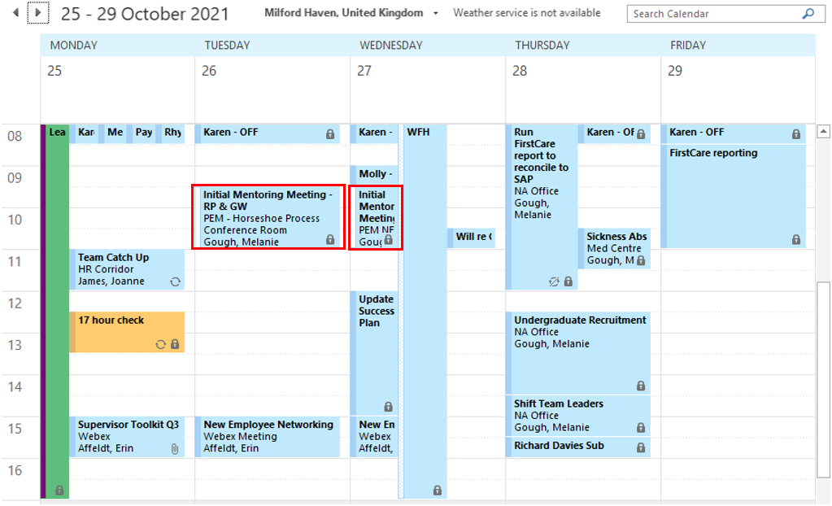

From: Muehlbauer, Karen
Sent: 5 October 2021 11:53
To: Gough, Melanie <Melanie.Gough@valero.com>
Cc: Bryant, Tracey <Tracey.Bryant@valero.com>
Subject: RE: Women in Industry - Mentoring Programme

Sounds great, thanks Mel

Karen Muehlbauer
Director Safety / Environmental Affairs

Valero Energy Ltd
Pembroke Refinery
Pembroke
Pembrokeshire SA71 5SJ
Tel +44[0]1646 649250
Mobile +44 [0] 7786 684404

Registered in England and Wales (reg. number 8566216), Registered Office: 27th Floor, 1 Canada Square, Canary Wharf, London, E14 5AA.

This message may contain confidential information and is intended only for the use of the parties to whom it is addressed. If you are not an intended recipient, you are hereby notified that any disclosure, copying, distribution or use of any information in this message is strictly prohibited. If you have received this message in error, please notify me immediately at the telephone number indicated above.

From: Gough, Melanie
Sent: 5 October 2021 11:22
To: Muehlbauer, Karen <Karen.Muehlbauer@valero.com>
Cc: Bryant, Tracey <Tracey.Bryant@valero.com>
Subject: Women in Industry - Mentoring Programme

Hi Karen

How are you?

Thank you for agreeing to be a mentor. I am pleased to confirm that you have been selected to mentor Lizzy McNamara and Ellie James. Please find attached their mentor forms that

Your initial meetings have been scheduled for:

Lizzy - 19/10/21 at 11:00 hours
Ellie - 19/10/21 at 15:00 hours

I will send the calendar invite's once I've made contact with Lizzy and Ellie.

If there's anything you need in the meantime, please don't hesitate to get in touch with me or Tracey.

Kind regards,

Mel

<<Mentor Form Lizzy McNamara.docx>>
<<Mentor Form Ellie James.docx>>

From: McNamara, Elizabeth
Sent: 5 October 2021 16:09
To: Gough, Melanie <Elizabeth.McNamara@valero.com>
Cc: Muehlbauer, Karen <Karen.Muehlbauer@valero.com>; Bryant, Tracey <Tracey.Bryant@valero.com>
Subject: RE: Women in Industry - Mentoring Programme

Thanks Mel, looking forward to it!
Lizzy

From: Gough, Melanie
Sent: 4 October 2021 14:31
To: McNamara, Elizabeth <Elizabeth.McNamara@valero.com>
Cc: Muehlbauer, Karen <Karen.Muehlbauer@valero.com>; Bryant, Tracey <Tracey.Bryant@valero.com>
Subject: Women in Industry - Mentoring Programme

Hi Lizzy

How are you?

Thank you for submitting your mentor form. I am pleased to confirm that Karen Muehlbauer will be your mentor.

Your initial meeting has been scheduled for 19/10/21 at 11:00 hours - I will send the calendar invite shortly.

In the meantime, please find attached a mentoring agreement - please could you bring this along to your first meeting and complete it with Karen.

If you have any questions at all before your meeting, please do get in touch with me or Tracey.

Kind regards,
Mel

<<Mentoring Agreement.docx>>

EV 23
Mentor Evaluation Form

Mentoring Evaluation Form
Mentor
Mentee
Start Date
Expected End Date

 | Strongly Disagree | Disagree | Neither Agree nor Disagree | Agree | Strongly Agree

EV 24
Email from Jamie Chesmer

From: Chesmer, Jamie
Sent: 18 August 2021 14:50
To: Gough, Melanie <Melanie.Gough@valero.com>
Subject: Thanks

Hi Mel, thanks for coaching me through the recent issues. It’s something I hope I never have to deal with again, but I now know how to approach any situations such as this in the future.

Regards

Jamie Chesmer CEng MIMechE

Valero Energy Ltd
Pembroke Refinery
Pembrokeshire
SA71 5SJ
Tel +44(0) 1646 649 232
jamie.chesmer@valero.com

Valero Energy Ltd. Fifth Floor, 100 Wood Street, London EC2V 7EX. Place of Registration: England and Wales. Company No. 8566216

This message may contain confidential information and is intended only for the use of the parties to whom it is addressed. If you are not an intended recipient, you are hereby notified that any disclosure, copying, distribution or use of any information in this message is strictly prohibited. If you have received this message in error, please notify me immediately at the telephone number indicated above.

From: Chesmer, Jamie
Sent: 12 August 2021 14:50
To: Gough, Melanie <Melanie.Gough@valero.com>
Subject: RE: FW: Private and Confidential

Hi Mel, will pop up tomorrow PM.

Regards

Jamie Chesmer CEng MIMechE

Valero Energy Ltd
Pembroke Refinery
Pembrokeshire
SA71 5SJ
Tel +44(0) 1646 649 232
jamie.chesmer@valero.com

Valero Energy Ltd. Fifth Floor, 100 Wood Street, London EC2V 7EX. Place of Registration: England and Wales. Company No. 8566216

This message may contain confidential information and is intended only for the use of the parties to whom it is addressed. If you are not an intended recipient, you are hereby notified that any disclosure, copying, distribution or use of any information in this message is strictly prohibited. If you have received this message in error, please notify me immediately at the telephone number indicated above.

From: Gough, Melanie
Sent: 11 August 2021 16:58
To: Chesmer, Jamie <Jamie.Chesmer@valero.com>
Cc: James, Joanne <Joanne.James@valero.com >
Subject: FW: Private and Confidential

Hi Jamie

Just following up to see how you got on with Dave. Can you pop and see me in the next day or so to update me?

Many thanks

Mel

From: Gough, Melanie
Sent: 26 July 2021 17:13
To: Chesmer, Jamie <Jamie.Chesmer@valero.com>
Cc: James, Joanne <Joanne.James@valero.com>
Subject: Private and Confidential

Hi Jamie

Both Adeeba and Raya have now forwarded me their statements and these will be with you shortly. It is concerning to see in Adeeba’s statement that she makes reference to this having already been brought up with Dave previously when she was on year placement with us.

Adeeba is feeling uncomfortable with including her name and would prefer for this to be discussed generically with Dave. I am going to follow up with her on this as the likelihood is Dave will work out who has made the complaints, even if they are discussed generically. Raya has now finished her placement and returned home ready for University. They have also requested that this is progressed informally in the first instance, which is appropriate in accordance with the attached grievance policy (see highlighted section). However, if there is any repeat of this type of allegation against Dave, I would recommend that the formal process is invoked and Dave needs to be made aware of the seriousness of this.

As we discussed last week, the recommendation would be to have a chat with Adeeba, and then have a 1:1 with Dave (a record of the discussion can be written up in advance to guide you or afterwards if you are clear in what you are saying). This will need to cover:

- The nature of the allegations/comments that have been made against Dave and how the way he has allegedly acted has made people feel;
- If Dave can recall doing any of this and the reason why he did this;
- How the alleged behaviour is entirely inappropriate and against a number of policies, including Anti-Harassment and Equal Opportunities (attached with highlighted sections for your reference). That these are allegations of behaviour that could also be classified as gross misconduct under the Disciplinary Procedure (attached and highlighted);
- That the complainants did not want this to be progressed formally at this stage, but that if you (Jamie) become aware of any other allegations of this nature the formal Disciplinary Procedure will be instigated.
- Ask Dave for his plan on how he will move forward.

If you need any further help on this, please don’t hesitate to call me or Jo.

Many thanks

Mel

References
Behesti, N., (2019). Improve Workplace Culture With A Strong Mentoring Program. [Online]
Available at: www.forbes.com/sites/nazbeheshti/2019/01/23/improve-workplace-culture-with-a-strong-mentoring-program/
[Accessed 14 October 2021].
Clutterbuck, D., (2012). Group mentoring. [Online]
Available at: https://davidclutterbuckpartnership.com/group-mentoring/
[Accessed 10 October 2021].
Creighton, K., (2018). 6 Types of Effective Mentorship Programs and When to Use Them. [Online]
Available at: https://hrdailyadvisor.blr.com/2018/04/16/6-types-effective-mentorship-programs-use/
[Accessed 10 October 2021].
Dwyer, S., (2021). What Women Want - 10 ways to Attract and Retain Female Talent in 2021. [Online]
Available at: https://ie.linkedin.com/in/susan-dwyer-10977244?trk=pulse-article_main-author-card
[Accessed 5 October 2021].
George, S., (2021). HR Policies. [Online]
Available at: www.cipd.co.uk/knowledge/fundamentals/people/hr/policies-factsheet#gref
[Accessed 04 October 2021].
Hayden, D., (2021). Coaching and mentoring. [Online]
Available at: www.cipd.co.uk/knowledge/fundamentals/people/development/coaching-mentoring-factsheet#6995
[Accessed 9 October 2021].
Ignatova, M., (2019). New Report: Women Apply to Fewer Jobs Than Men, But Are More Likely to Get Hired. [Online]
Available at: www.linkedin.com/business/talent/blog/talent-acquisition/how-women-find-jobs-gender-report
[Accessed 11 October 2021].
Inclusive Employers, (2021). About Inclusive Employers. [Online]
Available at: www.inclusiveemployers.co.uk/about/about-inclusive-employers/
[Accessed 12 October 2021].
Kellogg, R., (2018). The Magic Of Mentorship: How And Where To Find Your Match. [Online]
Available at: www.forbes.com/sites/forbeshumanresourcescouncil/2018/10/09/the-magic-of-mentorship-how-and-where-to-find-your-match/?sh=4e9d9ce12e77
[Accessed 7 October 2021].
Mind Tools, (2021). The GROW Model of Coaching and Mentoring. [Online]
Available at: www.mindtools.com/pages/article/newLDR_89.htm
[Accessed 8 October 2021].
Muller-Heyndyk, R., (2019). Firms failing on women in leadership mentoring. [Online]
Available at: www.hrmagazine.co.uk/content/news/firms-failing-on-women-in-leadership-mentoring
[Accessed 5 October 2021].
Newton, R., (2020). Why We Need Coaches And Mentors In Business Today More Than Ever. [Online]
Available at: www.forbes.com/sites/rebeccanewton/2020/07/15/why-we-need-coaches-and-mentors-in-business-today-more-than-ever/
[Accessed 11 October 2021].
Personnel Today, (2016). Can reverse mentoring unite the multi-generational workplace?. [Online]
Available at: www.personneltoday.com/hr/can-reverse-mentoring-unite-multi-generational-workplace/
[Accessed 10 October 2021].
Sandberg, S., (2015). Lean In: Women, Work, and the Will to Lead. 1st ed. London: WH Allen.
Sharma, S., (2020). The importance of mentoring through a crisis. [Online]
Available at: www.peoplemanagement.co.uk/voices/comment/the-importance-of-mentoring-through-a-crisis
[Accessed 15 October 2021].
Valero, (2021). Guiding Principles. [Online]
Available at: https://www.valero.com/about/guiding-principles
[Accessed 04 October 2021].
Valero, n.d. Performance Management. [Online]
Available at: www.valero.com/en-us/Pages/Pembroke/MyHR/ManagerCenter/PerformanceManagementGuide.aspx
[Accessed 13 October 2021].
Wheatley, J., (2016). Coaching High Potentials: 4 Critical Steps. [Online]
Available at: www.linkedin.com/pulse/coaching-high-potentials-4-critical-steps-joanne-wheatley/
[Accessed 19 October 2021].

