10min Taster Session -
Introduction to Web Graphics
Personalised Super Logo
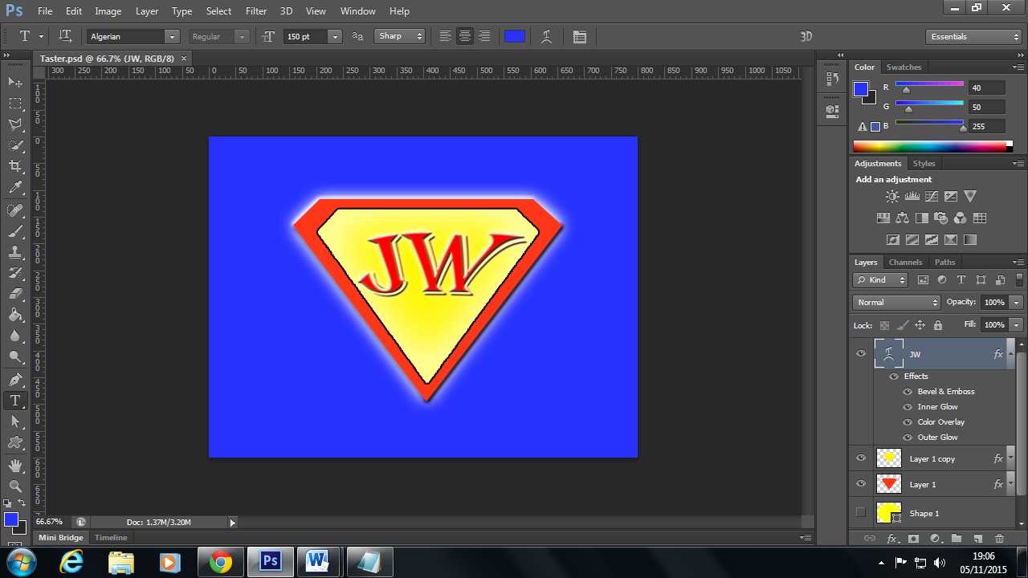
Notes - Alternate version: Duplicate outer shape, reduce size, rasterize and cut-out smaller shape from center. Also increase Opacity on Outer Glow on the Outer-shape layer for SUPER effect ;-).
Key stages:
- New document: 800 x 600 pixels.
- Turn Ruler on.
- Set Guides (lines) to ensure graphic proportions are correct.
- Pen Tool: Draw outline shape.
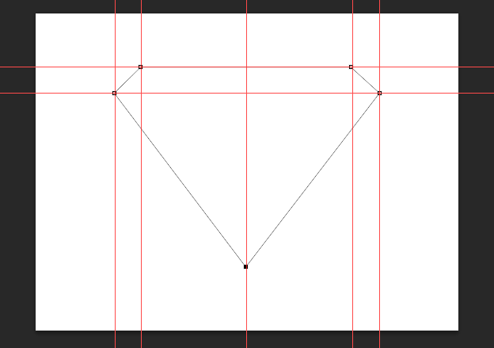
- Turn Guides Off: View > Show > Guides.
- Layers > Paths tab > Load Path as Selection.
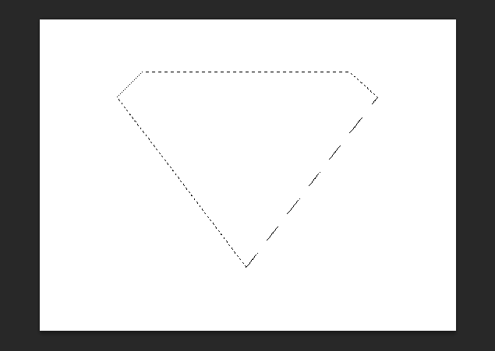
- Save Selection.
- Fill with Colour: Paint bucket Tool.

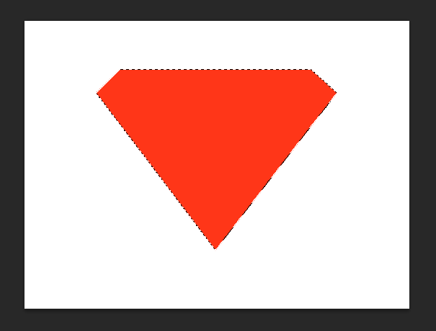
- Select > De-select.
- Duplicate Layer.
- Fill with different Colour: Paint bucket Tool.
- Reduce size of duplicated shape: Edit > Free Transform.
- Background Colour: Double click layer and Fill using Paint bucket.

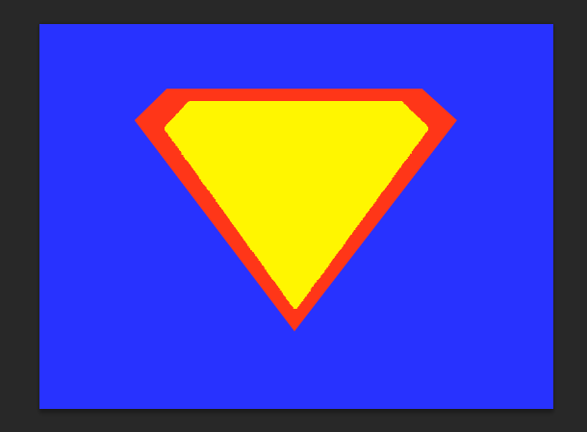
- Add fx to outer shape: Outer Bevel & Outer Glow.
- Add fx to inner shape: Inner Glow and Stroke.
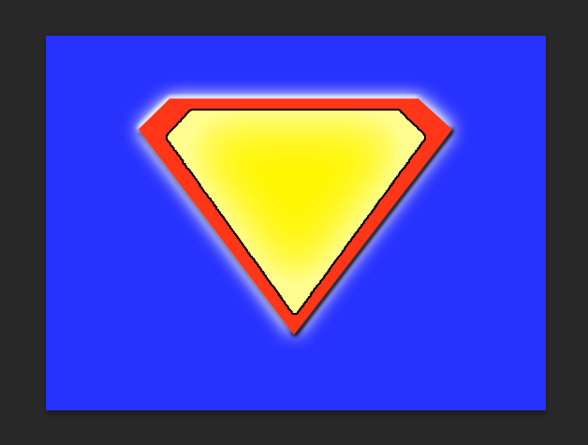
- Add your initials: Type Tool (Font: Algerian, 150px + Warped text tool: Shell Upper).
- Add fx to your text: Bevel Emboss, Inner Glow, Color Overlay, Outer Glow.

