Name: Paul Richards

Student No: 0251968

Course: Applied Computer Networks and Cybersecurity

Module: Academic and Employability Skills (ACCA4016)

Date: 24/07/2019

Table of Contents
Abstract 4
Section 1:Personal Statement and Presentation 5
Brief Overview of Self 5
Personality 5
Presentation 5
What Is Required for a Successful Presentation 7
How I Could Improve Future Presentations 7
Section 2: Research into Skills Evaluation 8
Higher Education Key Skills 8
Employment Personnel Skills 10
Skills Evaluation 12
Personality Type 12
Strengths and Weaknesses 15
Suitable Career Suggestions 16
Section 3: Action Plans 18
Long Term and Short Term Goals 18
Section 4:Application 24
Backing Up Data 24
Time Management and Self-Organisation 25
E-Portfolio 26
Section 5: Evaluation 27
Appendix A 29
1. Introduction 32
2. Trojans and Viruses 33
2.1 General overview 33
2.2 How they infect your computer 33
3. Ransomware 34
3.1 General overview 34
3.2 What to do if infected 34
4. The Crypto wall Trojan 38
4.1 Specifics of this threat 38
4.1.1 Infection methods 39
4.1.2 File types affected 39
4.2 Procedures of eradication 41
4.3 Payment 41
5. Examples of good practice 42
5.1 Initial avoidance 42
5.2 Backup procedures 42
Appendix B 44
Bibliography 50

Abstract

The report focuses on the following areas:

- Presentations - What is needed to give a successful presentation.

- Academic and Employment skills - What skills are needed to be successfully in education and employment.

- Personality types - I will be carrying out a JUNG personality test to evaluate my personality type and to help assess my strengths and weaknesses.

- Career types - I will be carrying out career tests to see what career is best suited to me.

- Long term and short-term goals - I will be setting long term and short term goals for myself, then using SMART and action plans to break down the long term goals to short term goals, this will help me achieve my long term goals.

- Backing up data and recovering data in disaster recovery scenario.

- Setting up strategies to manage my time better.

- Organising my data by creating a E-Portfolio.

Section 1:Personal Statement and Presentation

Brief Overview of Self

I was born in Llanelli, Carmarthenshire in 1977, and I am now living in Birchgrove, Swansea. I currently work within Dyfed Powys Police as an ICT Technician. My hobbies include running, DIY projects and experimenting/learning about new gadgets.

Personality

I am friendly, approachable and organised. I am also hard working and flexible. My weaknesses include over-thinking situations, being demanding on occasions, and lack of empathy towards others.

Presentation

Below are 4 screengrabs from my presentation.
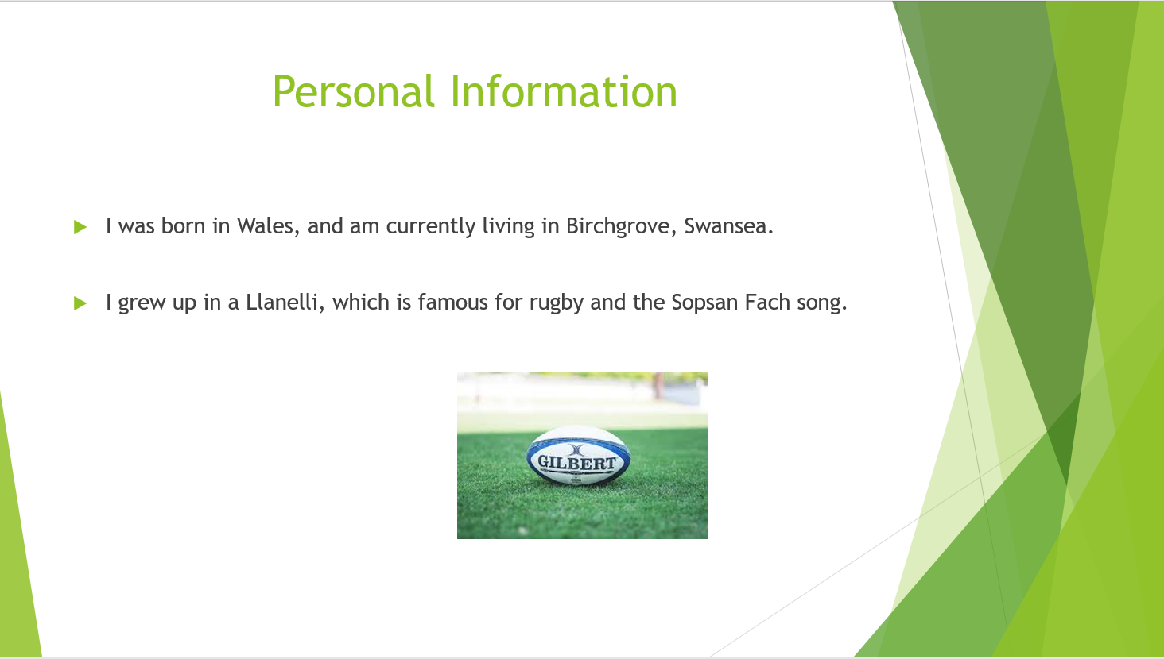

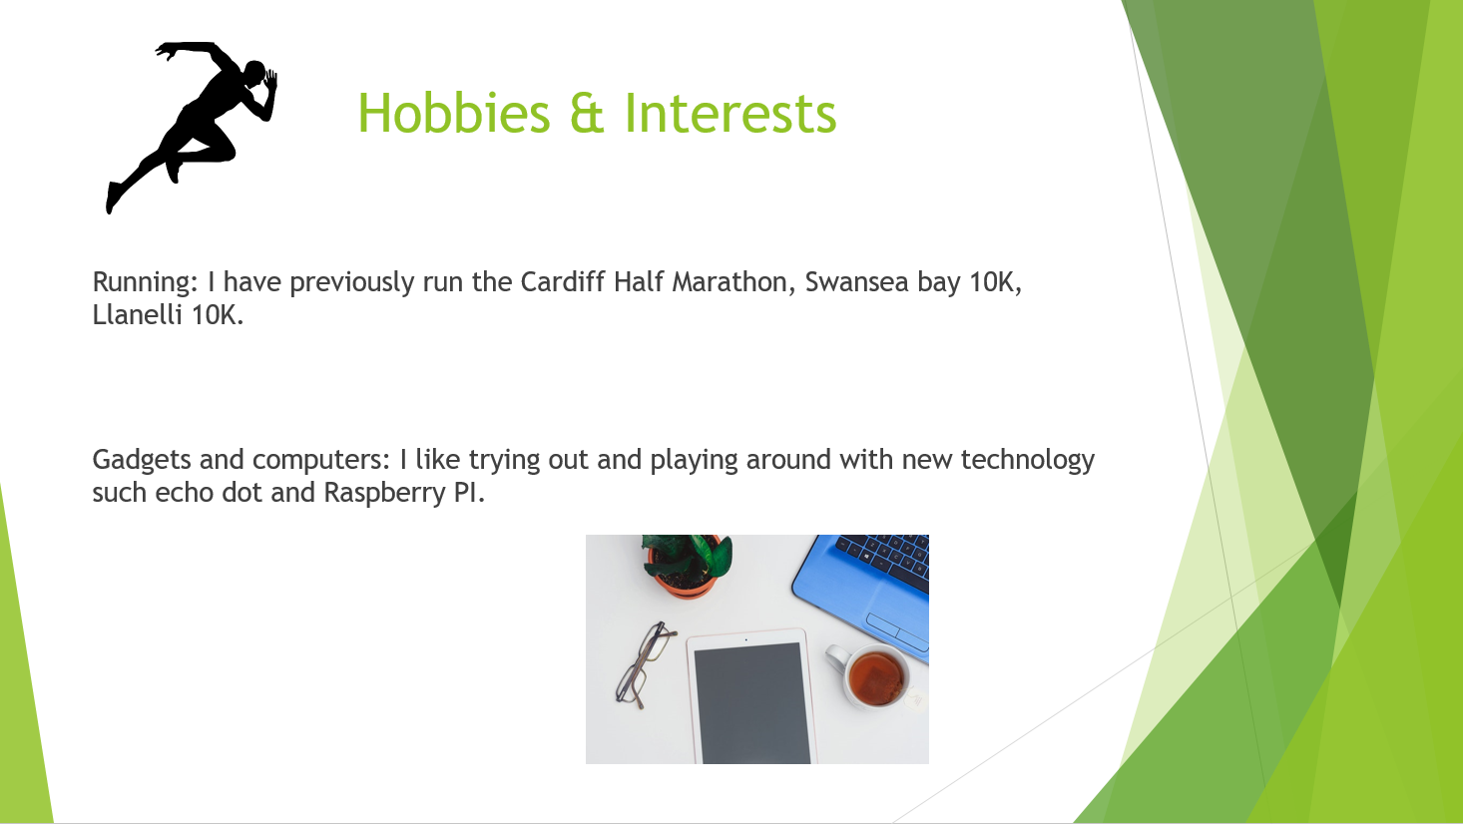
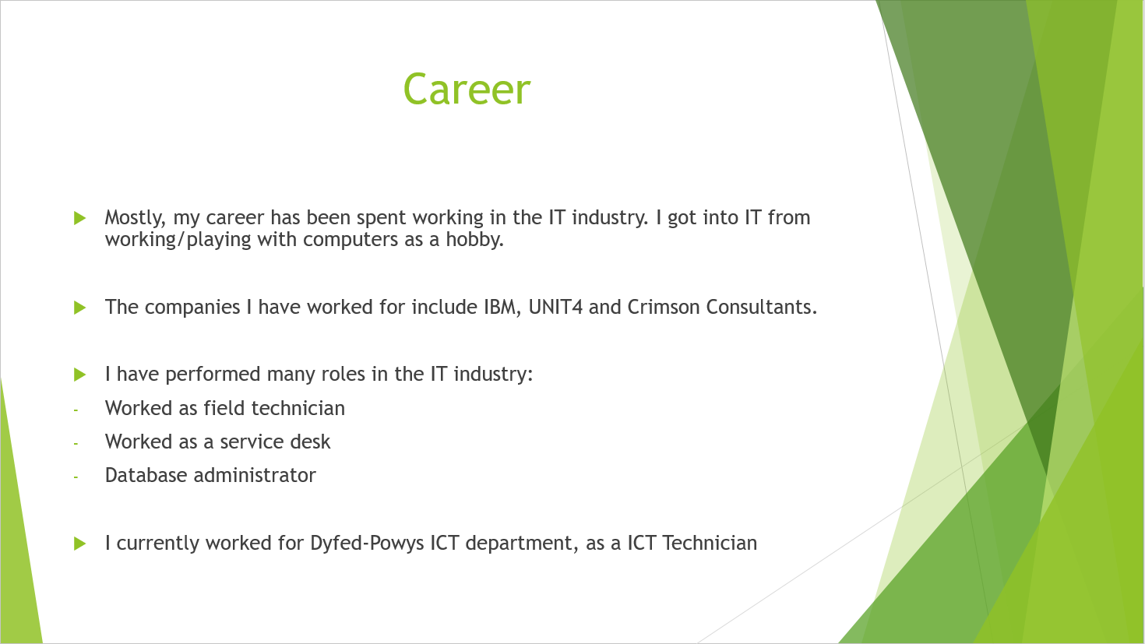

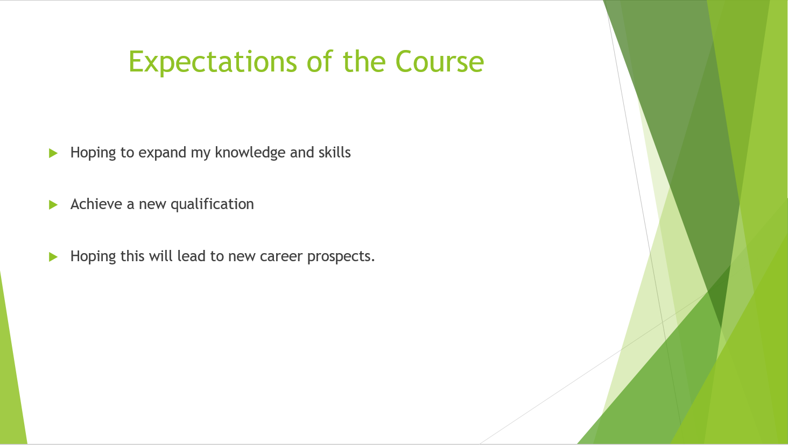

What Is Required for a Successful Presentation

Following my presentation, I learned that having too many special effects in the presentation can sometimes have a negatively effect on the flow of information. It is better to keep the presentation as simple as possible. This leads to a smoother presentation.
Using images can keep the attention of an audience, as it makes the presentation more visually attractive and stimulating. Also, using images that are relevant to the subject, can make information more memorable to the audience and more interesting to them.
Test the presentation in the room that you will be giving the presentation, to make sure that the equipment works efficiently, e.g. checking if people are able to see the presentation from the back of the room, or is the equipment running too slow, this could affect the timing of your presentation etc. Also, testing the presentation with colleagues/family before the intended audience, to make sure that there are no errors or mistakes.

How I Could Improve Future Presentations

Based on my experience of conducting the presentation, I will avoid using so many special effects, as this can effected timing. I also learnt that images sometimes convey more information that words, and greater usage of images can help with the presentation. Testing the presentation in the room I will be conducting the presentation will help identify and fix issues ahead of time.
Also, I will avoid reading verbatim from the slides, and I try developing my own dialogue to avoid making the presentation becoming dull and repetitive.

Section 2: Research into Skills Evaluation

Higher Education Key Skills

According to the signup genius website [1], the following academic skills are important to succeed in higher education:
- Time management - Managing your time effectively. Ensuring that assignments are completed on time, and ensuring sufficient time is allocated for study outside of lectures. One example is to set up a schedule or calendar to allocate slots for study, or using electronic aids, such as a computer or phone to create a calendar that can assist with managing your time effectively. Also ensuring that you turn up to lectures on time. Make sure you turn up to exams on time, so you have sufficient time to complete the exam.

- Goal management - Set manageable daily goals and try to keep to them. This will help break up larger assignments, and will help keep morale high.

- Health management - Looking after oneself. Regular exercise, scheduled rest times, healthy eating and sleep are vital. A healthy student tends to perform better than unhealthy student.

- Organisation - Keep your course notes and work in order. Make sure that you have a clean and organised workspace when studying. Ensure that you have all the equipment you need for lectures, e.g. notebook, pen etc. this will make it easy to follow the lecture.

- Team work - Set up study groups with your fellow students. This will help when working on assignments and preparing for exams. Regularly holding meetings to make sure everyone is on the same page. The genius website provides an online tool to help you organise regular times for study groups to meet up. See the following link about setting up study groups through the signup genius website:

https://www.signupgenius.com/go/4090d4dadaa2aa31-study

- Financial management - A lot of students will be living away from home and will have to manage their own bills, such as rent, food etc. You do not want to be running out of money half way through an academic year. Setup a budget and try to adhere to the budget. Make sure you check what you are spending money on by keeping receipts and comparing them with the money in your bank account, so you can monitor your finances effectively.

- Note Taking - Making notes either for lectures or for independent research is essential skill for university. Being able to summarise large amounts of information is important when revising for exams and when completing assignments. It is important to select process which suits you and allows you to refer to the notes later on. There is no point in making notes that do make sense when you read later.

In addition to the academic skills identified by the sign up genius website, the Oxford–royale site [2], recommends the following additional skills needed to succeed in university.

- Written skills - In university, you will have to express yourself in a written format when completing assignments, essays, dissertations and exams. A good command of the English language and being able to use that when expressing yourself is essential.

- Reading - Being able to read large amounts of information and process that information is another useful skill. You will need to read a lot of literature when doing research, or going through the reading lists given by lecturers. Being able to read the materials and use that information is important university skill.

- Independent learning - Being able to learn on your own is important. The lectures will only cover a certain amount of information. Further information must be obtained by being able to find the information and learn it yourself. When carrying out research, you will have to learn how to find information, process the information and apply it to your assignment.

- Presentation skills - Being able to express yourself verbally is important too. You will have to give presentations whilst in university. Being able to create effective presentations and handouts to accompany presentations is essential for university work. Getting involved in a debating or public speaking group in University may help harness this skill.

- Cooking - A lot of students will be living away from home. Being able to cook your own meals and feed yourself is important, and is fundamentally important for your health. A student who is unable to feed themselves and rely on take outs, may suffer health wise and this can affect their studies and later health.

- Home skills – As well as cooking, a lot of students will be living away from home and will have to look after themselves, and need to be able to clean up after themselves, e.g. keep their room tidy etc. This will help create an organised environment, which will make it easy to study, and creates a good base structure for living life as an adult.

- Conversational skills - Being able to converse with others will help you when working with other students when working in study groups.

Employment Personnel Skills

Below is a list of Personal or soft skills that have been identified from different web sites on what skills employees regards as desirable:

- Numeracy skills - According to the Kent University website [3] , being able to understand, process mathematical data is an important skill to have in the workplace. E.g. being able to check on stock levels, and order more stock when is needed, so the business can meet customer’s orders.

- IT Skills - According to the Kent University website [3], a lot of jobs require employees to be able to use computer, whether it is to use a computer to create a sale presentation for a client or to produce a report on the number of sales a business has made for the employer.

- Organisational Skills - According to Leo Benedictus from the Guardian website [4], organisation skills is the highest skill employers seek, and 99862 of employers advertised that they wanted organisational skills during the writing of his article in 2013. This is skill is also sometimes referred as time management, prioritization and planning skills. Being able to manage your time and prioritise tasks and set realistic targets of what is achievable within a working day, is important skill.

- Communication Skills - According to Leo Benedictus from the Guardian website [4] , communication skills is the second highest skill sought by employers, and 68064 employers advertised for this skill during the writing of his article in 2013.The ability to communicate and listen effectively is a necessary skill for most jobs. This can range from giving presentations to work colleagues, to talking to a customer on the phone.

- Team Work - According to the Target Jobs website [5], the ability to work in a team is an important skill. The ability to encourage and inspire team members to improve their performance. Being able to reach a comprise with other team members. Having the emotional intelligence to understand other team members responses, actions and behaviours. Using your communication and interpersonal skills to influence and negotiate with others.

- Commercial Awareness - According to the Target Jobs website [5], commercial awareness is one of the top skills for an employee to have. Understanding what activities and products make money for the business. What is your role in helping the business make money. Understanding the marketplace. Knowing who is the business competitors, and how they affect your business. What effects customer spending. E.g. if your customers are from the public sector, government cut backs or increase in funding can affect spending.

- Problem Solving Skills - According to the Target Jobs website [5] problem solving skills covers a wide range of skills, including analytical thinking, analysing data for trends, and patterns, then making conclusions on the data analysed.

- Time Management - According to the Target Jobs website [5], being able to meet deadlines and complete work on schedule is important skill. Providing goods or services late to customers, can affect sales and profits..

- Perseverance and motivation – According to the Target Jobs website [5], this is the ability to deal with setbacks, but not let it discourage you, and to continue to stay motivated and still complete the task(s) in hand is an invaluable skill.

- Leadership – According to the Target jobs website [5], the ability to manage work colleagues and teams, by delegating tasks, setting deadlines and leading by example. Also offering guidance and inspiration when needed is an invaluable skill.

- Confidence - According to the Target jobs website [5], having the ability to complete tasks on you own without supervision, is a good skill to have.

- Stress management – According to the Target jobs website [5] , being able to cope with high volumes of work, without getting stress is a useful skill to have as an employee.

Skills Evaluation

Personality Type

I have used the Jung personality tests, which is based on the psychology work of Carl Jung a famous Swiss psychologist to determine my personality type. According to the 123test website [6] this is the best method for determining your personality type.
After participating in several Jung Personality tests, it was concluded that my personality type either comes under ESTJ or ENTJ. Below are the results of the tests and the websites they came from:

The result from the 123test website:

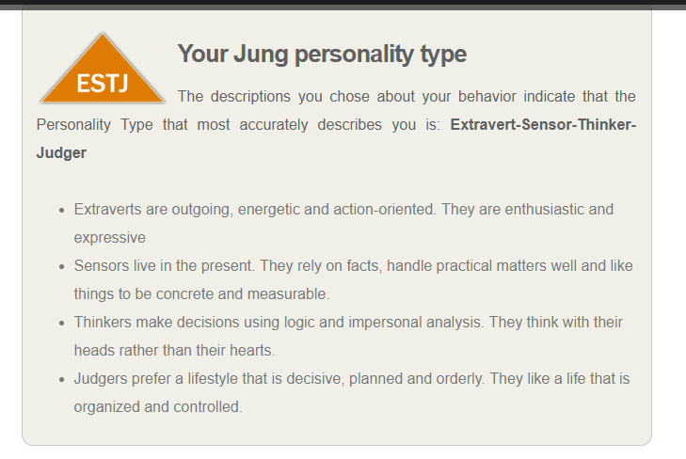

The result from the personality max report website [7] :

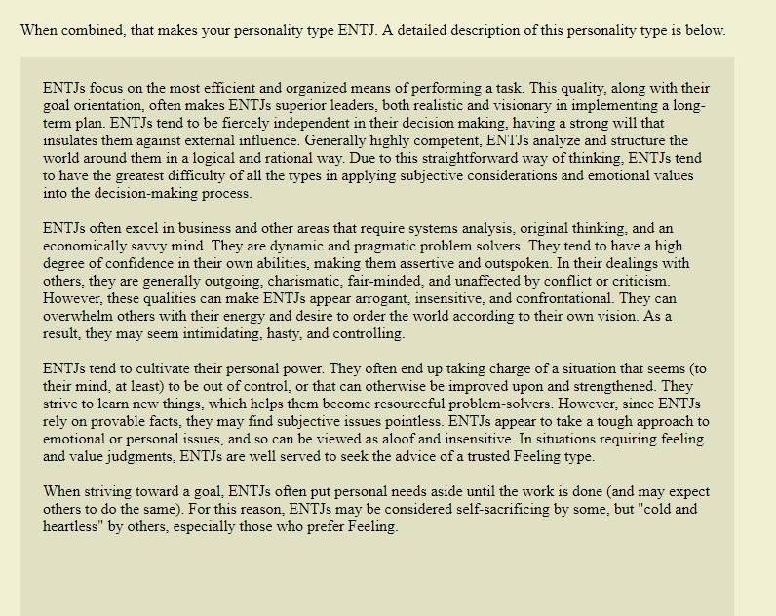

The result from the human metrics website [8]:

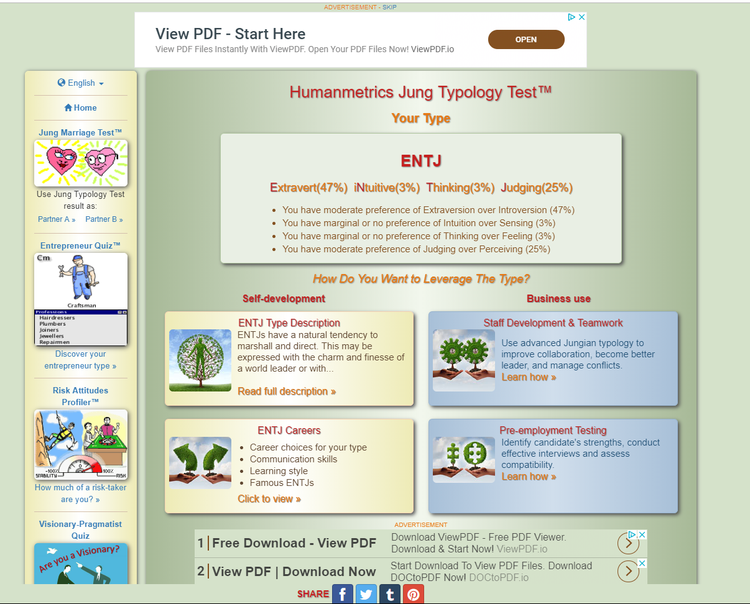

The Jung test typology central website [9]:
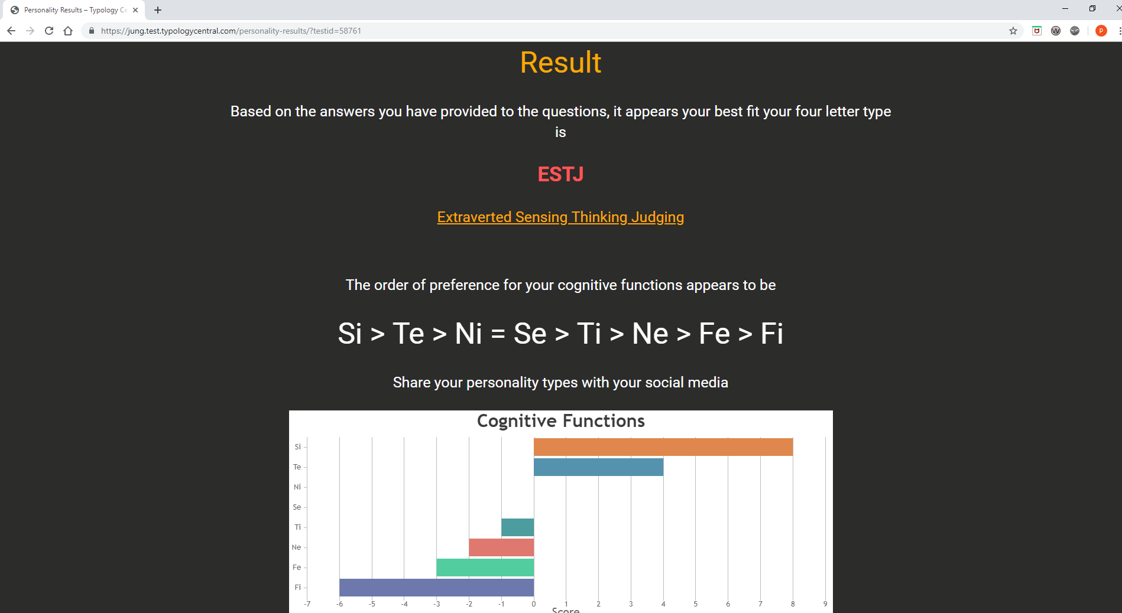

ESTJ and ENTJ personality types, can be broken down into the following:

Extrovert - Are people who are energetic, like to socialise and interact with others.

Thinkers - Are individuals who base their decisions on facts and are objective.

Judgers - Are individuals who enjoy an orderly, planed and organised lifestyle.

Sensors - Are people who live in the present, and do not think about the future. They are also very practical.

Intitutive - They are individuals who focus on concepts and ideas, and not on details.

Based on the results, I tend to agree with them. They fit my initial perception of myself. I am friendly and like socialising, which meets the criteria of Extrovert. I tend to think before I act, based on the information given, which meets the criteria of a thinker. I like organisation, which meets the criteria of Judger. I tend to focus on the current situation rather than on the future, which meets the criteria of a sensor. I focus more on the big picture rather than the little details, which meets the criteria of Intitutive.

Strengths and Weaknesses

According to the Jung test’s I carried out and my initial assessments of myself, below are my strengths and weaknesses;

Strengths
Hardworking and organised. I tend to focus on the most practical and efficient ways of carrying out a task.

Friendly and approachable. I can work alongside others as part of team.

Problem solving. I can evaluate information and work out the best way to solve a problem.

Weaknesses
I sometimes show a lack of empathy and emotion to others, which could affect personal and work relations.

I am very energetic and have high standards, which can be overwhelming for others and be seen as demanding.

Suitable Career Suggestions

After doing a number of career tests, there was no clear answer on what career would suit me best. Most of the careers tend to involve high intellectual skills and tended to be office based. The results are below:

Result from whatcareerisrightforme website [10] :

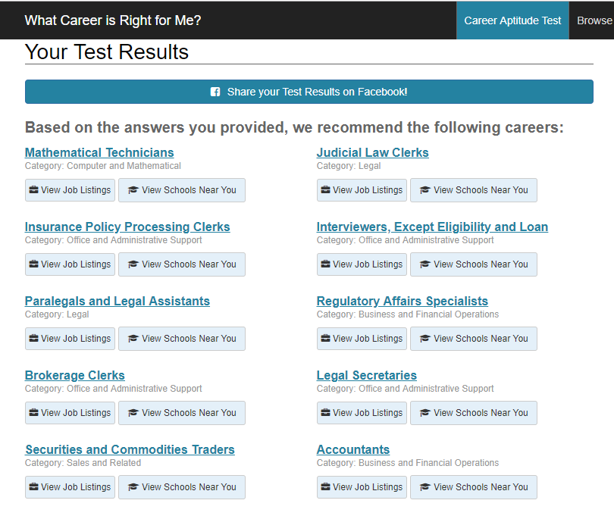

Result from career explorer website [11]:
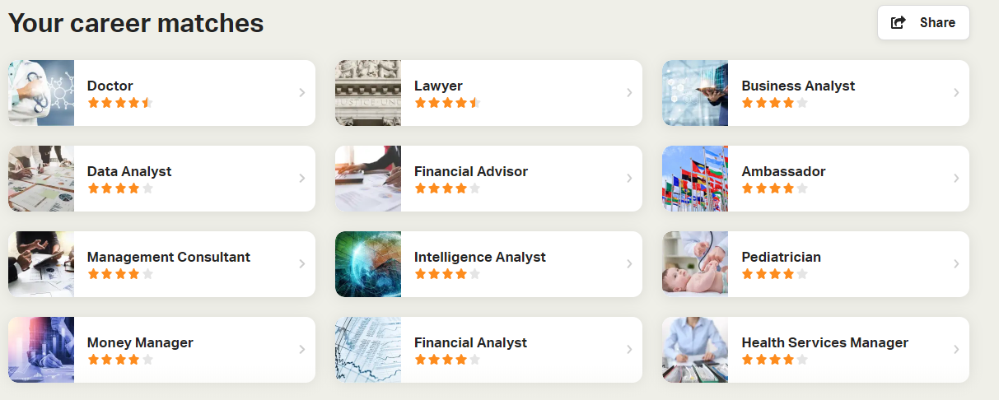

Result form 123 test website [6]

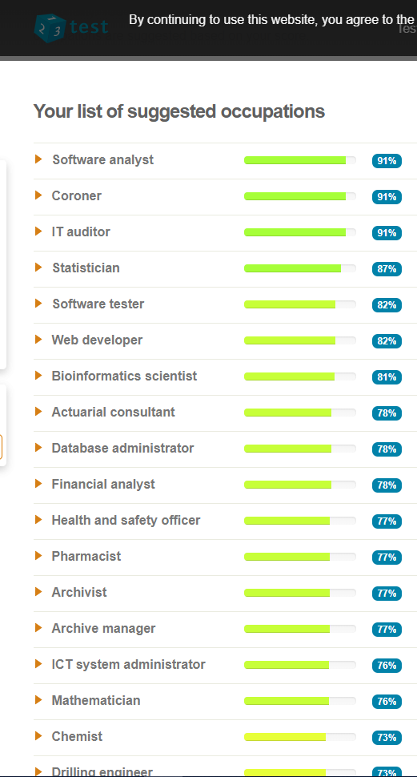

Section 3: Action Plans

Long Term and Short Term Goals

Below are my long term goals for the next 4 years:

- To complete the Digital Apprenticeship or Applied Cyber Security and Networking Degree, and become a IT security consultant with the skills I have learnt from the degree course.

- To run the Cardiff half marathon.

I will use SMART to help me archive, my long term goals. SMART is defined by the tutor2u website [12] in the diagram below:

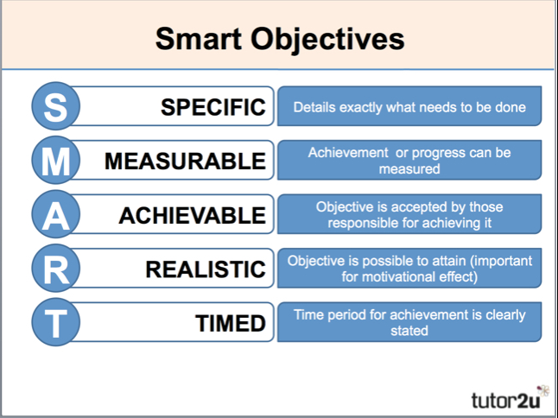

Degree Goal
To break my long term goal of completing the degree course, SMART will be used to break down my long term goal into smaller goals to assist in completing the long term goals. Currently there are 4 modules to complete in the first term or semester, these are my short term goals.

Academic and employment skills (ACCA 4016). One assignment to be completed at the end of the module. Below is my action plan set to achieving this goal;

Subject | Type of Assessment | Activities | Date/Duration | Description | Complete By | Submission Date
Academic and Employability skills | Report | Create a Plan  Write presentation  Carry out academic research | 18th July  19th July  24th July | Create a plan to carry out the work  Conduct presentation  Academic research | 18th July  23rd July  24th July | 26th July  23rd July  24th July
 |  | Write up Report | 24th July | Finalise findings and write up report | 24th July | 24th July
 |  | Proof Read  Assignment  Submit Report | 24th July | Proof read | 24th July | 24th July

Internet Technology and Security (ACCA 4018). There is one written assignment to complete the module;

Subject | Type of Assessment | Activities | Date/ Duration | Description | Complete By | Submission Date
Internet Technology & Security | Website & Report | Create a Plan  Decide on theme of website design  Install Web Design Software  Obtain images for website and wrote content  Create and Tested website  Write report  Submit report | 18th July  18th July  18th July  20th July  21st July  21st July  22nd July | Create a plan to carry out the work  Brainstormed different ideas for the design of the website  Install web design software  Download images and created content based on decided theme  Test out website to check for any errors  Write report on website  Submit report and website | 18th July  18th July  18th July  20th July  21st July  21st July  23rd July | 23rd July  23rd July  23rd July  23rd July  23rd July  23rd July  23rd July

Computer networks and architecture (ACCD4001). There is one written assignment to completed at the end of the module.

Subject | Type of Assessment | Activities | Date/Duration | Description | Complete By | Submission Date
Computer networks and architecture | Report | Create a Plan  Academic research  Write report  Proof read report  Submit report | 11th July  11th July  12th July  13th July  19th July | Create a plan to carry out the work  Carried out academic research  Write report based on findings  Proof read report for any potential errors  Submit report | 11th July  11th July  12th July  13th July  19th July | 19th July  19th July  19th July  19th July  19th July

Computational thinking (ACCA 4016). There is one in class exam, to be completed at the end of the module.

Subject | Type of Assessment | Activities | Date/Duration | Description | Complete By | Submission Date
Computational thinking | Exam | Create a revision schedule  Identify subject for revision  Attend exam | 11th July  11th July  23rd July | Create revision schedule and assign revision time  Outline test subjects for revision  Attend exam | 11th July  11th July  23rd July | 23rd July  23rd July  23rd July

Personal Goal – In order to achieve my long term goal of running the Cardiff half marathon, I will need to train for smaller running distance events, to build up my stamina for the Cardiff half marathon. I have set a short term of goal of doing the Swansea bay 10k to help me fulfilling my long term goal of completing the Cardiff half marathon.

Subject | Type of Assessment | Activities | Date/Duration | Description | Complete By | Submission Date
Swansea 10K & Cardiff Half Marathon | Running | Create a training schedule  Test out current fitness level  Amend fitness plan if needed  Look at current diet  Practice running and healthy eating  Enter Swansea 10K race  Attend and Partake in race | 11th July  21st July  22nd July  23rd July  23rd July  23rd July  22nd September | Create training timetable based on current fitness level  Set target time for run and test and analyse result  Make necessary adjustments to plan  Assess current diet to see if improvements can be made based on nutrition research for performance enhancement  Practice running and health eating  Enter race  Assess performance and enter into Cardiff Half Marathon | 19th July  21st July  22nd July  23rd July  23rd July  23rd July  22nd Sept | 22nd Sept  22nd Sept  22nd Sept  22nd Sept  22nd Sept  22nd Sept  22nd Sept

Section 4:Application

Backing Up Data
According to the IT World website [13], you should back up your data in 3 locations. They recommend backing up your data using the following methodology:

- Saving the data on your computer
- Save the data on an external drive
- Backing up the data in the cloud, in case a home disaster occurs.

I have followed their recommendations, by backing up my university, occupational and personal data to my home and work computers, a portable external drive and google drive account. Google drive is a cloud storage facility which is held on the internet.

Possible data disaster recovery scenarios:

In case of a work disaster where my computer is damaged beyond repair, I can recover the data from my home computer and external hard drive and google drive account.

In case of a home disaster where my computer and external hard drive is damaged beyond repair, I can recover the data from my work computer or google drive account.

If the data is encrypted by a virus like ransomware,(see appendix A for further information on ransomware), on my home computer, I can recover the data from my work computer, which is in separate environment from my home computer. The same applies if my work computer is encrypted by the ransomware virus, I can recover it from my home computer. The external drive is used to copy data manually between the work and home computer. The data copied to the external drive is checked by opening random files to make sure the data has not been encrypted, then disconnected after the data is checked. This avoids the ransomware virus transferring encrypted files. When backing up data to google drive, the data is tested before uploading it to make sure that no encrypted files are copied. Also, the files are added to the version list, so you can restore back to a previous copied version of the file, if the file uploaded is encrypted. No automated synchronous process has been setup with google drive, to avoid encrypted files being upload to the google drive account. All files are manually uploaded.

Time Management and Self-Organisation

To help me manage my time better, I have adopted a approach called calendar blocking, which I learnt in class and while watching a YouTube video by Amy Landino [14], which involves setting up a calendar and setting up blocks or time slots in your calendar to organise and carry out multiple activities. This help individuals organise their time to carry out all the tasks they need to complete in given time period. This avoids the stress of trying to worry about missing a task or not providing enough time for task.
A schedule has been setup through Google Calendar, to organise my university work and training for long distance running. This will help manage my time effectively by setting up designated times to carry out long term and short term goals, alongside my work commitments. I feel that this will help avoid or reduce stress levels. Below is an example of what I have created:

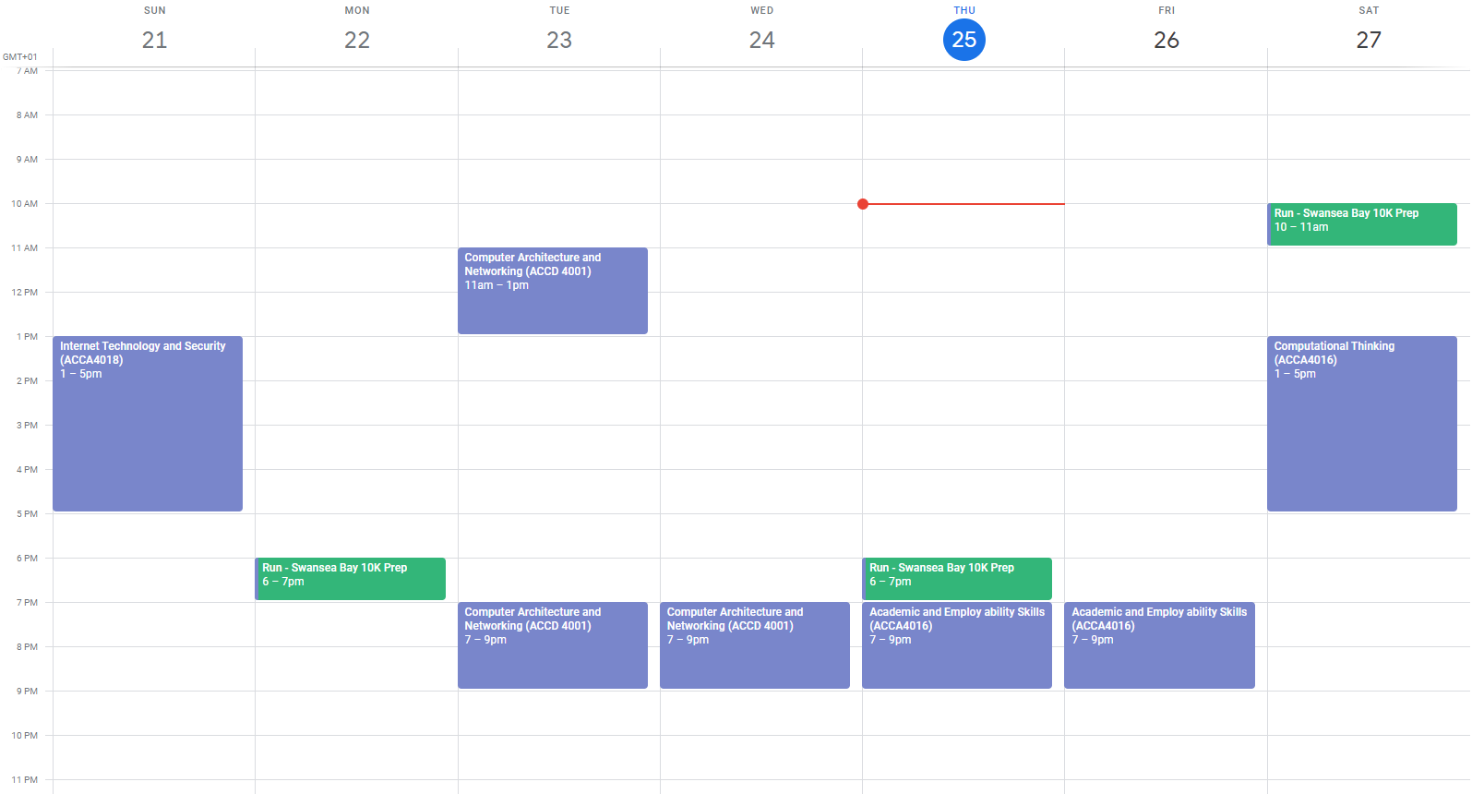
The entries in blue are designated times for my university work, and the green is for personal goals e.g. long distance running.

E-Portfolio

I have created a window folder structure which is replicated in google drive.

I have setup my E-Portfolio to split my four areas of my life into separate folders. The initial folder is called PR files (named after myself) to distinguish it from anything that is not related to me personally or professionally.

I have then setup four subfolders;

- E-Portfolio – folder contains my CV, Personal Statement etc.

- Personal folder is for my hobbies.

- UWTSD folder for my university work.

- Work folder for my job related work

Please see the screenshot below for my E-Portfolio.

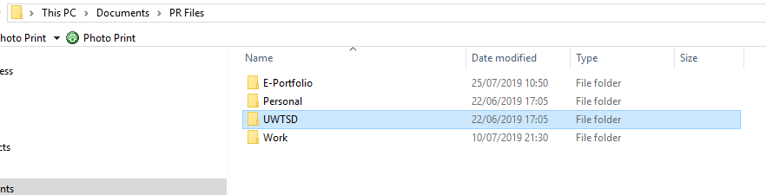

The four sub folders mentioned in the screenshot above are split into further sub folders where necessary, e.g. I have setup a separate folder structure for my personal and professional development within my E-Portfolio folder which contains my CV, Personal Statement and Goals etc. Please see screenshot below to see my folder structure.

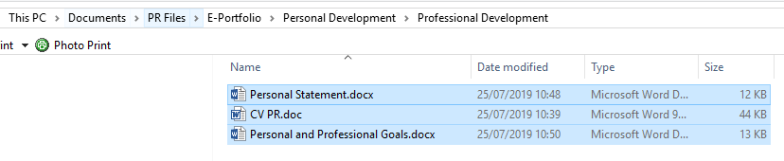

See appendix B for CV and screenshots of Linkedin Profile.

Section 5: Evaluation

The evaluation is broken down by each section of the report.

Section 1

I learnt what skills are needed to give a successfully presentation. Please see list below:

- I learnt that too many special effects can sometimes effect the flow of information. Keeping the presentation simple can lead to a better presentation.
- The use of images can make a dull presentation more interesting, and create better engagement with the audience.
- Test the presentation in the room you are giving the presentation. This can help find and resolve errors before giving a presentation.
- Avoiding reading off the slides, as this can make the presentation dull.

To sum up the skills, I have learnt giving a presentation will help me conduct more successfully presentations in the future.

Section 2

Researching about different academic skills needed for success in education, such as time management, etc. has helped me incorporate these skills into my own learning. I learnt that organisation and time management is essential to academic success. That is why I have setup action plans etc. as shown in section 4 to help me manage my time better, and complete all the assignments and exams on my course.

Learning about what employment skills employers are seeking, helped me understand what skills I need to improve, to make me more desirable in the employment market. For example, working as part of a team was highlighted as a skill. Also, the ability to demonstrate that skill could lead to better employment opportunities

The analysis of one self, when conducting the JUNG Personality Tests, has helped me learn more about myself. For example, I am an extrovert, which is a useful skill to have for my job as a ICT technician. Being able to communicate with a user to work out the cause of a problem, can help me resolve their IT problem. I also discovered other personality traits about myself, which I did not realise existed, e.g. I am thinker, I base my decisions on facts and show no bias in my decisions. In my job, being a thinker is a good skill to have, being able to assess facts and work out a solution to solve the problem is invaluable.

When conducting the career tests, I was unable to find a specific career for myself. The results gave me a long list of careers, so I was unable to determine if I am in the correct career, but the list of careers given, may be worth exploring.

Section 3

Learning how to set goals can give better structure to achieving more in life. Learning how to set long term goals e.g. completing my degree course, and breaking down those goals into short term goals with SMART e.g. setting smaller goals to complete my modules in my degree course etc., and implement them through action plans, has shown me how to plan my life out better. Better life planning, could lead to greater achievements and greater satisfaction in life.

Section 4

Learning that just backing up the data to one location, is not sufficient. You should at least back up your data to 3 locations, you should use your PC as one backup location, your external media as a second and your cloud storage as a third location. I have carried out the new approach when dealing with all my data. I have backed up my data on both my home and work computer, by transferring the data using removable media e.g. external hard drive. Also, I have set up a google drive account to upload my data. I now have better protection against data loss, and can recover my data with greater confidence.

Section 5

Learning how to organise my data and mange myself has improved my performance in work and other aspects in life. Using calendar blocking with google calendar has helped me organise my time better, and get more out of life. It has helped me with my training for long distance running and has helped me complete my modules. Creating an E-portfolio with separate folders to reflect different areas of my life e.g. work, has help me organise and find my data easier when needed. This has reduced my stress levels when trying to locate and find data.

Further study

Reflecting on the report, the areas that are worth further study is to explore personality types, and to use that research to better understand my personality type, and use my personality type more effectively in my career. For example, after carrying out the JUNG personality tests, it stated that the ENTJ Personality types tend to make great leaders. I would like to carry out further research on how to become a leader, so I can advance my career by trying to get promoted to a senior role.

Appendix A

Ransomware (The Crypto Wall Virus)
By
Paul Richards

  - Abstract

  - The report contains the following:

  - An explanation of the Ransomware and the Crypto Wall Virus, including information on how the cryptowall virus infects a computer, and how a hacker extracts money from the user.

  - A series of steps on recovering data from a computer infected by the crypto wall virus.

  - A methodology on protecting a computer from the cryptowall virus.

Contents
1. Introduction 4
2. Trojans and Viruses 5
2.1 General overview 5
2.2 How they infect your computer 5
3. Ransomware 6
3.1 General overview 6
3.2 What to do if infected 6
4. The Crypto wall Trojan 10
4.1 Specifics of this threat 10
4.1.1 Infection methods 11
4.1.2 File types affected 11
4.2 Procedures of eradication 13
4.3 Payment 13
5. Examples of good practice 14
5.1 Initial avoidance 14
5.2 Backup procedures 14
6. References 15

Introduction

  - Ransomware, in particular the crypto wall virus, is a new form of virus which is used by hackers to encrypt a user’s data, and demand a ransom to decrypt the data. This new threat has caused huge financial losses worldwide.

  - According to J.Petters [15], 40% of malware incidents reported, are made up of the crypto wall virus. He also states that the Crypto Wall 3.0 virus has cost business $325 million in damages since its release.

  - It is worth investigating this growing threat to an organisation’s data, to see what implications this can have for our organization and how to protect our organization’s data against such a threat.

Trojans and Viruses

2.1 General overview

  - The crypto wall virus is a Trojan Virus. A Trojan virus is a program that disguise itself as a legitimate program and when installed infects the computer. The virus can be used to deny access to a system, spy on a user or steal data.

2.2 How they infect your computer

  - Hackers use social engineering to infect computers with Trojans. Social Engineering is a psychological technique, used by hackers to trick a user into infecting their system without realising it. A Hacker tricks a user into thinking they are installing a legitimate program, when in fact they are installing a virus. For example, a hacker may fool a user into opening an email attachment and installing a program which the user thinks is legitimate.

Ransomware

3.1 General overview

  - Ransomware is a form of malware that infects, controls and locks a computer. The crypto wall virus encrypts a user’s data and allows a hacker to demand a ransom to decrypt the data.

3.2 What to do if infected

  - J.Petters from varonis [15], A. Kujawa from malware bytes [16] and the computer bleeps website [17] provide instructions on dealing with a computer infected by the crypto wall virus, which are listed below:

- Removing the Malware installed by the crypto wall virus
  - If you discover that your computer has been infected by the crypto wall virus, you should boot the computer into safe mode with networking, run an anti-virus scan to remove all malware. Unfortunately, a user will not know that they have been infected by the crypto wall virus until they receive a message from the hacker. However, any malware installed alongside the crypto virus will be detected and removed.

- How to find the encrypted files
  - According to the computer bleeps website [17], when the crypto wall virus encrypts a file, it will store the file and path as a value in the windows registry. The location of the sub key is in the following format:

  - HKCU\Software\<unique computer id>\<random id>

  - With an actual example being
  - HKCU\Software\03DA0C0D2383CCC2BC8232DD0AAAD117\01133428ABDEEEFF.
  - The crypto wall virus will then create a value for each file that it encrypts under this key.
  - Computer bleeps provides a software tool called ListCwall, which a finds and export the encrypted files to another computer. This tool allows you to back up the encrypted files, in case you need to archive the encrypted files and reformat the infected machines. The computer bleeps website, provides instructions on how to use the software on their website.

- Decrypting the encrypted files
  - You can try decrypting the files, by using the following methods:
- Brute force. According to the computer bleeps website [17], due to the length of time it would take to break encryption, this would not feasible.
- Finding a decryptor for the encrypted files. The malware bytes website provides a link to the website. https://www.nomoreransom.org which provides decryptors for the different types of crypto wall viruses.
  - Prior to visiting the site, you will need to identify the crypto wall virus that has infected your computer.
  - There are a number of ways to identity the crypto wall virus on your computer.
  - From the ransom message. The screenshot taken form malware bytes [16] site shows that the computer has been infected by the Petya ransomware:

  - 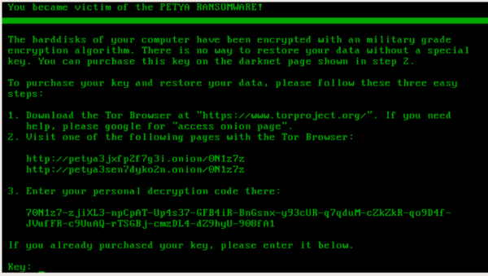
  - You can use the file extension. The screenshot taken from the malware bytes site [16], shows a file with the extension zcrypt, which is highlighted in yellow. This file extension is associated with the zcrypt ransomware virus.

  - 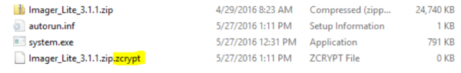

  - The code used by the crypto wall virus. You could perform a search online using the unique value, string or number from the code, to identify the ransomware virus.
  - You can visit the following site: ID Ransomware by the Malware Hunter Team, and submit the ransomware message and one of the encrypted files, to identify the ransom ware virus.

- File Recovery.

- Backup
  - The best method for recovering your files, is to perform a restore from a backup.

- File Recovery software
  - When the crypto wall virus infects a computer, it copies the file, encrypts the copy and deletes the original file. You may be able to recover the original file by using file recovery applications like R-Studio and PhotoRec. The computer bleep website provides links to both R-Studio and PhotoRec sites, if you wish to download the software. Please note, the more you use the computer after it is being infected, the less likely you are able to recover the software.

- Shadow copies.
  - This feature is available on all versions of windows. If System Restore is enabled, windows takes snapshots or copies of your system, that you can revert back too. This method is not full proof, because the shadow copy software tool may not have a copy of the most recent files. Also, the Crypto Wall virus tries deleting shadow volume copies. However, the Crypto wall virus does not always succeed in deleting shadow volume copies, so the method should be used when the Crypto wall virus has failed to delete shadow copies.
  - The Computer bleeps website [17] provides information and instructions on two shadow volume copy tools, to restore files.
  - Windows native features. In the properties of the files and folder, under the versions tab, you can restore previous versions of the file and folder. The only problem with this feature is that you can only restore one file and folder at a time. Shadow Explorer, a third party application, that allows you restore all folders and files at once. The computer bleeps website provides a link to download the shadow explorer.

- Cloud storage
  - If you have mapped drives for a cloud storage services like Drop Box. Many of these services, provide a facility to make previous copies of the files. However, you can only restore one file at a time. Some sites like computer bleeps, offer python scripts to restore more than one file at a time, but you will need to install Python to run these scripts, and the script needs to be run from the infected computer.

The Crypto wall Trojan

4.1 Specifics of this threat

  - The crypto wall virus was released in 2014. There have been many versions of the crypto wall virus. There is debate concerning the latest version of the crypto wall virus. According to the J.Petters [15], crypto wall 5.1, is not a new version of the crypto wall virus, because it does not use any of the original code. If you do a google search, most search results state that 4.0 is the latest version of the crypto wall virus. Both virus have the same impact, but just use different encryption technology. Crypto wall 4.0 uses RSA encryption, and 5.1 uses AES encryptions.
  - According to the J.Petters [15] from the Varonis website, the crypto wall virus infect a computer in the following way.
  - When a computer is infected by the crypto wall virus, it will inject code into window explorer.exe and restart window explorer.exe. The modified version of the explorer.exe, encrypts files, installs malware, deletes shadow copies, disables windows services, and spawns a new svchost.exe process with more injected modules.
  - If it cannot inject code into windows.exe explorer, it will use the svchost to spawn a new window explorer.exe and inject code into the new window explore.exe. This instance of svchost is responsible for file encryption, network communication and removing malware once it is finished.
  - Crypto Wall virus, installs itself in the registry and the startup folder. If not completely removed, it will start up again, once the user logs back on.
  - The crypto wall virus needs to communicate with command and control server, (C&C). The C&C Server sends an encryption key to the crypto wall virus to encrypt the files. The cryptowall will scan all your file stored on the internal drive, external drives, network shares and mapped drives to cloud storage sites like drop box, and encrypt the files with the encryption key provided by the (C&C) server.

  - According to the computer bleeps website [17], the crypto wall virus will create 3 files:

HELP_YOUR_FILES.PNG
HELP_YOUR_FILES.HTML
HELP_YOUR_FILES.TXT
  - The files are used to display the ransom ware messages and instructions concerning payment of the ransom.

4.1.1 Infection methods

  - According J.Petters [15], the crypto wall virus can infect a computer in 3 ways:
- Phishing email. This is where the user receives, what appears to be a legitimate email with a zip attachment, when they open up the zip file, it installs and executes the crypto wall virus. The email usually states that the attachment contains an invoice, bill, complaint or other legitimate business communication, which needs to be open.
- Exploitation Kits. This is taking advantage of security vulnerabilities in operating systems, applications and websites to infect a computer with the crypto wall virus.
- Malicious Ads. Hackers purchase or hack internet advertisements to install malware. They install the crypto wall virus, by using JavaScript through your browser.

4.1.2 File types affected

  - Below is a screenshot taken from the varonis website [15] on what files are effected by the crypto wall virus.

  - 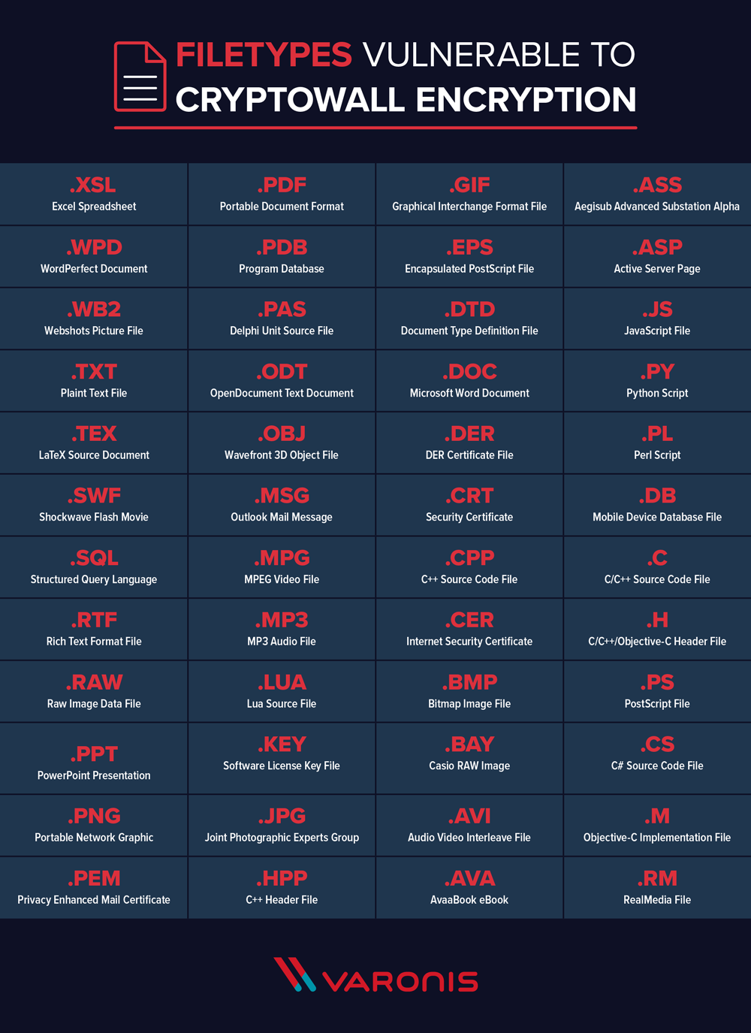

4.2 Procedures of eradication

  - If the computer is infected, by the crypto wall virus, J.Petters [15], states these are steps you need to follow to remove the virus:
- Boot your computer into Safe Mode with Networking
- If you have a recent and clean System Restore point, you can restore, if not:
- Download and install a malware removal application.
- Run malware removal app and scan all of your files

4.3 Payment

  - If you unable to decrypt the encrypted file or recover the encrypted file from a previous backup. Then depending on the value of the data, you may have to pay the ransom, but there is no guarantee the hacker will provide you with the encryption key to decrypt the file. According to J.Peter [15], only 19% of users that pay the ransom get a decryption key from the hacker.
  - The payment must be in Bitcoins, because Bit coin payments cannot be traced back to the hacker. The Payment is made through unique bit locker payment address via a Web to Tor gateway, to ensure the payment is not intercepted by other hackers or third parties. If you decide to pay the hacker, remember the sooner you pay the ransom the smaller the sum you have to pay. Hackers of the cryptowall virus, set deadlines to pay the ransom, if deadlines are missed, the ransom is increased. According to computer bleeps website [17], the usually charge for decrypting your files is $500 for seven days and the ransom increase to $500 for every seven days you miss the payment.

Examples of good practice

5.1 Initial avoidance

  - According to J.Petters [15] and computer bleeps website [17]these are steps you should take to protect your system from the crypto wall virus.
- Keep your systems patched, this involve applying the latest updates. If you do not keep your system up to date. This leave holes in your system, which hackers can exploit to gain access to your system.
- Use an up to date Anti-virus software, they can prevent malware from running and quarantine malware.
- Firewall. The crypto wall virus needs to contact the command and control server to carry out an encryption attack. A firewall can block this connection and halt the attack.
- Don’t click links from suspicious emails. This is a common way for hackers to infect your systems. User education is particular useful, to prevent users from infecting your network.
- Practice safe browsing habits. Use a up to date browser and has much encryption as possible. Turn off on JavaScript and adverts by default. Only run adverts from trusted sources.
- Network share. Access to network shares should only be given to authorized users or groups which should only have write access, this will stop a infected computer spreading the virus to a network share.
- Create Windows Group or Local Polices to prevent unauthorised executables from running. Using the native windows group or local policy tools, you can restrict what applications can run, which can block the crypto wall virus from running. Further instructions on how to use these tools, are found on the computer bleeps website.

5.2 Backup procedures

  - Perform regular backups on a routine basis, to keep a up to date copy of your data. Test backups on a regular basis to make sure you can restore, data from the backup. Make sure copies of the backups are stored separate from the computers, so they do not get infected by a virus. Make sure they are not connected through an external drive connected to a computer, because they can be infected by a virus too.

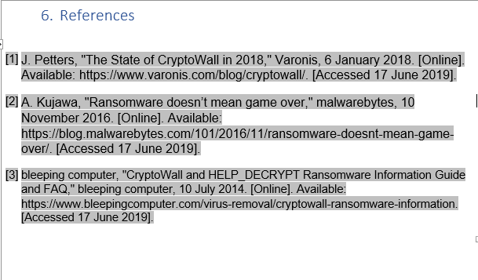

Appendix B

CURRICULUM VITAE

Paul Richards BSc, A+, Network+,
MCDBA, MCSE, MCTS.
101 Erw Werdd
Birchgrove
Swansea
SA7 0HF
Mobile no: 07907678023
Telephone no: 01792448943
Email Address: ric10962@yahoo.co.uk

Personal Profile
A highly experienced customer services professional, who has worked in fast paced and demanding environments. I have spent several years working on the IT helpdesk, engaging with customers on many different levels, from dealing with routine support issues to customer escalations.

Skills & Knowledge

Working on the helpdesk has provided me with many customer service skills;

- Competent in dealing with a variety of customers through different communication mediums, face to face, telephone and email.
- Comfortable dealing with customer escalations and providing suitable actions to resolve the problem.
- Able to break down complex subject matters and communicate the information to an understandable level.
- Can work to tight deadlines and adapt to customer needs if they change at short notice.
- Able to multi-task and deliver high levels of customer services simultaneously.

Qualifications

- MCDBA (Microsoft Certified Database Administrator)
- MCSE (Microsoft Certified System Administrator)
- MCTS (Microsoft Certified Technology Specialist) in CRM 4
- A+ and Network +
- 2:1 Degree in Business, Economics and Law

A Levels
Sociology (B), Business and Economics (C), Law (C), Politics (D)

GCSEs
Nine GCSE’s (B-C) including mathematics and English.

Employment History

Dyfed Powys Police Headquarters August 2017 – Present
Current Role: ICT Technician
- Provide hardware and software support to users within Dyfed Powys Police.
- Provide support for mobile devices e.g. mobile phones and tablets.
- Providing network support.
- Providing email support.
- Cover helpdesk support when required.
- Travelling out to remote police stations to set up/repair IT equipment as required.
Crimson Consultations | June 2014 – August 2017
Role: IT Helpdesk Technician (Senior)
- Provide advice and support on CRM – including taking telephone calls and email queries.
- Carry out software updates or solution imports – using various types of software.
- Manage and maintain customer’s databases – this includes monitoring the health of the databases, and performance tuning where necessary
- Work with customer through triage.
- Responsible for initial training of staff.
- In the event of staff’s absences, pick up and carry out whatever work is necessary.

UNIT 4 | March 2007 – June 2014
Role: IT Consultant & Database Administrator
- Provide advice and support on applications
- Carry out software updates or solution imports.
- Manage and maintain customer’s databases

DN Industries | February 2006 – March 2007
Role: IT Engineer
- Maintain and managed hardware and software.
- Administered servers.
- Provide support and advice on Microsoft office.

IBM | September 2002 – March 2006
Role: IT Engineer
- Maintain and managed hardware and software.
- Administered servers.
- Provide support and advice on Microsoft office.

Personal Details

Date of birth: 23/11/1977 Marital Status: Living with partner
I also have a full clean driving licence.

Hobbies
My hobbies include health & fitness, reading, socialising and dancing.

References
Available upon request.

Linkedin Profile

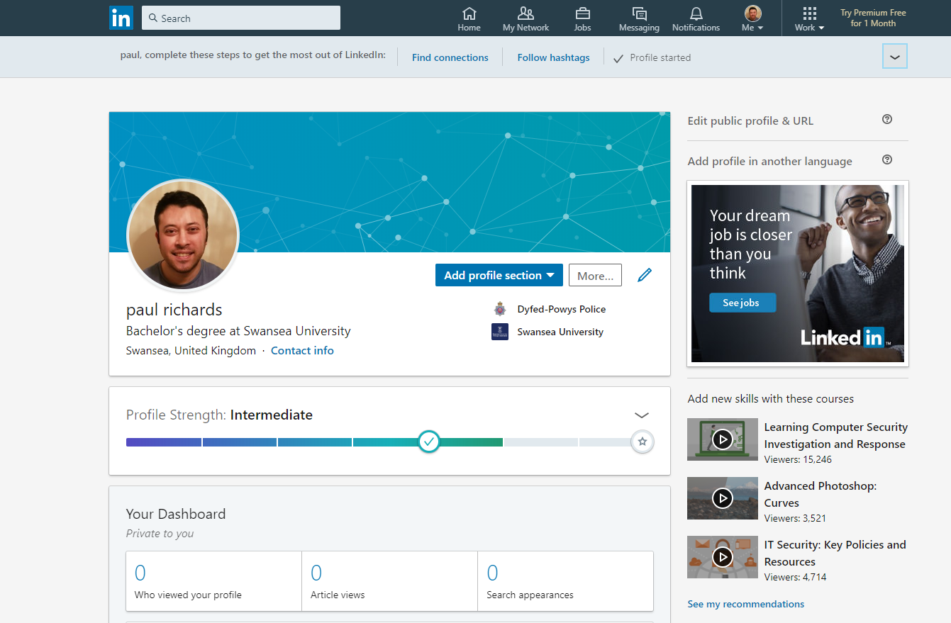

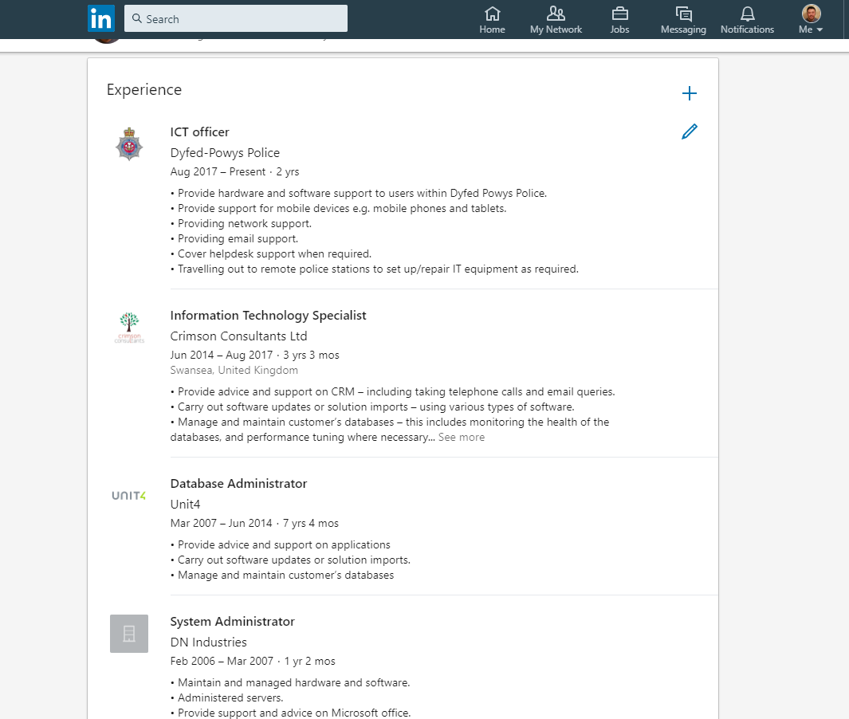

Bibliography

[1] | signupgenius, “15 Organizational Tips for College Students,” [Online]. Available: https://www.signupgenius.com/college/organization-tips-for-college-students.cfm. [Accessed 25 July 2019].
[2] | oxford-royale, “Essential Skills for Undergraduate Life: the 13 Things You Should Know How to Do Before You Go to University,” 31 March 2014. [Online]. Available: https://www.oxford-royale.co.uk/articles/13-skills-university.htm. [Accessed 25 July 2019].
[3] | University of Kent, “Careers and Employability Service,” 19 Feb 2019. [Online]. Available: https://www.kent.ac.uk/ces/student/skills.html. [Accessed 25 July 2019].
[4] | The guardian, “Top 10 things employers are looking for,” 22 April 2013. [Online]. Available: https://www.theguardian.com/money/2013/apr/22/top-10-things-employers-looking-for. [Accessed 23 July 2019].
[5] | GTI Media, “Teamwork: it's high on the graduate recruiters' wishlist,” [Online]. Available: https://targetjobs.co.uk/careers-advice/career-planning/273051-the-top-10-skills-thatll-get-you-a-job-when-you-graduate. [Accessed 18 July 2019].
[6] | 123test, [Online]. Available: https://www.123test.com/jung-personality-test/. [Accessed 25 July 2019].
[7] | personalitymax, [Online]. Available: https://personalitymax.com/report/?pt=11-42-26-80&mi=82-52-30-12-68-74-92-42&ls=54-87-38&bh=58&name_key=81d16071fa. [Accessed 25 July 2019].
[8] | humanmetrics, [Online]. Available: http://www.humanmetrics.com/personality. [Accessed 25 July 2019].
[9] | jung test typologycentral/, [Online]. Available: http://jung.test.typologycentral.com/. [Accessed 25 July 2019].
[10] | whatcareerisrightforme, [Online]. Available: https://www.whatcareerisrightforme.com/career-aptitude-test.php. [Accessed 19 July 2019].
[11] | careerexplorer, [Online]. Available: https://www.careerexplorer.com/. [Accessed 23 July 2019].
[12] | tutor2u, [Online]. Available: https://www.tutor2u.net/business/reference/marketing-objectives. [Accessed 25 July 2019].
[13] | M. Mombrea, “The best home backup plan options - Part 5: A complete backup strategy,” 26 December 2012. [Online]. Available: https://www.itworld.com/article/2832755/the-best-home-backup-plan-options---part-5--a-complete-backup-strategy.html. [Accessed 23 July 2019].
[14] | A. Landino, “GET MORE DONE WITH CALENDAR BLOCKING,” 13 May 2018. [Online]. Available: https://www.youtube.com/embed/LvZp-ogt1vw. [Accessed 22 July 2019].
[15] | J. Petters, “The State of CryptoWall in 2018,” Varonis, 6 January 2018. [Online]. Available: https://www.varonis.com/blog/cryptowall/. [Accessed 17 June 2019].
[16] | A. Kujawa, “Ransomware doesn’t mean game over,” malwarebytes, 10 November 2016. [Online]. Available: https://blog.malwarebytes.com/101/2016/11/ransomware-doesnt-mean-game-over/. [Accessed 17 June 2019].
[17] | bleeping computer, “CryptoWall and HELP_DECRYPT Ransomware Information Guide and FAQ,” bleeping computer, 10 July 2014. [Online]. Available: https://www.bleepingcomputer.com/virus-removal/cryptowall-ransomware-information. [Accessed 17 June 2019].

