HOTEL BREAKFAST BOARD
BMIH5003
Lecturer Name: Jinping Li
Student ID: 2111635 Laura Martinez Almeda

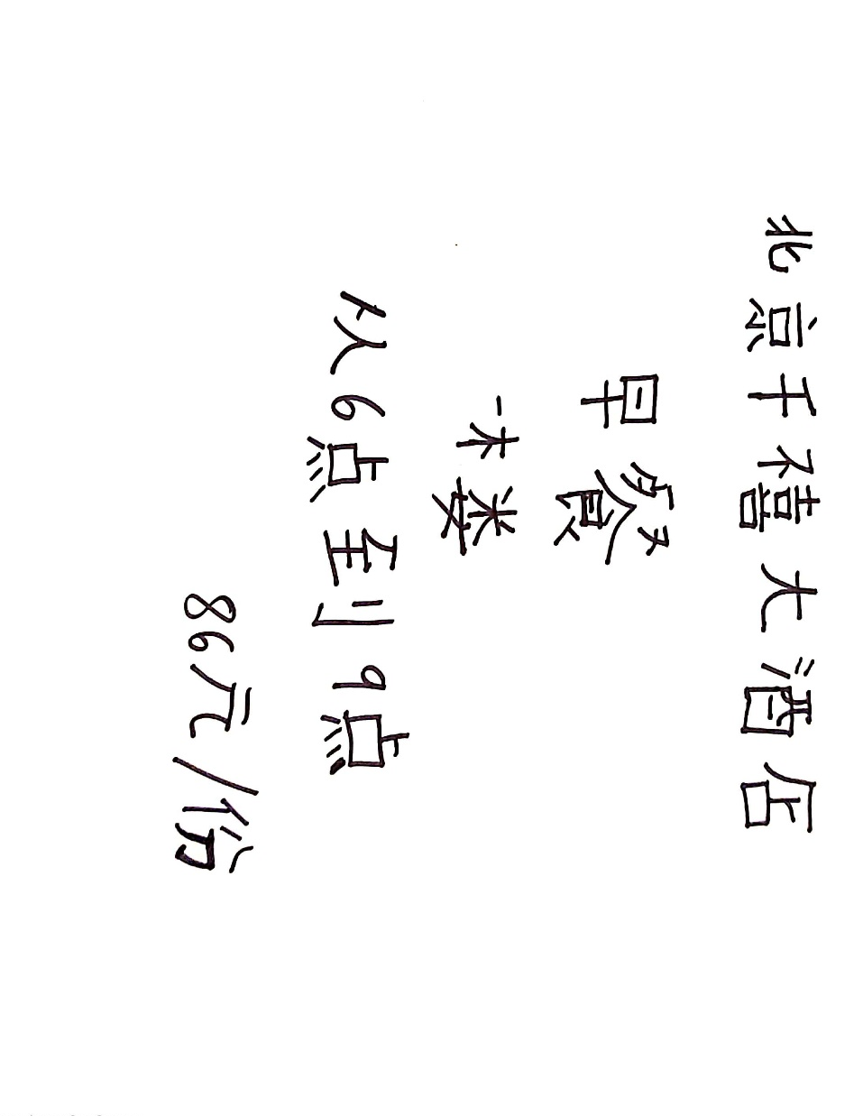

Hi,
My name is Laura, my name in chinese characters is Láo lā. I am from Spain and I am working in Beijing Millennium Hotel as a general manager. I have created this business card by hand with Chinese ink.
I hope it catches your attention and do not hesitate to contact me for any questions !
Kind Regards,
Láo lā
General Manager
Beijing Millennium Hotel

