

The Development of an Online Computer Science Learning Application

By
Edward Smith

Supervisor: John Williams
Second Marker: Jeanette Adams

Project submitted as part of the requirements for the award of BSc (Hons) Applied Computing

April 2021

DECLARATION
I, Edward Smith declare that I am the sole author of this Project; that all references cited have been consulted; that I have conducted all work of which this is a record, and that the finished work lies within the prescribed word limits.
This work has not previously been accepted as part of any other degree submission.

FORM OF CONSENT
I, Edward Smith hereby consent that my Project, submitted in candidature for the B.Sc. (Hons) Applied Computing degree, if successful, may be made available for inter-library loan or photocopying (subject to the law of copyright), and that the title and abstract may be made available to outside organisations.

Abstract

The overall aims of the project are to investigate currently used online computer science learning tools, and to apply the findings to develop an effective learning application. This is achieved through conducting a literature review to study the different areas of the learning process. The main finding of this review is the importance of the learning content and the usability of the application towards providing an effective learning experience to the user. The findings of this literature review are compared to a completed primary research in the form of a questionnaire. This finds that users rate their experiences with their use of online learning platforms as average. The development of the application is described and tested in full and is then compared against design criteria. This provides the conclusion that the application is effective in its educational ability.

Contents
Chapter 1- Introduction 6
Chapter 2- Research & Review of Literature 6
2.1 Introduction 6
2.2 Is Online Learning Effective? 6
2.3 Methods of Online Learning 7
2.4 Risks of Online Learning 8
2.5 What Coding Language to Teach? 8
2.6 Current Tools and Technologies Available? 9
2.6.1 W3Schools 9
2.6.2 CodeAcademy 10
2.6.3 Solo Learn 10
2.7 Government initiatives 10
2.8 Gender Imbalance 11
2.9 Application Usability 12
2.10 Conclusion 12
2.11 Primary Research 13
Chapter 3- Methodologies 14
3.1 Research Methodology 14
3.1.1 Philosophy 14
3.1.2 Approach 14
3.1.3 Strategy 14
3.1.4 Time Horizon 14
3.1.5 Data Collection 15
3.1.6 Evaluation Criteria 15
3.1.7 Methods of Testing 15
3.2 Development Methodology 16
3.2.1 Software 16
3.2.2 Hardware 16
3.2.3 Materials and tools 16
Chapter 4 - Design & Implementation 17
4.1 Design 17
4.1.1 Project Requirements 17
4.1.2 Data Flow Diagram 17
4.1.3 Logic Flow Chart 18
4.2 System Interface 19
4.3 Implementation 24
4.3.1 Problems and Successes 24
4.3.2 Unit Testing 24
4.3.3 System Testing 25
4.3.4 Usability Testing 25
4.3.5 Acceptance Testing 25
Chapter 5 – Evaluation 25
Chapter 6 – Conclusions and Recommendations 26
Chapter 7- Reflection 27
References 28
Appendix 1: Questionnaire Results 32

Chapter 1- Introduction

The purpose of this project is to develop an online learning application that improves user enticement and engagement whilst learning to code. A study shows that ‘programming is the aspect of computer science in school which is perceived to be the most challenging’ (1). The aim of this project is to investigate the current online computer science learning tools, and to use these findings towards the development of a new and effective application.
To achieve this aim, project objectives have been set including the conducting of a literature review to gain insight into the topic area. Primary and secondary research will be conducted with the intention to evaluate, compare, and reflect the data to see if they correlate. Also, an online learning application will be developed to attempt to solve the problem identified. Finally, a feedback form will be produced to establish future improvements for the application.

Chapter 2- Research & Review of Literature

2.1 Introduction

This literature review will aim to look at the various topics surrounding online learning and its effectiveness in education. The topics of discussion include studying how effective online learning is towards education, methods of online learning, risks of online learning, what coding language to teach, current tools and technologies available, government initiatives, gender imbalance in computer science, and application usability.

2.2 Is Online Learning Effective?

Online learning has become increasingly popular in today’s age, especially due to the recent pandemic which has left millions of educational institutions with no choice but to teach digitally. However, with this increased popularity, the question asked is whether 'online education is effective in getting students the information they need' (2). There is an ongoing debate about whether online learning improves learning. Clark believes that 'technologies are merely vehicles that deliver instructions' (3), and in themselves do not influence student achievement. Schramm supports Clark's theory that learning 'is influenced more by the content and instructional strategy' (3). An assumption can be made that the learning content is more important than the content’s delivery towards making online learning effective.

The benefits of using online learning include the ability to remotely access course material and that 'online learning knows no time zones' (3). Rovai believes the effectiveness of learning is not based on these benefits, but rather supporting previous theories that the 'course design determines the effectiveness of the learning' (3). This supports the conclusion that the e-learning content is fundamentally what affects the quality of learning for the student. Kirby and Boak argue that online learning effectivity is based on the learners 'strong sense of internet efficacy that enables them to effectively adapt to the requirements of working in this environment' (4). This argument supports the previous findings, as Kirby and Boak believe effective learning is based on previous experience rather than the execution of the learning tool.

Further research shows that students are keen ‘to enrol in the type of course that will be the most effective’ (5). This introduces the idea that students are interested in self learning. IBM support online learning with a study that shows ‘participates learn five times more material in online learning courses’ (5). They believe that this is because of the use of multimedia content, which supports the findings of Clark previously mentioned. Another study shows that online learning is the greener option compared to traditional courses, with ‘90% less energy and 85% fewer CO2 emissions per student’. This suggests that online learning could become essential in the future due to its sustainability.

Online learning according to Illinois University has the benefits of providing a 'level playing field' (6), as discriminating factors are largely absent and access to resources is easier. These factors play a significant part in the quality of education the student obtains. The ability to access resources that may be physically located anywhere can allow for better and 'creative teaching' (6).
With most advantages there are also disadvantages, and this is no expectation for online learning. A study shows that 'online courses require more time than on-campus classes' (7). Montgomery College believes that this is because the 'online environment is text-based' (7). The college also assumes that online courses make 'it easier to procrastinate' (7). This statement is supported by Illinois Online Network, who believe that 'online learners must exhibit self-discipline to be successful' (8). However, the Research Institution of American found that ‘online courses have increased student retention rates from 25% to 60%’ (5). A conclusion can be made that the effectiveness of online learning is based upon the individual's motivation to succeed.

2.3 Methods of Online Learning

There are multiple methods to online learning, both synchronous and asynchronous methodologies are chosen by educators. Harvard education believes the best approach to online learning is a mixed method of synchronous and asynchronous (9). This is interesting as originally the idea behind the teaching application was to make it completely asynchronous, however using a mixed method may 'heighten interactivity' (9) and promote students to engage with educators more. The importance to involve collaboration between students and teachers is essential, as it is said to 'build a sense of community and shared purpose' (10). It seems user engagement and activity are heavily reliant on communication between both parties.

Online learning methods are said to be most effective whilst 'employing multimodal strategies' (11). The variety of choices to online education can take many shapes including technology systems, media modality, instructional approaches, and temporal arrangements. The difficulty behind online learning is said to be 'how to craft the experience for your diverse students' (11). An assumption can be made that the approach to teaching must be carefully considered and tailored to the target audience.

Hakan Tuzun provides in-depth details on the dos and do nots of online learning. Hakan believes only ‘presenting video clips of a lecturing instructor in an online course’ (12) is bad practice, as it leaves the learner in a ‘passive state’ (12). This is supported by Doubler, Grisham & Paget who believe online learning should be shifted from ‘delivering to listening and supporting’ (12). This contradicts the previous literature as it suggests the deliverance of online learning is important to its success. Bruner highlights two kinds of knowledge in the learning process, ‘knowledge as detached, which is meaningless, and knowledge as a guide to purposeful action’ (12). This suggests that the learners’ skills will not improve until they use the knowledge for a meaningful purpose. Dewey supports the ‘importance of experience in learning’ (12), with the opportunities for learners to show what they have learned in the online experience. Another method of online learning suggested by Dewey is ‘trial and error in experiences’ (12). This method is when learners continuously perform a task until it works.

2.4 Risks of Online Learning

The internet fundamentally has an impact on the way people ‘interact in society and the way educators work in schools’ (13). Making it essential that the risks and effects of using these types of technology are assessed. Cristian Pop-Eleches from the university of Columbia believes that the negative consequences that are associated with long periods of computer use include ‘repetitive strain injuries, eye strain, and increased risk of obesity’ (14). This suggests that the application should be segmented into shorter tutorials to prevent long periods on the computer. However, Cristian also suggests that working on computers will ‘lead to better labour market outcomes as an adult’ (14). An assumption can be drawn that although there are negative effects of using the computer, it alternatively has its benefits.

A common effect according to Dr. Gardiner of using a computer for too long is eye strain. Gardiner suggests the effects can lead to the user having ‘difficulty focusing on the text and images on computer screens’ (15). This is supported by the London Clinic who states the ‘most common cause of eye strain today is from computer use’ (16). The clinic also suggests that this can be caused by flicking images, small images, and no breaks. This information informs me that the application layout and time of use must be carefully considered to prevent such effects from occurring.

Another negative effect of using a computer for a long period as previously mentioned is RSI. The NHS believes that RSI is commonly caused by using a ‘computer, keyboard, and mouse’ (17). They also suggested preventing such injury that users should take ‘short regular breaks’ (17). The London pian clinic supports this by conducting research that showed ‘60% of IT professionals, who spend more than eight hours a day on the computer, are likely to suffer from the symptoms of RSI’ (18). An assumption can be made that to prevent upper limb disorders whilst using the application is to make sure tasks are short.

2.5 What Coding Language to Teach?

Programming is the art of creating a process with a set of instructions to tell a computer how to complete a task. A user's first programming language ‘will have a profound impact’ (19). It will subjectively affect the style and quality of a learner’s work. Csponline believes Java is the number one language to learn due to it being the most popular, they stated from research that the ‘language is installed on more than 97 percent of enterprise desktops’ (19). However, they do also highlight the language is difficult to learn. Yu-Tzu Lin believes this is because of its ‘complex syntax’ (20) that can propose difficulty to novice learners. This suggests although the language is extremely popular it may not be suited to entice new students to code. On the contrary further research found that ‘Java has in recent years become the most influential programming paradigm, which is being taught to undergraduate students of CSE and IT’ (21). Iain & Glen believe that learning java the student must have a ‘clear mental model of how their programming is working’. This suggest that the language is teachable to beginner programmers.

Another language according to Shahadat Rahman that is one of the most popular programming languages of the 21st century is Python. Rahman believes python provides a simplistic ability to perform tasks with less code, this is supported by code academy who believe the language is ‘concise and easy to read’ (23). Rahman does suggest however the language is too simple and ‘lacks elements of object-oriented programming’ (22). Although python has benefits due to its simple syntax it also has drawbacks that may stop further progression for learners. Nicholas H. Tollervey suggests that the language is so popular due to there being ‘lots of resources for learners of all ages and levels’ (24) and it is affordable to attain hardware. Tollervey highlights pythons ‘plethora of libraries’ (24) that allow applications to be created that address different subject areas. This suggests that there is information available if learners get confused.

Alternatively, another programming language that is extremely popular according to Paul Wick is visual basics. Wick suggested that basics ‘played a key role in attracting millions of developers to every major Microsoft platform’ (25). Wick also describes the language as being designed for both ‘first-time programmers and experienced programmers’ (25). This suggests that the language can scale accordingly to fit the learner’s level of experience. VBTutor also describes the meaning of the word BASIC as ‘Beginners' All-purpose Symbolic Instruction Code’ (26). A conclusion can be drawn that this programming language is user friendly and fits the needs of a beginner programmer.

2.6 Current Tools and Technologies Available?

There are countless online applications available for teaching programing. These applications are becoming increasingly popular as choices to use with educational institutions. The applications available cover mostly all the main coding languages used in industries. The examples below are considered within the top 10 choices of learning code websites available in 2021 according to Kevin Wood (27).

2.6.1 W3Schools

The first online learning application to review is W3Schools. W3Schools has a simplistic interface with a great deal of tutorials and information at a learner’s disposal. Brain Wong believes that the tutorials benefit learners ‘who are looking to understand how the programming languages work’ (28). He also believes the application is so successful because of its ability for users to ‘pick & choose which tutorials and examples to study’ (28). This correlates with W3Schools aim to ‘practice easy learning’ (29) for its users. However, this application does not have any unique elements of use, making it not stand out as a prime choice of learning tool. From further review, W3Schools provides good usability meaning the interactions are ‘natural and intuitive where possible’ (30). Below is an example of the interface when trying to learn Java programming language.

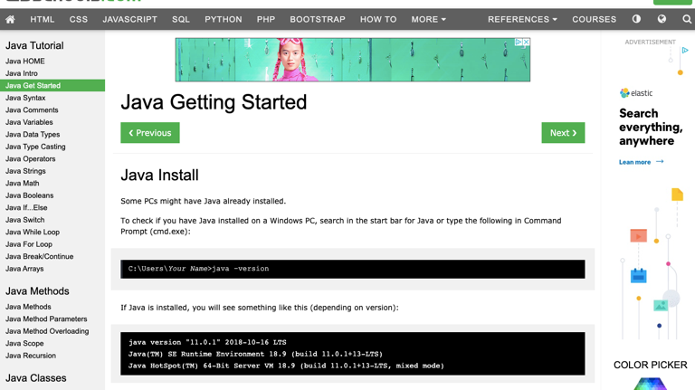(29)

2.6.2 CodeAcademy

Code academy is like W3Schools with it being a free to use, code learning application. However, this application offers personalized accounts, allowing users to save progress whilst learning to code. This feature can be considered useful as Sean M. Stone believes ‘saving digital information has become an everyday facet of human behavior’ (30). The website application allows free roam of its resources allowing users to enroll on specific courses. However, from reviewing the navigation and usability of the application it seems clunky and confusing at times. Anthony Grant believes that the Code Academy course does not ‘teach you to think like a coder’ (31), mainly becomes it doesn’t apply tutorials to ‘real life problems’ (31). This is supported by Gachr who states ‘you can’t experiment, you only have closed environments and tasks’ (32). A conclusion can be drawn that CodeAcademy does not allow users to express and develop their programming skills freely.

2.6.3 Solo Learn

Solo learn is another code learning online application. Like the other applications reviewed, solo learn offers a free choice of coding language to learn. The application teaches students differently in comparison to W3Schools and CodeAcademy. It follows a learning hierarchy meaning the learner must ‘first master a set of lower-level intellectual skills that are prerequisites to the higher order skill’ (33). This method of learning is supported by Bernhard Hengst as he believes that the advantage ‘of hierarchical decomposition is a reduction in computational complexity’ (34). This method of learning ensures beginners learn productively without missing key-stages in their development. However, In Jakob Nielsen’s principles of design he believes ‘users to remain in control of the system’ (35). This suggests that users can become stuck and frustrated whilst trying to use Solo Learn as a learning application. Below is a screenshot of Solo Learns learning structure.

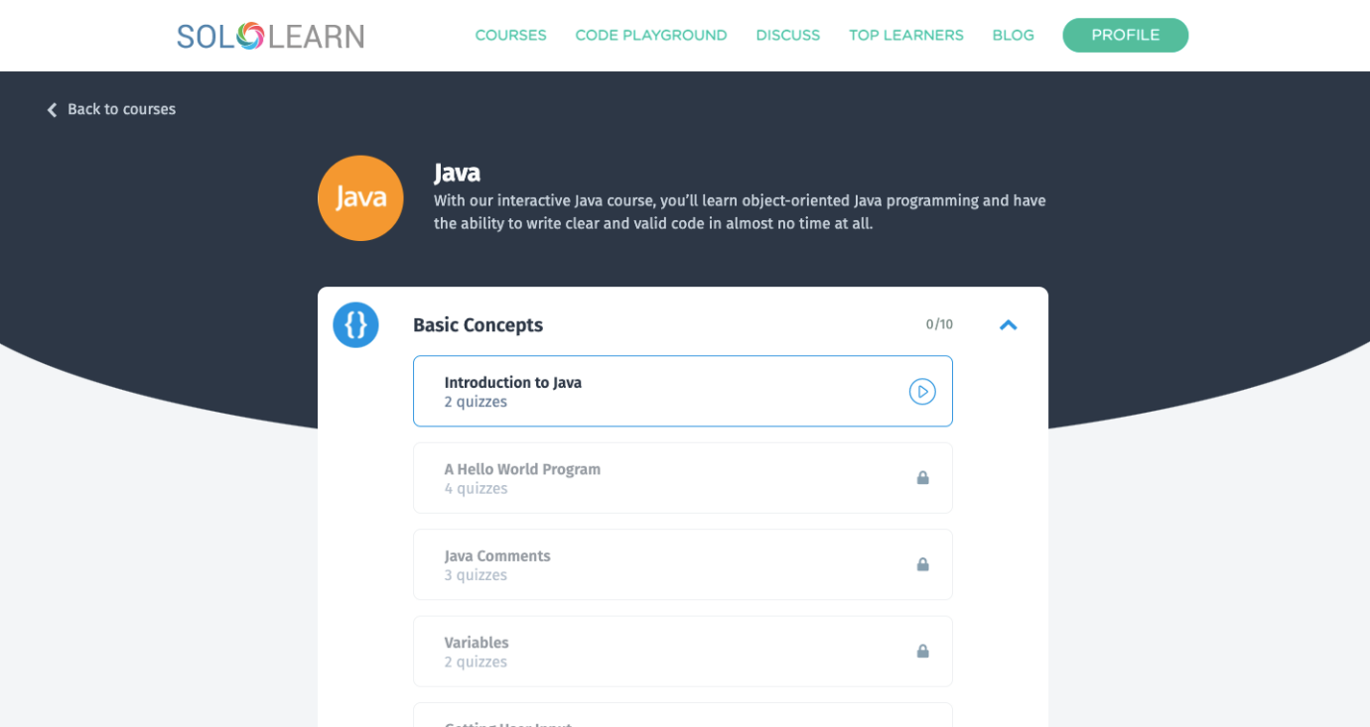
(36)

2.7 Government initiatives

The Government believes that ‘the fast paced world of technology is constantly evolving’ (37). They conducted a study that showed ‘1.2 million more people with specialist digital skills are needed by 2022’ (37). This suggests that the importance of developing accessible applications to teach students how to refine and develop computing skills are needed. The Government aim to maintain ‘the UK’s position as a leading global digital economy’ by developing and improving students learning environments. Other government initiatives include ‘introducing children to skills like computing and coding from an early age’ (38). This is part of their plan to ‘ensure Britain is the place to learn to code’ (38). This supports the projects’ purpose of developing an application for beginning programmers.

The Government wishes to ‘replace the old ICT program of study” (38), by teaching children how to code, develop programs and understand how a computer works. This suggests that there is a need for teaching code applications. Further research shows that the government is funding computing hubs, for ‘teachers who want to improve their knowledge of computer science’ (39). This supports the previous statement to ‘ensure Britain is the place to learn to code’ (38). This strengthens the theory that the need for learning applications is needed more than ever.

The Government state that ‘computer science students must develop practical programming skills’ (40). Further saying these skills must cover the ability to ‘design, write, test and refine computer programs’ (40). This supports the development of the online learning application as it aims to cover these skills. The Government conducted a study by interviewing computer science students on their educational experiences. The study showed the courses ‘had not always adequately prepared them for the working world’ (41). It also showed that students only took the course because ‘they would be in high demand from employers. This research suggests that the current learning tools and technologies are unjoyful to use, with students only taking the course for job security.

2.8 Gender Imbalance

Gender imbalance in the computer science industry has always been questioned. From the literature found there seem to be more psychological factors at play than originally thought. Studies conducted by Rasmussen College found that ‘less than 20 percent of bachelor’s degrees in Computer Science and Engineering are earned by women’ (42). The reasoning behind this is due to social barriers according to the frontiers in psychology. The study suggests women choose not to ‘pursue Computer Science because they believe stereotypes about the kind of people who work in the field’ (42). The study is alarming and implies that significant changes are needed to neutralize any gender bias that may be involved in computer science.

Ellen Spertus suggests that the number of women in the industry seems to be ‘increasing at a slow rate or even decreasing’ (43). Spertus believes this is down to women being conscious of being treated differently from men. A study was conducted to assess if teachers played an impact on advising the learner's career path. The study showed that ‘many women felt they had been given inadequate advice on careers’ (43). Spertus suggests that this could be caused by social issues, with it beginning in a female's childhood. This information suggest that women are not pursuing a computer science career path due to stereotypes and the lack of information provided by their learners.

These findings are contradicted by Reges, who from using data from the Digest of Education statistics found that ‘computer science has gone through boom-and-bust cycles among undergraduates’ (44). With both male and female students in the field going up and down at the same time. This suggest that gender imbalance is more linked to general views of computer science. Reges all states that ‘faculty members have reached out to women with the potential to succeed’ with these efforts have grown the number of women in the field. A conclusion can be made that gender imbalance in the industry is a difficult topic to cover. However, with this information a neutral approach can be made to the development of the application, that suits all gender types.

2.9 Application Usability

With every application developed, usability for the user interface design needs to be considered. Jakob Nielsen believes usability ‘is a necessary condition for survival’ (45). Nielsen believes with the use of usability principles improves ‘how easy user interfaces are to use’ (45). This contradicts my previous findings from Clark who believed content is more important than all. Nielsen also states ‘if a website is difficult to use, people leave’ (45). The project's purpose is to entice and engage with new learners, so if true usability of the application needs to be considered for the project to be a success. Ben Schneiderman supports Jakob Nielsen’s beliefs as he believes a good usable application needs a ‘great, productive and frustration free user interface’ (46). This suggests that usability plays a key part in the success of an application.

Further research conducted by the Management Research News, showed ‘ease of use was the criteria that the respondents considered most important’ (47) whilst choosing their application. Steve Wallace suggests that ‘cultural differences’ need to be considered when designing an application. This is important as the application aims to attract a wider variety of users. An assumption can be made that the online learning application needs to be catered carefully towards all target audiences. According to UnixWare, ‘clear communication between the user and the computer is the working premise of a good UI design’ (48). A conclusion can be drawn that although content is important for the success of the learning application, usability also plays an important part overall. When designing the application, the use of design principles will be used.

2.10 Conclusion

In summary, the literature suggests online learning is becoming more of the norm in the world of education and that educators have started to adapt to different methodologies to provide the best teaching experience. The literature also confirms that the deliverable is only as good as the content provided and that it take a multi-strategy approach to convey vast information. Also, the review established the risks of computer use and the mitigation methods to be put in place whilst using the application. The literature review also acknowledged that the language of coding to teach is subjective and can be chosen based on preference. The literature review also provided a comparative view on current code learning applications available, allowing the evaluation of both strengths and weaknesses of each. The review allowed a better understanding of the potential reasoning to gender imbalance in computer science and if the learning application itself affects this. Finally, the literature review provided an insight into application usability importance and its role in making an application engaging and enticing to use.

To conclude from the sub-topics, the application to be created will be in the form of a website application using NetBeans. NetBeans has been chosen as it allows a multi-strategy approach to be used and I’m comfortable developing the application using this software. The application will also regulate user use time by created short tasks. The literature suggested that the content included is vital in the success of the application, so the application will involve study sections to go through with lectures and then a multiple-choice quiz with the ability to verify selected answers to provide a sense of achievement. The application will perform this by comparing the student's answers with those stored within the application. The Application will teach users how to code in Java and when designing forms usability principles will be adopted. The application won’t be gender specific and will aim to fit the needs of its target audience (New computing students).

2.11 Primary Research

To expand my knowledge on the current and old teaching methodologies of computer science, I decided to conduct a questionnaire. The questionnaire was devised into 8 questions involving both quantitative and qualitative questions. I took the mix method approach to ‘provide stronger evidence and more confidence in the findings’ (49). The questionnaire was given to a sample size of 10 graduate computer scientists. The purpose of this questionnaire was to find out, what attracted them to computer science and to see if they had any suggests related to improving a beginners first experience. This would hopefully better the outcome of the project.

The first finding from the questionnaire showed that 80% of the respondents, had an initial interest in the subject field. The question was open-ended allowing me to select keywords forming them into discreate categories of data. Keywords such as hobbies and fun were amongst the most common used words. These findings contradict Ellen Spertus research of women being treated differently, as none of the respondents mentioned being advised by a teacher/parent to take the path of a computer scientists. A conclusion can be drawn that influential factor to taking computer science as a subject, may not be as gender specific as first thought.

Another question in the primary research, was the learning application enticing? Again, this questions aim was to evaluate current technologies, to adapt their positives to my own application. The question was closed ended, the questions outcome was, that most respondents experienced was average. An assumption can be created that applications were not enticing and joyful to use. This supports the literature of Hakan Tuzun, as the respondents seemed to be in a ‘passive state’ on their first coding experiences. The next question with notable responses, was to rate your learning experience out of 5. To analysis the results I found the average from the respondents to be a 2. This outcome confused me, as it drew a conclusion that initial experiences does not change a learner's mentality towards becoming a computer scientist. The next question with adequate responses, was what learning tools you have used and your thoughts on them. I had a lot of mix responses for this question, some unusable, which I believe was down to the wording of the question. However, a lot of respondents mentioned they have used W3Schools and Code Academy during the duration of their education. With keywords such as ‘easy learning’ being used by most. This supports W3Schools goals of having an application that practices easy learning. I could conclude that taking the best elements from each current technology tool and putting them into one application, would be most beneficial to the outcome of this project.

Another question that provided insightful knowledge was what features of the online learning applications did you like the most? The responses were analysed into keywords, the main responses all concluded towards usability. Respondents believed that by having an application that was easy to navigate and covered the main usability principles, benefited the learners experience. This was interesting as it contradicted Clark's suggestion that content is more important than the deliverable. However, when designing the application, I feel both are equally as important and will be carefully considered. Another keyword was feedback, it seemed respondents like the element of feedback with most stating it allows trial and error when learning. This supports Dewey’s research from the lit review with trial and error being a good method of online learning.

The last question to mention was what improvements would you make to the online learning tools? The purpose of this question was to have a range of perspectives on how to improve online learning. The responses were insightful. A lot of the respondents suggested making the learning more interactive, during learning. This supports the findings from the literature review that by heighten interactivity, improves students learning. Other suggestions included make the user interface ‘enticing’ and start from the very basics of coding.

Chapter 3- Methodologies

3.1 Research Methodology

3.1.1 Philosophy

Positivism will be used during research as it ‘adheres to the view that only “factual” knowledge gained through observation (the senses), including measurement, is trustworthy.’ (50). This philosophy will be used to strengthen the validity of the research as its back with evidence to support findings. The data from using a positivism approach is also known as empirical evidence, meaning positivism is based on empiricism. This philosophy has its advantages one being data is quantitative. Although qualitative data will be gathered during this project, it will be converted into quantitative data as its easier to analyse and scientific assumptions can be drawn. Another advantage of using positivism is its structure, as it follows specific laws and rules, there is minimum room for error. This is beneficial to the project as the aims and objectives are more likely to be achieved. However, using positivism as a research philosophy has its drawbacks. A Major drawback is while conducting research human emotion and behaviour must be disregarded. This will be difficult as ‘human behaviour naturally comes with human responses’ (51). To prevent this, I will need to careful considered research sources without inputted any biased behaviour.

3.1.2 Approach

The approach chosen is deductive and has been applied during the research process. The approach will allow me to assess current studies or theories and determine a suitable application based on hypotheses from these theories. The benefits to using this approach is research findings can be generalised, meaning relationships between concepts and variables can be explained. This is beneficial to the project as the approach ‘goes straight forwardly to the point and is time saving’ (52). However, Hammond believes that deductive research assumes that ‘all disciplines in natural science function the same way’ (53) when they do not. When developing hypotheses this must be considered.

3.1.3 Strategy

Case studies will be the strategy chosen for this project because it involves ‘up-close, in-depth and detailed investigation of a subject of study’ (54). The case studies can be used to ‘explain, describe or explore events or phenomena in the everyday contexts in which they occur’ (51). This strategy can be utilized amazingly due to the sheer number of case studies available for this project. A benefit of using case studies would be it turns opinions into facts, this is important as the research process is taking a positivism approach. Another benefit of using case studies is it involves several different research methodologies; this is beneficial to the project as questionnaires will be used. Case studies also offer accessibility to readers, meaning data is formatted for readers to note the outcomes. However, case studies do have their limitations, this being it takes longer to analyse data. This limitation can be managed by giving the research process more allocated time.

3.1.4 Time Horizon

Longitudinal will be the time horizon as the application will be prototyped and developed over a long duration which during this time changes will be monitored accordingly. This method allows for future improvements in the iterations during the application development. Longitudinal studies will offer extreme flexibility. This type of time horizon benefits the project as online learning methods are changing frequently, but by examining the same area over a long period of time, allows changes to be made throughout the project's life. However, using longitudinal studies has the drawback that participates may drop out over time. To minimise this risk the testing will be conducted using iterative testing, decreasing the number of participants involved with the project.

3.1.5 Data Collection

The collection method will be in the form of a questionnaire using the mixed-method approach. This will allow both qualitative and quantitative data to be collected and the capability to assist the development of the application based on the data gathered. Questionnaires have been chosen as the data collection method because they are cost effective. They also allow the project to gain data from a target audience. Another benefit of questionnaires is they provide fast results, with the project having deadlines to meet this is important. However, using questionnaires has drawbacks, for instances incorrect feedback. This can ruin the validity of the responses and the project. To mitigate this risk questionnaires will be given out to a specific target audience who can relate to the questions being asked. Additionally, a big enough sample size of participates will be chosen with consideration of incorrect feedback.

3.1.6 Evaluation Criteria

To evaluate the projects outcomes, I have devised a set of project requirements. They were created based of both the primary and secondary research outcomes. Below are the evaluation criteria:

- To ensure the application provides ease of learning.
- That the application provides interactivity throughout the learning aspects.
- The application offers trial and error elements, and feedback is provided.
- To ensure tasks are short to complete.
- The application offers user freedom and control.
- The ability for unique user accounts.
- That consistency and standards are applied throughout the application.
- The implementation of error prevention methods

3.1.7 Methods of Testing

For this project, functional testing will be conducted, that involves, unit testing, system testing, usability testing and acceptance testing.

Unit testing is the testing of ‘the smallest piece of code that can be logically isolate in a system’(55). This form of testing was chosen as it identifies bugs quick and easily. Furthermore, saving time, allowing more development of the application. This form of testing also allows code to be reusable and reliable as its clean and efficient.

System testing is the testing of a system. This form of testing is crucial to the project’s success as it checks to see if the everything is functioning as expected. System testing is useful as it verifies the system against functional and technical user requirements. This testing stage will also find large defects that other forms of test will not be able too. However, this type of testing is time consuming. Enough time needs to be allocated to system testing, to ensure it completed correctly.

Usability testing is the testing of how easy something is to use, by using real users as the testers. This form of testing creates a direct communication with the target audience. It also highlights potential problems before product launch. This type of testing also gives the opportunity to make further changes to improve user performance and satisfaction.

Acceptance Testing is the technique performed to see if an application has met the requirement specifications. This form of testing will verify if the application complies with in delivering user requirements to end users. This form of testing will reduce the risk of defects occurring when application goes live.

3.2 Development Methodology

Feature Driven Development will be used for the development of the application as the project is long and continually changing. By using FDD provides a better understating of the projects scope and context, hopefully resulting in better project outcomes. FDD’s software development is based of making progress on features. With the online learning application, involving loads of different features, this development methodology is more than suitable. Using FDD will minimize complexity with the development of the application, as it breaks down projects into smaller components.

3.2.1 Software

The software chosen includes Windows 10 OS, which will allow the application to be used after development. Windows 10 OS was chosen as it is important for an operating system to be updated. Using out of date OS systems can lead to malicious attacks, affecting the overall outcome of the project. NetBeans will be the IDE program for building the application. NetBeans is one of the more comfortable IDE languages I have used, with it also offering the ability to make web applications. I have also chosen this IDE as it uses the coding language Java that I prefer to code in. NetBeans also has a range of libraries and resources to support me throughout the development of the project. The last type of software to be used are DAT files, this will act as data storage for user details. I have chosen this form of storage as it is easy to use and convenient when calling upon the stored data.

3.2.2 Hardware

The hardware chosen to develop the application is powerful enough to run the application after the development has been completed, the hardware includes a CPU – i5-4690K, a GeForce GTX 1050 TI, 1TB of storage, and finally 16GB of RAM. The computer hardware here is more than capable of editing and running text files. The computer also has plenty of storage to store user records in the thousands. If additional space is needed, additional SSD drives can be implemented. The CPU used provides fast processing, that translates into increased productivity and efficiency whilst developing the application.

3.2.3 Materials and tools

NetBeans IDE was the chosen package to develop the application, firstly because it is free. The IDE also simplifies the development of web applications that use java. This made it more than a suitable choice as the language being taught in the application is java. The IDE also has ease of use features such as auto completion of code, making the development process more efficient. Another feature NetBeans offer is its ability to run server-based applications easily. This provided a user like experience as if the application were live, this would be beneficial the applications development. The last reason of using NetBeans is, as previously mentioned, the abundance of resources available to aid the development of the application.

Chapter 4 - Design & Implementation

4.1 Design

4.1.1 Project Requirements

The project requirements for the development of the application derived from both the primary and secondary research outcomes. Both methodologies of research provided insightful information on the elements necessary to making a good online learning application. The research also elaborated on what does not making a good online learning tool, reducing the chance of the project being a failure. The project requirements are as follows:

- To ensure the application provides ease of learning.
- That the application provides interactivity throughout the learning aspects.
- The application offers trial and error elements, and feedback is provided.
- To ensure tasks are short to complete.
- The application offers user freedom and control.
- The ability for unique user accounts.
- That consistency and standards are applied throughout the application.
- The implementation of error prevention methods

4.1.2 Data Flow Diagram

I decided to create a data flow diagram, to represent the flow of data across the login system. This would allow the user to gain a better understanding of the limits within the system. The use of the data flow diagram allows the system to be understood by both technical and non-technical users. Below is the 0-level DFD.

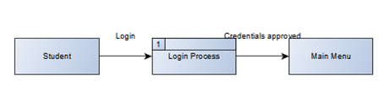

As you can see from this level 0 DFD, it explains how the login system would work with a single process. The next level 1 DFD will decompose the context diagram into multiple processes, to explain the flow of data within the login system.
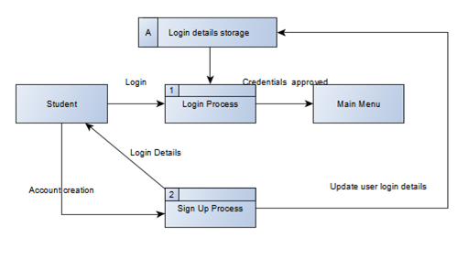
As you can the login system has been decomposed into multiple processes, with the sign-up process being added for new users. The level 1 DFD also shows the storage for the login details, which is used to store and call upon data. It also shows that when a new account is created the details get stored in the data storage ready for the user to login.

4.1.3 Logic Flow Chart

The next system model created is a flow chart, the purpose of this flowchart was to streamline the processes of the application without the use of technical jargon. The flowchart was extremely useful in defining a start and end point for the learning application. The flowchart also allowed an evaluation of certain processes, to see if any changes were necessary to improve the systems flow. Below is the logic flow chart for the online learning application.
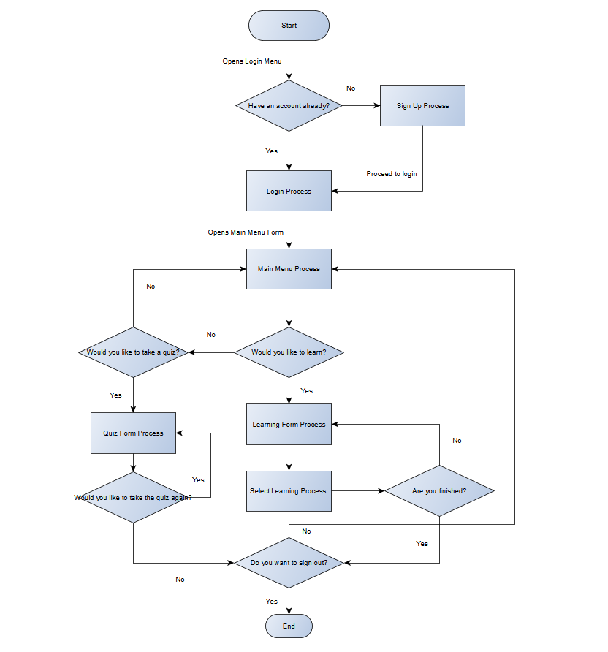
As you can see from the flow chart, there is a clear structure into how the application should work. The flowchart was used as a comparative tool whilst building the application. It improved code efficiency as it acted as a type of blueprint for the development process.

4.2 System Interface

I decided to develop mock-ups for my learning application, as it provides an overview of what the final product aims to look like. Developing mock-ups also allowed me to explore design decisions, before starting to write the code. This part of the system design plays an important part in the success of the application, as from the primary research usability plays a huge part in the success of online learning applications, therefore by laying the design out I could ensure this criterion was achieved.
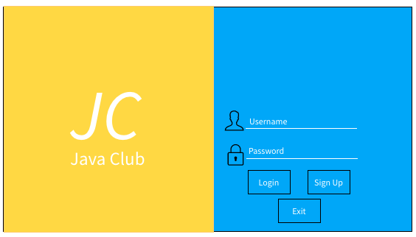

This is a mock-up of the login form. I decided to keep it simple, but recognisable. This would be to ensure new users would know what to do when first visiting the application. The colour scheme of the application follows an off orange/blue scheme, this is to relate to the java logo colours.

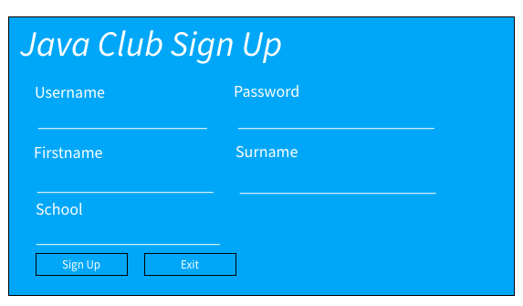

This is the sign-up form; it requires users to enter the most basic of user information. This is because user information is not really needed throughout using the application. However, having a sign-up form provides a user a customised feeling, making the experience more memorable to them.
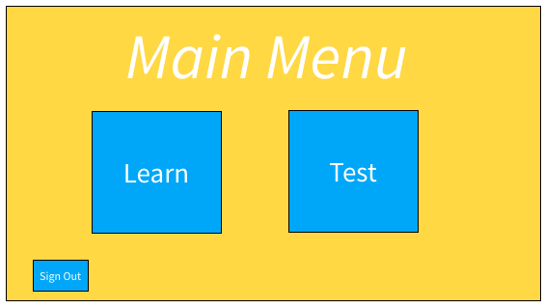

This is a mock-up of what the main menu aims to look like, it involves two feature buttons, learn and test. The form also allows users to sign out of there account when finished. As you can see the forms are following Jacob Nielsen’s design principles with ‘error prevention’.

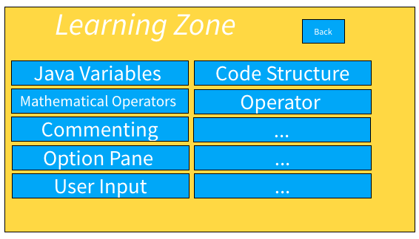

This is the mock-up of the learning form, that appears after the learn button is selected on the main menu. The form offers a wide variety of different topics to study. The form also provides a back button, which takes you back to the main menu, as you can see, I have kept consistency with the colour scheme throughout the mock-ups.
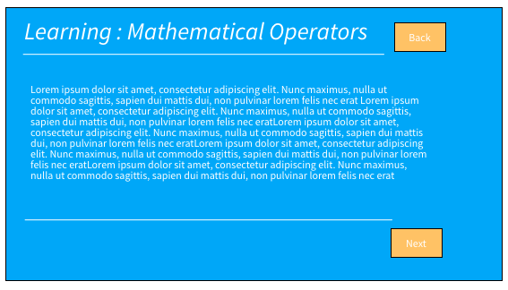

This is an example mock-up of what the learning topic forms will look like, it will give a short lesson on the topic. The form also allows users to go back to the learning form or continue studying the topic chosen.

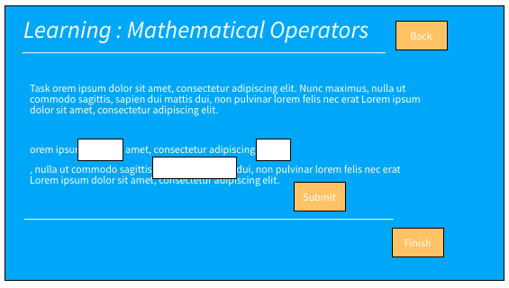

This is the practice form that follows on from the previous form when selecting next. The purpose of this form is to practice skills learnt from learning. There is a submit button that provides feedback to learners based of their answers. This form is mirrored though all topics of learning in the application.
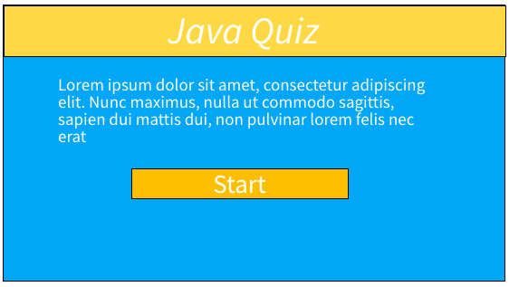

This is the mock-up if the user were to select the test button on the main menu form. It will act as an introduction page to the quiz.

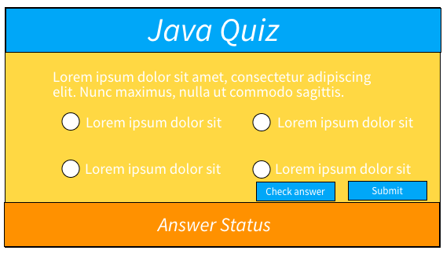

This is the quiz question format that will be multiple choice. The students can check their answer and submit to go onto the next.
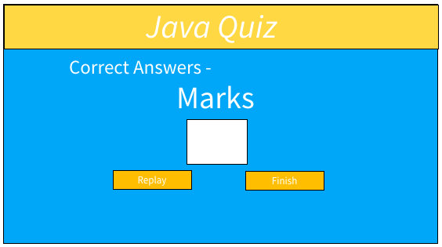

This is the results mock-up that will provide users with the number of questions they got right. It also allows users to take the quiz again or finish and go back to the main menu.

4.3 Implementation

4.3.1 Problems and Successes

During the development of the online learning application, there were noteworthy problems and successes. A main problem to highlight was how to validate the first two inputs in a text field. I have only done basic java validation, so originally, I did not have a clue. This problem wasted a significant amount of time, however after looking at forums and tutorials I found a solution to the problem. Although this problem did waste time, I would consider it a success also. This is due to the research conducted to find the solution, provided much more information on other validation techniques that could be used throughout the application.

A success in the coding of the application, would be the login and sign-up system. I have previously designed login and sign-up systems, so I did not expect this section to take long. It went smoothly with the features being feature tested, almost immediately using the feature driven development methodology. This saved time that could be allocated elsewhere. Another problem that I encountered whilst developing the application was how to code a score system. The test needed a way for users to measure their knowledge, so it was important this feature was implemented. This section of code took ages, resources were limited and not very insightful. Eventually I found a way, to allow scores to be carried across each question using global variables and counters.

4.3.2 Unit Testing

The first testing to be carried out was unit testing. This type of testing was carried out primarily after each feature was development and undertook the feature driven methodology. Unit testing allowed the capabilities of testing individual bits of code the see if their excepted outcomes correlated with the actual outcomes. The unit testing was conducted using a testing table. The table included test data such as, test name, test number, test type, expected results and the actual results. If the the actual outcome were not the same as the expected outcome, changes would be made accordingly with the test number being retested. However, if the expected outcome correlates with the actual outcome the next feature can be tested.

4.3.3 System Testing

The next type of testing to be carried out was system testing. This testing allowed the system to be tested end to end, it also performed functional and non-functional testing elements. Like unit testing, a test plan was devised. The test data was used to verify the interaction between all the system components, to see if they provided expected outcomes. If a system test outcome did not match the expected outcome, the relevant changes were made and the test retested. This reduces the number of issues that could occur if the system went live.

4.3.4 Usability Testing

Usability testing was the next type of testing to be carried out. The goal of this test was to have a participate perform tasks and provided feedback whilst observing their behaviour. A tasks list was created, that included all the features from the feature driven development. This provided the opportunity to have a neutral view on the functional and usability aspects of the application. The tester was a current computer science student, meaning they have used online learning application tools before. Making them a suitable usability tester. From the feedback given changes were made where seemed appropriate.

4.3.5 Acceptance Testing

The last type of testing conducted was acceptance testing. This form of testing allowed me to see if the system complied with the user requirements. For this type of testing, I created a test plan that included test case ID, test name, test objective, test procedure, expected outcome and actual outcome. Any expected outcomes that were not achieved will be changed and retested, otherwise the system will not be accepted.

Chapter 5 – Evaluation

One of the main points of evaluating the successfulness of the application is through its ease of learning. This was achieved as evidenced by the usability testing, with the participant highlighting how easy it was to select topics of interest and how the learning content is tailored to beginner programmers. The relevancy of this achievement is supported by Brain Wong’s belief that ease of learning is why W3Schools is so successful. Another main point that evaluates the successfulness of the application is through its interactivity throughout the learning aspects. This requirement was achieved due to the development methodology of feature driven development, which allowed interactivity features to be tested individual ready for implementation into the real world.

Ensuring that the tasks are short to complete is important to the applications usability. This aspect was achieved by creating short tutorials at the end of each learning topic. This was evidenced in the usability testing, with the participant finishing learning topics in no more than 20 minutes. This complies with the risks identified in the literature review, particularly the danger of eye strain and repetitive strain injuries in long-duration computer usage. The application offering trial and error elements was another requirement toward the evaluation of the application. This requirement was achieved, however there are some areas of improvement. While the learning trial and error features were sufficient, the quiz could offer further feedback to the student. This would improve the system as suggested within the primary research where feedback was found to be the most liked feature of an online learning application.

The ability for unique user accounts was achieved in the application design. This is proved in the systems testing, in which a test was successfully conducted to evaluate the interaction between user and system login. The system testing also proved that consistency and standards are applied throughout the application, since each individual test provided its expected outcome. This attains to Ben Schneiderman's recommendation towards a frustration-free application. This also relates to the requirement for the implementation of error preventing methods within the system. This is demonstrated in the application through the useability testing, where the participant encountered no errors within the system. The final criterion of evaluation for the application was to offer freedom and control to the user. This was achieved as this application allows the student to decide what topic they would prefer to study. However, this feature is less detailed compared to Solo Learn's platform who provided a hierarchical learning structure.

One of the objectives of this project was to conduct a literature review to gain insight into the topic of online learning. This was completed in-depth within a variety of topic areas. Some areas of this review, such as the effectiveness and different methods of online learning, were inherently beneficial towards the project outcomes. However, areas such as the question of gender imbalance within computer science potentially strayed outside the scope of the project. Primary research was also conducted and was found to be consistent in its findings in relation to the literature review. As discussed, the online learning application was also fully developed, successfully meeting the evaluation criteria. A feedback form was also constructed, which will be used to obtain suggestions to possible areas of improvement. This will further the applications effectiveness and competitiveness within the online learning market.

The aim of the project was to investigate the current online learning environment, and to use the findings towards the development of an effective application. From the discussed objectives of the project, it can be concluded that the aim of this project was attained. If this project were to be completed again, the scope of the research would be widened to strength the validity of the project outcomes. Iterative development methodology would also be used instead of feature driven development. This would introduce feedback into the development process, improving the effectives of the platform towards the target audience.

Chapter 6 – Conclusions and Recommendations

This project has provided an investigation within the current online learning environment. This entailed a literature review into the different areas of learning, establishing what provides its effectiveness and the different methods of achieving this. The main findings of the literature review were the subjectiveness of the programming language chosen by the online learning application, and the importance of the learning content and usability of the application towards effective learning. It was also found that student engagement can be increased by using a mixture of synchronous and asynchronous learning methods.

The literature review was supported successfully by the findings of primary research, which correlated well in its findings. The main finding of this was that majority of respondents introductory experience into programming was average. This provided the necessary tools for the development of an effective application. The design process was documented in full through a top-down approach. The overall effectiveness of the system was proven through its unit, system, usability, and acceptance testing with the aid of a testing participant. This resulted in the evaluation criteria of the system to be met.

The continuation of this project would involve the implementation of more programming language courses onto the application platform. This would expand the scope of the target audience for the learning system, enticing students who wish to learn programming towards different applications. Another area of further work would be to expand the scope of the learning course material. To achieve this, deeper research into the differences between beginner and intermediate learning content would have to be undertaken. This would further the understanding for the development of an effective online learning application.

Chapter 7- Reflection

One area of reflection for this project would be in the early stages, during the development of the project proposal. My original aim was to only investigate the relevancy of online learning in the present day, even though I wished to also develop a learning application of my own. This meant that the objectives of the project were hard to identify, therefore creating no clear path to the success of the project. Going forward, I would ensure that the aims of following projects were complete and fit for the purpose of the investigation.

Another problem encountered during the project was the misallocation of time for certain tasks, such as the testing stages of the application. This may have potential damaged the validity of the project’s outcome, in relation to the evaluation criteria. This was a cause of limitations due to the COVID-19 pandemic, resulting in distractions within the working space. This can be solved through working in a less distracting environment, or by planning the project with distractions in-mind accordingly.

The final point of reflection for this project is the sourcing of information for an investigation. I have learnt that it is better make use of sources which are more detailed to a particular topic of study. This is important to ensure that the supporting evidence for the points discussed are well documented and understood. Using sources such as these in the future will increase the validity of the literature review. This was learnt from the gender imbalance in computer science section of the report, which ultimately led to no conclusion due to a lack of supporting evidence.

References

1. Sentance S, Csizmadia A. Computing in the curriculum: Challenges and strategies from a teacher’s perspective [Internet]. Springer Link. 2021 [cited 23 April 2021]. Available from: https://link.springer.com/article/10.1007/s10639-016-9482-0

2. Is online education as effective as traditional on-campus schooling? [Internet]. Utep.edu. 2021 [cited 23 April 2021]. Available from: https://www.utep.edu/extendeduniversity/utepconnect/blog/november-2018/is-online-education-as-effective-as-traditional-on-campus-schooling.html

3. The Theory and Practice of Online Learning [Internet]. Google Books. 2021 [cited 23 April 2021]. Available from: https://books.google.co.uk/books?hl=en&lr=&id=RifNwzU3HR4C&oi=fnd&pg=PA15&dq=is+online+learning+good&ots=Sh6iOkIUoy&sig=wf4p607rlsVx28ii7DKImUkrBRc&redir_esc=y#v=onepage&q=is%20online%20learning%20good&f=false

4. The Theory and Practice of Online Learning [Internet]. Google Books. 2021 [cited 23 April 2021]. Available from: https://books.google.co.uk/books?hl=en&lr=&id=RifNwzU3HR4C&oi=fnd&pg=PA45&dq=is+online+learning+good&ots=Sh6iOkIUoy&sig=vhzSxGJ1IcvytJP0jciRTR7GEkA&redir_esc=y#v=onepage&q=is%20online%20learning%20good&f=false

5. Strengths and Weaknesses of Online Learning - ION Professional eLearning Programs - UIS [Internet]. Uis.edu. 2021 [cited 23 April 2021]. Available from: https://www.uis.edu/ion/resources/tutorials/online-education-overview/strengths-and-weaknesses/

6. [Internet]. Ditacademy.org. 2021 [cited 23 April 2021]. Available from: https://ditacademy.org/wp-content/uploads/2017/08/Online-Learning-Effective.pdf

7. Advantages and Disadvantages of Online Courses | Montgomery College, Maryland [Internet]. Montgomerycollege.edu. 2021 [cited 23 April 2021]. Available from: https://www.montgomerycollege.edu/academics/online-learning/distance/advantages-and-disadvantages-online-courses.html

8. Khan T. What are the Disadvantages of Online/Virtual Learning and Teaching? [Internet]. https://www.researchgate.net/post/What_are_the_Disadvantages_of_Online_Virtual_Learning_and_Teaching. 2021 [cited 23 April 2021]. Available from: https://www.researchgate.net/post/What_are_the_Disadvantages_of_Online_Virtual_Learning_and_Teaching

9. Best Practices: Online Pedagogy [Internet]. Teachremotely.harvard.edu. 2021 [cited 23 April 2021]. Available from: https://teachremotely.harvard.edu/best-practices

10. Take your teaching online [Internet]. OpenLearn. 2021 [cited 23 April 2021]. Available from: https://www.open.edu/openlearn/ocw/mod/oucontent/view.php?id=77528&section=1

11. Strategies and Tips for Successful Online Teaching [Internet]. SAGE Publications Inc. 2021 [cited 23 April 2021]. Available from: https://us.sagepub.com/en-us/nam/strategies-and-tips-for-successful-online-teaching

12. [Internet]. E-mentor.edu.pl. 2021 [cited 23 April 2021]. Available from: http://www.e-mentor.edu.pl/_xml/wydania/4/41.pdf

13. Introduction to Visual Basic [Internet]. Vbtutor.net. 2021 [cited 23 April 2021]. Available from: https://www.vbtutor.net/lesson1.html#:~:text=BASIC%20means%20Beginners'%20All%2Dpurpose%20Symbolic%20Instruction%20Code.&text=Visual%20Basic%20is%20a%20user,to%20replace%20Visual%20Basic%206.

14. [Internet]. Digitalcommons.brockport.edu. 2021 [cited 23 April 2021]. Available from: https://digitalcommons.brockport.edu/cgi/viewcontent.cgi?article=1196&context=ehd_theses

15. [Internet]. Columbia.edu. 2021 [cited 23 April 2021]. Available from: http://www.columbia.edu/~cp2124/papers/computer2.pdf

16. Publishing H. Electronic screen alert: Avoid this vision risk - Harvard Health [Internet]. Harvard Health. 2021 [cited 23 April 2021]. Available from: https://www.health.harvard.edu/diseases-and-conditions/electronic-screen-alert-avoid-this-vision-risk

17. Eye strain | The London Clinic [Internet]. Thelondonclinic.co.uk. 2021 [cited 23 April 2021]. Available from: https://www.thelondonclinic.co.uk/conditions/eye-strain

18. Tips to prevent computer-related RSI [Internet]. nhs.uk. 2021 [cited 23 April 2021]. Available from: https://www.nhs.uk/live-well/healthy-body/tips-to-prevent-rsi/

19. What is a good first programming language? | XRDS: Crossroads, The ACM Magazine for Students [Internet]. Dl.acm.org. 2021 [cited 23 April 2021]. Available from: https://dl.acm.org/doi/abs/10.1145/1027313.1027320

20. 4 Programming Languages for Beginners | Concordia University, St. Paul Online [Internet]. Concordia University, St. Paul Online. 2021 [cited 23 April 2021]. Available from: https://online.csp.edu/blog/technology/programming-languages-for-beginners/

21. Which Programming Language Should Students Learn First? A Comparison of Java and Python [Internet]. Ieeexplore.ieee.org. 2021 [cited 23 April 2021]. Available from: https://ieeexplore.ieee.org/document/7126267

22. [Internet]. Sciresol.s3.us-east-2.amazonaws.com. 2021 [cited 23 April 2021]. Available from: https://sciresol.s3.us-east-2.amazonaws.com/IJST/Articles/2011/Issue-8/Article23.pdf

23. [Internet]. 2021 [cited 23 April 2021]. Available from: https://medium.com/swlh/dont-choose-python-as-your-first-programming-language-bdb7a1e03946

24. Python Tutorial: Learn Python For Free | Codecademy [Internet]. Codecademy. 2021 [cited 23 April 2021]. Available from: https://www.codecademy.com/learn/learn-python

25. [Internet]. Cs.rutgers.edu. 2021 [cited 23 April 2021]. Available from: https://www.cs.rutgers.edu/~biglars/python/python-in-education.pdf

26. The Visual Basic .Net Programming Language [Internet]. Google Books. 2021 [cited 23 April 2021]. Available from: https://books.google.co.uk/books?hl=en&lr=&id=ejzRTF2TL6UC&oi=fnd&pg=PR17&dq=visual+basic+programming+language&ots=ThVWClMK_c&sig=Xd_OWvxoRqAgQ3m2m0HlfQgnetA&redir_esc=y#v=onepage&q=visual%20basic%20programming%20language&f=false

27. Top 25 Websites for You to Learn Coding for Free in 2021 [Internet]. Hostinger Tutorials. 2021 [cited 23 April 2021]. Available from: https://www.hostinger.co.uk/tutorials/learn-coding-online-for-free/

28. Resources P. A review of W3Schools as a web dev resource - Pathrise Resources [Internet]. Pathrise Resources. 2021 [cited 23 April 2021]. Available from: https://www.pathrise.com/guides/a-review-of-w3schools-as-a-web-dev-resource/#:~:text=An%20open%2Daccess%20platform%2C%20W3Schools,how%20the%20programming%20languages%20work.

29. On the Usability Evaluation of E-Learning Applications [Internet]. Ieeexplore.ieee.org. 2021 [cited 23 April 2021]. Available from: https://ieeexplore.ieee.org/abstract/document/1385237

30. Saving-Enhanced Memory: The Benefits of Saving on the Learning and Remembering of New Information - Benjamin C. Storm, Sean M. Stone, 2015 [Internet]. SAGE Journals. 2021 [cited 23 April 2021]. Available from: https://journals.sagepub.com/doi/abs/10.1177/0956797614559285

31. Why You Shouldn't Learn to Code With Codecademy [Internet]. MUO. 2021 [cited 23 April 2021]. Available from: https://www.makeuseof.com/tag/4-reasons-shouldnt-learn-code-codeacademy/#:~:text=Simply%20put%2C%20you%20need%20to,them%20to%20real%2Dlife%20problems.

32. Why Codecademy and similar websites SUCK [Internet]. Linus Tech Tips. 2021 [cited 23 April 2021]. Available from: https://linustechtips.com/topic/543658-why-codecademy-and-similar-websites-suck/

33. Learning Hierarchy Technique [Internet]. Link Springer. 2021 [cited 23 April 2021]. Available from: https://link.springer.com/referenceworkentry/10.1007%2F978-1-4419-1428-6_1803

34. Hierarchical Reinforcement Learning [Internet]. Link Springer. 2021 [cited 23 April 2021]. Available from: https://link.springer.com/referenceworkentry/10.1007%2F978-0-387-30164-8_363

35. Learn Java | SoloLearn [Internet]. Sololearn.com. 2021 [cited 23 April 2021]. Available from: https://www.sololearn.com/learning/1068

36. Schools Minister announces boost to computer science teaching [Internet]. GOV.UK. 2021 [cited 23 April 2021]. Available from: https://www.gov.uk/government/news/schools-minister-announces-boost-to-computer-science-teaching

37. Year of Code and £500,000 fund to inspire future tech experts launched [Internet]. GOV.UK. 2021 [cited 23 April 2021]. Available from: https://www.gov.uk/government/news/year-of-code-and-500000-fund-to-inspire-future-tech-experts-launched

38. Get support from your local computing hub [Internet]. GOV.UK. 2021 [cited 23 April 2021]. Available from: https://www.gov.uk/guidance/get-support-from-your-local-computing-hub

39. [Internet]. Assets.publishing.service.gov.uk. 2021 [cited 23 April 2021]. Available from: https://assets.publishing.service.gov.uk/government/uploads/system/uploads/attachment_data/file/771555/Consultation_Future_assessment_arrangements_for_GCSE_computer_science_Ofqual_18_6439.pdf

40. [Internet]. Assets.publishing.service.gov.uk. 2021 [cited 23 April 2021]. Available from: https://assets.publishing.service.gov.uk/government/uploads/system/uploads/attachment_data/file/523079/bis-16-114-computer-science-graduate-employability.pdf

41. Women in Computer Science: 6 Assumptions to Avoid | Rasmussen University [Internet]. Rasmussen.edu. 2021 [cited 23 April 2021]. Available from: https://www.rasmussen.edu/degrees/technology/blog/women-in-computer-science-assumptions-to

42. [Internet]. Dspace.mit.edu. 2021 [cited 23 April 2021]. Available from: https://dspace.mit.edu/bitstream/handle/1721.1/7040/AITR-1315.pdf?sequence=2.

43. Lecturer's explanation for gender gap in computer science is that it reflect women's choices [Internet]. Insidehighered.com. 2021 [cited 23 April 2021]. Available from: https://www.insidehighered.com/news/2018/06/25/lecturers-explanation-gender-gap-computer-science-it-reflect-womens-choices

44. Usability 101: Introduction to Usability [Internet]. Nielsen Norman Group. 2021 [cited 23 April 2021]. Available from: https://www.nngroup.com/articles/usability-101-introduction-to-usability/

45. Determining the importance of key criteria in web usability | Emerald Insight [Internet]. Emerald.com. 2021 [cited 23 April 2021]. Available from: https://www.emerald.com/insight/content/doi/10.1108/01409170710832250/full/html

46. Culture and the importance of usability attributes | Emerald Insight [Internet]. Emerald.com. 2021 [cited 23 April 2021]. Available from: https://www.emerald.com/insight/content/doi/10.1108/09593841311307150/full/html?journalCode=itp

47. What makes a good user interface? [Internet]. Uw714doc.sco.com. 2021 [cited 23 April 2021]. Available from: http://uw714doc.sco.com/en/SDK_vtcl/vtclgN.style_goodui.html#:~:text=A%20clear%20interface%20helps%20prevent,and%20consistent%20with%20one%20another.

48. Mixed methods study [Internet]. GOV.UK. 2021 [cited 23 April 2021]. Available from: https://www.gov.uk/guidance/mixed-methods-study#:~:text=Benefits%20include%3A,results%20than%20each%20individual%20method

49. Positivism - Research Methodology [Internet]. Research-Methodology. 2021 [cited 23 April 2021]. Available from: https://research-methodology.net/research-philosophy/positivism/#:~:text=As%20a%20philosophy%2C%20positivism%20adheres,interpretation%20in%20an%20objective%20way.

50. Advantages & Disadvantages of Positivism | Synonym [Internet]. Classroom.synonym.com. 2021 [cited 23 April 2021]. Available from: https://classroom.synonym.com/advantages-disadvantages-positivism-12088541.html

51. Advantages And Disadvantages Of Deductive Method - 946 Words | Bartleby [Internet]. Bartleby.com. 2021 [cited 23 April 2021]. Available from: https://www.bartleby.com/essay/Advantages-And-Disadvantages-Of-Deductive-Method-P3QJABLQVAR

52. David J, Rahman M, David J. Differences between deductive and inductive approaches to research | [Internet]. howandwhat. 2021 [cited 23 April 2021]. Available from: https://howandwhat.net/differences-deductive-inductive/#:~:text=Disadvantages%20of%20deductive%20approach%20(research)&text=It%20may%20also%20limit%20the,way%20when%20they%20do%20not.

53. Importance of a Case Study - EssayMin [Internet]. EssayMin. 2021 [cited 23 April 2021]. Available from: https://essaymin.com/blog/importance-of-a-case-study/

54. Crowe S. The case study approach [Internet]. NCBI. 2021 [cited 23 April 2021]. Available from: https://www.ncbi.nlm.nih.gov/pmc/articles/PMC3141799/

55. What Is Unit Testing? [Internet]. smartbear.com. 2021 [cited 23 April 2021]. Available from: https://smartbear.com/learn/automated-testing/what-is-unit-testing/

Appendix 1: Questionnaire Results


