

ASSESSMENT COMPONENT 2 : Marketing Strategies Portfolio

Strategic Marketing Analysis of IKEA’s Brand Extension

: The IKEA Smart study POD

Student name: Rahul Amitkumar Shrimali
Student ID: 2519362
Lecturer name: Mohammad Tariq

Contents
4
1.0 Introduction 4
1.1 RESEARCH ANALYSIS 6
Targeted 7
Distinction 7
Placement 7
2.0 Market Context 8
2.1 Remote Work and Hybrid Trends 8
2.2 Small-Space Living and Urbanization 8
3.0 Brand Extension: IKEA Smart Study Pod 9
4.0 Segmentation, Targeting, Differentiation, Positioning 10
5.0 ( 7 MARKETING P) 13
BLUEPRINT 20
6.0 Competition and Market Rivalry 21
6.1 Sustainability and Brand Values 22
6.3 Future Challenges and Problems 23
7.0 Conclusion 25
8.0 References 27

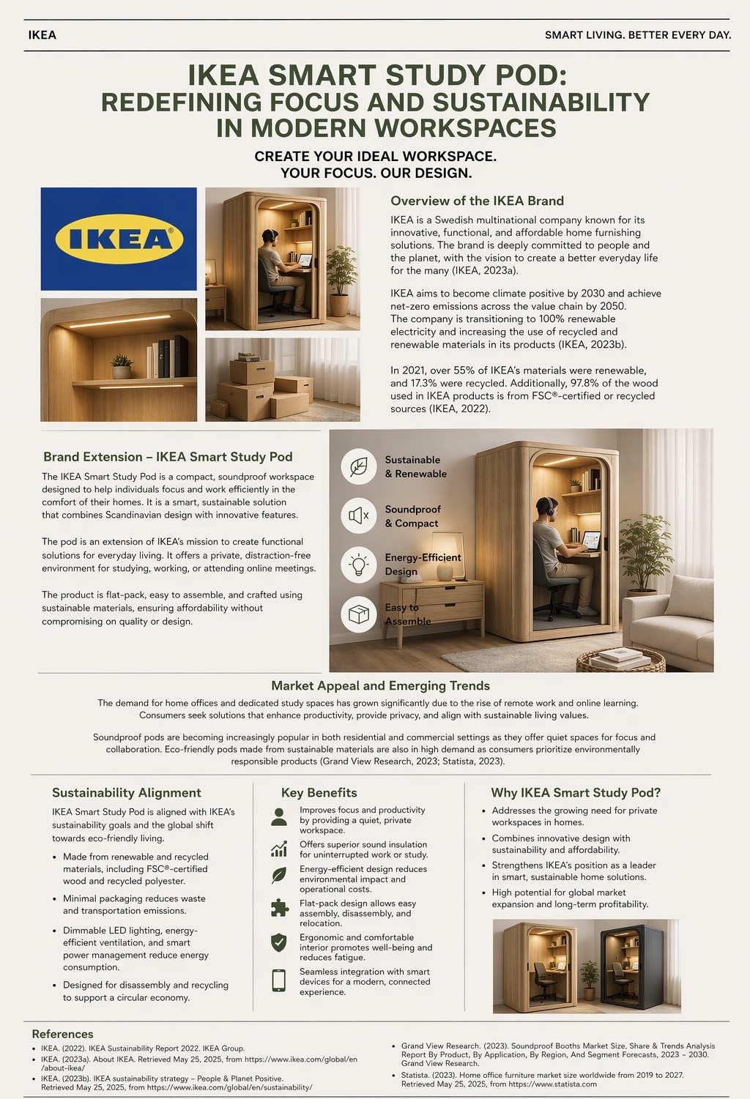
(POSTER)


1.0 Introduction
The recent emergence of remote and hybrid work modes has transformed living spaces into multifunctional environments with a demand for home-office solutions. IKEA, which designs and sells functional and low-cost home furnishings, is intensifying this need through a brand extension. A mini-office kit that you can assemble at home. It fits in with IKEA’s promise to make “healthy and sustainable living” affordable[1][2]. IKEA’s MITTZON focus workstation is an example its cocoon-like booth has acoustic felt to attenuate external noise so that one can focus[3][4]. The Smart Study Pod is an office idea that’s been taken home, using smart Scandinavian design, sound insulation and eco-friendly material all in one pod. This report examines the marketing strategy of Smart Study Pod. We look at the trends, the segments that the company will target, the positioning, and the 7ps. Competitor analysis, future market challenges, pricing strategy and customer decision factors are key questions.
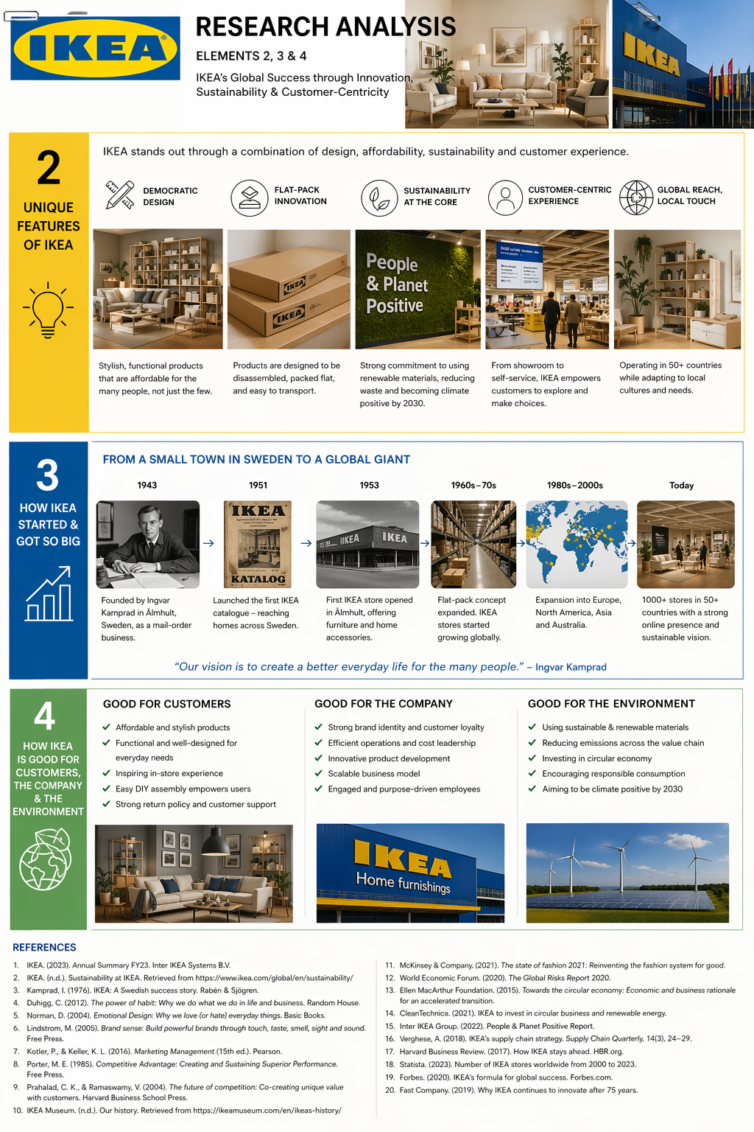
Figure 1: Abstract representation of a compact, sustainable workspace to illustrate the target context.

1.1 RESEARCH ANALYSIS
The market segmentation for the smart study pod will divide up the customers based on geo-demographic, psychographic & behavioral variables.

• This refers to urban and suburban areas of Europe, North America and Asia-Pacific where adoption of remote and hybrid work is high. Many well developed markets such as London, Manchester and so on have a high remote working prevalence. However, emerging markets are becoming demand for the digital connectivity.

• The target market is millennials and GenZs working professionals aged between 20-40, graduate and postgraduate students and small-business owners. This group of people have quality know-how about technology and often chooses to live in less space and like to work flexibly. IKEA offering appeals to individuals of middle and upper middle income group.

• Customers prioritizing sustainable living, work-life balance, productivity, and minimalistic Scandinavian design. The customer care for the environment and ethical labour practices, and prefer companies that match sustainability with convenience.

• Frequent remote workers and online learners that require a private, distraction-free space for their video calls and concentration. They are looking for modular solutions that can be easily assembled and moved when needed.

Targeted
According to the segments discussed above, the primary target audience is urban remote professionals and students aged 20-40 who appreciate sustainability and functional design. These consumers spend a lot of time working from home, acknowledge the need for a zone of concentration and are willing to invest in a quality solution. Small businesses, co-working spaces and educational institutions that need adaptable meeting or study pods are secondary targets.

Distinction
IKEA stands out for being affordable, sustainable, and easy to assemble. The Smart Study Pod is made from renewable wood and recycled materials that are in line with IKEA’s circular goal. This high‑performance desk allows users to gain essential privacy and productivity through sound insulation. Competitors like high-end office pods provide similar functionality at a much higher price tag. IKEA's flat-pack design harnesses its supply chain advantages to lower its costs and deliver high quality.

Placement
Smart Study pod will be communicated as an affordable, sustainable and accessible solution that enables remote workers and learners to create professional workspaces anywhere. The IKEA Smart Study Pod is the perfect solution for remote professionals and students who want to concentrate on their work while maintaining their well-being. An affordable, sustainable workspace with Scandinavian design, it is a comfortable and practical alternative to expensive office pods that are within the reach of the many.

2.0 Market Context

2.1 Remote Work and Hybrid Trends
Workplaces are more flexible. Post-pandemic surveys show that many workers prefer remote or hybrid. For example, 55% of professionals say hybrid work (a few days a week working remote) is their number one choice[9].

Also over a third of workers say getting more focus is a key benefit they get from working remote[10]. Hybrid work continues to thrive, despite some companies tightening rules for office return. In 2026, 15% of U.S. employees will be fully remote, and 10% hybrid. Key drivers of the preferences are focus and productivity. 44% of remote-capable employees cite being more productive at home, while 42% cite being able to focus more[10]. This indicates that the market needs home environments that facilitate focus. Yet, workplaces are diverse: SurveyMonkey data show remote work is highest in North America and Europe (~1.5–2 days/week) and lower in Asia. Employees with children are particularly likely to adopt hybrid models. IKEA’s Smart Study pod will look at markets that show strong hybrid trends e.g. Europe, North America and view the hybrid lifestyle as a permanent feature even as fully on-site roles tick up[11][12].

2.2 Small-Space Living and Urbanization
Rapid urbanization means many consumers live in limited space: by 2030, 60% of people will live in cities[15]. IKEA notes this as a strategic opportunity: “Small space living is one of our top three priorities”[2]. Importantly, IKEA emphasizes that small-space solutions are not just for young people – “people of all ages live in limited space”[16]. Limited living areas often lack dedicated offices, so a multi-purpose, compact workspace can significantly improve daily life. Design features like foldable desks, hidden storage and minimalist style all contribute to optimizing tiny homes[7]. For the Smart Study Pod, this context means it must be space-efficient, versatile, and blend into home decor. Unlike a bulky meeting booth, this pod is designed for a bedroom, living room corner or even dorm space. The product’s Scandinavian aesthetic and neutral tones help it fit modern small apartments. IKEA’s emphasis on smart space solutions[17] supports the idea: the pod should be a “smarter” use of space, not just a small furniture piece.

3.0 Brand Extension: IKEA Smart Study Pod
The Smart Study Pod has been designed as a home office by IKEA. It is a kit composed of flat panels (possibly recycled timber or plastic) for assembly, with sound-absorbing walls, fixed lighting and ventilating and power sockets. Products like Privacy Pod’s S Pod offer certified sound isolation and built-in electrical features[18][19]. The pod’s design indicates its purpose: to provide an encapsulated environment for studies, teleconferencing or creative work. It reflects IKEA’s values in being affordable, functional and Scandinavian in design. Even though IKEA has not put a “home pod” on sale just yet, it does offer the MITTZON office pod for businesses, indicating the tech is viable. The Smart Pod has gone ahead to incorporate extra smart features (e.g. app-controlled lighting, occupancy sensors) as well as eco-friendly materials (e.g. certified wood, recycled plastics) in keeping with IKEA’s smart innovation philosophy[1]. Ultimately, this brand extension uses IKEA’s parent brand and customer trust to enter the small office pod market.

4.0 Segmentation, Targeting, Differentiation, Positioning
4.1 Market Segmentation: We segment by user and situation. Key segments include: (1) Students and Young Professionals living in city apartments or dorms, needing quiet study space; (2) Remote Knowledge Workers (e.g. programmers, designers) who blend work and home life; (3) Families where parents share space with kids (creating noise conflicts); (4) Co-living or Shared Spaces (e.g. roommates who need personal offices). Psychographically, all segments value privacy, focus, and design. Behaviorally, target users spend significant time on concentration tasks (study, Zoom meetings) and are willing to invest in productivity. The product also appeals to sustainability-minded consumers who appreciate IKEA’s eco-credentials. One IKEA executive notes that “homes have become multi-functional with living and working space combined,” driving demand for home-office solutions[20].
4.2 Targeting: The Smart Study Pod’s ideal target is urban dwellers aged 20–45 with remote/hybrid work or study habits, living in small to medium-size homes. This includes graduate students, tech-savvy millennials, and digital nomads. These customers seek ergonomic, quiet workspaces at home and appreciate stylish design. We will use a differentiated targeting approach: the campaign will pitch the pod to both students (e.g. via university channels) and working professionals (e.g. tech industry press). To avoid diluting the message, marketing can be tailored: for students emphasize exam focus and group study, for professionals emphasize home office comfort. Research suggests parents often use hybrid models[14]; however, our positioning will focus on single-user pods, and we will not position it as a family room divider. Instead, families may see it as a gift to give each child or parent their own study area.
4.3 Differentiation: Against competitors, the Smart Study Pod differentiates on price, design, and sustainability. Competitor pods (Framery, Zenbooth, SnapCab etc.) are often high-end (starting ~$10–12K for a single-person booth[21]). IKEA can leverage economies of scale and flat-pack manufacturing to offer the pod at a significantly lower price (target around $4K–$6K for the entry model). This penetration pricing strategy (combined with perceived value) helps rapidly build market share. Product design-wise, the pod features IKEA’s signature minimalist look and modularity. Unlike many office booths designed for corporate lobbies, IKEA’s pod will be more home-friendly (lighter materials, easier assembly). Sustainability is another differentiator: we will use certified wood panels and recycled plastics per IKEA’s strategy[6], and highlight this in marketing. Competitors like Framery do stress sustainability (“pods are built to last with sustainably sourced materials”[22]), but IKEA’s broader brand story around circularity can be leveraged (e.g. offering buy-back or recycling options).
4.4 Positioning: The Smart Study Pod is positioned as “an affordable smart home office pod for focused living.” In the consumer’s mind, it sits between IKEA’s regular furniture and high-end office pods: it brings the functionality of a private booth to the home at an IKEA value. A possible positioning statement: “For urban students and professionals needing concentration, the IKEA Smart Study Pod is a flat-pack, eco-friendly workspace pod that creates a quiet focus zone, combining IKEA’s renowned design and sustainability at an accessible price”. This contrasts with expensive premium booths (Framery, starting ~$12K[23]) and with noisy multi-use rooms. The focus on sustainable focus (as the poster tagline suggests) conveys that one can “focus with peace of mind,” both in work and environment impact.

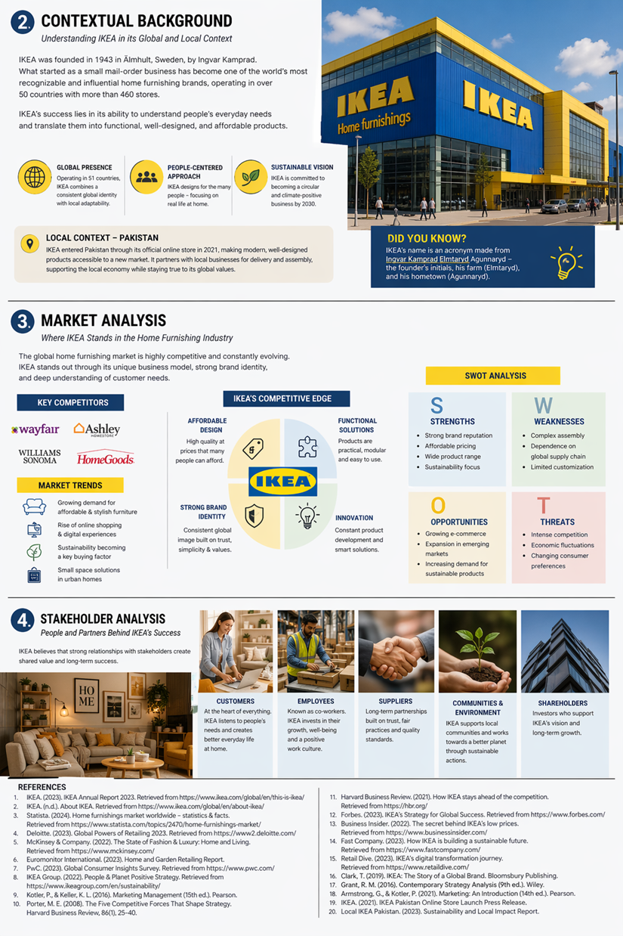
Figure 2: Abstract representation of the marketing mix elements.

5.0 ( 7 MARKETING P)

1.PRODUCT
The Smart Study Pod is a hybrid product-service. It is primarily a physical product (a booth kit) but supported by IKEA’s assembly and warranty services. Key features: soundproof walls (≥30dB reduction) for distraction-free work[24][21], built-in LED lighting, ventilation system with exchange fans, and integrated power/USB outlets. The interior may include a small desk surface and stool. The exterior uses recyclable wood panels with an attractive finish (e.g. light oak or white), in line with IKEA’s aesthetic. Importantly, the product is flat-packed and easy to ship, capitalizing on IKEA’s logistics model. Customers can assemble it at home with minimal tools, or optionally use IKEA’s assembly service.
The smart study pod will come as a modular flat-pack kit that customers can self-assemble using IKEA’s instructions. Pods are made with sustainable materials and come fitted with LED lights, ventilators, sound-absorbing panels, electricity sockets and optional smart home features compatible with IKEA’s TRÅDFRI system. The various finishes and add-ons of the pod which could range from ergonomic seating to extra storage will drive upselling.

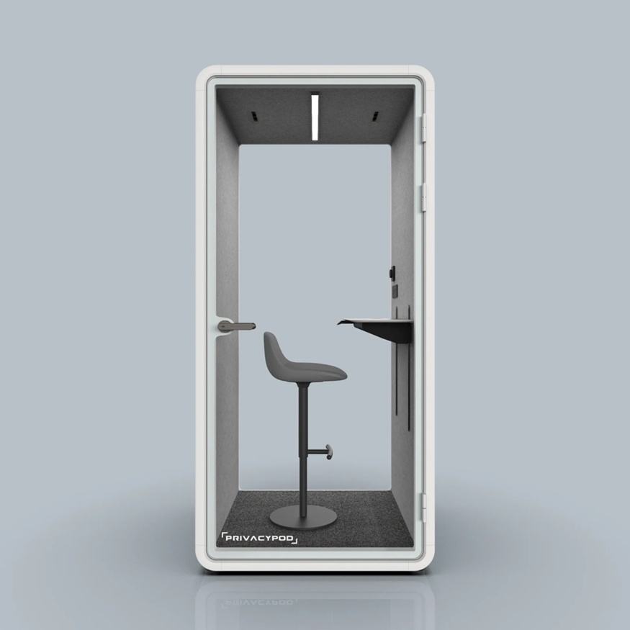
Figure: An example of a single-person soundproof workspace pod (PrivacyPod S-Pod). The IKEA Smart Study Pod will offer similar privacy and focus features for home use.
The product bundle extends beyond hardware: we add a 10-year IKEA warranty on parts (similar to other pods[25]) and free design consultation via IKEA’s AR app to see how it fits a home. Additional value-added services include an optional subscription for IoT features (e.g. app-controlled lighting scenes, occupancy data) and a recycling trade-in program for old units (supporting IKEA’s circular economy goals[1]). By thinking beyond the physical booth, IKEA can differentiate: for instance, providing an online community of remote workers (building brand engagement).

2.PRICE

IKEA's price is the only mix element by which the company generates revenue[26]. Hence, it has to reflect the value that a customer will receive and must be efficient in cost. We use both penetration and value-based pricing strategies. IKEA is in a position to price aggressively compared to competitors like Framery and Privacy Pod. Our expectation is a starting point model at ~\$4,000–\$5,000 (one-person pod), with a two-person pod at \$8,000–\$9,000. This undermines a lot of competitors. IKEA’s low-price strategy appeals to customers who can afford less. To put this in perspective, IKEA’s MITTZON focus workstation has a price tag of \$599 (for a partial booth)[27], but the enclosed Smart Pod has much more technology and materials.
By creating a perception in the minds of customers that price matches value, by placing it as a durable, high-quality product and by IKEA’s everyday low price signals accessibility. Nonetheless, survey data indicate that price is the main barrier to sustainable furniture[28]. As a result, we prevent a large premium for sustainability. Rather than offering discounts, we could provide introductory discounts and Ikea Family loyalty points for referrals. Given the cost of $4000 for purchase, we will consider a financing option. The pricing strategy is aligned with IKEA’s general marketing strategies; practical, but low cost[6].

3.PLACE

The Smart Study Pod will utilize IKEA's multifaceted distribution system. It'll be available for purchase at large IKEA retail locations and in IKEA's online store (with AR visualization tools). A demonstration pod will be set up in selected large showrooms to showcase the interiors to customers. Because of its size, it might fall under IKEA for Business (instead of just consumer). For instance, IKEA may join forces with universities or co-working spaces to bulk-sell the pods. IKEA will produce the pods in their current factories leveraging already established supply chains and ship them via global logistics network. IKEA’s click & collect alongside home delivery service is available with a strong return policy: IKEA’s 365-day return on home furnishing.
The strategy is consistent with the non-impulse product. The consumer will most likely research before buying, so the product should be located prominently on IKEA’s website and advertised in the catalogues. Tech blogs may also be used. The “homemakers” and advisors from the retail staff will need special training to explain the product. Owing to the IKEA network around the globe, the pod can launch in many market regions at the same time. The page of MITTZON booth states that it is “suitable for business use” and can be used in the “any public space”[29]. Likewise, the Smart Pod can be marketed not just to homes but also to small office setups via IKEA’s B2B channels. In general, the place strategy builds on IKEA’s solid direct-to-consumer model with institutional sales added as a channel.

4. PROMOTION

The promotion will make the target segments aware of the unique benefits of the pod. IKEA will rely on both general and specific communication strategy. Strategies encompass.
• The Smart Pod should be featured on IKEA's catalogue and Website in the digital and print catalogue under Work from Home and Study. Spot on visuals used in combination with a user story e.g. student using it in a London flat.
• Digital Marketing: Ads on social media sites (Instagram, YouTube, TikTok) with instances of focus/creativity in a restricted area. Collaborate with influencers in education and remote work bloggers to feature the pod (e.g. college dorm room setup).
• This is what I think about what we should do regarding a PR activity of ours… I am thinking we must issue a press release and a product demo to tech business press e.g. tech blog, new york times in home section. Highlighting modernity and sustainability (citing IKEA strategy).
• IKEA pop-up events or displays in flagship stores with the pod in Store Demos Inside test focus and noise machines all available for usage.
• Package deals of a pod, office chair and lamp for promotional prices.
• Work with universities and other co-working places, as in pilot programs placing them in libraries like Framery’s integrations[31]. These stories can be made public
The promotion emphasizes the brand values and features. The Home Oasis by IKEA: A product that you can easily place in your home without the need to drill into the walls. The PR campaign will refer to IKEA’s better everyday life promise. Ultimately, the promotion must do more than call attention to the new product: it must clearly associate it with the parent brand. We can mention IKEA’s existing MITTZON: e.g., “From IKEA’s MITTZON offices to your home: Smart Study Pod.” We can inform existing customers through IKEA Family loyalty channels, email notifications. The target market is keen on sustainability and minimalist design. Subsequently, the promotional imagery will be in neutral palettes. Further, the claims of eco-friendly features will be clearly made.

5. PEOPLE

“IKEA’s people” are everyone who comes into contact with customers[33]. For the Smart Pod, critical touchpoints include sales staff, customer service, and installation teams. Sales associates will be educated to position this product and assist in selection. Because the pod is a high-involvement purchase, having knowledgeable consultants (online chat or in-store) will build trust. IKEA’s existing self-serve model (booking a demo) will adapt to allow appointments with a pod specialist. After purchase, IKEA’s support staff (24/7 online chat) and installation teams ensure the pod is set up properly (assembly can be self-service or white-glove). Positive interactions with people (helpful service, clear instructions) can differentiate IKEA. For example, we can train staff to advise on optimizing home workspace, reinforcing IKEA’s brand of “creating a better everyday life.” Encouraging employees themselves to adopt the pod (e.g. in offices or work-from-home) can also make them advocates.

6. PROCESS

The customer journey of buying Smart Pod should be a smooth ride. Before they purchase, customers can use an IKEA planning tool or app to visualize the pod in their space (this information uses IKEA’s AR tech). Simply pick your model, schedule your delivery and get ready to enjoy your new car. IKEA’s logistics run the distribution line of large furniture from the factory to store or home as it does. The pod is flat-packed and comes in several boxes when assembled. IKEA could offer an optional assembly service (as it does with its kitchen assembly), which would include delivering the pod to the room of choice, level it and test the systems[34]. The user also receives training regarding lighting and ventilation controls. After the purchase, a follow-up could include a satisfaction survey which could be an automated email, or the buyer could receive extra tips on how to best use the pod. Timely response to any problems (e.g. missing parts) is vital. These processes will be like IKEA’s normal model as user-friendly. Information and booking will create an online experience. Thus, the complication of a technological product will be hidden behind convenience.

7. PHYSICAL EVIDENCE

Physical evidence suggests the quality of products. For IKEA, this includes showroom displays, packaging of the product and branding. IKEA’s smart pods will eventually be out at IKEA stores, where customers can view them physically before they buy. IKEA’s yellow/blue boxes act as packaging material, and a manual detailing the product story comes with every product. The IKEA website will feature high-quality images and videos (e.g. virtual 360 tours of the pod interior). As trust builders, the pod can include visible certifications (like GREENGUARD for indoor air) and partner logos (for acoustic certification). Warranty and user guides are also physical evidence. For example, I feel more confident having an IKEA card. In summary, the value of the pod can be seen in its clean finish. There’s a credibility attached to you simply being in an IKEA store since IKEA is known for home furnishing.

BLUEPRINT
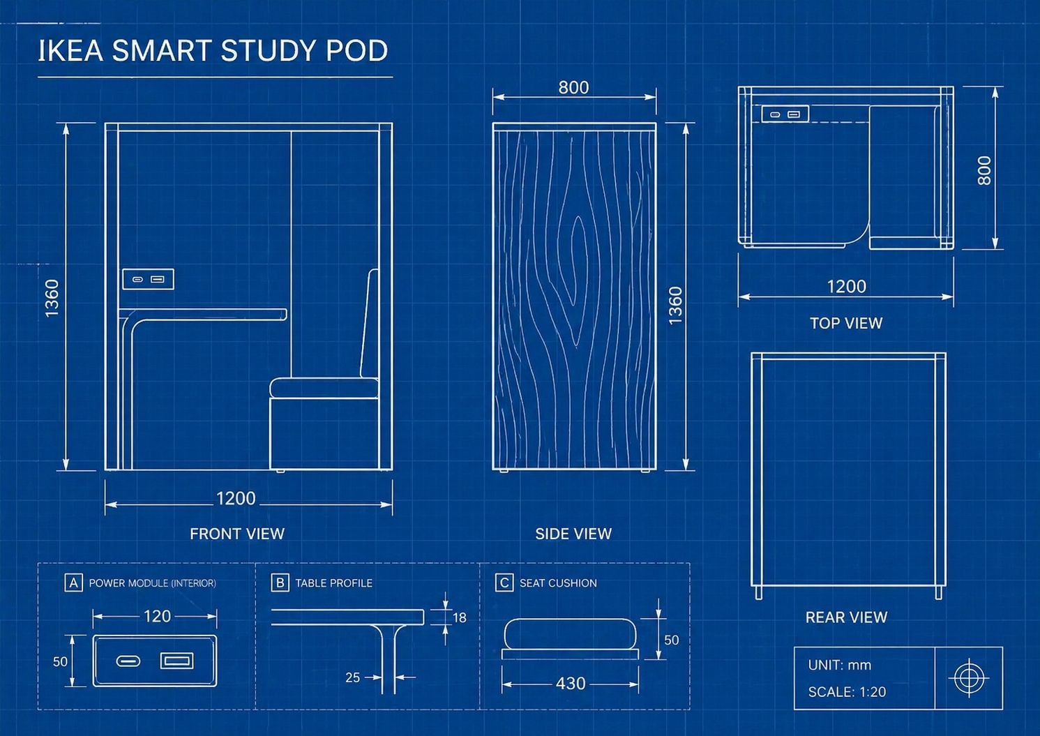

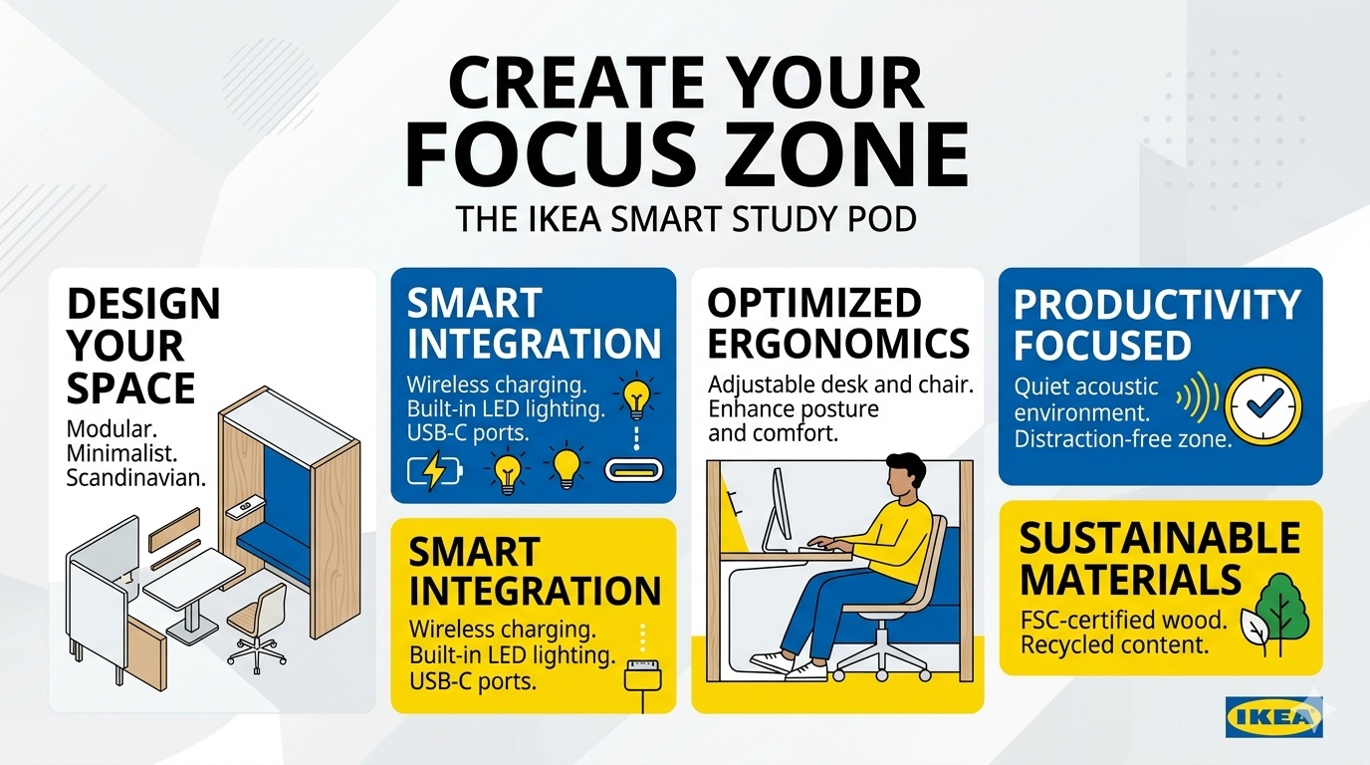
STUDY POD IKEA

6.0 Competition and Market Rivalry
The market for office pods are increasing rapidly The international demand for office or soundproof pods is expected to rise from $0.56B in 2025 to $1.33B by 2034[35]. Framery and Mikomax are the leading manufacturers of telephone booths for the workplace. Framery, for instance, which launched office pods, has created “smart pods” with advanced acoustics and technology. These companies compete on the basis of features and quality. For instance, Framery says pods are “built to last” with strong sustainable materials[22]. Cost of quality: starters for a single-person booth run for approximately $5–$9K[21] and premium models run for $12K and above. Teams meeting pods can cost between $15 - $40 k.
IKEA’s introduction has strengthened this rivalry in the market, particularly at the lower pricing and design end. Established pod companies deal with corporate clients; hardly any deal with home users. Due to its size and standing, IKEA can sell cheaper than its rivals. Despite this, their rivals have a strong set of credentials when it comes to acoustics. They might quickly adjust and introduce cheaper models. So IKEA needs to act quickly to change perception. Monitoring competitors’ new releases (e.g. Herman Miller’s Bay Pod[39]) will help us adapt. On top of that, retailers, namely, Amazon, also sell DIY pods (Zenbooth through retailers), so IKEA does compete in the new entry area indirectly.
The price, sound insulation quality, aesthetics, convenience, etc., are the key competitive factors. IKEA proposes to compete in all dimensions: at least 30dB acoustic reduction, cheaper than premium pods, more appealing “homey” style and IKEA’s distribution. IKEA may partner with other firms, drawing on their expertise, or grant licenses to do such things. It's extremely important that the products maintain quality because negative reviews about durability and assembly can affect the brand. Thus, R&D and quality control will be useful to stay ahead of competitors.

6.1 Sustainability and Brand Values
We must save our planet for future generations. IKEA aims to make sustainable choices affordable and mainstream through its sustainability strategy. Eco-friendly materials (FSC-certified wood panels, recycled textiles for the cushions, non-toxic glues) will form the Smart Pod. Any energy-saving features (e.g. LED lights, ventilation timed fans) will be highlighted. This aligns with consumer values: 43% of furniture buyers identify as environmentally conscious, and 57% say they probably will buy sustainable furniture[40]. Despite wanting to buy, consumers cited price sensitivity as a crucial factor, owing to over half [28]. We cannot set a high price for the pod under the pretext of sustainability, or else many prospects may not purchase it. By mass-producing the pod, IKEA can make the sustainability premium much lower since it will be efficient. The marketing strategy will emphasise sustainability but clarify that the price will be “small premium or none” as IKEA incorporates sustainability into their affordability [6].
They can also apply their circular economy programmes (resale, recycling). For example, this program could restore and resell used pods or recycle used parts for the brand's credibility. IKEA can also lead by making the pod itself disassemblable for recycling through its “take-back” initiatives[1]. Promoting your efforts around promotion will appeal to eco-friendly customers.
According to a Furniture Today survey, many consumers do not view furniture as a sustainability leader[41]. Marketing messages like that of the IKEA Smart Pod, designed sustainably to provide a focus, can help ease that perception. Given that 43% of buyers prefer to buy from brands that support climate and environmental causes (source), IKEA is in a position to use its NGO, the IKEA Foundation, and carbon-neutral logistics to showcase its commitment.

6.3 Future Challenges and Problems

Must be managed several potential challenges. Market Acceptance: Certain corporations are reinforcing the office after hybrid work, leading some to believe the home office pod may not be needed. Actually, 77% of new job postings are now fully on-site[11], indicating demand may have plateaued. The pod limitation may lose its attractiveness as remote work shrinks. It could monitor working trend and may adapt pod for other usage, say “gaming pod” ort teen study pod, to widen appeal.
The introduction of a high-tech product can create brand cannibalization, as is the case with IKEA software. The organization should clearly indicate that the Smart Pod is an extension of living space solutions, not an exit.
How you execute a brand strategy can weaken or enhance its meaning. Should IKEA have any simpler focus products (like MITTZON booth), care must be taken not to damage those products or confuse shoppers.
Competition response: Existing players may either offer low price or claims superiority. IKEA’s main advantage is its scale, but it needs proprietary know-how (patents on assembly or materials) to deter imitators.
The pandemic has impacted supplies chain which may increase the cost of materials (electronics of lighting, ventilation). The design of IKEA should represent both tech and strength. Increased complexity of technology can result in failure or high costs; hence quality control.
The pods must meet applicable building codes (for parts of the country a pod with power points may be considered an ‘installation’). IKEA must obtain UL/CE certification for product safety and home usability assessment. Any failure (ex: fire risk) could hurt brand.
Consumer Education: Since private pods are new to many homeowners, Ikea has to educate consumers on their benefits. Otherwise, some people will take it as luxury. One important challenge in promotion is showcasing tangible improvements in productivity or wellbeing, perhaps through studies like Framery’s case with Baylor University[43].
As the “smart home” market develops, new home office concepts (like virtual reality offices, etc.) could appear. IKEA ought to do some iterative upgrades (as Philips has done with smart lights) and maybe integrate it with the home assistants.
IKEA should conduct a user needs assessment for its Smart Pod, which means understanding user tasks. To counter these challenges, you will continuously need to gather customer feedback and iterate.
Customer Preferences and Decision Factors
Understanding how customers make choices is vital. Price sensitivity is high: our references show many buyers look for deals in furniture[44]. The Smart Pod launch should leverage promotions (introductory offers) accordingly. Customers also care about quality and durability. For pods, hearing “soundproofing works” is critical, so testimonials from early adopters will be used. The furniture industry survey noted durability/quality concerns in sustainable products[45], so we must assure customers (e.g. with a 10-year warranty).
Brand trust is significant: IKEA’s name itself will attract customers who might not consider an unknown tech company’s pod. 43% of shoppers prefer brands that support environmental causes[42], aligning with IKEA’s image. In decision-making, aesthetic style matters: our target segments appreciate minimalist, Scandinavian design (IKEA’s signature). The knowledge that IKEA furniture often wins “swedish design” acclaim[46] should be emphasized.
Functions like flexibility and connectivity are also valued. SurveyMonkey reported that 52% of remote-preferring workers cite saved commute time, 44% cite productivity, 42% focus[10]. This implies customers will evaluate the pod on how it improves focus (framed in marketing as the primary benefit). Features like built-in charging ports and compatibility with ergonomic chairs will resonate.
Finally, customers often rely on reviews and social proof. Early pilot programs (e.g. in campuses or coworking spaces) will help generate positive word-of-mouth. IKEA can showcase usage metrics (like Baylor University’s pod usage stats[43]) to demonstrate real value. By aligning with how consumers shop furniture (e.g. combining sale and full-price strategies[44]) and emphasizing traits they care about (eco-friendly, durable, stylish), IKEA can guide customer choices in favor of the Smart Study Pod.

7.0 Conclusion

The IKEA Smart Study Pod is a strategic brand extension tailored to contemporary needs. Our analysis shows that IKEA’s focus on small-space living and sustainability makes this product a logical fit[2][1]. By targeting urban students and professionals, differentiating on price and design, and leveraging the full 7Ps (product features, accessible pricing, omnichannel distribution, integrated promotion, and supportive services), IKEA can carve out a new market niche. Challenges remain – notably shifting work patterns and fierce competition – but IKEA’s scale and brand equity provide strong advantages. If executed thoughtfully, the Smart Study Pod can deliver on IKEA’s mission to improve life at home in a sustainable, affordable way[1][5].

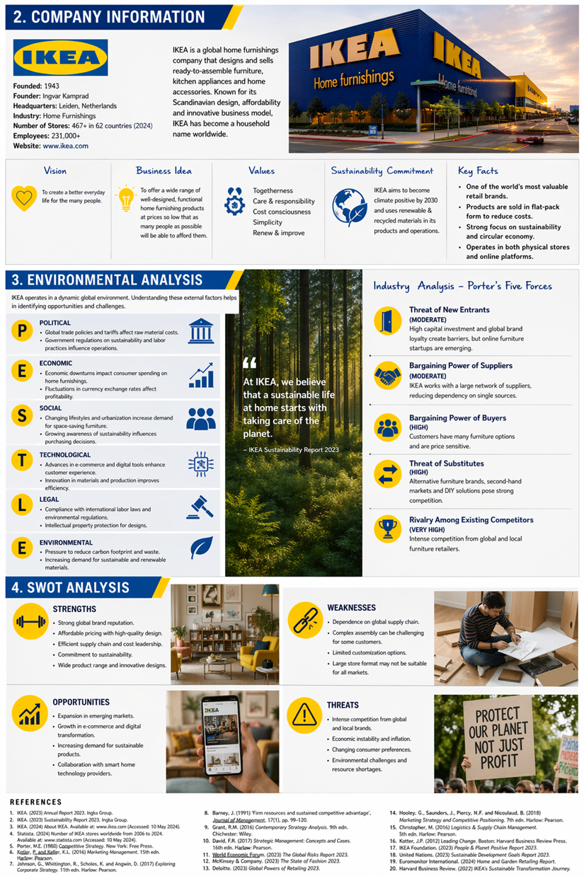
INFORMATION&ANALYSIS

8.0 References

IKEA. “Healthy, sustainable, affordable living for everyone.” IKEA Global, 2026. [1][6].
IKEA. “MITTZON Focus workstation.” IKEA USA (product page). [3][4].
IKEA Newsroom. “Innovative Living—Homes adapted for remote work.” Ingka Group News, June 2020. [20][47].
IKEA Stories. “From small-space living to smart-space solutions.” Inter IKEA Systems, May 2023. [2][16].
Robert Half. “Remote work statistics and trends for 2026.” Robert Half Workplace Research, Feb. 2026. [48][11].
Stanford SIEPR. “Working from Home in 2025: Five Key Facts.” Stanford Institute for Economic Policy Research, 2025. [49][50].
Surveymonkey. “Remote and hybrid work statistics in 2026.” SurveyMonkey Trends, 2026. [10][12].
Framery. “Study Pods Support Learning and Collaboration.” Framery blog, Apr. 2025. [24][51].
KI Insights. “Four Benefits of Privacy Pods at Colleges and Universities.” KI Company Blog, Aug. 2023. [52].
Fortune Business Insights. “Office Pods Market Size, Share | 2026-2034.” Fortune Business Insights, Oct. 2025. [35][36].
Autonomous.ai. “Office Pod Prices in 2025: What to Expect.” Autonomous WorkBlog, 2024. [21][38].
PrivacyPod. “S Pod – Office Phone Booth.” PrivacyPod Product Page. [19][53].
Furniture Today. “If furniture industry has sustainability message, consumers aren’t getting it.” Furniture Today, Oct. 2025. [40][28].
Oxford College of Marketing. “Understanding the 7Ps of the Marketing Mix.” Oxford College Blog, 2023. [54].
ScienceDirect (Anderson, 2012). “Brand Extension – definition.” ScienceDirect Encyclopedia of Economics, 2012. [8].
Cascade Strategy. “How IKEA Became a Household Name.” Cascade Strategy Blog, 2020. [5].
Framery. “Welcome to the next era of the workplace.” Framery.com, 2026. [37][22].

[1] [6] Healthy, sustainable, affordable living for everyone – IKEA Global
https://www.ikea.com/global/en/our-business/sustainability/healthy-and-sustainable-living/
[2] [7] [15] [16] [17] From small-space living to smart-space solutions – IKEA Global
https://www.ikea.com/global/en/stories/ideas-inspiration/small-space-living-230526/
[3] [4] [25] [27] [29] MITTZON focus workstation, beige/white, 373/8x341/4x61" - IKEA
https://www.ikea.com/us/en/p/mittzon-focus-workstation-beige-white-70528183/
[5] [46] Strategy Study: How IKEA Became a Household Name With Digitalization, Consistency, and Experience
https://www.cascade.app/studies/how-ikea-became-a-household-name
[8] Brand Extension - an overview | ScienceDirect Topics
https://www.sciencedirect.com/topics/economics-econometrics-and-finance/brand-extension
[9] [11] [48] Remote work statistics and trends for 2026
https://www.roberthalf.com/us/en/insights/research/remote-work-statistics-and-trends
[10] [12] The Workplace Today: 2026 Remote And Hybrid Work Trends
https://www.surveymonkey.com/learn/employee-feedback/remote-hybrid-work-statistics/
[13] [14] [49] [50] Working from Home in 2025: Five Key Facts | Stanford Institute for Economic Policy Research (SIEPR)
https://siepr.stanford.edu/publications/essay/working-home-2025-five-key-facts
[18] [21] [23] [38] Office Pod Prices In 2025: What to Expect
https://www.autonomous.ai/ourblog/office-pod-prices
[19] [34] [53] 1-Person Soundproof Office Pod for Calls & Focus | PrivacyPod
https://privacypod.ai/products/1-person-pod?srsltid=AfmBOorzIdX2F7xriUxachQEiFlNSTuodQq9lHc3nL3IYh1O895-8S5l
[20] [47] Increased time at home keeps IKEA relevant in lockdown | Ingka Group
https://www.ingka.com/newsroom/increased-time-at-home-keeps-ikea-relevant-in-lockdown/
[22] [37] Framery | The World's Leading Soundproof Pods & Booths
https://framery.com/en-us/
[24] [31] [43] [51] Study Pods Help Students Focus in the Classroom - Framery
https://framery.com/en-us/study-pods/
[26] [30] [32] [33] [54] The 7Ps of The Marketing Mix | Oxford College Of Marketing
https://blog.oxfordcollegeofmarketing.com/2020/10/08/understanding-the-7ps-of-the-marketing-mix/
[28] [40] [41] [42] [44] [45] If furniture industry has sustainability message, consumers aren’t getting it, survey shows - Furniture Today
https://www.furnituretoday.com/research-and-analysis/if-furniture-industry-has-sustainability-message-consumers-arent-getting-it-survey-shows/
[35] [36] [39] Office Pods Market Size, Share | Global Growth Report [2034]
https://www.fortunebusinessinsights.com/office-pods-market-110928
[52] Four Benefits of Privacy Pods at Colleges and Universities | KI
https://www.ki.com/insights/blog/four-benefits-of-privacy-pods-at-colleges-and-universities/

