  - Strategic Value Creation through Business Intelligence

Written Report

Business Intelligence as a Strategic Capability. Concepts, Applications and Organisational Impact in the Age of AI.

Module code - LCBB5014J_BIRM
Module Name - Data Handling & Business Intelligence
Lecturer’s Name - Ihsan Ul Haq
Student Name - Ovidiu Florin Socel
Student Number - 2310644
Submission deadline - 01st March 2026

Contents
1. Introduction. 2
2. Understanding Business Intelligence Concepts. 2
2.1 Core Components of BI. 2
2.2 Evolution of BI. 3
3. Business Intelligence Applications. 3
3.1 BI Tools and Platforms. 3
3.1.1 Tableau. 4
3.1.2 Microsoft Power BI. 7
3.1.3 SAP BusinessObjects. 9
3.2 Cross-Industry Applications. 10
4. Real-World Examples and Case Studies. 10
4.1 Amazon. Algorithmic Intelligence and Operational Optimisation. 10
4.2 Tesco. Customer Intelligence and Strategic Alignment. 12
5. Benefits and Challenges of Business Intelligence. 13
5.1 Benefits. 13
5.2 Challenges. 13
5.3 Mitigation Strategies. 13
6. Conclusion. 14
7. Reference list. 14

Business Intelligence as a Strategic Capability.

Concepts, Applications and Organisational Impact in the Age of AI.

1. Introduction.
Business Intelligence refers to an architecture, tools, databases, analytical methods and applications to harness raw data and transform it into useful information to support decision making (Visinescu et al., 2017). Modern organisations known for digitalisation, data abundance and intensifying competition, BI is viewed as a strategic capability rather than just a technical infrastructure. It allows organisations to improve situational awareness, lower uncertainty, and align operational decisions with their long-term strategic goals (Ransbotham et al., 2021).
The key benefits of business intelligence include the positive relationship between data integration processes, predictive analysis, and managerial decision-making from the perspective of business clients. As the market continues to be volatile, companies that can effectively exploit their data assets are better equipped to achieve operational efficiencies, customer intimacy, and innovation-led growth (Sivarajah et al., 2020).
This report analyses the principles and applications of Business Intelligence. It delves into core components of BI and moves from reporting to AI analytics. Next, it describes BI tools and applications across industries. After that, it studies real-world case studies that show measurable impact. The conclusion of the study looks at the advantages and the challenges of the implementation of BI and considers its future in digitally enabled enterprises.

2. Understanding Business Intelligence Concepts.
Business intelligence refers to the information that plays a crucial role in assisting decision-making at various levels in an enterprise. At its core, Business Intelligence (BI) is located at the nexus of information systems, data management and managerial strategy. It converts structured and unstructured knowledge into useful information that supports tactical and strategic decisions (Rikhardsson and Yigitbasioglu, 2018).

2.1 Core Components of BI.
- Data collection. It encompasses gathering information from internal systems (such as ERP, CRM, and supply chain databases) as well as external sources (including market data, social media, and the Internet of Things). Having data governance ensures accuracy, consistency and compliance with regulations like GDPR.
- Data warehousing. It brings together various sources of information into a central location that is purpose-built for analysis, not transactions. Modern cloud warehouses provide scalability and real-time processing (Sivarajah et al, 2020).
- Data mining. It employs statistical and machine learning methods for the identification of patterns, associations and anomalies in datasets. Methods involving clustering, classification and regression make predictive modelling and segmentation possible (CVR College of Engineering, 2023).
- Data visualisation. It can convert complex outputs into dashboards and interactive graphics for managers. Visual analytics connects technical assessment with executive thinking (Visinescu et al., 2017).
- Analytics and reporting. It includes descriptive analytics (what happened), diagnostic (why it happened), predictive (what will happen) and prescriptive (what should be done). The evolution from description to prescription in analytics indicates growth.

2.2 Evolution of BI.
Keys to success: Historically, BI encompassed mainly structured reporting and performance measurements. Nonetheless, improvements in big data architectures, cloud computing and Artificial Intelligence (AI), have made BI dynamic real-time capabilities (Chen et al., 2021). Technological advances have resulted in the emergence of BI systems that utilise artificial intelligence (AI) (MIT Sloan Management Review and Boston Consulting Group, 2021).
Predictive forecasting and anomaly detection are beyond the wisdom of a human but not that of machine learning algorithms. As a result, analytical intelligence has evolved from historical interpretation to preventive intelligence. As more organisations rely on data for decision-making, the authority for decisions is increasingly based upon analytical evidence rather than managerial judgment.
However, the advancement brings on issues that include algorithmic bias and interpretability. While AI-enabled BI (Business Intelligence) expands the analytical capability of the business, it also requires strong governance and analytical literacy at the managerial level.

3. Business Intelligence Applications.
Business Intelligence frameworks develop and deploy user interfaces and applications.

3.1 BI Tools and Platforms.
- Dashboards and reports provide real-time key performance indicators (KPIs). Tools for monitoring performance and operational transparency.
- Predictive analytics software utilises machine learning models to predict expected trends like customer churn, demand changes or credit risk.
- Data mining platforms are used for pattern discovery and segmentation analysis.
Prominent BI platforms include:

3.1.1 Tableau.
Tableau is known for its high-end visual analytics and intuitive dashboards, facilitating exploratory data analysis and executive reporting.
Tableau enables data visualisation and analytics through an AI-powered platform to see, understand, and act on data. Originally founded in 2003 and now a part of Salesforce, it enables organisations to visualise and share insights using interactive dashboards in a manner that supports business intelligence at scale.
Key facts.
- Developer: Salesforce, Inc.
- Founded: 2003, Seattle, Washington
- Headquarters: Seattle, Washington, U.S.
- Core products: Tableau Cloud, Server, Desktop, Prep, and Pulse
- Primary use: Data visualisation and business intelligence
Features and capabilities.
Tableau drag-and-drop analytics don’t require coding. Almost any data source cloud, on-premises, or spreadsheet can be connected to build dynamic visualisations in real time. Its visual query language, VizQL, translates users' actions into queries against databases, streamlining complex analysis into intuitive visuals. Tableau works with Salesforce AI and lets you use natural language to query with Agentforce Assistant.
Platform components.
The ecosystem includes:
- Tableau Desktop: For creating and analysing visualisations offline.
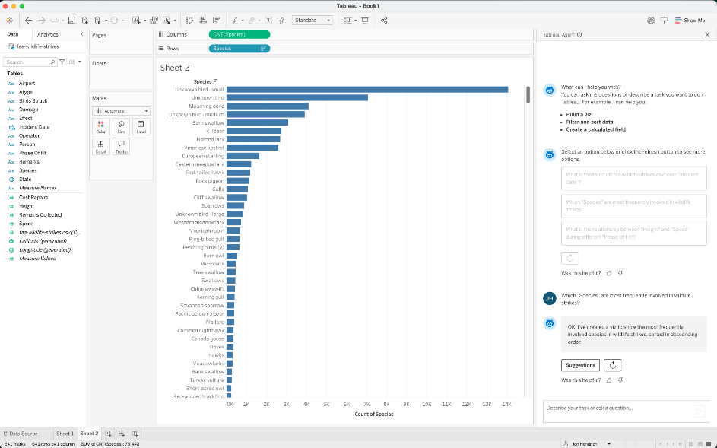
https://www.tableau.com/en-gb/products/desktop
- Tableau Server and Cloud: Platforms for enterprise deployment, sharing, and governance.

https://wiiisdom.com/blog/tableau-server-to-tableau-cloud-migration/

- Tableau Prep: For data cleaning and transformation with visual workflows.
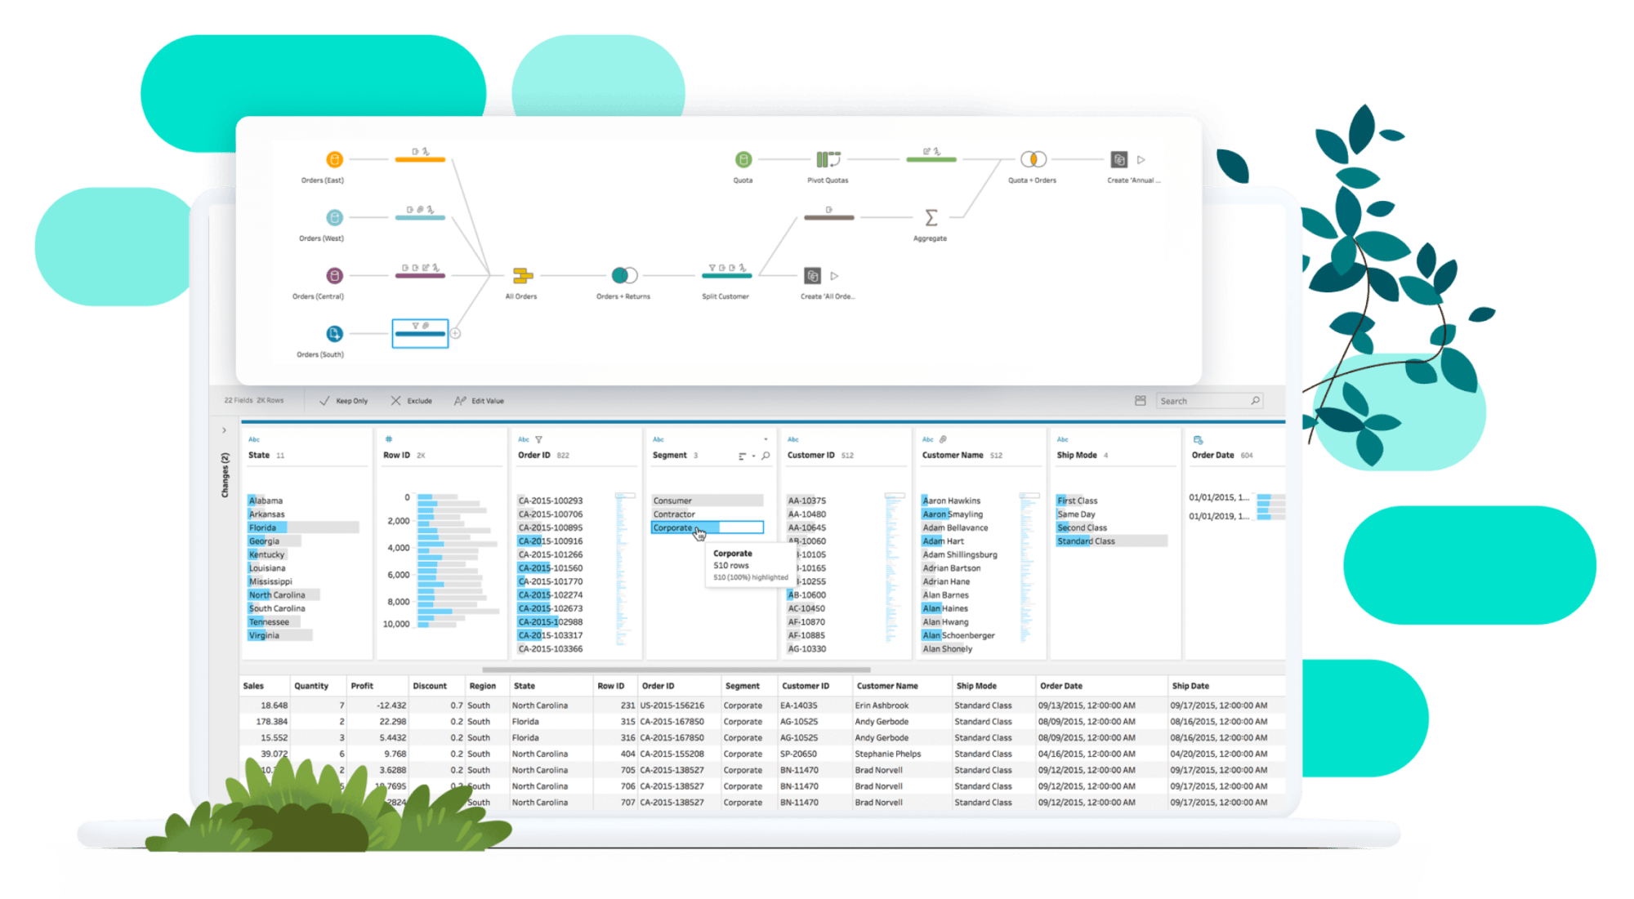
https://www.tableau.com/en-gb/products/prep
- Tableau Pulse: AI-enhanced products delivering proactive insights and automation.
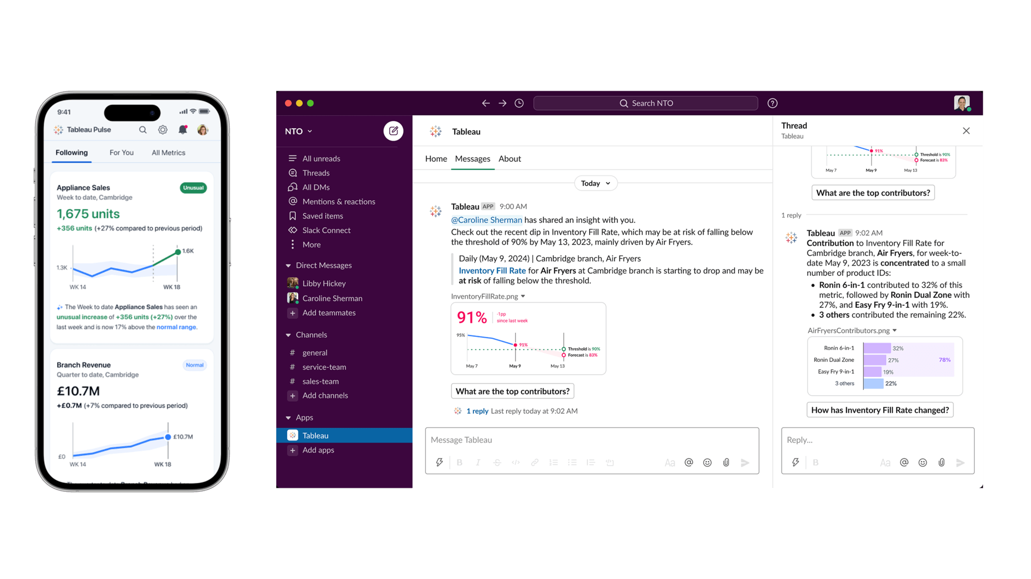
https://www.tableau.com/blog/tableau-pulse-and-tableau-ai
Deployment and integrations.
Tableau can be deployed on-premises, public or private cloud, or natively in Salesforce CRM. It easily connects to major analytics ecosystems and databases such as Amazon Snowflake, Google BigQuery, and Amazon Redshift. It has an extensible architecture for embedded analytics and custom APIs.
Adoption and impact.
Many enterprises, government departments, and researchers all over the world are leveraging Tableau, one of the leading analytics solutions, to drive a “data culture.” Tableau has been positioned as a Leader in the Gartner Magic Quadrant™ for Analytics and Business Intelligence Platforms consistently.

3.1.2 Microsoft Power BI.
Power BI integrates with Microsoft and offers scalable analytics, real-time dashboards, and cloud collaboration.
The Microsoft Power BI platform is a powerful business analytics service that allows visualising data to share insights across an organisation. Created by Microsoft, it connects to various data sources to provide interactive reports and dashboards for decision-making and business intelligence.
Key facts.
- Developer: Microsoft
- Initial release: 2015
- Primary use: Data visualisation and business intelligence
- Deployment models: Desktop, cloud (Power BI Service), mobile
- Integration: Connects with Excel, Azure, SQL Server, and hundreds of other data sources

Core Components.
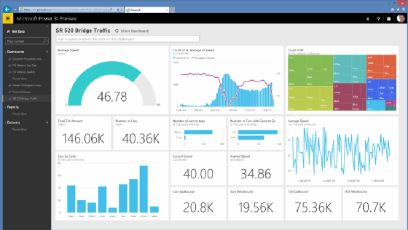
https://www.techtarget.com/searchcontentmanagement/definition/Microsoft-Power-BI
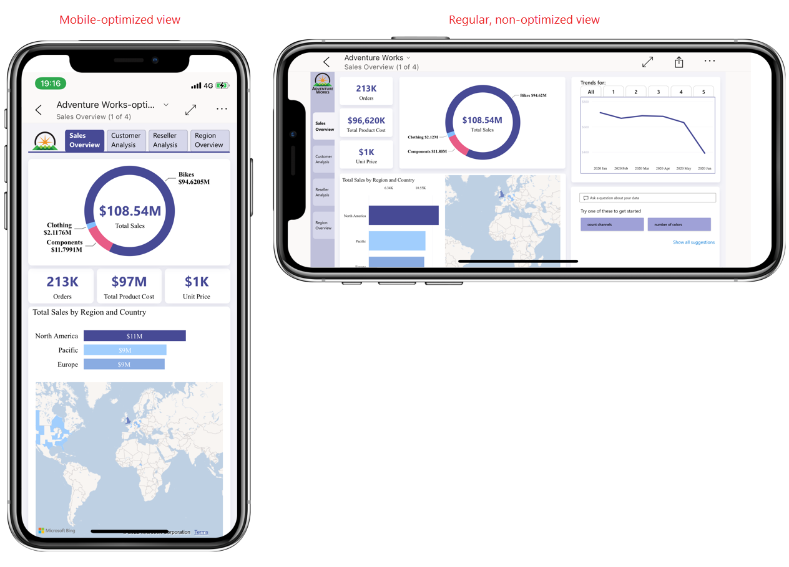
Power BI is a comprehensive toolkit to create desktop reports (Power BI Desktop), share and collaborate in the cloud (Power BI Service), and view dashboards on your device (Power BI Mobile). The Power BI Gateway for secure transfer of data and the Power BI Report Builder for paginated reports.
Functionality and Features.
Users can use Power Query & DAX (Data Analysis Expressions) to import, transform and model data on the platform. Supports personalised visual representations, AI-enabled analytics, and conversational queries. DuPowetbi dashboards provide real-time updates and can integrate analytics with apps and websites.
Integration and Ecosystem.
Power BI works easily with Microsoft 365, Azure and many others like Salesforce, Google Analytics, and SAP. Integration into enterprise workflows is facilitated by its API and data connectors. Data security and compliance standards are supported by governance tools.
Adoption and Impact.
Power BI is used by small or large businesses for data analysis and decision-making. Due to its low entry cost, scalability and ease of use, Tableau is the business intelligence software leader and is often referenced in reports such as the Gartner Magic Quadrant for Analytics and BI Platforms.

3.1.3 SAP BusinessObjects.
SAP Business Objects offers Enterprise Reporting, ERP Integration and Governance Controls. These are analytics democratised by allowing self-service BI without dependence on an IT specialist.
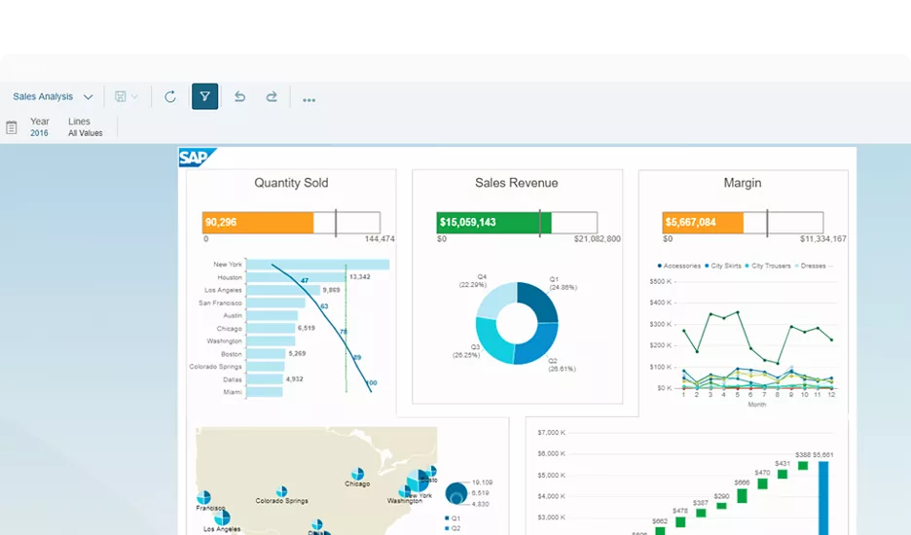https://www.sap.com/products/data-cloud/bi-platform.html

3.2 Cross-Industry Applications.
- In finance, Business Intelligence helps in detecting fraud, modelling risk and optimising portfolios. Predictive analytics improves the accuracy of credit scoring as well as compliance (Rikhardsson and Yigitbasioglu, 2018).
- In retail, Business Intelligence helps in categorisation of customers, forecasting demand and optimising inventory. Dynamic pricing and personalised marketing campaigns are enabled by real-time analytics (Davenport et al., 2020).
- In healthcare, Business intelligence (BI) aids in clinical decision systems, patient flow optimisation, predictive diagnostics, etc. The advanced analytics application improves resource allocation and treatment outcomes (Wang et al., 2021).
- In manufacturing, Business Intelligence improves visibility in the supply chain, predictive maintenance and production processes. IoT-based BI platforms use sensor data to improve asset use and reduce downtime.
In different sectors, BI helps to achieve operational excellence and strategic differentiation (Mikalef et al., 2020). Nonetheless, effectiveness depends on how analytical capability aligns with organisational strategy. Companies that embed business intelligence (BI) into their governance structures and performance management systems gain competitive advantages far superior to companies that merely execute BI as an IT project (Elbashir et al., 2020).

4. Real-World Examples and Case Studies.
The section would critically assess two organisations (Amazon and Tesco) to determine the extent to which Business Intelligence (BI) is embedded in their strategic and operational decision-making and its measurable organisational impact. The cases show that being effective in BI is not just about technology but also about strategy and organisation.

4.1 Amazon. Algorithmic Intelligence and Operational Optimisation.
Amazon exemplifies the industry giant of enterprise-scale Business Intelligence. The ability helps explain the competitive edge, which advanced analytics draws on customer, supply chain, and algorithm-based decision-making. Amazon uses predictive analytics and machine learning to make personalised product recommendations, optimise dynamic pricing, and forecast demand in various markets around the world. (Ransbotham et al., 2021) By analysing purchase histories, browsing behaviour and contextual data, its recommendation engines generate very personalised recommendations that have a direct impact on purchases.
Key facts.
- Founded: 1994 by Jeff Bezos
- Headquarters: Seattle, Washington, U.S.
- CEO: Andy Jassy (since 2021)
- Primary divisions: Amazon.com, Amazon Web Services, Prime Video, Alexa, Whole Foods Market
- Ticker symbol: AMZN (NASDAQ)
The effectiveness of this BI-led personalisation strategy is measurable. Personalised recommendations can significantly boost conversion rates and customer lifetime value while reinforcing the long-term retention of clients (Davenport et al., 2020). In addition, Amazon’s fulfilment network uses real-time analytics to optimise warehouse design, inventory location, and last-mile delivery. By cutting stock-outs and delivery lead times, data-rich logistics systems lower fulfilment costs while increasing service reliability.
In the operations of Amazon, BI is applied to demand forecasting and warehouse optimisation. Using real-time data streams, inventory allocation and last-mile delivery routing can reduce fulfilment errors and delivery delay. The analytics capabilities we observe, referred to as dynamic capabilities by Wamba et al. (2017), are facilitated by big data enables a firm to respond quickly. Reduced logistics costs, increased inventory turnover and sustained revenue growth due to improved customer retention are measurable outcomes. Consequently, the BI architecture of Amazon allows for operational efficiency and a strategic edge in the long term.

4.2 Tesco. Customer Intelligence and Strategic Alignment.
Tesco shows a different but no less interesting story in the retail space. The Clubcard programme, which has been in use for a long time, provides extensive customer-level data. This data can be used for advanced segmentation, behavioural profiling and targeted promotions. Tesco uses BI-enabled analytics platforms to convert transactional data into marketing intelligence so that it can align promotional strategies with preferences. (Rikhardsson and Yigitbasioglu, 2018).


Key facts.
- Founded: 1919 by Jack Cohen
- Headquarters: Welwyn Garden City, United Kingdom
- CEO: Ken Murphy (as of 2025)
- Employees: About 330,000
- Revenue: Approximately $89 billion (2025)
This approach will boost customer satisfaction by offering personalised options while cutting waste and imbalances in stock. As stated by Akter et al (2016), the impact on performance is mostly observed when an analytics capability is aligned with business strategy. However, the case of Tesco shows otherwise.
In strategic terms, Tesco’s adoption of BI exemplifies how data integration of marketing, operations, and logistics enhances organisation-wide coherence. According to Elbashir et al. (2020), Business intelligence (BI) more fully contributes to performance when it is enhanced by the organisation’s absorptive capacity to comprehend and act on analyses. The way they use loyalty data is a good example of this insight, with data being operationalised in pricing, assortment planning, and supply chain arrangements. According to lessons from case studies of Amazon and Tesco, BI can only generate measurable value if aligned with strategy rather than viewed as a standalone IT investment. This is consistent with the findings of the systematic review by Trieu (2017), which contends that BI systems confer performance benefits when the presence of governance mechanism absorptive capacity and cross-functional integration. The actions performed by both organisations show that for data to turn into a competitive advantage, analytics must be embedded into the decision processes.

5. Benefits and Challenges of Business Intelligence.

5.1 Benefits.
Business intelligence makes decision-making better by relying on data-backed evidence and reducing risk. It enhances operational efficiency through process optimisation and performance evaluation. According to Visinescu et al. (2017), examining customer analytics allows for a deeper understanding of their behaviour that can assist with marketing and retention. Through the identification of trends and opportunities, BI drives innovation.

5.2 Challenges.
BI implementation can be a challenge. If data quality is bad, the analytics may be affected too. Smaller firms may be deterred by implementation costs and complexity. Additionally, the inefficient use is due to a data literacy skills gap (Sivarajah et al., 2020). Governance mechanisms must be strengthened because of ethical concerns over privacy and bias.

5.3 Mitigation Strategies.
Firms need to invest in building up a data governance framework, workforce training and other cloud-based BI solutions for capex reduction. Embedding ethical rules in AI models and algorithms improves trust. Commitment from senior leadership is key to a strategic initiative for a culture change toward knowledge-based, data-driven decision-making.

6. Conclusion.
Business Intelligence evolved from simple reporting systems to intelligence-based decision support systems. The five critical elements of data management that help organisations to leverage insights for strategic value are data integration, warehousing, mining, visualisation and analytics. Applications in other industries show BI has many uses in finance, retail, healthcare and manufacturing.
A review of Amazon and Tesco case studies shows that measurable performance improvements come from predictive analytics and personalisation. But the efficacy of BI relies on data quality, organisational capacity and moral governance.
The future of business intelligence will be artificial intelligence, automation, real-time and more self-service platforms. Businesses with a long-term perspective need to strategically plan for business intelligence and foster analytical literacy along with responsible data governance. Technology and organisational culture and strategy must work together for a firm’s successful implementation of BI.

7. Reference list.
Akter, S., Wamba, S.F., Gunasekaran, A., Dubey, R. and Childe, S.J. (2016) ‘How to improve firm performance using big data analytics capability and business strategy alignment’, International Journal of Production Economics, 182, pp.113–131. Available at: https://doi.org/10.1016/j.ijpe.2016.08.018.
Chen, H., Chiang, R.H.L. and Storey, V.C. (2021) ‘Business intelligence and analytics: from big data to big impact’, MIS Quarterly Executive, 20(2), pp.1–10. Available at: https://aisel.aisnet.org
CVR College of Engineering (2023) Data Mining and Business Analytics: Handouts 1–8. IV Year & I Semester, Computer Science Engineering. Hyderabad: CVR College of Engineering. Available at: https://cvr.ac.in/cse/stud/NOTES/DMBA/DMBA.pdf
Davenport, T. et al. (2020) “How artificial intelligence will change the future of marketing,” Journal of the Academy of Marketing Science, 48(1), pp. 24–42. Available at: https://doi.org/10.1007/s11747-019-00696-0.
Elbashir, M.Z., Collier, P.A. and Sutton, S.G. (2020) ‘The role of organisational absorptive capacity in strategic use of business intelligence’, European Journal of Information Systems, 20(1), pp.1–15. Available at: https://doi.org/10.1057/ejis.2010.21.
Mikalef, P., Boura, M., Lekakos, G. and Krogstie, J. (2020) ‘Big data analytics capabilities and innovation’, Information & Management, 56(2), pp.1–13. Available at: https://doi.org/10.1016/j.im.2018.07.003.
MIT Sloan Management Review and Boston Consulting Group (2021) The cultural benefits of artificial intelligence in the enterprise. Available at: https://boardmember.com/wp-content/uploads/2022/06/BCG-The-Hidden-Cultural-Benefits-of-AI.pdf.
Ransbotham, S., Kiron, D., LaFountain, B. and Khodabandeh, S. (2021) ‘Expanding AI’s impact with organisational learning’, MIT Sloan Management Review, 62(4), pp.1–10. Available at: https://sloanreview.mit.edu.
Rikhardsson, P. and Yigitbasioglu, O. (2018) “Business intelligence & analytics in management accounting research: Status and future focus,” International journal of accounting information systems, 29, pp. 37–58. Available at: https://doi.org/10.1016/j.accinf.2018.03.001.
Sivarajah, U., Kamal, M., Irani, Z. and Weerakkody, V. (2020) ‘Critical analysis of big data challenges and analytical methods’, Journal of Business Research, 110, pp.263–286. Available at: https://doi.org/10.1016/j.jbusres.2019.08.043.
Trieu, V.H. (2017) ‘Getting value from Business Intelligence systems: A review and research agenda’, Decision Support Systems, 93, pp.111–124. Available at: https://doi.org/10.1016/j.dss.2016.09.019.
Visinescu, L.L., Jones, M.C. and Sidorova, A. (2017) “Improving Decision Quality: The Role of Business Intelligence,” The Journal of computer information systems, 57(1), pp. 58–66. Available at: https://doi.org/10.1080/08874417.2016.1181494.
Wamba, S.F., Gunasekaran, A., Akter, S., Ren, S.J.F., Dubey, R. and Childe, S.J. (2017) ‘Big data analytics and firm performance: Effects of dynamic capabilities’, Journal of Business Research, 70, pp.356–365. Available at: https://doi.org/10.1016/j.jbusres.2016.08.009.
Wang, Y., Kung, L. and Byrd, T.A. (2021) ‘Big data analytics: understanding its capabilities and potential benefits for healthcare organisations’, Technological Forecasting and Social Change, 126, pp.3–13. Available at: https://doi.org/10.1016/j.techfore.2015.12.019.

