Database Management Systems
  - Name
James Edward Millns

Student No
1708455

Email
1708455@student.uwtsd.ac.uk

Course
BSC (Hons) Software Engineering

Module Name
Database Management Systems

Module Code
ACCA5014

Lecturer
Kemi Ademoye

Table of Contents

Table of Contents 2
Table of Figures 3
1. Introduction 5
2. Performance Tuning 6
2.1 Data Query Analysis 6
2.2 Secondary Indexes 7
3. Distributed Database Solution 9
3.1 Background Research 9
3.2 No Fragmentation 11
3.3 Account Table 12
3.4 Account Subscription Table 15
3.5 Bike Table 18
3.6 Rental Table 21
3.7 BikeRental Table 23
4. Conclusion 25
References 26

Table of Figures
Figure 1: SELECT query example 7
Figure 2: Secondary index for Rental table. 7
Figure 3: Secondary index for Account table 8
Figure 4: Select query on account for last and first name. 8
Figure 5: SELECT query example for Bike Table 8
Figure 6: Secondary index for bike table. 8
Figure 7: Original City Table 11
Figure 8: Original Station Table 11
Figure 9: Original Tariff Table 11
Figure 10: Original Account Table 12
Figure 11: Account Fragment 1 12
Figure 12: Account Fragment 2 13
Figure 13: Account Fragment 2.1 13
Figure 14: Account Fragment 2.2 13
Figure 15: Account Fragment 2.3 13
Figure 16: Account Fragment 2.4 14
Figure 17: Account Fragment 2.5 14
Figure 18: Original AccountSubscription table 15
Figure 19: Columns from Account table needed for Join 15
Figure 20: AccountSubscription Joined with Account Table 16
Figure 21: AccountSubscription Fragment 1, See Figure 11 16
Figure 22: AccountSubscription Fragment 2, See Figure 12 16
Figure 23: AccountSubscription Fragment 3, see Figure 13 17
Figure 24: AccountSubscription Fragment 4, see Figure 14 17
Figure 25: AccountSubscription Fragment 5, see Figure 15 17
Figure 26: Bike Table 18
Figure 27: Bike Fragment 1 19
Figure 28: Bike Fragment 2 19
Figure 29: Bike Fragment 3 19
Figure 30: Bike Fragment 4 20
Figure 31: Bike Fragment 5 20
Figure 32: Original Rental Table 21
Figure 33: Rental Fragment 1 21
Figure 34: Rental Fragment 2 21
Figure 35: Rental Fragment 3 21
Figure 36: Rental Fragment 4 22
Figure 37: Rental Fragment 5 22
Figure 38: Original BikeRental Table 23
Figure 39: BikeRental Fragment 1 23
Figure 40: BikeRental Fragment 2 23
Figure 41: BikeRental Fragment 2.1 24
Figure 42: BikeRental Fragment 2.2 24
Figure 43: BikeRental Fragment 2.3 24
Figure 44: BikeRental Fragment 2.4 24
Figure 45: BikeRental Fragment 2.5 24

Introduction
Cycles to Share is a new bike share company based in Swansea which is rapidly growing and would benefit from a new database management system. This report details how the performance of the system can be affected and tuned. This will be demonstrated by analysing the probably queries that will be run on the system, and how they can be made more efficient.
Cycles to Share have also requested a schema for distributing the database between the different stations that will need to access specific data with acceptable response times. It has been stated in the assignment brief that the regional branch in Swansea will remain as the financial department and deal with and process all payment information on the database.

Performance Tuning

Data Query Analysis
When using the new system, the members of staff in cycles to share will be executing multiple queries on the database which will be retiring data from possibly many different tables at a time [1], [2]. It is important to analyse the queries which will be most important for running the business as it will help identify possible tuning enhancements which can improve performance [1], [2].
The City, Station and Tariff table would mostly have read queries performed on them [1], [2]. For example, a select query which references the respective primary keys with an inner join could be used to find the details of the station where a specific bike is located (which is an example of data normalisation [1], [2]). The City, Station and Tariff table are not likely to have over 100 fields each, which means that performing search queries on the tables should be quick and responsive due to the low number of entries it needs to search through [1], [2].
The Account, AccountSubscription, Bike, Rental and BikeRental tables are going have create, read and update queries performed on them [1], [2].
Create queries would be when a new customer sets up an account or when an existing customer wished to book a rental for a bike, these would use an INSERT data query [1], [2].
Read queries would be used when the system needs to check the number of bikes an account is currently hiring to prevent them from hiring more than sixbikes, this would use a SELECT query which would be used in a transaction check [1], [2].
Update would be used when changing the status of a specific bike from vacant to occupied or vice versa and when updating the activity of an account’s subscription in the AccountSubscription table, this would use the UPDATE data query [1], [2].
The Account, AccountSubscription, Bike, Rental and BikeRental tables have the potential to have hundreds to thousands of records, which would make performing searches on them taxing to the database’s performance [1], [2].
To improve performance, the implementation of secondary indexes could be introduced to reduce the number of records the query has to search through, and instead be directed to the addresses of the records [1], [3], [4].

Secondary Indexes
When performing data queries on tables, the performance of the database can vary based on the number of records and how the data has been organised [1], [3], [4]. If performing the data query shown in Figure 1, the system would need to search through every record in the table, which could be thousands of records, resulting in a slow response [1], [3], [4].
Figure 1: SELECT query example
To improve the performance of the database, a secondary index can be used to organise the records based on a selected column [1]–[4]. The indexes are a parallel table which store the record addresses of the table it is made for, much like an index in a book organising the contents alphabetically and showing the page each are on, it organises the records by a chosen column and shows the address the record is at for the system [1]–[4].
It not best practise to use a volatile column (a column that is frequently updated) as an index column, as every time the column is updated, the index will need to be rewritten which is taxing on the performance of the system and outweighs the performance boost gained by the index [1]–[4].
Figure 2 shows the index created for the rental table which will improve the performance of the query shown in figure 1 [1]–[4]. This index will be useful in scenarios where a user needs to view all rental records of a specific account holder [1]–[4].
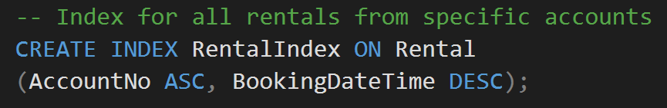
Figure 2: Secondary index for Rental table.
The account table can be indexed by the account holder’s last name, first name and date of birth, all in ascending order, as shown in figure 3 [1]–[4].
Figure 3: Secondary index for Account table
This would be useful for queries used in scenarios where a customer’s account needs to be found on the system, and the customer making the request does not have their account details on hand. An example query for this is shown in figure 4 [1]–[4]. These columns are appropriate indexes as they are non-volatile, and there is a little chance there would be a duplicate of the three in the database [1]–[4].
Figure 4: Select query on account for last and first name.
A common query that would be performed on the Bike table would be one that searches for all available bikes in a given station as shown in figure 5 [1]–[4]. This would be a taxing query as there are likely to be thousands of records of bikes on the system, so indexing this would be beneficial [1]–[4].
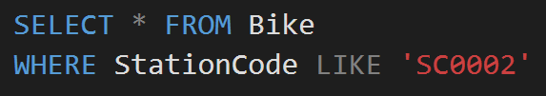
Figure 5: SELECT query example for Bike Table
A possible way to index the bike table is to use the station code column as the secondary index as shown in figure 6, so all bikes will be organised in the index by which station they are currently at [1]–[4].
An argument against this index would be the possibility of a customer dropping a rented bike of at a different station than they picked it up from, which would change the location of the bike on the table, resulting in the index being reordered [1]–[4].
Even though there is a possibility that the column can be updated, it is assumed that the customers will be informed to drop the bike off at the station they picked it up from if possible to prevent the station location of the bike changing too often [1]–[4].
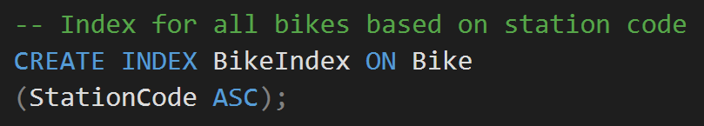
Figure 6: Secondary index for bike table.
As the database management system stands, the index shown in Figure 6 would be a legitimate index to implement if the database was to be in a centralised location, however this would be made redundant in the presence of a distributed database schema where the bike table was fragmented on the station code, this will be expanded upon in the next section [5]–[9].

Distributed Database Solution

Literature Review
When a company or organisation is spread across multiple sites and branches, where each needs to access information specific to their branch, having a single centralised database can be extremely inefficient and ineffective [5]–[9]. If the database is stored in one central location, then branches need to remotely connect to the system to access the data, which can be highly taxing on the performance of the system for the branches that are further away from the central database [5]–[9].
A method to combat this is distributing a database management system between the branches [5]–[9]. Each branch having fragments of the database specific to them is an efficient and effective method of improving the performance of a system which stores and manipulates large amount of data [5]–[9]. This is useful because it means that branches can quickly access the information that is specific to them, while being able to ignore all the irrelevant information that they do not need which was slowing down the performance of the searches before [5]–[9].
To distribute a database, a suitable schema design needs to be established, taking into consideration the requirements of each branch, and the complexity or the volume of data contained in each table [5]–[9]. To fragment a table, two basic techniques can be used, Horizontal fragmentation and Vertical fragmentation [5]–[9]. Horizontal fragmentation splits a table’s objects or rows into different sets of data [5]–[9]. Vertical fragmentation splits a table’s attributes or columns between sets [5]–[9]. These basic techniques can be used together to incur a hybrid or mixed fragmentation where either a vertical fragment of a table is fragmented further into horizontal fragments, or vice versa [5]–[9]. A table can also be horizontally fragmented based on a parent tables horizontal fragmentation, this is derived fragmentation [5]–[9].

When fragmenting a table, it is important to ensure that the data is completely fragmented, or that a specific item of data will appear at least once in one of the tables fragments, otherwise it has been lost and the original table cannot be reconstructed [5]–[9]. It is also important to ensure the fragments are disjoint from one another, or to say that if an item of data is present in one fragment, it should not appear in another fragment as this would be data redundancy and would waste memory [5]–[9]. The only exception to this is in the case of vertical fragmentation where each fragment needs a copy of the primary key for reconstruction [5]–[9].
Finally, a method to reconstruct the table from the fragments needs to be established as there will be scenarios where data from one branch will need to be accessed from another branch [5]–[9].

No Fragmentation
The Tariff, City and Station table should not been fragmented due to the reason that these tables contain a small amount of data entries which is not likely to be updated or have any additions made to them on a regular basis [5]–[9].
The tables will be replicated at each site, which does mean the data will be redundant (use up more memory than it needs) and could lead to some inconsistencies if one site changes their version [5]–[9].
This will be mitigated due to the fact that the tables are small in memory footprint and are not likely to be changed; they are required for normalising data on other more active tables, like the Account Subscription table which will be referencing the tariff table prices when a charge is being calculated [5]–[9].
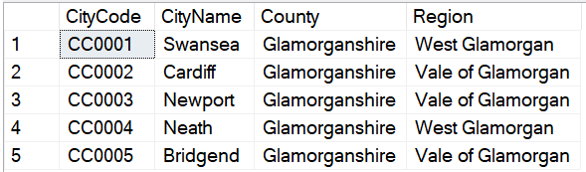
Figure 7: Original City Table
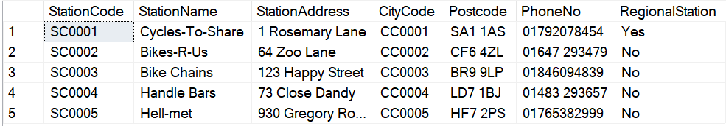
Figure 8: Original Station Table
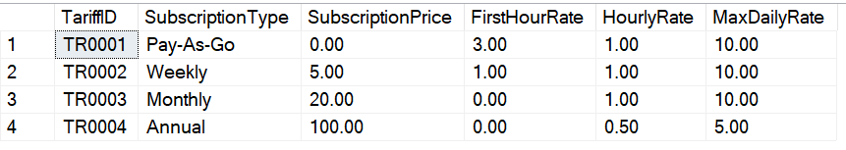
Figure 9: Original Tariff Table

Account Table
The Account table will be fragmented in a hybrid fashion, first a vertical fragmentation will be used to separate the financial columns from the human resources columns as the financial columns will only be required in the Swansea office as that is where all the payments will be processed [5], [6], [8]–[15].
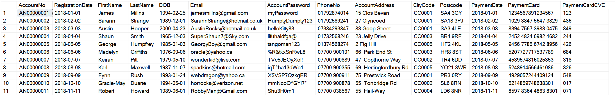
Figure 10: Original Account Table

A₁: ΠAccountNo, PaymentDate, PaymentCard, PaymentCVC (Account)
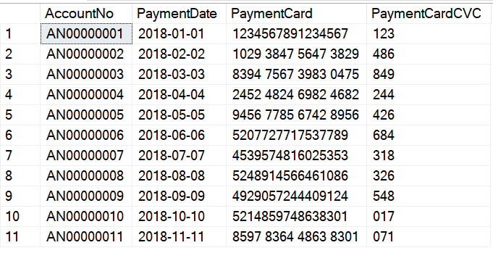
Figure 11: Account Fragment 1

A₂: ΠAccountNo, RegistrationDate, FirstName, LastName, DOB, Email, AccountPassword, PhoneNo, AccoundAddress, CityCode (Account)

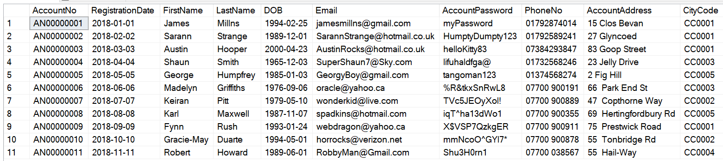
Figure 12: Account Fragment 2
The HR vertical fragment (A₂₎ will be further fragmented horizontally by the City Code so each station will have quicker access to the account details of the accounts that are in their city [5], [6], [8]–[15].

A_{2.1}: σ_{CityCode = 'CC0001’} (A₂)

Figure 13: Account Fragment 2.1

A_{2.2}: σ_{CityCode = 'CC0002’} (A₂)
Figure 14: Account Fragment 2.2

A_{2.3}: σ_{CityCode = 'CC0003’} (A₂)
Figure 15: Account Fragment 2.3

A_{2.4}: σ_{CityCode = 'CC0004’} (A₂)

Figure 16: Account Fragment 2.4
A_{2.5}: σ_{CityCode = 'CC0005’} (A₂)

Figure 17: Account Fragment 2.5
The fragments are complete as all columns in the original Account table are present in either A₁ or A₂, and Each row of A₂ appears in either A_{2.1}, A_{2.2}, A_{2.3}, A_{2.4} or A_{2.5} [5], [6], [8]–[15].
The vertical fragments are disjoint except for the primary key which will be used for reconstruction, and the horizontal fragments are disjoint as an account cannot be in two or more cities at once [5], [6], [8]–[15].
The original table can be reconstructed with the following method:
Original Account Relation = A₁ ⋈ (A_{2.1} ∪ A_{2.2} ∪ A_{2.3} ∪ A_{2.4} ∪ A_{2.5})

Account Subscription Table
As the Account table is going to be horizontally fragmented between the different cities, it would also be beneficial if the accounts corresponding account subscriptions were also horizontally fragmented in the same way, this will be accomplished with a derived fragmentation [5], [6], [8]–[14], [16].
As the AccountSubscription does not have a CityCode column, first a join will be needed between the account subscription and the account table [5], [6], [8]–[14], [16].
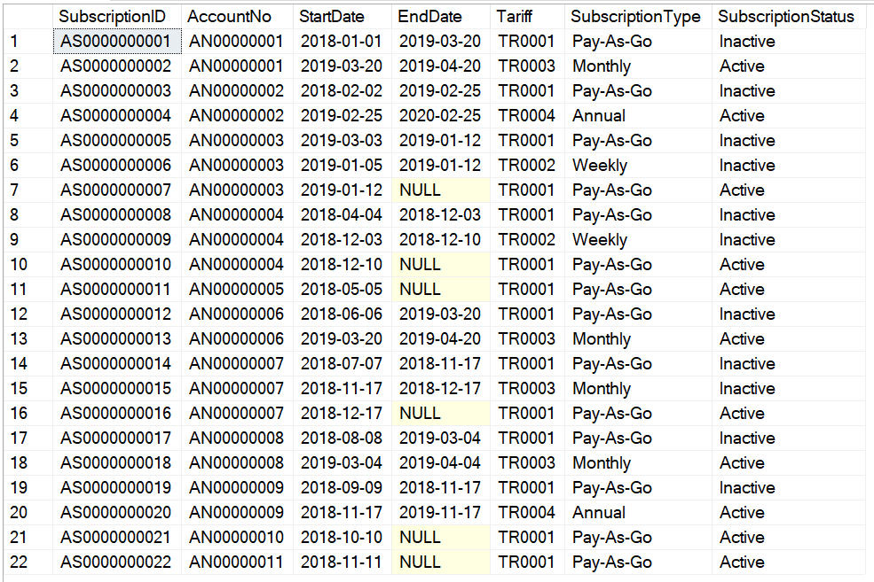
Figure 18: Original AccountSubscription table
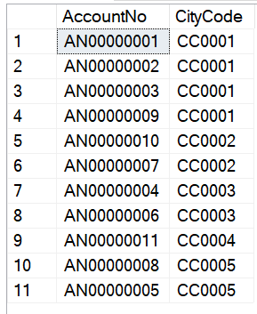
Figure 19: Columns from Account table needed for Join
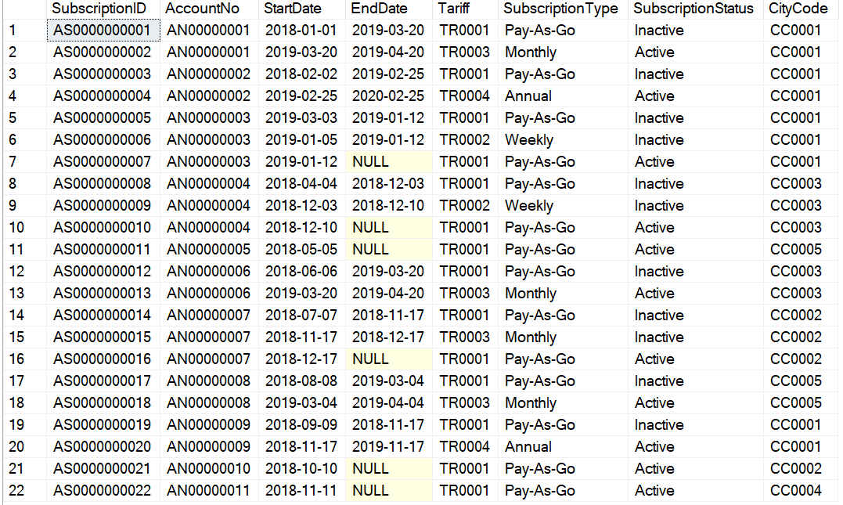
Figure 20: AccountSubscription Joined with Account Table
The Joined table would then be fragmented by the CityCode inherited from the Account table. The Account table has already been horizontally fragmented, so those fragments will be referred to when fragmenting this table to keep integrity [5], [6], [8]–[14], [16].
AS₁ = AS ⊳_{CityCode} A_{2.1} (A_{2.1} is a horizontal fragment where CityCode=’CC0001’)

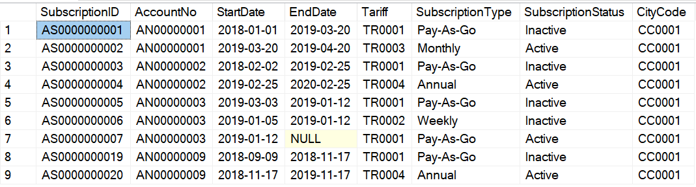
Figure 21: AccountSubscription Fragment 1, See Figure 11

AS₂ = AS ⊳_{CityCode} A_{2.2} (A_{2.2} is a horizontal fragment where CityCode=’CC0002’)
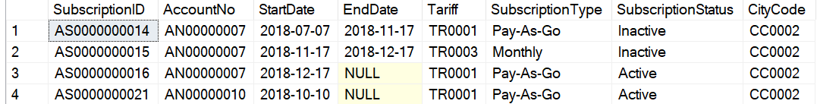
Figure 22: AccountSubscription Fragment 2, See Figure 12

AS₃ = AS ⊳_{CityCode} A_{2.3} (A_{2.3} is a horizontal fragment where CityCode=’CC0003’)
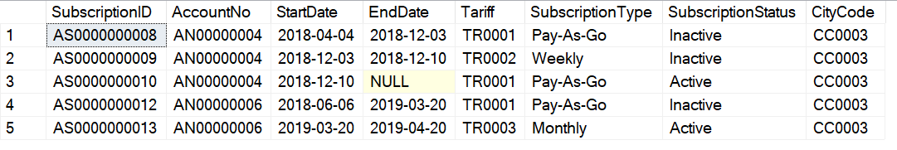
Figure 23: AccountSubscription Fragment 3, see Figure 13

AS₄ = AS ⊳_{CityCode} A_{2.4} (A_{2.4} is a horizontal fragment where CityCode=’CC0004’)
Figure 24: AccountSubscription Fragment 4, see Figure 14

AS₅ = AS ⊳_{CityCode} A_{2.5} (A_{2.5} is a horizontal fragment where CityCode=’CC0005’)
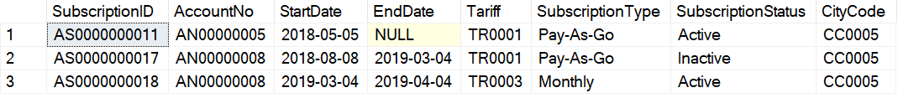
Figure 25: AccountSubscription Fragment 5, see Figure 15
The fragments are complete because all items in AS are present in AS_{1,} AS_{2,} AS_{3,} AS₄ or AS₅ [5], [6], [8]–[14], [16].
The fragments are disjoint because no AccountSubscription can be for more than one account, and no Account can be in more than one city [5], [6], [8]–[14], [16].
The original AccountSubscription table can be reconstructed from the fragments with the following method.
Original AccountSubscription Table = AS_{1 ∪} AS_{2 ∪} AS_{3 ∪} AS_{4 ∪} AS₅

Bike Table
The Bike table will be horizontally fragmented by the StationCode as the stations would need quicker access to the bikes that are currently in their possession [5], [6], [8]–[13].
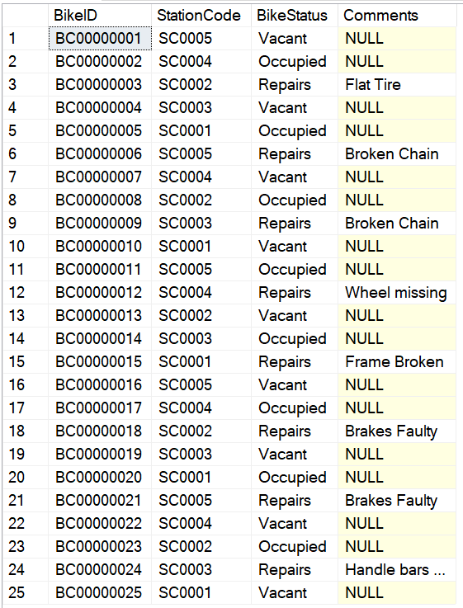
Figure 26: Bike Table
As there are five Station Codes, there would be 5 fragments as follows [5], [6], [8]–[13].

B₁: σ_{StationCode = 'SC0001’} (Bike)
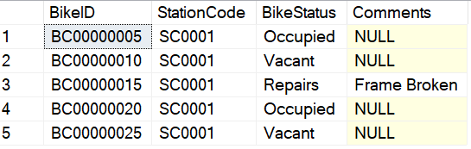
Figure 27: Bike Fragment 1

B₂: σ_{StationCode = 'SC0002’} (Bike)
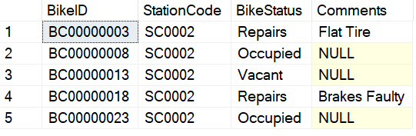
Figure 28: Bike Fragment 2

B₃: σ_{StationCode = 'SC0003’} (Bike)
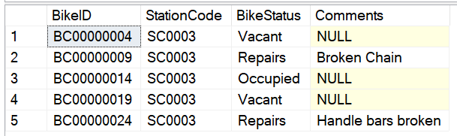
Figure 29: Bike Fragment 3

B₄: σ_{StationCode = 'SC0004’} (Bike)

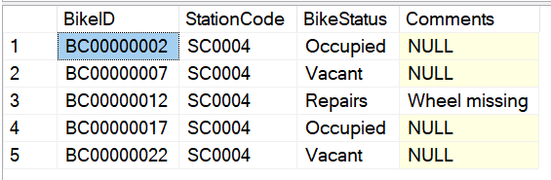
Figure 30: Bike Fragment 4

B₅: σ_{StationCode = 'SC0005’} (Bike)
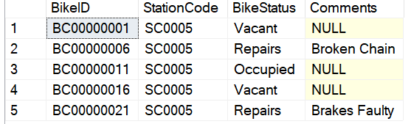
Figure 31: Bike Fragment 5
The fragments are complete because each row in the original bike table appears in either B₁, B₂, B₃, B₄ or B₅ [5], [6], [8]–[13].
The fragments are disjointed because no bike can be in more than one station at a time [5], [6], [8]–[13].
The original table can be reconstructed from the fragments with the following union method:
Original Bike Table = B_{1 ∪} B_{2 ∪} B_{3 ∪} B_{4 ∪} B₅

Rental Table
The Rental table will be horizontally fragmented by the PickupStation as the stations would need quicker access to the Rentals that are happening at their location [5], [6], [8]–[13].
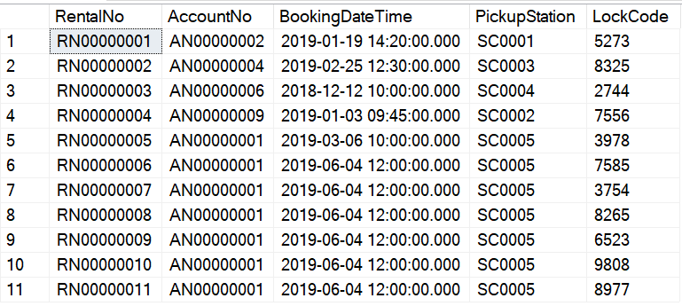
Figure 32: Original Rental Table
As there are five Station Codes, there would be five fragments as follows [5], [6], [8]–[13].

R₁: σ_{PickupStation = 'SC0001’} (Rental)
Figure 33: Rental Fragment 1

R₂: σ_{PickupStation = 'SC0002’} (Rental)
Figure 34: Rental Fragment 2

R₃: σ_{PickupStation = 'SC0003’} (Rental)
Figure 35: Rental Fragment 3

R₄: σ_{PickupStation = 'SC0004’} (Rental)

Figure 36: Rental Fragment 4

R₅: σ_{PickupStation = 'SC0005’} (Rental)

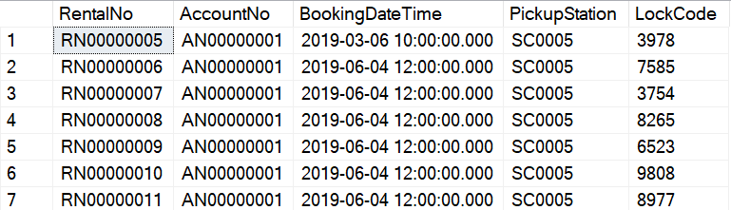
Figure 37: Rental Fragment 5
The fragments are complete because each row in the original Rental table appears in either R₁, R₂, R₃, R₄ or R₅ [5], [6], [8]–[13].
The fragments are disjointed because no Rental can be picked up from more than one station at a time [5], [6], [8]–[13].
The original Rental table can be reconstructed from the fragments with the following union method:
Original Rental Table = R_{1 ∪} R_{2 ∪} R_{3 ∪} R_{4 ∪} R₅

BikeRental Table
The BikeRental table will be fragmented in a hybrid fashion, first a vertical fragmentation will be used to separate the financial columns from the time details columns as the financial columns will only be required in the Swansea office as that is where all the payments will be processed [5], [6], [8]–[15].
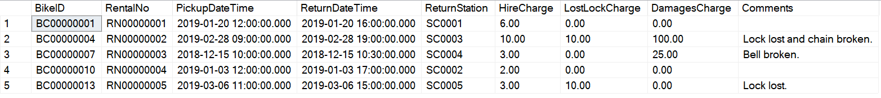
Figure 38: Original BikeRental Table

BR₁: ΠBikeID, RentalNO, HireCharge, LostLockCharge, DamagesCharge (BikeRental)
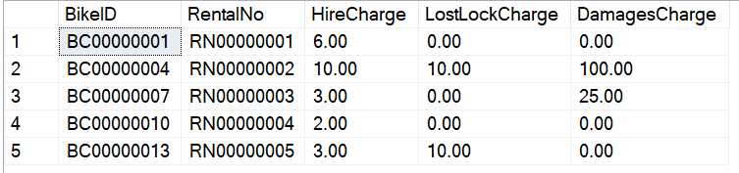
Figure 39: BikeRental Fragment 1

BR₂: ΠBikeID, RentalNo, PickupDateTime, ReturnDate, ReturnStation (BikeRental)
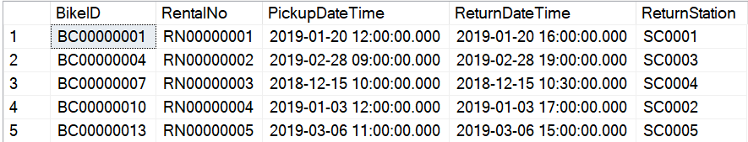
Figure 40: BikeRental Fragment 2
The time details vertical fragment (BR₂₎ will be further fragmented horizontally by the Return Station so each station will have quicker access to the time details of the bike rentals that are in taking place at their station [5], [6], [8]–[15].

BR_{2.1}: σ_{ReturnStation = 'SC0001’} (BR₂)

Figure 41: BikeRental Fragment 2.1

BR_{2.2}: σ_{ReturnStation = 'SC0002’} (BR₂)
Figure 42: BikeRental Fragment 2.2

BR_{2.3}: σ_{ReturnStation = 'SC0003’} (BR₂)
Figure 43: BikeRental Fragment 2.3

BR_{2.4}: σ_{ReturnStation = 'SC0004’} (BR₂)
Figure 44: BikeRental Fragment 2.4

BR_{2.5}: σ_{ReturnStation = 'SC0005’} (BR₂)
Figure 45: BikeRental Fragment 2.5
The fragments are complete as all columns in the original BikeRental table are present in either BR₁ or BR₂, and Each row of BR₂ appears in either BR_{2.1}, BR_{2.2}, BR_{2.3}, BR_{2.4} or BR_{2.5} [5], [6], [8]–[15].
The vertical fragments are disjoint except for the two primary keys which will be used for reconstruction, and the horizontal fragments are disjoint as a bike rental cannot be in two or more cities at once [5], [6], [8]–[15]. The original table can be reconstructed with the following method:
Original BikeRental Relation = BR₁ ⋈ (BR_{2.1} ∪ BR_{2.2} ∪ BR_{2.3} ∪ BR_{2.4} ∪ BR_{2.5})

Conclusion
Performance of a database can be greatly enhanced by identifying the specific types of queries that will be performed on specific tables [5]–[9]. When this information has been identified, secondary indexes can be designed to improve the search speed on the tables they are made for [5]–[9].
Performance can also be improved between multiple branches by distributing the database tables between the branches, each branch holding a fragment of the tables containing information that the branch will likely be using on a regular basis [5]–[9].
When designing a distributed database schema, it is important that suitable fragmentation methods are used for each table, giving reason for the fragmentation [5], [6], [8]–[16].
It needs to ensure it meets the following three criteria:
- Complete: Each item of data appears in at least one of its table’s fragments [5], [6], [8]–[16].
- Disjoint: No item of data is repeated between its table’s fragments except for primary key attributes [5], [6], [8]–[16].
- Reconstruction: Has a suitable method of reconstructing the original table from the fragments [5], [6], [8]–[16].
This report has successfully identified the performance tuning requirements of the proposed database management system, and successfully designed an appropriate distribution schema.

References
[1] D. B. Lomet, A. El Abbadi, S. Chaudhuri, D. Kossmann, and E. Rundensteiner, “DB2 Universal Database Performance Tuning,” Bull. Tech. Comm. Data Eng., vol. 22, no. 2, pp. 12–19, 1999.
[2] M. T. Gonzalez-Aparicio, M. Younas, J. Tuya, and R. Casado, “A New Model for Testing CRUD Operations in a NoSQL Database,” in 2016 IEEE 30th International Conference on Advanced Information Networking and Applications (AINA), 2016, pp. 79–86.
[3] B. R. Chang, H.-F. Tsai, C.-Y. Chen, C.-F. Huang, and H.-T. Hsu, “Implementation of Secondary Index on Cloud Computing NoSQL Database in Big Data Environment,” Sci. Program., vol. 2015, pp. 1–10, 2015.
[4] E. Barcucci and R. Pinzani, “Optimal selection of secondary indexes,” IEEE Trans. Softw. Eng., vol. 16, no. 1, pp. 32–38, 1990.
[5] F. Baião, M. Mattoso, and G. Zaverucha, “A framework for the design of distributed databases,” in Workshop on Distributed Data & Structures, 2002.
[6] A. M. Tamhankar and S. Ram, “Database fragmentation and allocation: an integrated methodology and case study,” IEEE Trans. Syst. Man, Cybern. - Part A Syst. Humans, vol. 28, no. 3, pp. 288–305, May 1998.
[7] R. Elmansouri, E. Ziyati, O. Elbeqqali, and D. Aboutajdine, “The fragmentation of data warehouses: An approach based on principal components analysis,” in 2012 International Conference on Multimedia Computing and Systems, 2012, pp. 18–23.
[8] W. W. Chu, “Optimal File Allocation in a Multiple Computer System,” IEEE Trans. Comput., vol. C-18, no. 10, pp. 885–889, Oct. 1969.
[9] S. Ceri, S. Navathe, and G. Wiederhold, “Distribution Design of Logical Database Schemas,” IEEE Trans. Softw. Eng., vol. SE-9, no. 4, pp. 487–504, Jul. 1983.
[10] S. Menon, “Allocating fragments in distributed databases,” IEEE Trans. Parallel Distrib. Syst., vol. 16, no. 7, pp. 577–585, Jul. 2005.
[11] S. P. Li and M. H. Wong, “Data Allocation in Scalable Distributed Database Systems Based on Time Series Forecasting,” in 2013 IEEE International Congress on Big Data, 2013, pp. 17–24.
[12] G.-M. Chiu and C. S. Raghavendra, “A model for optimal database allocation in distributed computing systems,” in Proceedings. IEEE INFOCOM ’90: Ninth Annual Joint Conference of the IEEE Computer and Communications Societies@m_The Multiple Facets of Integration, pp. 827–833.
[13] D. Nashat and A. A. Amer, “A Comprehensive Taxonomy of Fragmentation and Allocation Techniques in Distributed Database Design,” ACM Comput. Surv., vol. 51, no. 1, pp. 1–25, Jan. 2018.
[14] L. Bellatreche, A. Simonet, and M. Simonet, “Vertical fragmentation in distributed object database systems with complex attributes and methods,” in Proceedings of 7th International Conference and Workshop on Database and Expert Systems Applications: DEXA 96, pp. 15–21.
[15] Hui Ma, K.-D. Schewe, and M. Kirchberg, “A heuristic approach to vertical fragmentation incorporating query information,” in 2006 7th International Baltic Conference on Databases and Information Systems, pp. 69–76.
[16] S. De Capitani di Vimercati, S. Foresti, S. Jajodia, G. Livraga, S. Paraboschi, and P. Samarati, “Fragmentation in Presence of Data Dependencies,” IEEE Trans. Dependable Secur. Comput., vol. 11, no. 6, pp. 510–523, Nov. 2014.

marking criteria and Student FEEDBACK

This section details the extent to which the assessment criteria are demonstrated by you, which in turn determines your mark. The marks available for each category of skill are shown. Lecturers will use the space provided to comment on the achievement of the task(s), including those areas in which you have performed well and areas that would benefit from development/improvement.

Common Assessment Criteria Applied (Assignment 1) | Marks available | Marks  awarded
1. Engagement with Literature Skills

A wide-range of appropriate, reference sources have been consulted. (Grade mark: 100.00%) | 5 | 5
2. Knowledge and Understanding Skills

A very good range of queries to create sample data for the database has been provided with additional, appropriate queries to test the constraints added to the tables. A fair attempt at the transaction with some sample data to test it, but unfortunately your logic is not quite correct. The table you need to check is the RentalBike table as this is the table that stores the bikes taken out on each rental. As such, your transaction does not work. (Grade mark: 80.00%) | 20 | 16
3. Cognitive and Intellectual Skills

Excellent analysis to determine secondary indexes to create and the chosen indexes are very good and appropriate. The case study has been very well analysed for the distributed design strategy with a very good solution proposed and clear justifications for your solution. You have also clearly shown how the global relations can be reconstructed. See your report for some additional comments. (Grade mark: 86.67%) | 30 | 26
4. Practical Application Skills

An excellent attempt. Just a few minor things to note. You correctly identified that RegionalStation in the station table is a field to indicate if this is the region's main station office, but note that a BIT data type would have been better than char Yes or No. Also note that some cards have a CVC number with 4 characters. (Grade mark: 92.50%) | 40 | 37
5. Transferable Skills for Life and Professional Practice

The report is very well-written and presented.  (Grade mark: 80.00%) | 5 | 4

Assignment Mark (Assessment marks are subject to ratification at the Exam Board. These comments and marks are to give feedback on module work and are for guidance only until they are confirmed. ) | Late Submission Penalties (tick if appropriate) |  | 88%
 | Up to 1 week late (40% Max) |  | 88%
 | Over 1 week late (0%) |  | 88%

