ECIE5002/C
Numbers Count

By Carla Thompson

Contents Page
Element 1
Why is good numeracy important? 3

Reference list 5

Element 2
What can schools do encourage numeracy? 6

Reference list 10

Element 3
11
Resource – Information Sheet for professionals about a numeracy resource of your choice which aims to support numeracy development in pupils with ALN

Reference list

Element 4
Video of the resource in action
14

Element 5
Evaluation of the resource
15

Reference list
17

Element one (Essay)
Why is Good Numeracy Important?
Numeracy is “the ability to understand and use maths in daily life, at home, work or school” (National Numeracy,2019). It all comes down to thinking, reasoning and problem solving. The National Literacy and Numeracy Framework 2013 states that “There is more to numeracy than teaching the rules and procedures of mathematics. However, it is imperative that the fundamental mathematical techniques are taught to a standard that allows learners to be numerate”.
Victoria State Government (2024) states that “A child's first years are a time of rapid learning and development. They use maths concepts to make sense of their world and connect these concepts with their environment and everyday activities”. While much of the teaching happens in the maths learning area, it is strengthened as students take part in activities that connect their learning in other curriculum areas. With these skills being used and learnt throughout daily activities and experiences, this is where it fits into numeracy. As they go onto developing their skills and move through the years in school, the children will then be exposed to all of the different areas of numeracy but as this happens the link and connections will be made in their brains to be able to allow the students to respond to familiar and unfamiliar numeracy problems. (Victoria State Government,2024). These factors play a really strong roll as to why it is numeracy is so important in schools and to children as a whole.
To add to this good numeracy is important because it links into critical thinking, problem solving and reasoning, children need these skills in order to be able to learn and develop. These three skills links into lots of day-to-day experiences and so therefore the child would then find it difficult to carry the most basic of tasks out. The new curriculum for Wales has set out new goals because they want children to thrive in their learning and has said that the children “will have opportunities to ask questions, look at the evidence, make decisions and solve problems, will learn to make the most of your time and talents and children will learn to manage your time, set goals, make decisions and check your work” (WelshGovernment,2025).
Throughout numeracy there are five “proficiencies and these are: Conceptual understanding, Communication using symbols, Fluency, Logical reasoning and Strategic competence” (Welsh Government,2022). By using these for guidance with numeracy and going along with the numeracy framework that is in place in the setting, it would aim to meet the needs of the children.
The Government have had their say in how “Maths and English are vital building blocks to a successful future, which is why the Schools White Paper, sets an ambitious target for 90% of young people to leave primary school at the expected standard in reading and maths by 2030” (Department for Education and Burghart,2022). They have also targeted parents in order for them to provide the best opportunities for their children and for themselves, they would like for parents to take a quiz online for numeracy and have a £180 million budget in order to spread over three years and target the youngest of children (The Rt Hon Kelly Tolhurst and Department of Education,2022).
Building upon what has been said, there is also the National Literacy and Numeracy Framework last updated in February 2025. This policy is followed by schools around Wales as a guidance for practitioners so that they are able to provide the best education and learning experience possible for the children. This framework is used from as young as 3 years old and goes all the way up to children finishing primary and secondary education. This policy is beneficial to good numeracy because it sets the targets for learning and gives goals to help the children thrive and achieve.
Moving on from this, there are also effects if you have poor numeracy skills. “Poor numeracy can affect people’s confidence and self-esteem” (Schleicher,2014). Not only this, when the children are older, they may find it more difficult to find work, or when they have work, face unemployment due to lack of knowledge and understanding. When we look at this challenges that are faced with having poor numeracy skills, it shows how important it is to support your child with the basic understanding of numeracy and helping them grow and build upon their knowledge (National Numeracy,2014).
Psychological factors also play a part in why children may experience poor numeracy. It has been said that numeracy starts of a young age, and this then would mostly be support from parents. “While schools are vital to ensuring the younger generation build a positive relationship with numbers, the issue among adults often goes under the radar (Schleicher,2014).
Without having good numeracy, it could lead to children having poor confidence and social skills. Strengthening early numeracy and ensuring your skills are good it give children the confidence to continue learning different numeracy concepts throughout their schooling and beyond into adulthood (Sam,2023). Not only this, children with poor numeracy find it difficult to socialise and engage in activities with other children.
Piagets theory links in well with supporting good numeracy, he had come up with the cognitive development theory where children had a stage of development based upon their age and within that there would be stages in which the children would need to meet for their age group. This in turn would then make it easier for teachers and support staff to follow and help children achieve the goals and get them to having good numeracy. Alongside Piagets theory, John Deweys theory gives a hands on approach to learning which also works in with the new Curriculum for Wales. He said that “pedagogy was that it should be a holistic approach to teaching and learning. He believed in using experiential learning as part of the educational process, whereby students are encouraged to combine their theoretical knowledge with practical experience” (Main,2023).

Essay Reference
Schleicher Andreas, “Why Is Numeracy Important | National Numeracy,” 2014, Why is Numeracy Important? - The Effects of Poor Numeracy. Accessed 26/02/25.
Alex Burghart, Department for Education, Numeracy Support to Boost Maths Skills for All the Family, 18 May 2022, www.gov.uk/government/news/numeracy-support-to-boost-maths-skills-for-all-the-family. Accessed 22/02/2025.
Victoria State Government, “Numeracy for All Learners”, 8 February 2024, www.education.vic.gov.au/school/teachers/teachingresources/discipline/maths/Pages/numeracy-for-all-learners.aspx, Accessed 18/02/25.
Welsh Government, “Mathematics and Numeracy: Designing Your Curriculum - Hwb”, 10 Jan. 2022, hwb.gov.wales/curriculum-for-wales/mathematics-andnumeracy/designing-your-curriculum/. Accessed 19/02/25
Welsh Government, Let’s Get Started a New Curriculum in Wales a Guide for Children, Young People and Families, 2025, a-new-curriculum-in-wales-a-guide-for-children-young-people-and-families.pdf. Accessed 29/02/25.
Welsh Government, National Literacy and Numeracy Framework to Support Schools in Introducing the National Literacy and Numeracy Framework, Mar. 2013, to-support-schools-in-introducing-the-national-literacy-and-numeracy-framework.pdf. Accessed 28/02/25.
National Numeracy, “What Is Numeracy?”, 4 March 2019, www.nationalnumeracy.org.uk/what-numeracy, accessed 26/01/25.
Main Paul, “John Dewey’s Theory,” Structural Learning, 2023, www.structural-learning.com/post/john-deweys-theory. Accessed 1 Mar. 2025.
The Rt Hon Kelly Tolhurst, Department of Education, £180 Million to Improve Children’s Development in the Early Years, 20 Oct. 2022, www.gov.uk/government/news/180-million-to-improve-childrens-development-in-the-early-years. Accessed 22/02/2025.
Sam, “Importance of Developing Strong Numeracy Skills in Children | Mrs. Myers’ Learning Lab” 24 Jan. 2023, mrsmyersrr.com/news/importance-developing-strong-numeracy-skills-children. Accessed 29/02.25.

Blog
What can schools do to encourage numeracy?
Alright then, who can tell me what one earth numeracy is and why is it different to maths? I bet that’s somewhat what you’re thinking, am I right? Well numeracy is “the ability to understand and use maths in daily life, at home, work or school” (National Numeracy,2019), so it’s pretty much saying like when you have to measure a carpet or count your money to check you have enough type of thing.
Alright enough about that lets look at schools, what on earth are they doing to encourage numeracy. Wellllll, I suppose they look at allowing children to experience things for themselves. This is where a theorist called Piaget comes in. Piaget links in well with numeracy because he was a cognitive theorist, of which “he suggests that the construction of knowledge is based on the individuals’ experiences which, in turn are influenced by their emotional, biological and mental stage of development” (Bates,2016). So, if we allow them to go out and experience the big world around them and have a go at trying things and giving them a go for themselves then we are giving them such a great opportunity and setting them up for a great future, allowing them to go at their own pace. You should totally go and check out his theory for more!

From this it even goes down the line of linking to pedagogy, funny word right and you can try and say it any way you like because let’s be honest, I’m the other side of the screen so have no idea if you’re saying it right or wrong. I can’t say it correctly myself so not judgement here.




What is Pedagogy?
Pedagogy means “how we teach, or all the things that adults do to foster children’s learning and development. It covers a broad range of actions and activities” (The British Association for Early Childhood Education,2023).

(Britton,2025)
Play!
(VectorStock,2017)

Oh yes! Children learn through play!
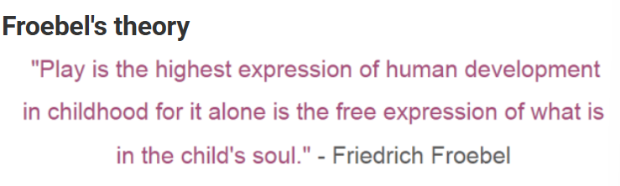
Guys Froebel is a great theorist to help you out here.
(Twinkl,2021)
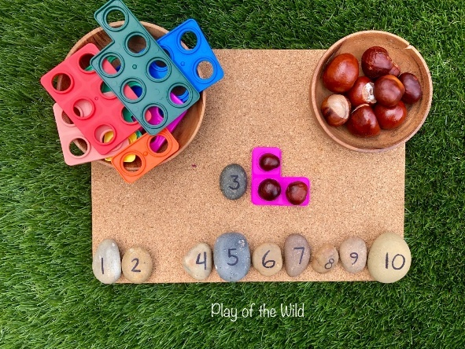
You could go down the route of:
- having different learning zones and allowing children to go off and choose as to where they want to learn
- Taking their interests into consideration
- Use the outdoors, bring the outdoors in and use sticks and conkers and all sorts of natures great creations.
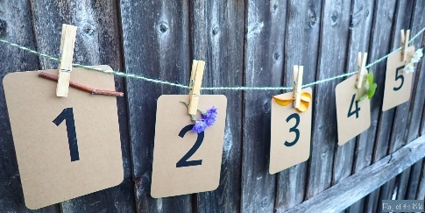
(Sabrina,2020)

(Sabrina,2020)

Honestly give my child a stick and he has a fan-ta-STICK (sorry I had to) time!
And you could guarantee he’d find the biggest stick going (practically a branch at that point).
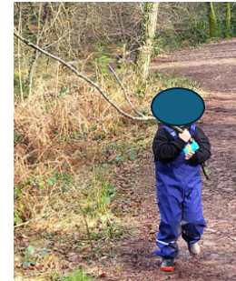
Here he is, this is my boys stick, as you can see it’s technically a branch but as he says a GIANT STICK!!! Anyway, of he goes determined to carry this stick all the way through our walk in the woods and to the car.
Me as a mum saying are you sure you can manage as that is bigger than you.
My 5 year old being a 5 year old- Yes it’s my stick I’m taking it home.
The walk continues for a few minutes and that stick is now in a river we passed because as he had discovered with the stick being as big or bigger than him, it became too heavy for him to keep carrying. Hay- that’s numeracy! (My own image)
OKAY OKAY you’re now probably wondering where are the teachers involved in this? Well, their there, somewhere.
Hello class I am still here! Hello? Anybody?


(Vector,2025)

Alongside Froebels theory, you could look at Bruner, whose theory looked at the teacher structuring the activities and learning. The activities would be somewhat free expression but also structured so that the children gain some learning from them just through having fun, doing things they enjoy and whilst learning without realising. So, between them both you then have them having the freedom of choosing what they want to do just the teacher has made sure they will get a numeracy experience from the activity (Bates,2016).
Then there is the fancy pants framework that has strand for teachers, this framework is divided into four:
- Strand One- Developing numerical reasoning
- Strand Two- Using Number skills
- Strand Three- Using measuring skills
- Strand Four- Using data skills
(WelshGovernment,2013).
Yeah! They have to follow those if they want the children to get anywhere with their teaching skills. Only joking, the teachers are doing an amazing job.

ANYWAYYYYYY!!!

Why is numeracy important anyway?
Good numeracy is important because it links into critical thinking, problem solving and reasoning, children need these skills in order to be able to learn and develop. These three skills links into lots of day-to-day experiences and so therefore the child would then find it difficult to carry the most basic of tasks out.

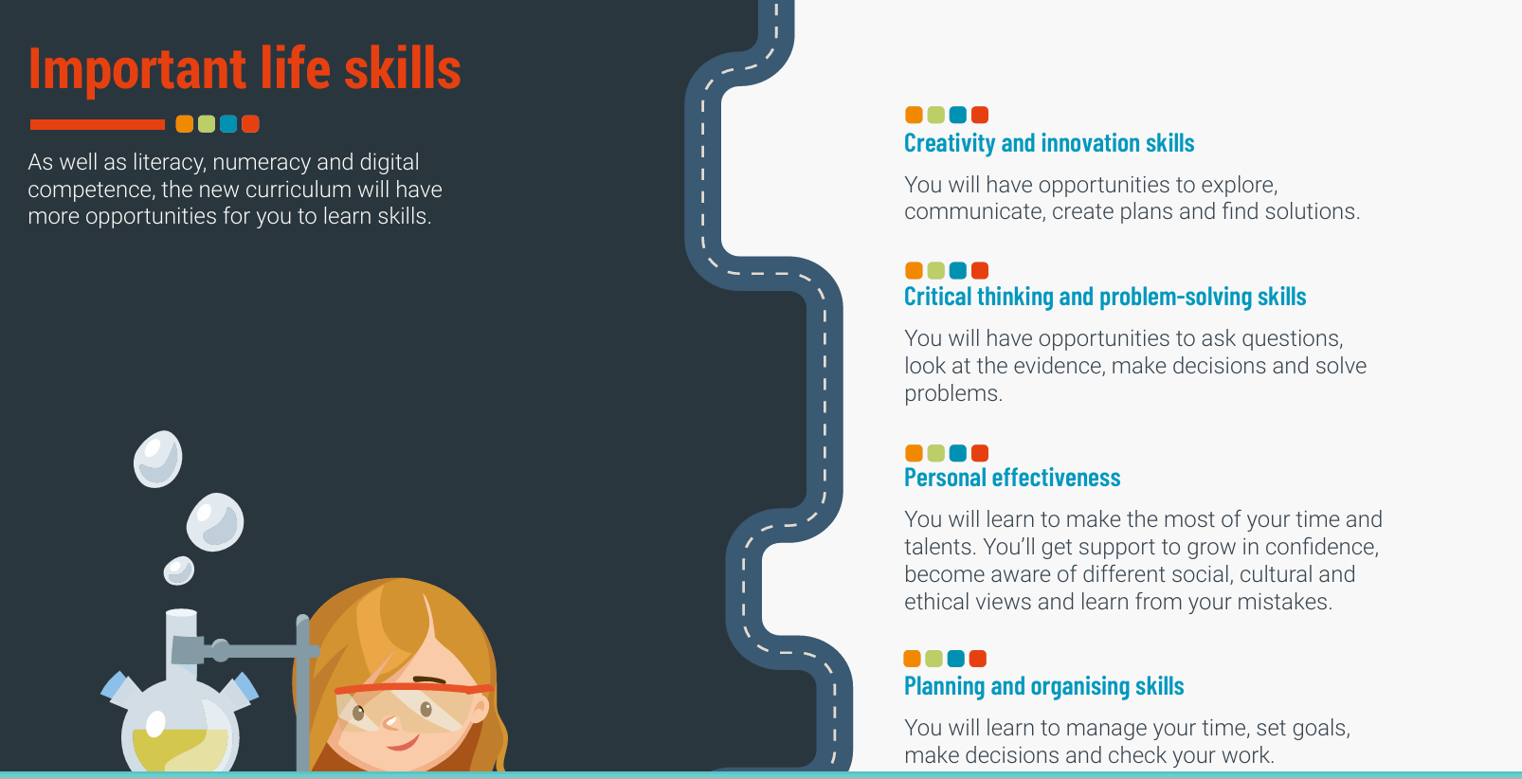
The new Curriculum in Wales wants to teach us some skills to and say what we are all hopefully going to achieve the new scheme in place.

What ways can we use numeracy then? Where might we see numeracy?
Numeracy can be used when in the shops-buying and selling toys they have at home, making arts and crafts- creating patterns when making bracelet and so many others. Things like these can all be done at home with parents and carers or at school.

Hay lets hope for a great future in numeracy, schools seem to know what they’re doing.

Blog Reference
Bates, Bob. Learning Theories Simplified : ... And How to Apply Them to Teaching. 3rd ed, London, Sage, 2016, page 48. Accessed 20/02/25.
Bates, Bob. Learning Theories Simplified : ... And How to Apply Them to Teaching. 3rd ed., London, Sage, 2016.
The British Association for Early Childhood Education . “Early Years Pedagogy”, 2023, early-education.org.uk/early-years-pedagogy/. Accessed 19/02/25
National Numeracy. “What Is Numeracy?”, 4 Mar. 2019, www.nationalnumeracy.org.uk/what-numeracy, accessed 26/01/25.
Britton Matthew, “Freehand Drawn Speech Bubble Cartoon How Sign”, 2025, www.vecteezy.com/vector-art/11785658-freehand-drawn-speech-bubble-cartoon-how-sign. Accessed 26 Feb. 2025.
Sabrina, “Outdoor Maths Activities EYFS – Outdoor Maths Ideas.” Play of the Wild, 29 Aug 2020, playofthewild.com/2020/08/29/outdoor-maths-activities-eyfs-outdoor-maths-ideas/. Accessed 27 Feb. 2024.
Vector Stock, “Dont Know Girl Vector Image on VectorStock”, 21 June 2017, www.vectorstock.com/royalty-free-vector/dont-know-girl-vector-15393007. Accessed 26 Feb. 2025.
Twinkl, “What Is Froebel’s Play Theory?”, 2021, www.twinkl.co.uk/teaching-wiki/froebels-play-theory. Accessed 26 Feb. 2024. Accessed 27/02/25.

Resource- Information Sheet
Element 3
Let’s teach and learn about money

It is important that money is taught in school because children need to understand the different ways you can create the same amount of money using different coins and also understand its value (McKillop,2021). Not only this is so important that they understand all of the different reasons as to when we may use it and why it is we need to understand it.


Money can be taught from as young as three years old. This can be done by simply looking at the coins and showing recognition that they are all different shapes and sizes. Not only this we can allow them to explore the concept of money through role play, playing shops and allowing them to pay for items using toys or items you already have.
After this you may go onto showing the different ways of making different values of money.
From here you may move up to the next stage of them having real money and have them take it to a real shop and experiencing them working out if they have enough and if they will get change back (MoneyHelper,2025).

(Teachers Resource Force,2022)



(Alamy Limited,2024)
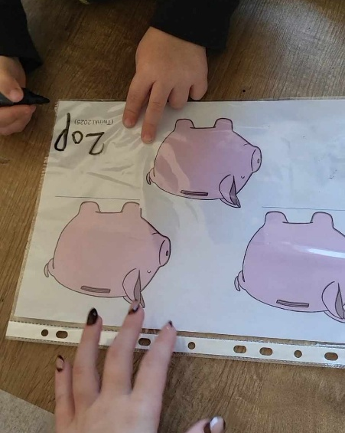
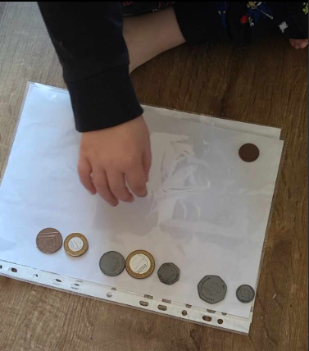
Ordering and making money
This activity is aimed at children from age 4-6 years depending on the level of ability of the child you are working with. The child in the photo is age 5 and is at an average level of understanding for this activity.

Activity Aims | Skills developed during the activity
To develop the understanding of the coins values. | The child will learn the order of coin value from smallest to biggest
To understand that the shape and size of the coin doesn’t effect it worth (5p is the smallest coin but not the biggest value). | The child will be able to see that just because there is a 20p coin, there are other ways in which 20p can be made if you don’t have one.
To understand the different ways in which you can make one value of coin.

Measuring progress
The child will independently be able to create the order or coins from smallest to largest value.
The child will be able to go onto pounds and pence and create different ways in creating the amounts.
Carry out the same style of activity after a few days of learning to observe the child as to see if the progress has been met.

The benefit of the activity for the child
The child will be able to see and feel how they have developed by seeing how quick they were able to carry out the coin line and also be able to see how they have gone from creating pence numbers to pounds.

Barriers you may face
Emotional barriers- they're afraid of failing or of the specific subjects at hand
Motivational barriers- If the activity is too challenging or too easy for a pupil, they'll lose motivation to complete it and this can then cause a disruption in the group
Children with Additional Learning Needs (ALN) may experience barriers to this activity because they may not understand the method of teaching, may not be able to keep the pace of learning. If you know one of the children you are working with have a learning need there maybe adaptions that needs to be put in place in order to meet their need (Twinkl,2020).

Reference
Teachers Resource Force, “British UK Coins Clip Art: 1p, 2p, 5p, 10p, 20p, 50p, £1, £2”, 2022, shop.trf.one/product/uk-coins-clip-art/. Accessed 25 Feb. 2025.
Money Helper, “Learning about money by age”, 2025,
https://www.moneyhelper.org.uk/en/family-and-care/talk-money/talk-learn-do/learning-about-money-by-age#:~:text=You%20can%20start%20to%20teach%20children%20about%20money,age.%20At%20this%20age%2C%20children%20learn%20through%20play. Accessed 25/02/25
McKillop Lora, “The Importance of Teaching Money Skills”, 21 Jan 2021, www.teachhub.com/classroom-activities/2021/01/the-importance-of-teaching-money-skills/. Accessed 9 Feb. 2025.
Alamy Limited, “Cartoon Shop Building with Carts Vector Illustration”, 2024, www.alamy.com/cartoon-shop-building-with-carts-vector-illustration-image601871733.html. Accessed 25 Feb. 2025.
Twinkl, “What Are Barriers to Learning?,” 2020, www.twinkl.co.uk/teaching-wiki/barriers-to-learning. Accessed 1 Mar. 2025.

Element Four
Video

https://www.canva.com/design/DAGgVuRgsSg/UmM8CaWWXD_BkaA0TC5PvA/edit?utm_content=DAGgVuRgsSg&utm_campaign=designshare&utm_medium=link2&utm_source=sharebutton

Element Five
Evaluation
The activity I carried out was creating a coin line from the smallest value of coin, this can be tricky for children as sometimes they base it upon the sizes of the coins and get it mixed up with how much they are worth. The second half of the activity was to get the child to create set amounts of money in different ways using different coins.
I feel that the activities worked really well for the age group of the child and met the targets that the child needed to reach. One of the reasons I feel the resource worked well is because it was simple. Children need things to be simple because if there is to much going on at once, you ask them to many things at once or they don’t feel comfortable in the environment they are carrying out the activity in, then they are less likely to pay attention and focus on the task at hand.
Another reason as to why I feel the resource worked well is because its short and straight to the point to catch the attention of the learner and to keep their interest engaged. Children have short attention spans and base upon the age of the child the activity was carried out with, the attention for a 5 year old child is ten to fifteen minutes (Shakibaie,2021). Therefore, the resource needs to ensure you can cover the needed skills and aim for that lesson so that when they learning for those 10-15 minutes they are taking it all in, to build upon on the next resource.
The numeracy framework wants children to have strategic competence and conceptual understanding and working with money and having and understanding money plays a part in that process because we use money everyday, whether that be by card, cash or online (WelshGovernment,2020). So, trying to build these skills into the activity is important. Piagets and John Deweys theory are all about being hands on which follows along with the new curriculum. By carrying out this activity it gave the hands-on approach that children need. These policies and theories all play a big role in numeracy and allow children to explore and learn.
Looking at the bigger picture, this resource also has its disadvantages. The resource could have been made more eye catching and engaging. This could have been done by getting the childrens senses having them search for the coins in a tough try and allowing them to find the coins and then put them into order. It could have also been adapted by having real money boxes to bring the activity to life. Children love getting a coin and have the ability to say it’s theirs and keeping it safe. From this you could go down the route of bringing the learning into other areas of the curriculum and making the money boxes, allowing the children to decorate it and have a special place for it.
Another disadvantage of the resource maybe that this method may not work for all learners. It involves sitting, counting and learning, whereas other learners need a physical, or more engaging approach where they are moving around playing without knowing they are learning. This approach would then play an advantage to those children because all though it involves playing and moving around they also take in so much information whilst doing so. This resource would not provide that for other learners. Not all learners are able to learn through sitting and doing. This can be backed up by Piagets theory of cognitive development and how “construction of knowledge is based on the individuals experiences” (Bates,2016).
If this resource were to be used again, I would take into consideration the aims and final outcomes but it would be important to adapt the resource for other learners. To think of those learners with ALN, who may need to look at the activity from a different approach or have the activity to their ability level where it may be just choosing one method of making a coin value. Either that or using 1p coins to make the amount.
The resource could have been made more exciting by playing it through a real life situation where the learners have a shop to ruin and paying customers. Getting the children to have different coins to make the values of the products they are buying. Over time you hope to see the development in the child and can move them onto their next stage of development where they could make bigger amount of money or incorporate giving change.
In conclusion to this activity and resource, I feel that the activity worked for this learner and as he was able to visually see that there are different ways to making one value of coin (20p can be made in different ways). Not only this, with support the child was able to order the coins from the smallest value to the biggest. Support was needed to help see that the value of one pound being 100 pennies to then process the information of it being a bigger coin, however this is something that may need to be covered if the resource is used again before carry out the coin line.
However, to add to this conclusion, If I were to use the activity again, I would also take into consider the adaptions that may need to be made or the challenges that maybe face with other learners’ abilities. You may face learners with ALN or have a group of younger/older learners or have a busy bunch that need the physical element.

References
Bates, Bob. Learning Theories Simplified : And How to Apply Them to Teaching. 3rd ed, London, Sage, 2016. Accessed 02/02/25
Shakibaie, Sarah, “Child’s Average Attention Span by Age: From Toddler to Teens.” ReadyKids, 21 Dec. 2021, readykids.com.au/average-attention-span-by-age/#elementor-toc__heading-anchor-3. Accessed 1 Mar. 2025.
Welsh Government, “Literacy and Numeracy Framework,” 2020, hwb.gov.wales/curriculum-for-wales/cross-curricular-skills-frameworks/literacy-and-numeracy-framework/. Accessed 1 Mar. 2025.

