

Module: Understanding and Engaging Stakeholders
Student name and ID: Valentin Otelea, 2410975

Understanding the importance of Stakeholder Engagement in successful commencement and completion of project

Module code: LCLM5001_BIRM
Lecture: Eric Osei
Executive Summary

This report presents a critical analysis of stakeholder engagement practices within HCA Healthcare, focusing on the development and launch of new wearable health device designed to monitor heart rate, oxygen saturation, and sleep patterns. Acting as the project manager, the report outlines strategies for effectively engaging both internal and external stakeholders to ensure successful project delivery within six months. A SWOT analysis is employed to assess HCA Healthcare’s strategic position, identifying its strengths in clinical expertise and innovation, alongside challenges such as data privacy and regulatory complexity. Key stakeholders, including clinical teams, product developers, suppliers, regulators, and patients, are mapped and analysed using frameworks such as the RACI Matrix, and the Stakeholders engagement and Communication plans. The 4C’s Model is critically applied to demonstrate how effective engagement can mitigate conflict and enhance project performance.
The findings emphasise that systematic stakeholder engagement not only drives innovation and ethical compliance but also strengthens organisational resilience and trust. The report concludes with strategic recommendations to institutionalise engagement frameworks, adopt digital collaboration tools, and embed inclusive governance across HCA Healthcare’s future digital health initiatives.

Table of Contents

- Brief Introduction of HCA Healthcare UK …………………. 4
- Appraisal of HCA Healthcare UK using SWOT and PESTEL
Analysis with SMART Objectives ………………………….. 5
2.a SWOT Analysis ………………………………………….…. 6
2.b PESTEL Analysis …………………………………………... 7
2.c SMART Objectives …………………………………………. 8
3. Key Internal and External Stakeholders ………………………9
3.a Stakeholder roles, responsibilities, benefits, and challenges…12
3.b RACI Matrix ………………………………………………. .13
3.c Benefits of Stakeholder Involvement ………………………..15
3.d Challenges Faced by Stakeholders ………………………… ..15
4. Stakeholder Engagement and Conflict Management through the
4C’s Model……………………………………………………. 16
5. Evaluation of the impact of Stakeholder Engagement on Business
Performance and Recommendations for the Future …………... .20
6. Conclusions ……………………………………………………21

- Brief Introduction of HCA Healthcare UK

HCA Healthcare UK is the country’s largest private healthcare provider, part of the global HCA Healthcare group founded in 1968 in the United States. It first entered the UK market in 1995 (Refer Figure 1). Since then, it has established a network of over 30 hospitals, outpatient clinics, and diagnostic centres, particularly in London, Manchester, Wilmslow, and more recently Birmingham (The Harborne Hospital, opened 2024).HCA UK offers a wide range of clinical services, from primary care, diagnostics, day-case treatments, and outpatient services, through to complex urgent and inpatient care, including critical care in all its hospitals (Wu, 2019). At its core, HCA Healthcare UK operates on values of compassion, integrity, and respect. By combining international expertise with a local presence, it aims to deliver personalised, patient-centred care that treats every individual as unique. Today, it plays a vital role in shaping the private healthcare landscape in the UK, offering patients choice, clinical excellence, and world-class treatment.
The organisation is preparing to launch a wearable health device within the next six months, which will track three key health indicators: heart rate, oxygen saturation, and sleep patterns. The project aligns with the wider transformation of the healthcare industry, where wearable technologies and remote monitoring tools are increasingly recognised for their role in preventive care, patient empowerment, and personalised treatment pathways (World Health Organization,2021). The project involves the design, development, regulatory approval, and market introduction of the wearable device under the HCA Healthcare brand. The device aims to address two primary objectives. Firstly, it supports patients with chronic conditions, such as cardiovascular disease, by enabling continuous monitoring and early detection of anomalies. Secondly, it empowers health-conscious consumers who wish to proactively track their wellness and optimize lifestyle habits.
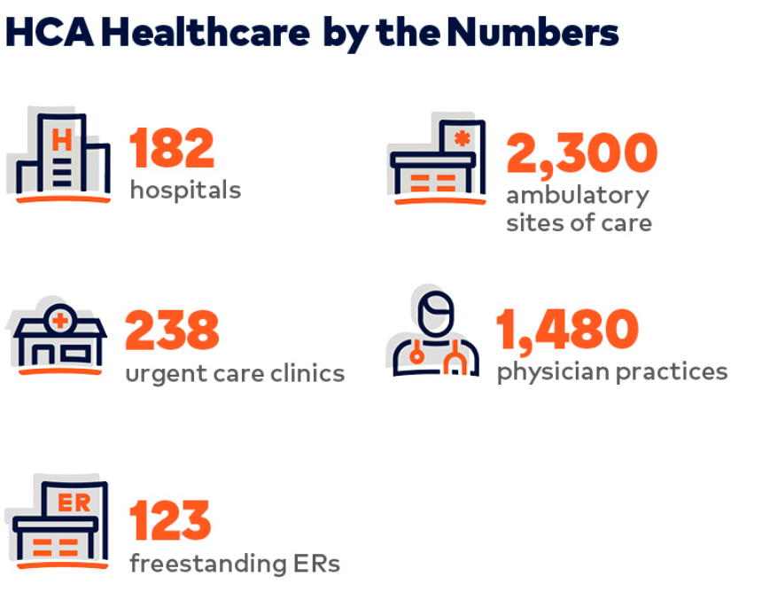
Figure 1. HCA Healthcare figures
Source: (HCA Healthcare, 2021)

2. Appraisal of HCA Healthcare UK using SWOT and PESTEL Analysis with SMART Objectives

To evaluate HCA Healthcare UK’s readiness for launching a wearable health device, it is vital to assess both internal capabilities (via SWOT) and external influences (via PESTEL). This structured appraisal helps align strategic actions with realistic objectives. According to Sammut-Bonnici and Galea (2015) a SWOT analysis evaluates the internal strengths and weaknesses, and the external opportunities and threats in an organization’s environment.

2.a SWOT Analysis
A SWOT analysis is a strategic tool that helps examine an organization's Strengths, Weaknesses, Opportunities, and Threats (Refer Figure 2). By assessing internal factors alongside external factors, it supports businesses or projects in shaping effective strategies and making more informed decisions (Leigh, 2009).
HCA UK shows powerful Strengths like that is a well-established private healthcare provider with a strong reputation for quality care and innovation. Has access to advanced clinical expertise and partnerships with leading specialists can support product credibility and development. Also is a loyal patient base and existing digital infrastructure providing a foundation for integrating wearable technology into personalised care plans.
We noticed the following possible Weaknesses like limited experience in consumer product development may delay execution, or high service costs may affect accessibility for a broader market. Integration of new technology across various departments may face resistance due to change management issues.
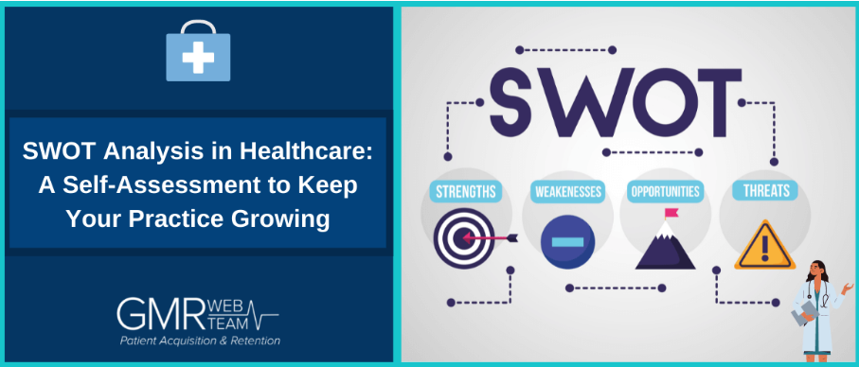
Figure 2. SWOT analysis in healthcare
Source: (Prasad, 2025)

Using SWOT framework, we can highlight some of the Opportunities like rising consumer demand for personalised health monitoring and remote care creates strong market potential. The wearable device can enhance preventive care services and reduce long-term treatment costs. Collaboration with tech companies may foster faster innovation and scalability.
Applying the framework, it will make us aware about the Threats as competition from established tech brands (e.g., Apple or Fitbit) already dominate the wearable market. Data security and regulatory compliance challenges may slow product approval and trust. Economic fluctuations and NHS competition may impact consumer affordability and demand.

2.b PESTEL Analysis

PESTEL (Political, Economic, Social, Technological, Environmental, Legal) analysis, as it stands, mainly provides a general idea about the macro environmental conditions and situation of the company (Refer figure 3). According to Yuksel (2012), “the PESTEL analysis model proposed in the study could determine the extent to which the macro environment of a company provides suitable conditions to achieve the aims of the company.”
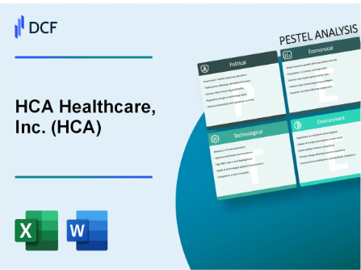
Figure 3. Inc. (HCA)
Source: (DCFmodeling, 2025)

UK government encourages digital health innovation, but regulatory approval from MHRA and compliance with GDPR are critical representing Political.
Inflation and funding cuts may affect consumer spending on private healthcare and devices are Economic factors.
Increasing health awareness and ageing population supports demand for heart rate and oxygen monitoring tools is Social factor.
Rapid advances in wearable tech present both opportunity and pressure to keep up – Technological.
Eco-conscious design and sustainable packaging may influence customer perception for Environmental part.
Device must comply with medical device regulations and data laws to ensure legal market entry. - Legal

2.c SMART Objectives
SMART is a goal-setting framework in which each letter represents a key criterion: Specific, Measurable, Achievable, Relevant, and Time-bound. It is designed to help establish clear, actionable, and measurable objectives that align with larger plans and improve the chances of achieving them (Vasuskaite et al., 2017).
The next statements regarding our wearable product would be achieved following our SMART objectives:
- Develop and launch a wearable health device that tracks heart rate, oxygen levels, and sleep patterns, targeting private health consumers.
- Achieve 10,000 device users within the first 12 months post-launch.
- Leverage HCA UK’s existing healthcare infrastructure and partnerships to support development and roll-out.
- Complete product development, testing, regulatory approval, and marketing in six months to meet the targeted launch date.
This integrated appraisal equips project stakeholders with a strategic view of internal capabilities, external pressures, and a clear set of objectives to guide the successful launch of the wearable health device.

- Key internal and external stakeholders

Stakeholders are individuals or groups who have an interest in or are affected by the outcomes of a project or organization’s activities. They can influence decisions and contribute to the project’s success or failure. Stakeholders in the healthcare system play a critical role in shaping the delivery, development, and success of health services and innovations. For a project like the launch of a wearable health device, engaging both internal and external stakeholders is essential to ensure alignment with patient needs, clinical standards, and business goals (Schönfelder, 2018). Effective stakeholder identification is a crucial first step in ensuring the success of HCA Healthcare’s wearable health device project. For HCA Healthcare (Refer Figure 4), stakeholders range from internal teams directly involved in development to external parties influencing regulation, distribution, and consumer adoption.
Fig. 4 Key Stakeholders 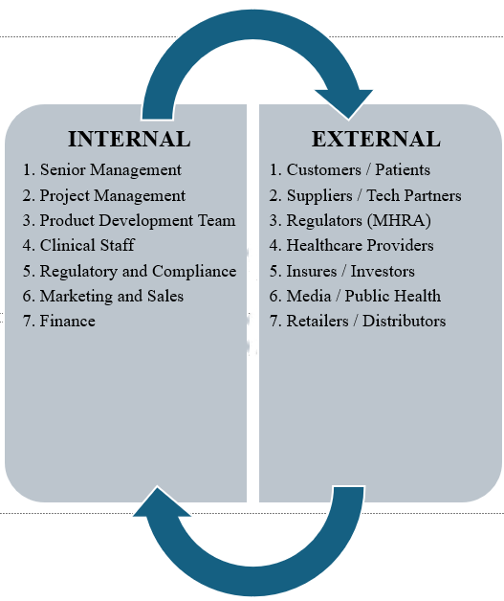
Internal Stakeholders
- Senior Management and Executive Board. The leadership team plays a strategic role by approving budgets, allocating resources, and ensuring the project aligns with HCA’s overall mission and long-term goals.
- Product development and Engineering Team. This group, comprising biomedical engineers, software developers, and data scientists, is responsible for designing and testing the wearable device. Their expertise determines product quality, reliability, and innovation.
- Clinical and Medical Staff. Physicians, nurses, and clinical researchers provide clinical validation for the device’s functionality, ensuring the accuracy of heart rate, oxygen, and sleep data. Their involvement ensures compliance with medical standards and strengthens the product’s credibility in the healthcare market.
- Marketing and Sales Department. This team will develop marketing campaigns, manage product positioning, and communicate the benefits of the wearable to consumers and healthcare professionals. They also gather market intelligence to refine the product strategy.
- Regulatory and Compliance Team. These specialists ensure that the device meets legal and ethical requirements under UK regulations, including the Medicine and Healthcare products Regulatory Agency (MHRA) and General Data Protection Regulation (GDPR) compliance.
- Finance Department. Responsible for budgeting, forecasting, and the monitoring financial performance to ensure the project remain cost-effective and sustainable.

External Stakeholders
- Suppliers and Technology Partners. External suppliers provide hardware components, sensors, and software integrations. Strategic partnerships with technology companies can also help enhance data analytics and product innovation.
- Customers and Patients. These are the end users who will benefit from continuous health monitoring and data insights. Their feedback will be critical for improving product design and usability.
- Healthcare Providers and Insurers. External clinicians and health insurers represent key channels for integrating the wearable into clinical and preventative care programmes, potentially broadening market reach.
- Regulatory Authorities. Agencies such as the MHRA and NHS Digital oversee product safety, certification, and data protection.
- Retail and Distribution Partners. Collaborations with pharmacies, health retailers, and e-commerce platforms will facilitate consumer access and enhance product visibility.
- Media and Public Health Organizations. These stakeholders influence public perceptions and can play a vital role in promoting awareness of the benefits of wearable health technologies.

HCA Healthcare’s stakeholder network is extensive and diverse, spanning clinical, technological, regulatory, and commercial domains. Identifying these groups early enables the project manager to establish clear engagement strategies, align expectations, and ensure the wearable device’s successful introduction to the market.

3.a Stakeholder roles, responsibilities, benefits, and challenges

Effective stakeholder management is vital to the success of HCA Healthcare’s wearable health device project. As (Parmar et al., 2010) proposes in the Stakeholder Theory, organisations achieve sustainable outcomes when they actively consider the interests and expectations of all individuals and groups who can affect or be affected by the project. Therefore, the identification of roles, clear responsibility allocation, and the balancing of benefits and challenges from the foundation for effective engagement.
The Project Manager serves as the central coordinating agent responsible for overseeing project planning, stakeholder alignment, and delivery. Acting as both Responsible and Accountable within the RACI framework, the project manager ensures that deliverables such as device design, regulatory approval, and marketing readiness are completed within scope and schedule. In terms of responsibilities the Product Development Team, including biomedical engineers, data scientists, and software developers, is responsible for creating and testing the wearable device. They ensure accuracy in heart rate, oxygen, and sleep tracking, focusing on compliance with clinical standards. Their role also includes collaborating with clinicians and suppliers to refine hardware and software functionality. The Clinical and Medical Team provides project’s scientific credibility. Their responsibilities include validating the medical accuracy of the sensors and analysing pilot data to confirm that the device meets evidence-based health requirements. This clinical endorsement is crucial for user confidence and regulatory compliance. Marketing and Sales Department translates technical product features into consumer-oriented benefits. This team develops communication strategies, mages advertising, and engages healthcare partners and retailers. They play an important role in shaping the product’s image and market positioning, which directly impacts adoption. (Shaffer, and Okundaye, 2025)
The Regulatory and Compliance Team ensures the device meets all statutory obligations under the UK’s Medicines and Healthcare Products Regulatory Agency (MHRA) and the General Data Protection Regulation (GDPR). Their responsibilities include certification submission, documentation, and privacy impact assessments to protect patient data. Finance Department supports budgeting, funding allocation, and financial reporting. They assess project return on investment and control costs related to Research and Development, marketing, and regulatory submissions. Externally, Suppliers and Technology Partners provide critical components such as biosensors and microprocessors. They collaborate closely with engineers to maintain quality standards and supply chain efficiency. Customers and Patients represent ultimate beneficiaries. Their role includes participation in trials and feedback sessions, which guide product refinement and help the organisation ensure usability and satisfaction. Healthcare Providers and Insurers are strategic partners who may integrate the wearable into care pathways or wellness programmes. Their engagement can drive large-scale adoption by linking device usage to preventive healthcare or insurance incentives. Finally, Regulatory Authority (like, MHRA, NHS Digital) act as gatekeepers of product safety and ethical use of data. They are consulted and informed throughout the project lifecycle.

3.b RACI Matrix

The RACI Matrix is a commonly used project management tool that helps clarify and communicate the roles, responsibilities, tasks, deliverables, and key milestones assigned to individuals and teams within a project (von Moltke, 2025). This matrix (Refer Table 1) clarifies accountability and communication pathways, reducing duplication of effort and conflict between departments.

RACI Matrix. Table 1.
Stakeholder | Responsible ® | Accountable (A) | Consulted © | Informed (I)
Senior Management |  | ✓ | ✓ | ✓
Project Manager | ✓ | ✓ | ✓ | ✓
Product Development Team | ✓ |  | ✓ | ✓
Clinical and Medical Team | ✓ |  | ✓ | ✓
Marketing and Sales Department | ✓ |  | ✓ | ✓
Regulatory and Compliance Team | ✓ |  | ✓ | ✓
Finance Department |  |  | ✓ | ✓
Suppliers and Technology Partners | ✓ |  | ✓ | ✓
Customers and Patients |  |  | ✓ | ✓
Regulatory Authorities (MHRA) |  |  | ✓ | ✓

3.c Benefits of Stakeholder Involvement

Stakeholder engagement creates shared value and enhances organizational performance. For instance, clinicians and engineers working collaboratively ensure the device’s clinical validity and technological accuracy, aligning with Parmar’s (2010) assertion that inclusive stakeholder participation strengthens outcomes. Engaging customers and healthcare providers generate user-centric design, leading to grater satisfaction and adoption. Effective stakeholder collaboration improves project predictability, reduces risks, and increases innovation through feedback integration (Parnell, and Gangwish, 2023). Suppliers bring specialised technical expertise that may not exist internally, fostering innovation and cost efficiency. Similarly, regulators, when engaged early, provide guidance that prevents non-compliance delays during product approval.

3.d Challenges Faced by Stakeholders

Despite these benefits, several challenges may arise. Internal challenges include communication barriers between clinical and technical teams, where differing professional languages or priorities may slow decision making. Large organizations like HCA Healthcare often experience bureaucratic delays due to hierarchical structures, hindering agile responses to emerging issues. External challenges include supply chain disruption and dependency on third-party vendors, which could affect timelines or quality. The regulatory environment presents further difficulties, as navigating MHRA medical device standards and GDPR compliance is complex and time consuming. Non-compliance could delay product launch or expose the company to legal risks. Customer related challenges involve privacy concerns and data security scepticism. Some consumers may be reluctant to share continuous health data, limiting product uptake. Moreover, the diversity of user demographics implies variation in digital literacy, requiring tailored communication strategies to ensure understanding and trust. In terms of project governance, there is a risk of conflicting priorities between departments, for example, marketing may prioritise rapid launch, while compliance teams focus on regulatory thoroughness. Mitchell, Agle, and Wood’s (2017) Stakeholder Salience Model highlights those stakeholders with high power and legitimacy, such as regulators, demand immediate attention, and their unmet expectations can jeopardise project success.
The integration of stakeholder management theories offers a valuable framework for understanding and navigating the complex relationships with HCA Healthcare’s wearable device project. Freeman’s (1984) stakeholder theory advocates for creating value for all stakeholders, not just shareholders, while Mendelow’s (1981) Power/interest Matrix helps prioritise stakeholder engagement by categorising them based on their influence and interest placing regulators and senior management in the “Manage closely” group, and the customers in the “Keep informed” category until the trial phase. Combined with tools like RACI matrix, these theoretical models support the clear definition of stakeholder’s roles and responsibilities. Overall, the project success hinges on balancing stakeholder expectation, maintaining strong communication, and addressing challenges such as compliance and coordination. Continuous, proactive engagement will be essential to secure stakeholder support and ensure the successful launch of the device within the planned six-month timeline.

- Stakeholder Engagement and Conflict Management through the 4C’s Model

The 4C Model offers a universally relevant framework for assessing organizational effectiveness, built around four key components: competency, communication, cooperation, and collaboration, elements that are fundamental to all types of organisations. Das (2011). As Project Manager for the launch of HCA Healthcare’s wearable health device, stakeholder engagement is a continuous, dynamic process requiring deliberate planning, communication, and adaptability. The complexity of the project, spanning clinical validation, regulatory compliance, product development, and consumer marketing, demands a structured approach to stakeholder management. Applying 4C’s model (Refer Figure 5) provides a robust framework for engaging diverse internal and external stakeholders while mitigating potential conflicts.
Figure 5. 4C’s Framework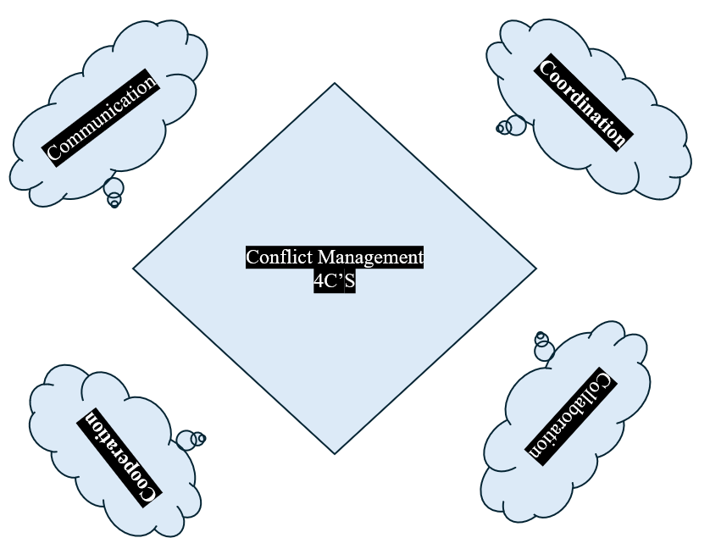

Communication – Building Transparency and Trust – Effective communication forms the foundation of stakeholder engagement. According to the PMBOK Guide (PMI, 2021), over 90% of a project manager’s time is spent communicating with stakeholders. For this project, communication will be multidirectional, ensuring upward (to senior management), downward (to project teams), and lateral (to external partners) information flow. A comprehensive communication plan will be established early in the project, outlining communication frequency, channels, and responsibilities. Examples include weekly progress meetings with the product development and clinical teams to review technical milestones, Bi-weekly compliance reviews with the Regulatory Affairs department to ensure adherence to MHRA and GDPR requirements. Monthly executive briefings to update senior management on timelines, risks, and budgetary performance and quarterly stakeholder forums involving suppliers, insurers, and healthcare providers to exchange feedback. Digital platforms such as Microsoft Teams, SharePoint, and Asana will support real-time communication, ensuring all stakeholders have access to up-to-date documentation and reports. This transparent communication strategy promotes trust and shared understanding, key principles emphasised by Freeman’s (1984) Stakeholder Theory. In conflict-prone environments, such as between engineers seeking rapid prototyping and compliance officers prioritising safety, communication servers as the first line of resolution. Open dialogue, supported by active listening and fact-based reporting, ensures disagreements are addressed constructively before they escalate.
- Coordination – Aligning Roles and Deliverables – Coordination transforms effective communication into structured actions. It also ensures that project resources, activities, and stakeholder contributions are harmonized toward shared objectives. The RACI matrix acts as the foundation for coordination by clarifying who is responsible, accountable, consulted, and informed. For example, the Project Manager coordinates interdepartmental collaboration between the Product Development Team (responsible for technical design) and the Clinical Team (responsible for medical accuracy). Similarly, coordination with Suppliers guarantees that hardware components meet the device’s performance and safety requirements. Regular coordination meetings will synchronise timelines across departments using tools such as Gantt charts and Critical Path Method (CPM) analysis. This approach reduces the likelihood of duplication and misalignment, issues often seen in complex healthcare technology projects. Conflicts may arise during coordination due to resource constrains or different priorities. For instance, the Marketing Department may push for early promotional campaigns, while the Regulatory Team may require additional time for certification. As Project Manager, I will mediate such conflicts by applying interest-based negotiation a process focusing on mutual gains rather than positional arguments. By identifying shared objectives, such as ensuring both compliance and timely launch, coordination transforms potential conflict into synergy.
- Cooperation – Fostering Mutual Commitment – Cooperation refers to the willingness of stakeholders to work jointly toward shared goals. Unlike coordination, which focuses on structure, cooperation relies on behavioural and relational dynamics. To support cooperation, I will employ several strategies like Shared Vision Workshop to collectively define project success criteria, Recognition Scheme to acknowledge stakeholder contributions, promoting motivation and goodwill, and Feedback Mechanisms to assess stakeholder satisfaction and adjust engagement methods. Building a culture of cooperation also helps prevent functional siloing, where departments act independently rather than collectively. Within HCA Healthcare, for example, cooperation between the IT department and the Clinical Research Team ensures that data from wearable devices are both accurate and securely processed. However, cooperation can be hindered by conflicting interests, such as when suppliers prioritise profit margins over innovation. Here, stakeholder incentive alignment is essential. Contractual agreements with performance-based rewards can ensure that suppliers remain committed to quality and delivery standards.

- Collaboration – Co-Creation and Innovation – Collaboration represents the highest level of stakeholder engagement. It involves co-creation of value, where stakeholders actively participate in problem solving and innovation rather than merely executing assigned tasks. Collaboration is especially important in the wearable health device project, which demands integration of medical science, engineering, and consumer technology. Collaborative platforms such as joint development workshops, virtual innovation labs, and cross-functional task forces will be implemented to encourage open idea exchange. These mechanisms support knowledge sharing, a key determinant of project success in health technology (REFERINTA). Through collaboration, clinicians can share insights on patient usability, while data scientists refine algorithms to improve accuracy in heart rate and oxygen tracking. This process aligns with the co-production model of stakeholder engagement, where diverse expertise generates more comprehensive and innovative outcomes. Conflicts in collaborative settings often emerge from intellectual property ownership or differing decision-making cultures. Such disputes will be managed through collaborative governance frameworks, ensuring transparency intellectual rights and data use agreements. Medication and structured decision-making will also be used to maintain collaboration without compromising stakeholder autonomy.

The evaluation of stakeholder engagement revealed substantial benefits to business performance, including improved innovation, operational efficiency, and reputational trust. However, challenges such as communication barriers, conflicting priorities, and regulatory complexity require ongoing management. Future success will depend on institutionalising engagement frameworks, adopting digital communication tools, and embedding ethical governance within project management practices.

- Evaluation of the impact of Stakeholder Engagement on Business Performance and Recommendations for the Future

Stakeholder Engagement is not only a management process but a strategic capability that directly impacts an organization performance, innovation potential, and long-term sustainability. In the context of HCA Healthcare’s new wearable health device, stakeholder engagement influences outcomes across multiple domains – clinical quality, financial performance, customer satisfaction, and regulatory compliance. The success of this project will therefore depend on the ability of the project manager to transform engagement mechanisms into measurable organisational value (Petkovic et al.,2023).
Enhanced Innovation and Product Development – The collaboration between clinicians, engineers, and data scientists lead to a richer integration of clinical expertise and technological innovation. Early engagement with external stakeholders such as suppliers and regulatory bodies ensures that the product design aligns with market and legal expectations. This aligns with PMI’s (2021) finding that projects with early stakeholder collaboration demonstrate a 20-30% improvement in delivery performance. Improved Organizational Reputation and Trust, which is essential in the healthcare sector where trust is paramount. By actively involving patients, clinicians, and regulators, HCA Healthcare signals transparency and ethical responsibility. Engaging stakeholders throughout the project lifecycle leads to more accurate forecasting for a better financial and operational efficiency. Early consultations with MHRA and continuous updates to compliance teams it covers the Regulatory Compliance and Risk Mitigations.
Challenges and Limitations of Stakeholder Engagement – Despite its advantages, it also presents potential drawbacks. Over-engagement can lead to decision paralysis, where conflict opinions delay progress. In large healthcare organisations, excessive consultation can also inflate administrative costs and extend project timelines. Conflicts between commercial and ethical priorities remain a persistent challenge (Huzzard,2021). Additionally, power imbalances may cause certain stakeholder’s groups, such as patients or front-line clinicians, to be underrepresented in decision-making processes. These issues highlight the need for structured engagement mechanisms that maintain inclusivity without compromising efficiency (Mitchell et al.,2022).

Recommendations for Future Projects

To strengthen future innovation projects, HCS Healthcare should institutionalise a stakeholder engagement framework supported by data-driven tools to monitor communication and feedback effectively. Establishing a stakeholder advisory board with patients, clinicians and suppliers will promote transparency and continuous input, while post-project evaluation should capture lessons learned to enhance future performance (Paltin et al., 2022). Training project teams in negotiation, and conflict resolution will improve collaboration. Moreover, fostering inclusive engagement by involving underrepresented groups will reinforce equity and social responsibility. Overall, by viewing engagement as a strategic capability grounded in communication, coordination, cooperation, and collaboration, HCA Healthcare can enhance innovation, operational efficiency, and long-term reputation in the evolving digital healthcare landscape.

- Conclusions

The launch of HCA Healthcare’s new wearable health device represents a significant strategic initiative aimed at enhancing patient monitoring and preventive care through innovation and technology. The success of this project is not determined solely by technological advancement but by the strengths and quality of stakeholder engagement. This report has demonstrated that effective engagement is central to achieving both project and organisational objectives. Using analytical tools such as SWOT analysis, RACI matrix, and stakeholder mapping, the report has identified the critical internal and external stakeholders influencing the project. Each group, from engineers and clinicians to suppliers and regulators, plays an essential role in ensuring the wearable device is clinically validated, technologically sound, and compliant with healthcare standards (Agnew, 2021). The application of the 4C’s model has provided a clear pathway for managing stakeholder relationships and resolving conflicts constructively. This model ensures transparency, role clarity, and shared responsibility, which are crucial for maintaining trust and alignment across departments and partners. The evaluation of stakeholder engagement revealed substantial benefits to business performance, including improved innovation, operational effectiveness, and reputational trust. However, challenges such as communication barriers, conflicting priorities, and regulatory complexity require ongoing management. Future success will depend on institutionalising engagement frameworks, adopting digital communication tools, and embedding ethical governance within project management practices. In conclusion, the project reinforces that effective stakeholder engagement is not a supplementary activity but a strategic enabler. By cultivating long-term, trust-based relationships, HCA Healthcare can deliver technological innovation that not only meets market demands but also strengthens its mission to provide compassionate, patient-centred care in the digital age.

References list:
- HCA Healthcare UK, (2024). Putting our patients and their families first. Available at: Putting our patients and their families first (Accessed: 22 September 2025).
- Rosery, H. and Schönfelder, T., (2018). Healthcare system stakeholders. White Paper on Joint Replacement, p.91.
- Wu, M., (2019). Wearable technology applications in healthcare: a literature review. On-Line Journal of Nursing Informatics, 23(3).
- Sammut‐Bonnici, T. and Galea, D., (2015). SWOT analysis. Wiley Encyclopedia of management, pp.1-8.
- Yüksel, I., (2012). Developing a multi-criteria decision-making model for PESTEL analysis. International Journal of Business and Management, 7(24), p.52.
- HCA Healthcare, (2021). HCA Healthcare by the Numbers. JPEG. Available at: Making an Impact in 2021 | HCA Healthcare Magazine (Accessed: 13 October 2025).
- Parmar, B.L., Freeman, R.E., Harrison, J.S., Wicks, A.C., Purnell, L. and De Colle, S., (2010). Stakeholder theory: The state of the art. Academy of Management Annals, 4(1), pp.403-445.
- Von Moltke, N. (2025). RACI Template & Ultimate 2025 Guide to the RACI Matrix. Available at: RACI Template [FREE Download] & RACI Matrix Guide - AIHR (Accessed: 15 October 2025).
- Parnell, R.A. and Gangwish, A., (2023). Effective collaborative decision-making includes stakeholder analysis and communication. In A Practical Guide for Developing Cross-Disciplinary Collaboration Skills (pp. 103-123). Cham: Springer International Publishing.
- Mitchell, R.K., Lee, J.H. and Agle, B.R., (2017). Stakeholder prioritization work: The role of stakeholder salience in stakeholder research. In Stakeholder management (pp. 123-157). Emerald Publishing Limited.
- Szyszka, P., (2024). Freeman (1984): Strategic Management. In Schlüsselwerke für die Strategische Kommunikationsforschung (pp. 219-229). Wiesbaden: Springer Fachmedien Wiesbaden.
- Mendelow, A.L., (1981). Environmental scanning--the impact of the stakeholder concept.
- Das, D., (2011). 4C model: A new approach to determine and measure organizational effectiveness. Available at SSRN 1879413.
- Project Management Institute, (2021), July. A Guide to the Project Management Body of Knowledge (PMBOK® Guide)–Seventh Edition and The Standard for Project Management. Project Management Institute.
- Shaffer, M. and Okundaye, I.O., (2025). Marketing, Sales, and Distribution. In Innovation in Nephrology (pp. 381-397). Academic Press.
- Ajay Prasad, (2025). SWOT Analysis in Healthcare: A Self-Assessment to Keep Your Practice Growing. JPEG. Available at: SWOT Analysis in Healthcare: A Self-Assessment to Keep Your Practice Growing (Accessed: 27 October 2025).
- DCFmodeling, (2025). HCA Healthcare, Inc. (HCA): PESTLE Analysis [Jan-2025 Updated]. JPEG. Available at: PESTEL Analysis of HCA Healthcare, Inc. (HCA) – DCFmodeling.com (Accessed: 17 October 2025).
- Paltin, D., Montoya, J.L., Weise, C., Conroy, C., Radatz, E.E., Strange, K.C., Moore, D.J., Sajatovic, M. and Levin, J.B., (2022). Effective engagement of a stakeholder advisory board in severe mental illness (SMI) research: A case study of a clinical trial to improve adherence among people with SMI and hypertension. International journal of healthcare, 8(2), p.9.
- Agnew Agnew, J.J., (2021). Internal and external stakeholder impact on curriculum design. Academia Letters, p.2.
- Huzzard, T., (2021). Achieving impact: exploring the challenge of stakeholder engagement. European Journal of Work and Organizational Psychology, 30(3), pp.379-389.
- Mitchell, J.R., Mitchell, R.K., Hunt, R.A., Townsend, D.M. and Lee, J.H., (2022). Stakeholder engagement, knowledge problems and ethical challenges. Journal of Business Ethics, 175(1), pp.75-94.
- Petkovic, J., Magwood, O., Lytvyn, L., Khabsa, J., Concannon, T.W., Welch, V., Todhunter-Brown, A., Palm, M.E., Akl, E.A., Mbuagbaw, L. and Arayssi, T., (2023). Key issues for stakeholder engagement in the development of health and healthcare guidelines. Research Involvement and Engagement, 9(1), p.27.
- Leigh, D., (2009). SWOT analysis. Handbook of Improving Performance in the Workplace: Volumes 1‐3, pp.115-140.
- Vasauskaite, J., Teufel, S. and Teufel, B., (2017). Smart framework: Application under the conditions of modern economy. Engineering Economics, 28(2), pp.180-186.

