ACBA6010 –
Advanced Construction Management
Assignment 1: Report with Gantt Chart
David Deeth (2223671)

Contents
Contents 1
List of Figures 1
1. TASK 1: Report 2
2. Critical Project Resources 2
2.1. Labour 2
2.2. Plant and Equipment 3
2.3. Materials 3
2.4. Financial Resources 3
2.5. Time 3
2.6. Design 3
2.7. Stakeholders 4
3. Project Control and Monitoring 4
3.1. Monitoring Tools 4
3.2. Cost Control 4
3.3. Quality Control 4
3.4. Risk Management 4
4. Managing Project Delays 5
4.1. Acceleration 5
4.2. Re-scheduling Tasks 5
4.3. Resource Control 5
4.4. Float 5
5. Suggested Methods and Justifications 6
5.1. Critical Path Method 6
5.2. Re-Sequencing. 6
5.3. Resource Levelling and Smoothing 6
5.4. Early Warning Systems 6
6. TASK 2: Gantt Chart 6
7. References 7
8. Appendix 8

List of Figures
Figure 1: Gantt Chart 8
Figure 2: Tracking Gantt Chart 9
Figure 3: Delay Gantt Chart 9
Figure 4: Resource Sheet 10

TASK 1: Report

Project management report for the construction of 30 residential apartments and associated works located in Upper Bank, Nantong Way, Pentrechwyth, Swansea. (Swansea.gov.uk, 2021)
Planning ref no. 2021/0944/FUL.

Every construction project faces unique challenges and constraints which require effective project planning and management to overcome these variables.

The key points of project planning addresses are:
- Project resources required
- Resource delivery timeframes
- Resource costs

Efficient resource management in essential to keep a project is completed safely, on time, within the budget, and consistent with the required quality standards.

This report will assess the critical resources required for a construction project and examine methods to control and manage them throughout the project’s timeframe.

Critical Project Resources

Critical resources are key elements of a construction project which can directly impact the project’s timeline and completion targets.

Three main construction resources are Labour, Plant, and Materials; this report will also cover additional resources required for a large construction project.

Labour
Labour is a critical resource for the construction industry
As some other industries can adopt more modernised and machine assisted work practices, construction relies on experienced human operatives for all aspects of the construction process.

Labour shortages or availability can significantly delay the construction process, particularly within specialised trades.
Key labour groups for this project include:
- Site supervisors and managers
- Health and safety officers
- Groundworkers
- Plant operators
- Bricklayers
- Carpenters
- Electricians
- Plumbers
- Mechanical and electrical specialists

Plant and Equipment
Plant availability, cost, and maintenance are essential elements for a large construction project
Key plant include:
- Excavators
- Dumpers
- Crains
- Telehandlers
- Scaffolding
- Services (power and water)
- Powered machines and tools (e.g. cement mixers)

Materials
Materials can be a more challenging resource to manage as they are unique to every construction project.
Establishing a reliable supply chain is crucial to ensure critical materials are available and delivered at the appropriate time.
Fluctuations with supply and demand for key materials can lead to major delays, cost increases, and availability of quality materials.

Financial Resources
As construction projects have a long timeframe, usually spanning multiple months or years.
The dynamic nature of the construction industry, such as fluctuations within material supply, labour demand, or other un-foreseen events, requires the project to have a robust and adaptable financial plan.

Unlike most other industries, construction projects usually involve multiple stakeholders (clients, subcontractors, suppliers etc,) who rely on consistent and accurate financial updates.

Time
The project should establish an agreed and realistic timeframe to complete the project, efficient use of allocated resources, and allowance for fluctuations and variable events during the construction period.
Poor time management can lead to overdue works, financial costs, and reputational damages.

Design
The project design must comply with the client’s vision and building regulations.
As designs are a main method of information sharing, accurate and timely delivered designs speed up the construction process and reduce the likelihood of delays.

Stakeholders
There are multiple stakeholders involved with a large construction project.
Maintaining communications and coordination between the different parties is a crucial part of construction management and is essential for the smooth running of the project.

Project Control and Monitoring

Monitoring Tools
The project’s progress needs to be closely monitored to ensure optimal usage of resources.
Monitoring can be included in the design phase using accurate estimations, or during the construction phase.
Common monitoring tools:
- Gantt Charts
- Building Information Modelling (BIM)
- Critical Path Method (CPM)
- Scheduled progress reviews
- Site record logs and diaries
- Key Performance Indicators (KPIs)

Progress is compared against the estimated baseline to prioritise key activities and identify and
manage float/slack.

Cost Control
Cashflow is the lifeline of any construction project.
Efficient cost management is vital to ensure the financial viability of the project.
Cost monitoring methods:
- Budget tracking
- Scheduled recuring valuations (usually monthly)
- Procurement schedules

Quality Control
Poor quality materials can lead to damages, renewal works, and reputation loss.
Quality is monitored via:
- Compliance with building regulations
- Material certifications
- Site inspections
- Snagging or quality audits

Risk Management
Construction involves numerous throughout the whole project which can result in a variety of damages if managed poorly.
Modern contracts (NEC or JCT) contain mechanisms to identify, assess, and mitigate risks as early as possible:
- Hazard Identification
- Risk Assessments
- Method Statements
- Early warning systems
- Probability-impact matrices
- Extension of Time (EOT) Claims

Managing Project Delays
Delays can occur at any time during the construction process and can incur major setbacks.
If they are identified early, there are methods which mitigate the outcome:

Acceleration
- Assigning extra labour and/or plant to complete tasks ahead of schedule
- Increasing work hours or working weekends
- Utilize alternative material supply chains

Acceleration methods usually incur negative side effects such as additional labour costs, or limited material options.
This option needs to be assessed against the predicted delay for the best outcome.

Re-scheduling Tasks
Some tasks can be re-ordered within the timeframe to maintain overall site progress, improve efficiency, manage time constraints, reduce conflicts, and mitigate risks.
Care needs to be taken to ensure the critical path tasks take priority, and any dependant tasks are not adversely affected by the new order of work.

Resource Control
Resources can be controlled during construction using Levelling and Smoothing.
Levelling:
Increases the project timeline by extending tasks to resolve resource constraints.
Used when available task resources are limited, or supply is unavailable, by postponing non-critical tasks later in the schedule when the resources become available.
Smoothing:
Re-schedules non-critical tasks to points in the timeframe where resources are over-allocated.
Used when meeting the project deadline is a priority by re-allocating available resources within the timeline.

Float
In construction terms, a “float” is the amount of slack time within a task or activity which can be delayed without affecting the overall project completion date or subsequent dependant tasks.
Total Float:
The maximum time the activity can be delayed by before affecting the project’s completion date.
Free Float:
The amount of time the activity can be delayed before affecting the next/dependant activity’s starting date.
Negative Float:
Amount of time the activity has surpassed its allowable float and is now affecting the critical path and project’s deadline.

Leveraging slack time in non-critical tasks to absorb delays or speed up tasks is a flexible mechanism within risk management.

Suggested Methods and Justifications
The recommended methods for this development project include:

Critical Path Method
CPM utilizes digital tools such as MS Project to create Gantt Charts to identify the key sequence of tasks which determine the project’s duration.
- It displays the information in an accessible format.
- Supports re-sequencing and resource allocation decisions
- Allows management to monitor high-priority tasks

Re-Sequencing.
Practical and cost-effective method of mitigating delays and maintaining progress without compromising quality or safety.
- Provides flexibility if task specific labour or materials are delayed
- Allows for phased construction
- Reduces risk of contractual disputes

Resource Levelling and Smoothing
Essential for managing resources on a large construction project.
- Assists with specialised labour availability, e.g. M&E specalists.
- Maintains productivity and reduces burnout
- Flexible, and can be applied throughout the whole project’s timeframe

Early Warning Systems
Identify issues before they impact the project utilizing methods within modern contracts (NEC JCT).
- Predict environmental issues related to the proximity of natural habitats
- Encourages collaboration and transparency between stakeholders
- Complies with CDM regulations and Welsh Building Standards

TASK 2: Gantt Chart
The Gantt chart for this assignment has been submitted as a separate MS Project document.
Screen captures of the main elements have been added into the appendix.

It is designed around the construction of a single building within the housing development.

References

Builder Expert. (2025). Construction Resource Planning: How To Manage Labour, Materials, And Equipment Effectively. [online] Available at: https://builderexpert.uk/construction-resource-planning/.

Edlund, C. (2024). The Essentials of Construction Financial Management. [online] Planyard. Available at: https://planyard.com/blog/the-essentials-of-construction-financial-management.

GOV.WALES. (n.d.). Building regulations: approved documents. [online] Available at: https://www.gov.wales/building-regulations-approved-documents.

Ohman, K. (2025). Critical Resources in Construction: Importance, Challenges, and Strategies. [online] Boomandbucket.com. Available at: https://www.boomandbucket.com/blog/critical-resources.

Swansea.gov.uk. (2021). 2021/0944/FUL | Construction of 30 residential apartments and associated works | Land At Upper Bank Nantong Way Pentrechwyth Swansea. [online] Available at: https://property.swansea.gov.uk/online-applications/applicationDetails.do?activeTab=documents&keyVal=QR8PO1EV00H00.

https://www.mybib.com/tools/harvard-referencing-generator

‌

Appendix

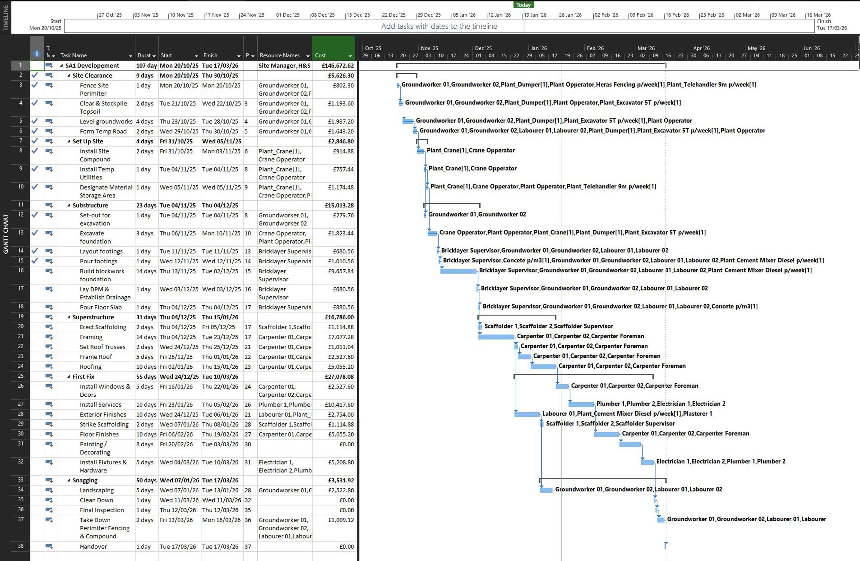
Figure 1: Gantt Chart

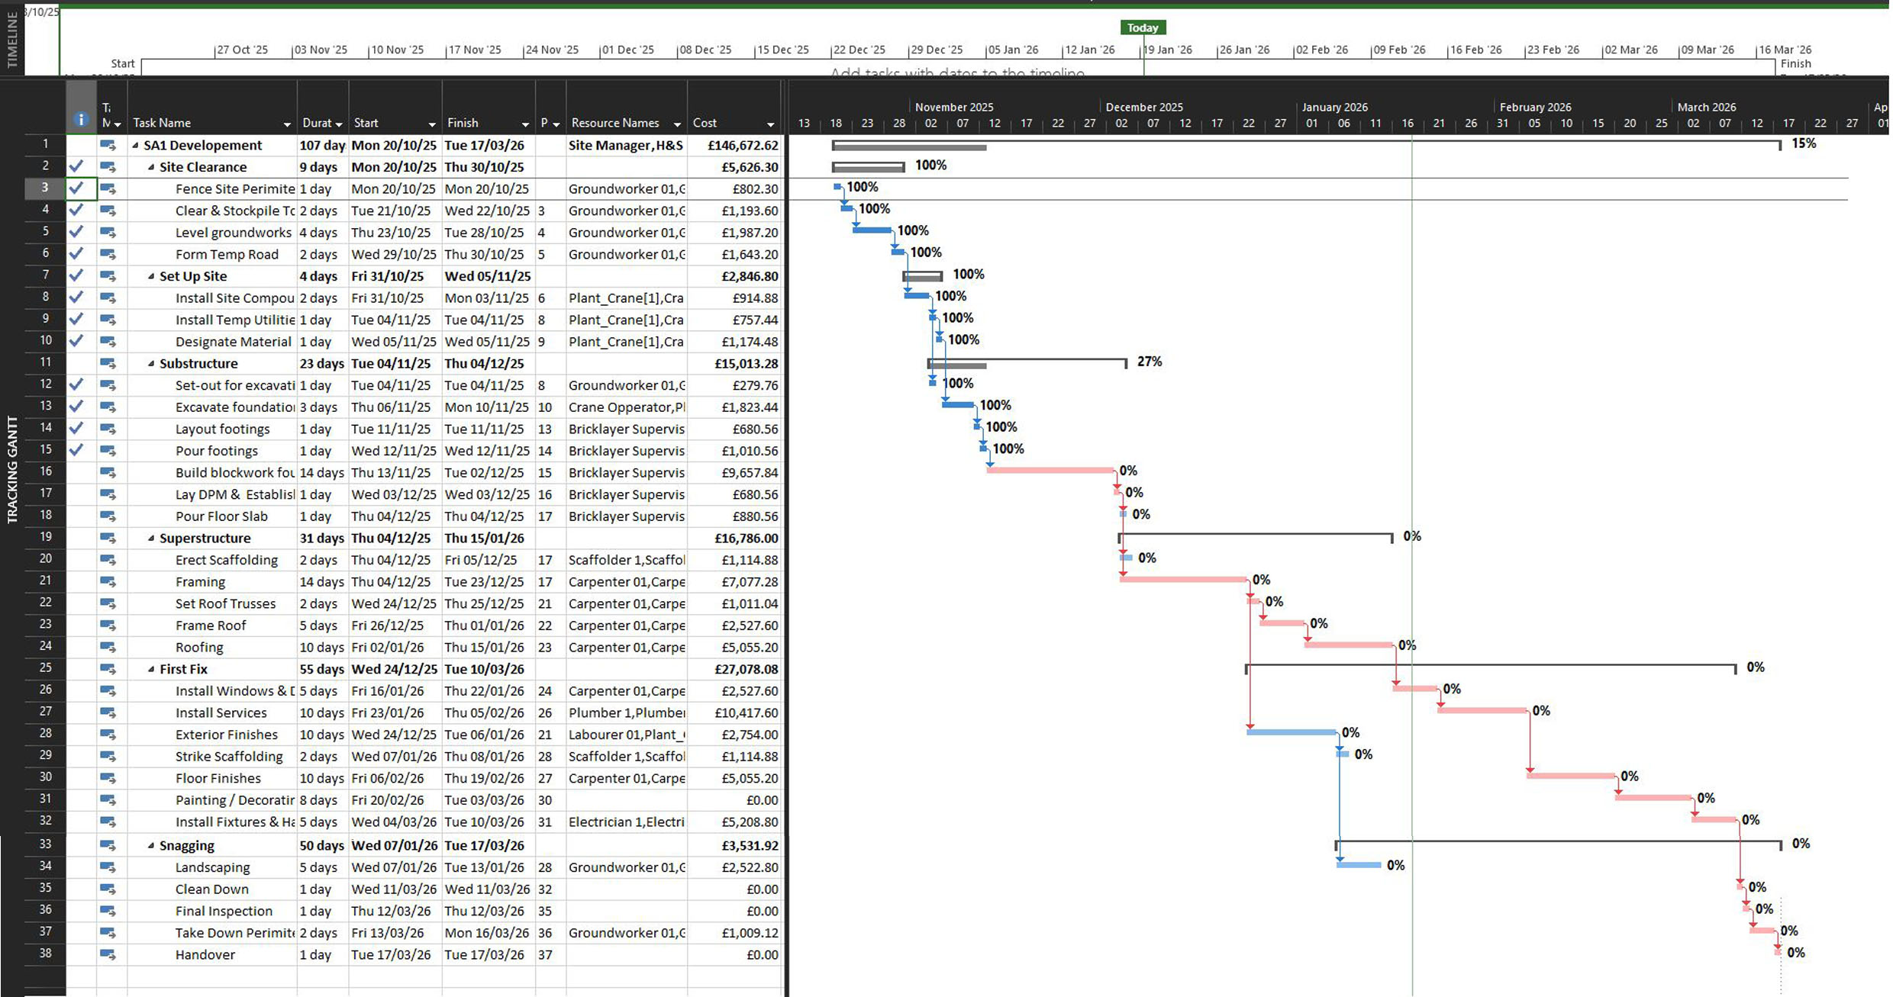
Figure 2: Tracking Gantt Chart

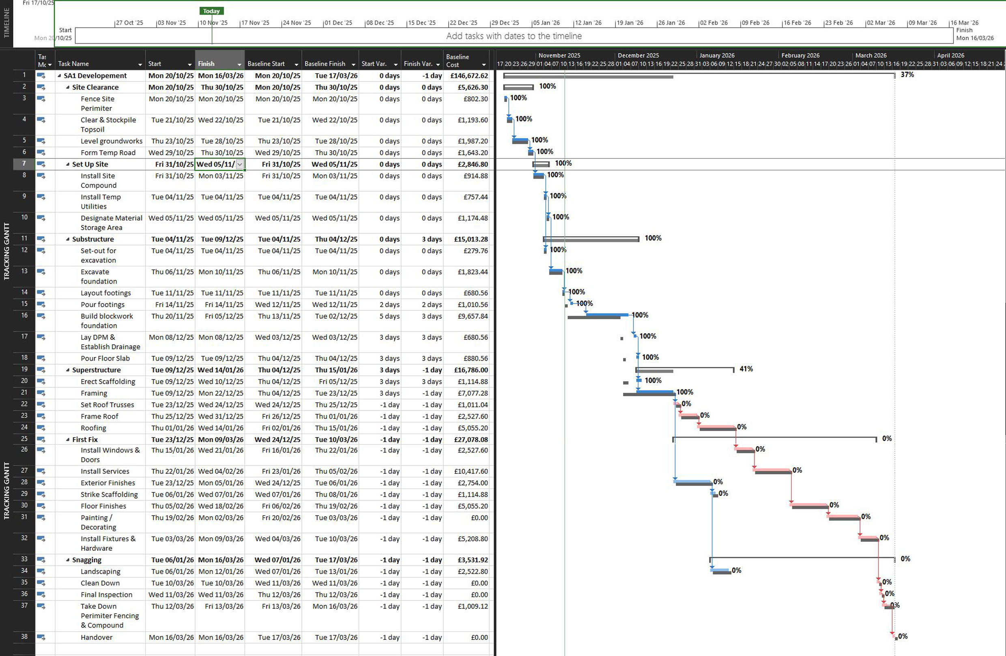
Figure 3: Delay Gantt Chart

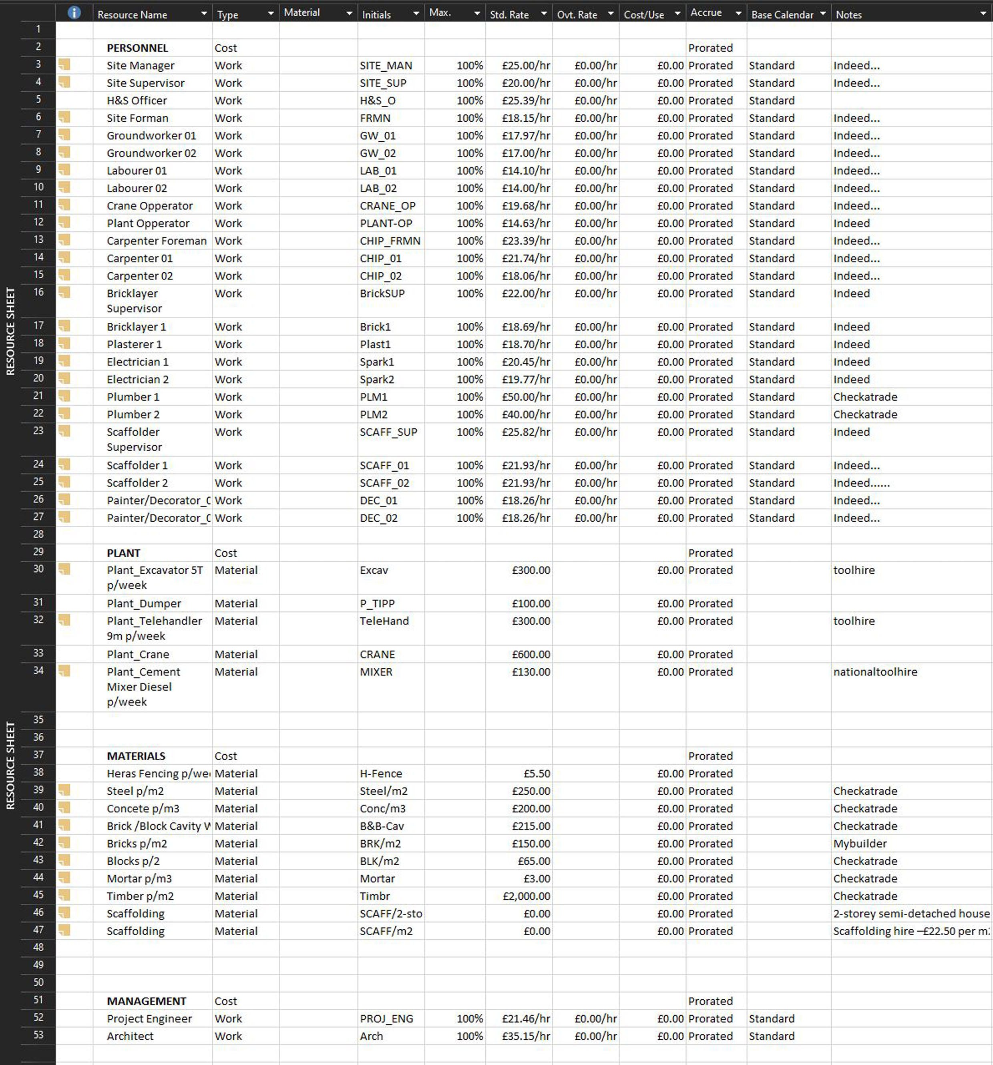
Figure 4: Resource Sheet

