

Name: SAQIB AHMED
Student ID: 2527092
Module Code: AS1 LCLM4001-A1P1
Module: Academic Skills

Submitted on: 04/10/2026

Assessment 1 – Reading Task Template
PART 1: Upload your photo of your A3 in-class notes here:
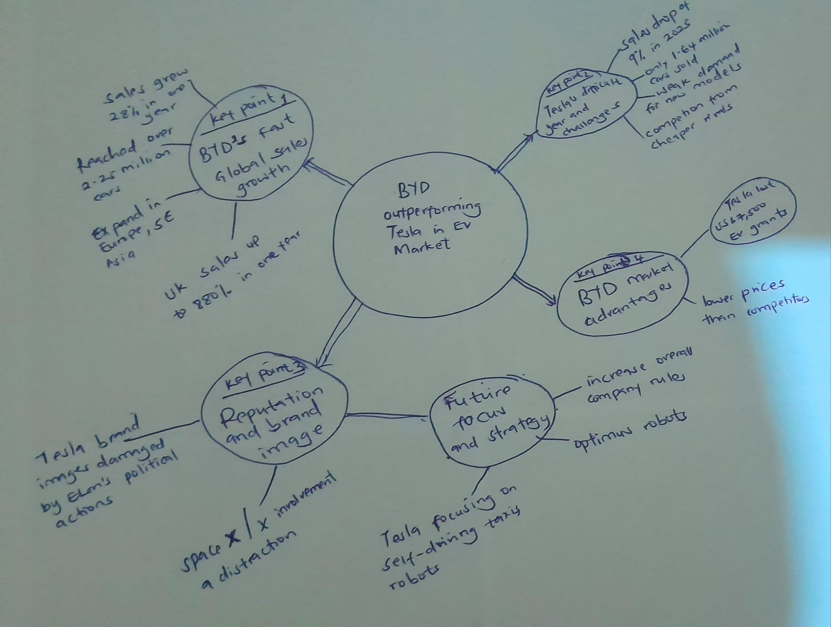

PART 2:
- Answer every question below in 1-3 full sentences.
- Use your own words. Do not use generative AI to answer these questions.
- Include a specific detail from the text when asked.
REMINDER
- The main idea is the overall message of the whole text.
- A key point helps to explain the main idea.
- A specific detail or example from the text shows that the key point is true.

- What is the main idea of the whole text?
The main idea is that BYD is now the world’s biggest electric-vehicle seller, and it has taken first place from Tesla.

- What is one key point that supports the main idea, and which specific example from the text shows this?
One key point is that BYD’s sales are growing very fast. For example, BYD’s sales grew by 28% to more than 2.25 million cars, and its UK sales went up by 880% in one year.
- What is a different key point that supports the main idea, and which specific example from the text shows this?
A different key point is that Tesla had a difficult year. For example, Tesla sold 1.64 million cars in 2025, which was a 9% drop from the year before. It also lost the US $7,500 EV grants and faced cheaper Chinese competitors like Geely.

- Which part of the text do you think is most important, and why?
I believe the numbers of the sales are the most significant aspect as they are clear evidence for the main idea. The figures (BYD 2.25 million, Tesla 1.64 million) indicate it is the fact, and not the opinion, that BYD sold more cars.

Reflection:
- What did you find difficult in this task (including in-class components), and why was it difficult?
It was hard for me to convert the long sentences in the article down to keywords that we can use in our mind map. For instance, I would have written an entire sentence about the discontent of customers, but I trimmed that to Weak demand for new models to make the map easier to read.

- What helped you with this difficulty, and how did it help you?
By comparing my mind map with the other pair's map in our group, I got an idea of how the other pair's map was clearer without any unnecessary words because of their use of precise statistics. It is important to note that they had BYD's 28% increase in global sales and 880% growth in the UK which helped me realize that it works much better to use specific numbers than lengthy descriptive sentences to support the main idea.

