UNIVERSITY OF WALES TRINITY SAINT DAVIS
Digital Skills for Personal and Professional Growth
Lecture: Philippa Fitzgerald
Student: Evaristo Mendez
ID: 2324422

Table of Contents
Questionnaire structure 2
Key Questions for Analysis 3
Explain how the findings can be used to shape and enhance your business idea. 6
Segmentation: Explain how you used the data to identify and target specific segments of your audience. 6
SEO: Describe how you optimized your website and marketing materials for search engines based on the insights from the questionnaire. 7
References 13

Questionnaire structure

 | https://forms.office.com/e/4rtdanC2RD | Your information is highly confidential, the following information is for internal research purpose only, all information will not be shared externally.
 | Question | options
1 | What is your gender? | - Man
 | What is your gender? | - Woman
2 | How old are you? | -61
 | How old are you? | -81
 | How old are you? | -101
3 | How long have you been working as a carer? | - Less than 1 year
 | How long have you been working as a carer? | - 1–3 years
 | How long have you been working as a carer? | - 4–6 years
4 | What type of care work do you currently perform? | - Nursing
 | What type of care work do you currently perform? | - Residential care
 | What type of care work do you currently perform? | - Adults with Disabilities
 | What type of care work do you currently perform? | - Dementia
5 | How would you rate your overall experience as a carer? | Excellent
 | How would you rate your overall experience as a carer? | Good
 | How would you rate your overall experience as a carer? | Average
 | How would you rate your overall experience as a carer? | Poor
6 | Do you feel supported by the company in your role as a carer? | - Yes, always
 |  | - Sometimes
 |  | - Rarely
7 | Do you feel you have access to adequate training and resources? | - Yes
 |  | - No
8 | Are you satisfied with your current salary as a carer? | - Yes, completely satisfied
 | Are you satisfied with your current salary as a carer? | - Somewhat satisfied
 | Are you satisfied with your current salary as a carer? | - Neutral
 | Are you satisfied with your current salary as a carer? | - Dissatisfied
9 | How does your current salary compare to industry standards? | - Above average
 | How does your current salary compare to industry standards? | -Average
 | How does your current salary compare to industry standards? | - Below average
10 | Do you feel valued and respected at work? | - Yes, always
 | Do you feel valued and respected at work? | - Sometimes
 | Do you feel valued and respected at work? | - Rarely
11 | Are you interested in continuing to work at this company? | - Yes
 | Are you interested in continuing to work at this company? | - Unsure
 | Are you interested in continuing to work at this company? | - No
12 | Would you recommend this company to other carers? | - Yes
 | Would you recommend this company to other carers? | - Unsure
 | Would you recommend this company to other carers? | - No
13 | What changes or improvements would encourage you to stay in your company? | - Open-ended response (e.g., Nothing)
14 | Do you have any other comments or suggestions for us? | - Open-ended response (e.g., No)

Key Questions for Analysis

For this questionnaire, were selected four important questions that reveal carers experiences:
- Do you feel supported by the company in your role as a carer?
- Do you feel valued and respected at work?
- Are you satisfied with your current salary as a carer?
- Would you recommend this company to other carers?

1. Feeling Supported Do you feel supported by the company in your role as a carer
A large percentage of carers said they rarely feel supported(83%), and some mentioned they only feel supported sometimes (17%). This shows the company isn’t offering consistent help when it’s needed. Without proper support, carers can feel left on their own, which makes their jobs harder and more stressful.
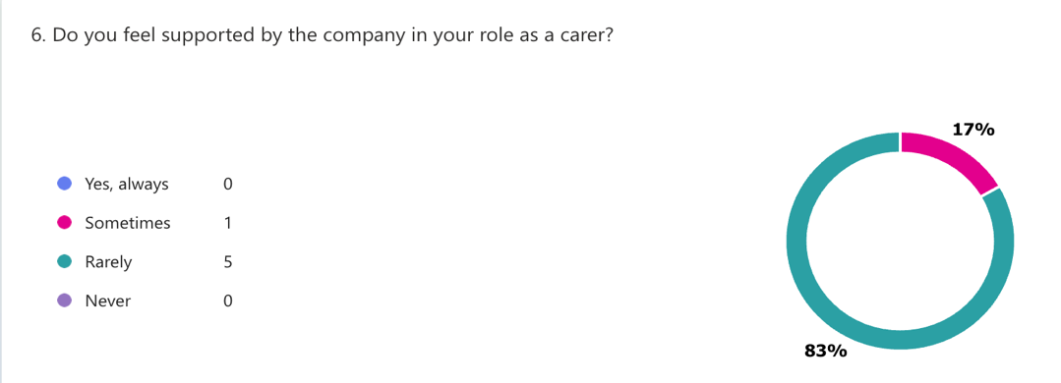
2. Do you feel valued and respected at work?
Most carers said they feel sometimes and rarely valued or respected at work (86%), and only a few said they feel appreciated. When carers don’t get recognized for their hard work, it’s easy for them to lose motivation and feel disconnected affecting the performance as a team and the well-being of the residents.
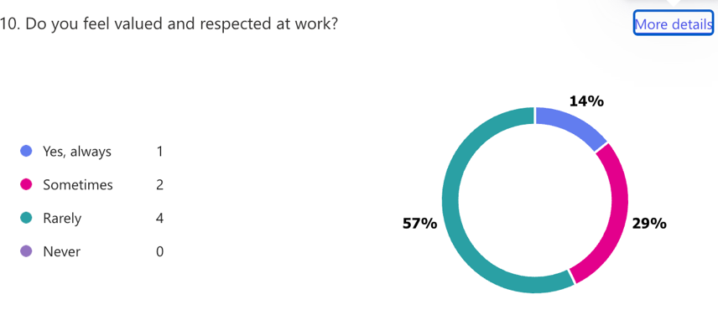
3. Are you satisfied with your current salary as a carer?
Most carers (57%) feel neutral about their pay, meaning it’s okay but not something they’re particularly happy with. A smaller group (14%) are dissatisfied, which suggests some feel their efforts aren’t valued enough. Another 14% are somewhat satisfied, while only 14% feel completely satisfied with their salary. The company could consider reviewing salaries or offering extra benefits to help carers feel more valued and positive about their pay.
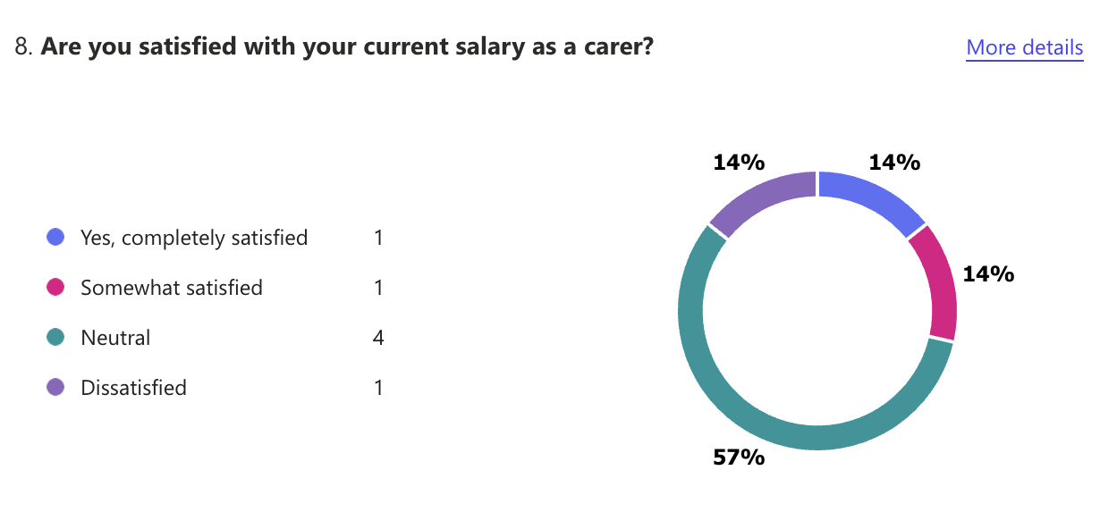
4. Would you recommend this company to other carers?
Most carers (57%) said they would not recommend the company or were unsure (29%). Very few responded positively. Low recommendation rates indicate dissatisfaction with various aspects of the workplace. Improving work culture, pay, and recognition could lead to a more positive perception of the company.
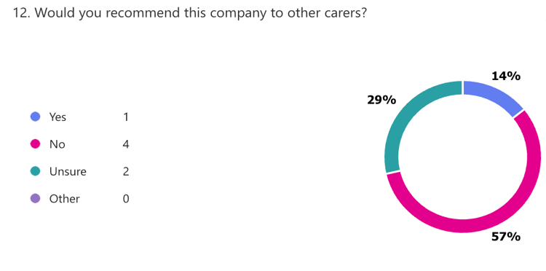

Explain how the findings can be used to shape and enhance your business idea.

Provide Better Support
The company should focus on making carers feel more supported, by having regular one-on-one meetings, setting up mentoring programs, and giving carers extra training.
Recognize Achievements
Carers need to feel appreciated for their hard work. Saying thank you during team meetings, or even writing personal notes of appreciation can truly make a difference in their work. Small rewards or incentives could also help carers feel more valued (Robbins & Judge, 2019).
Review Pay and Benefits
Looking at carers’ pay and making sure it’s competitive. Adding benefits like flexible working hours or mental health support. Being open and clear about how pay is decided can also help carers feel more respected and secure (Gallup, 2023).
Create a Positive Work Environment
Building a supportive and respectful workplace and encouraging open communication can make carers feel more connected and valued. A positive and inclusive culture will keep carers engaged and motivated (Armstrong, 2016).

Segmentation: Explain how you used the data to identify and target specific segments of your audience.

The questionnaire data helped shape the webpage for the business plan of CaringHorizons by showing who we needed to focus on and what they care about.
It turn out to be clear that carers fall into different groups, like those just starting out and those with more experience. New carers, need more support and training, so the webpage highlights things like mentoring programs and tailored training to help them feel confident in their roles.
For experienced carers, the focus is more on competitive pay, career growth, and feeling valued for their hard work. The webpage was designed to connect with carers in a way that feels personal and relevant to them.

SEO: Describe how you optimized your website and marketing materials for search engines based on the insights from the questionnaire.

the SEO strategy for the website and marketing materials focuses on the words carers are likely to use when searching online. Phrases like “better support for carers” and “competitive care salaries” made the content more relevant and easier to find on search engines. Local SEO was also important, so terms like “Bristol care home jobs” were included to attract carers and care homes in the right area. The SEO strategy didn’t just focus on carers; it also targeted care homes searching for reliable staffing solutions. Keywords like “staffing solutions for care homes” and “Bristol carers for hire” were included to make sure the website ranks well when care homes are looking for support.
By addressing the needs of both carers and care homes, the content ensures the website connects with the right audiences from both sides. As Chaffey and Ellis-Chadwick (2019) highlight, effective SEO involves understanding the specific needs of all target groups and using focused keywords to reach them. As Chaffey and Ellis-Chadwick (2019) explain, using clear and focused keywords is key to making a website both user-friendly and search-engine friendly.

Web side page 1
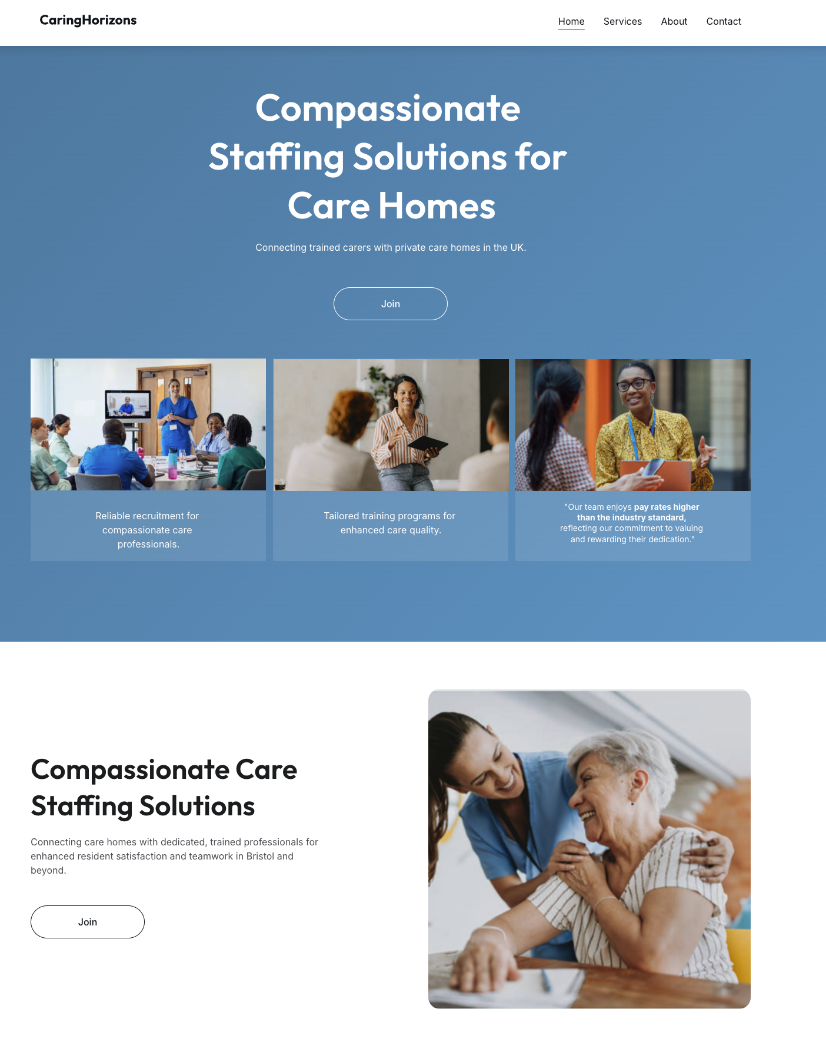

Page 2
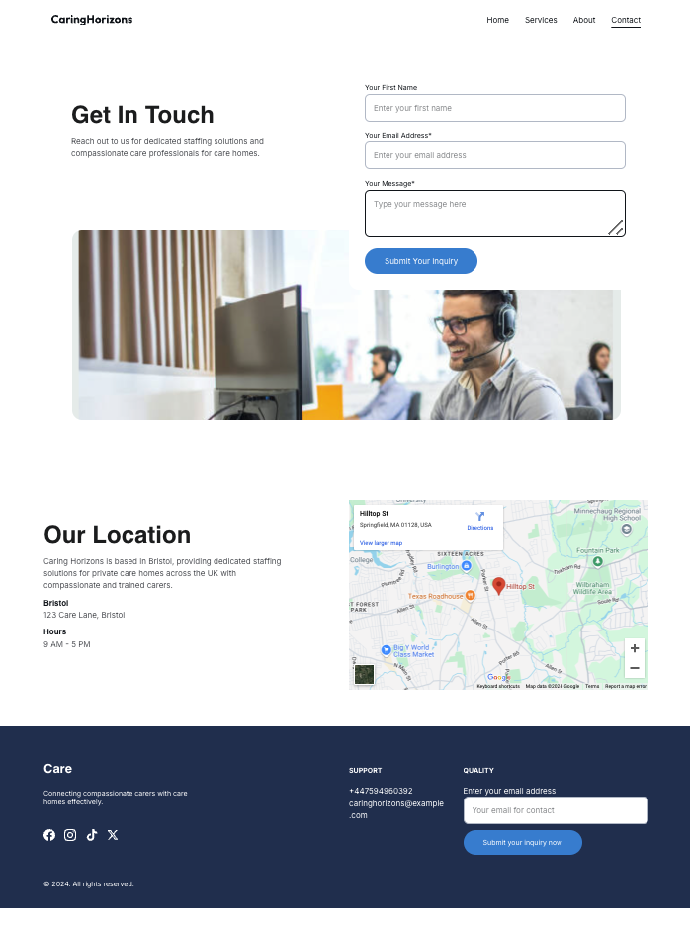

 | 
 | Marketing materials for social media

SPREADSHEET USING MICROSOFT EXCEL TO PROJECT THE FINANCES OF A SMALL BUSINESS OVER A THREE-MONTH PERIOD.

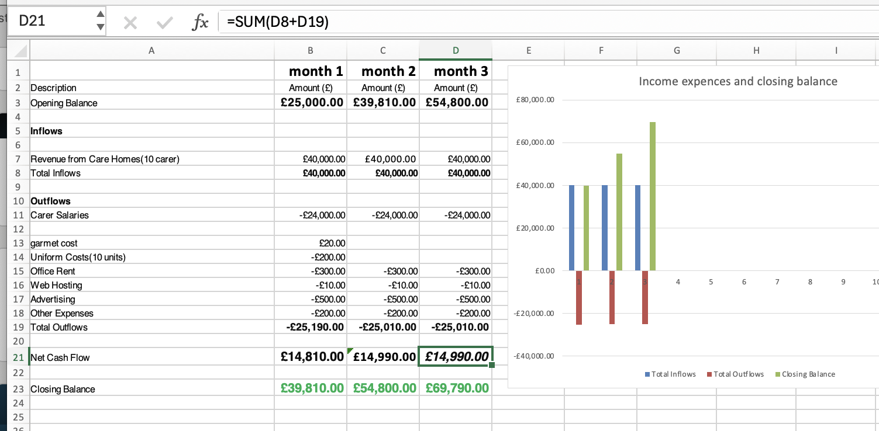

THE IMPORTANCE OF EXCEL IN THE DIGITAL ERA

When I think about how Excel can help a startup like Caring Horizons in this digital era show some important benefits: It’s affordable, easy to use, and incredibly versatile. For example, I could use it to keep track of carer schedules, payroll, and recruitment stats. It’s also perfect for managing client invoices however, it’s a learning curve to understand on details how to use in the right way
Excel also can help to create charts or reports to see where things stand and figure out the next steps for growth. It’s great for organizing data and clearly showing what’s working and what needs improvement. From a manager’s perspective it easy to spot trends and make smarter decisions
Another good feature about Excel is let teams work together in real-time in a bigger scale of the organization. If someone updates a spreadsheet, everyone else can see it right away.
In the digital era, Excel is a versatile tool that helps businesses stay organized and efficient like start-up, small business and big organitazion. Its ability to streamline tasks and provide actionable insights makes it essential for startups (Microsoft)

200-Word Paragraph video explanation
Video Link: https://youtu.be/r2__9hERBUs

In the video, we use storytelling to explain what Caring Horizons does. It starts with a personal story about why we began. Sharing real experiences, helps people feel connected and understand why we care about what we do (McKee, 1997). After that, we talk about the main problem: care homes are short-staffed, and carers don’t get enough support. According to Duarte, showing the difference between how things are and how they could be helps people see why change is important (Duarte, 2010).
Then, we focus on the solution. We show how Caring Horizons finds carers who are trained and ready to work. The video also highlights how we support carers to succeed. We use real examples to make this part relatable. finally, the video asks care homes if they need carers and invites carers to join us. Duarte’s advice to finish with a positive action helps make the message clear and encouraging (Duarte, 2010). The video is straightforward, so people can understand who we are and how we can help.

References

Armstrong, M. (2016) Handbook of Human Resource Management Practice. 14th ed. London: Kogan Page.
Chaffey, D. and Ellis-Chadwick, F. (2019) Digital Marketing: Strategy, Implementation and Practice. 7th ed. Harlow: Pearson Education Limited.
Duarte, N. (2010) Resonate: Present Visual Stories that Transform Audiences. Hoboken: Wiley.
Gallup (2023) State of the Global Workplace. [online] Available at: https://www.gallup.com [Accessed 2 Dec. 2024].
McKee, R. (1997) Story: Substance, Structure, Style and the Principles of Screenwriting. New York: HarperCollins.
Maslow, A.H. (1943) ‘A Theory of Human Motivation’, Psychological Review.
Microsoft Support, n.d. Excel Support. [online] Available at: https://support.microsoft.com/en-us/excel [Accessed 1 December 2024].
Robbins, S.P. and Judge, T.A. (2019) Organizational Behavior. 18th ed. Essex: Pearson Education Limited.
Scarborough, N. M. (2015). Essentials of Entrepreneurship and Small Business Management (8th ed.). Pearson.

